Supplemental Materials
Bastian, Vauclair, et al., (2019) Explaining illness with evil: Pathogen prevalence fosters moral vitalism. Proceedings of the Royal Society B: Biological Sciences.
DOI: 10.1098/rspb. 2019-1576

Study 1
Additional discussion of other explanations for illness
Also included in the SCCS data set are other potential explanations for illness. While many of these touch on spiritual explanations, such as mystical retribution, soul loss, spirit aggression, or sorcery, only Witchcraft explicitly and specifically refers to a propensity for channeling evil (see Murdock, 1980 cited in the article for a full review). For instance, mystical retribution is coded as beliefs that norm violations themselves cause illness directly, rather than through the mediation of an offended or punitive spirit. Likewise, sorcery is defined by the use of magic by a human being often involving physically acting on the victim’s body either directly (i.e., intrusion of foreign objects) or via magical rites performed over hair, nail parings, or clothing. Sorcery can also include the dispatch of alien spirits to possess the victim’s body, consistent with our account, but coding for this explanation is not limited to this spiritual intrusion. Finally, although one example of spirit aggression refers to supernatural beings consistent with our argument, it also codes for aggression by the spirits of ancestors, kinsmen, nature spirits, lesser divinities or higher deities or gods. This index therefore captures explanations that disease may be caused by a range of spiritual forces, some of which are not necessarily evil. Consistent with prior work showing a negativity bias in contagion concerns (Rozin & Royzman, 2001) our theory predicts that specific beliefs about evil forces, rather than spiritual forces more generally, should be most sensitive to the effects of pathogens. Therefore, in line with our argument that it is specifically the belief in an evil force which functionally models the effects of pathogens, we compared both the evil eye belief and a belief in Witchcraft to these other potential explanations.
Control Variables Study 1
The SCCS includes observational data for 186 distinct cultures with a significant number of variables coded from these observations in the existing data set. We draw on a number of these to control for several other potential explanations for the emergence and maintenance of evil eye and witchcraft beliefs. One possibility is that these beliefs could simply be an artefact of religious belief, itself perhaps arising for other reasons (see; Fincher & Thornhill, 2008). To control for this we drew on coding of political and religious differentiation (1 = considerable overlap between political and religious leaders; 2 = some overlap; 3 = distinct) and a of religious influence (0 = no formal political office present; 1 = religious specialists have no influence on decision making at level of maximal political authority; 2 = religious specialists participate in decision making at level of maximal political authority; 3 = officials at level of max political authority are at the same time religious specialists).
It is also possible that evil-eye beliefs or witchcraft beliefs may have emerged due to attempts to restore psychological control or manage death anxiety (see Hafer, 2000; Jong, Halberstadt & Bluemke, 2012; Kay, Whitson, Gaucher & Galinsky, 2009), a need that would have been heightened under conditions of conflict or resource scarcity. To control for this possibility, we included coding of social or political conflict in the local community (1 = Endemic: a reality of daily existence; 2 = High: Conflict present but not a pervasive aspect of daily life; 3 = Moderate: Disagreements and differences do not result in high violence or severe disruption; 4 = Mild or rare) and coding of internal and external warfare (1 = Frequent, occurring at least yearly; 2 = Common, at least every five years; 3 = Occasional, at least every generation; 4 = Rare or never) by Ross (1983). To capture resource scarcity, we also included coding of severity of famine (1 = very low, 2 = low, 3 = high, 4 = very high; Dirks, 1993) and agricultural potential (4 = poorest potential to 23 = richest potential; Pryor, 1986).
Previous research has also linked the prevalence of evil eye beliefs to the experience of envy, and therefore to the level of wealth inequality within a given society (Gershman, 2015). Following Gershan et al. (2015), we controlled for class stratification adapted from Murdock (1967) which comprises five categories (1 = absence of significant wealth distinctions among freemen, 2 = wealth distinctions based on the possession and distribution of property, not crystallized into distinct social classes, 3 = elite stratification, in which an elite class has control over scarce resources, particularly land, 4 = dual stratification into a hereditary aristocracy and a lower class of ordinary commoners or freemen, and 5 = complex stratification into social classes correlated in large measure with extensive differentiation of occupational statuses. Since this scale is not really ordinal, and in line with Gershan et al. (2015) we converted it into a stratification dummy, which equals 0, if the society is of the first type, and 1, otherwise.
Finally, as noted above, in addition to the Witchcraft variable as an explanation for health impairment, several other possible explanations are coded for on the same scale. We examined each of these and controlled for them in our analyses.

Additional Analyses Study 1
All correlations and regressions are reported in Table S1, S2, and S3.

Study 2
Additional Analyses Study 2
We further explored Model 3 by adding cross-level interactions with historical pathogen prevalence. Using a Bonferroni adjustment due to the high numbers of tests (7 cross-level-interactions), we found that only the slopes for age (B = 0.010, Odds Ratio = 1.010, p < .007) and religiosity (B = -0.347, Odds Ratio = 0.707, p < .007) were significantly moderated by historical pathogen prevalence, but the main effect of pathogen prevalence remained unaffected (B = 0.711, Odds Ratio = 2.037, p = .020).

Study 3
Additional Explanation of Mediation Model Used in Study 3
It is noteworthy that several procedures have been suggested for testing multilevel mediation within the standard multilevel modelling (MLM) framework (Preacher, Zhang, & Zyphur, 2011). Yet, in the case of a 2-1-1 mediation, MLM does not fully separate a between-cluster and within-cluster effect which means that it can introduce a bias in the estimation of the indirect effect and lead to very high Type-I error rates (Zhang, Zyphur, & Preacher, 2008). Although our focus is on the between-cluster relationships - because any mediation of the effect of a level-2 variable must also occur at the between-cluster level regardless at which level the mediator and outcome variable are assessed - it is important to differentiate the relationships at the two levels rather than combining them into a single estimate within the indirect effect. One option that has recently been developed is a mediation analysis within the multilevel structural equation modelling (MSEM) framework (see Preacher et al., 2011). MSEM provides unbiased estimates of the between-group indirect effect by treating the cluster-level component of the level-1 variable as latent.
Similar to mediation with single-level data, we conducted the multilevel mediation analyses in three steps (see Zhang et al., 2008): Step 1 showed whether there was a significant association between the independent and dependent variable (also called total effect in the mediation model). Step 2 tested whether the independent variable predicted the mediator variable at the between-level. And Step 3 showed whether the mediator affected the dependent variable when both the independent and mediator variables are included as predictors. The final step allowed us to evaluate the so-called indirect effect which indicates whether a significant mediation has occurred. Note that all of the paths are quantified with unstandardized regression coefficients as is typically done with these kinds of analyses (Preacher & Hayes, 2008).
Additional Analyses Study 3
Unlike Study 2, we did not explore cross-level interactions here because the random slopes were not reliably significant between the analyses with the 4- and 5-item moral vitalism composite score (see Tables 2 and S5).
Regarding the hypothesized mediation model, a reverse mediation is also conceivable in the way that antipathogen psychological tendencies have an effect on moral vitalistic beliefs. In the case of the moral binding foundations, this alternative mediation model cannot be assessed because there is no significant association between the independent variable historical disease prevalence and the mediating variable moral binding foundation (B = 0.114, SE = 0.094, p = 0.226). When we tested the alternative mediation model involving conservative values as the mediating variable, we found that all paths were significant, and the indirect effect revealed to be significant as well. However, contrary to the hypothesized mediation model, there was evidence for only partial and not full mediation (see Figure S3). In sum, the hypothesized mediation models are better supported by the data than the alternative models.
Additional Discussion Points
- How does our work link to that of Murdock (1980)? Although Murdoch also examined explanations for illness, the focus of that work was on how people explained illness explicitly, and therefore the implications were largely constrained to that domain. Our findings go beyond this work by examining how a generalized belief in the existence of evil forces may have emerged which helped to explain the effects of illness, but which also represented a belief system with broader social implications.
- Our argument that disease threat encouraged development of lay theories that facilitated or cognitively justified evolved responses is consistent with theorizing within other domains. For instance, some have argued that a belief in moralizing Gods emerged to facilitate cooperation and reciprocity within human groups (Shariff & Norenzayan, 2007). Understood as such, lay theories may not be necessary for adaptive behavioral responses to emerge, but their presence likely reinforces, constrains, and encourages such responses.
- Explaining illness with evil is consistent with evidence that people often seek to treat those who are ill, and does not suggest they would have been ostracized or avoided under all circumstances (e.g., Shweder et al., 1997). Indeed, interventions such as those relied on by witchdoctors, but also current day spiritual healers, assume negative energy or evil forces which need to be acted upon and treated.
- Recent work by Tybur et al. (2015) suggests that sexual strategies played a central role in reinforcing socially conservative attitudes that promoted monogamous pair bonds. We see our account as consistent with this possibility. As noted by Bastian et al. (2015), a belief in moral vitalism is associated with concerns over purity of behavior and mental content, suggesting that it may have reinforced sanctioned behavioral standards associated with sexual conduct.
- While we did not account for phylogenetic closeness between cultures in Study 2 and 3, we did so in Study 1 by drawing on the SCCS data set which was specifically designed to overcome this problem. We also note, however, that phylogenetic closeness mostly impacts on interpreting evidence for the emergence of cultural traits, as opposed to their persistence (see Thornhill & Fincher, 2013). Our argument is consistent with both possibilities; that moral vitalism emerged due to pathogen threat or was merely reinforced within these contexts, thus limiting the impact of this potential confound.

References
Dirks, R. 1993. Starvation and Famine: Cross-Cultural and Some Hypothesis Tests.
Cross-Cultural Research, 27, 28-69. doi:10.1177/106939719302700103
Murdock, G.P. (1967). Ethnographic Atlas. Pittsburgh, PA: University of Pittsburgh Press.
Preacher, K. J., Zhang, Z., & Zyphur, M. J. (2011). Alternative methods for assessing mediation in multilevel data: The advantages of multilevel SEM. Structural Equation Modeling, 18, 161–182. doi:10.1080/10705511.2011.557329
Pryor, F. L. (1986). The Adoption of Agriculture: Some Theoretical and Empirical Evidence. American Anthropologist, 88, 894-897. doi:10.1525/aa.1986.88.4.02a00060
Ross, M. (1983). Political Decision Making and Conflict: Additional Cross-Cultural Codes
and Scales. Ethnology, 22, 69-192. doi:10.2307/3773578
Rozin, P., & Royzman, E. B. (2001). Negativity bias, negativity dominance, and contagion.
Personality and Social Psychology Review, 5, 296-320. doi:10.1207/S15327957PSPR0504_2
Shariff, A. F., & Norenzayan, A. (2007). God is watching you: Priming God concepts increases prosocial behavior in an anonymous economic game. Psychological Science, 18, 803-809. doi:10.1111/j.1467-9280.2007.01983.x

Table S1. Pearson correlation between belief in evil eye, historical pathogen prevalence, and control variables for Study 1
 |  | 1 | 2 | 3 | 4 | 5 | 6 | 7 | 8 | 9 | 10 | 11
1 | Evil Eye Belief
2 | Historical Pathogen Prevalence | .24**
Control Variables
3 | Political and Religious Differentiation | .16 | -.01
4 | Religious and Political Overlap | .05 | .01 | -.06
5 | Conflict (social or political in local community | -.28** | -.04 | .01 | .01
6 | Internal warfare | -.32** | -.18 | -.04 | .08 | .49*
7 | External warfare | -.16 | -.09 | -.27* | -.06 | .14 | .29**
8 | Severity of famine | .15 | .09 | .06 | -.05 | -.05 | -.12 | -.37**
9 | Agricultural potential | -.03 | .39** | -.03 | .21 | -.03 | -.03 | .08 | -.10
10 | Wealth Inequality | .29** | .15 | .05 | .21 | -.15 | -.10 | -.01 | -.19* | -.01
Explanations for Illness
11 | Witchcraft | .57** | .32** | .30* | .10 | -.50** | -.35** | -.23 | .18 | .11 | .11
 | Infection | .18* | .08 | -.05 | .17 | -.11 | -.16 | -.07 | .01 | .02 | .08 | .10
 | Stress | -.07 | .01 | -.04 | .06 | -.10 | -.18 | .20 | .12 | -.05 | .09 | .01
 | Deterioration | -.14 | -.02 | -.29* | -.03 | -.01 | .12 | .04 | .06 | .02 | .10 | -.16
 | Accident | .13 | .02 | -.20 | .04 | -.07 | -.09 | .03 | .10 | .07 | .06 | .02
 | Fate | .02 | .22* | -.12 | .03 | .11 | .21 | -.07 | -.03 | .07 | .27** | -.02
 | Ominous Sensation | -.05 | -.01 | .25 | -.01 | .34** | .18 | -.02 | -.01 | .01 | .04 | -.04
 | Contagion | -.14 | -.18* | .09 | .12 | .27* | .07 | .03 | -.09 | -.01 | -.07 | -.17
 | Mystical Retribution | -.15 | .01 | -.21 | -.09 | .14 | -.04 | .03 | .05 | .03 | -.12 | -.12
 | Soul Loss | -.25** | -.14 | -.12 | .21 | .21 | .13 | .14 | .04 | -.02 | -.07 | -.20*
 | Spirit Aggression | -.05 | .01 | -.17 | -.02 | .05 | .05 | .26* | -.06 | -.09 | .14 | -.17*
 | Sorcery | -.12 | -.19* | -.03 | .06 | .15 | .23 | -.16 | -.06 | .06 | -.11 | -.23**
*p < .05, **p < .01. Note: for variables #3 to #7 sample ranges from n=80 to n=90, variable #8 sample n=124, explanations for illness sample ranges from n=122 to n=130 due to missing data.
Table S2. Regressions predicting evil eye belief with historical pathogen prevalence and control variables for Study 1
Model |  | Model | Control Variable |  |  | Historical Pathogen Prevalence
# |  | df | Standardized  Beta | p |  | Standardized  Beta | p
1 | Political and Religious Differentiation | 82 | .164 | .118 |  | .325 | .002
2 | Religious and Political Overlap | 89 | .050 | .615 |  | .368 | <.001
3 | Conflict (social or political in local community | 89 | -.268 | .008 |  | .289 | .004
4 | Internal warfare | 84 | -.265 | .010 |  | .312 | .003
5 | External warfare | 83 | -.128 | .224 |  | .322 | .003
6 | Severity of famine | 123 | .128 | .147 |  | .239 | .007
7 | Agricultural potential | 185 | -.134 | .084 |  | .286 | <.001
8 | Wealth Inequality | 185 | .258 | <.001 |  | .197 | .005
9 | Alternative explanations for Illness | 98 | -.232 - .227 | .045 - .999 |  | .227 | .030

Table S3. Regressions predicting witchcraft belief with historical pathogen prevalence and control variables for Study 1
Model | Control Variables | Model | Control Variable |  |  | Historical Pathogen Prevalence
# |  | df | Standardized  Beta | p |  | Standardized  Beta | p
1 | Political and Religious Differentiation | 61 | .315 | .009 |  | .313 | .010
2 | Religious and Political Overlap | 65 | .150 | .180 |  | .482 | <.001
3 | Conflict (social or political in local community | 66 | -.476 | <.001 |  | .257 | .016
4 | Internal warfare | 64 | -.298 | .013 |  | .249 | .038
5 | External warfare | 63 | -.199 | .105 |  | .263 | .034
6 | Severity of famine | 89 | .170 | .088 |  | .349 | .001
7 | Agricultural potential | 130 | -.021 | .820 |  | .325 | .001
8 | Wealth Inequality | 130 | .060 | .481 |  | .307 | <.001
9 | Alternative explanations for Illness | 98 | -.387 - .288 | .001 - .709 |  | .288 | .004

Table S4. Multilevel regression predicting belief in the Devil controlling for country-level covariates (Study 2).

 |  | (1) |  |  | (2) |  |  | (3) |  |  | (4) |  |  | (5) |  |  | (6)
 |  |  |  |  |  |  |  |  |  |  | With robust standard errors
 |  | Coefficient | Odds Ratio |  | Coefficient | Odds Ratio |  | Coefficient | Odds Ratio |  | Coefficient | Odds Ratio |  | Coefficient | Odds Ratio |  | Coefficient | Odds Ratio
Fixed Effects
Intercept |  | 0.119 | 1.127 |  | 0.122 | 1.129 |  | 0.122 | 1.129 |  | 0.118 | 1.125 |  | 0.118 | 1.125 |  | 0.121 | 1.128
Individual-level Predictors
 | Age | -0.009*** | 0.991 |  | -0.009*** | 0.991 |  | -0.009*** | 0.991 |  | -0.009*** | 0.991 |  | -0.009*** | 0.991 |  | -0.009*** | 0.991
 | Gender (0 = male, 1 = female) | 0.217*** | 1.242 |  | 0.217*** | 1.242 |  | 0.217*** | 1.242 |  | 0.216*** | 1.242 |  | 0.216*** | 1.242 |  | 0.218*** | 1.243
 | Religiosity | 0.827*** | 2.287 |  | 0.828*** | 2.288 |  | 0.828*** | 2.287 |  | 0.827*** | 2.287 |  | 0.827*** | 2.287 |  | 0.827*** | 2.287
 | Conservative Political Orientation | 0.034** | 1.034 |  | 0.034** | 1.034 |  | 0.034** | 1.034 |  | 0.034** | 1.034 |  | 0.034** | 1.034 |  | 0.034** | 1.034
 | Education | -0.128** | 0.880 |  | -0.128** | 0.880 |  | -0.128** | 0.880 |  | -0.128** | 0.880 |  | -0.128** | 0.880 |  | -0.129** | 0.880
 | Social Class | -0.068* | 0.935 |  | -0.068* | 0.935 |  | -0.068* | 0.935 |  | -0.068* | 0.935 |  | -0.068* | 0.935 |  | -0.067* | 0.935
 | Subjective Health | -0.065** | 0.937 |  | -0.065** | 0.937 |  | -0.065** | 0.937 |  | -0.065** | 0.937 |  | -0.065** | 0.937 |  | -0.065** | 0.937
Country-level Predictors
 | Historical pathogen prevalence | 0.622* | 1.862 |  | 0.604* | 1.829 |  | 0.486† | 1.626 |  | 0.488† | 1.629 |  | 0.488 | 1.738 |  | 0.401 | 1.494
 | Corruption Index | 0.004 | 1.004 |  |  |  |  |  |  |  |  |  |  |  |  |  | 0.009 | 1.010
 | Democracy Index |  |  |  | 0.041 | 1.042 |  |  |  |  |  |  |  |  |  |  | 0.046 | 1.047
 | Peace Index |  |  |  |  |  |  | -0.129 | 0.879 |  |  |  |  |  |  |  | -0.413 | 0.661
 | Human Development Index |  |  |  |  |  |  |  |  |  | -0.496 | 0.609 |  | -0.496 | 0.609 |  | 1.215 | 0.297
Random Effects
Intercepts |  | 0.630*** |  |  | 0.646*** |  |  | 0.624*** |  |  | 0.628*** |  |  | 0.628*** |  |  | 0.611***
Age |  | 9.00E-05*** |  |  | 9.00E-05*** |  |  | 9.00E-05*** |  |  | 9.00E-05*** |  |  | 9.00E-05*** |  |  | 9.00E-05***
Gender |  | 0.017** |  |  | 0.017** |  |  | 0.017** |  |  | 0.017** |  |  | 0.017** |  |  | 0.017**
Religiosity |  | 0.126*** |  |  | 0.126*** |  |  | 0.126*** |  |  | 0.126*** |  |  | 0.126*** |  |  | 0.126***
Conservative Political Orientation |  | 0.003*** |  |  | 0.003*** |  |  | 0.003*** |  |  | 0.003*** |  |  | 0.003*** |  |  | 0.003***
Education |  | 0.045*** |  |  | 0.045*** |  |  | 0.045*** |  |  | 0.045*** |  |  | 0.045*** |  |  | 0.045***
Social Class |  | 0.017*** |  |  | 0.017*** |  |  | 0.017*** |  |  | 0.017*** |  |  | 0.017*** |  |  | 0.017***
Subjective Health |  | 0.011*** |  |  | 0.011*** |  |  | 0.011*** |  |  | 0.011*** |  |  | 0.011*** |  |  | 0.011***
Note. †p <.10; *p <0.05; **p <0.01; ***p <0.001 (two-tailed). Sample size is N = 42,482 (k = 43 countries) in all models. All predictors are grand-mean centred and unit-specific results with non-robust standard errors are reported, except if indicated differently. Regression coefficients are log-odds. The reported odds ratios indicate the changes in odds as a result of a one-unit change in the predictor variable, holding all other predictor variables constant. Design weights were used as provided by the World Value Survey.

Table S5. Multilevel regression predicting belief in moral vitalism controlling for country-level covariates (Study 3).
 |  |  | (1) |  |  | (2) |  |  | (3) |  | (4) |  |  |  | (5)
Fixed Effects |  |  | B | SE |  | B | SE |  | B | SE |  | B | SE |  | B | SE
 | Intercept |  | 3.823*** | 0.089 |  | 3.818*** | 0.088 |  | 3.822*** | 0.091 |  | 3.819*** | 0.091 |  | 3.817*** | 0.086
 | Individual-level Predictors
 |  | Age | -0.005 | 0.005 |  | -0.005 | 0.004 |  | -0.005 | 0.004 |  | -0.005 | 0.004 |  | -0.005 | 0.004
 |  | Gender (0 = male, 1 = female) | 0.096 | 0.004 |  | 0.094 | 0.050 |  | 0.096 | 0.050 |  | 0.094 | 0.050 |  | 0.094 | 0.050
 |  | Religion (0 = no, 1 = yes) | 0.504*** | 0.055 |  | 0.494*** | 0.056 |  | 0.499*** | 0.055 |  | 0.491*** | 0.057 |  | 0.504*** | 0.056
 |  | Conservative economic political orientation | -3.31E-04 | 0.016 |  | -5.00E-05 | 0.016 |  | -6.6E-05 | 0.016 |  | 7.80E-05 | 0.016 |  | 4.79E-05 | 0.016
 |  | Conservative social political orientation | 0.067*** | 0.017 |  | 0.067*** | 0.017 |  | 0.067*** | 0.017 |  | 0.067*** | 0.017 |  | 0.066*** | 0.017
 | Country-level Predictors
 |  | Historical Pathogen prevalence | 0.485** | 0.144 |  | 0.261† | 0.131 |  | 0.404** | 0.124 |  | 0.275† | 0.141 |  | 0.421** | 0.133
 |  | Corruption Index | 0.004 | 0.005 |  |  |  |  |  |  |  |  |  |  | 0.019* | 0.008
 |  | Democracy Index |  |  |  | -0.074 | 0.052 |  |  |  |  |  |  |  | -0.161* | 0.069
 |  | Peace Index |  |  |  |  |  |  | 0.058 | 0.166 |  |  |  |  | 0.087 | 0.224
 |  | Human Development Index |  |  |  |  |  |  |  |  |  | -0.983 | 1.076 |  | -2.117 | 1.602
Random effects
 |  | Residuals | 0.949 |  |  | 0.949 |  |  | 0.949 |  |  | 0.949 |  |  | 0.949
 |  | Intercepts | 0.212*** |  |  | 0.207*** |  |  | 0.219*** |  |  | 0.219*** |  |  | 0.195***
 |  | Age | 0.030 |  |  | 0.030 |  |  | 0.030 |  |  | 0.030 |  |  | 2.00E-05
 |  | Gender | 0.019 |  |  | 0.020 |  |  | 0.019 |  |  | 0.019 |  |  | 0.021
 |  | Religiosity | 0.034* |  |  | 0.036* |  |  | 0.035* |  |  | 0.037* |  |  | 0.034*
 |  | Conservative economic political orientation | 0.001 |  |  | 0.001 |  |  | 0.001 |  |  | 0.001 |  |  | 0.001
 |  | Conservative social political orientation | 0.003 |  |  | 0.003 |  |  | 0.003 |  |  | 0.003 |  |  | 0.003
Note. †p <.10; *p <0.05; **p <0.01; ***p <0.001 (two-tailed). Sample size is N = 3028 (k = 28 countries) in all models. All predictors are grand-mean centred and results with non-robust standard errors are reported.
Table S6. Country-level descriptive statistics of main variables (Study 3).

Country | N | % female | Age (Mean) | Economic political orientation (Mean) | Social political orientation (Mean) | Religion (% indicating yes) | Binding Foundation (Mean) | Conservative Values (Mean) | Moral Vitalism (Mean) | Historical Pathogen Prevalence Score
Australia | 87 | 71 | 20.87 | 3.63 | 3.10 | 40 | 3.98 | 0.57 | 3.54 | -0.25
Austria | 56 | 91 | 24.67 | 3.02 | 2.55 | 68 | 3.74 | 0.29 | 3.11 | -0.77
Belgium | 160 | 86 | 18.55 | 3.64 | 3.14 | 34 | 3.81 | 0.87 | 3.48 | -1.00
Brazil | 111 | 52 | 22.62 | 3.59 | 2.77 | 55 | 3.81 | 0.54 | 3.37 | 0.93
China | 119 | 61 | 20.3 | 3.85 | 3.39 | 0 | 3.97 | 0.87 | 4.57 | 1.03
Cyprus | 80 | 44 | 21.26 | 3.59 | 3.77 | 79 | 4.46 | 1.25 | 4.64 | -0.34
Finland | 187 | 78 | 27.75 | 2.81 | 1.98 | 35 | 3.36 | -0.19 | 2.81 | -0.75
France | 71 | 63 | 20.9 | 3.05 | 2.62 | 30 | 3.82 | 0.55 | 3.71 | -0.46
Germany | 104 | 72 | 23.33 | 2.90 | 2.45 | 52 | 3.53 | -0.01 | 2.68 | -0.87
Greece | 101 | 91 | 23.05 | 2.85 | 2.52 | 56 | 3.74 | 0.30 | 3.58 | 0.08
Hong Kong | 79 | 79 | 21.24 | 3.61 | 3.61 | 30 | 4.13 | 1.04 | 4.37 | 0.27
Indonesia | 100 | 81 | 20.03 | 3.74 | 4.06 | 97 | 4.11 | 1.08 | 4.70 | 0.63
Israel | 140 | 73 | 22.92 | 4.09 | 2.92 | 56 | 4.44 | 1.10 | 3.75 | 0.52
Japan | 154 | 13 | 19.68 | 3.43 | 3.88 | 13 | 3.53 | 0.97 | 4.38 | 0.43
Mexico | 100 | 73 | 25.44 | 3.27 | 3.53 | 82 | 2.6 | 0.97 | 4.13 | 0.28
New Zealand | 149 | 74 | 19.63 | 2.89 | 1.97 | 31 | 4.02 | 0.58 | 3.78 | -0.98
Norway | 78 | 49 | 23.43 | 3.68 | 3.37 | 35 | 3.52 | 0.55 | 3.22 | -0.85
Poland | 107 | 48 | 22.84 | 4.05 | 4.66 | 81 | 4.01 | 0.81 | 3.64 | -0.87
Portugal | 193 | 90 | 20.95 | 3.79 | 3.16 | 58 | 4.36 | 0.78 | 3.74 | 0.47
Russia | 85 | 65 | 20.18 | 3.71 | 3.76 | 56 | 3.67 | 0.25 | 3.60 | -0.39
Singapore | 88 | 64 | 21.26 | 3.60 | 3.73 | 55 | 4.46 | 0.77 | 4.48 | 0.31
Spain | 200 | 20 | 36.04 | 3.12 | 2.76 | 32 | 2.86 | 0.07 | 3.43 | -0.05
Switzerland | 118 | 77 | 23.98 | 2.91 | 2.26 | 52 | 3.87 | 0.30 | 3.13 | -1.08
Taiwan | 104 | 51 | 19.58 | 3.10 | 3.15 | 30 | 4.36 | 0.86 | 4.41 | 0.30
Turkey | 110 | 87 | 20.8 | 3.23 | 3.07 | 89 | 4.53 | 1.03 | 4.87 | 0.16
UK | 54 | 78 | 20.44 | 3.68 | 2.94 | 35 | 3.99 | 0.74 | 3.81 | -1.01
United States | 101 | 48 | 18.81 | 5.27 | 4.65 | 89 | 4.27 | 1.30 | 4.58 | -0.89
Venezuela | 104 | 60 | 20.85 | 3.87 | 3.55 | 64 | 4.22 | 0.61 | 3.81 | 0.48
Totals | 3140 | 66 | 22.21 | 3.5 | 3.19 | 51 | 3.9 | 0.67 | 3.83 | -0.17

Table S7. Multilevel regression predicting belief in moral vitalism measured with 4 items (Study 3).

 |  |  | Model 0 |  |  | Model 1 |  |  | Model 2 |  |  | Model 3
Fixed Effects |  |  | B | SE |  | B | SE |  | B | SE |  | B | SE
 | Intercept |  | 3.821*** | 0.124 |  | 3.802*** | 0.117 |  | 3.802*** | 0.102 |  | 3.809*** | 0.010
 | Individual-level Predictors
 |  | Age |  |  |  | -.005 | 0.004 |  | -0.006 | 0.004 |  | -0.007 | 0.005
 |  | Gender (0 = male, |  |  |  | 0.086 | 0.046 |  | 0.085 | 0.046 |  | 0.083 | 0.053
 |  | 1 = female)
 |  | Religion (0 = no, 1 = yes) |  |  |  | 0.556*** | 0.045 |  | 0.556*** | 0.045 |  | 0.531*** | 0.056
 |  | Conservative economic political |  |  |  | 0.001 | 0.016 |  | 0.002 | 0.006 |  | -0.001 | 0.018
 |  | orientation
 |  | Conservative social political orientation |  |  |  | 0.080*** | 0.014 |  | 0.080*** | 0.014 |  | 0.082*** | 0.019
 | Country-level Predictors
 |  | Historical Pathogen prevalence |  |  |  |  |  |  | 0.476** | 0.158 |  | 0.435* | 0.128
Random effects
 |  | Residuals | 1.255 |  |  | 1.158 |  |  | 1.158 |  |  | 1.136
 |  | Intercepts | 0.431*** |  |  | 0.369*** |  |  | 0.281*** |  |  | 0.261***
 |  | Age |  |  |  |  |  |  |  |  |  | 5.000E-05
 |  | Gender |  |  |  |  |  |  |  |  |  | 0.018
 |  | Religiosity |  |  |  |  |  |  |  |  |  | 0.028
 |  | Conservative economic political orientation |  |  |  |  |  |  |  |  |  | 0.002
 |  | Conservative social political orientation |  |  |  |  |  |  |  |  |  | 0.004
 | Variance explained (%)
 |  | Individual-level | - |  |  | 7.729 |  |  | 7.729 |  |  | 9.482
 |  | Country-level | - |  |  | 14.385 |  |  | 34.803 |  |  | 39.443
Note. *p < .05; **p < .01; ***p < .001 (two-tailed). All predictors are grand-mean centred and results with non-robust standard errors are reported.
Figure S1. Scatterplot showing the correlation between historical pathogen prevalence and belief in the Devil (Study 2; World Value Survey data, Wave 3).
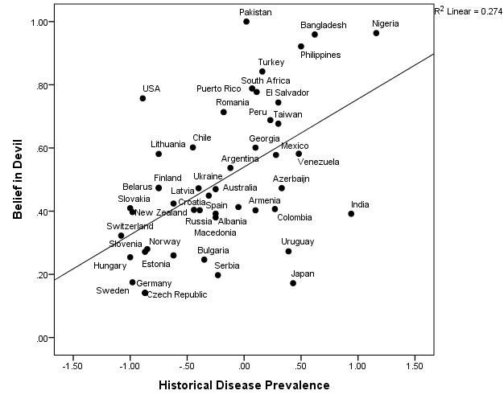

Figure S2. Multilevel mediation model showing the country-level associations between historical pathogen prevalence and antipathogen psychological tendencies as mediated by moral vitalism (Study 3).
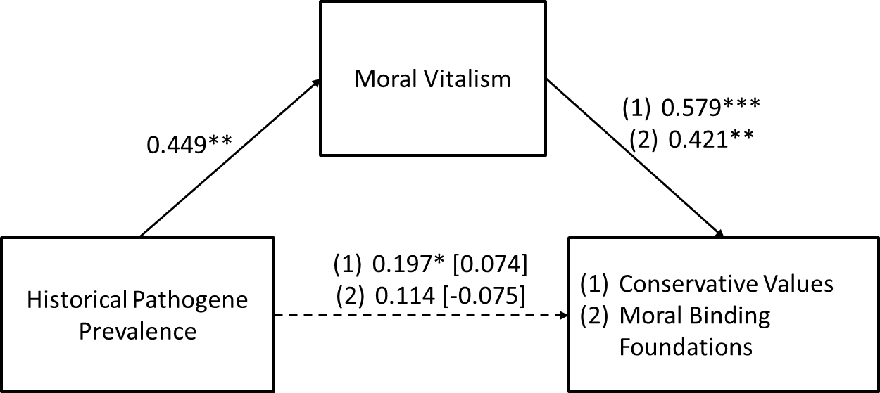

*p < .05, **p < .01, ***p < .001 (two-tailed). Regression coefficients are unstandardized and those in brackets are the coefficients after including the mediator. This model is just-identified with 0 df, therefore, fit indices cannot be reported.

Figure S3. Reverse mediation model -- historical pathogen prevalence and moral vitalism as mediated by conservative values (Study 3).
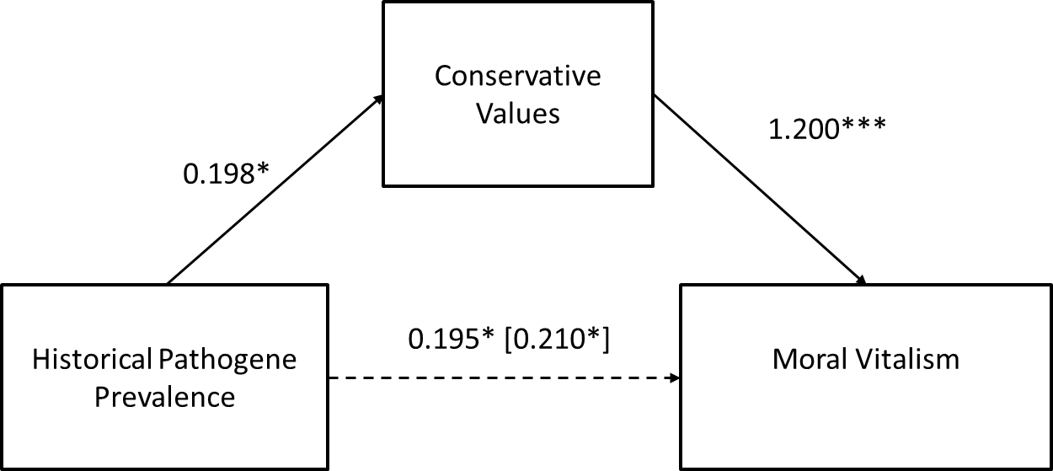
*p < .05, **p < .01, ***p < .001 (two-tailed); indirect effect = 0.238, SE = 0.112, p < .05. Regression coefficients are unstandardized and those in brackets are the coefficients after including the mediator. The model is just-identified with 0 df, therefore, fit indices cannot be reported.

