Supplementary figure S1
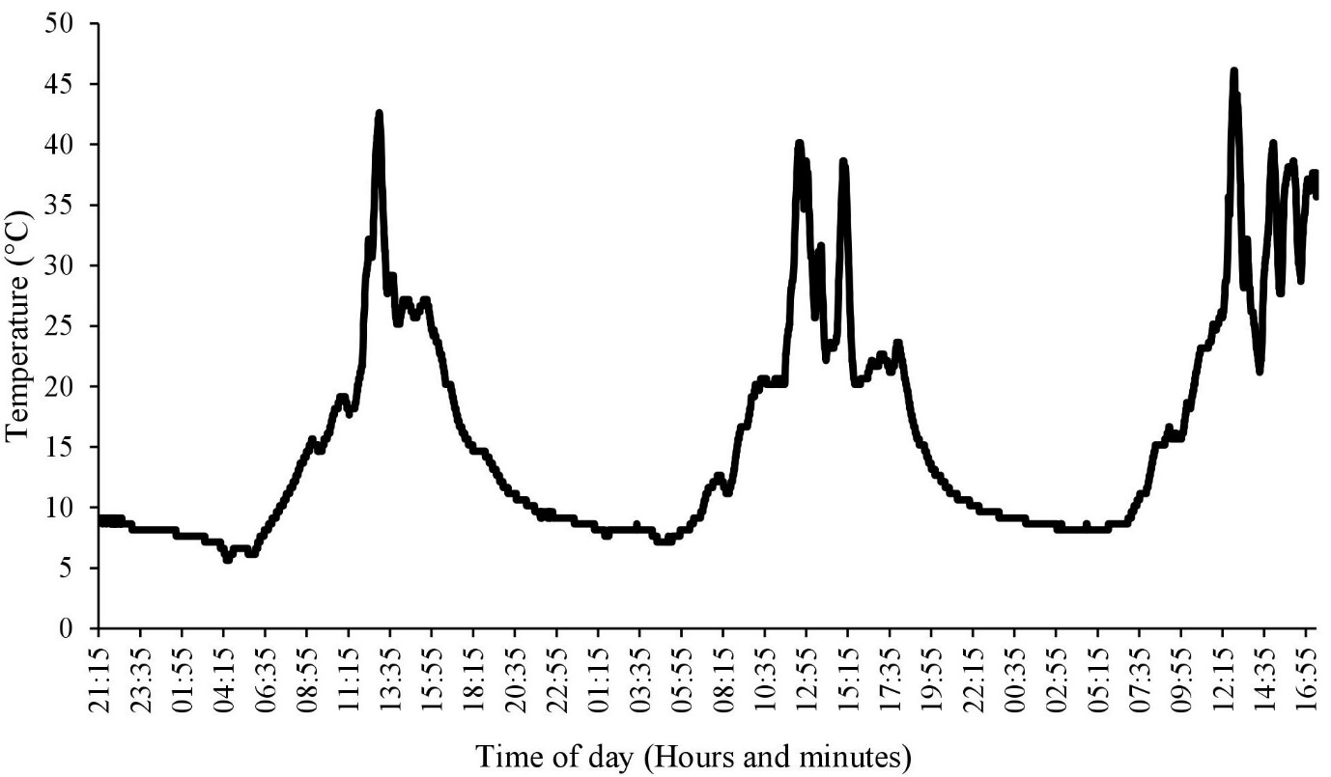
Figure S1: Temperature data from the site of collection (Lat: 61.180 °N, Long: 45.400 °W) spanning 68 hours. Temperature was continuously measured, at ground level, in the period of 10th august – 13th august, 2017 (Maxim IButton DS1923#F5 temperature data logger).

