Supplementary figure S3
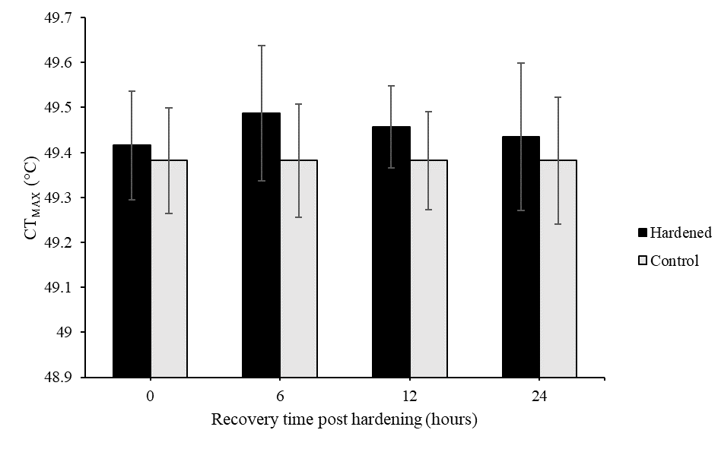
Figure S3: Effect of post-hardening recovery duration (0, 6, 12, and 24 hours) on mean critical thermal maximum (CT_{max}). Hardened individuals were exposed to 42°C for 1 hour followed by recovery periods before CT_{max} was assessed. Black bars represent corrected means of hardened samples (± SE) and grey bars represent corrected means of control samples (± SE). N = 13-15 per sample. * indicate significant differences between hardened individuals and corresponding control; * = P < 0.05, ** = P < 0.01, *** = P < 0.001.

