Supplementary information
Table S1. Classification of the coral species recorded in this study according to four morpho-functional groups (see methods) and colony morphology (obtained from Reyes-Bonilla & Jordan-Dahlgren (2017)¹.
Coral species | Morpho-functional group | Colony morphology
Agaricia agaricites | Non-framework | Sub-massive or encrusting
Acropora cervicornis | Framework-building branching | Branching
Agaricia grahamae | Non-framework | Foliose
Acropora palmata | Framework-building branching | Branching
Acropora prolifera | Framework-building branching | Branching
Agaricia humilis | Non-framework | Sub-massive or encrusting
Agaricia lamarcki | Non-framework | Foliose
Agaricia tenuifolia | Foliose-digitiform | Foliose
Colpophyllia natans | Massive | Massive
Dendrogyra cylindrus | Massive | Massive
Diploria labyrinthiformis | Massive | Massive
Dichocoenia stokesii | Non-framework | Small massive
Eusmilia fastigiata | Non-framework | Small branching
Favia fragum | Non-framework | Small massive
Helioseris cucullata | Non-framework | Foliose/platty
Isophyllia rigida | Non-framework | Small massive
Isophyllia sinuosa | Non-framework | Small massive
Madracis aurentenra | Non-framework | Digitiform
Madracis decactis | Non-framework | Digitiform
Meandrina meandrites | Massive | Massive
Manicia areolata | Non-framework | Sub-massive
Montastraea cavernosa | Massive | Massive
Mycetophyllia lamarckiana | Non-framework | Foliose
Mussa angulosa | Non-framework | Small massive
Orbicella annularis | Massive | Massive
Orbicella faveolata | Massive | Massive
Orbicella franksi | Massive | Massive
Porites astreoides | Non-framework | Small massive
Pseudodiploria clivosa | Massive | Massive
Porites divaricata | Non-framework | Digitiform
Porites furcata | Non-framework | Digitiform
Porites porites | Foliose-digitiform | Digitiform
Pseudodiploria strigosa | Massive | Massive
Solenastrea bournoni | Non-framework | Small massive
Stephanocoenia intersepta | Non-framework | Sub-massive or encrusting
Siderastrea radians | Non-framework | Sub-massive or encrusting
Siderastrea siderea | Massive | Massive
¹Reyes-Bonilla, H., & Jordán-Dahlgren, E. (2017). Caribbean Coral Reefs: Past, Present, and Insights into the Future. Marine Animal Forests: The Ecology of Benthic Biodiversity Hotspots, 31-72.

Table S2. Mann-Whitney U-test values
Years | Reef zone | Variable | U-value | P-value | Confidence interval
1985 vs. 2016 | Back-reef | Coral cover | 334 | 0.004 | y1=-19.833291  y2=-3.333358
1985 vs. 2016 | Fore-reef | Coral cover | 200 | 0.3402 | y1= -3.499965  y2= 11.833350
1985 vs. 2016 | Back-reef | Framework-building branching | 847.5 | 0.0000026 | y1=1.529743e-05  y2=4.499947e+00
1985 vs. 2016 | Back-reef | Foliose-digitiform | 799 | 0.00005067 | y1=7.190187e-05  y2=2.000051e+00
1985 vs. 2016 | Back-reef | Massive | 452.5 | 0.1627 | y1=-7.500005  y2=0.833340
1985 vs. 2016 | Back-reef | Non-framework | 600 | 0.2399 | y1=-7.500005  y2=0.833340
1985 vs. 2016 | Fore-reef | Framework-building branching | 183 | 0.556 | y1= -8.784154e-06  y2= 3.985645e-05
1985 vs. 2016 | Fore-reef | Foliose-digitiform | 154 | 0.5837 | y1= -3.027599e-05  y2= 3.782326e-05
1985 vs. 2016 | Fore-reef | Massive | 156 | 0.7274 | y1= -6.500027  y2= 6.499931
1985 vs. 2016 | Fore-reef | Non-framework | 90 | 0.01857 | y1= -4.3333978  y2= -0.4999497

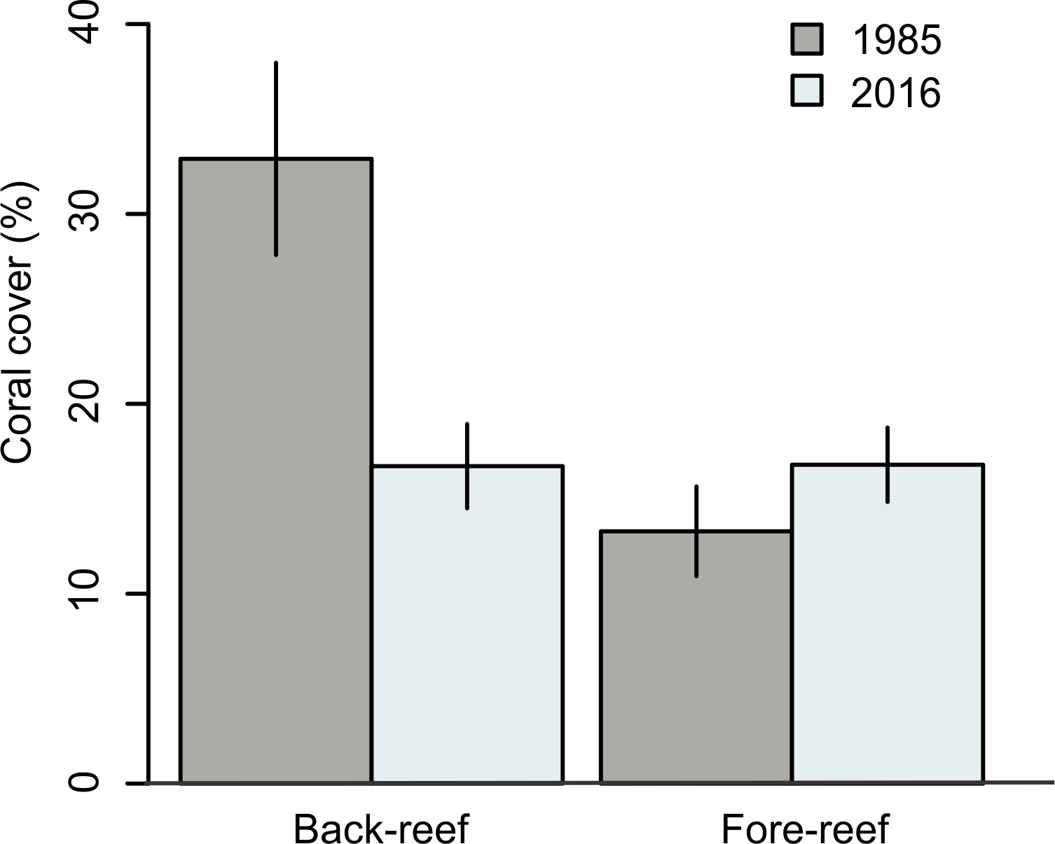
Figure S1. Average coral cover for the studied sites for the back- and fore-reef zones. The error bars are the confidence intervals from the mean
Table S3. Coral cover (mean±SE) on the surveyed sites (n = 16) with their respective reef-zone for each year.
Site | Year | Reef zone | Coral cover (%)
Bocana | 1985 | Back | 35.5 ±8.6
Bonanza | 1985 | Back | 16.8±6.3
Bonanza | 1985 | Fore | 4±1.1
Maroma | 1985 | Fore | 28.5±2.4
Nizuc | 1985 | Fore | 20.1±3.7
Petempich | 1985 | Fore | 37.4±14.2
Puerto Morelos | 1985 | Back | 33.8±4.5
Bonanza Profundo | 2016 | Fore | 15.5±3.2
Bonanza | 2016 | Back | 7.3±2.3
La Bocana | 2016 | Back | 20.8±4.8
MX1062 | 2016 | Fore | 5.7±1.7
Punta Maroma Norte | 2016 | Fore | 24.7±3.6
Punta Maroma Sur | 2016 | Fore | 21.3±2.9
Radio Pirata | 2016 | Back | 20.8±3.5
Tanchacté Norte | 2016 | Back | 16.6±4.1
Tanchacté Sur | 2016 | Back | 18.6±3.1

Table S4. Mann-Whitney U-test values of the reef function parameters
Years | Reef zone | Variable | W-value | P-value | Confidence interval
1985 vs. 2016 | Back-reef | Coral carbonate production | 755 | 0.01909 | y1=0.1212755  y2=1.6372102
1985 vs. 2016 | Back-reef | Functional Reef Index | 795 | 0.004515 | y1= 0.02737289  y2= 0.18858781
1985 vs. 2016 | Back-reef | Net carbonate production | 755 | 0.01909 | y1=0.1212755  y2=1.6372102
1985 vs. 2016 | Fore-reef | Coral carbonate production | 124 | 0.3767 | y1=-0.8126667  y2=0.2479000
1985 vs. 2016 | Fore-reef | Functional Reef Index | 124 | 0.1906 | y1=-0.16145356  y2=0.02694995
1985 vs. 2016 | Fore-reef | Net carbonate production | 138 | 0. 3767 | y1=-0.8126667  y2=0.2479000

Table S5. Summary of bioerosion rates for each group of bioeroder and the carbonate production for each functional group.
Bioerosion rates
Zone | Group | Mean bioerosion (G) ± SD
Back-reef | Parrotfish | 3.32±0.33
Back-reef | Microbioerosion | 0.25±0.06
Back-reef | Macrobioerosion (sponges) | 0.004±0.002
Back-reef | Urchins | 0.09±0.15
Fore-reef | Parrotfish | 1.50±1.49
Fore-reef | Microbioerosion | 0.25±0.07
Fore-reef | Macrobioerosion (sponges) | 0.02±0.003
Fore-reef | Urchins | 0±0

Carbonate production
Zone | Year | Group | Mean production(G) ± SD
Back-reef | 1985 | Branching | 4.91±5.98
Back-reef | 1985 | Foliose digitiform | 0.23±0.38
Back-reef | 1985 | Massive | 0.21±0.31
Back-reef | 1985 | Non-framework | 0.10±0.13
Fore-reef | 1985 | Branching | 0.58±0.45
Fore-reef | 1985 | Foliose digitiform | 0.04±0.02
Fore-reef | 1985 | Massive | 0.16±0.2
Fore-reef | 1985 | Non-framework | 0.06±0.06
Back-reef | 2016 | Branching | 0.28±
Back-reef | 2016 | Foliose digitiform | 0.11±0.20
Back-reef | 2016 | Massive | 1.37±1.28
Back-reef | 2016 | Non-framework | 0.17±0.18
Fore-reef | 2016 | Branching | 0.41±0.23
Fore-reef | 2016 | Foliose digitiform | 0.07±0.05
Fore-reef | 2016 | Massive | 0.98±0.83
Fore-reef | 2016 | Non-framework | 0.23±.01

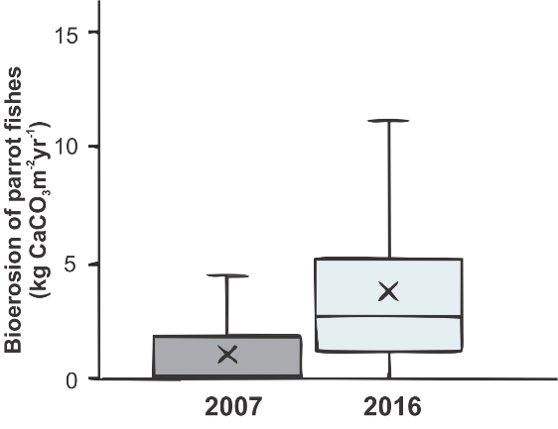
Figure S2. Box and whisker plot of bioerosion from parrotfishes for back-reef sites in 2007 and 2016. The bottom and top of the box are the first and third quartiles, respectively, the “x” is the average and the black line is the median. Whiskers are the minimum and maximum, the notches.

