Supplementary Materials
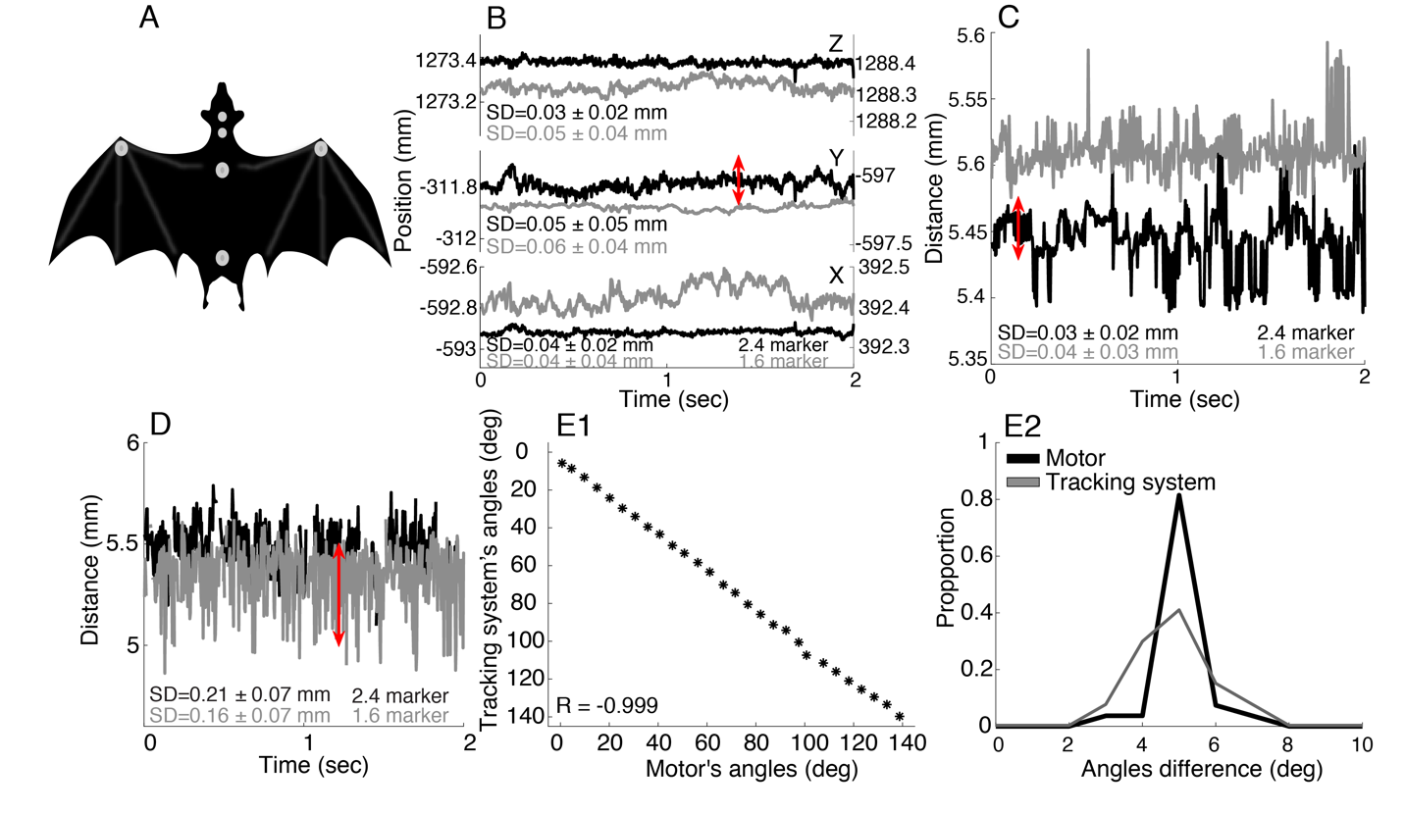
Fig. S1. Controlling for the accuracy of the tracking system. The system has already been scientifically used in several publications which have used it for tracking movement of small scales )e.g. [42](. However, to convince ourselves of its accuracy, we ran a series of control experiments to validate that our system was capable of measuring movements in the order of a few degrees. All of the experiments below (except for the 4'th) were repeated with markers of two sizes (1.6 and 2.4mm diameter). Note that all positions and distances are given in millimeters. In all panels (except E1-2), two tracking trials are shown (in grey and black), while the SD that is reported in each panel is the result of recording performed at 10 positions in the flight room. In panels B-D the 2 presented trials used different sizes of markers - 1.6 mm in black and 2.4 mm in grey. The markers that were used in E were 2.4 mm. (A) A schematic of the positions of the markers on the bat (two on the head, two on the back and one on each wrist). (B) A stationary marker was positioned in 10 different locations in the room and its position was tracked over time to estimate the jitter (the standard deviation of the position). The X-Y-Z coordinates of a stationary marker are presented. The jitter in the location is on the order of 0.05mm for a stationary marker (see red double-headed arrow which has a length of 0.05mm). (C) To assess our error in estimating the distance between two stationary markers, we positioned a pair of markers ~5mm apart at 10 different positions in the room. The distance between two stationary markers is presented. The tracking error (i.e., the standard deviation) was in the order of 0.03mm (see red double-headed arrow which has a length of 0.05mm. The results of the two sized markers are presented). (D) To test the robustness of tracking the distance between two markers on a moving basis, the same two markers were placed (5.5mm apart) on a base representing a bat which was moved in the room at a speed of ~1 m/s. This was repeated in 9 positions in the room. (see red double-headed arrow which has a length of 0.05mm. The results of the two sized markers are presented). (E1) To estimate our accuracy in measuring the angles of a moving object relative to a target, we used a motor (Herkulex DRS-0101 Robot servo, Dongbu Robot), with a resolution of 0.325 degrees, carrying a head-model. The elevation of this head was changed in steps of 5 degrees and we used the tracking system to track two markers that were placed on the model at the same positions as in the real bat. A third marker was placed on an object representing the target. We compared the vertical gaze (α) of the model estimated from the tracking to the actual movement angles reported by the motor. The correlation between the two was very high (R =-0.99, P<${10}^{-42}$, Pearson correlation coefficient). (E2) The distribution of the angle steps (i.e., the difference between each two consecutive gaze angles) for the actual motor (black) and the result of the tracking (grey).

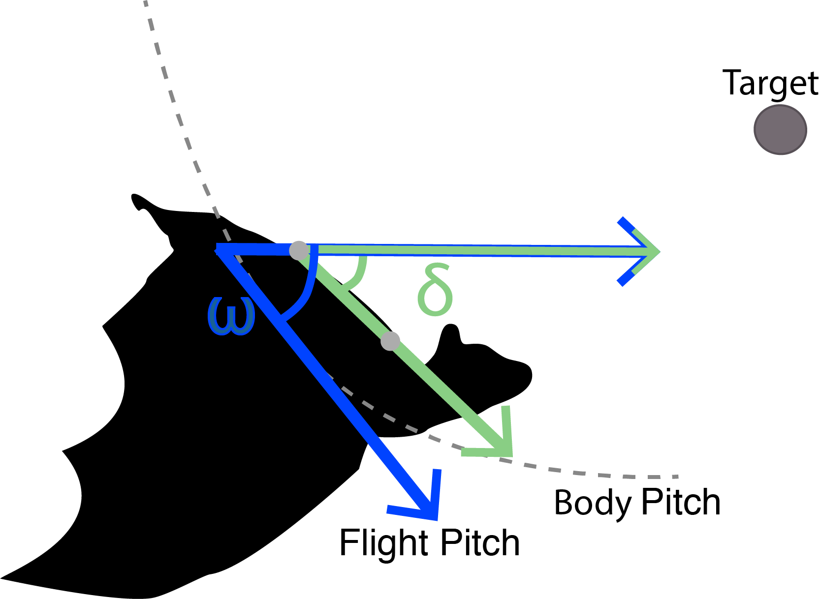
Fig. S2. Schematic showing the angles: δ - body-pitch (green line, Fig. 1D-E) and ω – flight-pitch (blue line, Fig. 2B and Fig. S6). Flight pitch is tangential to the flight curve (dashed line) while the body pitch is parallel to the main axis of the body. The grey dots represent the body markers which were used in order to calculate the body pitch angle.

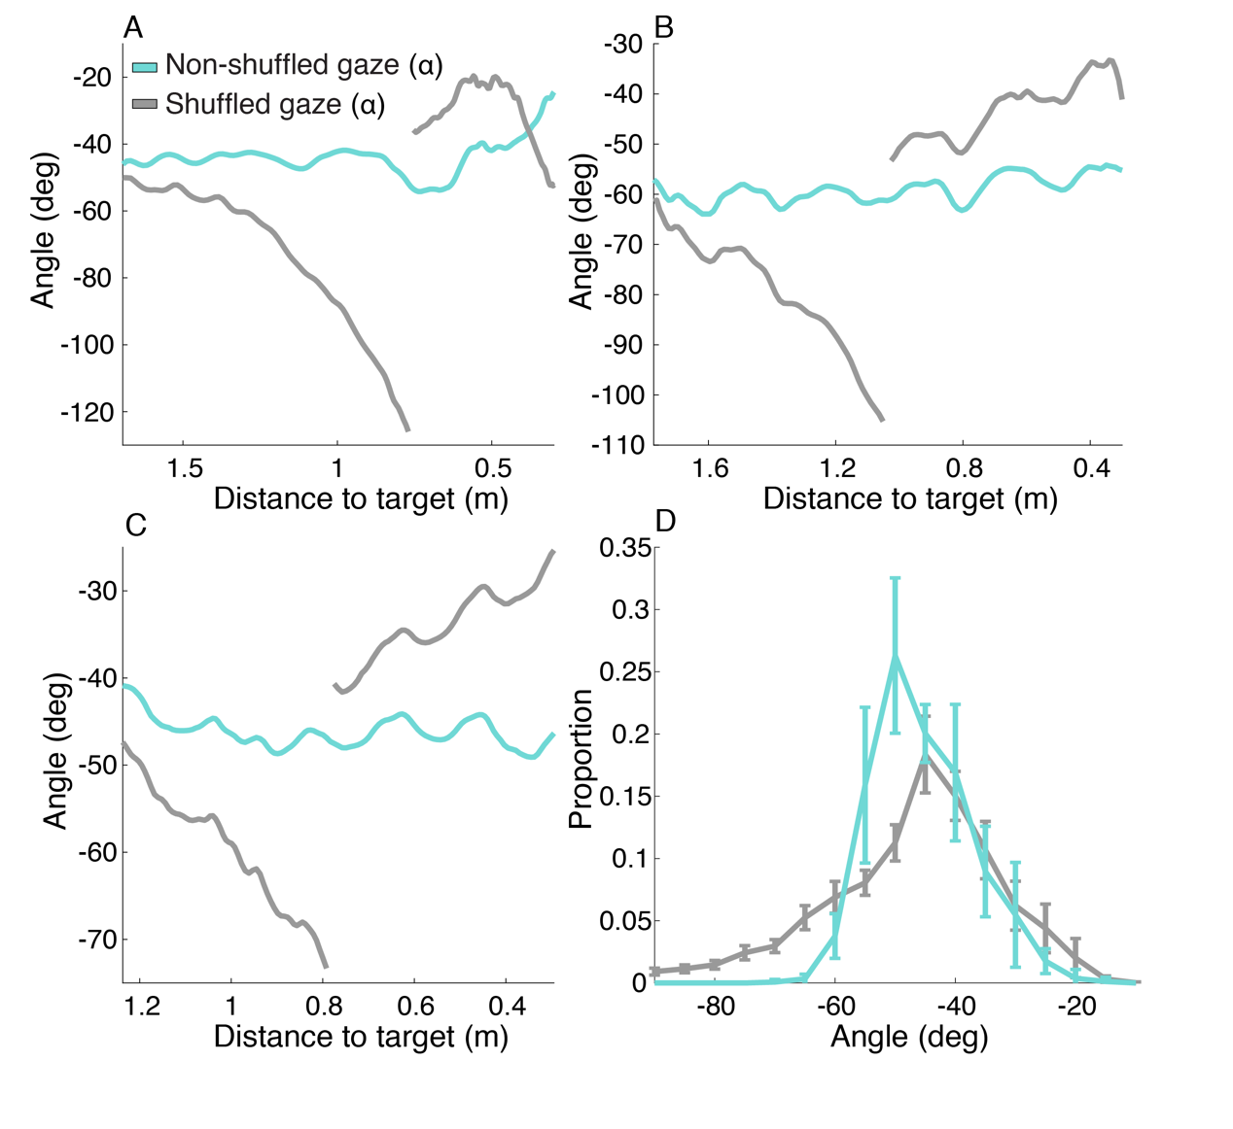
Fig. S3. Shuffled vertical gaze (α). In order to validate that the bat could not simply control its head movements based on internal-vestibular information, we shuffled the tracking data from the first and second halves of the flight (after locking). To this end, the first half of the tracking data was shifted in time to start after the middle of the trial and the second half of the tracking was shifted backwards to the locking point. We then ran the same angle estimations as mentioned above for the original data. (A-C) Examples of 3 trials with the shuffled (grey line) and the non-shuffled vertical gaze (light blue line). (D) The distribution of the original (light blue) and shuffled vertical gaze (grey). The mean of all bats’ distributions (and their s.e.) is presented (N=8). The width of the distribution of the non-shuffled vertical gaze angles (α) was significantly narrower than the width of the shuffled angles (12 deg vs 21 deg, on average; P<0.05, N=8 bats, Paired, two-tailed, t-test, on the group level). We compare the distributions of the non-shuffled angles 20 frames after the locking point and the shuffled angles from the defined locking point to the end.
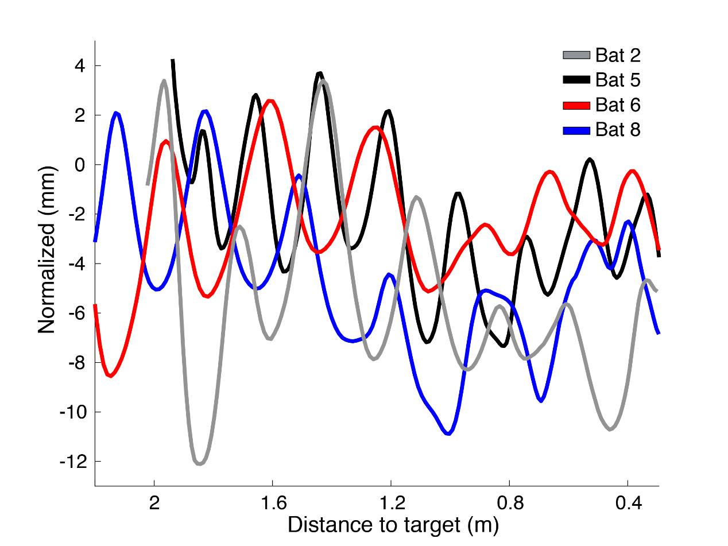
Fig. S4. Head translations. The Z-coordinate of the head of four bats, each in one trial, reveal, complex oscillatory movements of the head along the vertical axis of 4 bats. The values are normalized by subtracting the average which was calculated with a moving window of 70 samples (i.e., 0.35 Seconds).

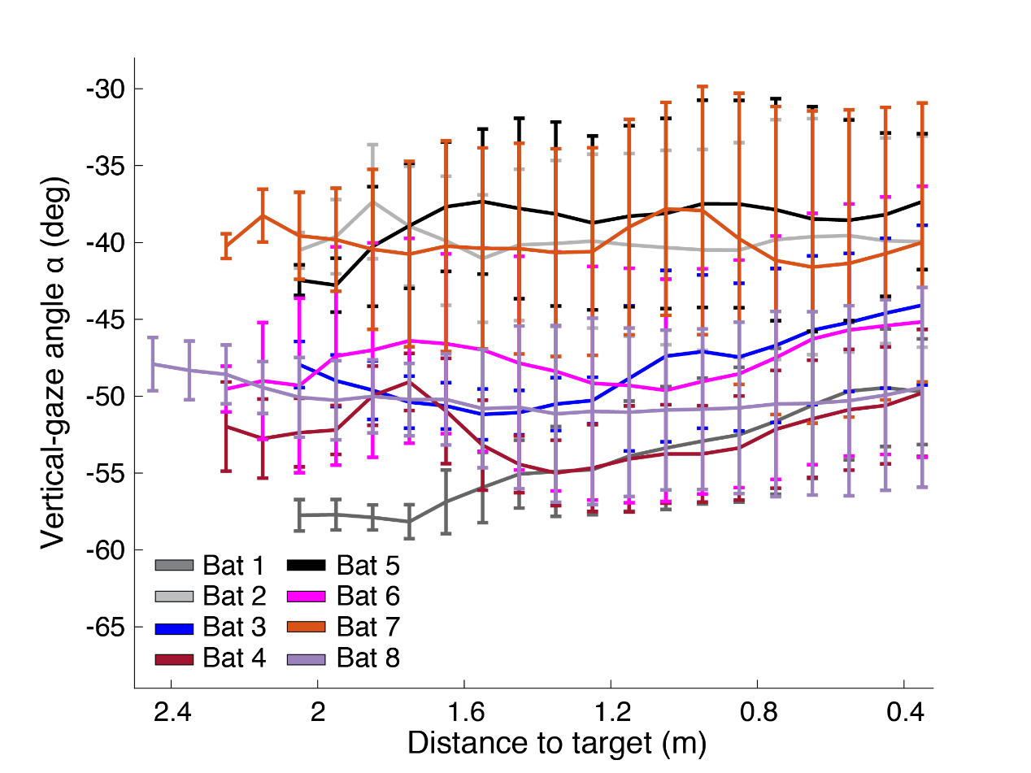
Fig. S5. Vertical gaze (α) as a function of the bats’ distance to the target. Mean and SE for each individual (N=8).

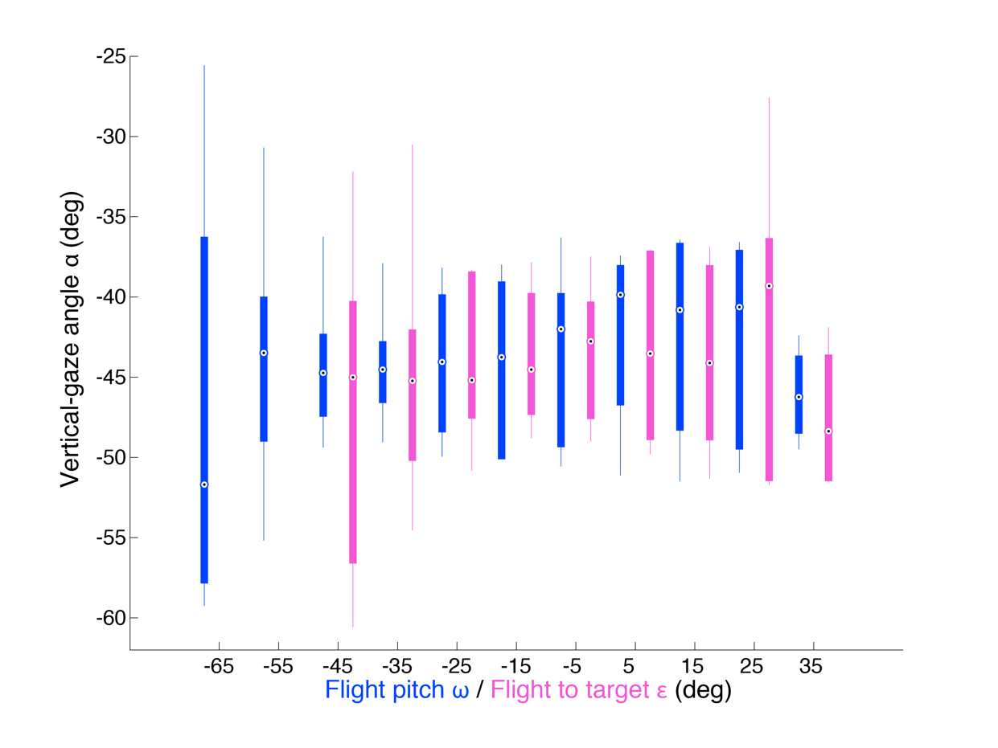
Fig. S6. Flight pitch (ω) and flight to target (ε) angles. A different presentation of figure 2B. Flight pitch (ω) in blue and flight to target (ε) in pink. The boxplots were calculated using the mean values of each bat (in each bin).

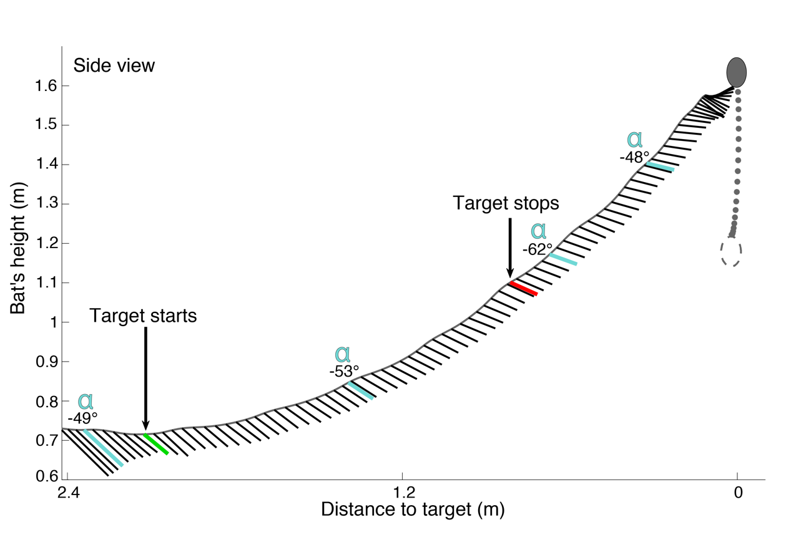
Fig. S7. Schematic shows the movement of the bat and the direction of its gaze (α) at a constant interval along one flight trajectory, when the target is moving up. Green line indicates the starting movement point of the target (also marked with an arrow), red line indicates the target’s stopping point (also marked with an arrow). Light blue lines show different (α) angles along the trajectory. Notice how the vertical gaze lags behind the elevation of the target when it is moving.

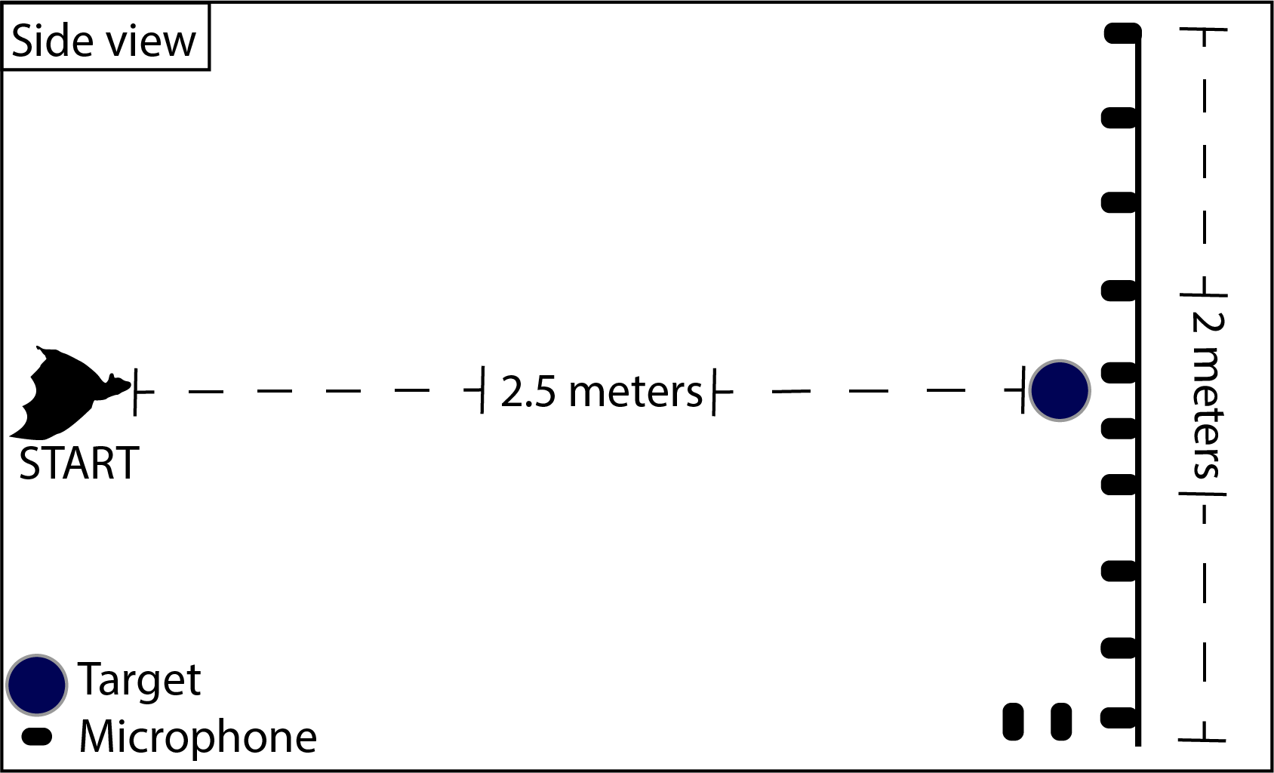
Fig. S8. Schematic showing a side view of the vertical microphone array. The array was present only in this set up while in most trials the target was far from any nearby object. The reconstruction of the echolocation beam was performed using our in-house acoustic software (Batalef) written in Matlab. Processing was similar to our similar work [19]. All beams were estimated at 28kHz - the average frequency with peak energy. A 5ms window was automatically defined around each echolocation click and its spectrogram was estimated (using an FFT window of 1024 samples with a flat-top window of 512 samples and an overlap of 480 samples). By applying MATLAB's medfreq function to the spectrogram (after thresholding), we got our primary assessment of the signal's ridge - a frequency over time vector representing the center of the signal in the spectrogram. This function estimates the median frequency of the spectrogram at each time sample.
Once the signal's ridge was estimated, we could estimate the signal's intensity at each microphone at 28kHz (in the past, we have shown that this spectrogram analysis produces similar results to using the FFT). Finally, based on the location of the bat when the signal was emitted (which was computed from the video tracking), we compensated for both the spreading loss and atmospheric attenuation. We also calculated the angle of each of the microphones relative to the bat during emission, which was used along with the intensities in the beam reconstruction process. We estimated the accuracy of our beam reconstruction method using a speaker (Vifa, connected to an Avisoft D/A converter) which's beam was accurately measured (by rotating the speaker in-front of a calibrated microphone, GRAS, 40DP). The beam was estimated at a frequency of 30kHz, where its width was within the bat range (at higher frequencies the speaker beam is much narrower). This procedure revealed that our method is able to accurately reconstruct the beams. All beams were calculated after the locking point and up to a distance of 30cm from the target

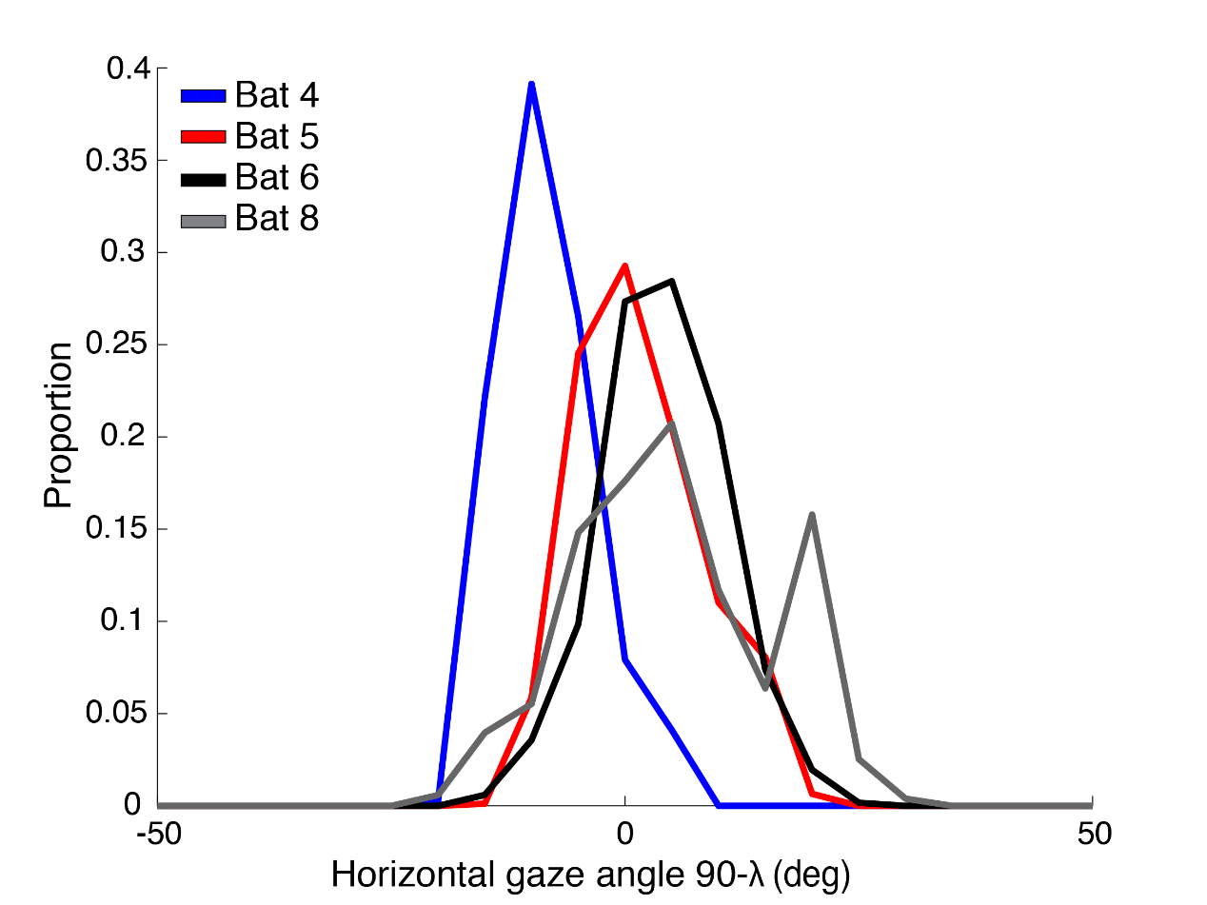
Fig. S9. The distribution of horizontal gaze (90- λ) of each individual, bat 4 is different due to the position of the marker.

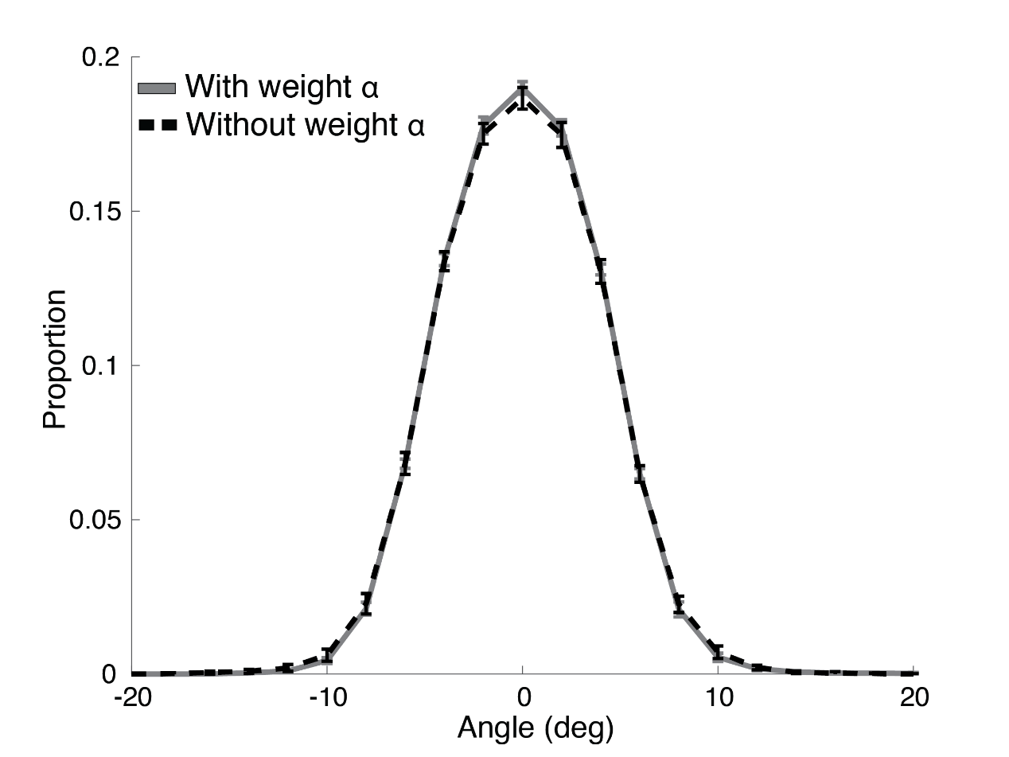
Fig. S10. The distribution of the vertical gaze angles (α), with (grey line) and without the additional weight (black dashed line) N = 8.

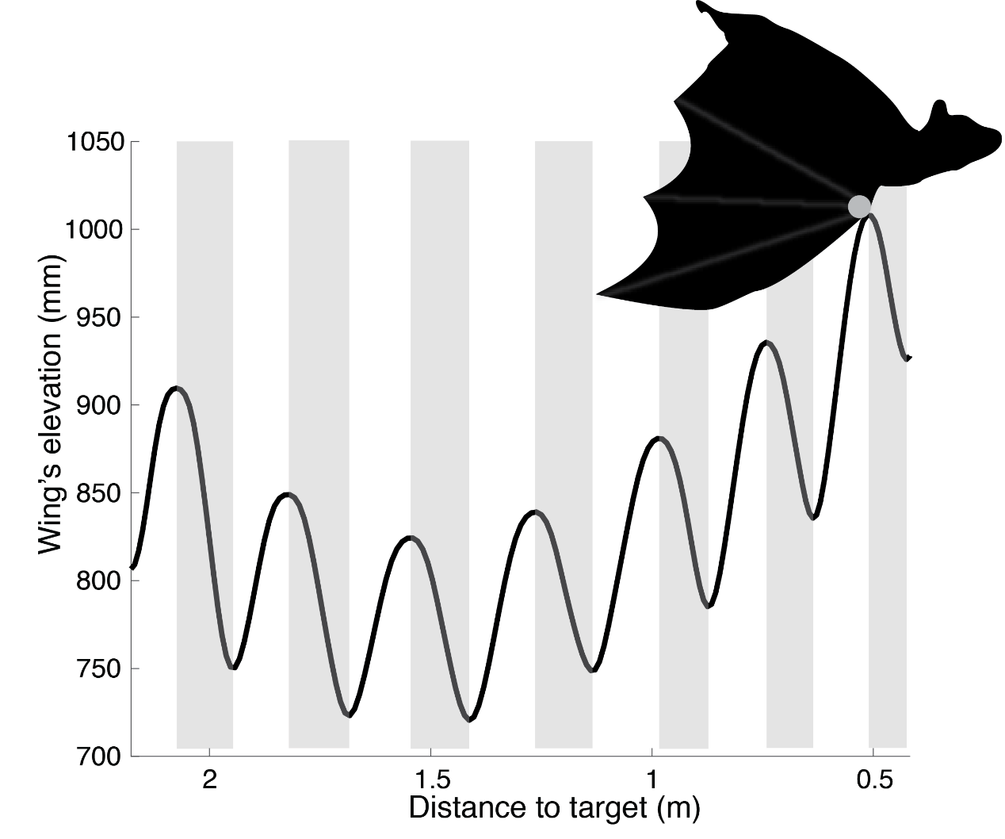
Fig. S11. Wing beat calculation. The wing beat was estimated using the wrist marker (grey point). The black line shows the wing’s elevation, the grey shadings represent a half wing beat cycle.

Bat | Dark | Dark without weight | Dim – light | Microphone array | Moving target | Azimuth* | Roll*
1
2
3
4
5
6
7
8
Total | 8 | 8 | 3 | 4 | 2 | 4 | 3

Supplementary Table 1. A summary of the different conditions each bat was tested in.
*The azimuth and Roll represent the number of bats for which we managed to estimate these parameters.

Angle | Symbol | Vector 1 | Vector 2
Vertical gaze angle | α | Vertical head direction vector | Vertical target direction
Body-target angle | β | Vertical body direction | Vertical target direction
Head-body angle | γ | Body direction vector | Head direction vector
Body-pitch angle | δ | Body direction vector | Horizon
Flight-pitch angle | ω | Flight direction | Horizon
Flight relative to the target | ε | Flight direction | Vertical target direction
Head-azimuth | λ | Horizontal head direction vector | Horizontal target vector
Flight-horizontal angle-to-target | Κ | Horizontal flight direction | Horizontal target vector

Supplementary Table 2. A summary and definitions of the different angles we used in the study. For the angles measurements we used the reflective markers that were glued to the bats (Fig.S1A). The vertical gaze angle (α, see schematic in Fig.1A), is the angle between the vertical head direction vector and vertical target direction. Since it’s impossible to track the mouth using spherical markers, we had to place the markers on the head thus, we needed to correct for this bias. To do so, we used the tracking system to measure the angle between the head and mouth of a dead specimen and found that the difference between the head’s and the mouth’s vertical gaze is ~10 degrees, therefore we subtracted 10 degrees from all of the head vertical gaze angles (α). All angles were calculated up to a distance of 30cm from the target. Measuring the angle becomes noisier when the bat is closer to the target, because at short distances even small errors in distance measurement can result in an angular error of several degrees. Another reason for the increased error at the end of the flight is that we used the bat’s landing point as the ‘position’ of the target for angle calculation. Unlike the other points that we use for measuring angle, the target it not a point and we have to define a point on it. This point is only an approximation because we do not know where exactly the bats are pointing their beam to. Angularly, this approximation is more accurate when the bat is farther from the target and it becomes less accurate the closer the bat is. In the moving target experiments we used the upper pole of the sphere.

Bat | Vertical-gaze (α) average | Beam (peak) angle average
5 | -42.35 ± 10 | -43.65± 15
6 | -47.6 ± 11 | -39.20 ± 19
7 | -41.05 ± 9 | -37.70 ± 15
8 | -48.26 ± 5 | -37.54 ± 17

Supplementary Table 3. Vertical-gaze angle (α) vs vertical beam direction (the peak intensity of the beam). A comparison of the beams vertical direction and the mean vertical-gaze (α) at the time of the emissions for all bats. The mean and SD are presented.

Bat | Threshold | Minimum consecutive frames
1 | 0.13 | 8
2 | 0.07 | 8
3 | 0.07 | 8
4 | 0.06 | 30
5 | 0.1 | 8
6 | 0.14 | 31
7 | 0.07 | 30
8 | 0.07 | 30

Supplementary Table 4. Locking position criterion for all bats
In order to automatically define the locking point in each trial we calculated the derivative of the vertical gaze (α). We then fitted this curve that had decaying shape with a 4th degree polynomial curve. Locking was defined as the first point along the trajectory where the fitted derivative polynomial was smaller than 0.06-0.14 on a minimum of 8-31 consecutive frames (the exact values were determined for each bat separately manually by eyeballing many trials(. This criterion was run on all trials in parallel to our manual marking of the locking point and the correlation between the two methods was very high. We cut the trials 20 frames after the defined point in order to assure that we were analyzing post-locking data.

Supplementary Movie S1
Video of one trial. Note the jitter of the body and the fixed head gaze. Light in the background is IR at 850 nm.
Supplementary Movie S2
Video of Cynopterus brachyotis flying in a wind tunnel. Note the stabilization of the head. Movie in courtesy of S. Swartz K. Breuer Labs, Brown University. Video was taken by Nick Hristov and Tatjana Hubel, with support from the AFOSR and NSF.

