Supplementary Material

Supplementary Figures
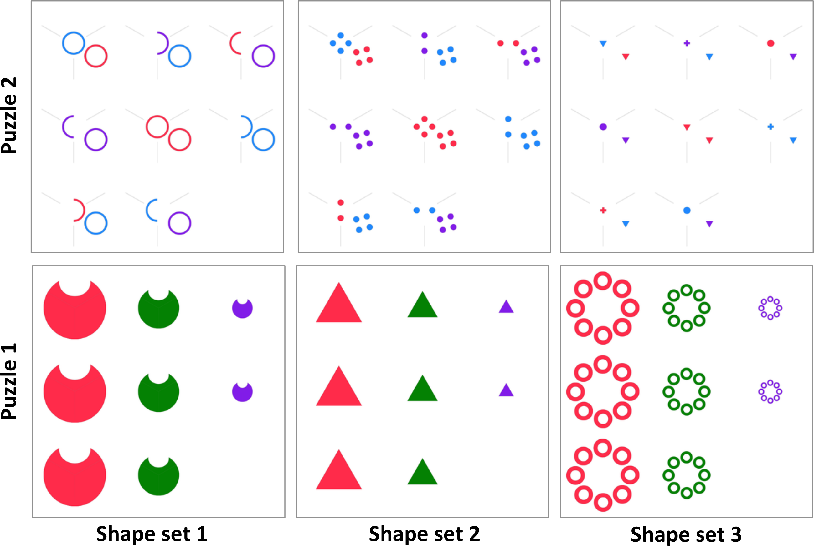

Figure S1. Shape Sets. Examples of the three different shape sets for two puzzles.

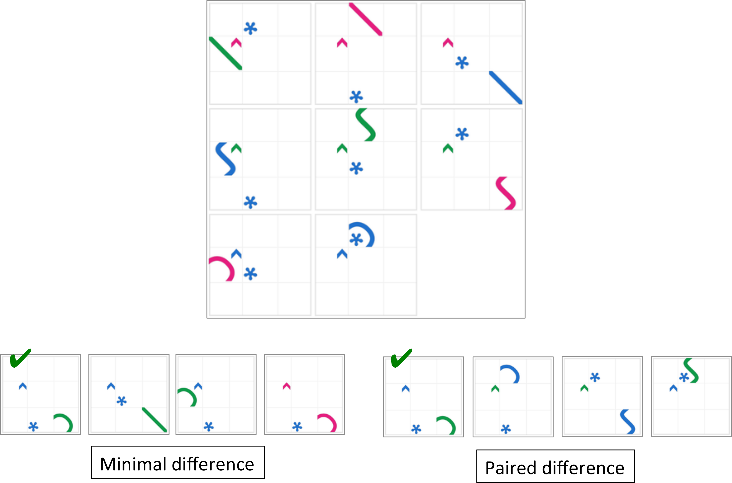

Figure S2. Target and Distractor Generation. The minimal difference strategy potentially allows solving the puzzle by looking at the solutions only (e.g., one of the solutions is “minimally different” from all the others). The paired difference strategy does not allow this but potentially allows “pop-out” effects. Green tick marks indicate the correct response option.
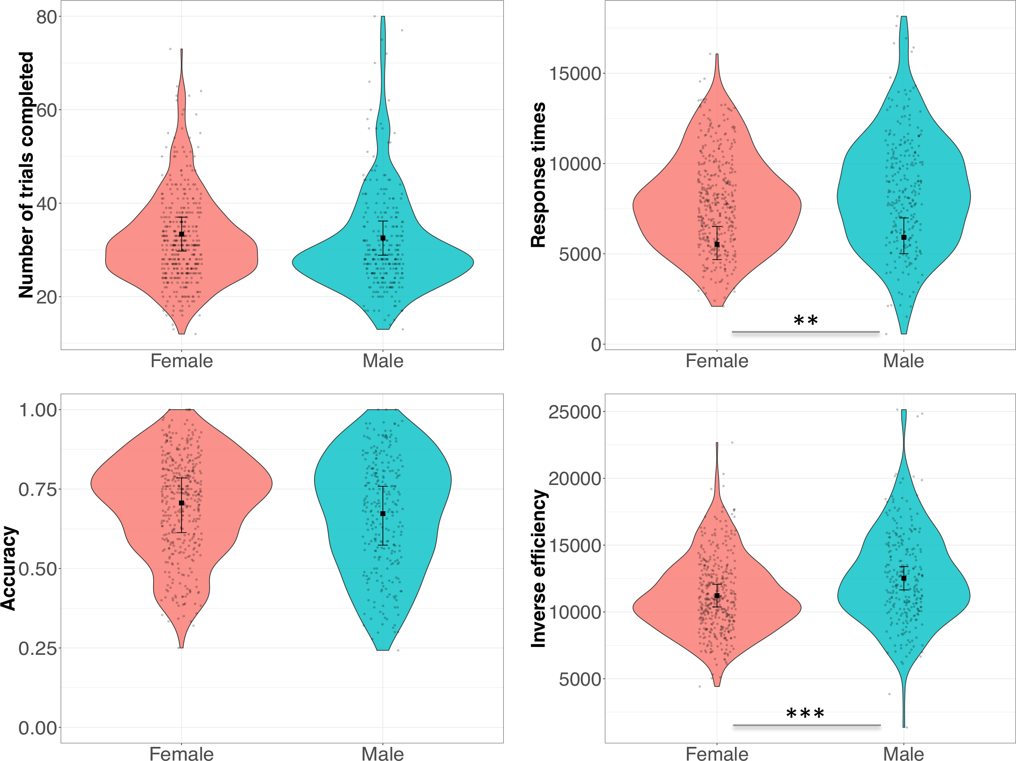

Figure S3. Gender Differences in MaRs-IB Performance. Figure shows the number of items completed, accuracy, response times and inverse efficiency. ** p < .01, *** p < .001.

Supplementary Tables

Table S1. Descriptive Statistics of the MaRs-IB by Test Form.
 | puzzle set 1 | puzzle set 2 | puzzle set 3
Median RT | 8372.50 | 7530.75 | 7790.00
IQR RT | 3606.0 | 4051.5 | 4338.5
Mean correct (%) | 69.45 | 69.04 | 69.01
SE correct (%) | 1.09 | 1.18 | 1.11
Min correct (%) | 27.78 | 25.00 | 24.24
Max correct (%) | 100 | 100 | 100
Mean N items | 31.29 | 32.32 | 32.19
SE N items | 0.70 | 0.61 | 0.74
Min N items | 13 | 12 | 14
Max N items | 77 | 64 | 80

Table S2. Descriptive Statistics of the MaRs-IB by Shape Set.
 | shape set 1 | shape set 2 | shape set 3
Median RT | 7713.50 | 8198.75 | 7855.25
IQR RT | 4548.50 | 5234.62 | 5325.25
Mean correct (%) | 69.83 | 69.10 | 68.08
SE correct (%) | 0.79 | 0.80 | 0.80
Min correct (%) | 10.00 | 9.09 | 18.18
Max correct (%) | 100 | 100 | 100
Mean N items | 10.65 | 10.66 | 10.63
SE N items | 0.13 | 0.13 | 0.14
Min N items | 4 | 4 | 3
Max N items | 27 | 27 | 26

Table S3. Descriptive Statistics of the MaRs-IB by Distractor Strategy.
 | minimal difference | paired difference
Median RT | 7853.00 | 7968.75
IQR RT | 4344.38 | 4781.00
Mean correct (%) | 68.91 | 69.45
SE correct (%) | 0.71 | 0.73
Min correct (%) | 18.75 | 18.18
Max correct (%) | 100 | 100
Mean N items | 15.96 | 15.98
SE N items | 0.2 | 0.2
Min N items | 5 | 5
Max N items | 40 | 40

Table S4. Descriptive Statistics of the MaRs-IB by Age Group and Gender.
statistic | younger adolescents | mid-adolescents | older adolescents | adults
 | 11.27 - 13.40y | 13.40 - 15.92y | 15.93 - 17.99y | 18.00 - 33.15y
Median RT | 6944 (m=7005.5 f=6871.75) | 7552.5 (m=7964.5 f=6841) | 7951.75 (m=8774.25 f=7582) | 9454.5 (m=10276 f=9304)
IQR RT | 3879 (m=4301.25 f=3771.5) | 3722.75 (m=4629.25 f=2669) | 3309.25 (m=3337.88 f=2780.88) | 3230.88 (m=3011.5 f=3297)
Mean correct (%) | 60.7 (m=57.37 f=62.58) | 67.52 (m=67.49 f=67.56) | 72.56 (m=72.11 f=72.87) | 80.82 (m=78.85 f=81.43)
SE correct (%) | 1.25  (m=2.22 f=1.48) | 1.18  (m=1.79 f=1.54) | 1  (m=1.69 f=1.23) | 1.3  (m=3.27 f=1.37)
Mean N items completed | 33.68 (m=34.4 f=33.27) | 32.29 (m=32.17 f=32.42) | 28.99 (m=28.24 f=29.52) | 33.43 (m=31.96 f=33.89)
SE N items completed | 0.74  (m=1.26 f=0.92) | 0.76  (m=1.19 f=0.92) | 0.75  (m=1.22 f=0.94) | 0.93  (m=2.07 f=1.04)
Note. m = males, f = females.

Table S5. Accuracy: Age Group Contrasts.
contrast | estimate | SE | p_{Bonf.} | p_{uncorr.}
Younger adolescents - Mid adolescents | -0.28 | 0.13 | .163 | .027
Younger adolescents - Older adolescents | -0.33 | 0.2 | .592 | .099
Younger adolescents - Adults | -1.13 | 0.4 | .027 | .005
Mid adolescents - Older adolescents | -0.06 | 0.16 | 1 | .728
Mid adolescents - Adults | -0.85 | 0.39 | .159 | .026
Older adolescents - Adults | -0.8 | 0.38 | .22 | .037
Note. Results are shown on the log odds scale.

Table S6. Response Times: Age group Contrasts.
contrast | estimate | SE | p_{Bonf.} | p_{uncorr.}
Younger adolescents - Mid adolescents | 0.03 | 0.04 | 1 | .542
Younger adolescents - Older adolescents | 0.01 | 0.06 | 1 | .873
Younger adolescents - Adults | -0.11 | 0.12 | 1 | .357
Mid adolescents - Older adolescents | -0.01 | 0.05 | 1 | .783
Mid adolescents - Adults | -0.14 | 0.12 | 1 | .253
Older adolescents - Adults | -0.12 | 0.12 | 1 | .317
Note. Results are shown on the log scale.

Table S7. Number of Items Completed: Age Group Contrasts.

contrast | estimate | SE | p_{Bonf.} | p_{uncorr.}
Younger adolescents - Mid adolescents | 0.93 | 1.31 | 1 | .478
Younger adolescents - Older adolescents | 0.12 | 2.02 | 1 | .951
Younger adolescents - Adults | 1.51 | 5.17 | 1 | .772
Mid adolescents - Older adolescents | -0.81 | 1.66 | 1 | .625
Mid adolescents - Adults | 0.58 | 5.11 | 1 | .91
Older adolescents - Adults | 1.39 | 5.11 | 1 | .788

Table S8. Inverse Efficiency: Age Group Contrasts.
contrast | estimate | SE | p_{Bonf.} | p_{uncorr.}
Younger adolescents - Mid adolescents | 762.94 | 413.23 | .395 | .066
Younger adolescents - Older adolescents | 844.14 | 612.87 | 1 | .171
Younger adolescents - Adults | 681.36 | 1317.95 | 1 | .612
Mid adolescents - Older adolescents | 81.2 | 515.11 | 1 | .875
Mid adolescents - Adults | -81.57 | 1300.44 | 1 | .951
Older adolescents - Adults | -162.77 | 1318.15 | 1 | .903

Table S9. MaRs-IB item statistics. N = number of responses; Dim = dimensionality; RT = median response time of correct responses (with interquartile range); IES = inverse efficiency
Order | N | Dim | P-value (SE) | RT (IQR) | IES
1 | 648 | 2 | 97 (1) | 2412 (1579) | 2489
2 | 654 | 1 | 97 (1) | 4447 (2513) | 4566
3 | 646 | 1 | 98 (1) | 2464 (1188) | 2515
4 | 653 | 1 | 99 (0) | 3763 (1710) | 3786
5 | 647 | 1 | 100 (0) | 2528 (1381) | 2531
6 | 642 | 2 | 78 (2) | 9428 (7129) | 12154
7 | 644 | 1 | 98 (1) | 5184 (2923) | 5283
8 | 643 | 1 | 85 (1) | 7655 (5596) | 9031
9 | 653 | 1 | 94 (1) | 5899 (3017) | 6284
10 | 630 | 3 | 53 (2) | 15262 (10196) | 28787
11 | 628 | 3 | 59 (2) | 13966 (9770) | 23641
12 | 622 | 4 | 25 (2) | 16342 (12690) | 64332
13 | 619 | 3 | 49 (2) | 17343 (10754) | 35198
14 | 607 | 5 | 37 (2) | 18898 (12920) | 50983
15 | 641 | 3 | 56 (2) | 13600 (11373) | 24216
16 | 647 | 4 | 89 (1) | 7707 (6052) | 8642
17 | 638 | 4 | 59 (2) | 13944 (10089) | 23534
18 | 626 | 3 | 41 (2) | 15692 (11098) | 38223
19 | 635 | 2 | 82 (2) | 7902 (5100) | 9631
20 | 629 | 2 | 67 (2) | 12114 (7182) | 18099
21 | 596 | 7 | 49 (2) | 16676 (9658) | 33691
22 | 596 | 2 | 82 (2) | 7713 (4963) | 9362
23 | 591 | 4 | 81 (2) | 9847 (6226) | 12226
24 | 553 | 7 | 41 (2) | 15723 (11576) | 38303
25 | 542 | 2 | 77 (2) | 9358 (7050) | 12135
26 | 509 | 5 | 36 (2) | 17140 (10786) | 47674
27 | 477 | 3 | 54 (2) | 11507 (8290) | 21275
28 | 438 | 2 | 57 (2) | 13086 (7615) | 22928
29 | 392 | 7 | 62 (2) | 11622 (8504) | 18748
30 | 348 | 7 | 60 (3) | 9362 (5374) | 15663
31 | 316 | 3 | 55 (3) | 11404 (7901) | 20711
32 | 288 | 1 | 56 (3) | 8090 (6122) | 14472
33 | 253 | 1 | 60 (3) | 6414 (3698) | 10675
34 | 233 | 3 | 37 (3) | 8640 (8548) | 23139
35 | 210 | 8 | 42 (3) | 8321 (8830) | 19857
36 | 191 | 6 | 36 (3) | 6836 (8263) | 19203
37 | 176 | 3 | 36 (4) | 8496 (9960) | 23735
38 | 156 | 1 | 83 (3) | 4240 (2509) | 5087
39 | 135 | 2 | 41 (4) | 5448 (7342) | 13372
40 | 122 | 4 | 44 (5) | 5020 (4839) | 11341
41 | 113 | 1 | 84 (3) | 4248 (2618) | 5053
42 | 106 | 4 | 27 (4) | 5674 (6414) | 20739
43 | 91 | 1 | 33 (5) | 4720 (4510) | 14319
44 | 83 | 6 | 19 (4) | 2424 (4126) | 12574
45 | 73 | 7 | 33 (6) | 6316 (7412) | 19210
46 | 61 | 6 | 38 (6) | 4185 (5728) | 11099
47 | 57 | 2 | 21 (5) | 5035 (7364) | 23916
48 | 49 | 1 | 33 (7) | 2942 (6569) | 9010
49 | 47 | 2 | 47 (7) | 4181 (2674) | 8932
50 | 46 | 2 | 37 (7) | 4021 (4195) | 10880
51 | 41 | 2 | 29 (7) | 5712 (3462) | 19516
52 | 35 | 5 | 37 (8) | 1757 (2072) | 4730
53 | 30 | 4 | 20 (7) | 1286 (1058) | 6432
54 | 30 | 6 | 13 (6) | 1612 (1382) | 12094
55 | 28 | 6 | 36 (9) | 2770 (3133) | 7755
56 | 25 | 3 | 20 (8) | 1726 (1443) | 8630
57 | 21 | 1 | 43 (11) | 4151 (2261) | 9686
58 | 21 | 3 | 43 (11) | 3836 (2070) | 8951
59 | 20 | 5 | 25 (10) | 2806 (3091) | 11224
60 | 14 | 4 | 50 (14) | 1944 (1010) | 3888
61 | 16 | 2 | 12 (9) | 1590 (1312) | 12724
62 | 15 | 3 | 27 (12) | 5922 (4046) | 22208
63 | 14 | 5 | 14 (10) | 4792 (3122) | 33540
64 | 11 | 6 | 36 (15) | 1010 (452) | 2779
65 | 9 | 2 | 11 (11) | 849 (0) | 7641
66 | 9 | 8 | 22 (15) | 1194 (636) | 5375
67 | 8 | 5 | 25 (16) | 768 (59) | 3072
68 | 6 | 1 | 100 (0) | 1964 (527) | 1964
69 | 7 | 3 | 57 (20) | 3776 (1369) | 6608
70 | 8 | 2 | 50 (19) | 3495 (1420) | 6990
71 | 6 | 2 | 50 (22) | 4439 (2121) | 8878
72 | 5 | 4 | 40 (24) | 1164 (689) | 2910
73 | 6 | 4 | 17 (17) | 1033 (0) | 6198
74 | 4 | 5 | 50 (29) | 4274 (3827) | 8548
75 | 6 | 6 | 50 (22) | 989 (524) | 1978
76 | 4 | 5 | 75 (25) | 507 (327) | 676
77 | 3 | 3 | 33 (33) | 455 (0) | 1365
78 | 4 | 7 | 25 (25) | 631 (0) | 2524
79 | 5 | 4 | 0 (0)
80 | 3 | 4 | 33 (33) | 640 (0) | 1920

Table S10. MaRs-IB item statistics on items with no variance in completion rate. N = number of responses; Dim = dimensionality; RT = median response time of correct responses (with interquartile range); IES = inverse efficiency; ITC = item-total correlation. None of the items displayed uniform or non-uniform differential item functioning relative to age and gender.
Item | N | Dim | P-value (SE) | RT (IQR) | IES | ITC
6 | 348 | 2 | 75 (2) | 8064 (5357) | 10752 | 0.3
7 | 348 | 1 | 97 (1) | 4680 (2239) | 4819 | 0.13
8 | 348 | 1 | 81 (2) | 6522 (4959) | 8077 | 0.4
9 | 348 | 1 | 90 (2) | 5516 (2825) | 6114 | 0.31
10 | 348 | 3 | 50 (3) | 13642 (7592) | 27128 | 0.4
11 | 348 | 3 | 56 (3) | 11396 (7299) | 20442 | 0.25
12 | 348 | 4 | 19 (2) | 12684 (7888) | 66879 | 0.26
13 | 348 | 3 | 44 (3) | 14850 (9108) | 33557 | 0.22
14 | 348 | 5 | 33 (3) | 14443 (10586) | 43706 | 0.28
15 | 348 | 3 | 49 (3) | 11278 (7295) | 22819 | 0.31
16 | 348 | 4 | 86 (2) | 6528 (4228) | 7572 | 0.3
17 | 348 | 4 | 55 (3) | 11762 (8817) | 21543 | 0.19
18 | 348 | 3 | 31 (2) | 12776 (8538) | 41552 | 0.29
19 | 348 | 2 | 78 (2) | 6914 (4294) | 8846 | 0.35
20 | 348 | 2 | 56 (3) | 9958 (6473) | 17680 | 0.47
21 | 348 | 7 | 44 (3) | 13687 (8355) | 31336 | 0.42
22 | 348 | 2 | 79 (2) | 6600 (4052) | 8352 | 0.34
23 | 348 | 4 | 77 (2) | 8692 (4909) | 11329 | 0.4
24 | 348 | 7 | 34 (3) | 12947 (10951) | 37546 | 0.21
25 | 348 | 2 | 72 (2) | 8353 (4843) | 11674 | 0.36
26 | 349 | 5 | 34 (3) | 14413 (11665) | 42270 | 0.17
27 | 348 | 3 | 51 (3) | 10591 (6562) | 20706 | 0.37
28 | 348 | 2 | 55 (3) | 12398 (7486) | 22709 | 0.33
29 | 348 | 7 | 60 (3) | 10856 (8430) | 18164 | 0.4
30 | 348 | 7 | 60 (3) | 9362 (5374) | 15663 | 0.43

Supplementary Information

Supplementary information SI1. Convergent validity (N = 50)
In the manuscript, we report of a follow-up study that was conducted to assess convergent validity of the MaRs-IB. A power analysis suggested that 38 participants are sufficient to detect a correlation of 0.5 at 90% power. For this study, we originally recruited 50 participants, which were increased to 100 upon reviewer request. Below we report the results of the first sample (N = 50) (36 females, 14 males, mean age = 24.18, SE = 0.49, age range 20-35 years) for transparency on multiple rounds of data collection.
To assess convergent validity we inspected the product-moment correlation between MaRs-IB performance (at the aggregate level) and matrix reasoning scores in the ICAR (Condon & Revelle, 2014). The correlation was 0.54 [t (48) = 4.44, p < 0.001, 95% CI = 0.31 0.71], acceptable for convergent validity purposes (Carlson & Herdman, 2010). Linear regression also showed that correlation did not interact with the order in which participants did the two tasks (p = 0.716). The performance standard deviations of the ICAR matrix reasoning items in our sample and in Condon & Revelle (2014) were 0.25 and 0.5, respectively, warranting a correction for age restriction (Condon & Revelle, 2014). The range corrected correlation was 0.79, thus again within acceptable range. To assess the extent of divergent validity, we further compared the correlation described above to the correlations between the MaRs-IB and the remaining tasks of the ICAR (Table S11), namely, letter-number series completion, verbal reasoning and 3D rotations. The highest correlation with MaRs-IB performance was indeed with the ICAR matrix reasoning (Table 2). However, comparing the correlations using the Fisher r-z transform revealed that the MaRs-IB-ICAR matrices correlation did not significantly differ from the others (all p_{s} > 0.24). Taken together, this evidence suggests an acceptable degree of convergent validity between the MaRs-IB and ICAR-matrix reasoning, with correlation sizes that are similar to those observed between the ICAR and other cognitive ability tests, such as the Shipley 2 (Condon & Revelle, 2014). We observe no evidence of divergent validity from other IQ-related measures of the ICAR, suggesting that the MaRs-IB may tap into a broad cognitive functioning construct.
Table S11. Correlations between MaRs-IB and tasks from the International Cognitive Ability Resource (“MR” = matrix reasoning, “R3D” = 3D rotations, “LN” = letter and number series completion, “VR” = verbal reasoning). *** p < 0.001, ** p < 0.01, *p < 0.05, °p<0.1. Bonferroni corrected.
 | MaRs-IB | MR | R3D | LN
MaRs-IB
MR | 0.54***
R3D | 0.43* | 0.29
LN | 0.39° | 0.46** | 0.35
VR | 0.45** | 0.52** | 0.38° | 0.37°

