ELETRONIC SUPLEMENTAR MATERIAL (ESM) to Diniz-Filho et al. “Quantitative Genetics of Body Size Evolution in Islands: an individual-based simulation approach”

SUPPLEMENTARY METHODS
The basic model: evolutionary processes within and between generations
Our simulation approach is loosely based on a similar approach proposed by Roff [1]. As compared to Roff’s, our model incorporates more processes and a more realistic parametrization. We assumed a dioic species with sexual reproduction, balanced sex-ratio, monogamous random mating, and non-overlapping generations (so the overall reproductive success and fitness of individuals, as well as population processes, are averaged for a given fixed generation time).
After island colonization, the local population (deme) starts growing by a logistic process up to the island carrying capacity K. The simulation starts with a vector G of genotypic values for N₀ island colonizers, sampled from a normal distribution with mean u_{G} and additive genetic variance v_{A}, for a single quantitative trait (i.e., body size). This trait is built assuming an infinitesimal model [2], in which the genotypic value of the trait is determined by a large number of loci and alleles, each one with very small additive effects, with negligible interactions and epistatic effects. These initial values of u_{G} and v_{A} (defined also as u₀ and v_{A0}) are further recruited for immigrants reaching the island after the initial deme has settled (see below; also notice that number of immigrants recolonizing the island at each generation, with a given probability, must be defined independently). Thus we are assuming that a large continental population in demographic and genetic equilibrium provides N_{C} new colonizers with a probability P_{C} in each generation.
The phenotypic value of the insular individuals (the vector P) can then be obtained by simply adding to the vector G, a vector E with randomly distributed environmental effects with mean zero and environmental variance v_{E}. This value v_{E} is determined by assuming a known heritability h² for the trait (i.e., the ratio between v_{A} and the total variance v_{P}, so that variances of P and G can be used to calculate the realized h² values in a generation). The h² values are assumed to be constant throughout the simulation. This translates into a constant-heritability model, which is adequate for a relatively small number of generations (see [3]). However, this simple model of the form P = G + E does not account for possible effects of phenotypic plasticity that may canalize trait evolution. Under resource depletion, for example, it is well known that individual growth (developmental) rates will be reduced, so individuals can maintain their fitness (i.e., can survive and reproduce, [4]). We can then assume that a linear reaction norm can be defined for body size, so that mean P (for the same G), will vary in the continent and in the island (i.e., the new environment, with poor resources). Thus, in our simulation the vector of phenotypic values P is actually obtained by a linear reaction norm in the form
P = G₀ + (G₁ x I) + E (eq. 1)
where G₀ and G₁ are the intercept and slope of the reaction norm, and the environment I indicates the effect of varying environments (see [5]). Following [6], the slope G₁ is equal for all individuals, whereas the intercept G₀ is modeled by the additive genetic effect G, as defined above based on the infinitesimal model. The value of G₁ is expressed by a parameter b that will give the maximum reduction in respect to optimum peak in the island, so that b = 1 indicates that the island optimum would be achieved by mean P instantaneously along the reaction norm, and b = 0 indicates that there is no reaction norm at all (so, if b = 0, the phenotype is given by the additive effects of genetic and environmental factors, as P = G + E). b indicates the proportion of phenotypic response along the stabilizing selection landscape that could be attributed to plasticity (see [7]), or how the same genotypic value in the continent (with more abundant resources) will be expressed in the insular environment (with resource depletion) just after colonization, in order to keep fitness as high as possible regardless of any genetic change. Thus, maximum value of b will be expressed only when abundance N tends to K and resources become scarce.
As this initial population with N₀ individuals settles on the island, it starts to reproduce and evolve. First, it is important to define the fitness W_{i} of each individual in the new environment, based on the phenotypic values in the vector P, that will determine its reproductive success by a Gaussian approximation of stabilizing selection, given as:
W_{i} = (P_{i} – O)² / w² (2)
where P_{i} is the phenotypic value of the i-th individual, O is the value for the adaptive peak for which fitness is maximized (equal to 1), and w² is the width of the adaptive surface (see Fig. S1).

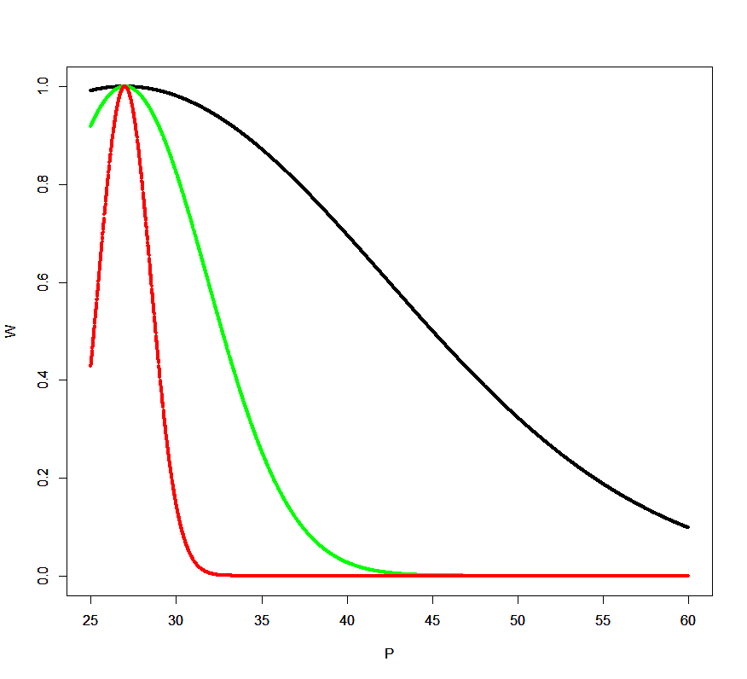
Fig. S1. Examples of fitness functions used in our simulations, with w² varying between 100v_{A} (black line), 10v_{A} (green line) and 1v_{A} (red line) and indicating weak, moderate and strong stabilizing selection, for an adaptive peak at 27 kg and initial value of 60 kg (see text for details). Notice, however, that maximum fitness and the peak O will be fixed only when N ~ K. In simulations performed here, values of w² ranged between 100 v_{A} and 150v_{A}, as much lower values as in red and green curves cause a quick extinction of populations due to low fitness in initial phases of colonization.

In the classical models of adaptation to new environments, the optimum will be fixed and initial mean phenotypes will be a given distance apart from it, thus at lower fitness (e.g., [8]). We can think, for example, that under the island rule the optimum body size would be much smaller than in the continent, thus explaining the evolution of dwarfism. However, in the particular context of dwarfism, there is an “island syndrome” [9], whereas in the first phases of colonization (in which N << K) there is necessarily no selective advantage of small-bodied individuals, because general environmental conditions in the island are similar to those in the continent and resources are still enough to support the population (although it can start to mature earlier, but this can be accounted for by reaction norm in principle). Natural selection operates just like in the original population on the continent, with mean phenotypic values quite close to O (except for small sampling errors). However, as long as the population starts growing fast due to the high initial fitness and low population size N, the resources in the island will be depleted and natural selection would start favoring smaller individuals (Fig. S1). Then, as population density increases, optimum O will shift linearly and will achieve its final value only when the population achieves K.
Given the distribution of fitness values in the population with N individuals, in our model natural selection will act through both differential survival (i.e., before reproduction) and viability (i.e., number of offspring, [10]). Survival is defined by comparing fitness values with a random uniform distribution, so that, for example, an individual with W_{i} = 0.9 will have 90% chance of surviving and achieving sexual maturity. Second, after establishing the pool of individuals that survive, the fitness values W_{i} are converted into the number of offspring considering random pairs of individuals sampled (without replacement) from the vector G. This number of offspring (i.e., adults in the next generation, N_{t+1}) is defined considering a logistic growth of the population (Ricker model; see [4]), so that the number of offspring for a given couple is a proportion of total number in t+1, given by:
N_{t+1} = W_{i} N_{t} e^{( λ (1 – N/K))} (3)
where λ is the maximum replacement rate (i.e., the number of offspring per parent that survive to adulthood), K is the carrying capacity of the population and W_{i}, in this case, is the mean fitness of the two parents. The genotypic value of the offspring from each couple is then sampled from a normal distribution with mean equal to the mean genotypic values of the two parents (the vector G) and segregation variance equal to v_{A}/2 (see [3]). In our simulation, demographic stochasticity is incorporated by varying λ at each generation, randomly sampling values from a normal distribution with pre-defined mean and variance. Environmental stochasticity can be incorporated by varying K at each generation, both by sampling from a pre-defined distribution of K values or by tracking real paleoenvironmental data (see below).
Inbreeding is yet another important factor as it tends to reduce fitness, especially when populations are small. We assumed a linear relationship between the level of inbreeding among parents and their reduction in fitness by increasing mortality (see [11]; [12]). Although it is not viable here to keep a sib network of ancestry through time in our simulations for all individuals, we evaluate inbreeding by Markovian approximation tracking if the pairs of individuals generating offspring are brothers and sisters (and keeping the overall mean inbreeding in the previous generation as the background level). For instance, data allow interpolating that under inbreeding depression the fitness of an individual derived from a brother-sister couple in mammals (f = 0.5) will be reduced by around 73% (see below for kinship estimation). Also, we defined an overall level of population inbreeding f that will be assigned to “unbred” individuals. This is recorded for the next generation and this will affect the fitness in the next generation, as pointed out above. Thus, although small populations will tend to have higher mean levels of inbreeding, especially at the starting of the populations, highly inbred individuals will tend to die and not leave offspring, so the mean value of f will quickly achieve equilibrium at low levels.
It is also known that although selection and inbreeding erase the additive genetic variance from the population as mean G approximates to the optimum O, variance can be restored by other microevolutionary processes. First, mutation will add variance at a rate equal to v_{U}/v_{A}, which is usually assumed to be around 10⁻⁴ and 10⁻⁵ per loci (Wash and Lynch 2018). Because we are modeling a polygenic trait determined by hundreds of loci, we can use much higher values for v_{U}/v_{A} ratio around 2-3% for body size in mammals [13]. In our model this is added as a “mutation kernel” [14], which is a random vector U with mean 0 and variance v_{U}/v_{A} added to the G values of the offspring. Second, we can also add to the model the possibility that new individuals from the continent arrive on the island, with genotypic values sampled from the original values of G in the start of the simulations, as described above. That is, this migration process depends on two parameters, so that a given number of individuals Ni can immigrate to the island with a given probability, with genotypic value sampled from a normal distribution with mean equal to G₀ and v_{A0}. The immigrant individuals are then incorporated into the insular population, composing the output vector G that will form the next generation, to restart the cycle of processes described above in the iterative process.
Demographic and environmental stochasticity were also incorporated into the simulations by assigning, at each time step, distinct value to λ and K, sampled from random normal distributions (in the case of λ) or varying systematically (in the case of K) (see below for more details in the subsection of model parametrization for H. floresiensis). Thus, at each step of the simulation, body size will evolve in the new individuals according to the processes defined above. In particular, under stabilizing selection this is accomplished with a moving peak that successively approximates the optimum for high population density in the island. The time to adaptation is defined as the time P takes to reach the final optimum on the island. As this is an iterative process across generations, it is possible to record several parameters and outcomes of the model at each generation or at the end of simulation, including the mean and variance of G, population density, inbreeding level, realized heritability h², as well as statistics describing the intensity of selection process (i.e., mean-standardized selection gradient; see [15]; [16], see Fig. S3 below).

Model Parametrization and Empirical Application: evolution of body size in Homo floresiensis
We parametrized and tested our model by using empirical data from the Homo floresiensis case, that was previously studied by two of us using analytical models in quantitative evolutionary genetics [17]. H. floresiensis was a small-bodied hominin discovered on Flores Island, Indonesia, in 2004 [18]. Several subsequent analyses revealed that it may most likely be a dwarf form of Homo erectus, that colonized East Asia at least 1,000,000 years ago [19].
Following the steps of the model described above, we ran 5,000 simulations randomly combining the parameter values within the ranges defined in Table 1 in the main text (see also [17] for detail). H. floresiensis body size (mass) was estimated at 27 kg, and initial H. erectus values at 45–55 kg. This sets a first reference for the adaptive peak in Flores Island (the dwarfed species) and the initial phenotypic body size in the simulations. Heritability for body size usually ranges between 0.6 and 0.85, with coefficients of variation around 5%, so this allows defining the genotypic values of the initial G and P vectors.
For mammal body size in general, and human in particular, it is well known that resource depletion will result in a small body size, achieved by lower growth rates and later age of menarche [20]. This is particularly important in the early phases of human growth, during fetal life, infancy and early childhood [21]. Thus, the reaction norm in our simulation is defined by a linear decrease in P (for the same G) when occupying an island in which resources are scarce or overall environmental conditions deteriorate at maximum population density. We ran the simulations with phenotypic plasticity parameter b ranging from 0 to 0.5, so that instantaneously an individual would reduce by the half of the distance between initial mean P (about 50-50 kg) and final optimum (27 kg) without any changes in G (see [4]). This maximum value approximates, for example, the current values of body size in dwarf natives of Flores and other islands in Polynesia (although the dwarfing of these populations also involves genetic adaptations; [22]). Note that this randomly selected b between 0 and 0.5 for each simulation defined the maximum slope of the reaction norm, that will be achieved only when N ~ K (see Walker and Hamilton 2008). The length of the vector G is defined by the initial population size N₀ (i.e., number of initial colonizers), varying in our simulations between 25 and 100 individuals. Initial inbreeding was set as 0.1, but through time the mean inbreeding is given by a Markovian approximation, tracking only brother-sister couples.
Body size evolution tracks a stabilizing selection fitness function with a moving peak O, which moves linearly with population size and achieves the minimum value of 27 kg found in H. floresiensis only when the island is at the carrying capacity K. The values of w² in equation 2, determining the strength of stabilizing selection, were initially set to range between 100v_{A} and 10v_{A} (for weak to very strong selection, respectively), following [24]. However, in most cases with strong and moderate stabilizing selection the mortality is too high, and colonization fails due to low initial population size (i.e., colonization success). Thus, to evaluate body size evolution in viable demographic scenarios, values of weak selection with w² ranging between 100v_{A} to 150v_{A} were used.
To define patterns of population growth under Ricker model, maximum fecundity of females is sampled, at each time step, from a normal distribution with mean equal to 5.4 ± 1 offspring (i.e., the total number of offspring in a given lifespan, some of which will not survive and reproduce, depending on its fitness; [25]). This creates demographic stochasticity by varying the values of λ. Flores Island is about 13,400 km². Based on estimates of hunter-gatherer population density from about 0.02 to 0.1 individuals/km² [26,27], we could estimate values of K ranging from 270 to about 13,400 individuals occupying the entire island. However, K values worldwide are correlated with climatic and environmental conditions, and tropical environments tends to support higher densities (e.g., [28]). Thus, in our simulations with H. floresiensis we set maximum K values varying between about 9,000 and 12,000 individuals (assuming this high population densities in tropical environments), but related these values as a log-linear response to Net Primary Productivity (NPP).
Values of NPP were obtained from a paleoclimate emulator, following precisely the approach of [29] (see [30] for a recent application with a similar approach). Briefly, we apply Gaussian process emulation [31] of the singular value decomposition of ensembles of the intermediate complexity atmosphere-ocean GCM PLASIM-GENIE [32]. We use current NPP values from NASA/MODIS [33] as a baseline, and emulate anomalies compared to this baseline as spatial fields of NPP at 1,000 year intervals, driven by analytically calculated orbital parameters and observationally-derived time-series of CO₂ and ice-volume, and assuming the climate is in quasi-equilibrium. NPP anomalies through time are downscaled from climate model resolution of 5° (where a single grid cell covers the region around Flores) to the spatial resolution of the observed modern distribution of NPP (0.5°) using bilinear interpolation, following the downscaling approach as described for precipitation [29]. Starting a 1 million years before present, the NPP time series is linearly interpolated onto time steps of 15 years, assuming that this is the average generation time for the species, especially valid if dwarfing in H. floresiensis is related to reduction of age at sexual maturity. At each time step, a small error in K is added, by sampling a normal distribution with mean K derived from NPP with a standard deviation given by a coefficient of variation of 5%. Although at large temporal scales there is a cyclic variation in NPP and K, in the first 500 generations there in actually a slight increase in productivity (Fig S2).
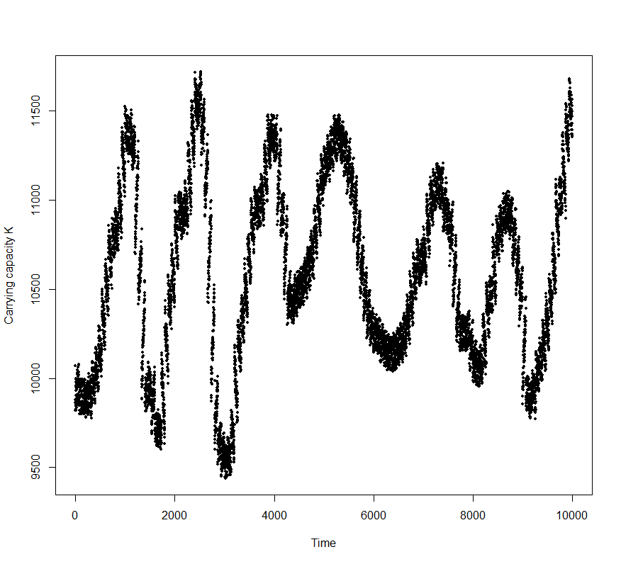
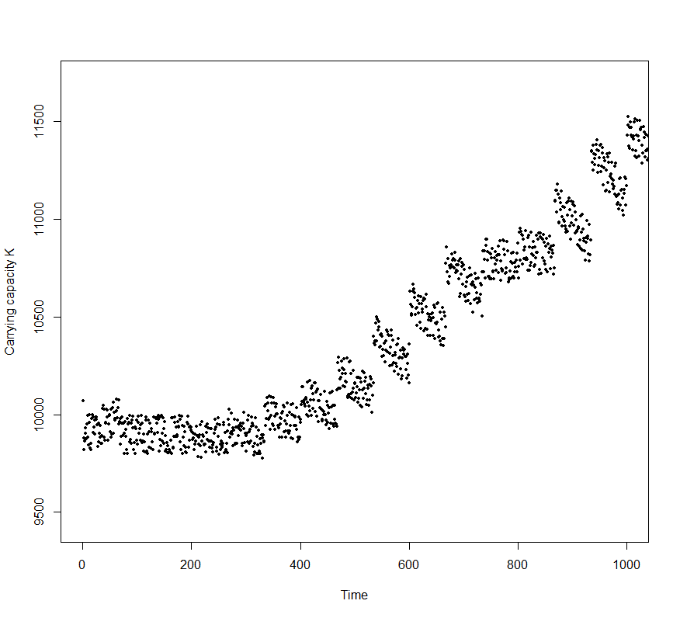
Fig. S2. Temporal dynamics of productivity (NPP) in the Flores Island in the last 1 my, derived by paleoclimatic reconstructions of temperature and precipitation (see [30] for details), above for 10,000 time steps of 15 years (roughly coinciding with generation time in our simulations) and a zoom in the first 1000 generations, showing the increasing NPP values though time corresponding to an increasing K in the simulations.

Restoration of genetic variability is given by a genomic mutation rate mu equal to 0.027v_{A} per generation [13], which also tends to reduce mean inbreeding by a factor of mu². Because Flores is considered a relatively isolated population and colonization routes are uncertain (see [34, 35]), we also set small recolonization rates, with a few individuals (from 1 to 10) potentially arriving in each generation with a low probability between 5% and 10%.
Adaptations to the new final peak are considered as successful if mean G is below 30 kg (given the uncertainty around the 27 kg value for H. floresiensis and normal variation of 5% around this initial estimate). The main response variable in our simulations is the time for adaptation and we also recorded final mean G and v_{A}, final inbreeding and adaptive peak (under the moving environment). We also estimated the mean-standardized selection gradient β_{u} by the regression slope of W on P, multiplied by mean G. The selection gradient β_{u} is more frequently estimated in natural populations than selection differentials, making it easier to compare the minimum selection intensity necessary to differentiate H. floresiensis from H. erectus with the analytical approximations by [17], as well as additional empirical estimates [16, 36].

SUPPLEMENTARY RESULTS
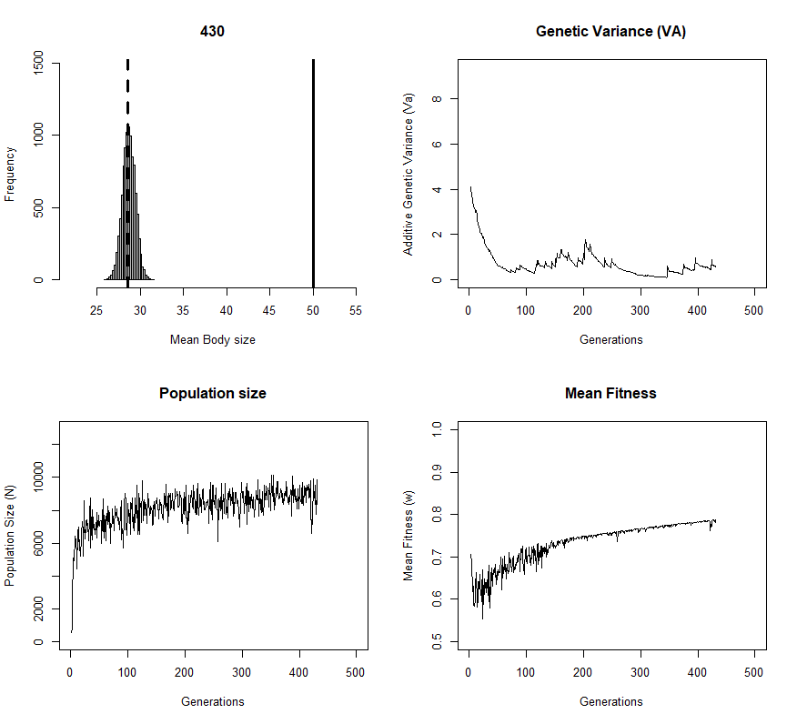
Fig. S3. Screenshot of a single simulation output, showing (in the upper left quadrant) the final distribution of genotypic values G in the population, tracking the new peak (27 kg, dashed line) and the initial peak of 50 peak. The other panels show the temporal dynamics of genetic variance v_{A}, population size N and mean fitness W.
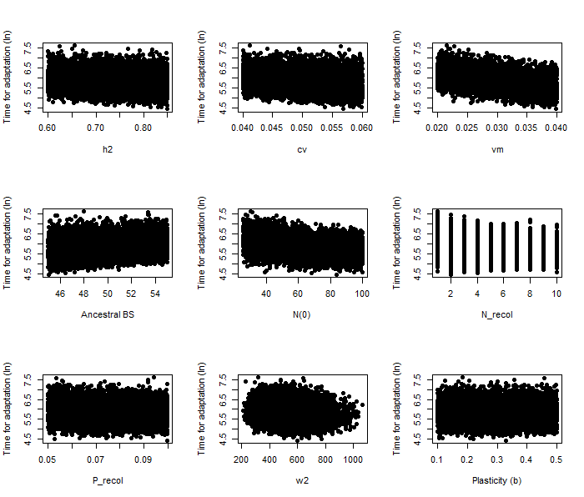

Fig. S4. Relationship of time for adaptation, across the 10,000 simulations, with several genetic and demographic parameters (see also the partial effects shown in Table 2 of the main text).

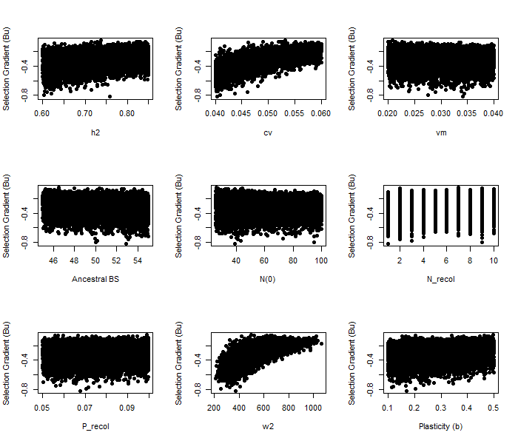
Fig. S5. Relationship of mean standardized selection gradient β_{u}, across the 10,000 simulations, with several genetic and demographic parameters (see also the partial effects in Table 2 of the main text).

Some additional results fixing some parameters in the model
Although results above (Figs. S4 and S5), as well as Table 2 in the main text, can help understanding the relative effect size of each parameter on the simulations, we decided to run a few additional simulations fixing a few parameters. We can then see how these parameters can produce significant changes in time for adaptation.
In the simulations shown in the main text, varying all parameters, the median time for adaptation was equal to 354 (CI 95%: 150 – 675). If we fix the phenotypic plasticity parameter to zero the results are basically the same, with median time for adaptation equal to 354 (CI 95%: 150 – 892), although the upper limit of the distribution is a bit higher. This is expected by Fig. S4, which shows a small unique effect for this parameter b, but it is is also expected that without plasticity, which may be slightly more important in the initial phases of the adaptation (as in Lister two-phase model), in some simulations the time for adaptation is a bit higher.
On the other hand, if we fix the optimum since the early phases of the simulation, the median time for adaptation is slightly lower, but with wider confidence limits and smaller lower limit (median = 295, CI95%: 96 – 687). This is expected because selection strength is stronger than in the simulations in the main text. This is because the initial optimum is already the peak with 27 kg for H.floresiensis, and in our simulation this peak is density-dependent, which is actually a novelty of our simulation approach (see main text for details). But one interesting results here is that, if we fix the optimum and assume that adaptation to final peak of 30 kg is required, simulations fail in almost 90% of the times and population crashes (in contrast with original simulations, in which adaptation was successful in 97.3% of the times).
Finally, we assume, based on current area of Flores island, that carrying capacity is 10,000 individuals, roughly based on population densities in tropical hunterer-gatherers [17]. However, van der Geer et al. [37] recently estimated the area of Flores in the late Pleistocene in almost 22,000 km², so populations would grow even larger (with the same population density). So, we rebuild the simulations with the maximum reference population size for K ranging for 5000 and 20,000 individuals. For 5000, time for adaptation is similar to the original simulations (median time = 292, CI95%: 146 – 675). But increasing carrying capacity to 20,000 individuals increases the median time for adaptation to 400 generations, with CI95%: 177 – 1140). So, with a large K the time for adaptation would go 25% higher than our median estimates, with maximum of 1000 generations (rougly corresponding to 15,000 years). But anyway these results are hard to interpret, as island size is not fixed and varied in time as well, so this would be a maximum upward limit for best conditions.
So, the above “experiments” showed, as expected by Fig. S4, that effects of some individual parameters is not high and did not qualitatively affect our main results, in terms of a short potential time for adaptation in H. floresiensis. Increase the carrying capacity to match maximum island area would increase a bit median expectations, but this is an unlike scenario as island area have been reduced in time.

References to ESM
1. Roff D. 2010. Modeling Evolution. Oxford, UK: Oxford University Press.
2. Barton N, Etheridge AM, Véber A. 2017. The infinitesimal model: Definition, derivation, and implications. Theor. Popul. Biol. 118, 50-73.
3. Walsh B, Lynch M. 2018. Evolution and selection of quantitative traits. Oxford, UK Oxford University Press.
4. Chevin LM, Lande R. 2011. Adaptation to marginal habitats by evolution of increased phenotypic plasticity. J. Evol. Biol. 24, 1462-1476.
5. Lande R. 2009. Adaptation to an extraordinary environment by evolution of phenotypic plasticity and genetic assimilation. J. Evol. Biol. 22, 1435–1446.
6. Schmid M, Guillaume F. 2017. The role of phenotypic plasticity on phenotypic differentiation. Heredity 119, 214–225.
7. Chevin LM, Lande R, Mace GM. 2010. Adaptation, plasticity, and extinction in a changing environment: towards a predictive theory. PLoS Biol. 8, e1000357.
8. Gomulkiewicz R, Holt RD. 1995. When does evolution by natural selection prevent extinction? Evolution 49, 201-204.
9. Adler GH, Levins R. 1994. The Island Syndrome in Rodent Populations. Q. Rev. Biol. 69, 473-490.
10. Nagylaki T. 1987. Evolution under fertility and viability selection. Genetics 115, 367-375.
11. Bittles AB, Neel JV. 1994. The cost of human inbreeding and their implications for variations at the DNA level. Nat. Genet. 8, 117-121.
12. Huisman J, Kruuk LEB, Ellis PA, Clutton-Brock T, Pemberton JM. 2016. Inbreeding depression across the lifespan in a wild mammal population. Proc. Natl. Acad. Sci. 113, 3585-3590.
13. Kemper KE, Visscher PM, Goddard ME. 2012. Genetic architecture of body size in mammals. Genome Biol. 13, 244.
14. Débarre F, Otto SP. 2016. Evolutionary dynamics of a quantitative trait in a finite asexual population. Theor. Popul. Biol. 108, 75–88.
15. Hereford J, Hansen TF, Houle D. 2004. Comparing strengths of directional selection: How strong is strong? Evolution 58, 2133–2143.
16. Kingsolver JG, Hoekstra H, Hoekstra JM, Berrigan D, Vignieri SN, Hill CE, Hoang A, Gibert P, Beerli P. 2001. The strength of phenotypic selection in natural populations. Am. Nat. 157, 245-261.
17. Diniz-Filho JAF, Raia P. 2017. Island Rule, quantitative genetics and brain–body size evolution in Homo floresiensis. Proc. Royal Soc. Lond, 284, 20171065.
18. Brown P, Sutikna MJ, Morwood MJ, Soejono RP, Jatmiko, Wayhu Saptomo E, Awe Due R. 2004. A new small-bodied hominin from the Late Pleistocene of Flores, Indonesia. Nature 431, 1055-1061.
19. Baab KL. 2016b. The place of Homo floresiensis in human evolution. J. Anthropol. Sci. 94, 5–18.
20. Stulp G, Barret L. 2016. Evolutionary perspectives on human height variation. Biol. Rev. 91, 206-234.
21. Kuzawa CW, Bragg JM. 2012. Plasticity in human life history strategy: Implications for Contemporary Human Variation and the Evolution of Genus Homo. Curr. Anthropol. 53, S369-S382.
22. Tucci S, Vohr SH, McCoy RC, Vernot B, Robinson MR, Barbieri C, Nelson BJ, Fu W, Purnomo GA, Sudoyo H, Eichler EE, Barbujani G, Visscher PM, Akey JM, Green RE. 2018. Evolutionary history and adaptation of a human pygmy population of Flores Island, Indonesia. Science 361, 511-516.
23. Walker RS, Hamilton MJ. 2008. Life-history consequences of density dependence and the evolution of human body size. Curr. Anthropol 49, 115-122.
24. Burger R, Lynch M. 1995. Evolution and exinction in a changing environment: a quantitative-genetic analysis. Evolution 49, 151-163.
25. Barton N, Etheridge AM, Véber A. 2017. The infinitesimal model: Definition, derivation, and implications. Theor. Popul. Biol. 118, 50-73.
26. Binford LR. 2001. Constructing frames of reference: an analytical method for archaeological theory building using ethnographic and environmental data sets. Oakland, CA: University of California Press.
27. Marlowe FW, Berbesque JC. 2005. The human operational sex ratio effects of marriage, concealed ovulation, and menopause on mate competition. J. Hum. Evol. 63, 834-842.
28. Eriksson A, Betti L, Friend AD, Lycett SJ, Singarayer JS, von Cramon-Taubadel N, Valdes PJ, Balloux F, Manica A. 2012. Late Pleistocene climate change and the global expansion of anatomically modern humans. Proc. Natl. Acad. Sci. 2, 16089-16094.
29. Holden PB, Edwards NR, Rangel TF, Pereira EB, Tran GT, Wilkinson RD. 2018. PALEO-PGEM v1.0: A statistical emulator of Pliocene-Pleistocene climate, Geosci. Mod. Dev. Disc., doi.org/10.5194/gmd-2018-242.
30. Rangel TF, Edwards NR, Holden PB, Diniz-Filho JAF, Gosling WD, Coelho MT P, Cassemiro FAS, Rahbek C, Colwell RK. 2018. Modeling the ecology and evolution of biodiversity: Biogeographical cradles, museums, and graves. Science 361, 6399, eaar5452. (doi: 10.1126/science.aar5452)
31. Rasmussen CE, Williams CKI. 2006. Gaussian Processes for Machine Learning. MIT Press. http://www.GaussianProcess.org/gpml.
32. Holden PB, Edwards NR, Fraedrich K, Kirk E, Lunkeit F, Zhu X. 2016. PLASIM–GENIE v1.0: a new intermediate complexity AOGCM. Geosci. Mod. Dev. 9, 3347-3361.
33. Running S, Mu Q, Zhao M. 2015. MOD17A3H MODIS/Terra Net Primary Production Yearly L4 Global 500m SIN Grid V006. NASA EOSDIS Land Processes DAAC. https://doi.org/10.5067/MODIS/MOD17A3H.006.

34. Dennell RW, Louys J, O’Regan HJ, Wilkinson DM. 2014. The origins and persistence of Homo floresiensis on Flores: biogeographical and ecological perspectives. Quat. Sci. Rev. 96, 98-107.
35. Ruxton GD, Wilkinson DM. 2012. Population trajectories for accidental versus planned colonisation of islands. J. Hum. Evol. 63, 507-511.
36. Matsumura S, Arlinghaus R, Ieckman U. 2012. Standardizing selection strengths to study selection in the wild: a critical comparison and suggestions for the future. Bioscience 62, 1039-1054.
37. Van der Geer AA., van den Bergh GD, Lyras GA, Prasetyo UW, Due RA, Setiyabudi E, Drinia H. 2016. The effect of area and isolation on insular dwarf proboscideans. J. Biogeogr. 43, 1656-1666.

