¹H NMR of 3 (Aromatic expansion only)
2-Phenylimidazo[1,2-a]pyridine (3a)
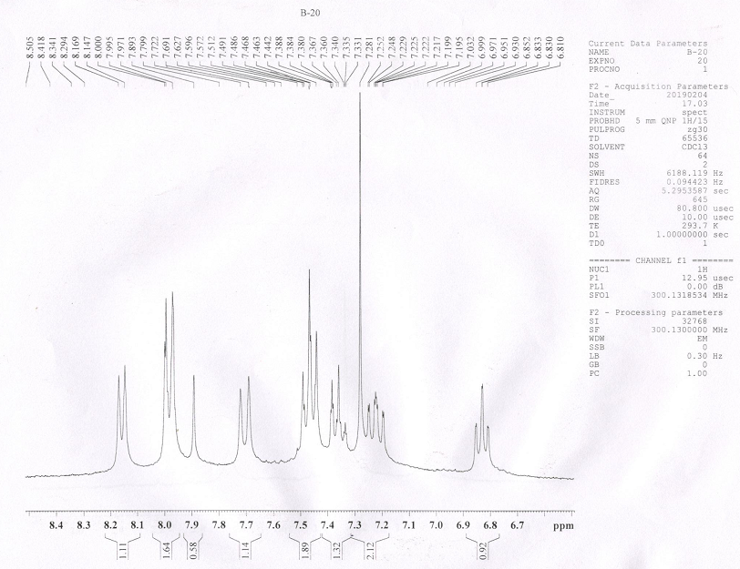

4-(Imidazo[1,2-a]pyridin-2-yl)benzonitrile (3b)
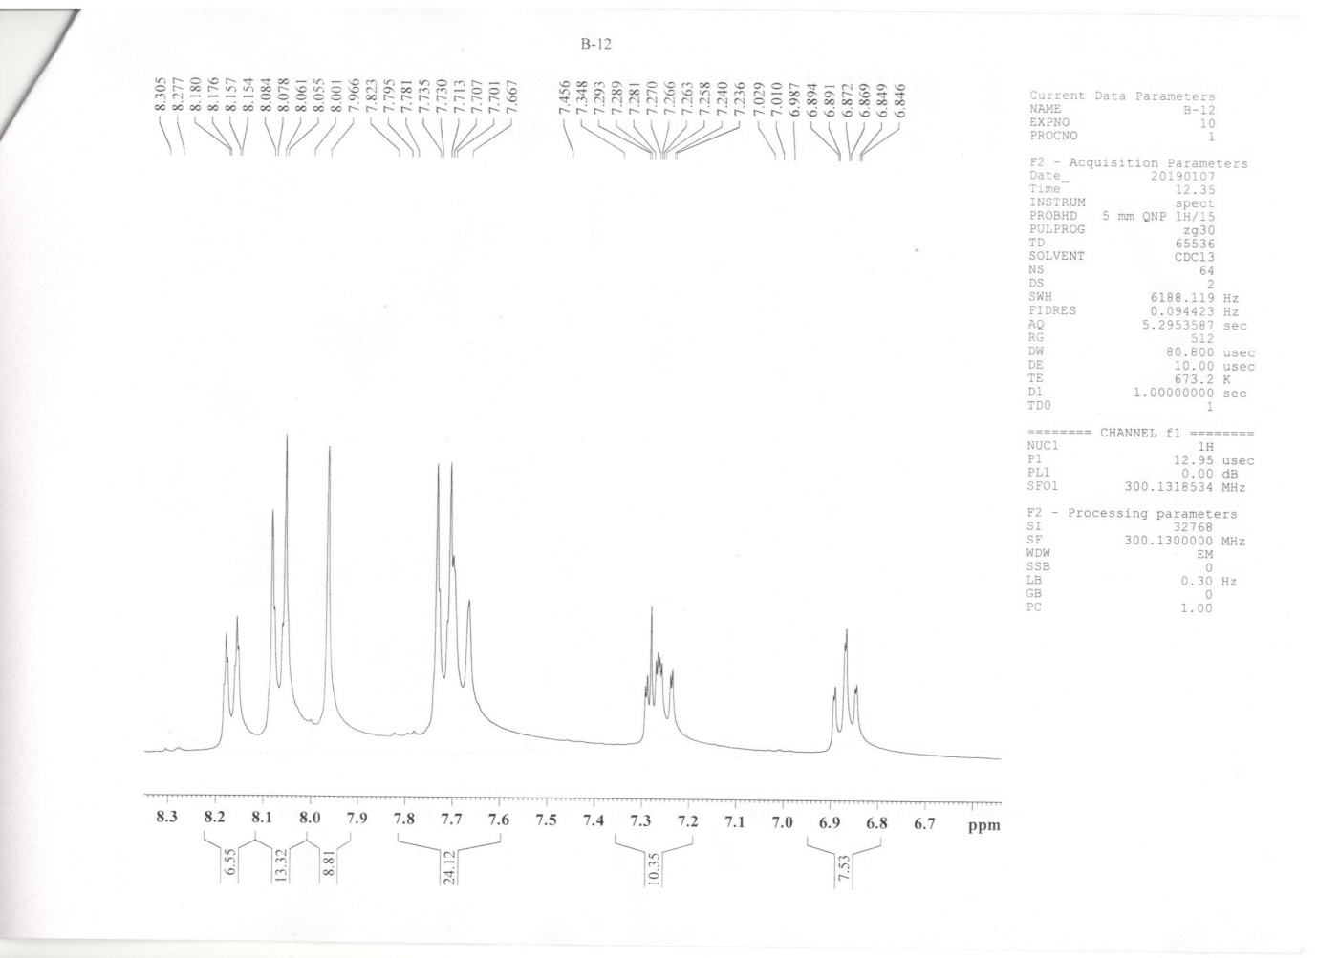

2-(3-Nitrophenyl)imidazo[1,2-a]pyridine (3c)
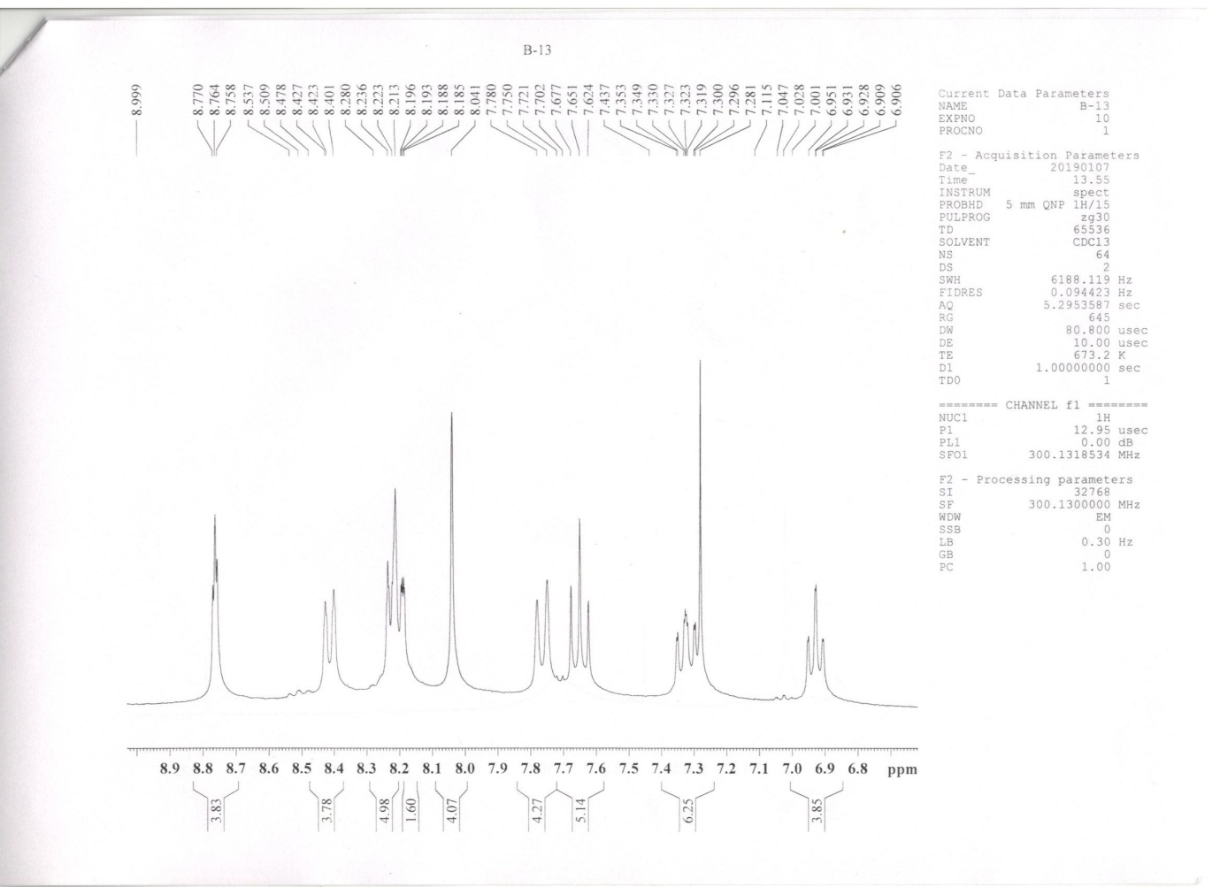

2-(4-Bromophenyl)imidazo[1,2-a]pyridine (3d)
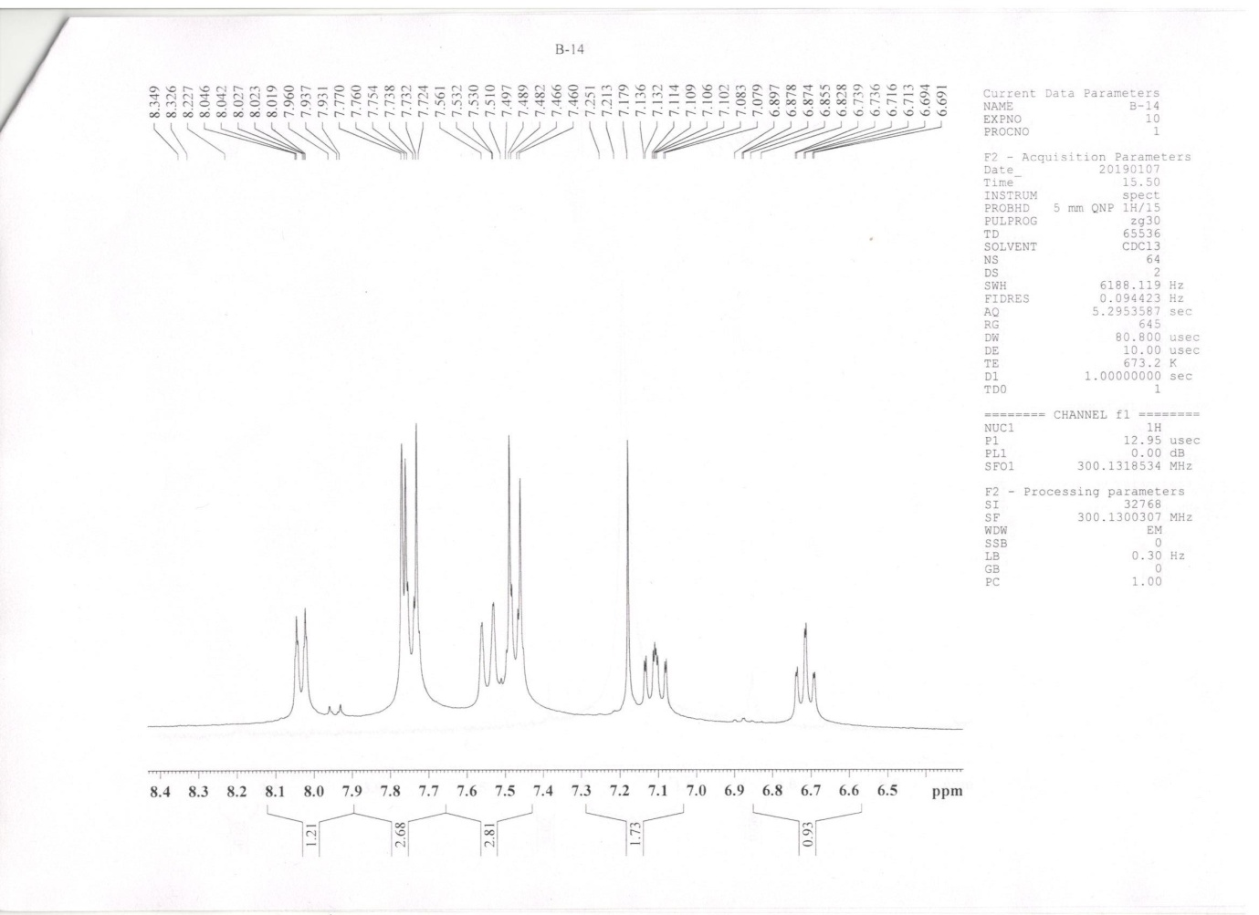

2-(4-Chlorophenyl)imidazo[1,2-a]pyridine (3e)
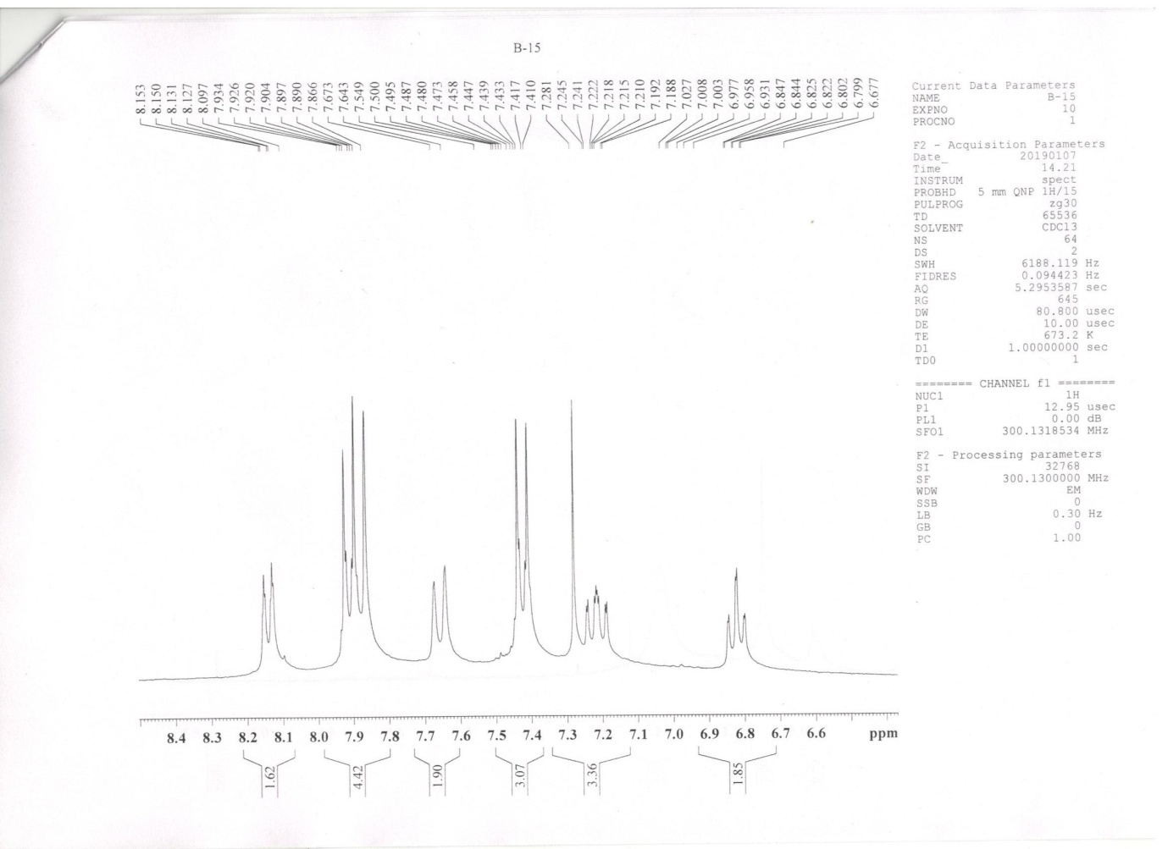

2-(4-Fluorophenyl)imidazo[1,2-a]pyridine (3f)
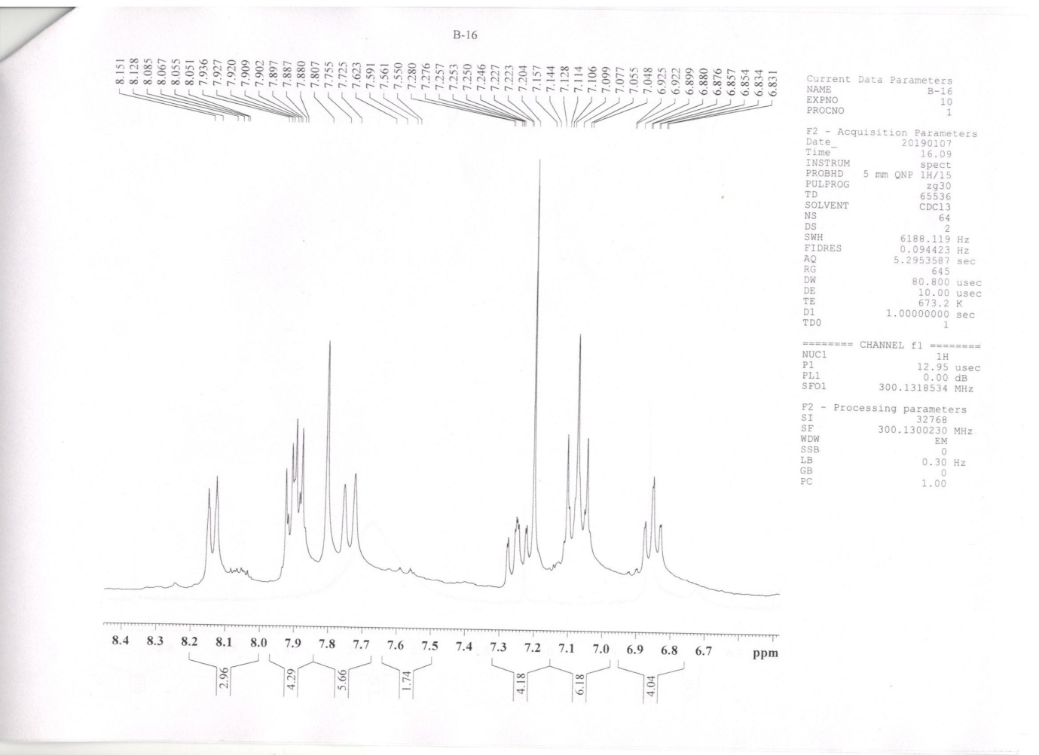

2-(4-Methylphenyl)imidazo[1,2-a]pyridine (3g)
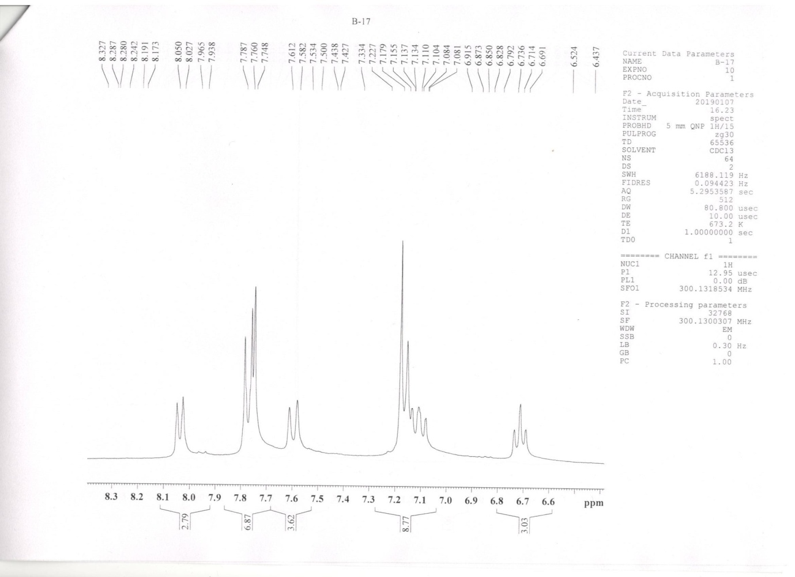

2-(4-Methoxyphenyl)imidazo[1,2-a]pyridine (3h)
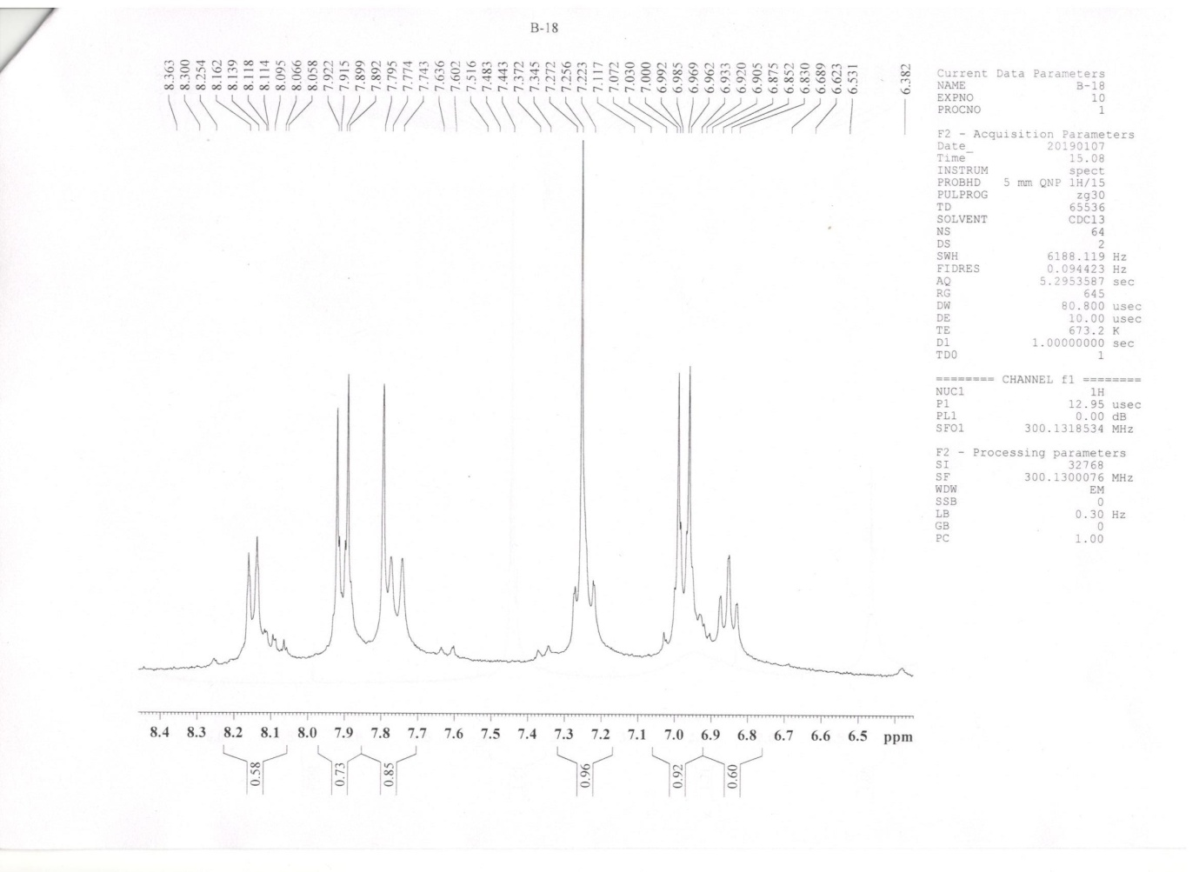

2-(3-Methoxyphenyl)imidazo[1,2-a]pyridine (3i)
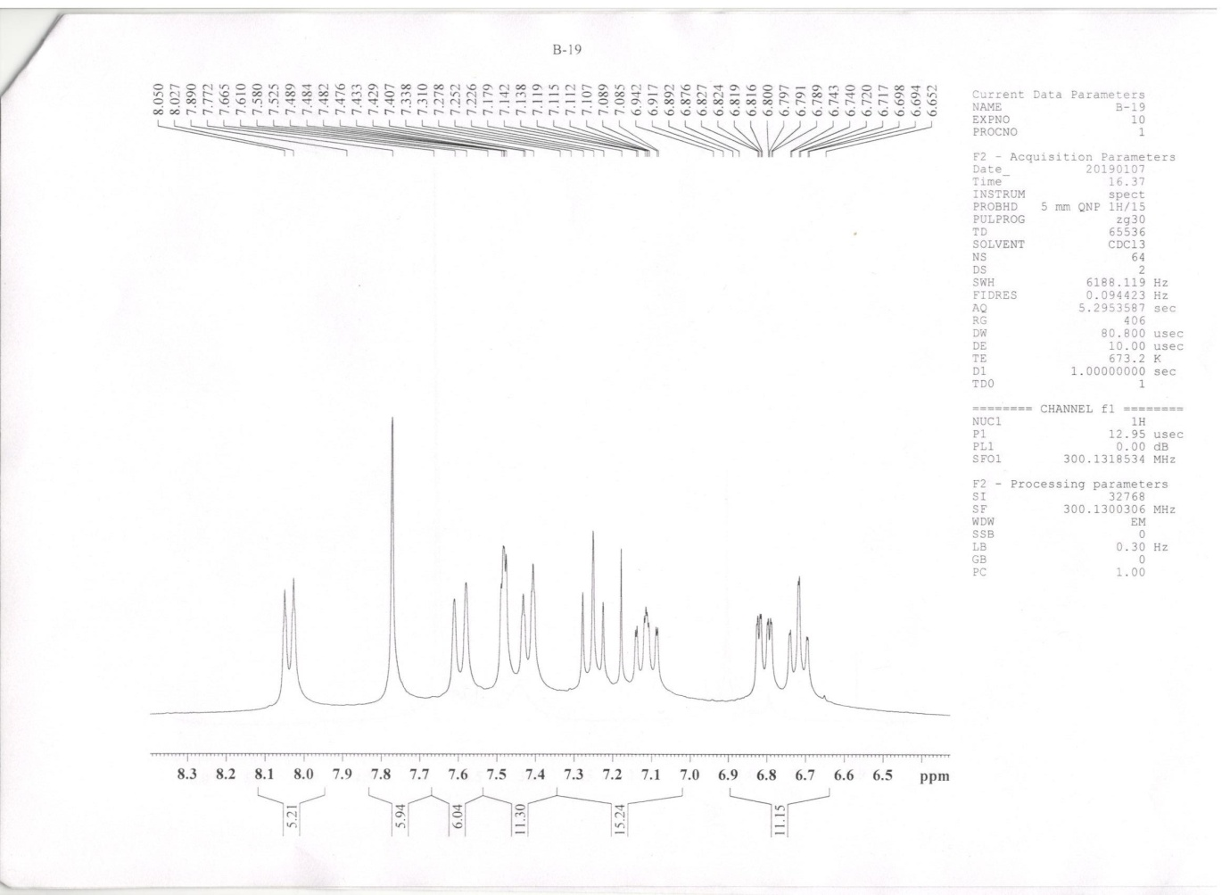

2-(4-Nitrophenyl)imidazo[1,2-a]pyridine (3j)
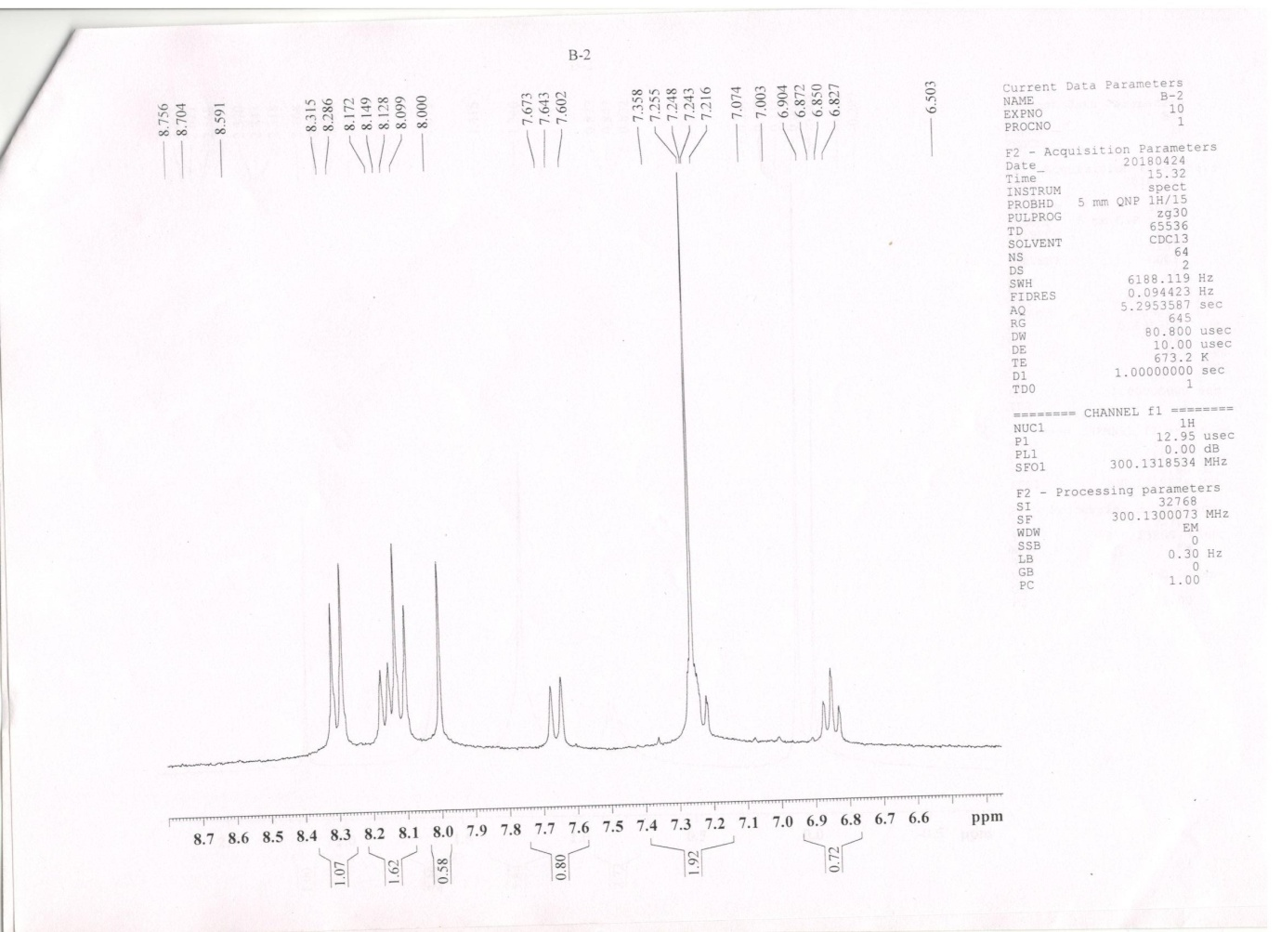

Mass spectrum of Pyridinium salt (A)
