Electronic supplementary material

Fear effects associated with predator presence and habitat structure interact to alter herbivory on coral reefs

Andrew G. Bauman, Jovena C.L. Seah, Fraser A. Januchowski-Hartley, Andrew S. Hoey, Jenny Fong and Peter A. Todd

Supplemental Methods

- Study site and species

Pulau Satumu is the southernmost island in Singapore, approximately 15 km south of main island (1º16’N, 103º74’E, figure S1). P. Satumu has a well-developed fringing reef along its leeward western margin with a clearly defined reef crest at a depth of 3–4 m (figure S1c), marking the transition between the narrow reef flat and the reef slope. Coral reefs surrounding P. Satumu have the highest coral species richness and percent coral cover [1], the lowest macroalgal cover [1], the highest herbivorous fish biomass, and the highest rates of macroalgal removal [2] of reefs in Singaporean waters.

Sargassum ilicifolium is the most abundant and widespread Sargassum species found on reefs in Singapore [3]. S. ilicifolium is a relatively tall species (mature thalli >2 m height) with smooth cylindrical axes and large thick ovate blades, or leaves. Individual S ilicifolium thalli of similar heights (ca. 70 cm) were collected from the reef flat of Pulau Hantu (figure S1b), where they are abundant and grow larger due to minimal herbivory [2]. S. ilicifolium thalli on P. Hantu also appeared to be in better condition than conspecifics on P. Satumu. Most S. ilicifolium on P. Satumu at the time of the study were small (height <30 cm), not abundant (<3% cover) and were exhibiting signs of intense herbivory on the blades and axes.

- Sargassum transplants and video observations

Following the collection of S. ilicifolium, individual thalli were spun in a salad spinner for ~20 sec to remove excess water, and the fresh weight recorded to the nearest 0.1 g. The mean initial mass of each thallus was 81.4 ± 0.8 g (SE). Each thallus was randomly allocated to one of three density treatments: high (25 thalli), medium (15 thalli; ) and low (5 thalli) that were placed with 0.5m² experimental plots. These densities were selected to represent range of densities with the highest density treatment approximating the density of natural Sargassum stands on Singapore reefs [3]. After weighing, each thalli was attached to a sequentially-numbered plastic clip using small cable ties, and secured together in density treatment groups. All thalli were kept in-situ at P. Hantu overnight and transplanted to P. Satumu the following morning.

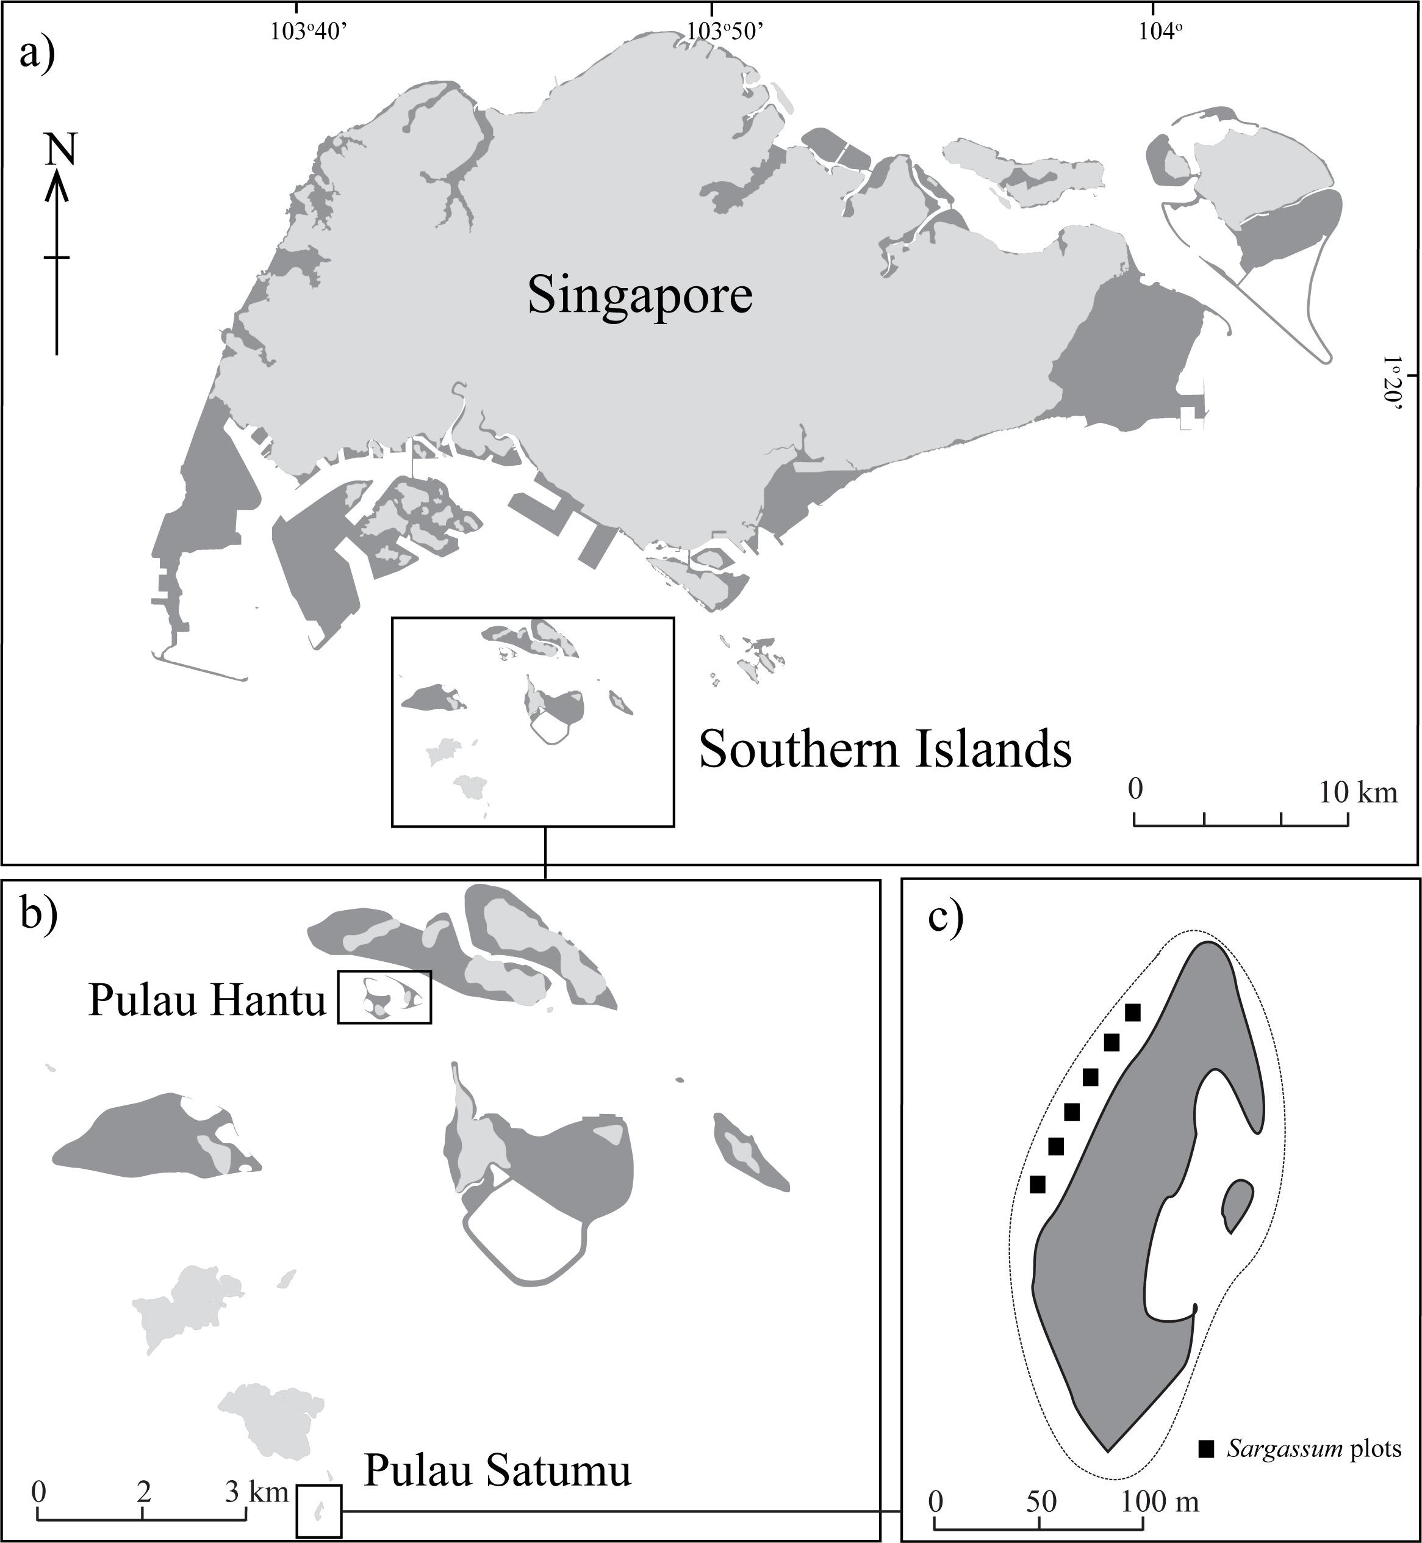
Fig S1. Map of Singapore showing the Southern Islands, Pulau Satumu and Pulau Hantu.

Each week two replicates of each density treatment were deployed to the reef crest on P. Satumu (six plots in total) with either a predator model (Plectropomus leopardus, ca. 53 cm total length) or an object control (53 cm length of light grey PVC, 8 cm in diameter) placed ~1m from the experimental plots. Individual thalli for each replicate were randomly placed within 0.5m² (71 cm × 71 cm) experimental plots. Each plot was composed of PVC pipe (16 mm diameter) frame covered with plastic mesh that had diamond-shaped holes (2.5 cm × 2.5 cm). All plots were haphazardly positioned on the reef crest at a depth of 3–4 m where coral cover and fish biomass is greatest [1].

All plots were installed on horizontal surfaces relatively free of live coral and macroalgae. Small lengths of steel angle-bar were hammered into the substratum and plots secured to the angle-bar using cable-ties. Adjacent S. ilicifolium density plots were separated by a minimum of 15 m. All thalli were randomly placed within plots using randomly generated number coordinates (horizontal and vertical distance from bottom left corner). These coordinates were numbered in running order (left to right; top to bottom) and kept the same throughout the duration of the study. Any pieces of Sargassum (e.g. blades) that become detached during deployment were collected for each replicate and weighed. This loss was subtracted from the difference in mass for each replicate after the experiment to account for handling loss.

Fiberglass predator fish models and object controls were attached to two sets of weights (3 kg) using monofilament line and secured to the reef substratum. Both predator models and object controls were positioned ~1 m away from each plot. The object control was used to control for the effect of introducing a novel object into the water column [4]. Three additional S. ilicifolium thalli were placed inside exclusion cages (15 cm radius; 100 cm height; 0.5 cm mesh) to control for handling effects and translocation, and placed randomly among treatments. All thalli were transplanted to the reef in the morning (10:00–11:00) and collected 24 hours later. After 24 hours, all assays were collected, spun and measured as described above, and all models and experimental frames retrieved. Metal angle-bars were left in place as the same six sites were used each week, but the allocation of treatments (density and predator model) was randomized among plots.

Small underwater digital video cameras (GoPro) were used to quantify feeding activity and identify herbivorous fish species responsible for removing S. ilicifolium biomass within each treatment. For each plot, two video cameras mounted on weighted stands, were positioned approximately 1 m away from adjacent corners. This arrangement allowed the entire plot and height of the Sargassum stand to be viewed. Filming commenced immediately after all assays were deployed, and models and controls were positioned, with a 10 cm scale bar being placed adjacent to each plot for 10 s in order to calibrate fish body sizes on the video footage. Filming was continuous for ~4 h after which the cameras were recovered.

All video footage was viewed and the number of bites taken from the S. ilicifolium by each species and size (total length, TL) was recorded. The first 20 min of each video was discarded to minimize potential diver interference and the following 3 h 30 mins was view During video analysis, we marked the ends of scale bar for each video on the screen and estimated the body length (Total length, TL) of each fish that enter the experimental plot and foraged. The size of individual fishes that were not clearly visible or recorded at angles that prevented accurate measurements (<2% or ~40 individuals) were visually estimated (i.e. head size) from previously measured conspecifics. Body size of fishes observed feeding within our plots was small, with the majority of individuals being 23 to 27 cm TL (table S1). Size estimates for each species were converted to biomass using published length-weight relationships [5]. To account for variation in the feeding impact of fishes related to body size we used mass-standardised bites, calculated as the product of body mass and number of bites following [6].

Supplemental Results

Table S1. The mean body length, body length range, estimated body depth, number of independent feeding observations, and total number of bites per species for six species of herbivorous fish within each treatment (object control and predator model). Note: since individual fishes may move in and out of video frame, n is the number of times that a particular species was observed, not the total number of individuals.

Treatment | Species | Mean body length (cm TL) | Body length range | Body depth range (cm) | n | Total bites
Object control | Kyphosus vaigiensis | 32 |  | 12.5 | 22 | 134
 | Platax pinnatus | 34 |  | 28.2 | 1 | 2
 | Scarus ghobban | 32.3 | 30–36 | 9.8–11.8 | 8 | 20
 | Scarus rivulatus | 24.2 | 18–32 | 5.9–10.4 | 58 | 125
 | Siganus javus | 24 | 20–26 | 7.8–10.1 | 33 | 103
 | Siganus virgatus | 23.9 | 23–27 | 9.7–11.4 | 909 | 5276
Predator model | Kyphosus vaigiensis | 32 |  | 12.5 | 2 | 7
 | Scarus ghobban | 31.3 | 30–36 | 9.8–11.8 | 6 | 0
 | Scarus rivulatus | 25.3 | 20–32 | 6.4–10.4 | 42 | 17
 | Siganus javus | 23.7 | 22–26 | 8.5–10.1 | 22 | 60
 | Siganus virgatus | 24.11 | 7–27 | 2.9–11.4 | 852 | 4260

Table S2 Table 1. Results of linear mixed-effects models for mass-standardised bites

 | Fixed effects | Estimate | Standard Error | df | t-value | Pr (>|t|)
Mass standardised bites | Density (M) | -50.681 | 24.458 | 20 | -2.072 | 0.051
 | Density (H) | -77.365 | 24.458 | 20 | -3.163 | <0.005
 | Predator | -32.193 | 24.458 | 20 | -1.316 | 0.203
 | Predator*Density (M) | -5.971 | 34.588 | 20 | -0.173 | 0.865
 | Predator*Density (H) | 31.307 | 34.588 | 20 | 0.905 | 0.376
The lmer function automatically calculates t-tests using Satterthwaite approximations to degrees of freedom.

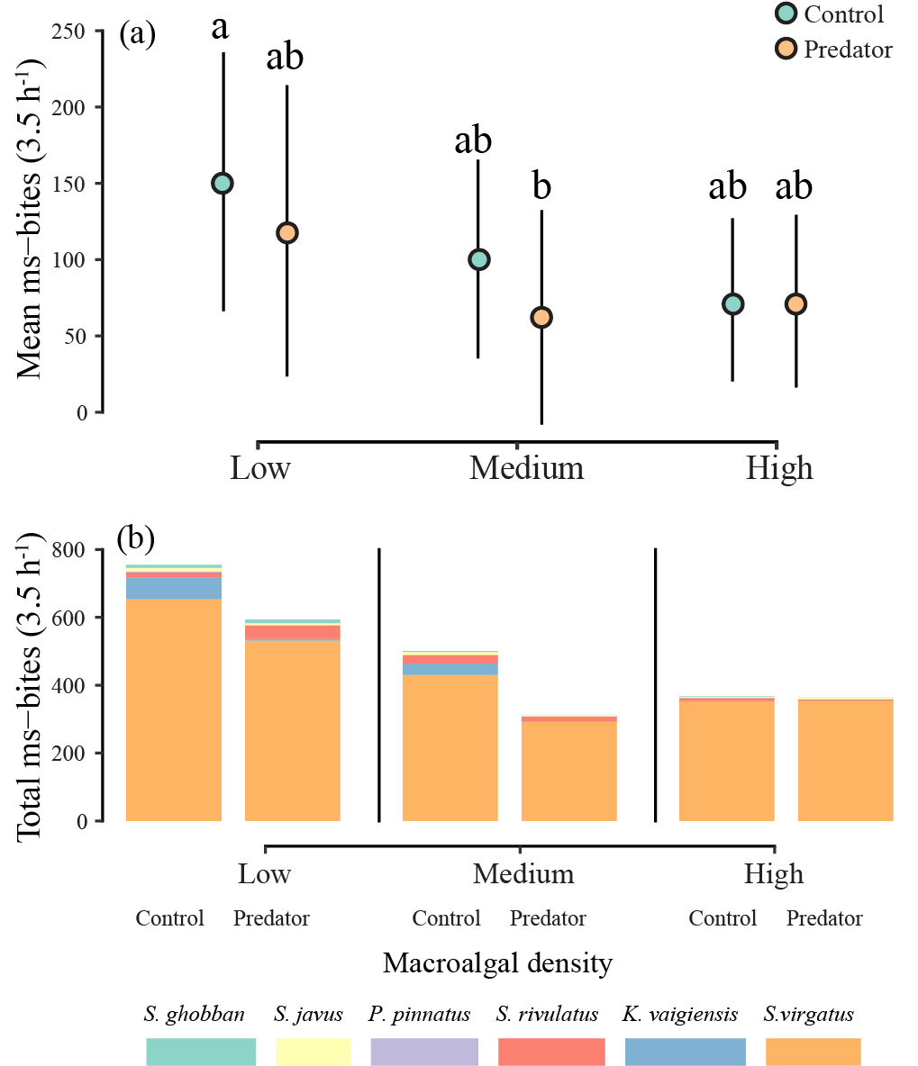

Fig S2. Effect of Sargassum ilicifolium density, object controls (teal circles) and predator models (orange circles) on herbivore foraging behaviour on (a) mass-standardized bites 3.5h⁻¹ and (b) number of mass-standardised bites taken by all species recorded at each treatment and density. Letters above density treatments indicate significant differences (p < 0.05).

Supplemental References
- Guest JR, Tun K, Low J, Vergés A, Marzinelli EM, Campbell AH, Bauman AG, Feary DA, Chou LM, Steinberg PD. 2016 27 years of benthic and coral community dynamics on turbid, highly urbanised reefs off Singapore. Sci. Rep. 6, 36260. (doi: 10.1038/srep36260)
- Bauman AG, Hoey AS, Dunshea G, Feary DA, Low J, Todd PA. 2017 Macroalgal browsing on a heavily degraded, urbanized equatorial reef system. Sci. Rep. 7, 8352. (doi:10.1038/s41598-017-08873-3)
- Low JKY, Fong J, Todd PA, Chou LM, Bauman AG. 2019 Seasonal variation of Sargassum ilicifolium (Phaeophyceae) growth on equatorial coral reefs. J. Phycol. (doi:10.1111/jpy.12818)
- Rizzari JR, Frisch AJ, Hoey AS, McCormick MI. 2014 Not worth the risk: apex predators suppress herbivory on coral reefs. Oikos 123, 829–836. (doi:10.1111/oik.01318)
- Froese R. Pauly D. (Eds) (2019). Fishbase. World Wide Web Electronic Publication. Retrieved from: www.fishbase.org.
- Hoey AS, Bellwood DR. 2009 Limited functional redundancy in a high diversity system: single species dominates key ecological process on coral reefs. Ecosystems 12, 1316–1328. (doi:10.1007/s10021-009-9291-z)
- Huang DW, Tun KPP, Chou LM, Todd PA 2009 An inventory of zooxanthellate scleractinian corals in Singapore including 33 new records. The Raffles Bulletin of Zoology 22S, 69–80
- Chou LM 1996 Response of Singapore reefs to land reclamation. Galaxea 13, 85–92

