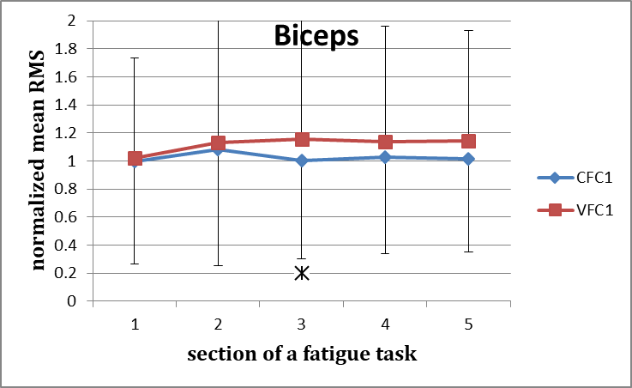 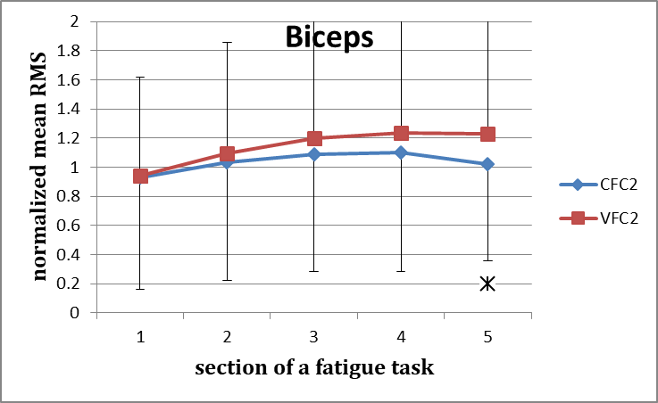Figure 14 Figure 15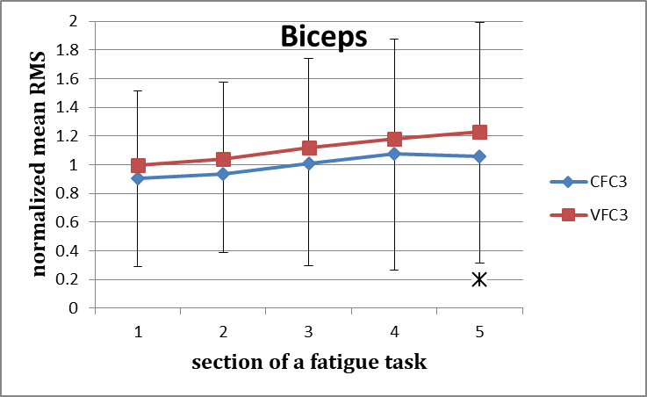 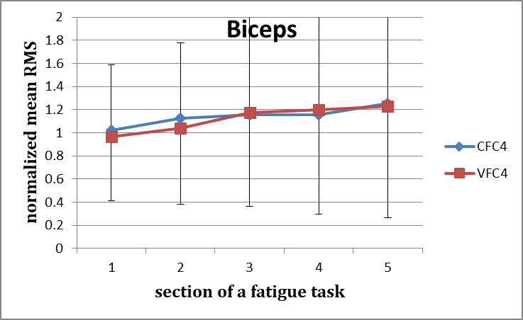Figure 16 Figure 17
Figures 14-17: Normalised mean EMGrms values for the Biceps for the five consecutive sections of the fatigue effort during the progression of each of the successive four fatiguing exercise efforts performed, under control and vibration condition. Effort 1- CFC1 vs VCF1 (Figure 14), Effort 2- CFC2 vs VCF2 (Figure 15), Effort 3- CFC3 vs VCF3 (Figure 16), and Effort 4- CFC4 vs VCF4 (Figure 17).
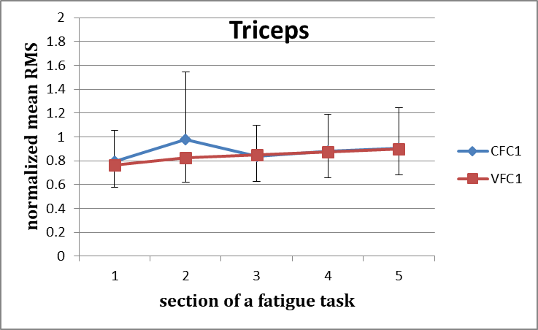 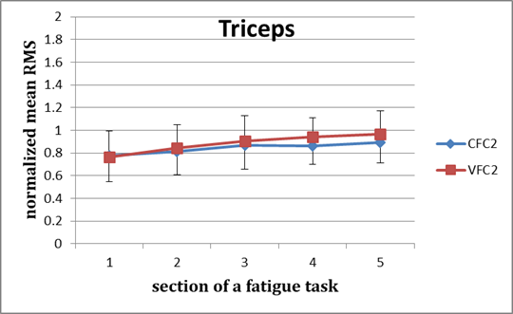Figure 18 Figure 19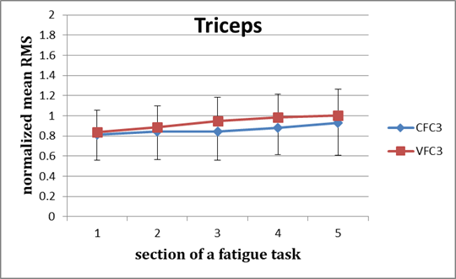 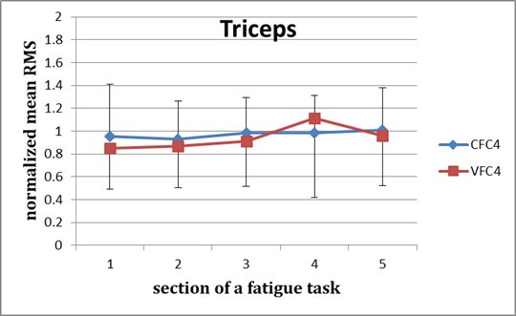Figure 20 Figure 21
Figures 18-21: Normalised mean EMGrms values for the Triceps for the five consecutive sections of the fatigue effort during the progression of each of the successive four fatiguing exercise efforts performed, under control and vibration condition. Effort 1- CFC1 vs VCF1 (Figure 18), Effort 2- CFC2 vs VCF2 (Figure 19), Effort 3- CFC3 vs VCF3 (Figure 20), and Effort 4- CFC4 vs VCF4 (Figure 21).

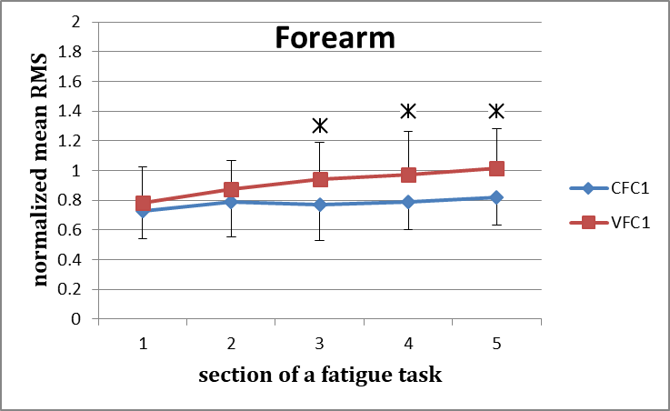 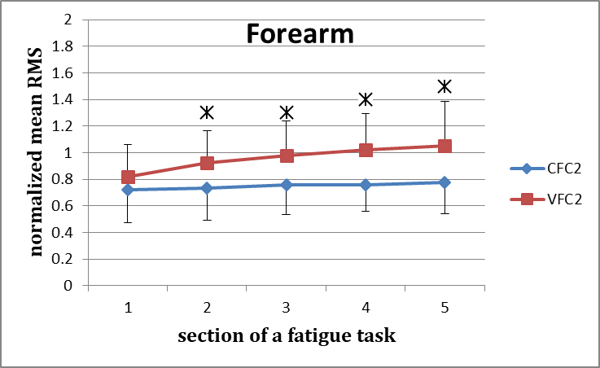Figure 22 Figure 23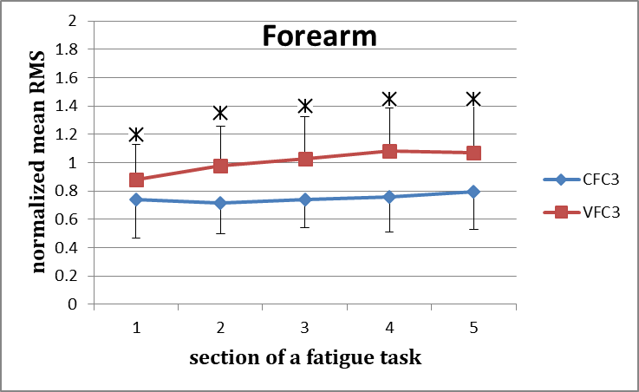 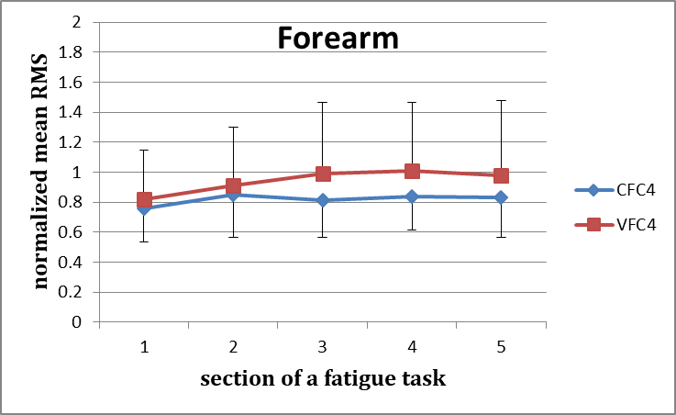Figure 24 Figure 25
Figures 22-25: Normalised mean EMGrms values for the Forearm for the five consecutive sections of the fatigue effort during the progression of each of the successive four fatiguing exercise efforts performed, under control and vibration condition. Effort 1- CFC1 vs VCF1 (Figure 22), Effort 2- CFC2 vs VCF2 (Figure 23), Effort 3- CFC3 vs VCF3 (Figure 24), and Effort 4- CFC4 vs VCF4 (Figure 25).

