Supplemental Material

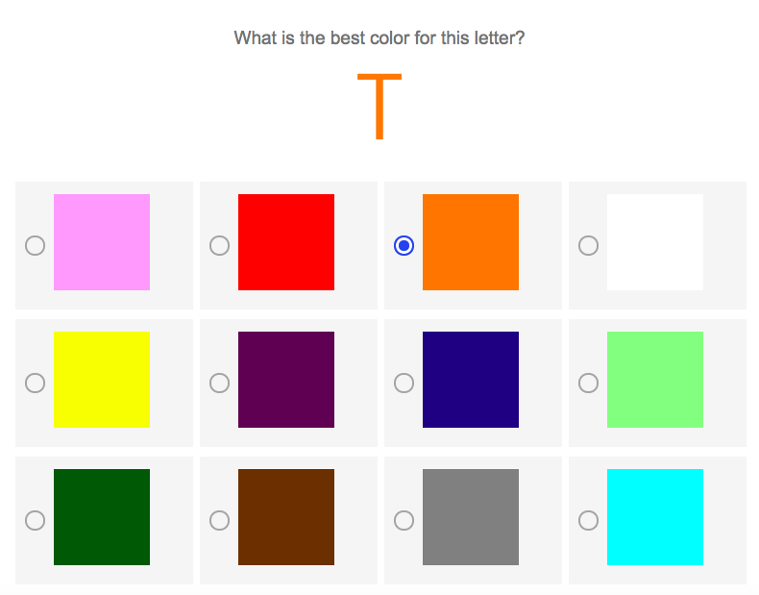

Figure S1. An example trial from Experiment 1.

