**Electronic supplementary material**

**Plant-mediated interactions between a vector and a non-vector herbivore promote the spread of a plant virus**

**Paul J. Chisholm a, Sanford D. Eigenbrodeb, Robert E. Clarka, Saumik Basua, and David W. Crowdera**

a Department of Entomology, Washington State University, Pullman, WA, USA

b Department of Entomology, Plant Pathology, and Nematology, University of Idaho, Moscow, ID, USA

Author for Correspondence:

David Crowder

dcrowder@wsu.edu

**Figure S1.** Details of experimental setup. (*a*) Cages were erected in a grid pattern with 1-m spacing. A concurrent and unrelated experiment was also performed at this same field site in the same type of cages, and so the total number of cages seen in the figure represents more than the 12 experimental replicates reported in this manuscript. (*b*) Plants were first treated with 25 *Acyrthosiphon pisum* (infectious or not) and adult *Sitona lineatus* (2 or none) 24-h before being placed in the middle of an 8-plant ring.

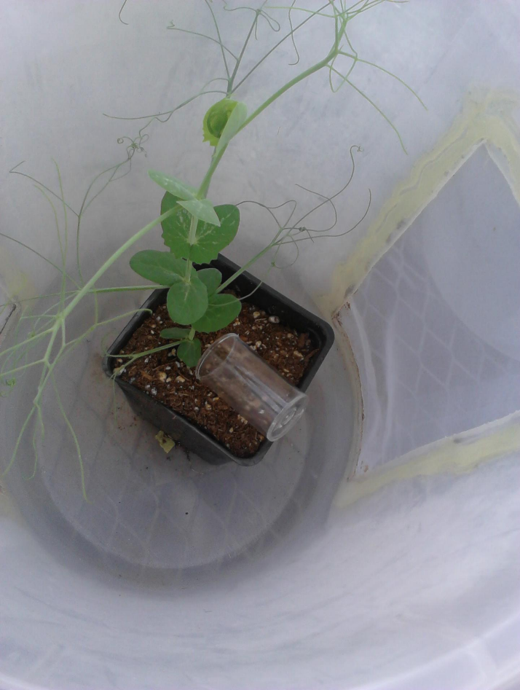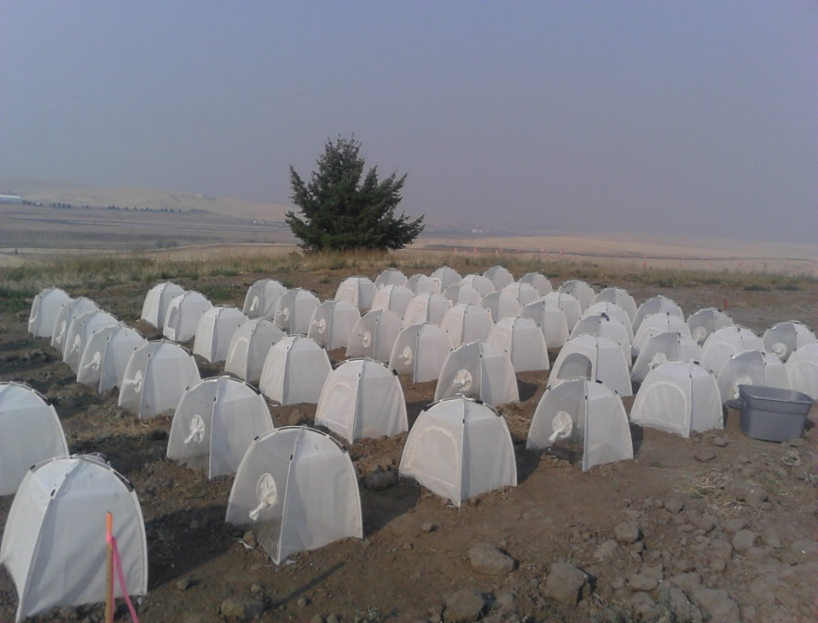

(*b*)

(*a*)

**Figure S2.** Graphical sequence of events for the field experiment. (*a*) Individual pea plants were first treated with *Acyrthosiphon pisum* and *Sitona lineatus* (electronic supplementary material, figure S1*b*) and then (*b*) these plants were placed in the centre of an 8-plant grid in field cages (one treated plant and 8 recipient plants per field cage). (*c*) Over the course of the experiment *A. pisum* individuals reproduced and (*d*) moved to surrounding plants. At the end of the experiment, the infection status and *A. pisum* abundance on each of the nine plants was recorded.



**Figure S3.** Picture of the *Acyrthosiphon pisum* feeding location experiment. Cages were applied to the top and bottom of pea plants to restrict where vectors fed. Inoculation success and viral titre were measured in response.

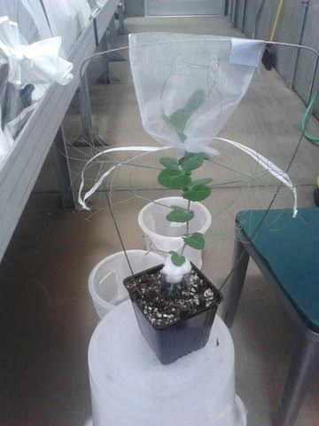

Table S1: Standardized path coefficients, significance tests, and tests of directed separation from accepted path model. Standardized coefficients (βstd) indicate relative magnitude and direction of effect. Predictors and coefficients under heading of ‘tests of directed separation' indicate dropped interactions that did not significantly contribute to path model.



Table S2: MANOVA summary table for gene expression levels of *PR1* and *OPR1*.

|  |  |  |  |  |
| --- | --- | --- | --- | --- |
| Response: *PR1* Delta CT | *F* | *df* | *P* |  |
| Location | 3.217 | 2 | 0.057 |  |
| Aphid Treatment | 10.97 | 3 | <0.001 |  |
| Location x Aphid Treatment | 2.310 | 6 | 0.066 |  |
|  |  |  |  |  |
| Response: *OPR1* Delta CT | *F* | *df* | *P* |  |
| Location | 4.452 | 2 | 0.022 |  |
| Aphid Treatment | 12.83 | 3 | <0.001 |  |
| Location x Aphid Treatment | 3.098 | 6 | 0.021 |  |
|  |  |  |  |  |
| MANOVA Summary | Pillai | *num. df* | *den. df* | *P* |
| Location | 0.552 | 4 | 48 | 0.003 |
| Aphid Treatment | 1.213 | 6 | 48 | <0.001 |
| Location x Aphid Treatment | 0.852 | 12 | 48 | 0.003 |