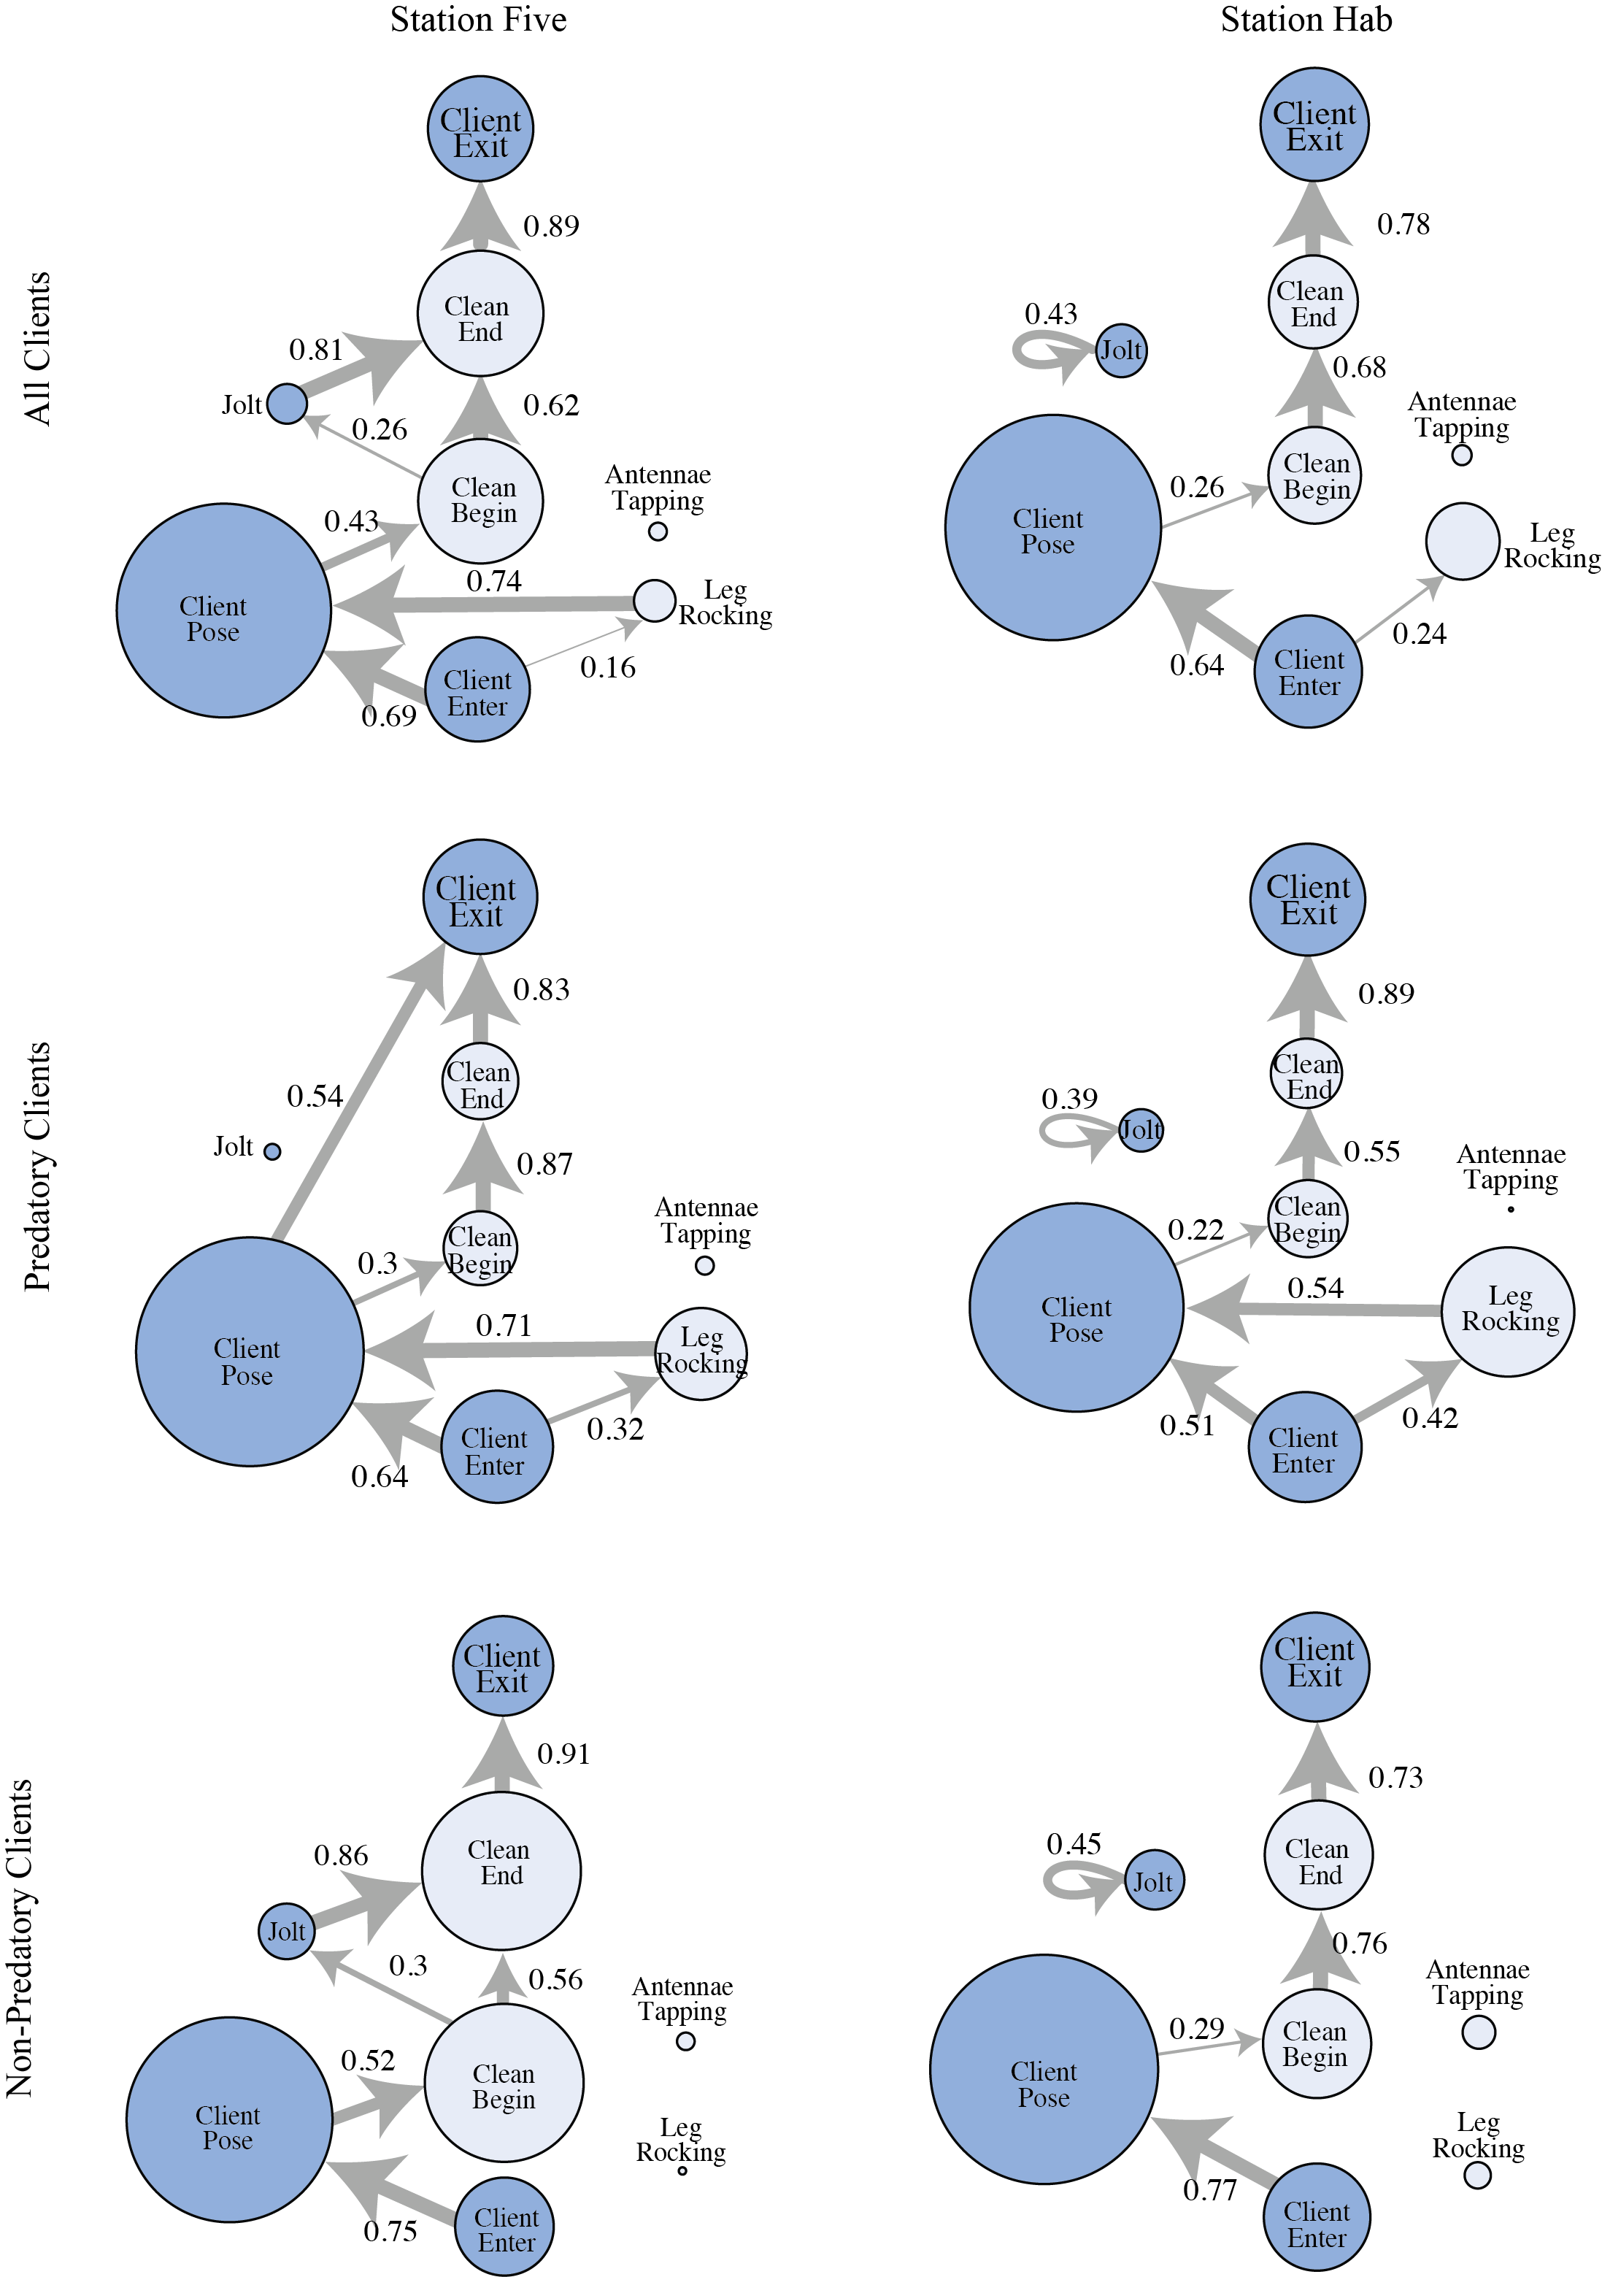
Figure S1. Behavioral networks for each cleaning station separately, Station 1 (called “Five”) at left and Station 2 (called “Hab”) at right, for all clients (top), predatory clients (middle), and non-predatory clients (bottom). Network diagrams show significant behavioural transitions across interactions between cleaner shrimp (light) and client fish (dark). Network vertices (circles) represent behaviours and are scaled to represent the number of times a behaviour was observed. Transitional probabilities—the probability of progressing to a subsequent behaviour from a given current behaviour—between each behaviour are shown by numbers and arrows; thicker edges represent more common transitions.

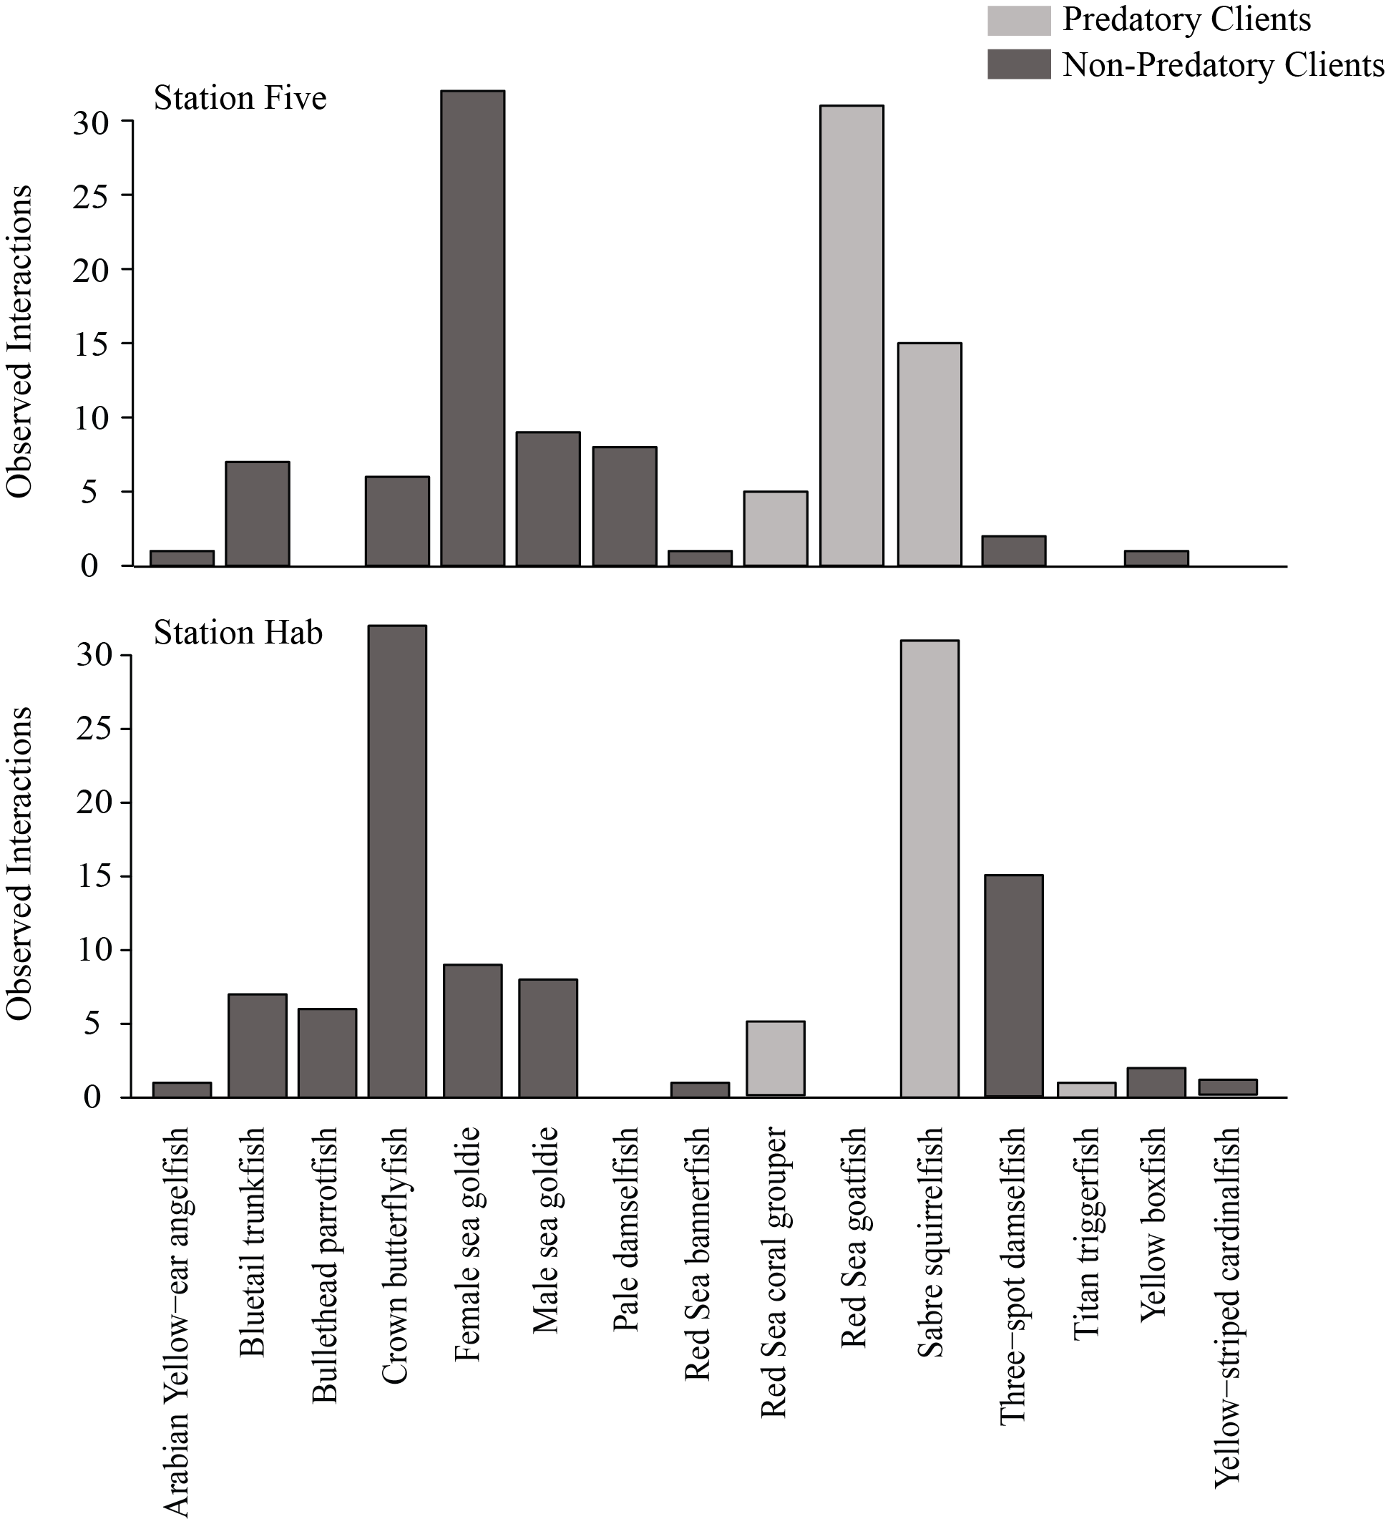

Figure S2. Histogram of number of visits per client species separated by station.

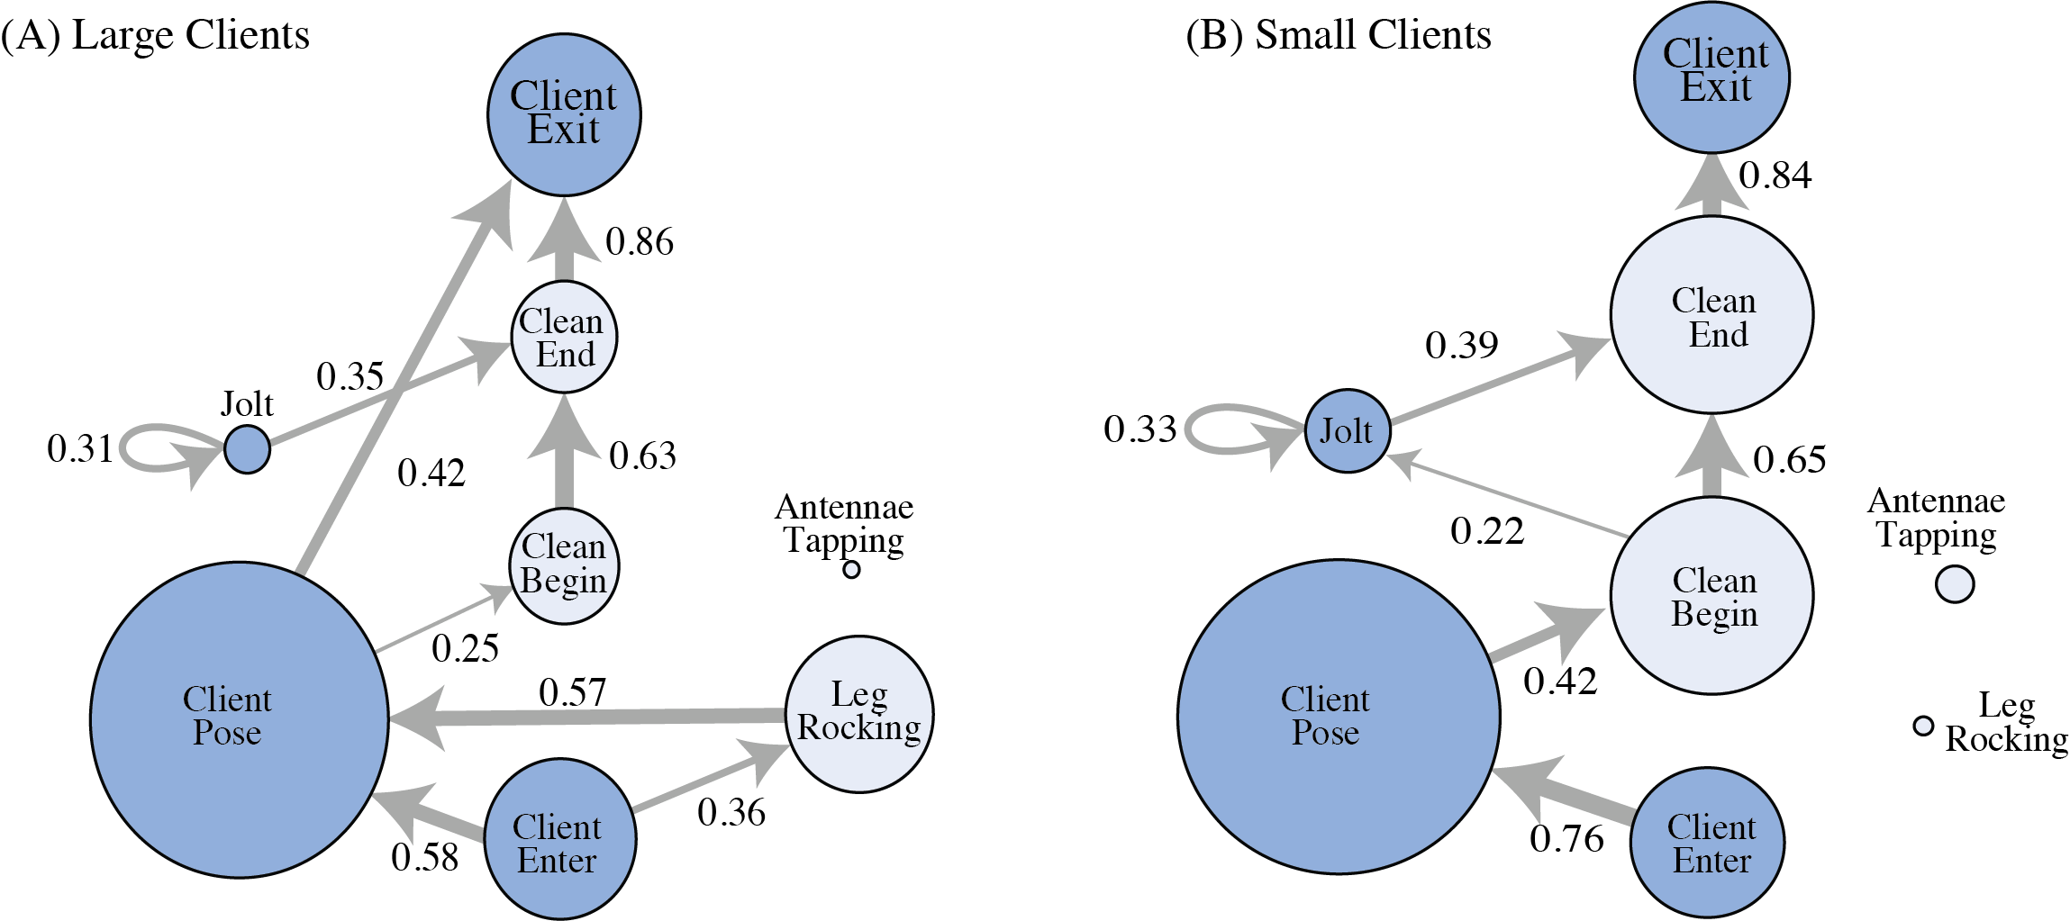
Figure S3. Network diagrams of significant behavioural transitions across interactions between cleaner shrimp (light) and client fish (dark) with large (n=7; A) and small (n=8; B) clients. Network vertices (circles) represent behaviours and are scaled to represent the number of times a behaviour was observed. Transitional probabilities—the probability of progressing to a subsequent behaviour from a given current behaviour—between each behaviour are shown by numbers and arrows; thicker edges represent more common transitions.

