Synaesthetic colour associations for Japanese Kanji characters: From the perspective of grapheme learning (Asano, Takahashi, Tsushiro, & Yokosawa)
Supplementary Materials

Table S1. The full list of the stimulus Kanji antonym pairs used in Study 1. ‘Grade’ = the school grades in which the characters are taught in Japan. Children in the first grade are 6–7 years old in Japan.
# | Antonym | Grade (paired mean) |  | Character 1 |  |  |  | Character 2
 |  |  |  | Kanji | Meaning | Grade |  | Kanji | Meaning | Grade
1 | 上下 | 1.0 |  | 上 | up | 1 |  | 下 | down | 1
2 | 右左 | 1.0 |  | 右 | right | 1 |  | 左 | left | 1
3 | 大小 | 1.0 |  | 大 | large | 1 |  | 小 | small | 1
4 | 男女 | 1.0 |  | 男 | man | 1 |  | 女 | woman | 1
5 | 天地 | 1.5 |  | 天 | heaven | 1 |  | 地 | earth | 2
6 | 朝夕 | 1.5 |  | 朝 | morning | 2 |  | 夕 | evening | 1
7 | 前後 | 2.0 |  | 前 | front | 2 |  | 後 | back | 2
8 | 東西 | 2.0 |  | 東 | east | 2 |  | 西 | west | 2
9 | 南北 | 2.0 |  | 南 | south | 2 |  | 北 | north | 2
10 | 強弱 | 2.0 |  | 強 | strong | 2 |  | 弱 | weak | 2
11 | 春秋 | 2.0 |  | 春 | spring | 2 |  | 秋 | autumn | 2
12 | 夏冬 | 2.0 |  | 夏 | summer | 2 |  | 冬 | winter | 2
13 | 昼夜 | 2.0 |  | 昼 | day | 2 |  | 夜 | night | 2
14 | 生死 | 2.0 |  | 生 | alive | 1 |  | 死 | dead | 3
15 | 丸角 | 2.0 |  | 丸 | round | 2 |  | 角 | angular | 2
16 | 売買 | 2.0 |  | 売 | sell | 2 |  | 買 | buy | 2
17 | 行来 | 2.0 |  | 行 | go | 2 |  | 来 | come | 2
18 | 明暗 | 2.5 |  | 明 | bright | 2 |  | 暗 | dark | 3
19 | 長短 | 2.5 |  | 長 | long | 2 |  | 短 | short | 3
20 | 楽苦 | 2.5 |  | 楽 | easy, comfortable | 2 |  | 苦 | hard | 3
21 | 教習 | 2.5 |  | 教 | teach | 2 |  | 習 | learn | 3
22 | 高低 | 3.0 |  | 高 | high | 2 |  | 低 | low | 4
23 | 深浅 | 3.5 |  | 深 | deep | 3 |  | 浅 | shallow | 4
24 | 喜悲 | 3.5 |  | 喜 | happy | 4 |  | 悲 | sad | 3

Table S1 (continued)
# | Antonym | Grade (paired mean) |  | Character 1 |  |  |  | Character 2
 |  |  |  | Kanji | Meaning | Grade |  | Kanji | Meaning | Grade
25 | 新旧 | 3.5 |  | 新 | new | 2 |  | 旧 | old | 5
26 | 有無 | 3.5 |  | 有 | present | 3 |  | 無 | absent | 4
27 | 公私 | 4.0 |  | 公 | public | 2 |  | 私 | private | 6
28 | 官民 | 4.0 |  | 官 | government | 4 |  | 民 | nongovernment, private | 4
29 | 得損 | 4.5 |  | 得 | gain | 4 |  | 損 | loss | 5
30 | 善悪 | 4.5 |  | 善 | virtuous | 6 |  | 悪 | evil | 3
31 | 貸借 | 4.5 |  | 貸 | lend | 5 |  | 借 | borrow | 4
32 | 富貧 | 5.0 |  | 富 | rich | 5 |  | 貧 | poor | 5
33 | 老若 | 5.0 |  | 老 | elderly | 4 |  | 若 | young | 6
34 | 送迎 | 5.0 |  | 送 | see off | 3 |  | 迎 | go out to meet | 7
35 | 攻守 | 5.0 |  | 攻 | offence | 7 |  | 守 | defence | 3
36 | 愛憎 | 5.5 |  | 愛 | love | 4 |  | 憎 | hatred | 7

Table S2. The full list of sound similarity, visual similarity, and concreteness ratings of the stimulus Kanji antonym pairs used in Study 1.
The sound similarity is the similarity between the first syllables of the most typical reading of each of the paired characters. A Kanji character may have multiple readings, and in fact all of the stimulus characters had multiple readings. For example, the character 上 can be read ue, joh, kami, age[-ru] ([-ru] is one of a set of suffixes called okurigana), uwa, aga[-ru], and gami. Therefore, we identified the most typical reading of each character based on the Japanese vocabulary database ‘‘Nihongo-no Goi Tokusei’’ (Amano & Kondo, 1999) and used it for the first syllable of each character for the calculation of sound similarity.
The visual similarity is the subjective similarity between the paired characters as rated by six Japanese-speaking adults. We presented participants of the rating experiment the 36 stimulus character pairs, each presented twice (switching the left-right location on each repetition). The characters were displayed in MS Gothic font, which is the font we used to present the stimulus characters in the main experiment of Study 1. Participants were asked to rate the subjective similarity of the two characters on a five-point scale ranging from 1 (dissimilar) to 5 (similar). The rating scores were averaged over repetitions and participants.
The concreteness is the paired mean of the percentage of participants who answered ‘yes’ to the question ‘Does this Kanji character elicit an image of concrete objects or events?’ in the study by Kitao and his colleagues (Kitao, Hatta, Ishida, Babazono, & Kondo, 1977). Of the 72 characters, 5 (each one character from 5 pairs out of all 36 pairs) were not in the concreteness database. The correlation between the concreteness of paired characters based on the remaining 31 pairs was r = .62, indicating that paired characters had similar concreteness. Therefore, for the five pairs with missing data, we treated the concreteness score of the character that could be found in the database as the “paired mean” concreteness score for that pair. ‘Char.’ = Character, ‘Sim.’ = Similarity, ‘Concrete.’ = Concreteness.

# | Antonym  (Char.  1, 2) | Sound similarity |  |  | Visual  sim. | Concreteness
 |  | Most typical reading |  | Sim. |  | Char.  1 | Char.  2 | Concrete. (paired mean)
 |  | Char. 1 | Char. 2
1 | 上下 | u.e | shi.ta | 0 | 4.00 | 67 | 71 | 69.0
2 | 右左 | mi.gi | hi.da.ri | 1 | 4.75 | 55 | 45 | 50.0
3 | 大小 | o.o.[ki.i] | sho.u | 1 | 3.00 | 63 | 63 | 63.0
4 | 男女 | o.to.ko | o.n.na | 2 | 1.92 | 88 | 87 | 87.5
5 | 天地 | te.n | ti (chi) | 1 | 1.33 | 80 | 73 | 76.5
6 | 朝夕 | a.sa | yu.u | 0 | 1.33 | 78 | 68 | 73.0
7 | 前後 | ma.e | a.to | 1 | 1.42 | 47 | 35 | 41.0
8 | 東西 | hi.ga.shi | ni.shi | 1 | 2.08 | 56 | 50 | 53.0
9 | 南北 | mi.na.mi | ki.ta | 1 | 1.33 | 50 | 56 | 53.0
10 | 強弱 | kyo.u | yo.wa.[i] | 1 | 3.92 | 54 | 56 | 55.0
11 | 春秋 | ha.ru | a.ki | 1 | 1.42 | 65 | 85 | 75.0
12 | 夏冬 | na.tsu | fu.yu | 0 | 2.58 | 80 | 81 | 80.5
13 | 昼夜 | hi.ru | yo.ru | 0 | 1.75 | 77 | 77 | 77.0
14 | 生死 | na.ma | shi | 0 | 1.33 | 55 | 74 | 64.5
15 | 丸角 | ma.ru | ka.ku | 1 | 1.75 | - | 88 | 88.0
16 | 売買 | ba.i | ka.[u] | 1 | 2.00 | 60 | 57 | 58.5
17 | 行来 | o.ko.na.[u] | ra.i | 0 | 1.17 | 61 | 45 | 53.0
18 | 明暗 | me.i | a.n | 0 | 4.08 | 81 | 71 | 76.0
19 | 長短 | na.ga.[i] | mi.ji.ka.[i] | 0 | 1.25 | 64 | 47 | 55.5
20 | 楽苦 | ta.no.[shi.i] | ni.ga | 0 | 2.25 | 54 | 65 | 59.5
21 | 教習 | kyo.u | shu.u | 0 | 1.25 | 70 | 44 | 57.0
22 | 高低 | ta.ka.[i] | te.i | 1 | 1.25 | 75 | 52 | 63.5

Table S2 (continued)
# | Antonym  (Char.  1, 2) | Sound similarity |  |  | Visual sim. | Concreteness
 |  | Most typical reading |  | Sim. |  | Char. 1 | Char.  2 | Concrete. (paired mean)
 |  | Char. 1 | Char. 2
23 | 深浅 | shi.n/fu.ka.[i] | a.sa.[i] | 0 | 3.17 | 64 | 67 | 65.5
24 | 喜悲 | yo.ro.ko.[bu] | ka.na.[shi.i] | 0 | 2.50 | 61 | 73 | 67.0
25 | 新旧 | shi.n | kyu.u | 0 | 1.33 | 40 | 36 | 38.0
26 | 有無 | yu.u | mu | 1 | 1.42 | 31 | 44 | 37.5
27 | 公私 | ko.u | wa.ta.shi | 0 | 2.92 | 30 | 58 | 44.0
28 | 官民 | ka.n | mi.n | 0 | 2.42 | 62 | 71 | 66.5
29 | 得損 | to.ku | so.n | 1 | 3.42 | 40 | 49 | 44.5
30 | 善悪 | ze.n | a.ku | 0 | 2.83 | 37 | 55 | 46.0
31 | 貸借 | ka.[su] | ka.[ri.ru] | 2 | 2.58 | 49 | 39 | 44.0
32 | 富貧 | to.mi/fu | ma.zu.[shi.i] | 0 | 2.17 | 67 | 67 | 67.0
33 | 老若 | ro.u | wa.ka.[i] | 0 | 3.50 | 75 | - | 75.0
34 | 送迎 | o.ku.[ru] | mu.ka.[e.ru] | 0 | 4.25 | 52 | - | 52.0
35 | 攻守 | ko.u | ma.mo.[ru] | 0 | 1.33 | - | 61 | 61.0
36 | 愛憎 | a.i | ni.ku.[i] | 0 | 1.33 | 46 | - | 46.0

Table S3. The full list of the stimulus Kanji characters used in Study 2. In (a)~(d), ‘Familiarity’ is the subjective familiarity rating, and ‘visual complexity’ is the subjective visual complexity, both in the Japanese language (based on the Japanese vocabulary database ‘‘Nihongo-no Goi Tokusei’’, Amano & Kondo, 1999) and both on a scale that ranged from 1 to 7 (where higher values mean higher familiarity/visual complexity).

- Test stimulus character for sound learning task block. For each synaesthete, a different set of six test stimulus characters was selected from the 40 characters in this list (see main text for details).
# | Kanji | Japanese sound | Chinese sound | Familiarity | Visual complexity
1 | 亜 | a | yà | 5.96 | 3.17
2 | 胃 | i | wèi | 6.25 | 3.58
3 | 井 | i | jǐng | 6.42 | 2.50
4 | 委 | i | wěi | 5.83 | 3.71
5 | 宇 | u | yǔ | 5.96 | 3.21
6 | 迂 | u | yū | 4.50 | 3.62
7 | 卯 | u | mǎo | 4.87 | 3.67
8 | 絵 | e | huì | 6.46 | 3.83
9 | 佳 | ka | jiā | 5.42 | 3.67
10 | 架 | ka | jià | 5.42 | 3.83
11 | 呵 | ka | hē | 3.79 | 3.79
12 | 貨 | ka | huò | 5.87 | 3.75
13 | 基 | ki | jī | 6.08 | 3.96
14 | 希 | ki | xī | 6.12 | 3.62
15 | 忌 | ki | jì | 5.46 | 3.75
16 | 季 | ki | jì | 6.42 | 3.71
17 | 几 | ki | jǐ | 4.17 | 2.42
18 | 杞 | ki | qǐ | 3.83 | 3.88
19 | 句 | ku | jù | 5.58 | 3.12
20 | 区 | ku | qū | 6.54 | 2.83
21 | 庫 | ko | kù | 5.96 | 3.75
22 | 差 | sa | chā | 6.29 | 3.71
23 | 査 | sa | chá | 5.87 | 3.54
24 | 詐 | sa | zhà | 5.04 | 3.88
25 | 祖 | so | zǔ | 5.79 | 3.71

Table S3(a) (continued)
# | Kanji | Japanese sound | Chinese sound | Familiarity | Visual complexity
26 | 租 | so | zū | 5.33 | 3.75
27 | 地 | chi | dì | 6.50 | 3.54
28 | 奈 | na | nài | 6.25 | 3.54
29 | 乃 | no | nǎi | 5.42 | 2.96
30 | 把 | ha | bǎ | 5.29 | 3.67
31 | 非 | hi | fēi | 6.12 | 3.25
32 | 否 | hi | fǒu | 5.79 | 3.33
33 | 卑 | hi | bēi | 5.21 | 3.88
34 | 批 | hi | pī | 5.37 | 3.96
35 | 比 | hi | bǐ | 6.21 | 3.08
36 | 普 | fu | pǔ | 6.04 | 3.67
37 | 屁 | he | pì | 4.79 | 3.75
38 | 未 | mi | wèi | 6.21 | 2.83
39 | 呂 | ro | lǚ | 5.42 | 3.00
40 | 炉 | ro | lú | 5.04 | 3.88

- Control stimulus character for sound learning task block. Note that the Chinese sounds of these characters were not taught in the experiment.
# | Kanji | Japanese sound | Chinese sound | Familiarity | Visual complexity
1 | 可 | ka | kè | 6.50 | 2.88
2 | 規 | ki | guī | 5.92 | 3.79
3 | 個 | ko | méi | 6.33 | 3.71
4 | 佐 | chi | zuǒ | 6.29 | 3.50
5 | 智 | sa | zhì | 6.33 | 3.96
6 | 斗 | to | dǒu | 5.29 | 2.96

Table S3 (continued)

- Test stimulus character for meaning learning task block.
# | Kanji | Japanese meaning | Chinese meaning | Familiarity | Visual complexity
1 | 机 | table | machine | 6.12 | 3.46
2 | 床 | floor | bed | 5.96 | 3.33
3 | 坊 | monk | town | 5.67 | 3.58
4 | 放 | to release | to place | 6.12 | 3.71
5 | 念 | to wish | to read aloud | 5.96 | 3.75
6 | 聞 | to hear | to smell | 6.46 | 3.96

- Control stimulus character for meaning learning task block. Note that the Chinese meanings of these characters were not taught in the experiment.
# | Kanji | Japanese meaning | Chinese meaning | Familiarity | Visual complexity
1 | 花 | flower | to spend | 6.46 | 3.29
2 | 泡 | foam | blister | 5.58 | 3.79
3 | 牙 | fang | tooth | 5.12 | 3.25
4 | 云 | to say | cloud | 5.42 | 2.79
5 | 配 | to deliver | to match | 6.00 | 3.92
6 | 割 | to break | to cut | 5.96 | 3.92

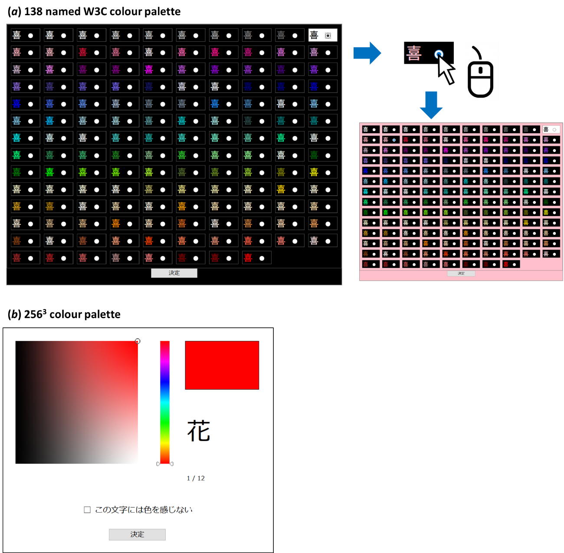

Figure S1. Screenshots of (a) the 138 named W3C colour palette used in Study 1 and (b) the 256³ colour palette used in Study 1. In (a), the stimulus character (in this illustration, the Kanji character 喜) was displayed in each of the 138 colours. The background colour was set to black as the default. Upon clicking on one of the colours, the background changed to that colour so that the participant could view the selected colour in a larger area. Colour locations were fixed across trials, and characters were displayed in MS Gothic font in both (a) and (b).

Supplementary Results of the main experiment of Study 2
- Pre-post learning colour consistency
The left panels of Figure S2(a) and (b) illustrate the mean colour distances in the CIE L*a*b* colour space between the pre- and post-learning sessions in the sound leaning task and the meaning leaning task, respectively.

- Pre-post learning luminance and saturation consistency
Some previous studies reported that synaesthetic colours for frequently occurring graphemes tend to be brighter and/or more saturated (Beeli, Esslen, & Jäncke, 2007; Watson, Akins, & Enns, 2012). Based on this, it is possible that the greater synaesthetic colour change of test stimuli between pre- and post- learning sessions, compared to that of the control stimuli, was caused by the increased exposure to the test stimuli during the learning session. To test this possibility, we converted the colour coordinates in the CIE L*a*b* system to coordinates in the CIE L*C*h system in order to obtain luminance and saturation values and analysed the changes in luminance (L*) and saturation (C*) between pre- and post-learning sessions.
The middle panels of Figure S1(a) and (b) illustrate the mean luminance (L*) distances in the CIE L*C*h colour system between the pre- and post-learning sessions in the sound leaning task and the meaning leaning task, respectively. A three-way ANOVA with participant group (synaesthetes/non-synaesthetes), task (sound learning/meaning learning), and stimulus type (test/control) as factors revealed that there was no significant change in luminance (main effect of the participant group: F(1, 20) = 0.06, p = .81, eta-squared = 0.00; main effect of the task: F(1, 20) = 0.08, p = .78, eta-squared = 0.00; main effect of the stimulus type: F(1, 20) = 1.34, p = .26, eta-squared = 0.06, interaction between the group and task: F(1, 20) = 0.00, p = .99, eta-squared = 0.00; interaction between the group and stimulus type: F(1, 20) = 0.03, p = .86, eta-squared = 0.00; the three-way interaction: F(1, 20) = 0.00, p = .98, eta-squared = 0.00).
The right panels of Figure S1(a) and (b) illustrate the mean saturation (C*) distances between the pre- and post-learning sessions in the sound leaning task and the meaning leaning task, respectively. A three-way ANOVA with participant group, task, and stimulus type as factors revealed that there was no significant change in saturation (main effect of the participant group: F(1, 20) = 0.19, p = .67, eta-squared = 0.01; main effect of the task: F(1, 20) = 0.32, p = .58, eta-squared = 0.02; main effect of the stimulus type: F(1, 20) = 0.39, p = .54, eta-squared = 0.02, interaction between the group and task: F(1, 20) = 0.00, p = .98, eta-squared = 0.00; interaction between the group and stimulus type: F(1, 20) = 0.44, p = .51, eta-squared = 0.02; the three-way interaction: F(1, 20) = 0.33, p = .57, eta-squared = 0.02).
As shown above, there was no significant change in luminance and saturation, suggesting that the modulation was not merely due to the increased exposure to the test stimuli

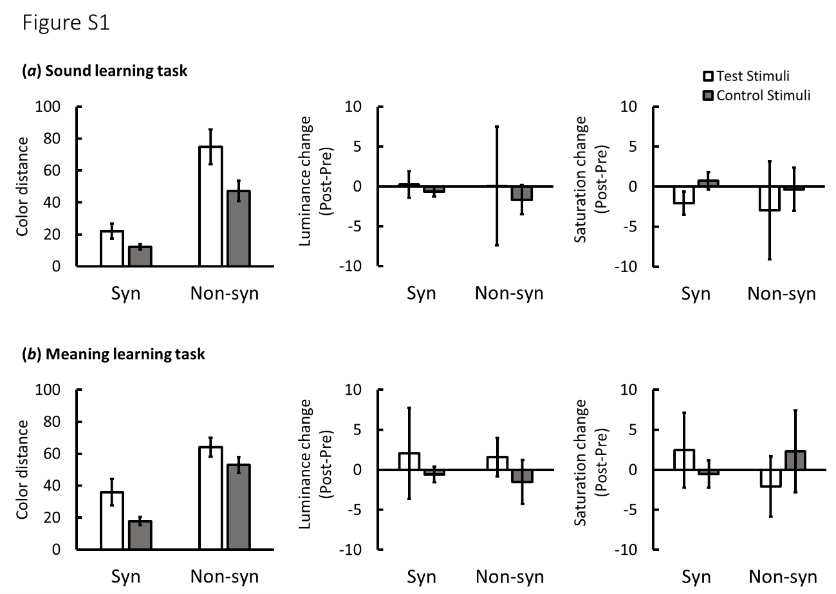

Figure S2. Results for the separate analysis for sound and meaning leaning tasks. (a) sound learning task. (b) meaning learning task. In both panels, left: pre-post leaning colour consistency, middle: pre-post learning luminance consistency, right: pre-post saturation consistency. Error bars represent standard errors.

Supplementary Data
Please see ‘Study1_rawdata.xlsx’ and ‘Study2_rawdata.xlsx’ for the raw data and the CIE L*a*b* colour coordinates of colours associated with stimulus graphemes in Study 1 and 2, respectively.

