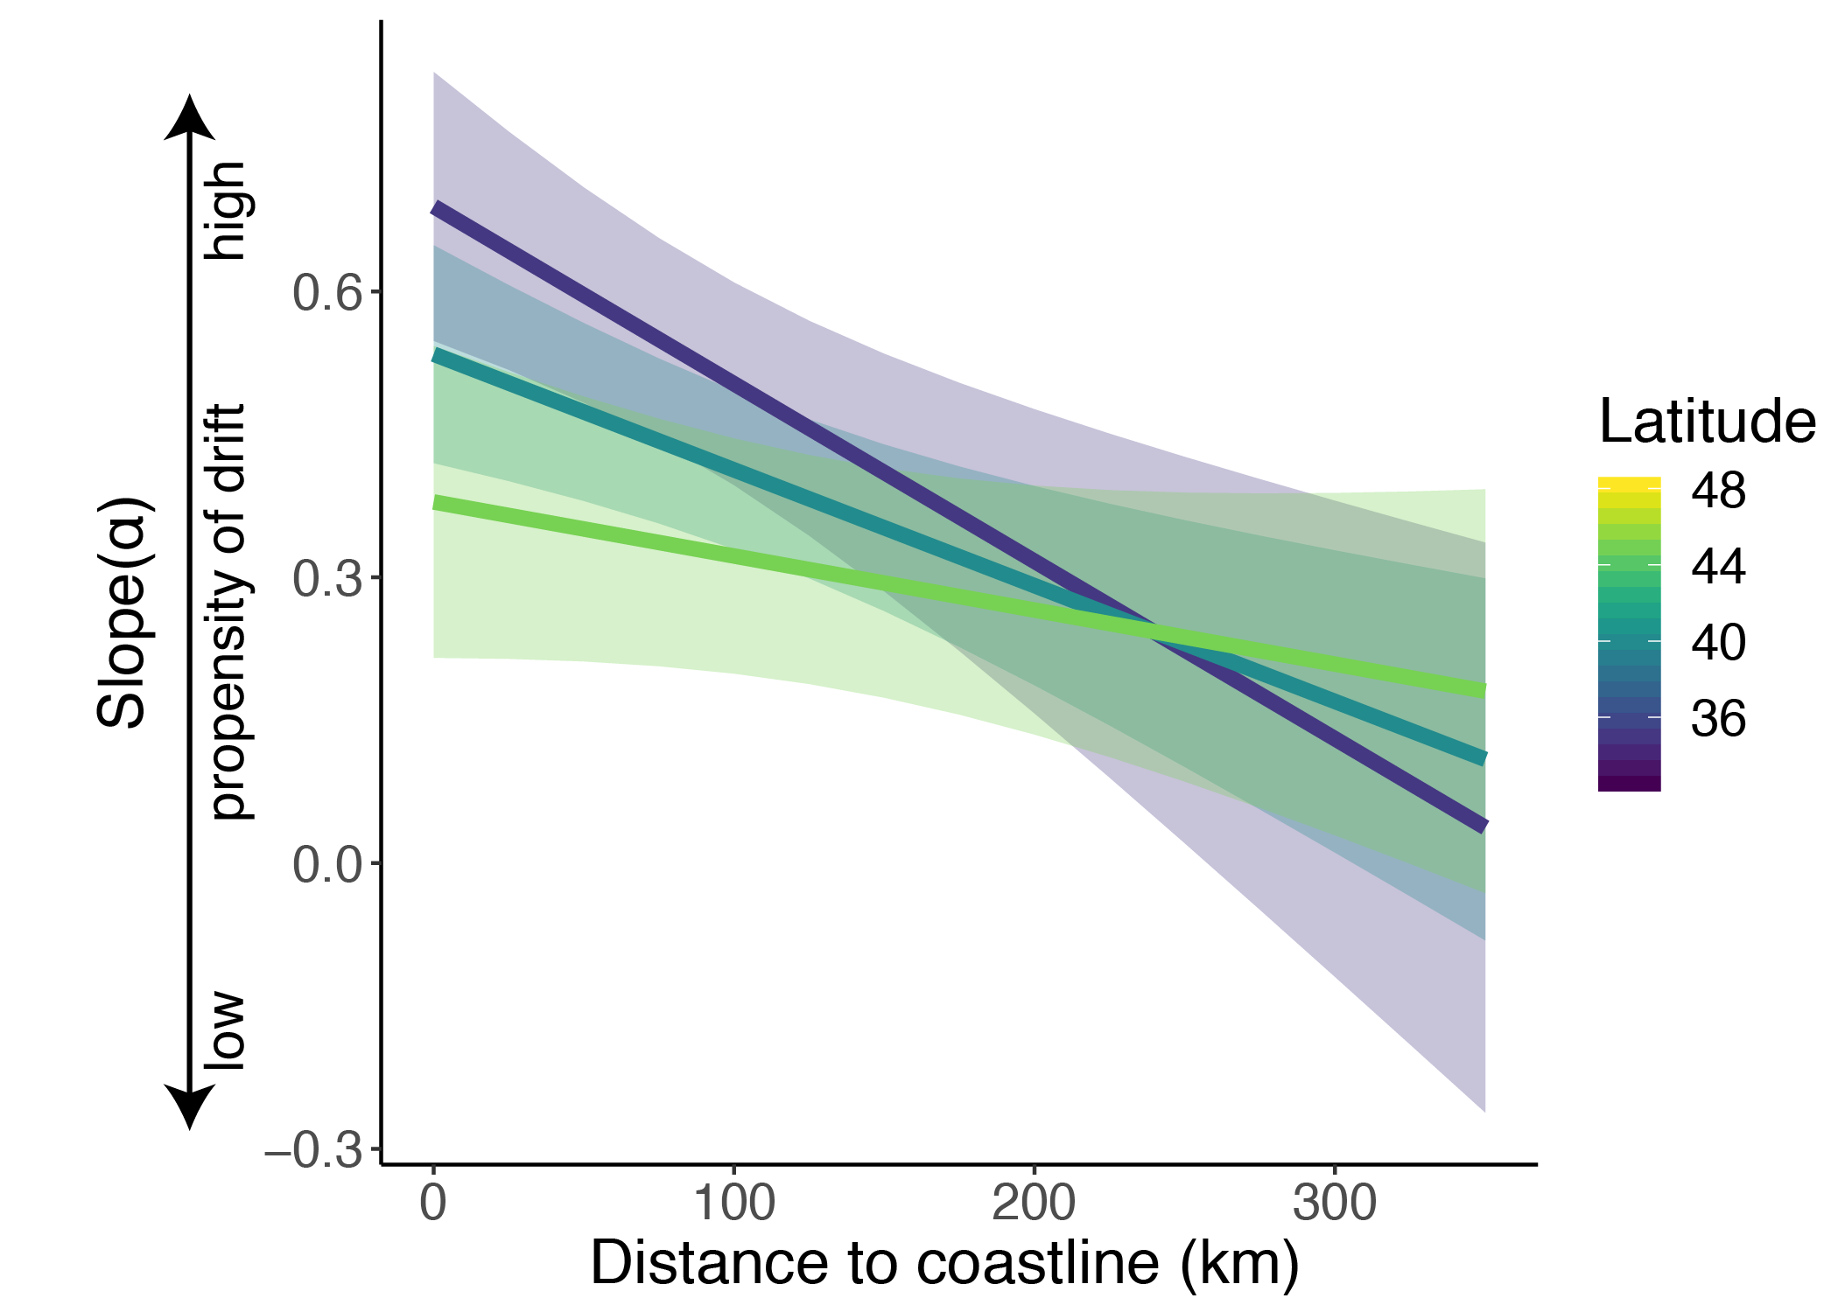

Figure S1: Wind drift propensity across distance to coastline and latitude at 19 weather surveillance radar stations during spring migration (1995-2018). Slope of α represents drift propensity; 0 is complete compensation for wind, 1 is complete drift with wind. Predictions of propensity of drift are shown from 0 to 325 km distance to coastline at 35°N, 40°N, and 45°N. The fitted lines and 95% confidence bands are from a least squares linear model with an interaction between latitude and distance to coastline.

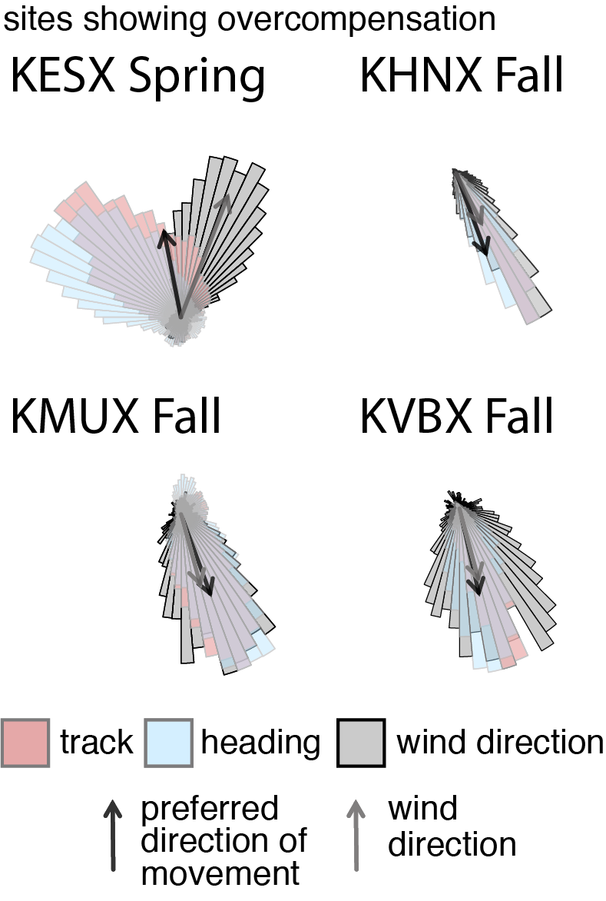
Figure S2: Four sites showing overcompensation, a rare flight behavior. Spring (March 1st to June 15th, a-b) and fall (August 1st to November 15th, c-d) distributions of migrant track (pink), heading (blue), and wind direction (gray) at weather surveillance radar (WSR) stations summarized from 1995 to 2018 between sunset and sunrise. Black arrows denote preferred direction of movement and the gray arrows the average wind direction. PDM arrows’ lengths are scaled to average migrant groundspeed and wind arrows’ lengths are scaled to the average wind speed. Note, all distributions are scaled to the same size and number of observations but exhibit differing maxima. Rose diagrams are summarized in 5° sectors.

