Supplements:
n | 76 | 75 | 40 | 183 | 77 | 65 | 67 | 76 | 39 | 74 | 113 | 107 | 79 | 69
% | 58 | 48 | 53 | 83 | 88 | 91 | 66 | 68 | 62 | 84 | 53 | 52 | 54 | 68

Fig.S1 Periods of locomotor activity under permanent darkness or UV light 365nm. Mean with SEM are figured, Tukey’s multiple comparisons test used, all significant differences are given. P<0.05 (*), P<0.01 (**), P<0.001 (***), P<0.0001 (****). n – number of tested individuals, % - percentage of rhythmic individuals

n | 76 | 75 | 35 | 37 | 34 | 38 | 38 | 80
% | 58 | 48 | 77 | 54 | 76 | 50 | 55 | 41

Fig.S2 Periods of locomotor activity under permanent darkness (same as in Fig. 1) and green light 505nm. The light lengthens the period proportionally to its intensity. Static MF shortens the period (significant in middle light intensity only). Mean with SEM are figured, Tukey’s multiple comparisons test used, all significant differences are given. P<0.05 (*), P<0.01 (**), P<0.001 (***), P<0.0001 (****). n – number of tested individuals, % - percentage of rhythmic individuals

Supplemental Materials and Methods:

Testing scheme: For each experiment 40 German cockroaches (Blattella germanica) adults were immobilized using CO₂ and irrespective of sex individually transferred into 5 cm diameter glass Petri dishes. Bottom of dishes was covered by transparent 1% agarose gel enriched with D-glucose monohydrate (20g/l), liquid Nipagin M (8,5ml/l) and reagent grade L-ascorbic acid (1g/l) serving as a source of food and water. All 40 dishes with opaque white walls were placed on a glass pane on a nonmagnetic table 100cm above DMK 31AU03 (Imaging Source GmbH) CCD camera and covered by a sheet of filter paper dispersing light coming from the LED light source 80cm above the testing area. Entire testing setup was localized within the electromagnetically shielded chamber (Fig. S3). Starting on next morning at 6:00 silhouettes of cockroaches were captured by camera located underneath every 5 minutes for 14 consecutive days using control software IC Capture, AS 2.2 (Imaging Source GmbH). Steady thermal (23.8°C ± 0.6°C), light, and magnetic conditions were checked prior to and after each experiment.
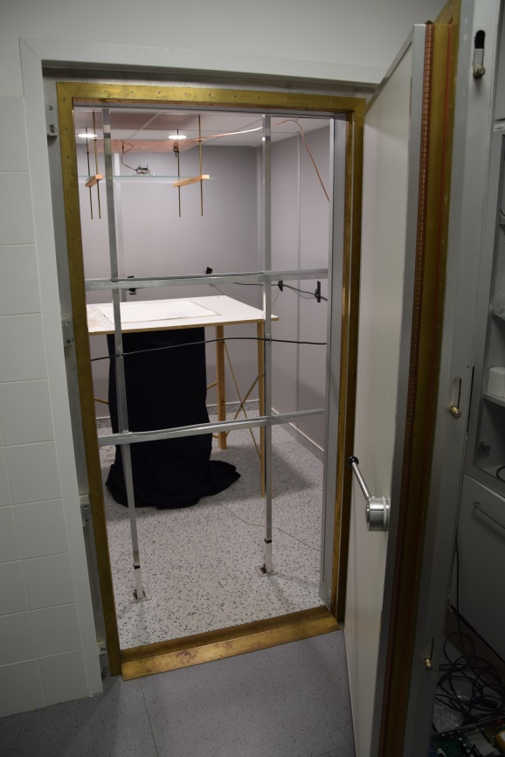
Fig. S3 Electromagnetically shielded chamber. Note 3D Merritt coil generating MFs, loop antenna generating RFs along the walls, wooden table with camera below hidden by black cloth, LED source of light above.

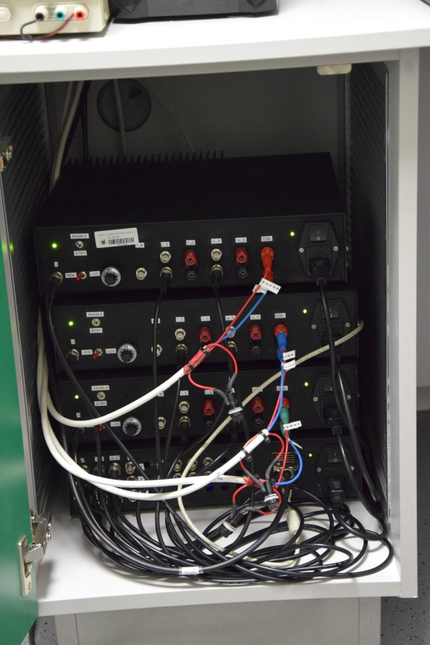

Fig. S4 Computer-controlled power supplies.

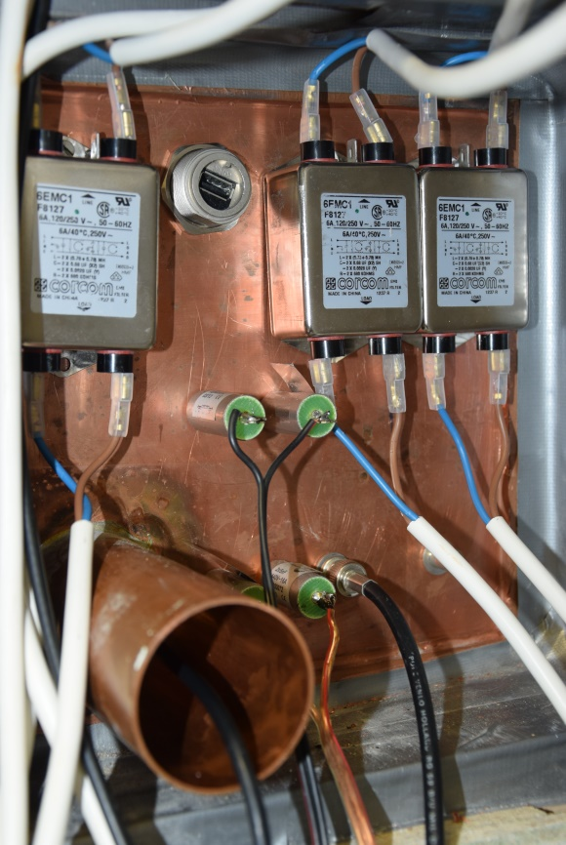

Fig. S5 Filter and communication box of the shielded chamber. Inputs feeding Merritt coils and lamps are filtered. Coaxial cable from the camera goes through the communication pipe.

Light Conditions: Two intensities of UV light (365nm) and three intensities of green light (505nm) and darkness represent 6 constant luminous testing conditions double-checked prior to and after the experiment using radiometer (International Light IL700, SHD 033 probe). For light measurements, the same light dispersing filter paper and dish put onto the probe was used as for experiments. UV-A LED 365nm (Nichia NCSU033A) illumination 1.7x10⁻⁶ Wcm⁻² varied from maximum in the center to minimum at the periphery by 0,07x10⁻⁶ Wcm⁻² and brighter illumination 6x10⁻⁶ Wcm⁻² varied from maximum in the center to minimum at the periphery by 0,66x10⁻⁶ Wcm⁻². Green LED 505nm (SELV CK7P) illumination 1.3x10⁻⁶ Wcm⁻² varied from maximum in the center to minimum at the periphery by 0,22x10⁻⁶ Wcm⁻², 4.5x10⁻⁶ Wcm⁻² by 0,97x10⁻⁶ Wcm⁻² and 1.3x10⁻⁵ Wcm⁻² by 0,25x10⁻⁵ Wcm⁻². LED spectra distributions were measured by USB 2000 spectrometer (Ocean Optics, NL) (Fig. S6).
Fig.S6 Light emission spectra from UV (365nm) and green (505nm) LED light sources.

Magnetic Conditions: Three static magnetic field (MF) intensities were set inside the electromagnetically shielded chamber (constructed by MR Schutztechnik GmbH): total vector 0.5μT ± 0.4μT (near-zero field,), total vectors 50μT (space deviation ±0.5μT) and 120μT (space deviation ±0.5μT) and inclinations 45° (measured by FGM3D/100 magnetic field sensor; SenSys). MFs were generated by 3D Merritt coils (2.5 x 2.5 x 2.5m) located inside the chamber (Fig. S3) and fed by custom made, computer-controlled power supplies (Fig. S4) operating on D/A interface (National Instruments). Coil feeding unit was located outside the chamber and connected to Merritt coils through filters (Fig. S5).

RF Conditions: Four experimental intensities (0nT, 1nT, 22nT and 420nT) of the radio-frequency noise generated by Programmable Direct Digital Synthesizer 4085 (B&K Precision Corp.) were used. RF signal was generated by a loop antenna constructed as a single horizontal winding of coaxial cable around the walls of the chamber in the plane of the testing table (i.e. square 2.3m x 2.3m). A 2cm piece of the screening was removed in the center of the loop. Spectrum analyzer (FSC3, 9 kHz–3 GHz, Rohde and Schwartz) and calibrated 6511 ETS Lindgren passive antenna was used for magnetic component of radiofrequency noise measurements (Fig. S7). Active antenna Schwarzbeck EFS 9218 was used for electric component of radiofrequency noise measurements (Fig. S8).
Fig.S7 Magnetic inductions (flux density - H) of four experimental fields. Total inductions are summed over all the frequencies in the spectra (calculated according to Schwarze et al., 2016). A range between 100 kHz and 10 MHz was measured. Spectrum on lab bench outside the shielded chamber is given for comparison. Spectrum analyzer R&S FSC3 was set for 10 min of max-hold intensity measurement with a resolution bandwidth of 10 kHz.

Fig.S8 Electric fields (intensity - E) of four experimental fields (corresponding to Fig. S7). A range between 100 kHz and 10 MHz was measured. Spectrum on lab bench outside the shielded chamber is given for comparison. Spectrum analyzer R&S FSC3 was set for 10 min of max-hold intensity measurement with a resolution bandwidth of 10 kHz.

Evaluation and Statistics: Sets of 4032 frames were automatically analyzed by Matlab based custom-made image analysis software RoachLab (Paučula). For motoric activity detection, the number of body shifts > 1cm was calculated resulting in a binary record of moves for each animal. The binary text file was visualized and analyzed using plugin ActoJ (Schmid et al., 2011) of ImageJ software (1.49v; NIH). Based on Refinetti et al. (2007) actogram setup was set to Lomb-Scargle analysis method with period range 980-2220 minutes, one peak, no smoothing Gaussian standard deviation, step size equal to one sample, p-level of 0.05, 288 samples per period and 5 minutes interval duration. Only samples with a statistical significance value PN > 20 were scored as rhythmic and respective period recorded. Then individual periods under same conditions were grouped and groups plotted and statistically compared by ANOVA and post-hoc Tukey’s multiple comparisons test (GraphPad Prism 7.04). Complete list of primary data is available online at: https://is.muni.cz/auth/www/vacha/supplementary_materials_blatella_rhythms/Blatella_rhythms_primary_data.xls)

Supplemental Reference:
Roberto Refinetti, Germaine Cornélissen & Franz Halberg (2007) Procedures for numerical analysis of circadian rhythms, Biological Rhythm Research, 38:4, 275-325.
Benjamin Schmid, Charlotte Helfrich-Forster & Taishi Yoshii (2011) A new ImageJ plug-in “ActogramJ” for chronobiological analyses. Journal of Biological Rhythms, 26: 464–467.

