The following supplement accompanies the article
Stable isotope analyses reveal unique trophic role of reef manta rays (Mobula alfredi) at a remote coral reef
Lauren R Peel*, Ryan Daly, Clare A Keating Daly, Guy MW Stevens, Shaun P Collin, Mark G Meekan
*Corresponding author: lauren.peel@research.uwa.edu.au

Table S1 Summary of reef fishes sampled at D’Arros Island and St. Joseph Atoll, Seychelles, for stable isotope analysis. Estimated trophic level (TL; www.fishbase.org, 29/10/2018) and fork length given as mean ± standard error.
Trophic Guild | Species Name | n | Est. TL | Fork Length (cm) | Capture Method (# Samples)
Herbivore | Chlorurus sordidus | 10 | 2.62 ± 0.29 | 20.82 ± 3.89 | Spearpole (10)
 | Scarus rubroviolaceus | 9 | 2.00 ± 0.00 | 31.14 ± 5.36 | Spearpole (9)
Detritivore | Crenimugil crenilabis | 10 | 2.29 ± 0.14 | 12.90 ± 6.62 | Thrownet (10)
Planktivore | Caesio teres | 10 | 3.40 ± 0.45 | 27.27 ± 1.84 | Spearpole (10)
 | Caesio xanthonota | 10 | 3.40 ± 0.45 | 26.12 ± 2.10 | Spearpole (10)
 | Pterocaesio tile | 1 | 3.33 ± 0.33 | 18 | Spearpole (1)
Corallivore | Chaetodon trifasciatus | 10 | 3.34 ± 0.61 | 9.67 ± 1.12 | Spearpole (10)
Invertivore | Lethrinus enigmaticus | 7 | 3.83 ± 0.58 | 36.31 ± 2.20 | Spearpole (1); Hook and Line (6)
 | Lethrinus lentjan | 10 | 3.94 ± 0.25 | 32.12 ± 7.01 | Spearpole (6); Hook and Line (4)
 | Lethrinus nebulosus | 10 | 3.76 ± 0.19 | 52.41 ± 8.81 | Hook and Line (10)
 | Parupeneus macronemus | 10 | 3.50 ± 0.37 | 15.62 ± 3.00 | Spearpole (10)
Reef Carnivore | Cephalopholis sonnerati | 2 | 3.81 ± 0.60 | 35.25 ± 5.87 | Hook and Line (2)
 | Variola louti | 10 | 4.33 ± 0.70 | 50.14 ± 4.90 | Spearpole (1); Hook and Line (9)
Reef Piscivore | Aethaloperca rogaa | 8 | 4.20 ± 0.71 | 31.95 ± 7.02 | Spearpole (8)
 | Cephalopholis miniata | 1 | 4.29 ± 0.51 | 25.5 | Spearpole (1)
 | Lutjanus bohar | 10 | 4.27 ± 0.50 | 36.84 ± 10.93 | Spearpole (4); Hook and Line (6)
Reef & Pelagic Carnivore | Selar crumenophthalmus | 10 | 3.81 ± 0.18 | 26.83 ± 1.45 | Hook and Line (10)
Pelagic Piscivore | Katsuwonus pelamis | 5 | 4.43 ± 0.47 | 48.80 ± 3.63 | Hook and Line (5)
 | Sarda orientalis | 1 | 4.21 ± 0.69 | 56 | Hook and Line (1)
 | Thunnus albacares | 8 | 4.41 ± 0.41 | 68.88 ± 10.43 | Hook and Line (7)
 | Total | 157

Table S2 Summary of values of δ¹⁵N and δ¹³C, and ratios of C:N reported for lipid and urea extracted reef manta ray (Mobula alfredi) muscle tissues relative to sample collection year, sex and life stage class.
Year | Sex | Life Stage Class | n | δ¹⁵N (‰) | δ¹⁵N (min/max) | δ¹³C (‰) | δ¹³C min/max | C:N
2016 | Female |  | 8 | 10.37 ± 0.48 | 9.67, 10.93 | -17.87 ± 1.02 | -18.98, -16.23 | 3.03 ± 0.16
 |  | Juvenile | 3 | 10.44 ± 0.39 | 10.00, 10.75 | -18.28 ± 0.83 | -18.98, -17.36 | 3.07 ± 0.1
 |  | Sub-adult | 4 | 10.31 ± 0.65 | 9.67, 10.93 | -17.98 ± 0.93 | -18.59, -16.61 | 3.06 ± 0.18
 |  | Adult | 1 | 10.44 | - | -16.23 | - | 2.78
 | Male |  | 5 | 10.64 ± 0.44 | 9.87, 10.95 | -17.94 ± 0.86 | -19.16, -16.89 | 3.03 ± 0.11
 |  | Juvenile | 1 | 10.95 | - | -18.25 | - | 3.07
 |  | Sub-adult | 1 | 9.87 | - | -18.00 | - | 3.03
 |  | Adult | 3 | 10.79 ± 0.11 | 10.69, 10.91 | -17.82 ± 1.19 | -19.16, -16.89 | 3.02 ± 0.15
 | Annual Average | - | 13 | 10.47 ± 0.47 | 9.67, 10.95 | -17.9 ± 0.92 | -19.16, -16.23 | 3.03 ± 0.14
2017 | Female |  | 16 | 10.84 ± 0.41 | 10.03, 11.42 | -18.8 ± 1.02 | -20.22, -16.53 | 3.17 ± 0.19
 |  | Juvenile | 2 | 11.07 ± 0.23 | 10.91, 11.23 | -19.22 ± 0.06 | -19.27, -19.18 | 3.25 ± 0.03
 |  | Sub-adult | 7 | 10.86 ± 0.55 | 10.03, 11.42 | -18.98 ± 1.02 | -20.22, -16.97 | 3.21 ± 0.21
 |  | Adult | 7 | 10.76 ± 0.29 | 10.2, 11.03 | -18.5 ± 1.18 | -19.45, -16.53 | 3.10 ± 0.20
 | Male |  | 20 | 11.04 ± 0.23 | 10.61, 11.48 | -19.05 ± 0.44 | -19.45, -17.77 | 3.18 ± 0.07
 |  | Juvenile | 2 | 10.74 ± 0.19 | 10.61, 10.88 | -19.04 ± 0.09 | -19.11, -18.98 | 3.16 ± 0.06
 |  | Sub-adult | 8 | 11.18 ± 0.22 | 10.89, 11.48 | -18.98 ± 0.53 | -19.41, -17.77 | 3.19 ± 0.08
 |  | Adult | 10 | 11 ± 0.19 | 10.75, 11.31 | -19.11 ± 0.42 | -19.45, -18.09 | 3.18 ± 0.08
 | Unknown | - | 1 | 10.66 | - | -17.33 ± 0 | - | 2.82
 | Annual Average | - |  | 10.95 ± 0.34 | 10.03, 11.48 | -18.9 ± 0.79 | -20.22, -16.53 | 3.17 ± 0.15
Total Combined | - | - | 50 | 10.82 ± 0.42 | 9.67, 11.48 | -18.64 ± 0.93 | -20.22, -16.23 | 3.13 ± 0.16

Table S3 Summary of total (TA), core (SEA_{c}) and overlapping trophic niche areas for male and female reef manta rays (Mobula alfredi) over two sampling years at D’Arros Island, Seychelles. Overlap is based upon ellipses encompassing 95% of the data.
Sampling Year | Sex | n | TA | SEA_{C} | Total Trophic Overlap (%)
2016 | Female | 8 | 2.09 | 1.44 | 71.59
 | Male | 5 | 1.20 | 1.57 | 78.06
2017 | Female | 16 | 2.04 | 0.8 | 51.63
 | Male | 20 | 0.80 | 0.34 | 89.34

Fig. S1 Isoscapes presenting the core (SEA_{c}, solid lines) and total (TA, dashed lines) trophic niche areas of male (grey) and female (black) reef manta rays (Mobula alfredi) sampled at D’Arros Island, Seychelles, in November 2016 (A) and November 2017 (B).

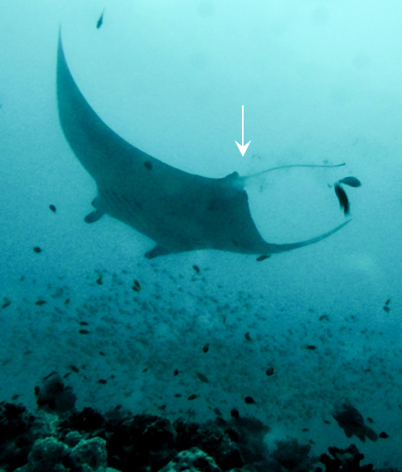
Fig. S2 A reef manta ray (Mobula alfredi) defecates over the cleaning station at D’Arros Island, Seychelles. Arrow indicates faecal material.

