Genetic diversity and structure of baobab (Adansonia digitata L.) in south-eastern Kenya
Anna Chládová¹, Marie Kalousová¹, Bohumil Mandák^{2,3}, Katja Kehlenbeck^{4,5}, Kathleen Prinz⁶, Jan Šmíd², Patrick Van Damme^{1, 4, 7}, Bohdan Lojka^{1*}

The affiliations and addresses of the authors:
¹ Department of Crop Sciences and Agroforestry, Faculty of Tropical AgriSciences, Czech University of Life Sciences Prague, Kamýcká 129, CZ-165 00, Prague, Czech Republic
² Department of Ecology, Faculty of Environmental Sciences, Czech University of Life Sciences Prague, Kamýcká 129, CZ-165 00, Prague, Czech Republic.
³ The Czech Academy of Sciences, Institute of Botany, Zámek 1, CZ-252 43 Průhonice, Czech Republic.
⁴ World Agroforestry Centre (ICRAF), PO Box 30677, 00100 Nairobi, Kenya
⁵ Rhine-Waal University of Applied Sciences, Marie-Curie-Straße 1, 47533 Kleve, Germany
⁶ Professorship for Systematic Botany, Friedrich-Schiller-University Jena, Philosophenweg 16, 07743 Jena, Germany
⁷ Department of Plants and Crops, Faculty of Bioscience Engineering, Ghent University, 9000 Ghent, Belgium

* Corresponding author: tel. +420 224 382 171, fax. +420 234 381 829; e-mail: lojka@ftz.czu.cz

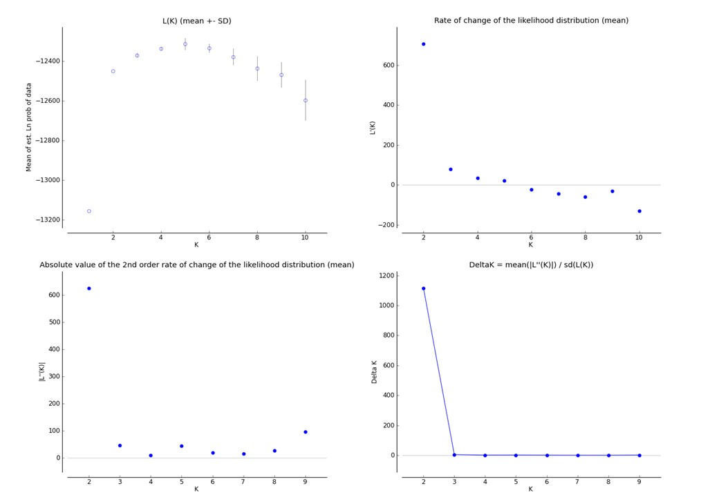
Figure 1 Optimal number of genetic clusters in the studied Adansonia digitata seven populations in Kenya. The results obtained from STRUCTURE (Pritchard et al. 2000) were summarized in STRUCTURE HARVESTER (Earl & VonHoldt 2012).
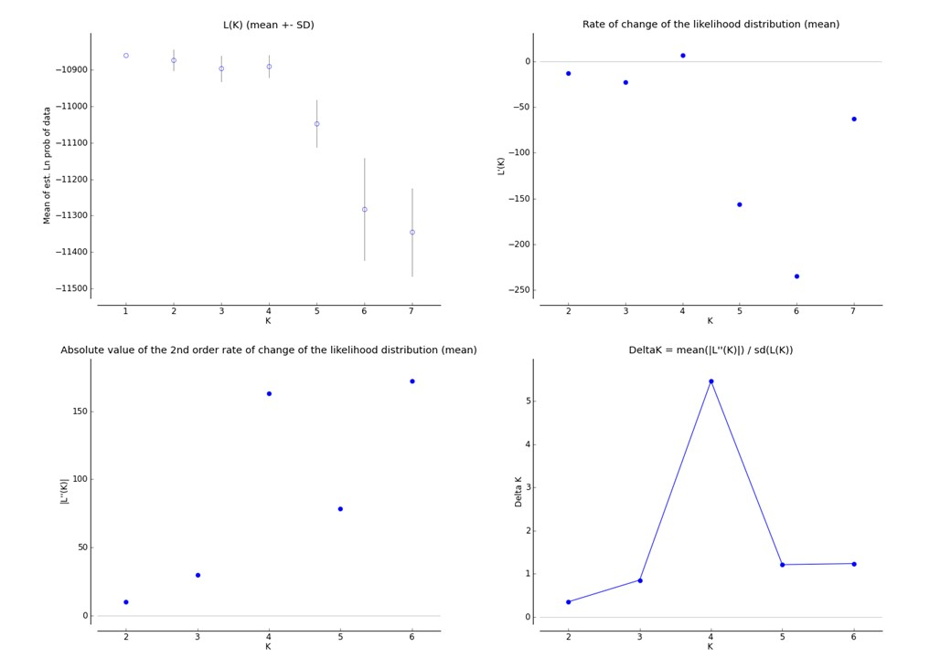
Figure 2 Optimal number of genetic clusters in the studied Adansonia digitata inland populations in Kenya. The results obtained from STRUCTURE (Pritchard et al. 2000) were summarized in STRUCTURE HARVESTER (Earl & VonHoldt 2012).
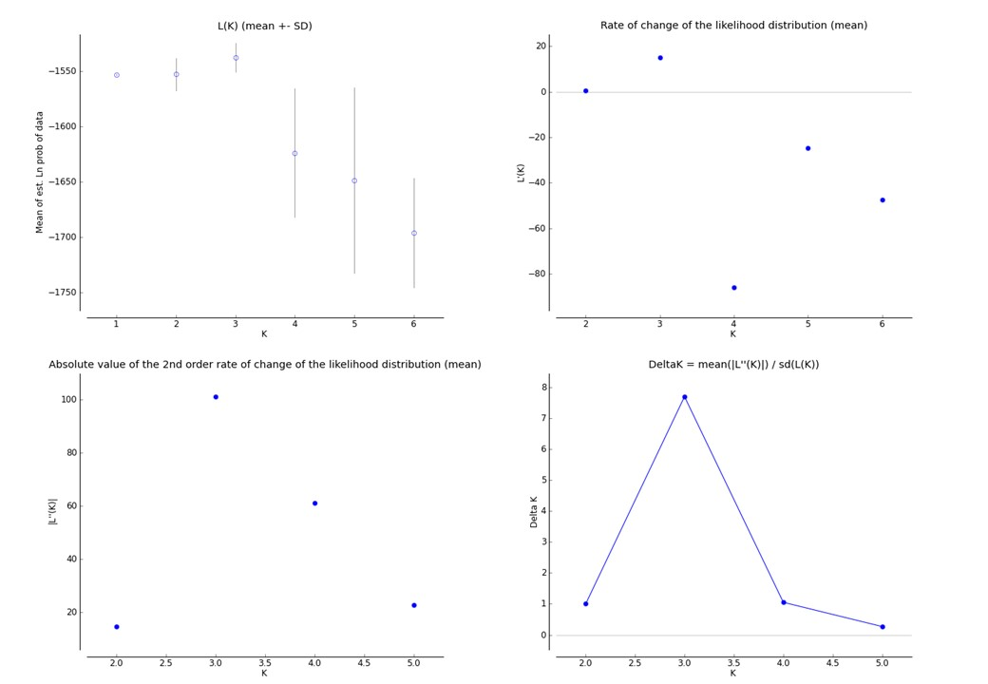
Figure 3 Optimal number of genetic clusters in the studied Adansonia digitata coastal populations in Kenya. The results obtained from STRUCTURE (Pritchard et al. 2000) were summarized in STRUCTURE HARVESTER (Earl & VonHoldt 2012).

Pritchard JK, Stephens M, Donnelly P. 2000 Inference of population structure using multilocus genotype data. Genetics 155, 945–959.
Earl DA, VonHoldt BM. 2012 STRUCTURE HARVESTER: A website and program for visualizing STRUCTURE output and implementing the Evanno method. Conserv. Genet. Resour. 4, 359–361. (doi:10.1007/s12686-011-9548-7)

