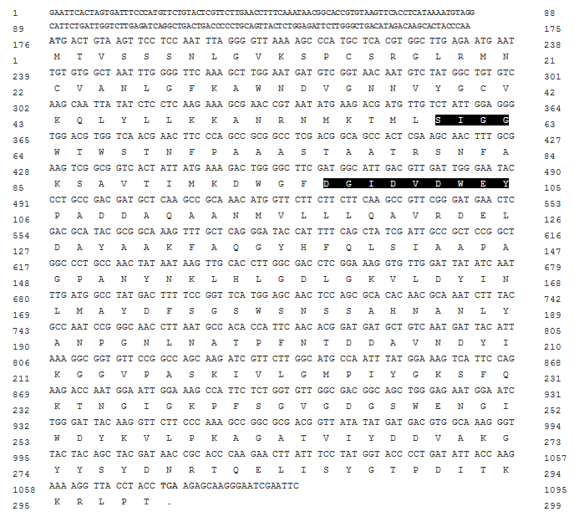
Figure 1: Nucleotides along deduced amino acids indicated below codons of Met_Chit1 gene of M. anisopliae isolate Tn-16. Substrate binding and catalytic domains are highlighted while start and stop codons are represented in bold

