Supplementary Information
Photocatalytic decolorization of three commercial dyes using a new heteropolyoxotantalate catalyst
Yansong Wang^{a,b} and Zhimin Zhou^{a,}*
ªInstitute of Natural Resources and Environment, College of Environment and Planning, Henan University, Kaifeng, 475004, China E-mail: pom@henu.edu.cn; Fax: (+86)371-23881850.
^{b} National Demonstration Center for Environmental and Planning, Henan University, Kaifeng, 475004 Henan, China.
CONTENTS
- Figure S1. Ball-and-stick representation of P₂Ta₃ fragment (a), PO₄ environment (b) and TaO₇ coordination environment (c).
- Figure S2. Viewing from different direction of ball-and-stick representations of polyanion 1.
- Table S1. Bond lengths in 1a.
- Table S2. BVS calculation results of all the atoms on polyanion 1a.
- Figure S3. Ball-and-stick representation of 1 highlighting the pronated oxygen atoms.
- Figure S4. IR spectrum of 1a in the region between 4000 to 500 cm⁻¹.
- Figure S5. XRD patterns of compound 1a.
- Figure S6. Chemical structures of RhB, MB and AR1.
- Figure S7. Photocatalytic decolorization performance of compound 1a without light on RhB dye.
- Figure S8. Photocatalytic decolorization performance of compound 1a on RhB.
- Figure S9. The TOC removal of RhB dye treated by material 1a.
- Figure S10. a) The time-scale UV spectra for the solution of compound 1a; b) the UV spectra of compound 1a and RhB mixed solution before and after irradiation.
- Figure S11. Negative-ion ESI-MS spectra of compound 1a.
- Figure S12. IR spectra of compound 1a before and after catalysis.
- Figure S13. Photocatalytic decolorization performance of compound 2a on RhB dye.
- Figure S14. Photocatalytic decolorization performance of compound 1a on MB.
- Figure S15. Photocatalytic decolorization performance of compound 1a on AR1.
- Figure S16. The photocatalytic H₂ evolution of compound 1a.
- Figure S17. Schematic illustration for the photocatalytic mechanism of compound 1a.

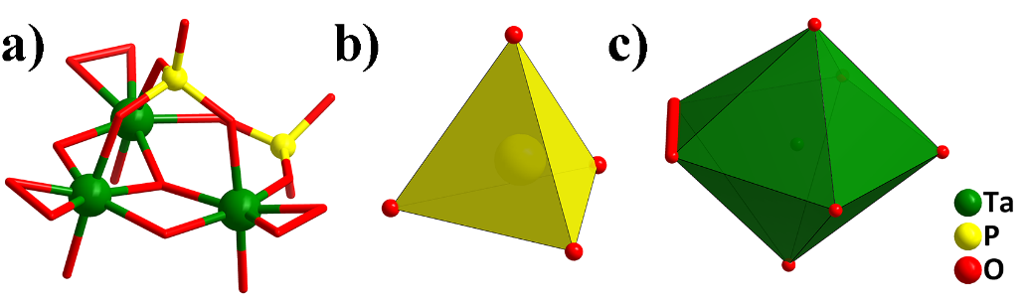
Figure S1. Ball-and-stick representation of P₂Ta₃ fragment (a), PO₄ environment (b) and TaO₇ coordination environment (c).
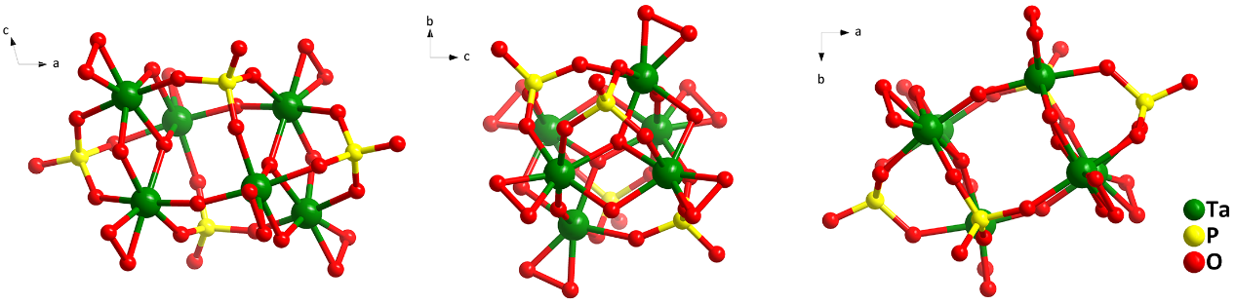
Figure S2. Viewing from different direction of ball-and-stick representations of polyanion 1 (a-c) and the ellipsoid structure of polyanion 1 (d).
Table S1. Bond lengths in 1a.
Ta–O distance (Å)
Ta1–O1 | 1.918 | Ta2–O4 | 2.046 | Ta3–O1 | 1.916
Ta1–O2 | 1.964 | Ta2–O5 | 2.096 | Ta3–O5 | 2.099
Ta1–O3 | 1.946 | Ta2–O8 | 1.955 | Ta3–O10 | 2.094
Ta1–O4 | 2.070 | Ta2–O9 | 1.946 | Ta3–O13 | 1.973
Ta1–O5 | 2.096 | Ta2–O10 | 2.052 | Ta3–O14 | 1.957
Ta1–O6 | 2.056 | Ta2–O11 | 2.022 | Ta3–O15 | 2.070
Ta1–O7 | 2.047 | Ta2–O12 | 1.984 | Ta3–O17 | 2.027
O–O distance (Å)
O2–O3 | 1.477 | O8–O9 | 1.509 | O13–O14 | 1.496
P–O distance (Å)
P1–O6 | 1.549 | P1–O11 | 1.559 | P1–O15 | 1.560
P1–O16 | 1.485 | P2–O7 | 1.528 | P2–O12 | 1.541
P2–O17 | 1.524 | P2–O18 | 1.503
Table S2. BVS calculation results of all the atoms on polyanion 1a.
Atom Code | Bond Valence | Atom Code | Bond Valence | Atom Code | Bond Valence
Ta1 | 5.52 | O3^{Ψ} | 0.93 | O11 | 1.89
Ta2 | 5.47 | O4* | 1.38 | O12 | 2.02
Ta3 | 5.44 | O5 | 1.86 | O13^{Ψ} | 0.87
P1 | 4.80 | O6 | 1.85 | O14^{Ψ} | 0.90
P2 | 4.97 | O7 | 1.94 | O15 | 1.80
 |  | O8^{Ψ} | 0.91 | O16* | 1.38
O1 | 2.02 | O9^{Ψ} | 0.93 | O17 | 1.99
O2^{Ψ} | 0.89 | O10‡ | 1.32 | O18‡ | 1.32
Ψ, ‡ and * represent peroxo oxygen atoms, mono-pronated groups and O/OH ligands, respectively.
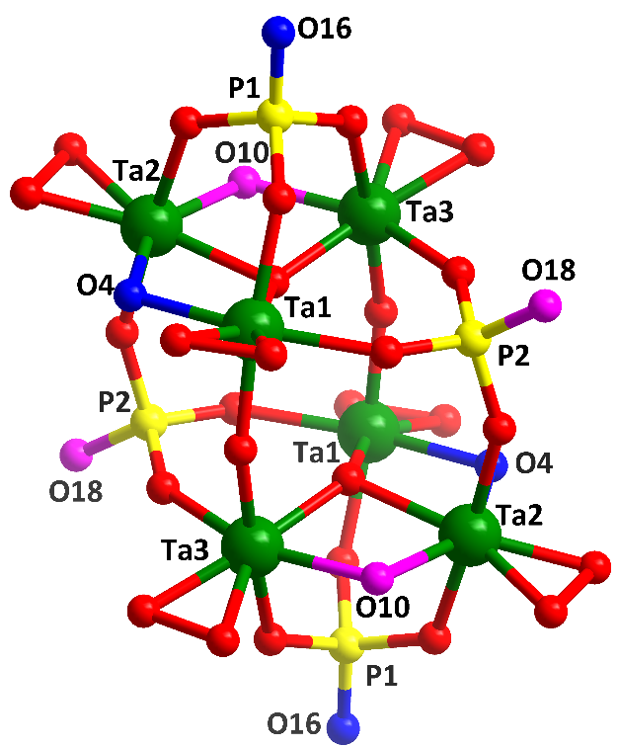
Figure S3. Ball-and-stick representation of 1 highlighting the pronated oxygen atoms. Color code: Ta green balls; P yellow balls, O red balls, OH pink balls, disordered O/OH blue balls.
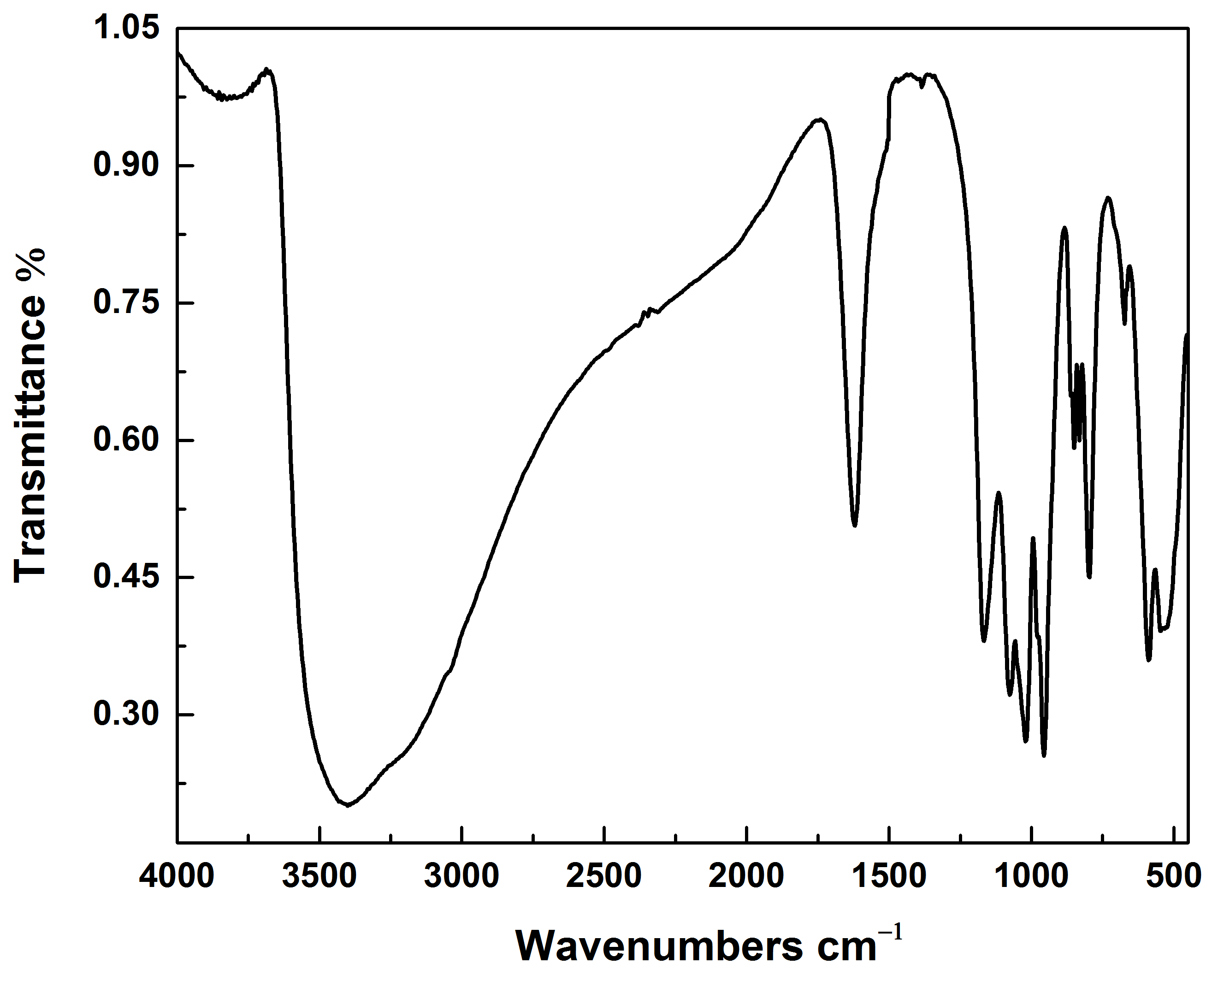
Figure S4. IR spectrum of 1a in the region between 4000 to 500 cm⁻¹.
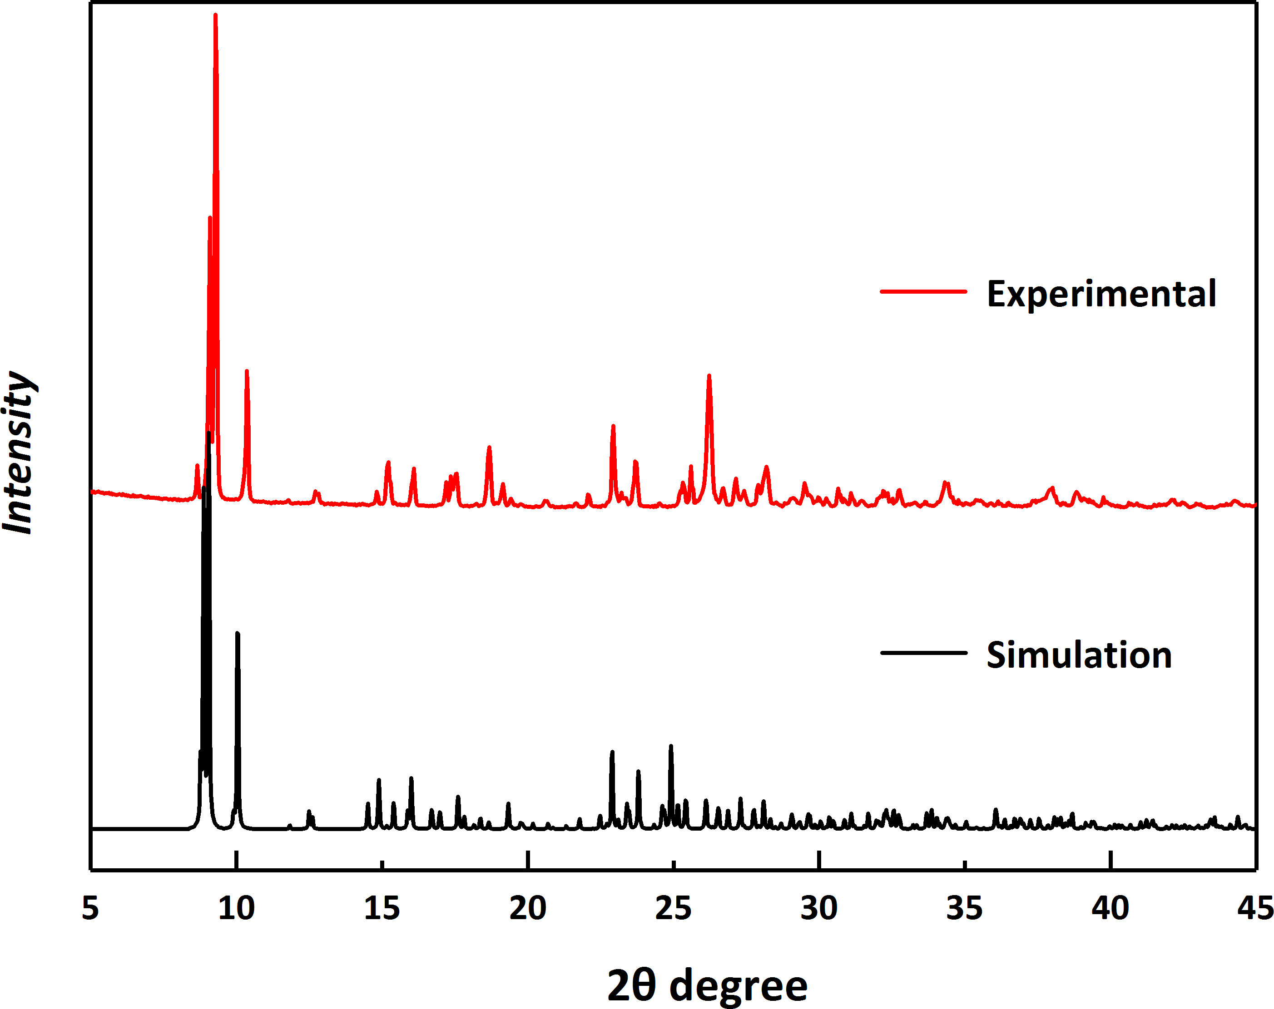
Figure S5. XRD pattern of compound 1a (red) and its simulated XRD pattern (black).
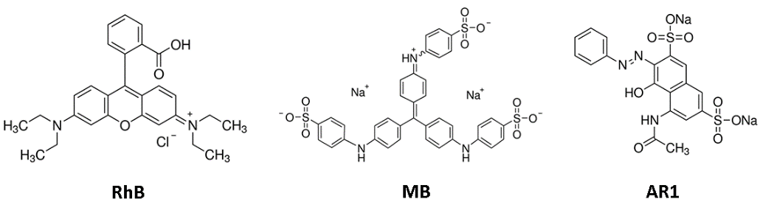
Figure S6. Chemical structures of RhB, MB and AR1.
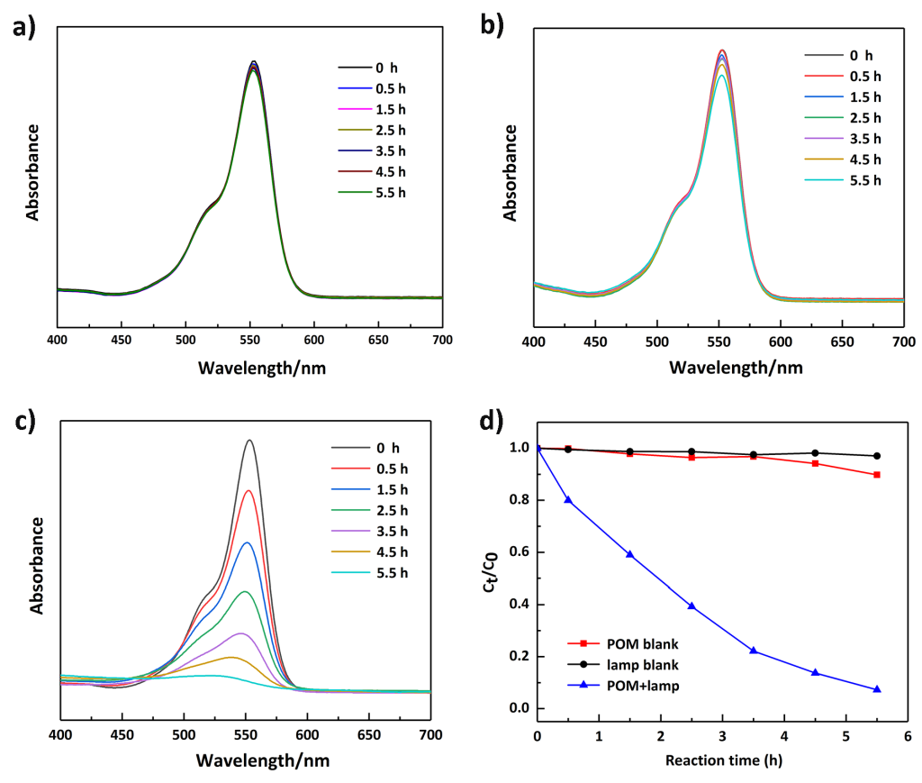
Figure S7. Photocatalytic decolorization performance of compound 1a on RhB dye. a) Change in absorption of RhB in the absence of 1a with Xe lamp; b) Change in absorption of RhB in the presence of 1a (40 mg) without Xe lamp; c) Change in absorption of RhB in the presence of 1a (40 mg) with Xe lamp; d) Plot of C_{t}|C₀ vs time with 1a (blue), the absence of 1a (black) and the blank experiment without lamp (red).
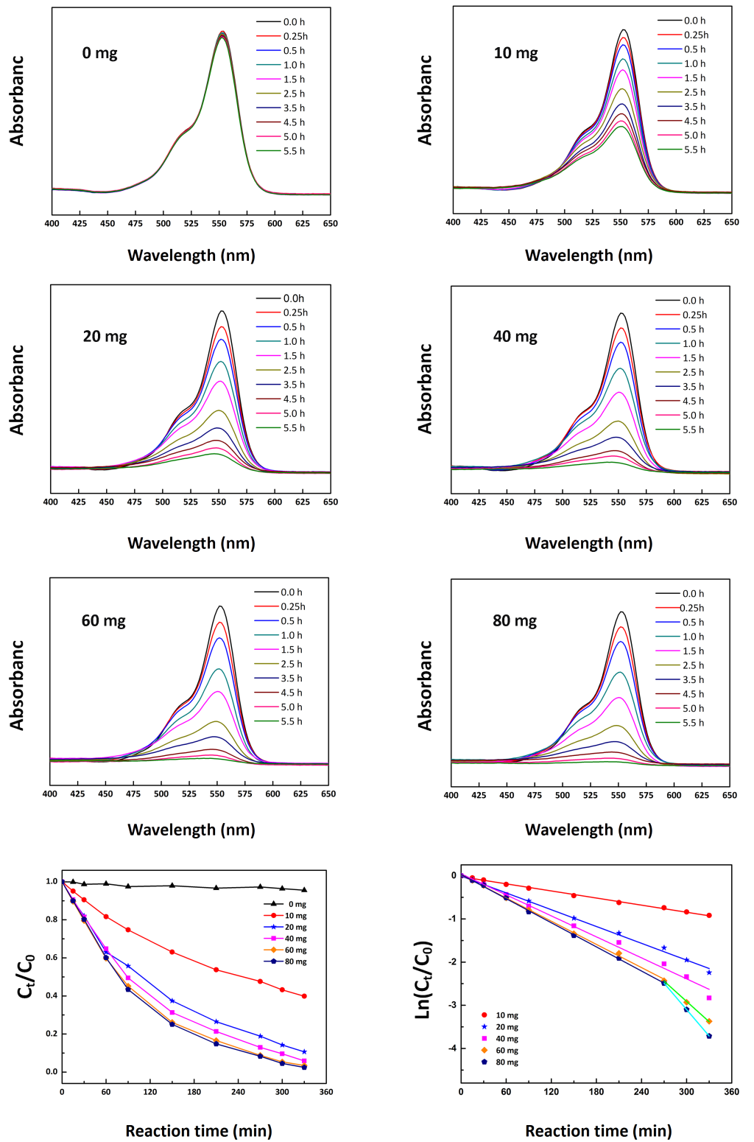
Figure S8. Photocatalytic decolorization performance of compound 1a on RhB dye.
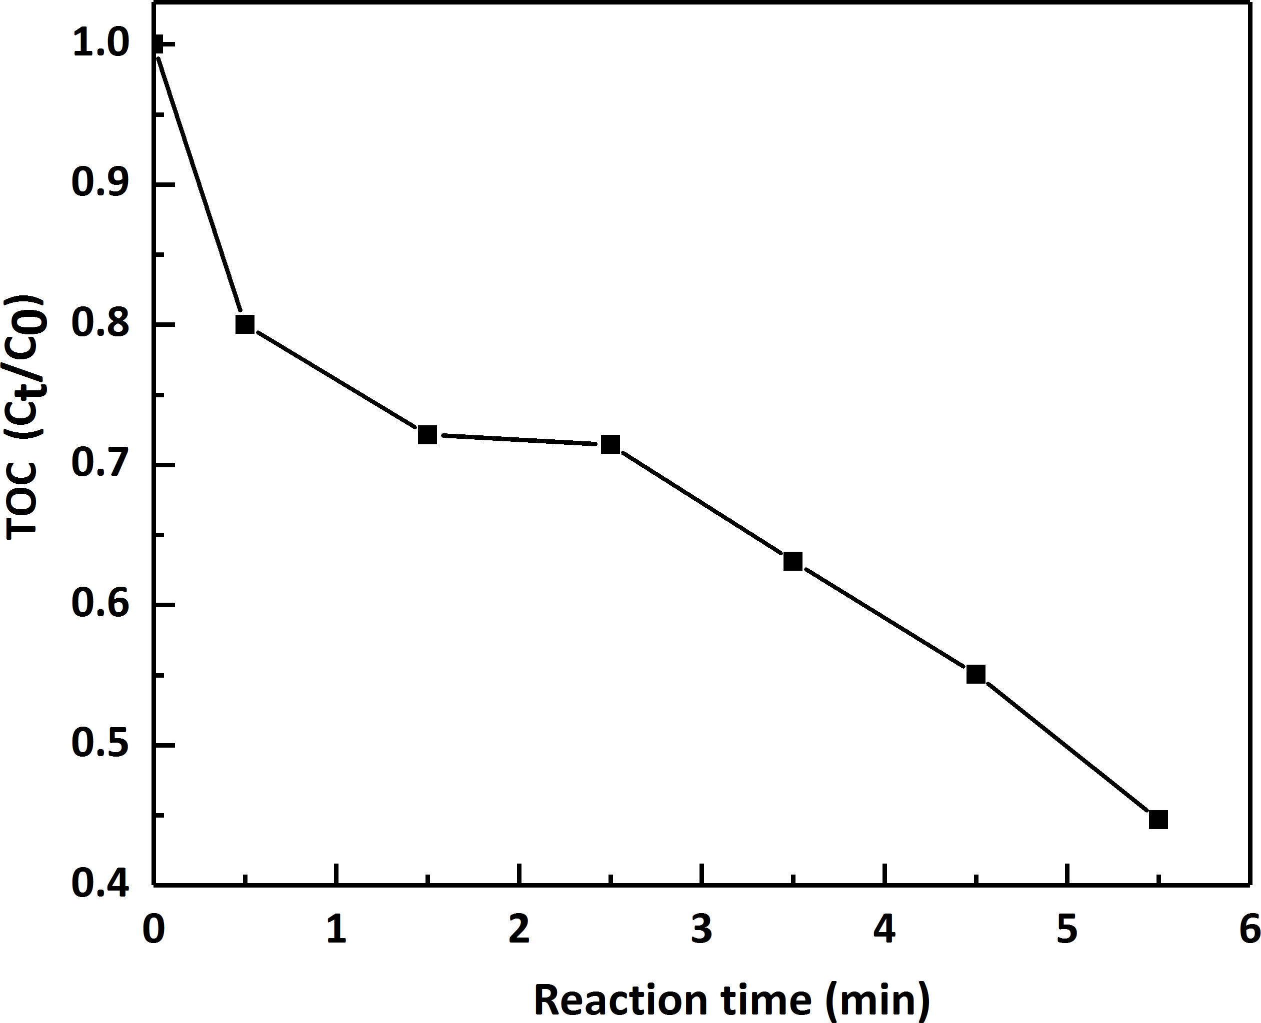
Figure S9. The TOC removal of RhB dye treated by material 1a.
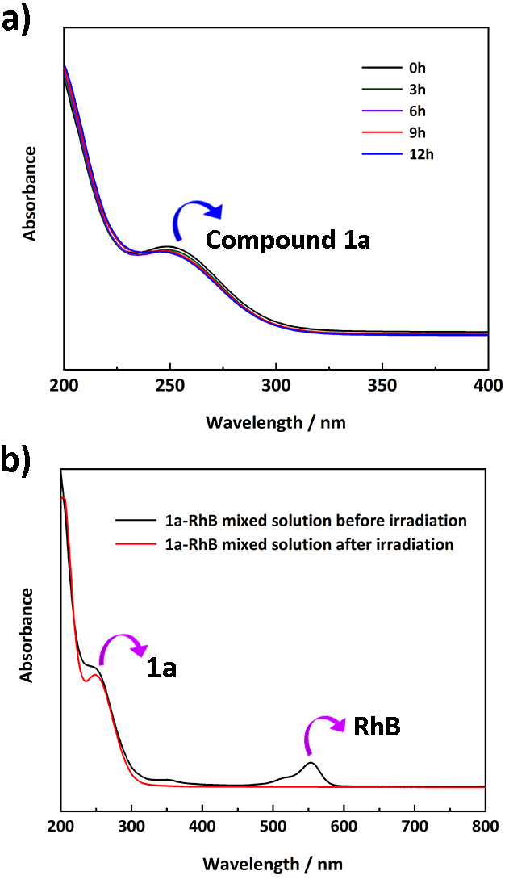
Figure S10. a) The time-scale UV spectra for the solution of compound 1a; b) the UV spectra of compound 1a and RhB mixed solution before and after irradiation.
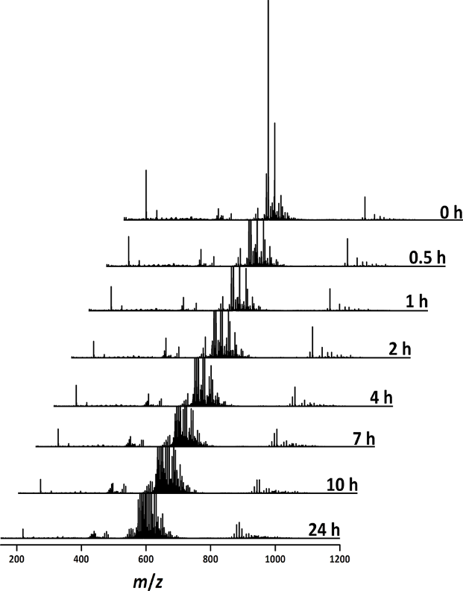
Figure S11. Negative-ion ESI-MS spectra of cluster anion in compound 1a during 24 h. To investigate the stability of POM cluster presented in this study, ESI-MS measurement was performed on an AB SCIEX Triple TOF 4600 spectrometer operating in negative ion mode and data was analyzed using the Peakview 2.0 software provided. ESI-MS sample was prepared by dissolving single crystal in mixed solvent CH₃CN-H₂O with HPLC grade and diluting to a concentration of ca. 1 x 10⁻⁶ M. It can be seen that the main envelope observed at m/z = 597.5 for 1a could be assigned to the formula [H₇{P₄Ta₆(O₂)₆O₂₄}]³⁻, which can be also remained for 24 h.

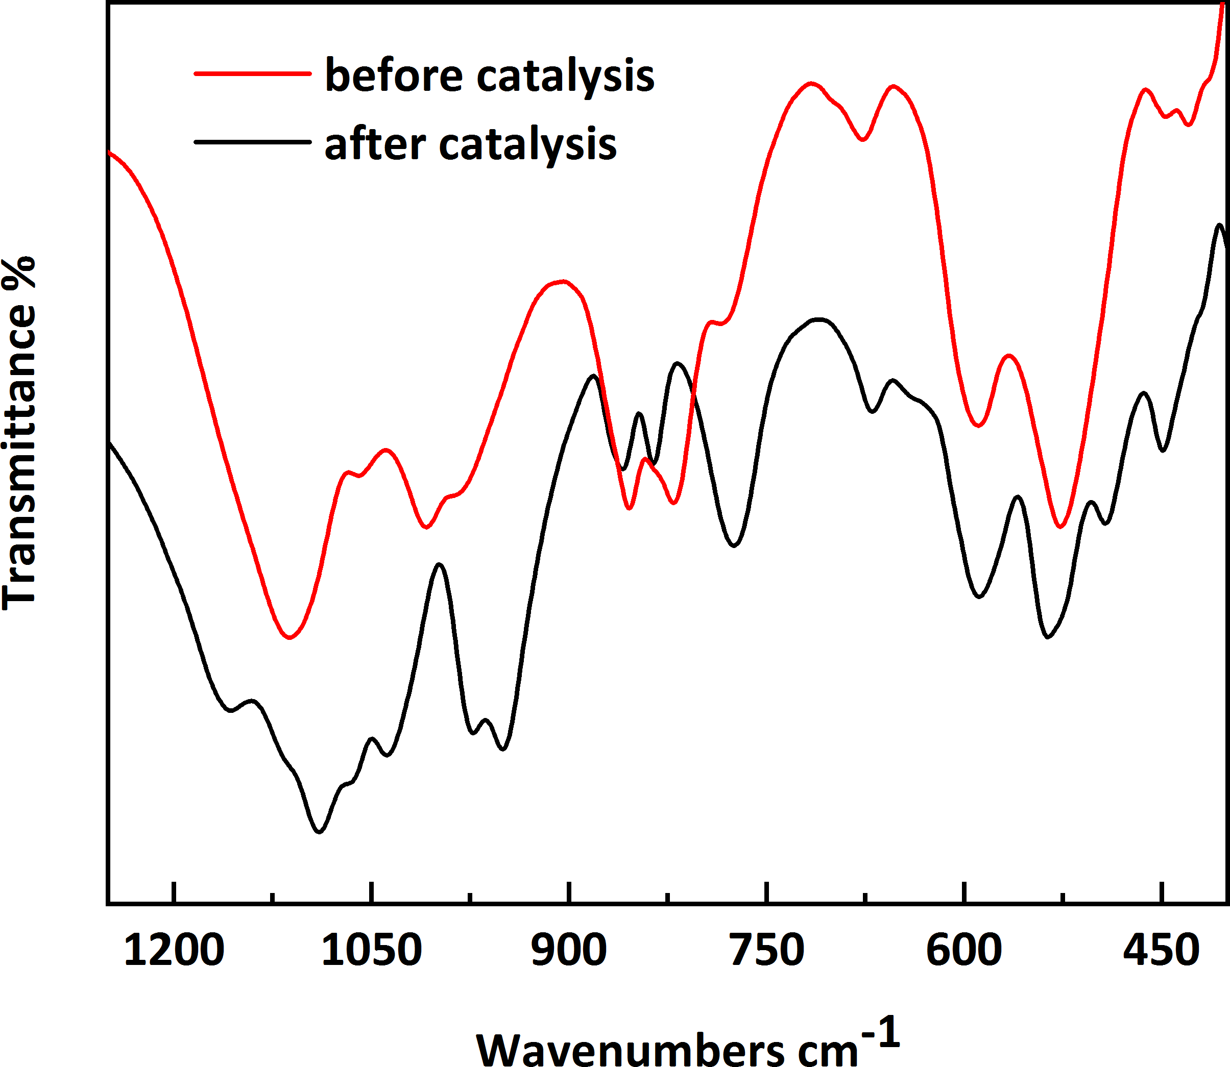
Figure S12. IR spectra of compound 1a before and after catalysis, highlight the region between 1250 to 400 cm⁻¹.

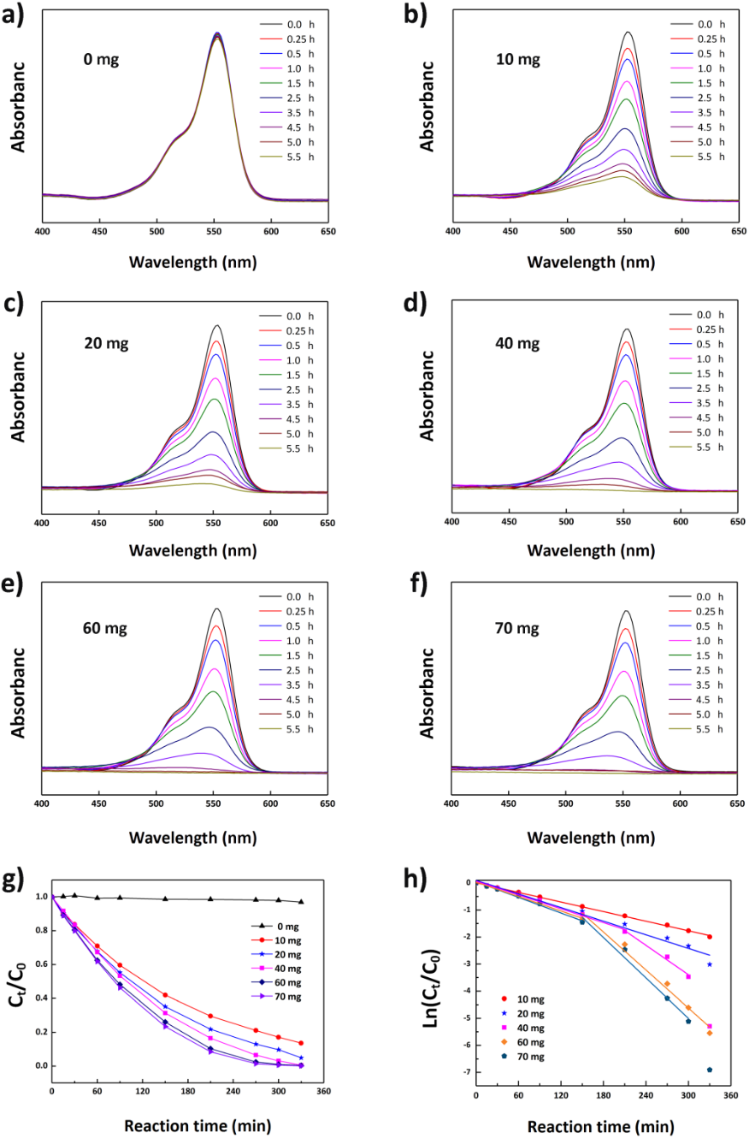
Figure S13. Photocatalytic decolorization performance of compound 2a on RhB dye.
For comparison, the photocatalytic performances of different amount 2a (10, 20, 40, 60 and 70 mg) on the decolorization of RhB dyes have been also investigated. It can be seen that RhB dye can be completely decolorized within 5.5 h when the amount of compound 2a is higher than 20 mg. This may be attributed the fact that 1a is a structural analogue of 2a.
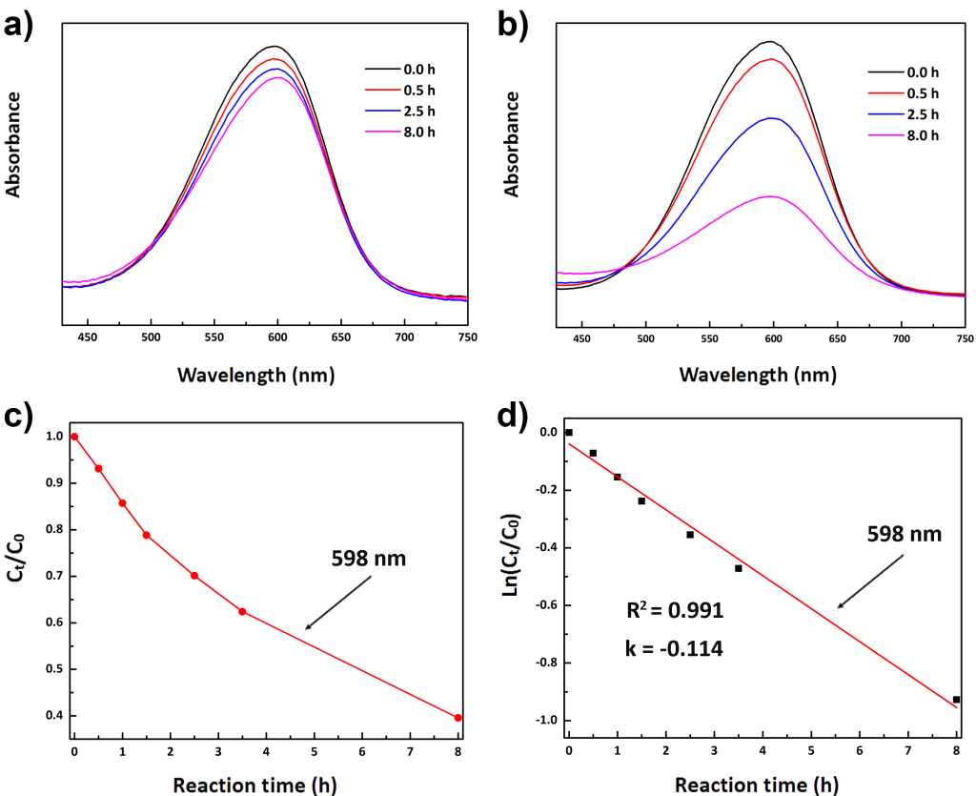
Figure S14. a) Absorption spectrum of the MB solution in the absence of compound 1a; b) Absorption spectrum of the MB solution in the presence of compound 1a (40 mg); c) plots of the concentration ratios of MB C_{t}|C₀ vs time (h) in the presence of compound 1a under Xe lamp irradiation; d) The first order linear plot of ln(C_{t}|C₀) vs. time for MB.
It can be clearly seen that the absorbance peaks of MB (598 nm) decreased obviously along with the reaction time in the presence of 1a, 60.4% of MB decolorized after 8 h of irradiation, which is higher than that of absence of 1a (12.5%). The catalytic reaction could be considered as a pseudo first order kinetics with regard to the linear fit of the ln(C_{t}|C₀) data. The calculated rate constant (k_{app}, h^{–1}) for the reduction of MB in the presence of 1a is 0.114 h^{–1}.
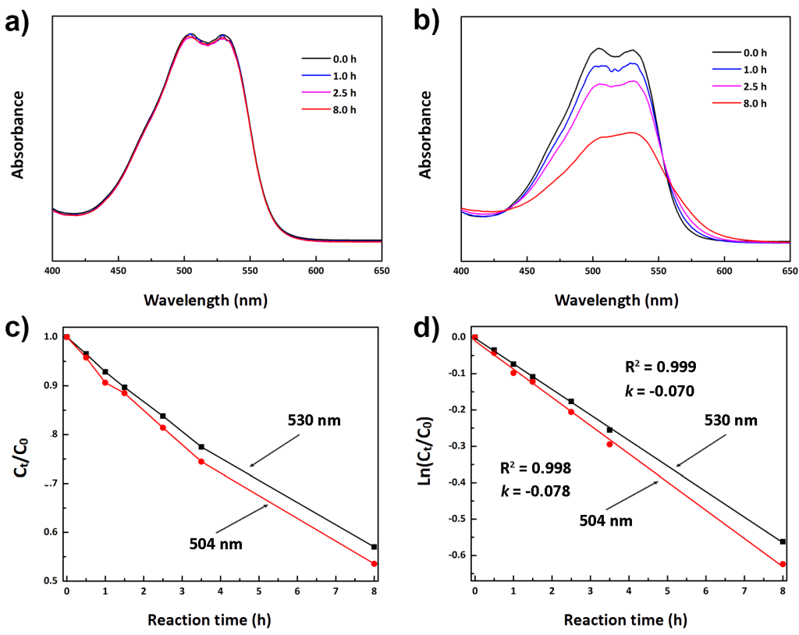
Figure S15. a) Absorption spectrum of the AR1 solution in the absence of compound 1a; b) Absorption spectrum of the AR1 solution in the presence of compound 1a (40 mg); c) plots of the concentration ratios of AR1 C_{t}|C₀ vs time (h) in the presence of compound 1a under Xe lamp irradiation; d) The first order linear plot of ln(C_{t}|C₀) vs. time for AR1.
It can be clearly seen that the absorbance peaks of AR1 (504 and 530 nm) decreased along with the reaction time in the presence of 1a, 46.4% (504 nm) and 42.7% (530 nm) of AR1 decolorized after 8 h of irradiation, which is obviously higher than that of absence of 1a (almost no decolorization). The catalytic reaction could be considered as a pseudo first order kinetics with regard to the linear fit of the ln(C_{t}|C₀) data. The calculated rate constant (k_{app}, h^{–1}) for the reduction of AR1 in the presence of 1a is 0.078 h^{–1} (504 nm) and 0.070 h^{–1} (504 nm).
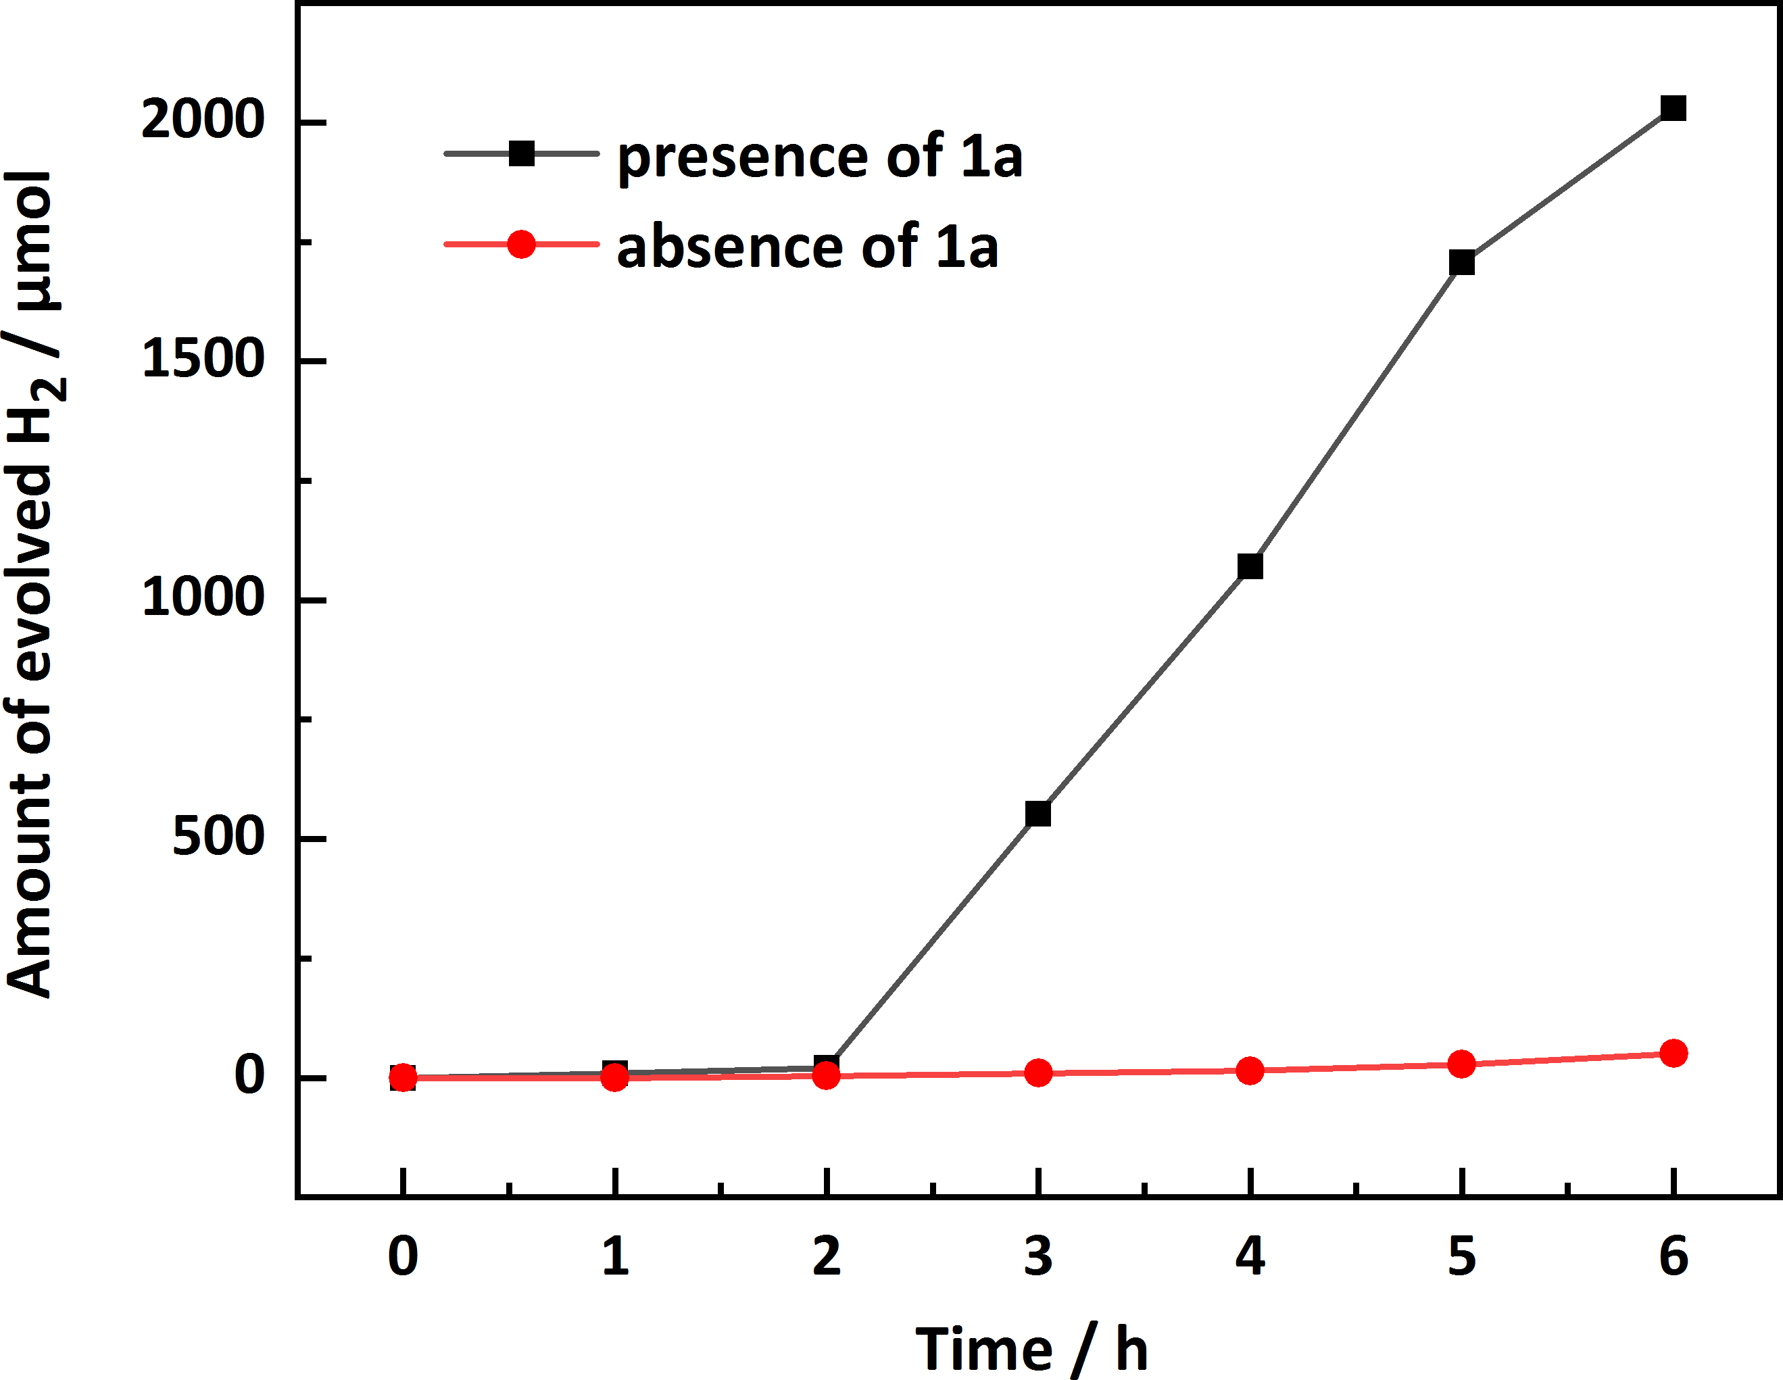
Figure S16. Time courses of photocatalytic H₂ evolution under the presence of compound 1a (black) and the absence of compound 1a (red). Experiment condition: 100 mg of 1a and 0.05 mg of H₂PtCl₆ were dissolved in 100 mL of 10% methanol, which was irradiated under UV using a 500 W mercury lamp.
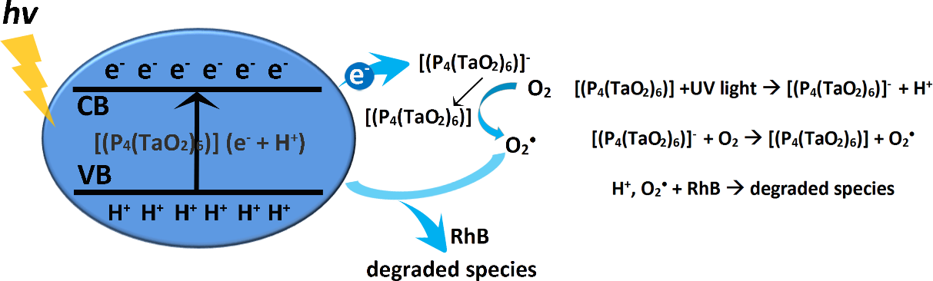
Figure S17. Schematic illustration for the photocatalytic mechanism of compound 1a.

