Bacterial ageing in the absence of external stressors
Ursula Lapinska,^{1,2} Georgina Glover,^{1,2} Pablo Capilla-Lasheras,³ Andrew J. Young,³ Stefano Pagliara^{1,2}
¹Biosciences, University of Exeter, Exeter, Devon EX4 4QD, UK
²Living Systems Institute, University of Exeter, Exeter, Devon EX4 4QD, UK
³Centre for Ecology and Conservation, College of Life and Environmental Sciences, University of Exeter,
Penryn Campus, Cornwall TR10 9FE, UK
Keywords: microfluidics; ageing; protein aggregates; glucose uptake; single-cell analysis; senescence; bacteria; E. coli

*Authors for correspondence (s.pagliara@exeter.ac.uk; a.j.young@exeter.ac.uk; u.lapinska@exeter.ac.uk).

Supplementary Material

Table S1. (A) Likelihood-ratio test results and (B) effect size estimates from the minimum adequate model (MAM) explaining variation in bacterium doubling time (min) between generations 2 and 11 inclusive (we combine data from both experimental runs A and B, fitting ‘Run’ as a fixed effect predictor). The MAM contains only those predictors that explained significant variation in cell doubling times; in this case Polarity (new pole daughter cells showed significantly shorter doubling times than old pole daughter cells), Generation number (there was a progressive increase in the doubling times of cells with each successive generation of cell division), and Run (the doubling times of the cells in experimental run B were shorter than those in run A). There was no evidence that the effect of Polarity (new vs old pole daughter) changed with increasing generation number (i.e. there was no significant Polarity x Generation number interaction), and the initial number of bacteria in the run had no effect on the division times of the focal cells.

A) Likelihood-ratio test results
Predictor | χ² | df | p
Polarity | 5.192 | 1 | 0.023
Generation number | 38.327 | 1 | < 0.001
Run | 30.277 | 1 | < 0.001
Polarity x Generation number | 0.001 | 1 | 0.971
Initial number of bacteria | 0.068 | 1 | 0.794
B) Minimum adequate model estimates
Fixed effects | Estimate | SE
Intercept | 23.893 | 0.677
Polarity (new pole daughter effect) | -1.084 | 0.476
Generation number | 0.517 | 0.082
Run (Run B effect) | -3.588 | 0.476
 | Variance
Random effects: Channel | ~ 0
Residual variance | 22.01
Table S2. (A) Likelihood-ratio test results and (B) effect size estimates from the minimum adequate model (MAM) explaining variation in bacterium doubling time (min) between generations 2 and 24 inclusive for experimental run B. The MAM contains only those predictors that explained significant variation in cell doubling times; in this case Polarity (new pole daughter cells showed significantly shorter doubling times than old pole daughter cells) and Generation number (there was a progressive increase in the doubling times of cells with each successive generation of cell division – i.e. positive Generation number¹ effect - but the size of this effect decreased with each successive generation - i.e. negative Generation number² effect). There was no evidence that the effect of Polarity (new vs old pole daughter) changed with increasing generation number (i.e. there was no significant Polarity x Generation number interaction), and the initial number of bacteria in the run had no effect on the doubling times of the focal cells.

A) Likelihood-ratio test results
Predictor | χ² | df | p
Polarity | 11.222 | 1 | < 0.001
Generation number¹ | 52.199 | 1 | < 0.001
Generation number² | 32.832 | 1 | < 0.001
Polarity x Generation number¹ | 0.545 | 1 | 0.460
Polarity x Generation number² | 0.459 | 1 | 0.498
Initial number of bacteria | 0.379 | 1 | 0.538
B) Minimum adequate model estimates

Fixed Effects | Estimate | SE
Intercept | 18.842 | 0.828
Polarity (new pole daughter effect) | -1.390 | 0.414
Generation number¹ | 1.065 | 0.144
Generation number² | -0.032 | 0.005
Random effects: Channel | ~ 0
Residual variance | 18.82

Figure S1. Position dependent glucose uptake. Uptake of the fluorescent glucose analogue 2-(N-(7-Nitrobenz-2-oxa-1,3-diazol-4-yl)Amino)-2-Deoxyglucose (2-NBDG) in the first (magenta downward triangles) and second bacterium (blue upward triangles) from the top of each dead-end channel of a mother machine filled with an aliquot of a stationary phase E. coli culture. Noteworthy, in this experiment bacteria have yet to divide in the mother machine, therefore, the 1st and 2nd bacteria from the top of each dead-end channel are two bacteria randomly drawn from the culture with unknown orientation and pole age (see Fig. 1) rather than old and new pole daughters. The points and error bars are means and standard error of the means of measurements performed on 60 individual bacteria. Paired t-test returned that the amount of 2-NBDG accumulated by the 1st and 2nd bacteria from the top of each dead-end channel after 840s incubation was not statistically different (N=30 pairs, p-value=0.9) The dashed and dotted lines are guides-for-the-eye.

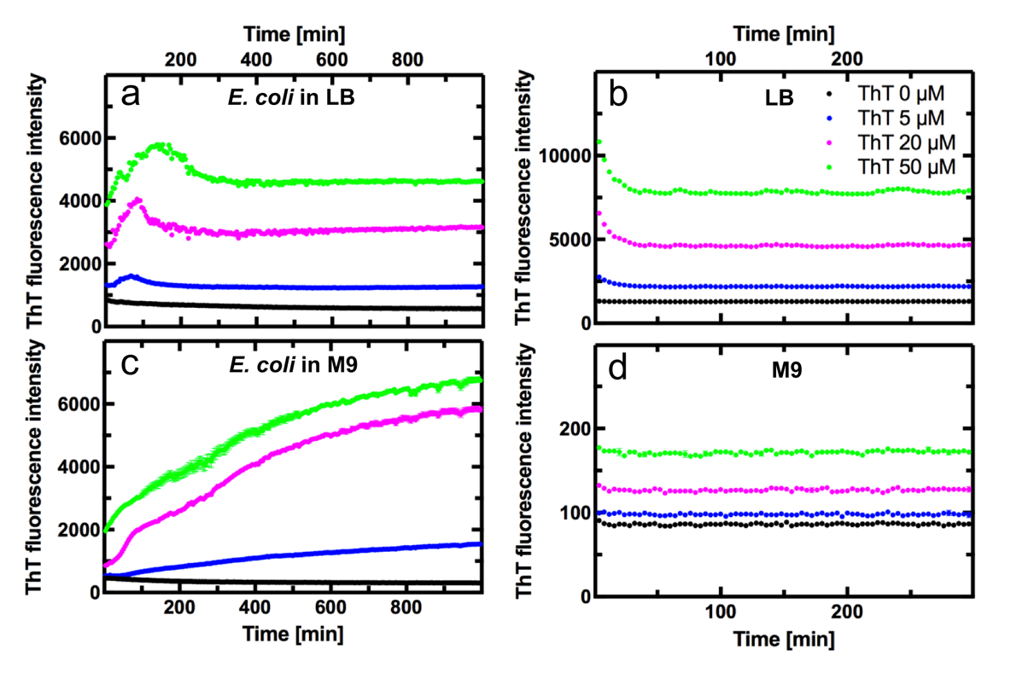
Figure S2. Ensemble measurements of thioflavin T (ThT) staining. a) ThT fluorescence intensity as a function of time elapsed after diluting an aliquot of stationary phase E. coli in fresh LB or c) M9 with the addition of 0, 5, 20, or 50 µM ThT (black, blue, magenta, and green circles, respectively). Corresponding ThT fluorescence intensity profiles without the addition of E. coli to b) LB or d) M9. The data points and error bars are calculated as the mean and standard error of the mean of measurements performed in triplicate. Error bars are hidden behind the data points.

