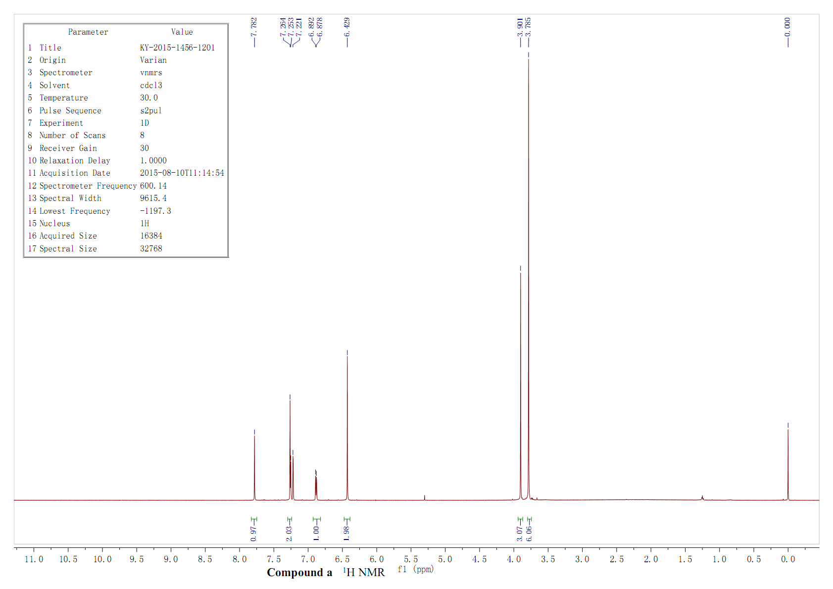Figure S1. ¹H NMR spectrum of compound a

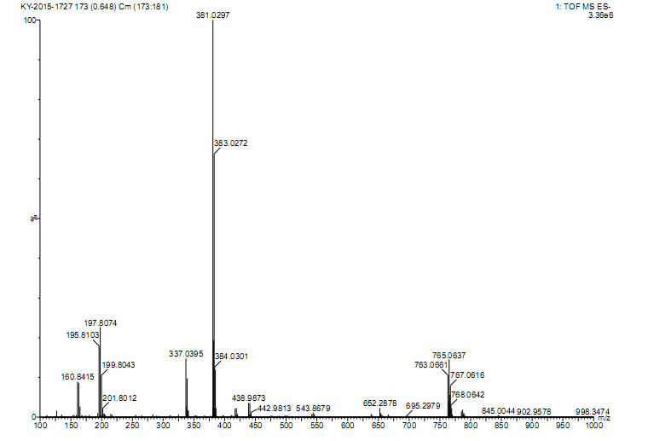Figure S2. HRMS spectrum of compound a

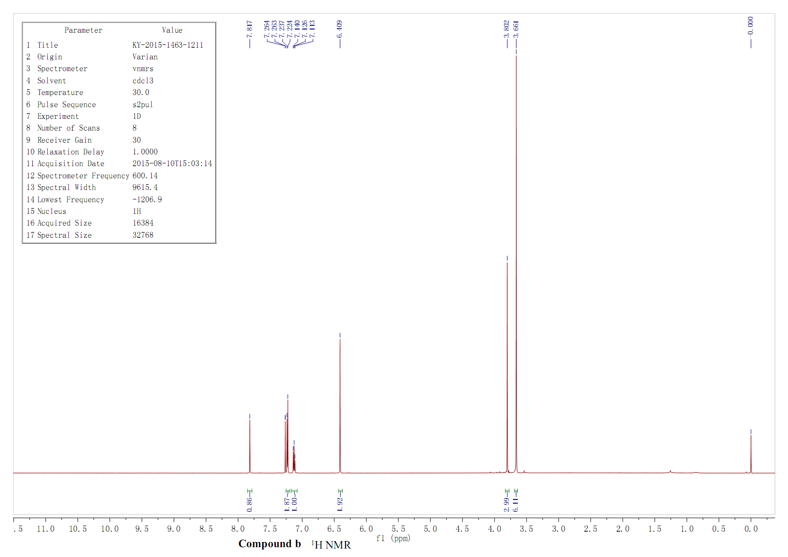Figure S3. ¹H NMR spectrum of compound b

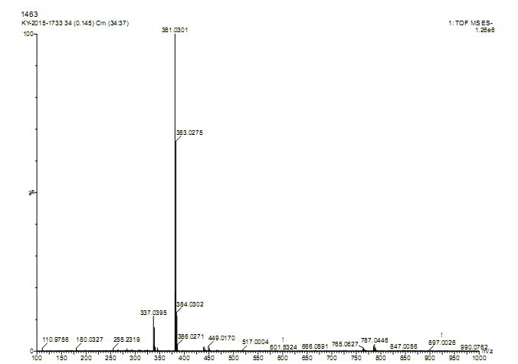Figure S4. HRMS spectrum of compound b

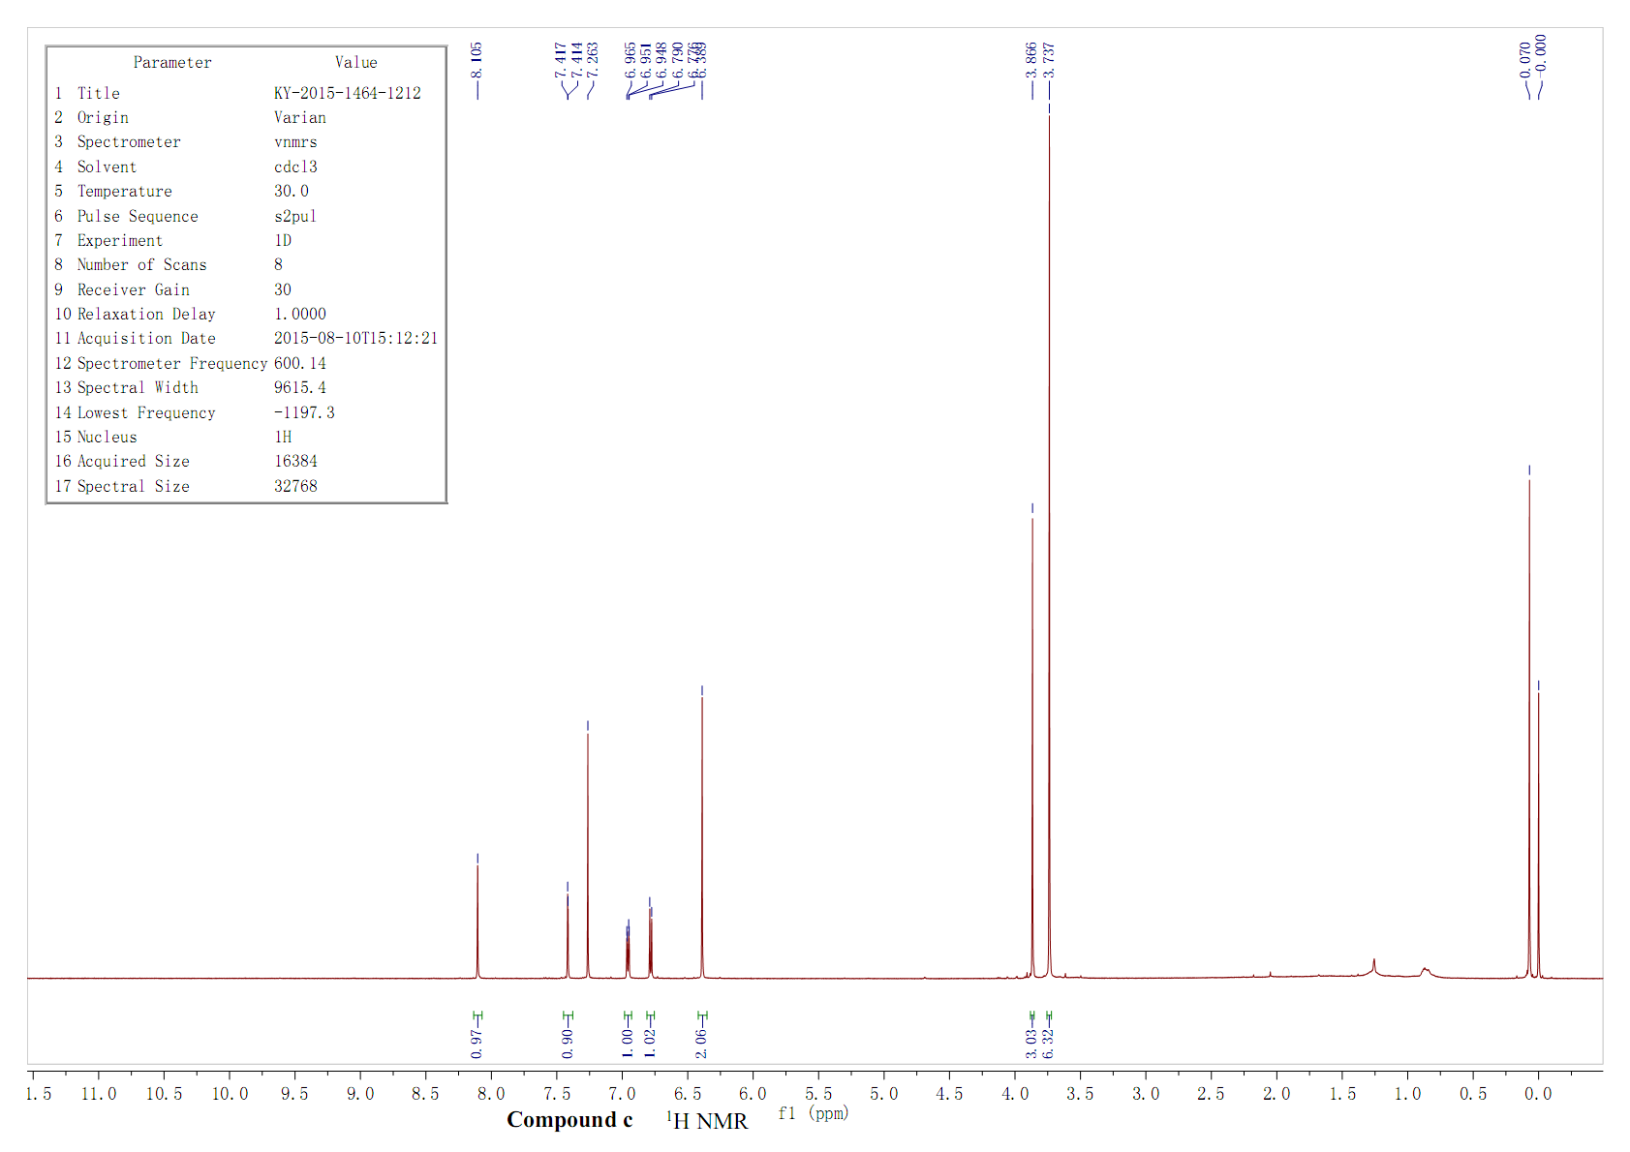Figure S5. ¹H NMR spectrum of compound c

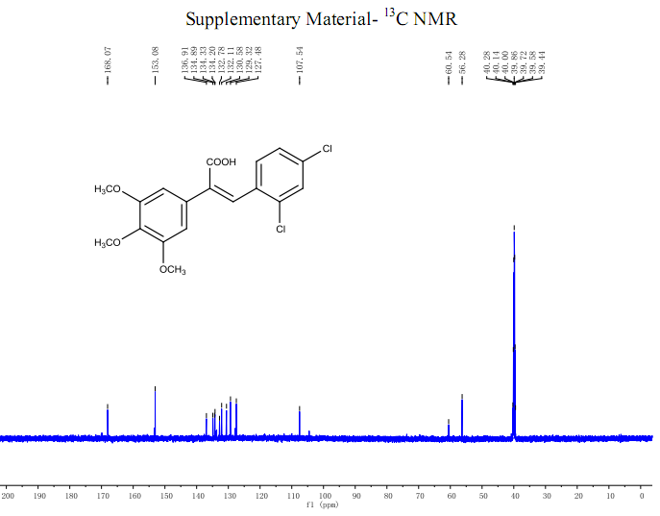Figure S6. ¹C NMR spectrum of compound c

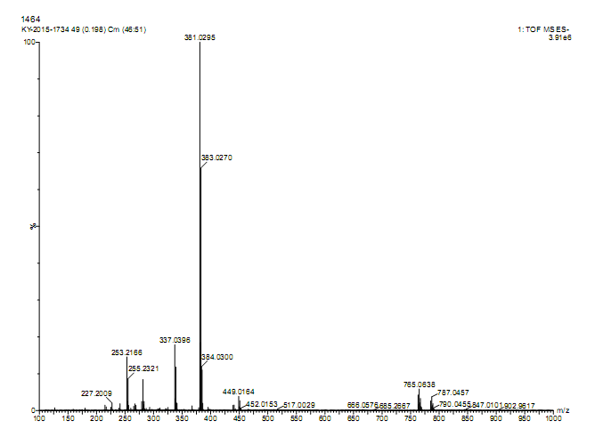Figure S7. HRMS spectrum of compound c

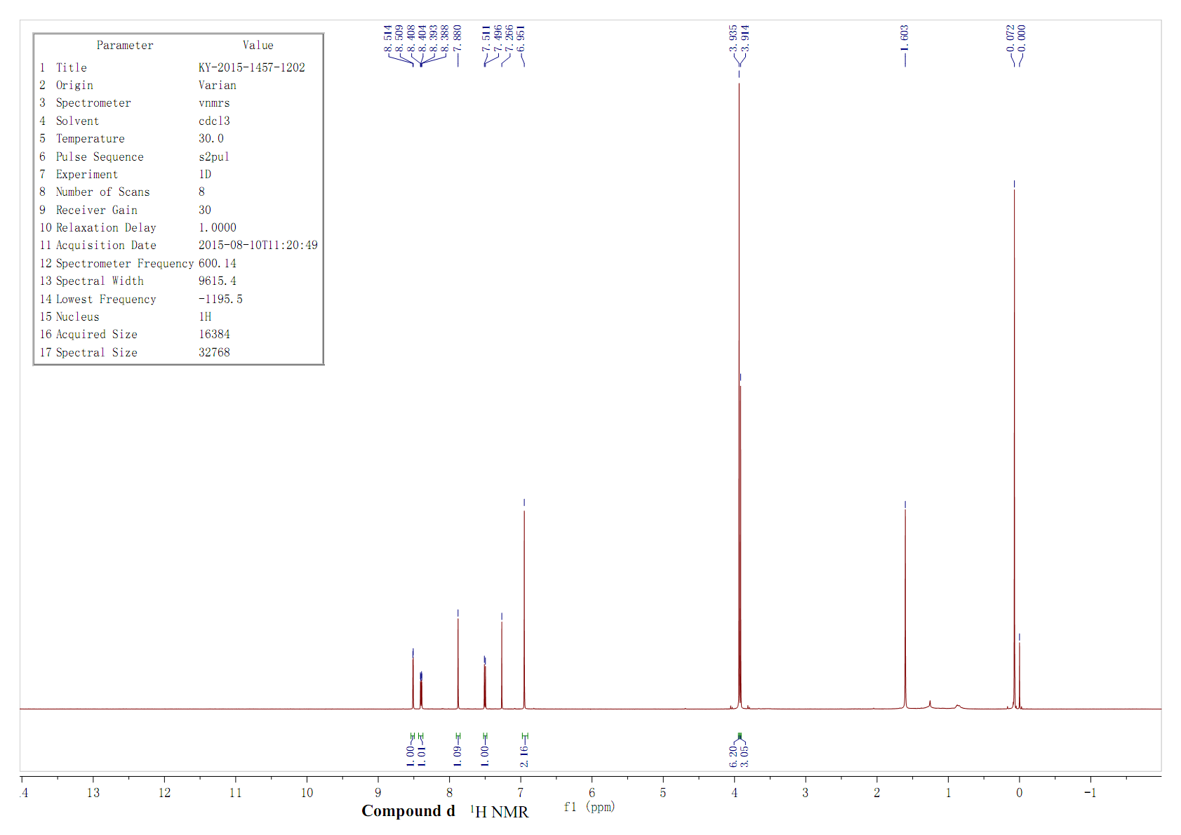Figure S8. ¹H NMR spectrum of compound d

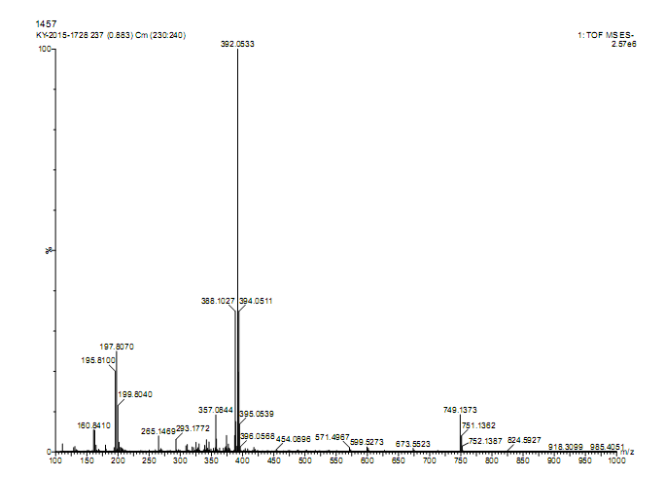Figure S9. HRMS spectrum of compound d

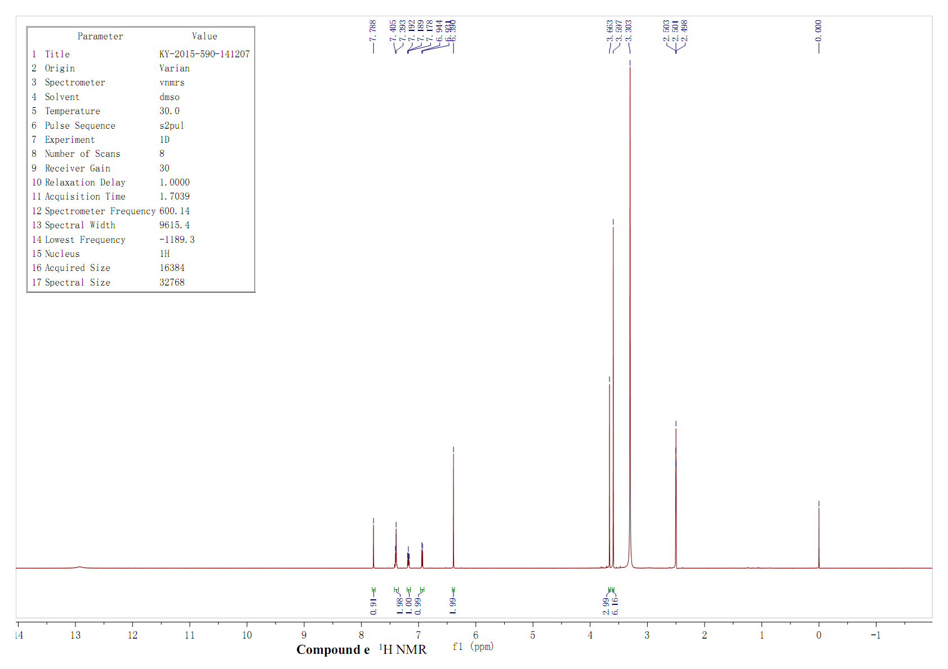 Figure S10. ¹H NMR spectrum of compound e

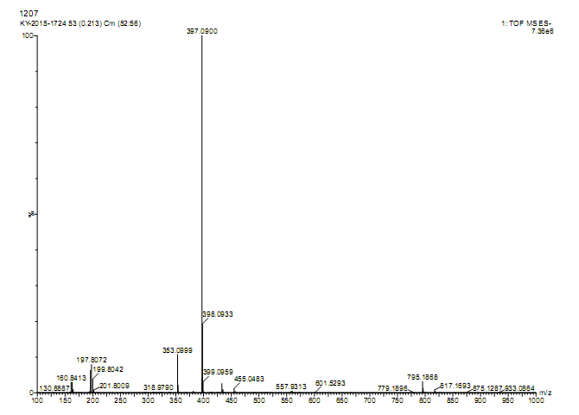Figure S11. HRMS spectrum of compound e

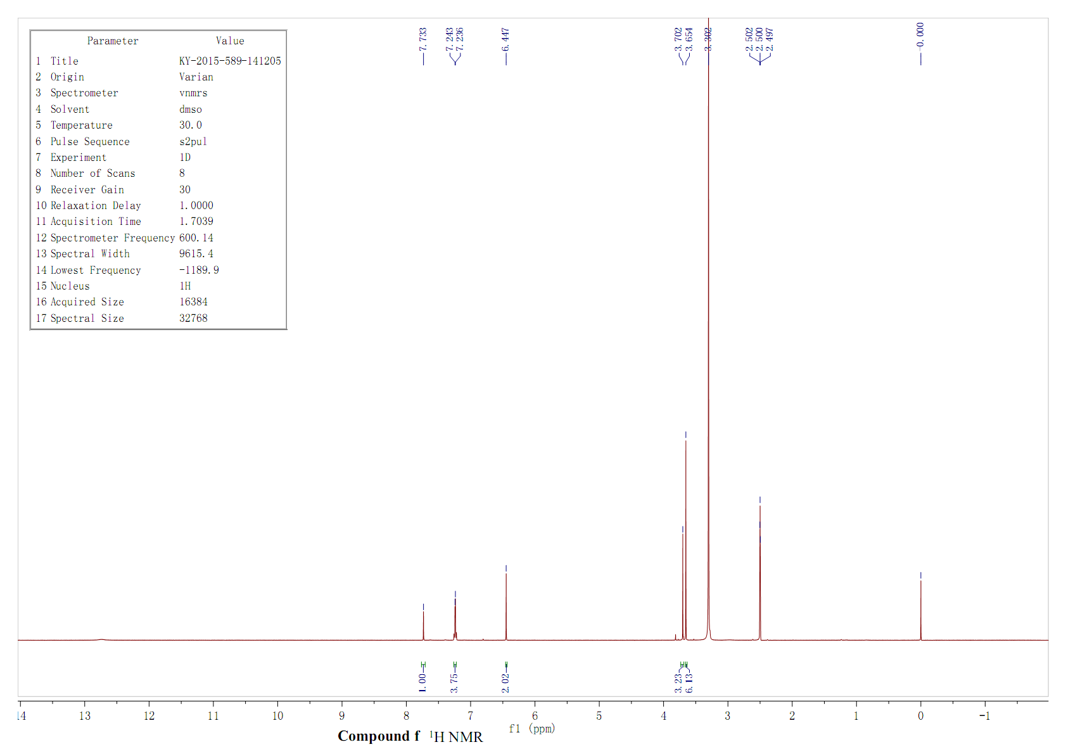Figure S12. ¹H NMR spectrum of compound f

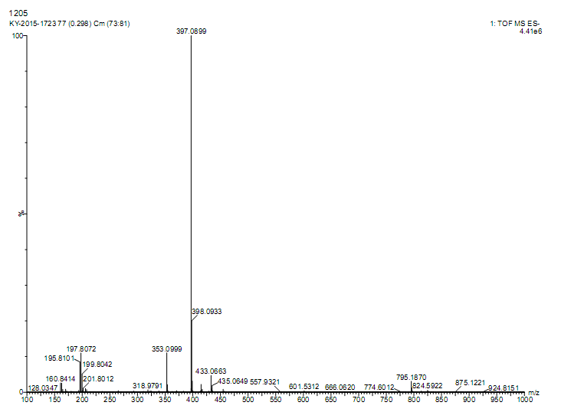Figure S13. HRMS spectrum of compound f

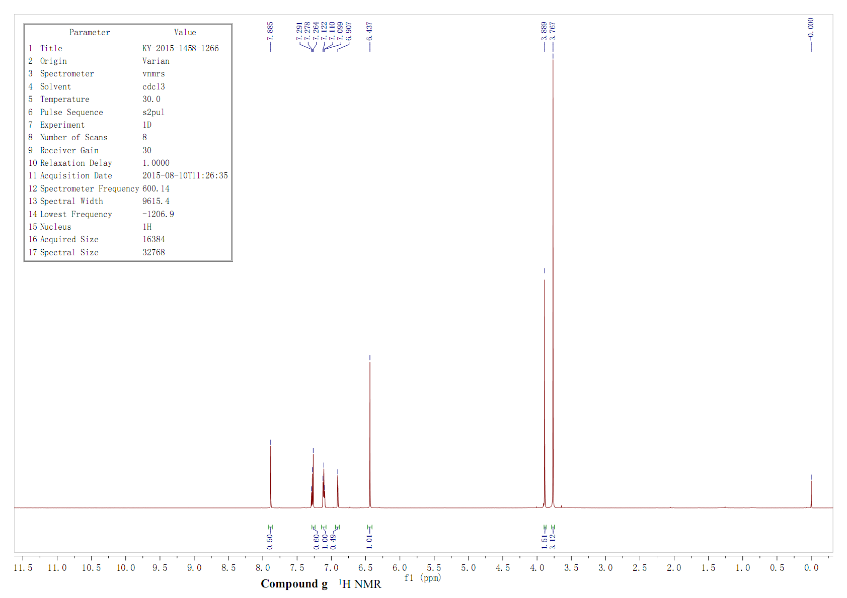Figure S14. ¹H NMR spectrum of compound g

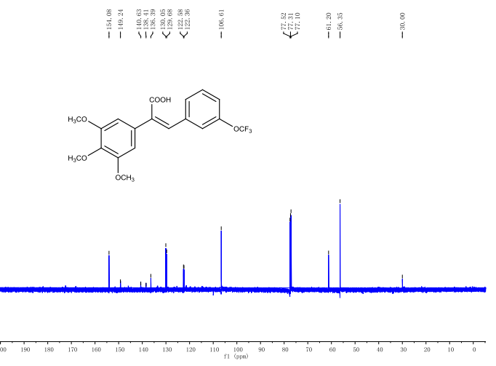Figure S15. ¹C NMR spectrum of compound g

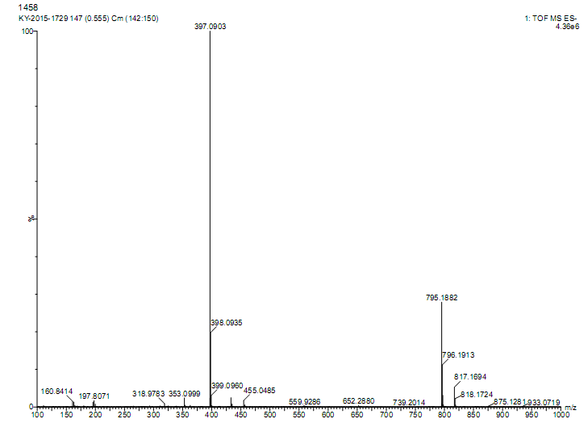Figure S16. HRMS spectrum of compound g

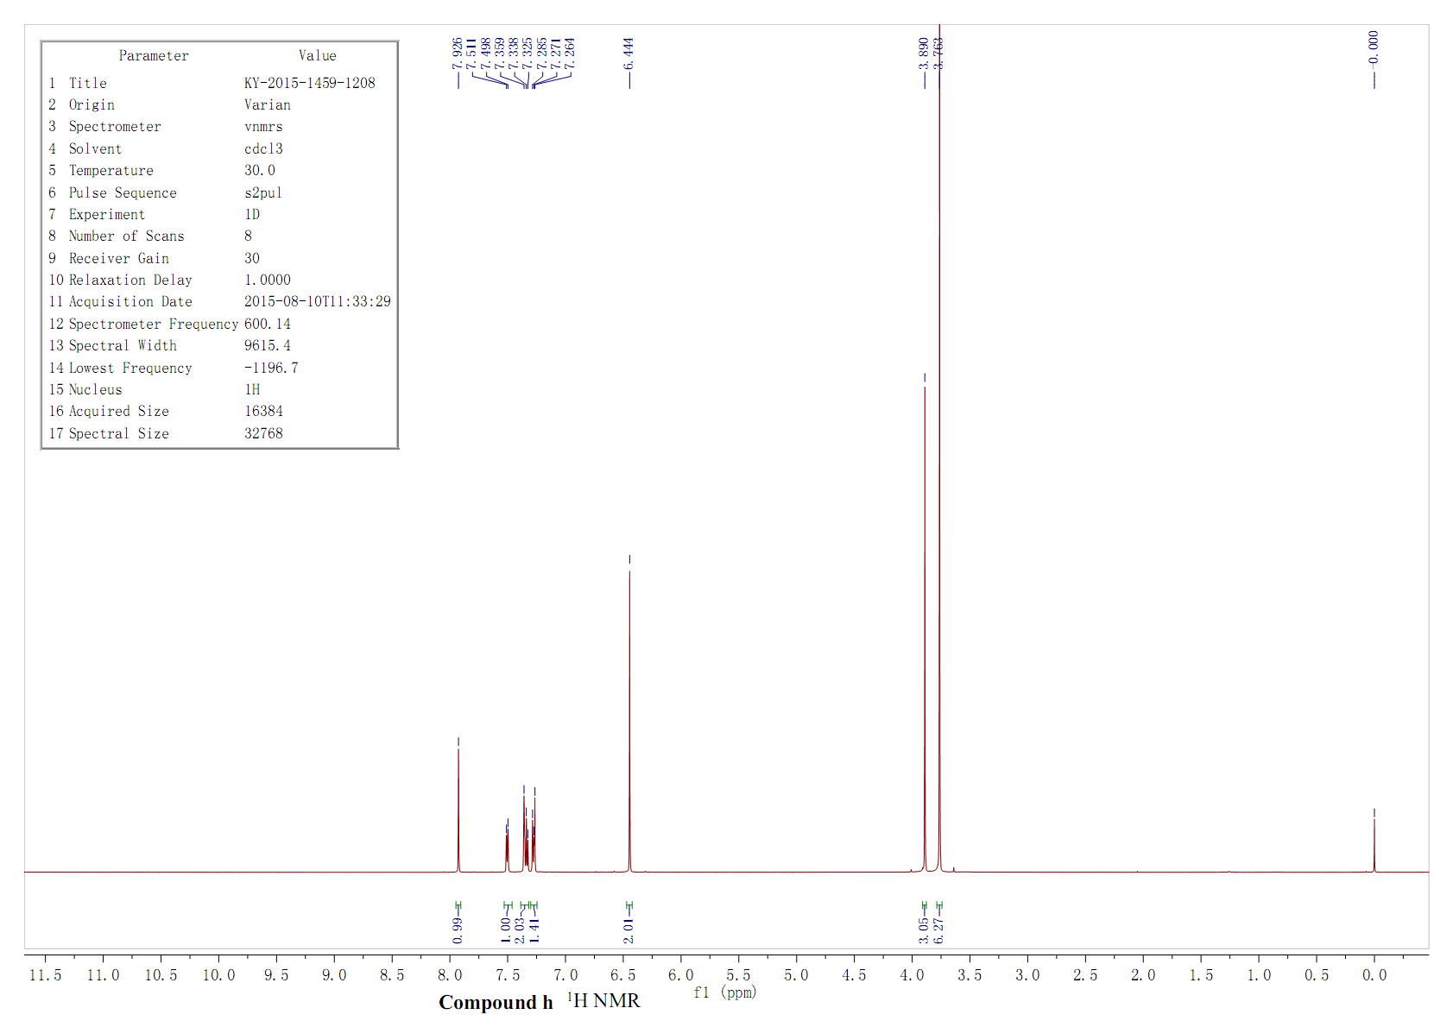Figure S17. ¹H NMR spectrum of compound h

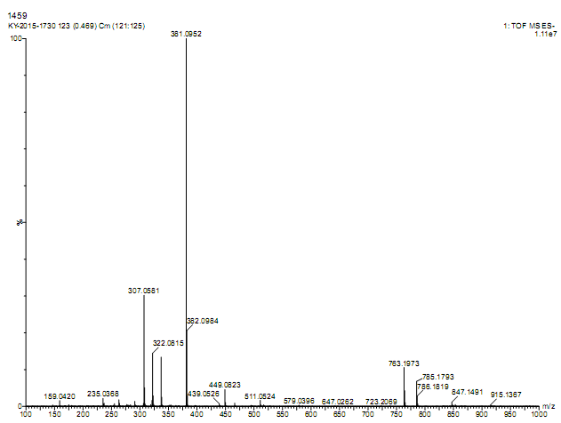Figure S18. HRMS spectrum of compound h

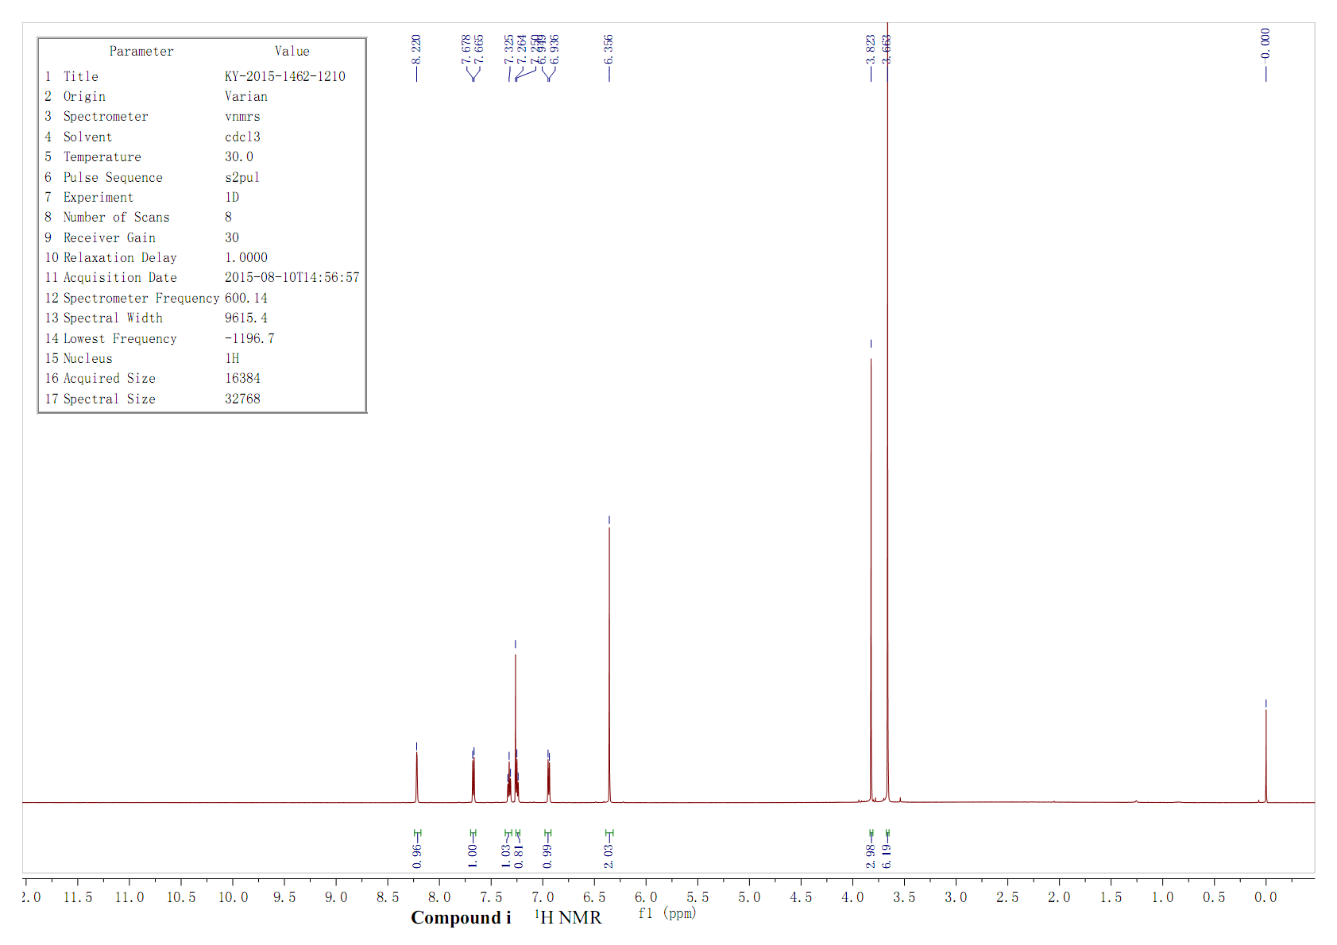Figure S19. ¹H NMR spectrum of compound i

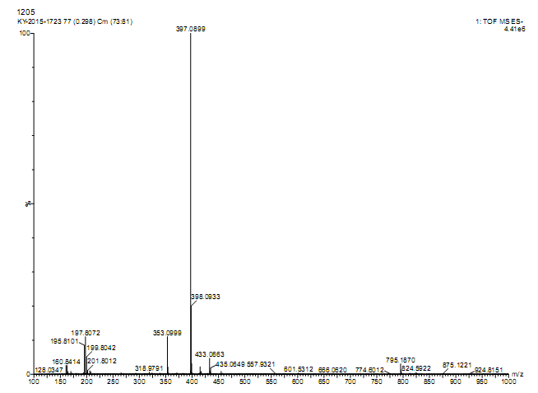Figure S20. HRMS spectrum of compound i

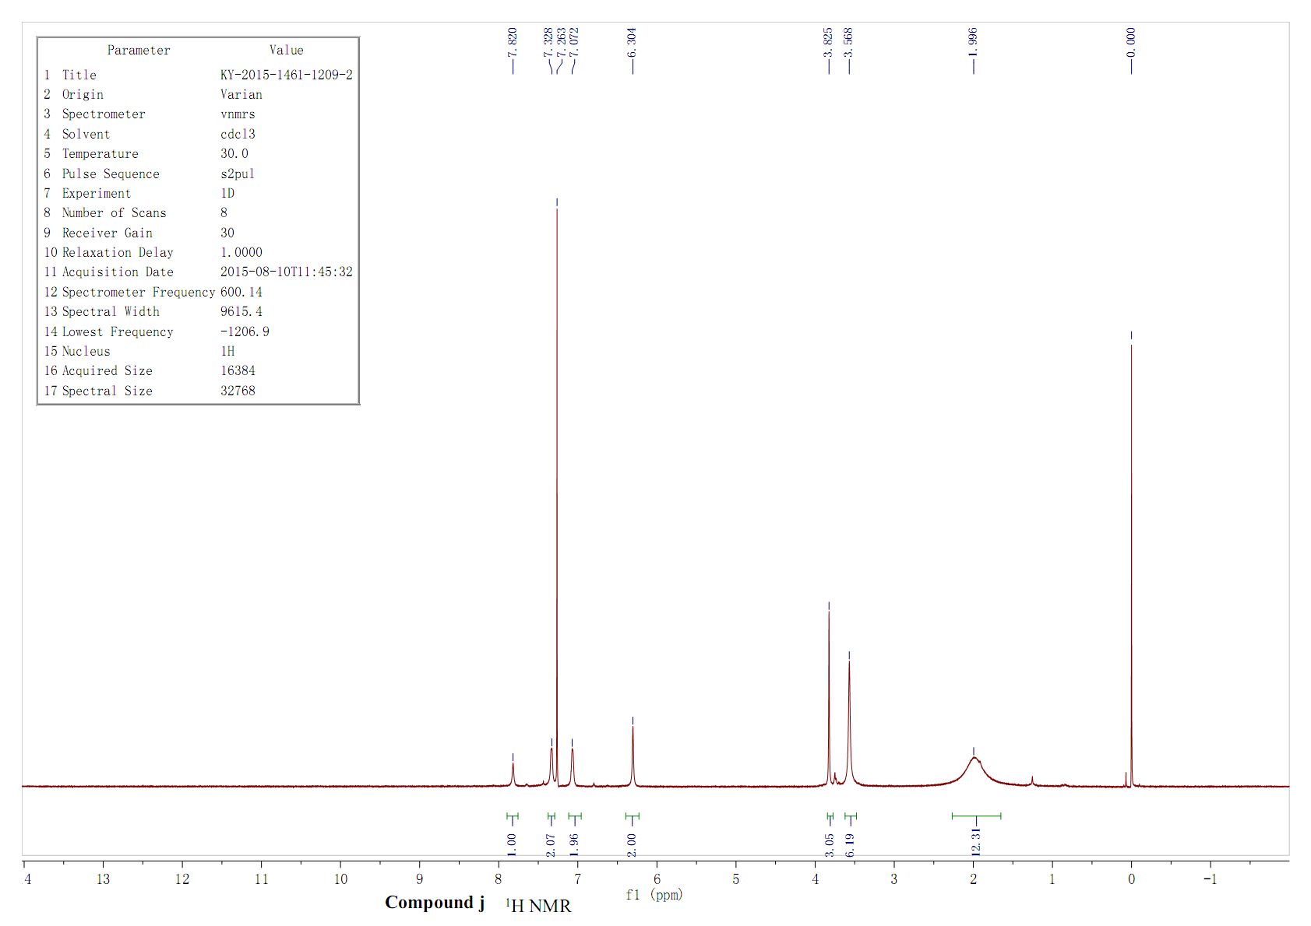Figure S21. ¹H NMR spectrum of compound j

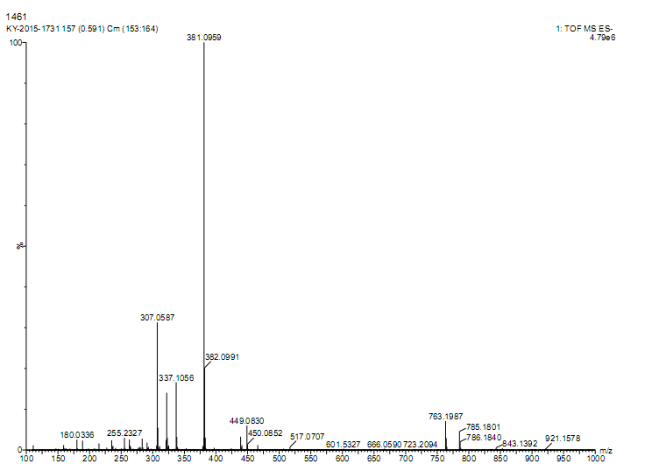Figure S22. HRMS spectrum of compound j

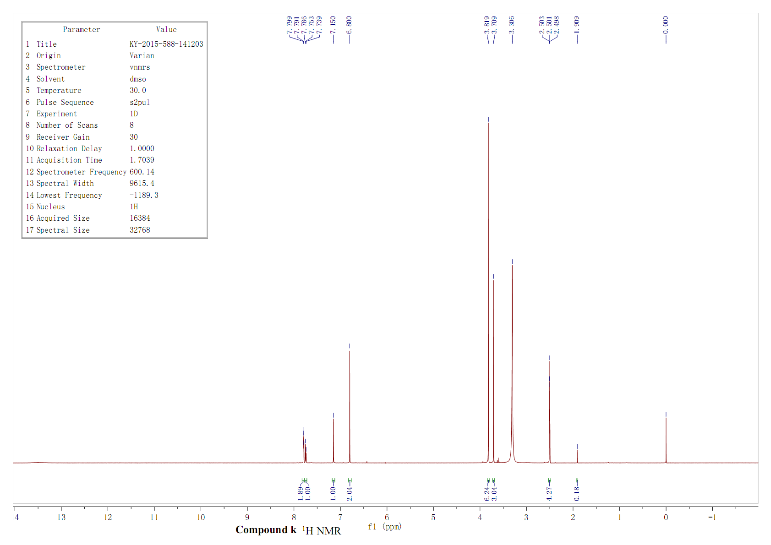Figure S23. ¹H NMR spectrum of compound k

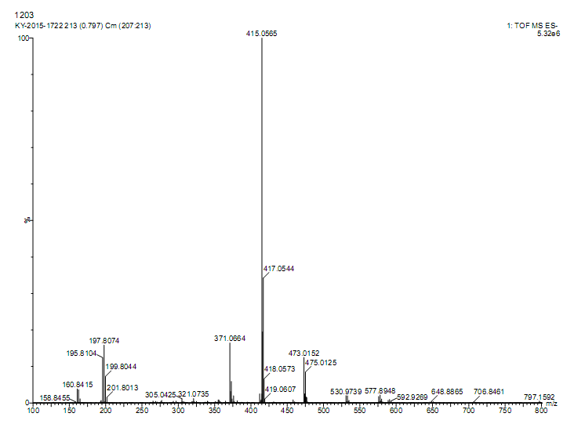Figure S24. HRMS spectrum of compound k

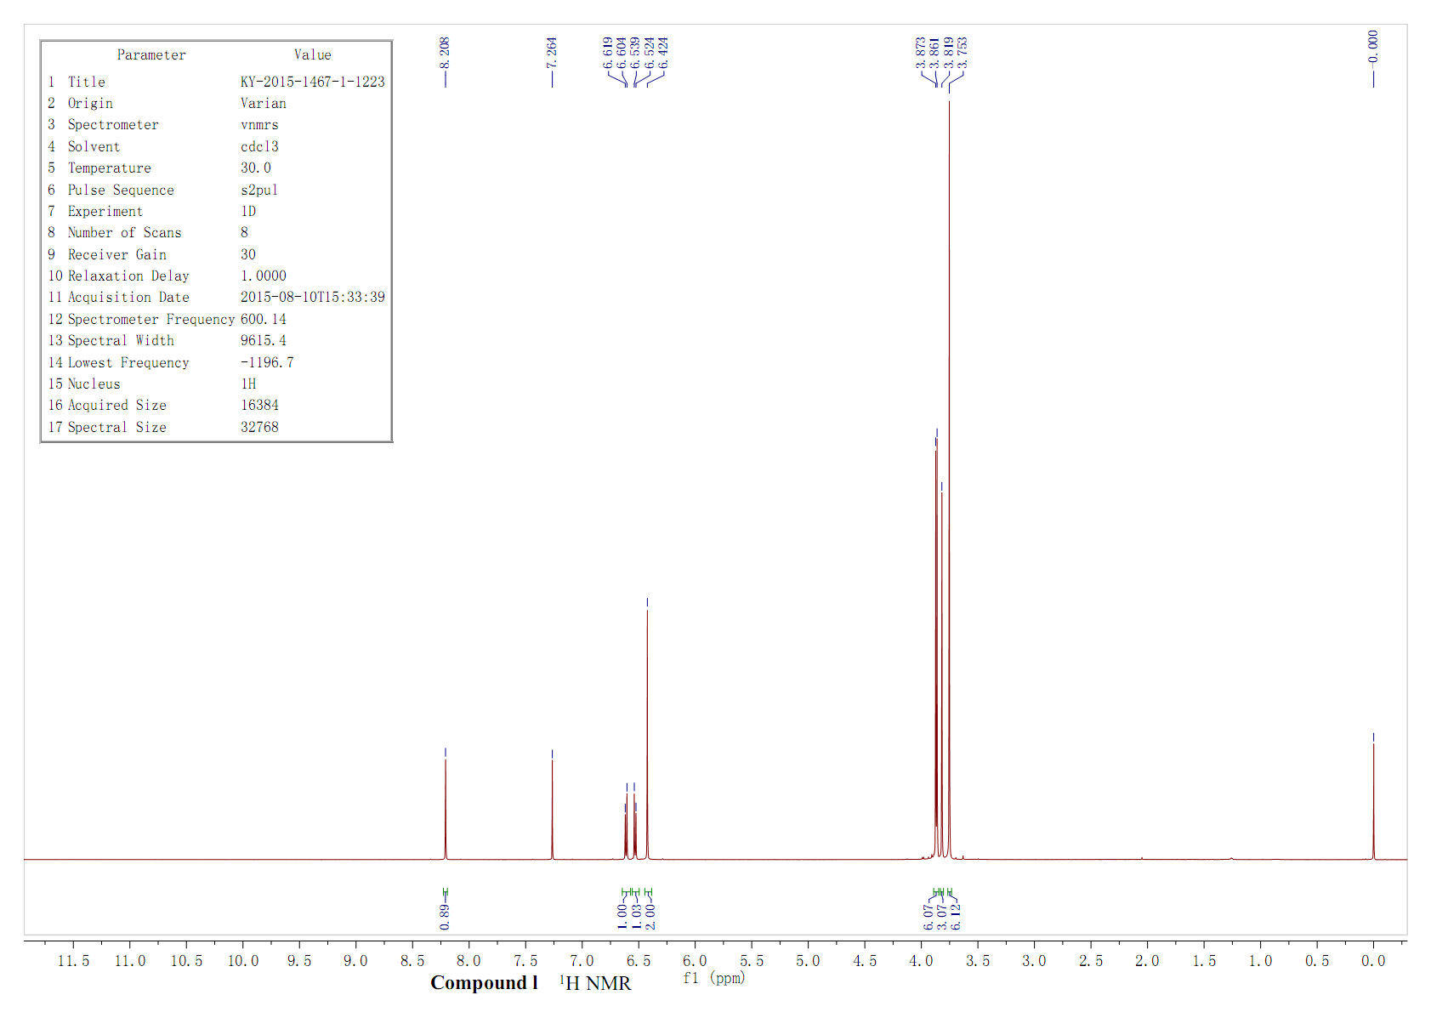Figure S25. ¹H NMR spectrum of compound l

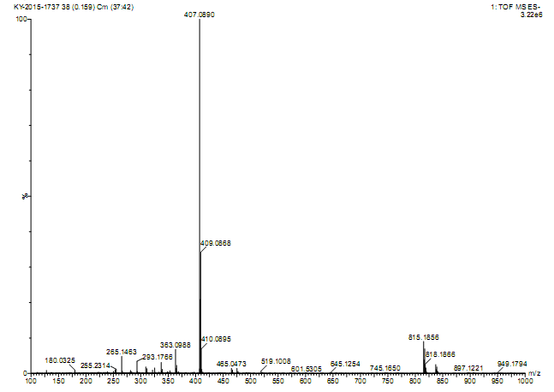Figure S26. HRMS spectrum of compound l

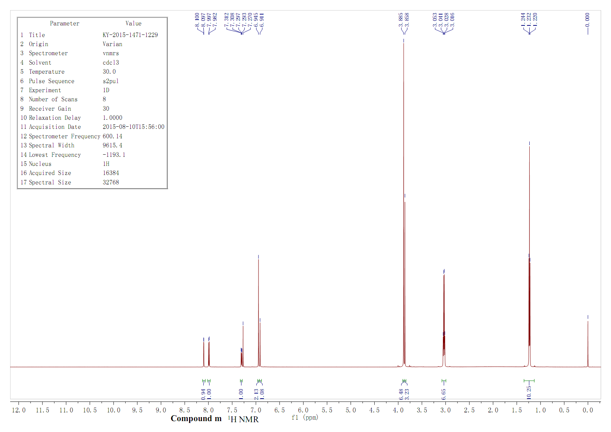Figure S27. ¹H NMR spectrum of compound m

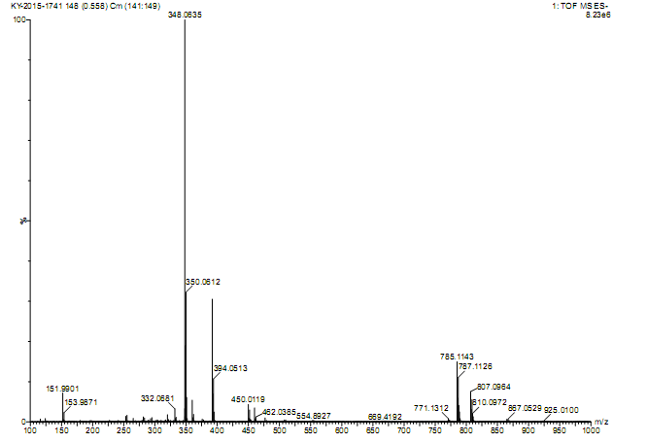Figure S28. HRMS spectrum of compound m

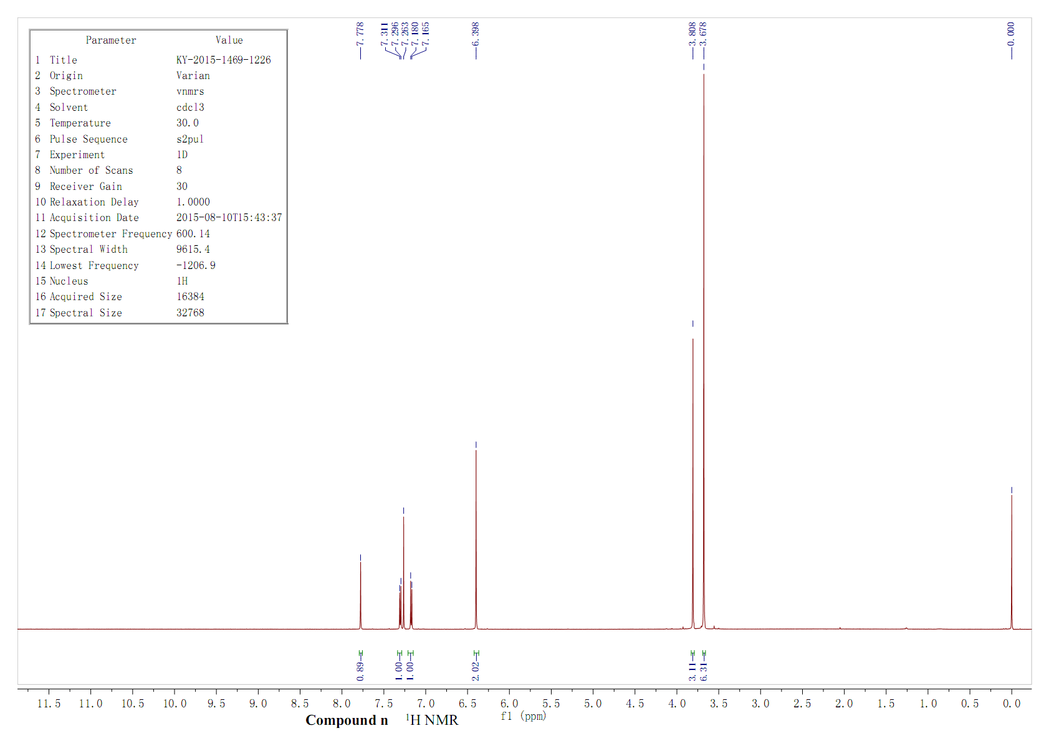Figure S29. ¹H NMR spectrum of compound n

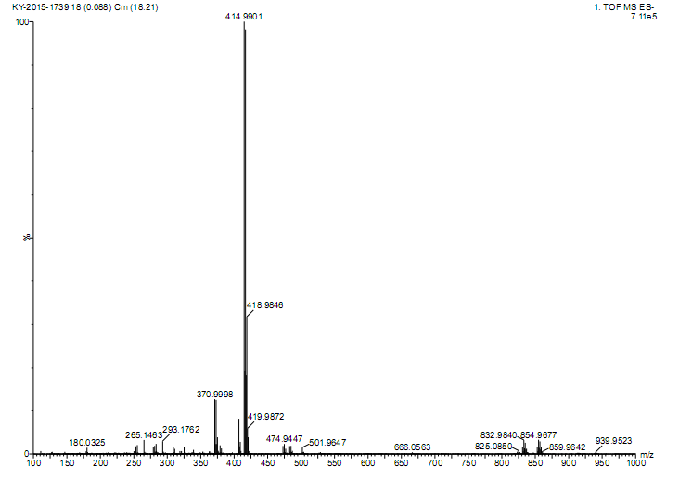Figure S30. HRMS spectrum of compound n

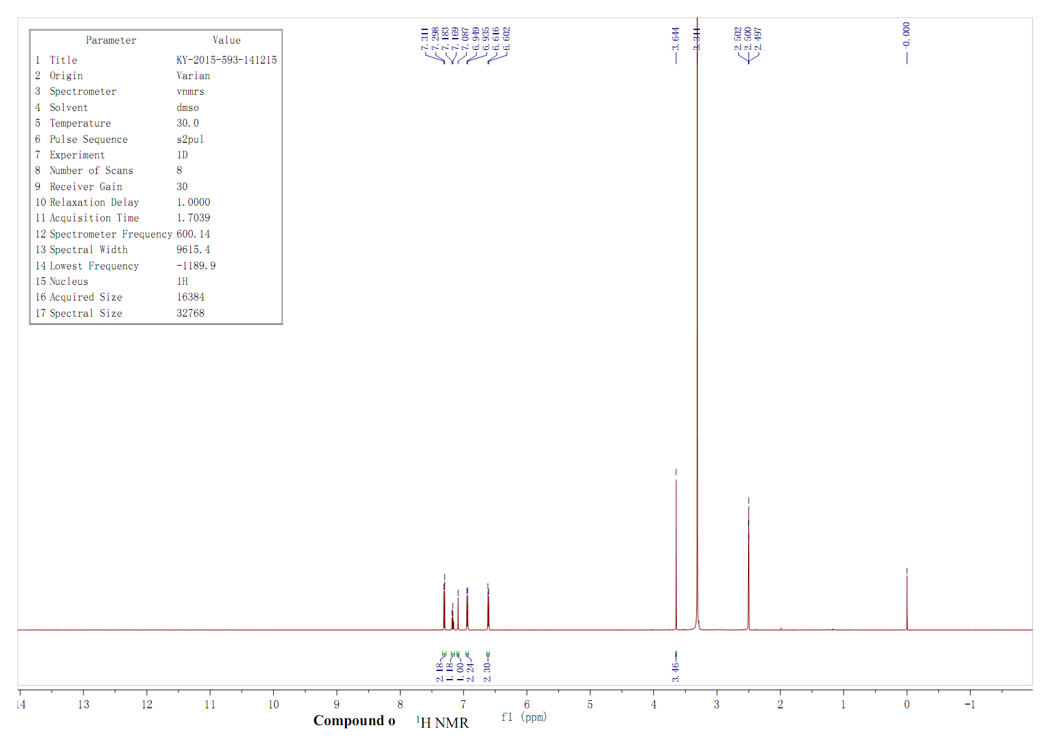Figure S31. ¹H NMR spectrum of compound o

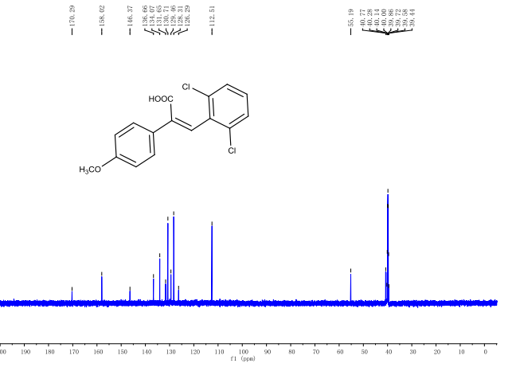Figure S32. ¹C NMR spectrum of compound o

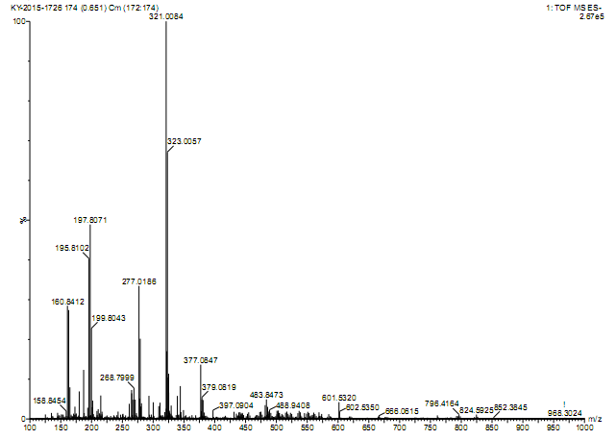Figure S33. HRMS spectrum of compound o

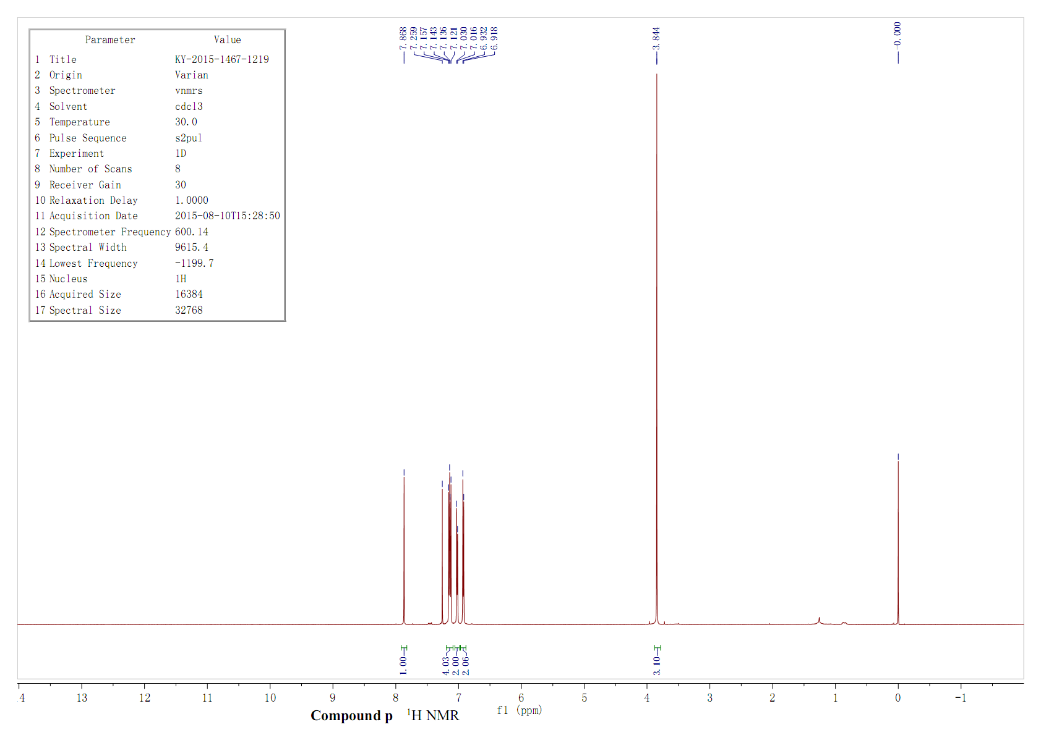Figure S34. ¹H NMR spectrum of compound p

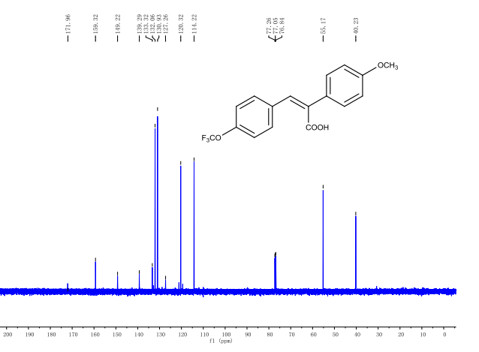Figure S35. ¹C NMR spectrum of compound p

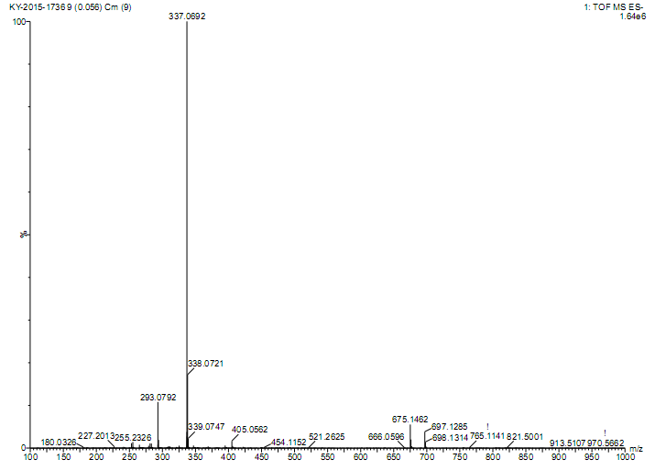Figure S36. HRMS spectrum of compound p

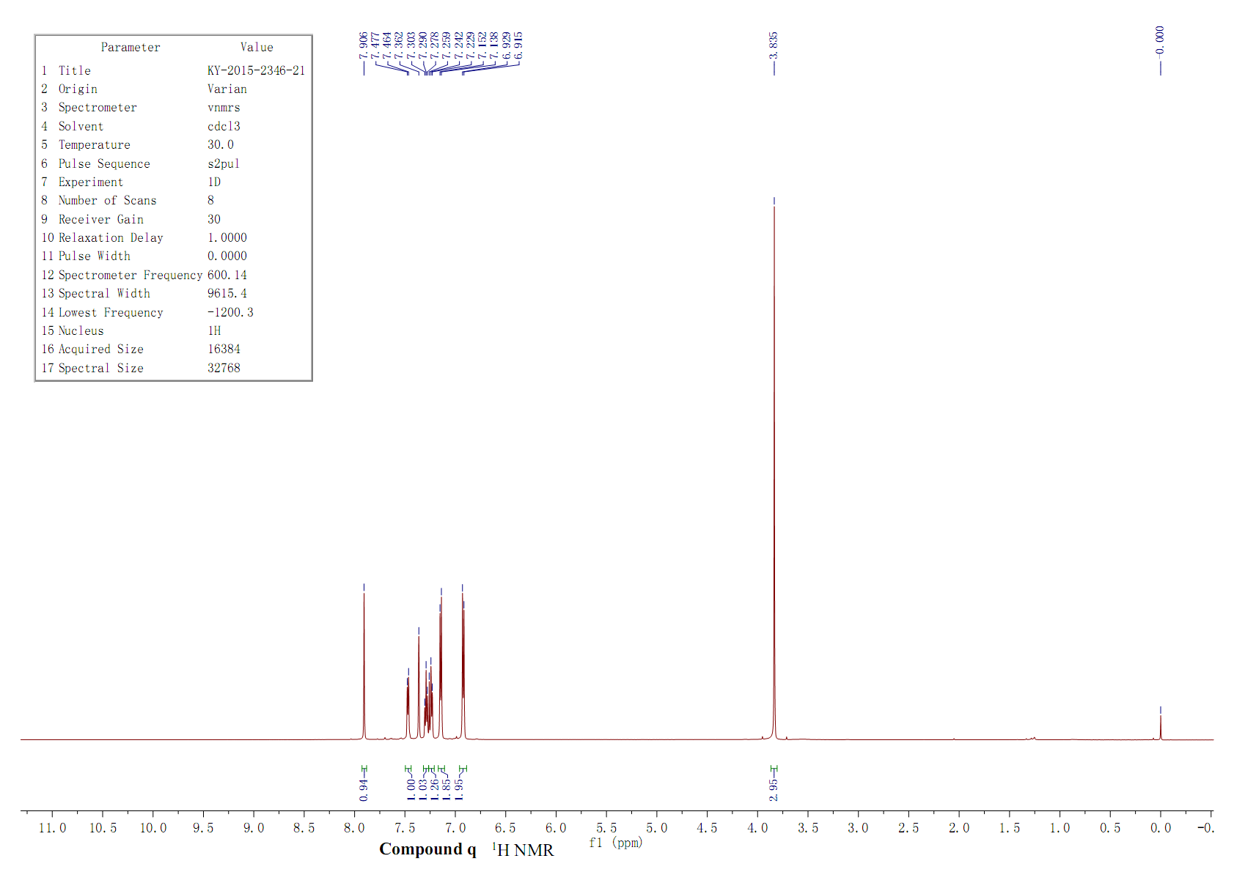Figure S37. ¹H NMR spectrum of compound q

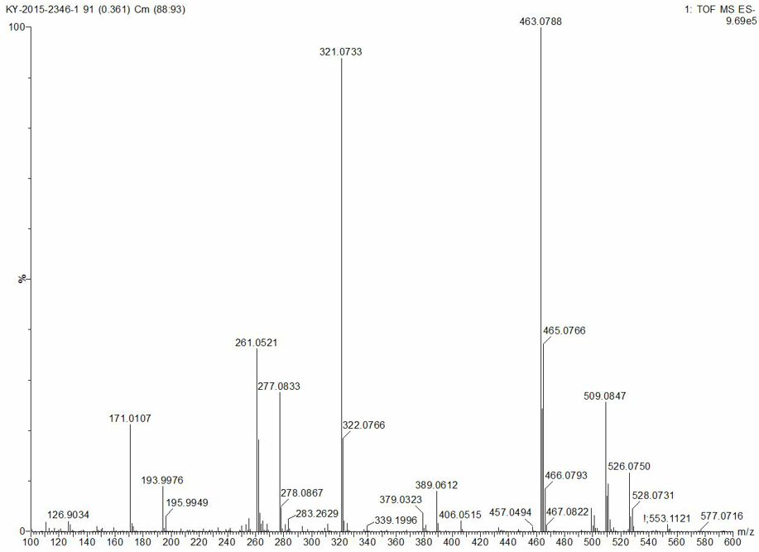Figure S38. HRMS spectrum of compound q

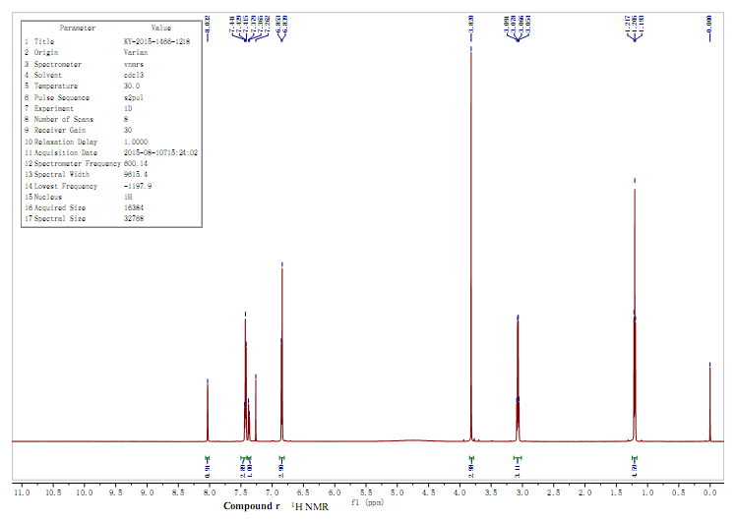Figure S39. ¹H NMR spectrum of compound r

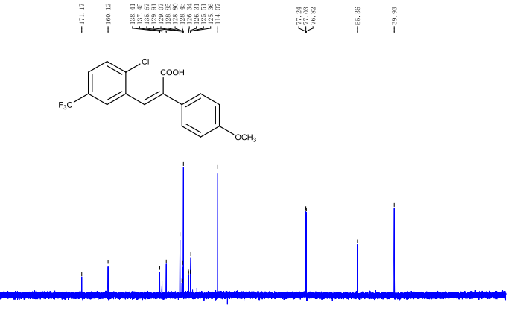Figure S40. ¹C NMR spectrum of compound r

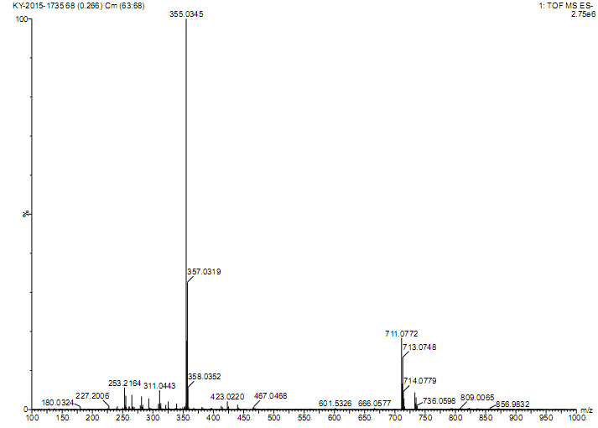Figure S41. HRMS spectrum of compound r

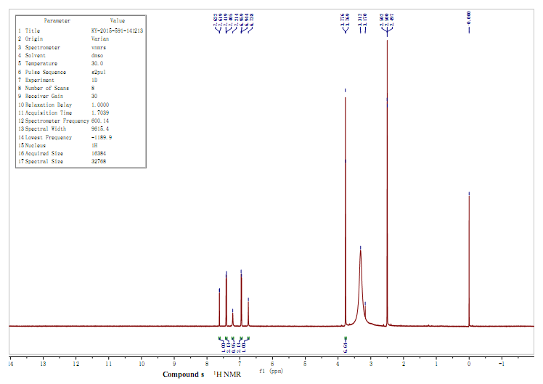Figure S42. ¹H NMR spectrum of compound s

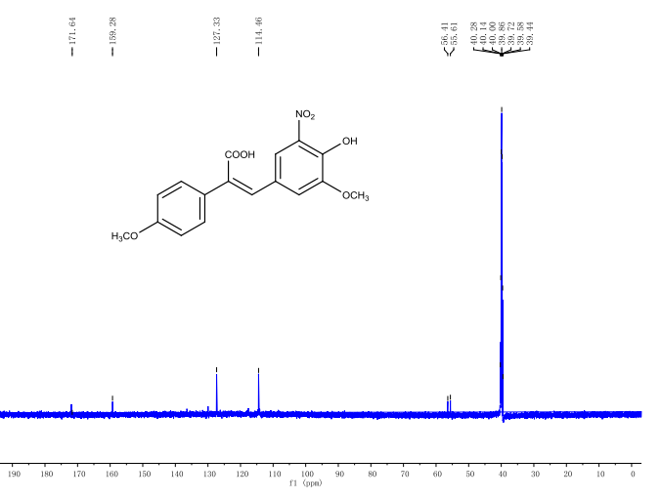Figure S43. ¹C NMR spectrum of compound s

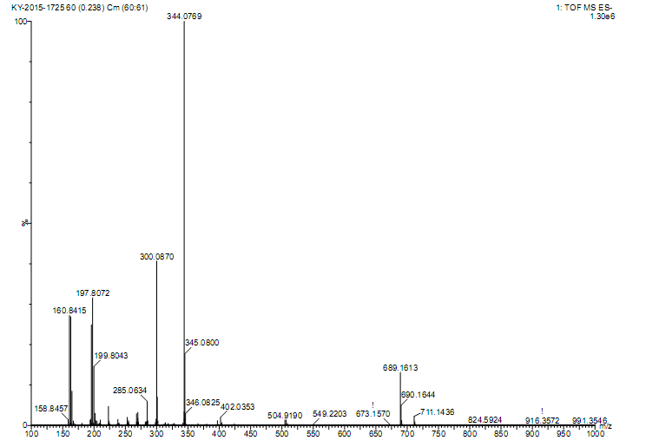Figure S44. HRMS spectrum of compound s

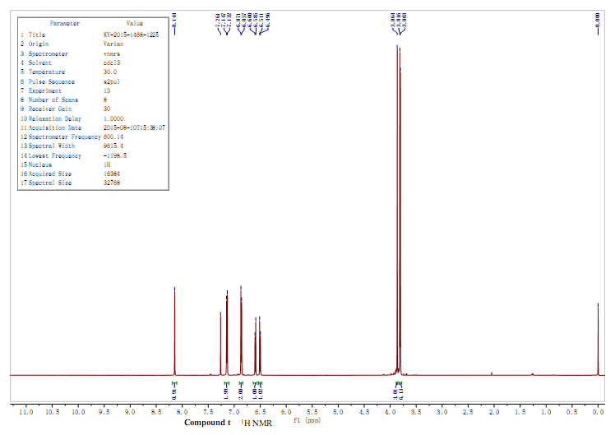Figure S45. ¹H NMR spectrum of compound t

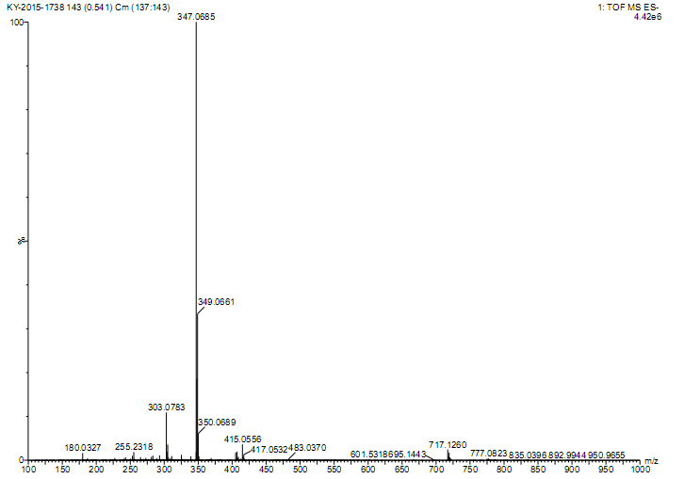Figure S46. HRMS spectrum of compound t

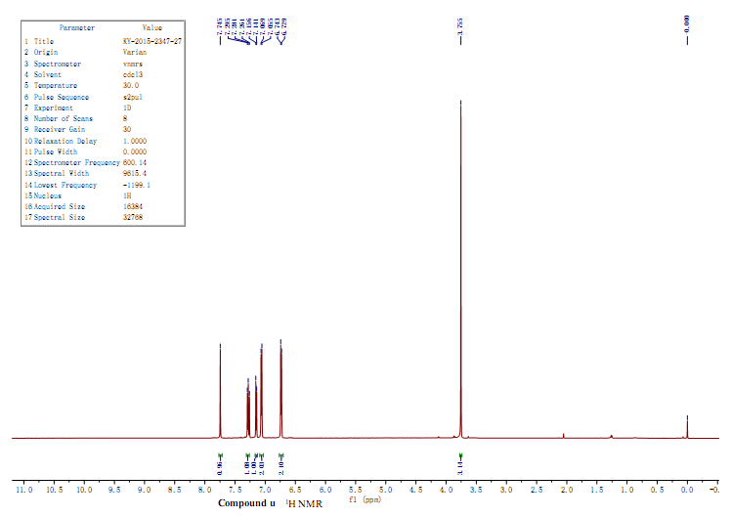Figure S47. ¹H NMR spectrum of compound u

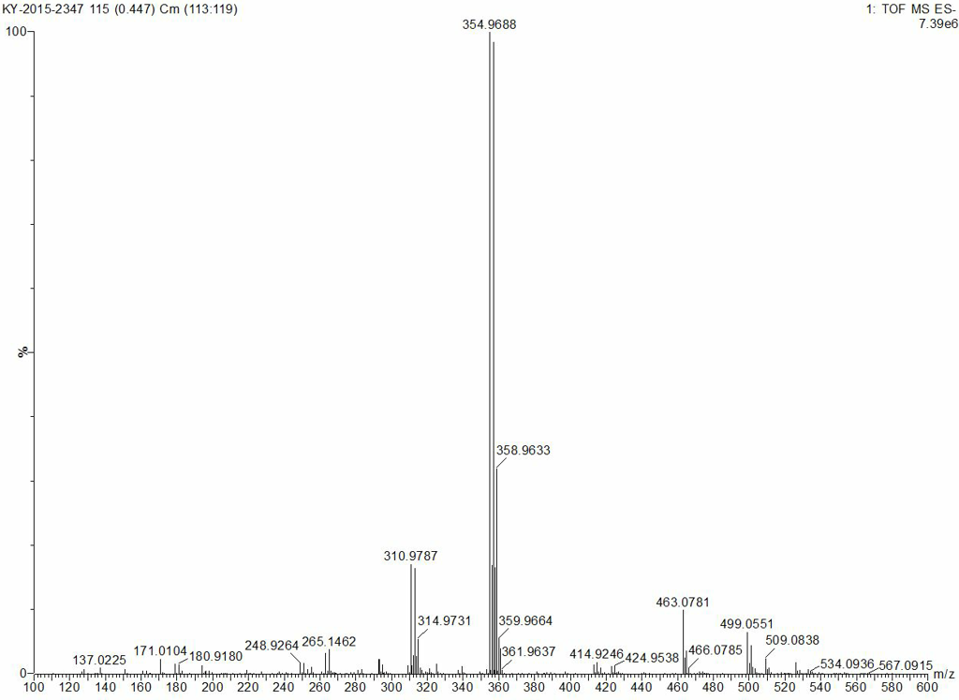Figure S48. HRMS spectrum of compound u

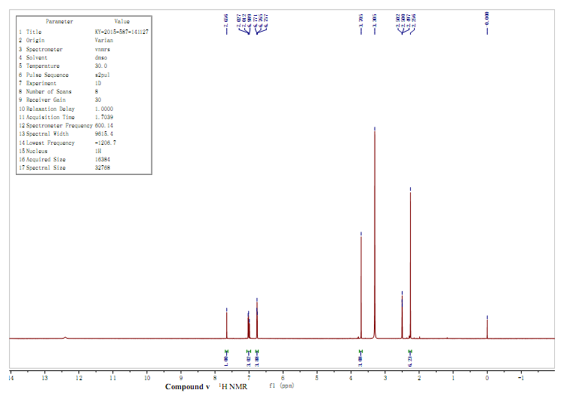Figure S49. ¹H NMR spectrum of compound v

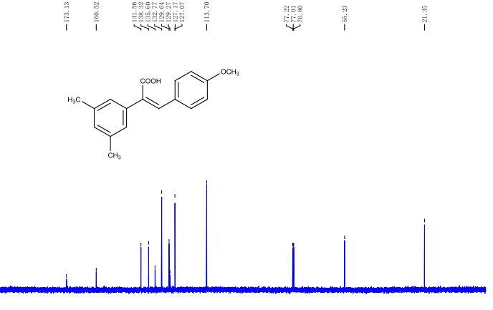Figure S50. ¹C NMR spectrum of compound v

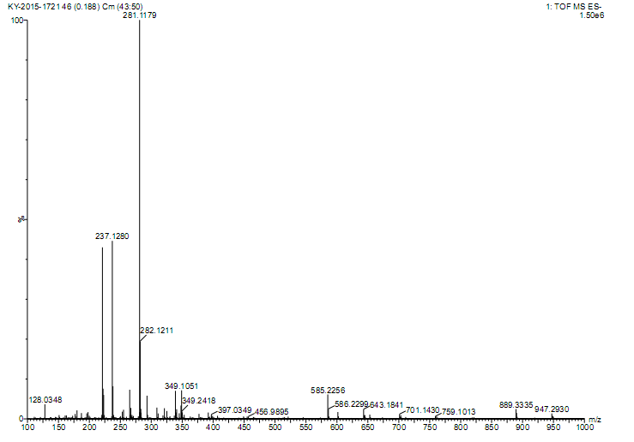Figure S51. HRMS spectrum of compound v

