Electronic Supplementary Material

Article type: Full length article

Three-dimensional structural evolution of the cuttlefish Sepia officinalis shell from embryo to adult stages

Charles Le Pabica, Julien Derrb, Gilles Luqueta, Pascal-Jean Lopeza, Laure Bonnaud-

Ponticellia*

a Unité Biologie des organismes et écosystèmes aquatiques (BOREA), Muséum national d’Histoire naturelle, UMR CNRS 7208, Université de Caen Normandie, Sorbonne Université,
IRD 207, Université des Antilles, 75005 Paris, France

b Unité Matière et Systèmes Complexes (MSC), Université Paris Diderot, UMR CNRS 7057, 75205 Paris Cedex 13, France

*Corresponding author. Tel.: + 33 1 40 79 53 48

E-mail address: laure.bonnaud@mnhn.fr (L. Bonnaud-Ponticelli)

Running head: Sepia shell 3D-structure

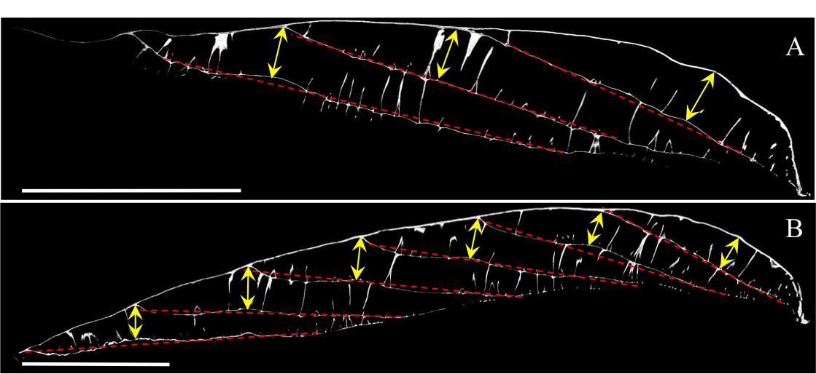

Figure S1. CAT-scan pictures of A) stage 27 and B) stage 30 shells along a mid-sagittal plan illustrating the method to measure the shell chamber heights. Scale bars: 1 mm.

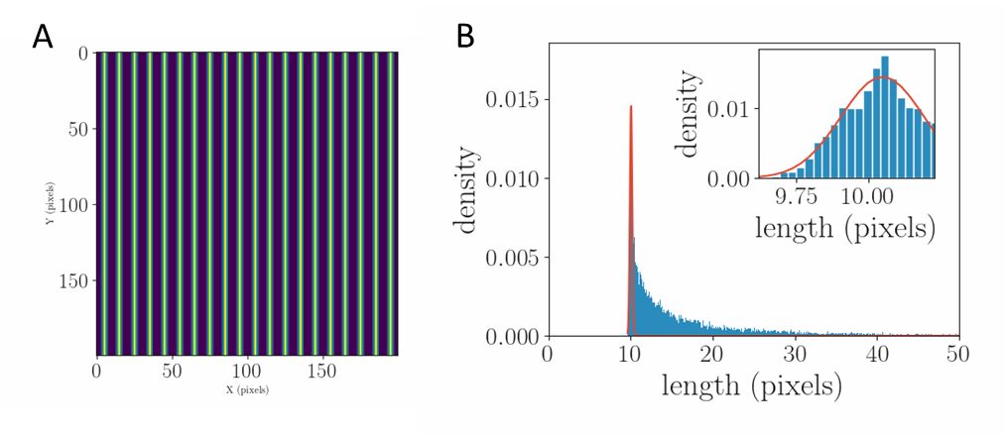

Figure S2. For a stereotype example consisting of parallel lines spaced by a tabulated value of 10 pixels (figure S2A), we obtained a distribution (figure S2B). The distribution is characterized by a steep increase starting at x_start=9.61 pixels, leading to a maximum value at x_max = 10.05, then by a long tail of longer measures corresponding to artefacts extending to length higher than 50 pixels and slowly decreasing in density. These last measurements are due to geometrical biases when the 1D cut is tilted with respect to the principal direction of the stripes. The same patterns in the distribution were obtained for real images. Our methodology consisted in fitting the first sharp peak of this distribution in order to define the characteristic length scale of the images. To do so, we filtered the data by setting the arbitrary range (x in [x_start,x_max+0.5*(x_max-x_start)]). Finally, we fit the sharp peak in this range by a Gaussian function centred in x_peak, and with standard deviation sigma_peak. For our test image, our method gives x_peak=10.04, with standard deviation sigma_peak=0.14, which is in very good agreement with the theoretical value of 10 pixels.
Therefore, we defined as pillar spacing the position of the first sharp peak obtained in our length distribution. The procedure has then been repeated in order to get enough measurements for each chamber to reduce the standard error lower than the typical symbol size (typically between 500 and 1000 measurements).

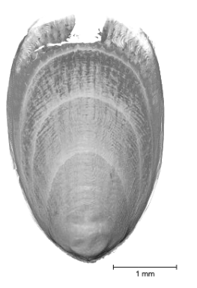
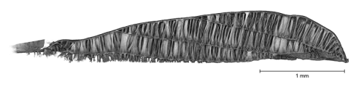
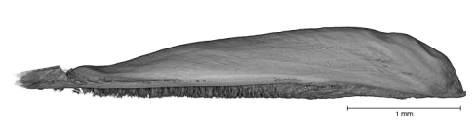
A

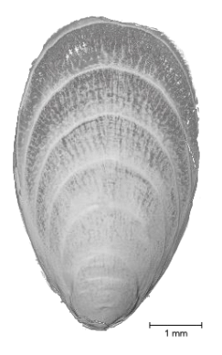
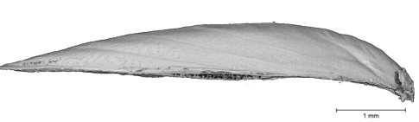
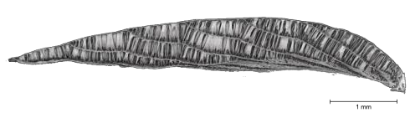
B

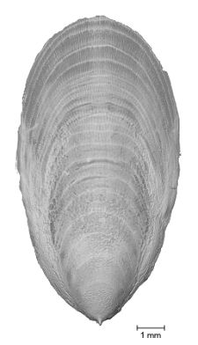
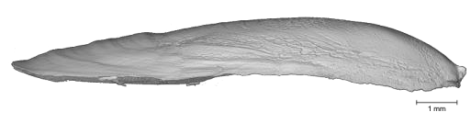
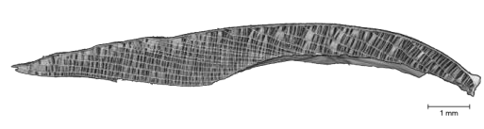
C

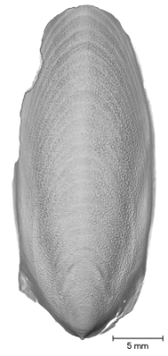
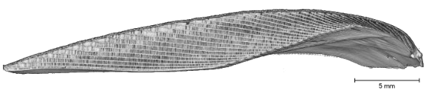
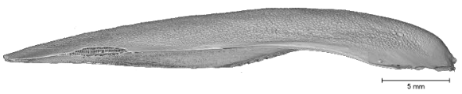
D

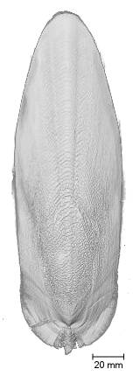
E

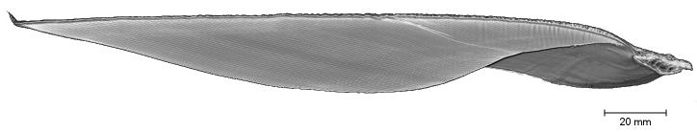

Figure S3. 3D images of the different shells studied at A) embryonic stage 27, B) embryonic stage 30, C) 1-month and D) 3-month old, and E) adult stages. Every shell is represented by external dorsal and lateral views, and internal lateral view. Scale bars are 1 mm for A), B) and C), 5 mm for D), and 20 mm for E). The growth allometry is clearly visible between embryo and adult shells. Arrowheads indicate the spine.

Figure S4. Embryonic stage 27 shell movie showing external and internal structures.

Figure S5. 3-month old shell movie showing the internal labyrinthine structure.

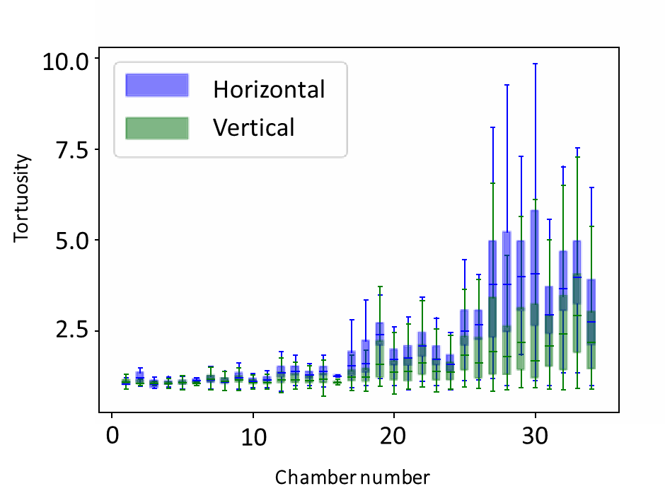
Figure S6. Boxplot representing the evolution of pillar network tortuosity in the different chambers of the 3-month shell with segregation of horizontal (blue) and vertical (green) tortuosity

