Electronic Supplementary Material for:
Cretaceous winged stick insects clarify the early evolution of Phasmatodea
Hongru Yang¹, Xiangchu Yin², Xiaodan Lin¹, Chen Wang³, Chungkun Shih^{1,4}, Weiwei Zhang⁵, Dong Ren^{1,}* and Taiping Gao^{1,}*
Proceedings of the Royal Society B: Biological Sciences
Figure S1. Phylogeny of Phasmatodea by using WinClada (Version1.00.08) and NONA (Version 2.0). (•) Unambiguous unique characters; (◦) Homoplasious characters.
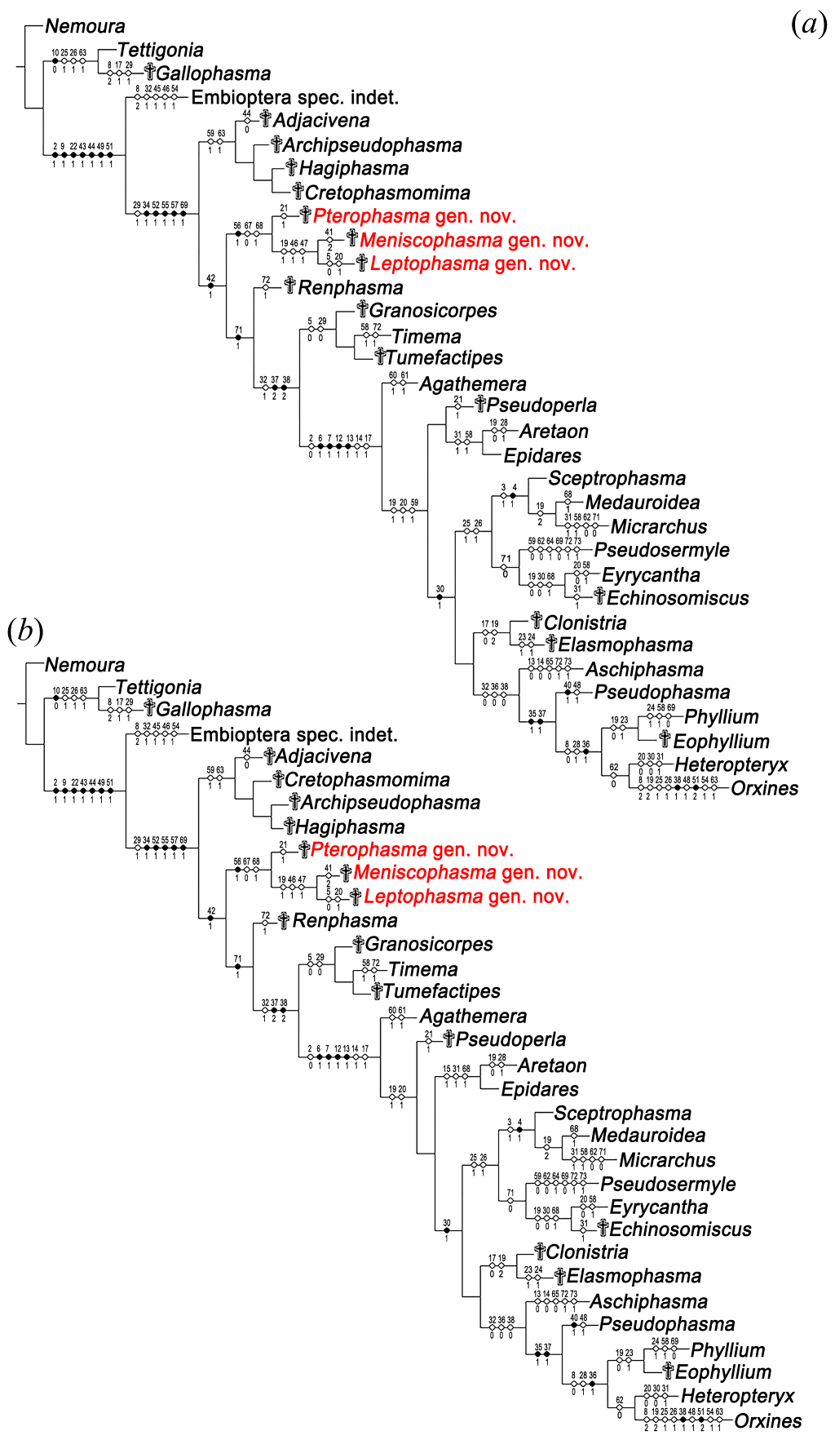
Figure S2. Phylogeny of Phasmatodea by using TNT (Version1.5).
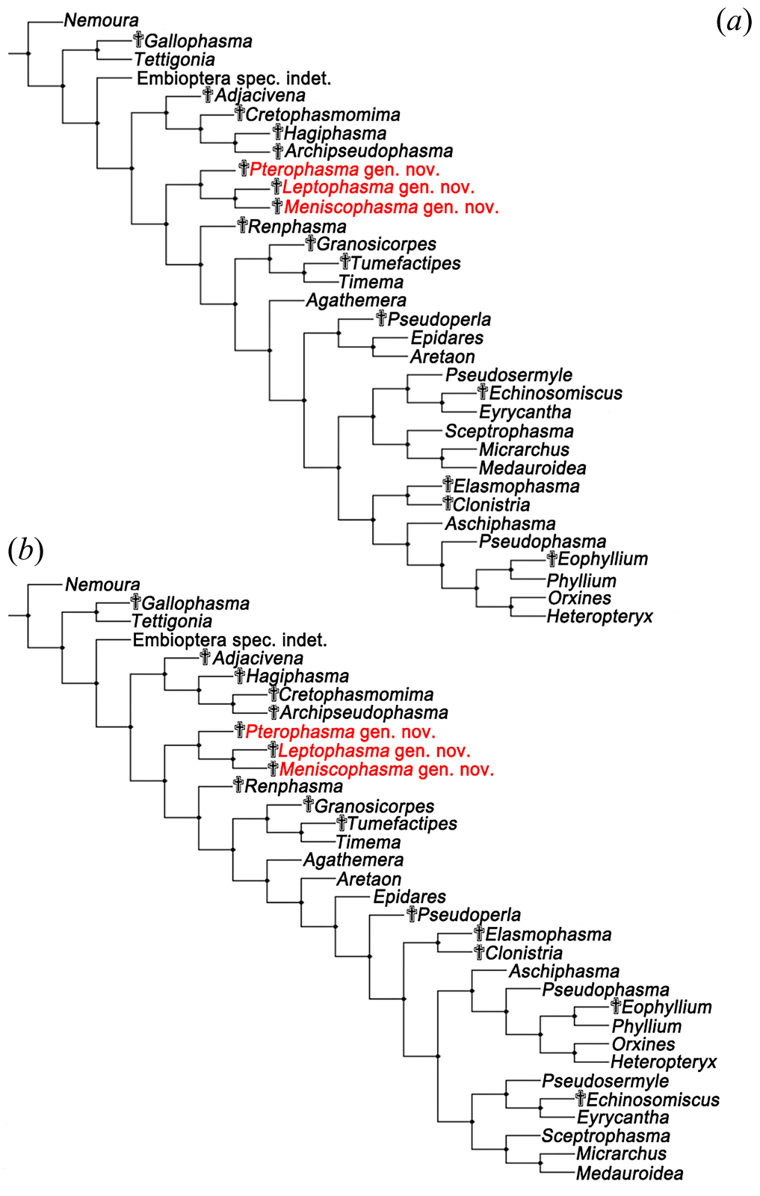
Figure S3. Supporting values of strict consensus trees. (a) Bootstrap supporting values are represented as numbers under the branch nodes (data in blue); (b) Bremer supporting values are represented as numbers on the branch nodes (data in purple).
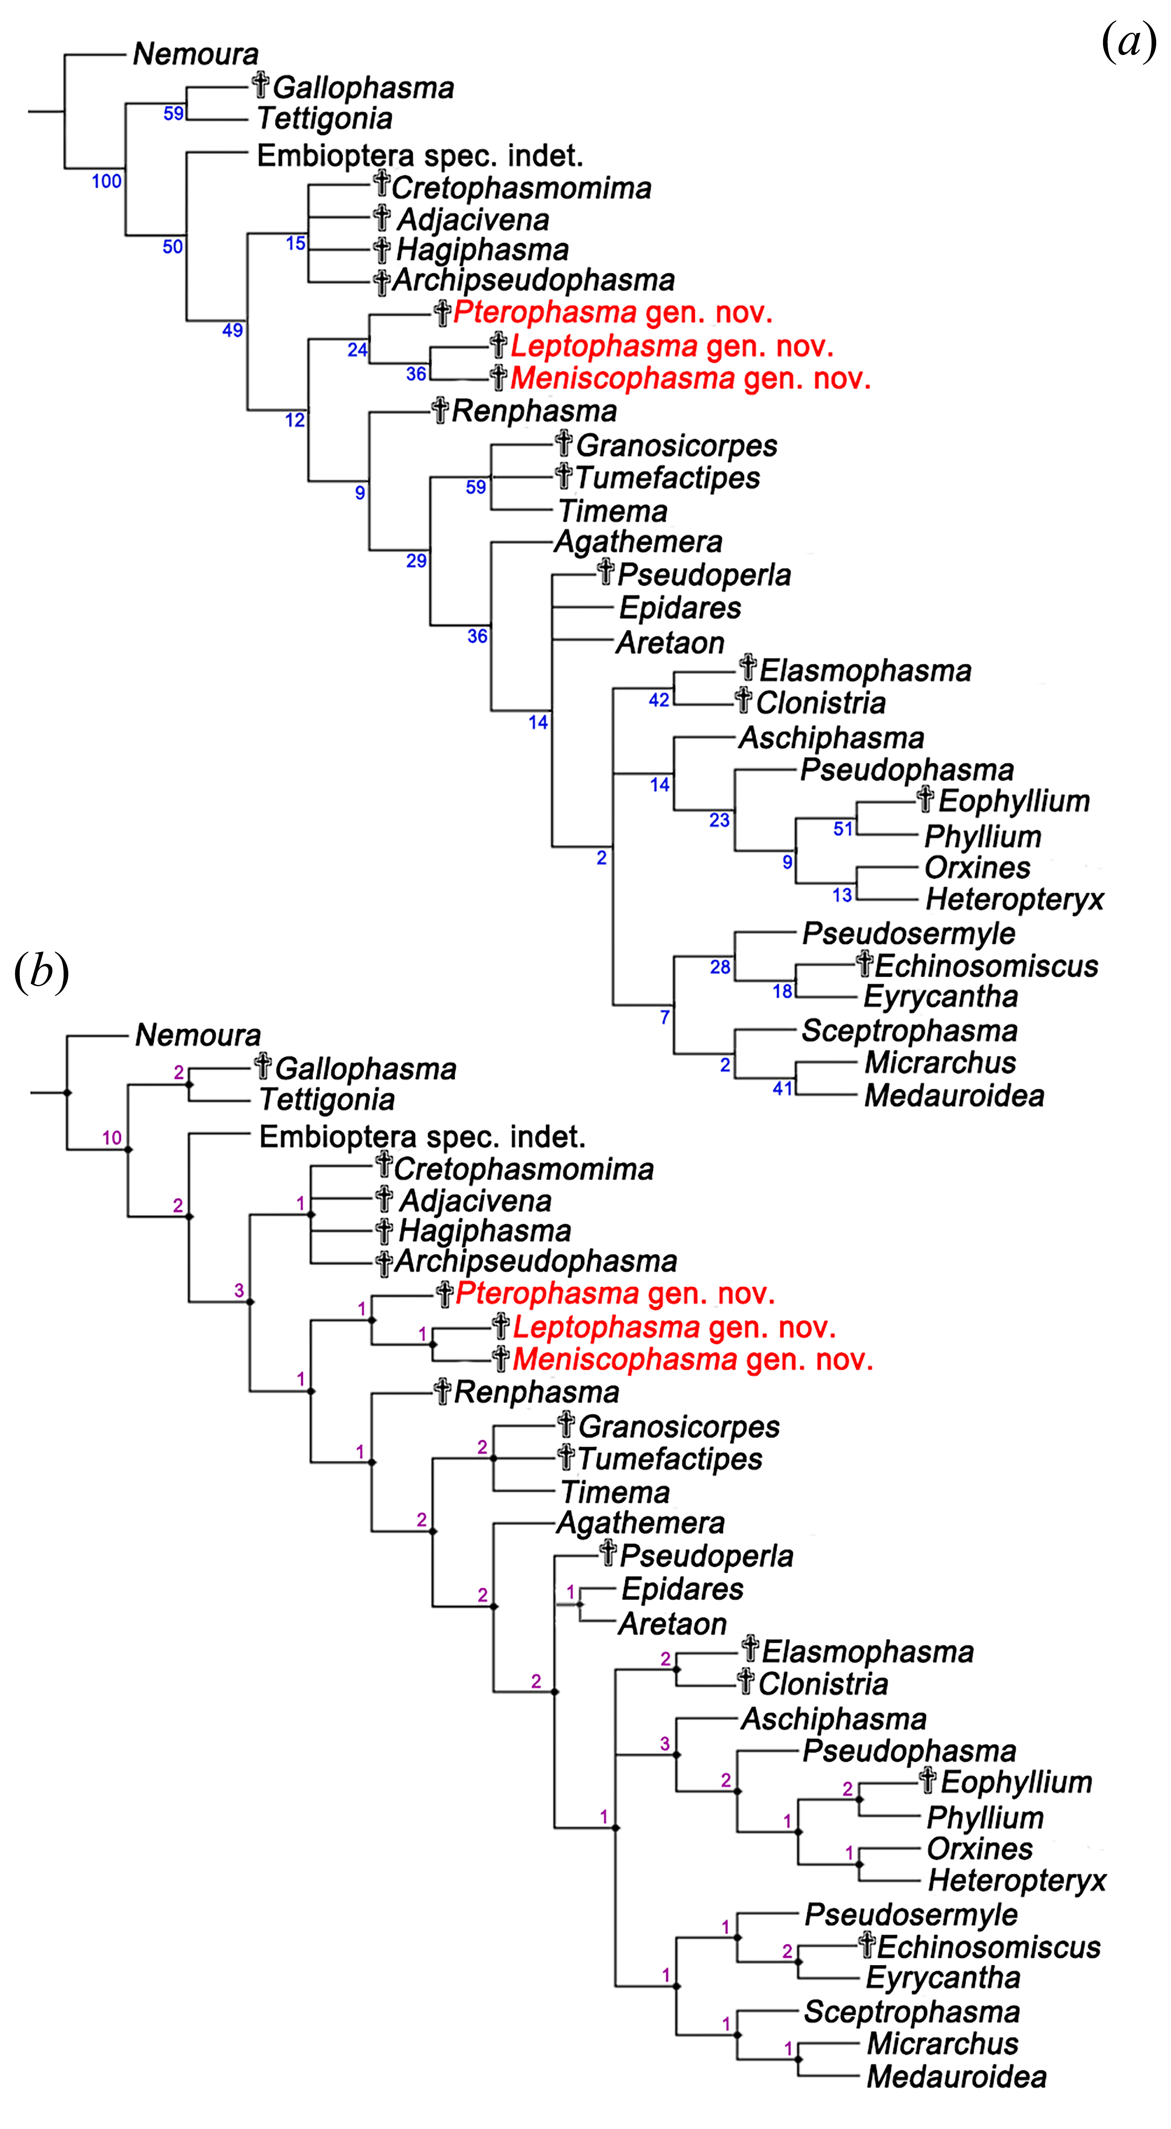
Figure S4. Heteropteryx dilatata Parkinson, 1798
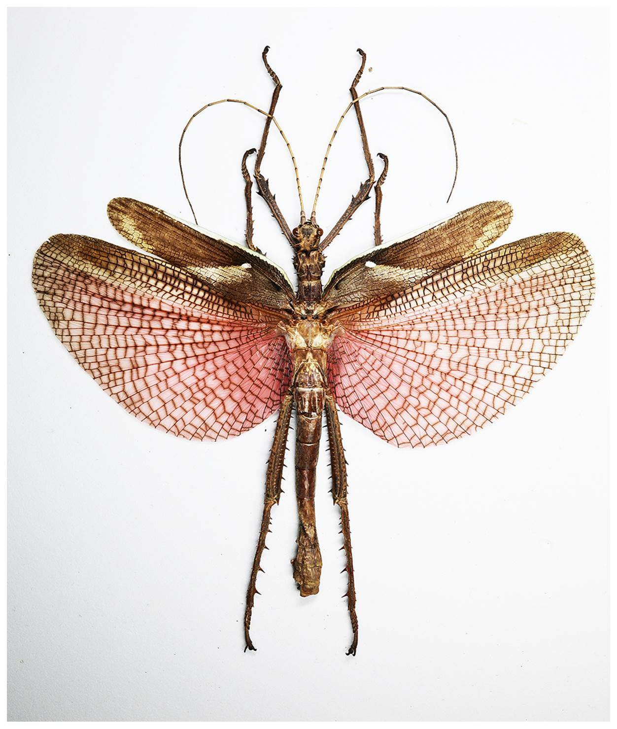

Figure S5. Sipyloidea amica Bei-Bienko, 1959
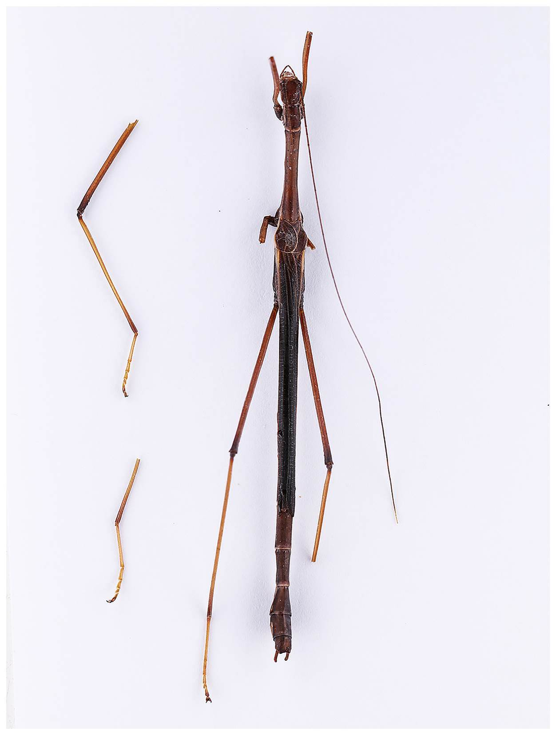

Data S1. Pterophasma erromera Yang, Shih, Ren & Gao gen. et sp. nov.
Description. Fully winged male (figure 2a, b); whole body covered with numerous setae; head ovoid in dorsal view, prognathous; three ocelli present in vertex; compound eyes subglobose, exophthalmic; antennifer well-defined; antenna filiform, bearing numerous setae, distinctly longer than profemur, with a prominence on surface of pedicel base (figure 2c); right antenna with 13 antennomeres as preserved; scape cylindrical, longer than wide; pedicel cylindrical, shorter and thinner than scape; first flagellomere shorter than scape and pedicel combined; left antenna with only one scape as preserved (figure 2e); labrum emarginated (figure 2g); maxillary palps pentamerous, with numerous setae; cervix not preserved.
Prothorax slightly shorter than meso- and metathorax; pronotum rectangular, longer than width, no extension of the lateral margin; apertures of prothoracic defensive glands not clear due to preservation, distinctly transverse furrows on anterior part of pronotum (figure 2e); meso- and metathorax covered with wings; metasternum distinctly fused with abdominal sternum I.
Tegmina (figure 5f) slightly shorter than hind wings at rest; with the pronounced ‘knob-like dorsal eversion’ (figure 2d); without ‘procostal’ area; area between costal margin and ScP wide in proximal part; ScP about 5.4 mm long as preserved, parallel and close to RA; RA single and straight; RP with two branches, forking at about two third of wing length; MA and MP single; CuA+CuPaα with two distal branches; CuPaβ and CuPb single and straight respectively; two anal veins present, anal area with many cross-veins.
Hind wings extending beyond tegmina at rest (figure 2a, b), with the distal portion not covered by tegmina, wing venation not clear due to overlapping.
Fore and middle legs much shorter than hind legs, metafemora thicker and stronger than pro- and mesofemora; all femora round in cross section; profemora straight (figure 2a, b); trochanter small and tightly connected with femur; all tibiae round in cross section, with Y-shaped area apicalis but without spines (figure 2h); with a spine at the base of hind tibia (figure 2a, b); basitarsus elongate, but shorter than remaining tarsomeres combined; all tarsi five-segmented, with large arolia and euplantulae (figure 2h); left foreleg and hind leg not preserved.
Abdomen ventrally with a longitudinal median carina, lateral edges obvious; eleven abdominal segments preserved (figure 2a, b); segments II–VII of similar length and width; segment VIII shorter than segment VII; abdominal stigmata VIII moving back to the middle of the segment; segment X longer than segment IX, apex cleft into two lobes medially, thorn pads on the hind margin, with only two teeth on either side (figures 2f and 6a, b); epiproct and paraproct apparently (figures 2f and 6c); subgenital plate splitting into two parts transversally (figure 6a, b, denoted in blue and purple), apical part with two lobes (figure 6a, b, denoted in purple), reaching the base of segment X; two phallomeres broad and lamelliform (figure 6a, b, denoted in yellow); cerci bifurcated in basal position, outside one straight, thickened at the base and tapered toward the apical, inside one curved inward, cylindrical, both un-segmented, circular in cross section, with abundant elongated setae (figure 6a, b, c).
Measurements (in mm): body 17.34 (excluding antennae); head 2.11; right antenna (as preserved) 11.87; scape 0.52, pedicel 0.42, flagellomeres I–V 0.78, 0.48, 0.69, 0.88, 0.90, VI–VIII 1.10, IX–XI 1.30; prothorax 1.78; mesothorax 2.26; metathorax 3.22; tegmina 12.80; abdomen 8.85; profemur 2.72, protibia 2.25, protarsus 2.03, mesofemur 2.44, mesotibia 2.02, mesotarsus 1.83, metafemur 5.21, metatibia 4.97, metatarsus 2.76.

Data S2. Leptophasma physematosa Yang, Shih, Ren & Gao gen. et sp. nov.
Description. Fully winged male (figure 3a, b); whole body covered with numerous setae; head ovoid in dorsal view, prognathous; ocelli absent; compound eyes subglobose, exophthalmic; antennifer well-defined; antenna filiform, with 12 antennomeres as preserved, bearing numerous setae and distinctly longer than profemur; scape large and swollen in terminal, longer than pedicel and first flagellomere combined; pedicel cylindrical, longer than first flagellomere; first flagellomere longer than second and third flagellomeres; other flagellomeres gradually extending; labrum emarginated; maxillary palps pentamerous; labial palps trimerous (figure 3c).
Prothorax longer than head; pronotum rectangular, length twice as width, the first quarter prominent, no extension of the lateral margin (figure 3c); prothoracic defensive glands not clear; mesothorax and metathorax elongate and longer than prothorax; metasternum distinctly fused with abdominal sternum I.
Tegmina (figure 5e) without ‘procostal’ area; with the ‘knob-like dorsal eversion’; area between costal margin and ScP wide in proximal part; ScP extending to middle of the tegmina, parallel and close to RA; RA with two distal short branches; RP forking at about three quarters of wing length, with two distal branches; the branch location of M distal to RP origin; MA and MP single; CuA+CuPaα with two long branches; CuPaβ and CuPb single and straight respectively; an anal vein present, anal area narrow.
Hind wings extending beyond tegmina at rest (figure 3a, b), with the distal portion not preserved, wing venation not clear due to overlapping.
All legs slender, fore and middle legs shorter than hind legs; all femora round in cross section; profemora slightly curved near base (figure 3c, arrow); trochanter small and tightly connected with femur; all tibiae round in cross section, with Y-shaped area apicalis but without spines (figure 3d, arrows); basitarsus elongate, but shorter than remaining tarsomeres combined; all tarsi five-segmented and with arolia (figure 3e).
Abdomen ventrally without a longitudinal median carina, lateral edges obvious; nine abdominal segments preserved (figure 3a); segments II–VI of similar length and width; segments VII–VIII shorter than segments II–VI; segment IX incompletely preserved; abdominal stigmata VIII not clear.
Measurements (in mm): body 17.97 (excluding antennae); head 1.51; antenna (as preserved) 7.29; scape 0.75, pedicel 0.36, flagellomeres I–X 0.33, 0.27, 0.24, 0.44, 0.59, 0.65, 0.79, 0.88, 1.01, 0.98; prothorax 1.83; mesothorax 2.29; metathorax 3.36; tegmina 13.55; abdomen (as preserved) 9.97; profemur 2.64, protibia 1.98, protarsus 2.19, mesofemur 2.71, mesotibia 2.17, mesotarsus 1.92, metafemur 5.62, metatibia 3.96, metatarsus 2.59.

Data S3. Meniscophasma erythrosticta Yang, Shih, Ren & Gao gen. et sp. nov.
Description. Fully winged male (figure 4a, b); whole body covered with short setae; head subglobose, prognathous; three ocelli present in protuberance of the head; compound eyes ovoid, exophthalmic; antennifer well-defined; antenna filiform, bearing numerous setae, much longer but slightly shorter than body, with a prominence on inner surface of pedicel base; left antenna incompletely preserved; right antenna with 22 antennomeres; scape cylindrical, longer than wide; pedicel shorter than scape, cylindrical; first flagellomere longer than pedicel, shorter than scape and pedicel combined; flagellomeres 4–11 of similar length; flagellomeres 11–20 of similar length and longer than all other flagellomeres; labrum emarginated; maxillary palps pentamerous, with numerous setae; labial palps trimerous, bearing numerous setae (figure 4c).
Prothorax shorter than head; pronotum rectangular (figure 4c), slightly longer than width, no extension of the lateral margin; prothoracic defensive glands not clear due to preservation; mesothorax longer than prothorax; metathorax longer than pro- and mesothorax; abdominal sternum I associated with metasternum not clear due to preservation.
Tegmina (figure 5g) slightly shorter than hind wings at rest; with the ‘knob-like dorsal eversion’; without ‘procostal’ area; area between costal margin and ScP wide in proximal part; ScP parallel and close to RA; RA single; RP unbranched, forking from RA at the one third of wing length; branches of M rather long, bifurcating distal to RP origin; MA and MP single; CuA + CuPaα with two long branches; CuPaβ single and straight; CuPb incompletely preserved; an anal vein visible, anal area without cross-veins.
Hind wings extending beyond tegmina at rest (figure 4a, b), with the distal portion not covered by tegmina, wing venation not clear due to overlapping.
Fore and middle legs shorter and thinner than hind legs; all femora round in cross section, with regular red spots (figure 4g, h, arrows); trochanter small and tightly connected with femur; profemora straight; femora of hind legs slightly curved apparently; all tibiae round in cross section, with Y-shaped area apicalis but without spines (figure 4f, arrows); all tarsi five-segmented, basitarsus slightly elongate; arolia present (figure 4d, f); left midleg and protarsus not preserved.
Eleven abdominal segments preserved, lateral edges obvious, segments I-VII covered by wings (figure 4a, b); segments VIII and IX of similar length and width; abdominal stigmata VIII not clear; abdominal tergum X splitting into two parts, crescent-shaped, extended and curved inward respectively, thorn pads present on the hind margin, with only one tooth on either side (figure 6e, f); epiproct and paraproct apparently (figure 6g); subgenital plate splitting into two part transversally (figure 6e, f, denoted in blue and purple), apical part with two lobes (figure 6e, f, denoted in purple); two elongated phallomeres beyond the tergum X (figure 6e, f, denoted in yellow); cerci bifurcated at the middle position, 1.5 mm long and 1.3 mm long respectively, un-segmented, circular in cross section, bearing abundant elongate setae (figure 6e, f, g).
Measurements (in mm): body 10.23 (excluding antennae); head 1.16; antenna 9.25; scape 0.39, pedicel 0.18, flagellomeres I 0.37, II 0.19, III 0.32, IV–X about 0.40, XI–XX about 0.50; prothorax 0.94; mesothorax 1.32; metathorax 1.47; tegmina 8.21; abdomen 6.29; profemur 1.92, protibia 1.56, protarsus 1.43, mesofemur 2.15, mesotibia 1.62, mesotarsus 1.13, metafemur 3.69, metatibia 3.11, metatarsus 1.58.
Table S1. Definition of characters and their states.
No. Characters and their states
- Labrum: 0 - not emarginated; 1- emarginated.
- Antennifer: 0 - vestigial; 1- well-defined.
- Antenna of female: 0 - longer than profemora; 1 - shorter than profemora.
- Antenna of male: 0 - longer than profemora; 1 - shorter than profemora.
- Scape of antenna: 0 - large and swollen; 1 - not swollen.
- Galealobulous: 0 - absent; 1 - present.
- Lacinia: 0 - with two apical teeth; 1 - with three apical teeth.
- Cervix: 0 - membranous; 1 - with two lateral plates or a median plate; 2 - gula.
- Lateral cervical sclerites: 0 - undivided; 1 - bipartite.
- Prothorax: 0 - with lateral extension; 1 - without lateral extension.
- Defensive glands of prothorax: 0 - absent; 1 - present.
- Profurca: 0 - available; 1 - largely reduced.
- Pro- and Mesospina: 0 - present; 1 - absent.
- Anapleurite and coxopleurite of prothorax: 0 - separated; 1 - fused.
- The sensory areas of prosternum or profurcasternum: 0 - absent; 1 - present.
- Episternum of mesothorax: 0 - undivided; 1 - divided.
- Metanotum and abdominal tergum I: 0 - separated; 1 - fused.
- Metasternum and abdominal sternum I: 0 - separated; 1 - fused.
- Forelegs: 0 - short; 1 - slender, but shorter than body; 2 - as long as or longer than body.
- The base of profemora: 0 - straight; 1 - curved.
- Metafemora of the males: 0 - not or only slightly stronger than the other femora; 1 - conspicuously thickened and reinforced.
- Trochanter: 0 - movably detached from the femur; 1 - fused with the femur.
- Lateral lamellae of thorax and abdomen: 0 - absent; 1 - present.
- Lateral lamellae of femur and tibia: 0 - absent; 1 - present.
- Area apicalis of protibiae: 0 - present; 1 - absent.
- Area apicalis of meso- and metatibiae: 0 - present; 1 - absent.
- Area apicalis: 0 - membranous; 1 - partly sclerotised; 2 - completely sclerotised.
- Spines of area apicalis: 0 - absent; 1 - present.
- Tarsus: 0 - < 4 articles; 1 - ≥ 4 articles.
- Probasitarsus: 0 - shorter than the next four tarsomeres together; 1 - as long as or longer than the next four tarsomeres together.
- Spines of body: 0 - absent; 1 - present.
- Wings: 0 - present; 1 - absent.
- Position of tegmina in mesothorax: 0 - in the basal half of mesothorax; 1 - in the distal half of mesothorax.
- ‘Knob-like dorsal eversion’ of tegmina: 0 - absent; 1 - present.
- Tegmina of females: 0 - well-developed, reaching the end of abdomen; 1 - shorter, not reaching the end of abdomen; 2 - absent.
- Hind wings of females: 0 - well-developed, reaching the end of abdomen; 1 - shorter, not reaching the end of abdomen; 2 - absent.
- Tegmina of males: 0 - well-developed, reaching the end of abdomen; 1 - shorter, not reaching the end of abdomen; 2 - absent.
- Hind wings of males: 0 - well-developed, reaching the end of abdomen; 1 - shorter, not reaching the end of abdomen; 2 - absent.
- Area between costal margin and ScP in proximal part: 0 - wide; 1 - narrow.
- R of tegmina: 0 - branched; 1 - unbranched or without R.
- RP of tegmina: 0 - three or more than three branches; 1 - two branches; 2 - unbranched.
- Branch location of RP: 0 - in proximal of RP origin; 1 - in distal of RP origin.
- M of tegmina: 0 - three or more than three branches; 1 - two branches; 2 - unbranched or without M.
- Branch location of M: 0 - basal to RP origin; 1 - distal to RP origin.
- Cu of tegmina: 0 - more than three branches; 1 - three branches; 2 - less than three branches.
- Anal veins of tegmina: 0 - two or more than two anal vein; 1 - one anal veins.
- Anal area: 0 - wide; 1 - narrow.
- R of hind wing: 0 - branched; 1 - unbranched or without R.
- RP of hind wings: 0 - branched; 1 - unbranched.
- Branch location of R: 0 - in proximal of tegmina; 1 - in distal of tegmina.
- M of hind wings: 0 - three or more than three branches; 1 - two branches; 2 - unbranched or without M.
- Cu of hind wing: 0 - branched; 1 - unbranched or without Cu.
- MP ending in Cu of hind wing: 0 - present; 1 - absent.
- Anal field of hind wing: 0 - present; 1 - absent.
- 2–7A of hind wing: 0 - without a common origin at the wing base; 1 - with a common origin at the wing base.
- Cerci: 0 - single; 1 - bipartite.
- Cerci: 0 - segmented; 1 - un-segmented.
- Cerci: 0 - circular in cross-section; 1 - flatted or flatted at the base, thickened toward the apical.
- Sternum VIII (operculum) of females: 0 - short, not covering the ovipositor valves; 1 - long, at least beyond the ovipositor valves.
- Gonapophyses VIII: 0 - available; 1 - reduced.
- Gonapophyses IX: 0 - available; 1 - reduced.
- Gonoplac: 0 - present; 1 - absent.
- Length of ovipositor: 0 - not protruding the abdomen end; 1 - gonapophysis VIII or all ovipositor strongly elongated.
- Abdominal stigmata VIII: 0 - near the anterior border; 1 - moved back to the middle of the segment.
- Subgenital plate (abdominal sternum IX) of the males: 0 - undivided; 1 - divided transversally.
- Gonopods (gonostyli) of male: 0 - present; 1 - absent.
- Genitalia (phallic organ of abdominal segment IX): 0 - symmetric; 1 - asymmetric.
- Abdominal tergum X of males: 0 - undivided; 1 - split.
- Thorn pads of tergum X in males: 0 - absent; 1 - present.
- Tergal thorn fields of males: 0 - ventrally or medioventrally directed; 1 - after inside against each other.
- Vomer: 0 - absent; 1 - present.
- Cerci of males: 0 - straight; 1 - curved, crescent shaped.
- Thorns of cerci in males: 0 - absent; 1 - present.

Table S2. Character state matrix of 73 characters for the 33 taxa included in the phylogenetic study.
Taxa/ character | 1 | 2 | 3 | 4 | 5 | 6 | 7 | 8 | 9 | 10 | 11 | 12 | 13 | 14 | 15 | 16 | 17 | 18 | 19 | 20 | 21 | 22 | 23 | 24
Nemoura | 0 | 0 | 0 | 0 | 1 | 0 | ? | 0 | 0 | 1 | 0 | 0 | 0 | 0 | 0 | 0 | 0 | 0 | 0 | 0 | 0 | 0 | 0 | 0
Tettigonia | 0 | 0 | 0 | 0 | 1 | 0 | 0 | 0 | 0 | 0 | 0 | 0 | 0 | 1 | 0 | 0 | 0 | 0 | 0 | 0 | 1 | 0 | 0 | 0
Embioptera spec. indet. | 0 | 1 | 0 | 0 | 1 | 0 | 0 | 2 | 1 | 1 | 0 | 0 | 0 | 0 | 0 | 0 | 0 | 0 | 0 | 0 | 1 | 1 | 0 | 0
Timema | 1 | 1 | 0 | 0 | 0 | 0 | 0 | 0 | 1 | 1 | 1 | 0 | 0 | 0 | 0 | 0 | 0 | 1 | 0 | 0 | 0 | 1 | 0 | 0
Agathemera | 1 | 0 | 0 | 0 | 1 | 1 | 1 | 0 | 1 | 1 | 1 | 1 | 1 | 1 | 0 | 0 | 1 | 1 | 0 | 0 | 0 | 1 | 0 | 0
Aretaon | 1 | 0 | 0 | 0 | 1 | 1 | 1 | 0 | 1 | 1 | 1 | 1 | 1 | 1 | 1 | ? | 1 | 1 | 0 | 1 | 0 | 1 | 0 | 0
Aschiphasma | 1 | 0 | 0 | 0 | 1 | 1 | 1 | 1 | 1 | 1 | 1 | 1 | 0 | 0 | 0 | 1 | 1 | 1 | 1 | 1 | 0 | 1 | 0 | 0
Epidares | 1 | 0 | 0 | 0 | 1 | 1 | 1 | 0 | 1 | 1 | 1 | 1 | 1 | 1 | 1 | ? | 1 | 1 | 1 | 1 | 0 | 1 | 0 | 0
Eyrycantha | 1 | 0 | 0 | 0 | 1 | 1 | 1 | 2 | 1 | 1 | 1 | 1 | 1 | 1 | 0 | 0+1 | 1 | 1 | 0 | 0 | 0+1 | 1 | 0 | 0
Heteropteryx | 1 | 0 | 0 | 0 | 1 | 1 | 1 | 0 | 1 | 1 | 1 | 1 | 1 | 1 | 0 | ? | 1 | 1 | 1 | 0 | 0 | 1 | 0 | 0
Medauroidea | 1 | 0 | 1 | 1 | 1 | 1 | 1 | 2 | 1 | 1 | 1 | 1 | 1 | 1 | 0 | 1 | 1 | 1 | 2 | 1 | 0 | 1 | 0 | 0
Micrarchus | 1 | 0 | 1 | 1 | 1 | 1 | 1 | 1+2 | 1 | 1 | 1 | 1 | 1 | 1 | 0 | 1 | 1 | 1 | 2 | 1 | 0 | 1 | 0 | 0
Orxines | 1 | 0 | 0 | 0 | 1 | 1 | 1 | 2 | 1 | 1 | 1 | 1 | 1 | 1 | 0 | 1 | 1 | 1 | 2 | 1 | 0 | 1 | 0 | 0
Phyllium | 1 | 0 | 1 | 0 | 1 | 1 | 1 | 0 | 1 | 1 | 1 | 1 | 1 | 1 | 0 | 1 | 1 | 1 | 0 | 1 | 0 | 1 | 1 | 1
Pseudophasma | 1 | 0 | 0 | 0 | 1 | 1 | 1 | 1 | 1 | 1 | 1 | 1 | 1 | 1 | 0 | 1 | 1 | 1 | 1 | 1 | 0 | 1 | 0 | 0
Pseudosermyle | 1 | 0 | 0 | 0 | 1 | 1 | 1 | 2 | 1 | 1 | 1 | 1 | 1 | 1 | 0 | 1 | 1 | 1 | 1 | 1 | 0 | 1 | 0 | 0
Sceptrophasma | 1 | 0 | 1 | 1 | 1 | 1 | 1 | 2 | 1 | 1 | 1 | 1 | 1 | 1 | 0 | 1 | 1 | 1 | 1 | 1 | 0 | 1 | 0 | 0
Echinosomiscus | ? | ? | ? | 0 | ? | ? | ? | ? | ? | 1 | ? | ? | ? | ? | 0 | ? | 1 | ? | 0 | 1 | 1 | ? | 0 | 0
Clonistria | ? | ? | 0 | 0 | 1 | ? | ? | ? | ? | 1 | ? | ? | ? | ? | ? | ? | 0 | ? | 2 | 1 | 0 | ? | 0 | 0
Pseudoperla | ? | ? | 0 | 0 | 1 | ? | ? | ? | ? | 1 | 1 | ? | ? | ? | ? | ? | 1 | ? | 1 | 1 | 1 | ? | 0 | 0
Elasmophasma | 1 | ? | ? | 0 | 1 | ? | ? | 1 | 1 | 1 | 1 | 1 | 1 | ? | 1 | ? | 0 | 1 | 2 | 1 | 0 | 1 | 1 | 1
Tumefactipes | ? | ? | 0 | 0 | 0 | ? | ? | ? | ? | 1 | ? | 0 | 0 | ? | 0 | ? | 0 | 1 | 0 | 0 | 0 | 1 | 0 | 0
Granosicorpes | ? | ? | 0 | 0 | 0 | ? | ? | ? | ? | 1 | ? | ? | ? | ? | 0 | ? | 0 | 1 | 0 | 0 | 0 | 1 | 0 | 0
Gallophasma | ? | ? | 0 | 0 | 1 | ? | ? | 2 | ? | 0 | ? | ? | ? | ? | ? | ? | 1 | ? | 0 | 0 | 1 | ? | 0 | 0
Eophyllium | ? | ? | ? | ? | ? | ? | ? | ? | ? | ? | ? | ? | ? | ? | ? | ? | ? | ? | 0 | 1 | 0 | 1 | 1 | 0
Archipseudophasma | ? | ? | 0 | 0 | 1 | ? | ? | ? | ? | 1 | ? | ? | ? | ? | ? | ? | ? | ? | 1 | 0 | 0 | ? | 0 | 0
Pterophasma gen. nov. | 1 | 1 | ? | 0 | 1 | ? | ? | ? | ? | 1 | ? | ? | ? | ? | ? | ? | ? | 1 | 0 | 0 | 1 | 1 | 0 | 0
Meniscophasma gen. nov. | 1 | 1 | ? | 0 | 1 | ? | ? | ? | ? | 1 | ? | ? | ? | 0 | ? | ? | ? | ? | 1 | 0 | 0 | 1 | 0 | 0
Leptophasma gen. nov. | 1 | 1 | ? | 0 | 0 | ? | ? | ? | ? | 1 | ? | ? | ? | 0 | ? | ? | ? | 1 | 1 | 1 | 0 | 1 | 0 | 0
Renphasma | ? | ? | ? | 0 | ? | ? | ? | ? | ? | 1 | ? | ? | ? | ? | ? | ? | ? | ? | 0 | 0 | 0 | ? | 0 | 0
Hagiphasma | ? | ? | 0 | 0 | 1 | ? | ? | ? | ? | 1 | ? | ? | ? | ? | ? | ? | ? | ? | 1 | 0 | 0 | ? | 0 | 0
Adjacivena | ? | ? | ? | 0 | ? | ? | ? | ? | ? | 1 | ? | ? | ? | ? | ? | ? | ? | ? | ? | ? | ? | ? | 0 | 0
Cretophasmomima | ? | ? | 0 | 0 | 1 | ? | 0 | ? | ? | 1 | ? | ? | ? | ? | ? | ? | ? | ? | 1 | 0 | ? | ? | 0 | 0

Taxa/ character | 25 | 26 | 27 | 28 | 29 | 30 | 31 | 32 | 33 | 34 | 35 | 36 | 37 | 38 | 39 | 40 | 41 | 42 | 43 | 44 | 45 | 46 | 47 | 48 | 49
Nemoura | 0 | 0 | 0 | 0 | 0 | 0 | 0 | 0 | 0 | 0 | 0 | 0 | 0 | 0 | 1 | 0 | 0 | 0 | 0 | 0 | 0 | 0 | 0 | 0 | 0
Tettigonia | 1 | 1 | - | - | 0 | 0 | 0 | 0 | 0 | 0 | 0 | 0 | 0 | 0 | 0 | 0 | 0 | 0 | 0 | 0 | 0 | 0 | 0 | 0 | 0
Embioptera spec. indet. | 0 | 0 | 0 | 0 | 0 | 0 | 0 | 1 | 0 | 0 | 2 | 2 | 0 | 0 | 1 | 0 | 2 | - | 1 | 1 | 1 | 1 | 0 | 0 | 1
Timema | 0 | 0 | 0 | 0 | 0 | 0 | 0 | 1 | - | - | 2 | 2 | 2 | 2 | - | - | - | - | - | - | - | - | - | - | -
Agathemera | 0 | 0 | 1 | 0 | 1 | 0 | 0 | 1 | - | - | 2 | 2 | 2 | 2 | - | - | - | - | - | - | - | - | - | - | -
Aretaon | 0 | 0 | 2 | 1 | 1 | 0 | 1 | 1 | - | - | 2 | 2 | 2 | 2 | - | - | - | - | - | - | - | - | - | - | -
Aschiphasma | 0 | 0 | 2 | 0 | 1 | 1 | 0 | 0 | 1 | - | 2 | 0 | 2 | 0 | - | - | - | - | - | - | - | - | - | 0 | 1
Epidares | 0 | 0 | 2 | 0 | 1 | 0 | 1 | 1 | - | - | 2 | 2 | 2 | 2 | - | - | - | - | - | - | - | - | - | - | -
Eyrycantha | 1 | 1 | - | - | 1 | 0 | 0 | 1 | - | - | 2 | 2 | 2 | 2 | - | - | - | - | - | - | - | - | - | - | -
Heteropteryx | 0 | 0 | 2 | 1 | 1 | 0 | 1 | 0 | 1 | 1 | 1 | 1 | 1 | 0 | 0 | 0 | 1 | 0+1 | 1 | 0+1 | 1 | 1 | 1 | 0 | 1
Medauroidea | 1 | 1 | - | - | 1 | 1 | 0 | 1 | - | - | 2 | 2 | 2 | 2 | - | - | - | - | - | - | - | - | - | - | -
Micrarchus | 1 | 1 | - | - | 1 | 1 | 1 | 1 | - | - | 2 | 2 | 2 | 2 | - | - | - | - | - | - | - | - | - | - | -
Orxines | 1 | 1 | - | - | 1 | 1 | 0 | 0 | 1 | - | 1 | 1 | 1 | 1 | - | - | - | - | - | - | - | - | - | 1 | -
Phyllium | 0 | 0 | 2 | 1 | 1 | 1 | 0 | 0 | 1 | 1 | 0 | 1 | 1 | 0 | 0 | 0 | 2 | - | 2 | - | 2 | 1 | 1 | 0 | 1
Pseudophasma | 0 | 0 | 2 | 0 | 1 | 1 | 0 | 0 | 1 | 1 | 1 | 0 | 1 | 0 | 0 | 1 | - | - | 2 | - | 2 | 1 | 1 | 1 | -
Pseudosermyle | 1 | 1 | - | - | 1 | 1 | 0 | 1 | - | - | 2 | 2 | 2 | 2 | - | - | - | - | - | - | - | - | - | - | -
Sceptrophasma | 1 | 1 | - | - | 1 | 1 | 0 | 1 | - | - | 2 | 2 | 2 | 2 | - | - | - | - | - | - | - | - | - | - | -
Echinosomiscus | 1 | 1 | - | - | 1 | 0 | 1 | 1 | - | - | 2 | 2 | 2 | 2 | - | - | - | - | - | - | - | - | - | - | -
Clonistria | ? | ? | ? | ? | 1 | 1 | 0 | 1 | - | - | 2 | 2 | 2 | 2 | - | - | - | - | - | - | - | - | - | - | -
Pseudoperla | 0 | 0 | ? | 0 | 1 | 0 | 0 | 1 | - | - | 2 | 2 | 2 | 2 | - | - | - | - | - | - | - | - | - | - | -
Elasmophasma | 0 | 0 | ? | 0 | 1 | 1 | 0 | 1 | - | - | 2 | 2 | 2 | 2 | - | - | - | - | - | - | - | - | - | - | -
Tumefactipes | 0 | 0 | ? | 0 | 0 | 0 | 0 | 1 | - | - | 2 | 2 | 2 | 2 | - | - | - | - | - | - | - | - | - | - | -
Granosicorpes | 0 | 0 | ? | 0 | 0 | 0 | 0 | 1 | - | - | 2 | 2 | 2 | 2 | - | - | - | - | - | - | - | - | - | - | -
Gallophasma | 1 | 1 | - | - | 1 | 0 | 0 | 0 | 0 | 0 | 0 | 0 | 0 | 0 | 0 | 0 | 1 | 0 | 0 | 0 | 0 | 0 | 0 | ? | ?
Eophyllium | ? | ? | ? | ? | ? | ? | 0 | 0 | ? | ? | ? | ? | 1 | ? | ? | ? | ? | ? | ? | ? | ? | ? | ? | ? | ?
Archipseudophasma | 1 | 1 | ? | ? | 1 | 0 | 0 | 0 | 0 | 1 | 0 | 0 | 0 | 0 | 0 | 0 | ? | ? | ? | ? | ? | ? | ? | ? | ?
Pterophasma gen. nov. | 0 | 0 | ? | ? | 1 | 0 | 0 | 0 | 0 | 1 | ? | ? | 0 | 0 | 0 | 0 | 1 | 1 | 1 | 1 | 0 | 0 | 0 | ? | ?
Meniscophasma gen. nov. | 0 | 0 | ? | ? | 1 | 0 | 0 | 0 | 0 | 1 | ? | ? | 0 | 0 | 0 | 0 | 2 | - | 1 | 1 | 0 | 1 | 1 | ? | ?
Leptophasma gen. nov. | 0 | 0 | ? | ? | 1 | 0 | 0 | 0 | 0 | 1 | ? | ? | 0 | 0 | 0 | 0 | 1 | 1 | 1 | 1 | 0 | 1 | 1 | ? | ?
Renphasma | ? | ? | ? | ? | 1 | 0 | 0 | 0 | 0 | ? | ? | ? | 0 | 0 | 0 | 0 | 1 | 1 | 1 | 1 | 0 | 0 | 0 | ? | ?
Hagiphasma | 1 | 1 | - | - | 1 | 0 | 0 | 0 | 0 | ? | 0 | 0 | 0 | 0 | 0 | 0 | 1 | 0 | 1 | 1 | 0 | 0 | 0 | 0 | 1
Adjacivena | ? | ? | ? | ? | ? | ? | 0 | 0 | 0 | ? | 0 | 0 | 0 | 0 | 0 | 0 | 0 | 0 | 1 | 0 | 0 | 0 | 0 | 0 | 1
Cretophasmomima | ? | ? | ? | ? | ? | ? | 0 | 0 | 0 | 1 | 0 | 0 | 0 | 0 | 0 | 0 | 1 | 0 | 1 | 1 | 0 | 0 | 0 | 0 | 1

Taxa/ character | 50 | 51 | 52 | 53 | 54 | 55 | 56 | 57 | 58 | 59 | 60 | 61 | 62 | 63 | 64 | 65 | 66 | 67 | 68 | 69 | 70 | 71 | 72 | 73
Nemoura | 1 | 0 | 0 | - | 0 | 0 | 0 | 0 | 0 | 0 | 1 | 1 | 0 | 0 | 0 | 0 | 1 | 1 | 0 | 0 | - | 0 | 0 | 0
Tettigonia | 0 | 0 | 0 | - | 0 | 0 | 0 | 0 | 0 | 0 | 0 | 0 | 1 | 1 | 0 | 0 | 0 | 0 | 0 | 0 | - | 0 | 0 | 0
Embioptera spec. indet. | 0 | 1 | 0 | - | 1 | 0 | 0 | 0 | 0 | 0 | 1 | 1 | 0 | 0 | 0 | 0 | 1 | 1 | 0 | 0 | - | 0 | 0 | 0
Timema | - | - | - | - | - | - | 0 | 1 | 1 | 0 | 0 | 0 | 1 | 0 | 0 | 1 | 1 | 1 | 0 | 0 | - | 1 | 1 | 0
Agathemera | - | - | - | - | - | - | 0 | 1 | 0 | 0 | 1 | 1 | 0 | 0 | 0 | 1 | 1 | 1 | 0 | 1 | 0 | 1 | 0 | 0
Aretaon | - | - | - | - | - | - | 0 | 1 | 1 | 1 | 0 | 0 | 0 | 0 | 0 | 1 | 1 | 1 | 0 | 1 | 0 | 1 | 0 | 0
Aschiphasma | 0 | 1 | 1 | 0 | 0 | 1 | 0 | 1 | 0 | 1 | 0 | 0 | 1 | 0 | 0 | 0 | 1 | 1 | 0 | 1 | 0 | 1 | 1 | 1
Epidares | - | - | - | - | - | - | 0 | 1 | 1 | 1 | 0 | 0 | 1 | 0 | 0 | 1 | 1 | 1 | 0 | 1 | 0 | 1 | 0 | 0
Eyrycantha | - | - | - | - | - | - | 0 | 1 | 1 | 1 | 0 | 0 | 1 | 0 | 0 | 1 | 1 | 1 | 1 | 1 | 1 | 0 | 0 | 0
Heteropteryx | 0 | 1 | 1 | 1 | 0 | 1 | 0 | 1 | 0 | 1 | 0 | 0 | 0 | 0 | 0 | 1 | 1 | 1 | 0 | 1 | 0 | 1 | 0 | 0
Medauroidea | - | - | - | - | - | - | 0 | 1 | 0 | 1 | 0 | 0 | 1 | 0 | 0 | 1 | 1 | 1 | 1 | 1 | 1 | 1 | 0 | 0
Micrarchus | - | - | - | - | - | - | 0 | 1 | 1 | 1 | 0 | 0 | 0 | 0 | 0 | 1 | 1 | 1 | 0 | 1 | 1 | 0 | 0 | 0
Orxines | - | 2 | 1 | 1 | 1 | - | 0 | 1 | 0 | 1 | 0 | 0 | 0 | 1 | 0 | 1 | 1 | 1 | 0 | 1 | 0 | 1 | 0 | 0
Phyllium | 1 | 1 | 1 | 0 | 0 | 1 | 0 | 1 | 1 | 0 | 0 | 0 | 1 | 0 | 0 | 1 | 1 | 1 | 0 | 0 | - | 1 | 0 | 0
Pseudophasma | - | 1 | 1 | 1 | 0 | 1 | 0 | 1 | 0 | 1 | 0 | 0 | 1 | 0 | 0 | 1 | 1 | 1 | 0 | 1 | 0 | 1 | 0 | 0
Pseudosermyle | - | - | - | - | - | - | 0 | 1 | 0 | 0 | 0 | 0 | 0 | 0 | 1 | 1 | 1 | 1 | 0 | 0 | - | 0 | 1 | 1
Sceptrophasma | - | - | - | - | - | - | 0 | 1 | 0 | 1 | 0 | 0 | 1 | 0 | 0 | 1 | 1 | 1 | 0 | 1 | 0 | 1 | 0 | 0
Echinosomiscus | - | - | - | - | - | - | 0 | 1 | 0 | ? | ? | ? | ? | ? | ? | ? | ? | ? | 1 | 1 | 1 | 0 | 0 | 0
Clonistria | - | - | - | - | - | - | 0 | 1 | 0 | ? | ? | ? | ? | ? | ? | ? | ? | ? | 0 | ? | ? | ? | 0 | ?
Pseudoperla | - | - | - | - | - | - | 0 | 1 | 0 | ? | ? | ? | ? | ? | ? | ? | ? | ? | 0 | ? | ? | ? | 0 | 0
Elasmophasma | - | - | - | - | - | - | 0 | 1 | 0 | ? | ? | ? | ? | ? | ? | ? | ? | ? | 0 | ? | ? | ? | 0 | 0
Tumefactipes | - | - | - | - | - | - | 0 | 1 | 0 | ? | ? | ? | ? | ? | ? | ? | ? | ? | 0 | ? | ? | ? | 0 | 0
Granosicorpes | - | - | - | - | - | - | 0 | 1 | 0 | ? | ? | ? | ? | ? | ? | ? | ? | ? | 0 | ? | ? | ? | 0 | 0
Gallophasma | ? | ? | ? | ? | ? | ? | 0 | 0 | 0 | ? | 0 | 0 | ? | 1 | ? | ? | ? | ? | ? | ? | ? | ? | 0 | 0
Eophyllium | ? | ? | ? | ? | 0 | ? | 0 | 1 | 0 | ? | ? | ? | ? | ? | ? | ? | ? | 1 | ? | 1 | ? | 1 | 0 | ?
Archipseudophasma | ? | ? | ? | ? | ? | ? | 0 | 1 | 0 | ? | ? | ? | ? | ? | ? | ? | ? | ? | ? | ? | ? | ? | 0 | ?
Pterophasma gen. nov. | ? | ? | ? | ? | ? | ? | 1 | 1 | 0 | ? | ? | ? | ? | ? | 1 | 1 | 1 | 0 | 1 | 1 | 1 | 0 | 0 | 0
Meniscophasma gen. nov. | ? | ? | ? | ? | ? | ? | 1 | 1 | 0 | ? | ? | ? | ? | ? | ? | 1 | 1 | 0 | 1 | 1 | 1 | 0 | 0 | 0
Leptophasma gen. nov. | ? | ? | ? | ? | ? | ? | ? | ? | ? | ? | ? | ? | ? | ? | ? | ? | ? | ? | ? | ? | ? | ? | ? | ?
Renphasma | ? | ? | ? | ? | ? | ? | 0 | 1 | 0 | ? | ? | ? | ? | ? | ? | ? | ? | ? | ? | ? | ? | 1 | 1 | ?
Hagiphasma | 0 | 1 | 1 | 0 | 0 | 1 | 0 | 1 | 0 | 1 | 0 | 0 | ? | 1 | ? | ? | ? | ? | ? | ? | ? | ? | 0 | ?
Adjacivena | 0 | 1 | 1 | ? | 0 | ? | 0 | 1 | 0 | 1 | 0 | 0 | ? | 1 | ? | ? | ? | ? | ? | 1 | 1 | ? | ? | ?
Cretophasmomima | 0 | 1 | 1 | ? | 0 | ? | 0 | 1 | 0 | 1 | 0 | 0 | ? | 1 | ? | ? | ? | ? | ? | ? | ? | ? | 0 | 0

