Confronting models with data: The challenges of estimating disease spillover:
Online Supplemental Material

Paul C. Cross, Diann Prosser, Andrew M. Ramey, Ephraim M. Hanks, Kim M. Pepin

S1. Directed acyclic graph of a statistical model of the donor host population size.
S2. A comparison of observed versus predicted spillover events for the brucellosis case-study

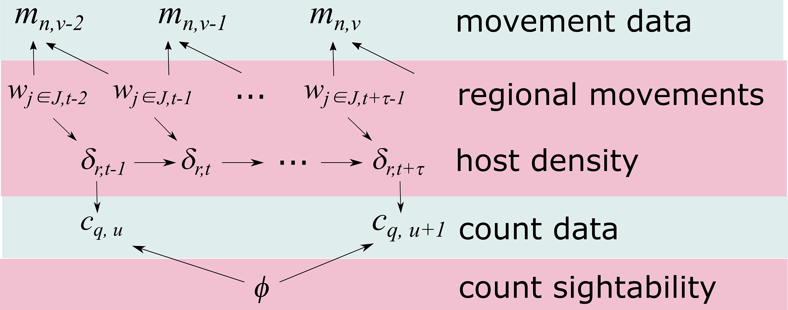

Figure S1. Directed acyclic graph of a statistical model of the donor host population size, $δ$, in spatial regions r and time periods t. Blue areas are the observed data, while pink areas are latent and estimated. The observed count data, c, at a different spatial scale, q, and time period u are dependent on the host density as well as the sightability$ϕ$. Host movement, w, into a region j from all of its neighbors J affects the host population distribution over time as well as the observed movement data m for individuals n, which may also be collected at a different temporal resolution.

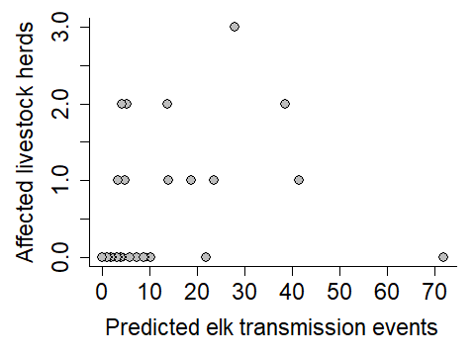

Figure S2. The relationship between the number of observed brucellosis spillover events in livestock herds from 2001 to 2018 and the predicted number of elk transmission events per year in areas potentially occupied by livestock. Each point is a different elk management unit in Montana and Wyoming. Predictions are based upon ([1] and [2]).

References:

[1] Merkle, J. A., Cross, P. C., Scurlock, B. M., Cole, E. K., Courtemanch, A. B., Dewey, S. R. & Kauffman, M. J. 2018 Linking spring phenology with mechanistic models of host movement to predict disease transmission risk. J. Appl. Ecol. 55, 810-819. (DOI:10.1111/1365-2664.13022).

[2] Rayl, N. D., Proffitt, K. M., Almberg, E. S., Merkle, J. A., Jones, J. H., Gude, J. A. & Cross, P. C. 2018 Modelling elk-to-livestock transmission risk to identify hotspots of brucellosis spillover. (pp. 1-56, Montana Fish, Wildlife and Parks.

