Supplementary Material for Shutt et al “The environmental predictors of spatiotemporal variation in the breeding phenology of a passerine bird”, Proceedings of the Royal Society B (DOI: 10.1098/rspb.2019.0952)

Appendix A

Contents:

1. Fig A1 Map of field sites in Scotland
2. Focal tree selection protocol
2. Table A1 Focal tree details
2. Equation A1 Calculating abundance-weighted site-level tree phenology
3. Trivariate cross-validation model matrix
3. Fig A2 Night-time and day-time temperatures as predictors of blue tit phenology
4. Table A2 Temperature as a predictor of blue tit phenology
5. Table A3 Tree phenology as a predictor of blue tit phenology
5. Table A4 Invertebrate availability as a predictor of blue tit phenology
6. Fig A3 Cross-validation using the national datasets
7. Correlation of birch leafing phenology to oak leafing phenology
7. Literature cited in the supplementary material

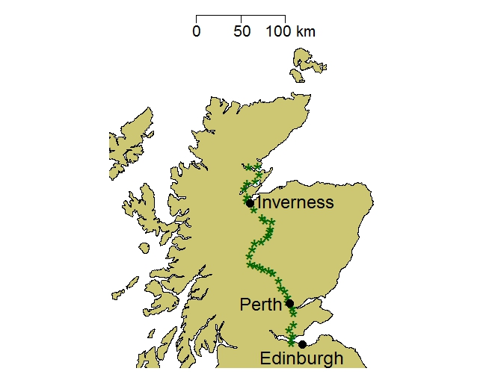
Fig A1 Map of Scotland illustrating the locations of all 40 sites along the transect (green stars) with selected cities as location indicators.
Focal tree selection protocol
In 2014, six focal trees were selected (the nearest deciduous tree with a trunk diameter ≥ 20cm to each nestbox) and identified to genus level at each site. If oak (Quercus sp) or birch (Betula sp) were present at a site but not represented in this selection, up to six of each relevant species present were numbered and one of each present selected by the random roll of a die, resulting in six to eight focal trees per site. In subsequent years (2015-16) the same individual focal trees were used wherever possible (consistency 2014-15 = 80%, 2015-16 = 97%), and additional trees were added so that each site contained 8-10 focal trees. These extra trees were selected by using the method described above for oak and birch but extending this to sycamore (Acer pseudoplatanus) and willow (Salix sp). If there were fewer than eight focal trees at the site by this stage, the selection method described above was used on randomly selected deciduous trees of species typical of the surrounding habitat, leaving each site with at least eight locally representative focal trees.

Table A1 Detailing the number of focal trees studied of each taxon each year, with the percentage of intensively studied sites (2014 n=30, 2015 n=35, 2016 n=37) with at least one focal tree of this taxon (site coverage), ordered by focal tree number in 2016, followed by site coverage in 2016. Total focal tree n=186 in 2014 (mean 6.2/site), 293 in 2015 (mean 8.4/site) and 313 in 2016 (mean 8.5/site). Species within each tree taxon along the transect are detailed in [1].

Tree Taxon (Genus) | 2014 |  | 2015 |  |  | 2016
 | Focal Trees | Sites (%) |  | Focal Trees | Sites (%) | Focal Trees | Sites (%)
Birch (Betula) | 85 | 93 | 118 |  | 97 | 123 | 97
Oak (Quercus) | 19 | 40 | 48 |  | 57 | 53 | 57
Sycamore (Acer) | 29 | 47 | 30 |  | 37 | 33 | 38
Willow (Salix) | 7 | 13 | 20 |  | 31 | 22 | 32
Alder (Alnus) | 15 | 30 | 22 |  | 31 | 22 | 30
Beech (Fagus) | 13 | 27 | 17 |  | 23 | 17 | 22
Ash (Fraxinus) | 7 | 20 | 10 |  | 20 | 11 | 19
Elm (Ulmus) | 2 | 3 | 7 |  | 17 | 8 | 19
Rowan (Sorbus) | 6 | 17 | 8 |  | 14 | 8 | 14
Aspen (Populus) | 2 | 3 | 6 |  | 9 | 7 | 11
Hazel (Corylus) | 3 | 10 | 5 |  | 14 | 4 | 11
Cherry (Prunus) | 0 | - | 2 |  | 3 | 2 | 3
Chestnut (Castanea) | 0 | - | 0 |  | - | 2 | 3
Lime (Tilia) | 0 | - | 0 |  | - | 1 | 3

Equation A1 Calculation to obtain weighted site mean budburst at a single site in a single year, where $f$ = frequency of tree at site (percentage), $b$ = mean budburst of tree species at site per year and 1-14 denote tree taxa. Weighted site mean leafing was calculated identically.

$$\frac{\sum_{i=1}^{n=14}{f_{i}}b_{i}}{\sum_{i=1}^{n=14}{f_{i}}}$$

Trivariate model matrix in space and time

Blue tit first egg date (F), temperature (T) and birch phenology (P) from across the UK were included in a mixed model with a trivariate response. Then for each random term included in the model we were able to estimate a 3 x 3 variance-covariance matrix:

$\left[\begin{matrix}σ_{F}^{2} & σ_{F,T} & σ_{F,P} \\ σ_{F,T} & σ_{T}^{2} & σ_{T,P} \\ σ_{F,P} & σ_{T,P} & σ_{P}^{2}\end{matrix}\right]$

From this matrix we can define A as the 2 x 2 variance-covariance matrix of predictors (T and P) and B as a vector of the covariance of predictors and response. Then A⁻¹B returns the equivalent to the multiple regression coefficients across levels of a focal random term [2]. We use this approach to obtain separate estimates of the effect of temperature and birch leafing on blue tit lay date over space (50km grid cells) and time (years). If the predictor variables are causative and there is no local adaptation we predict that responses over space and time should be the same [3].

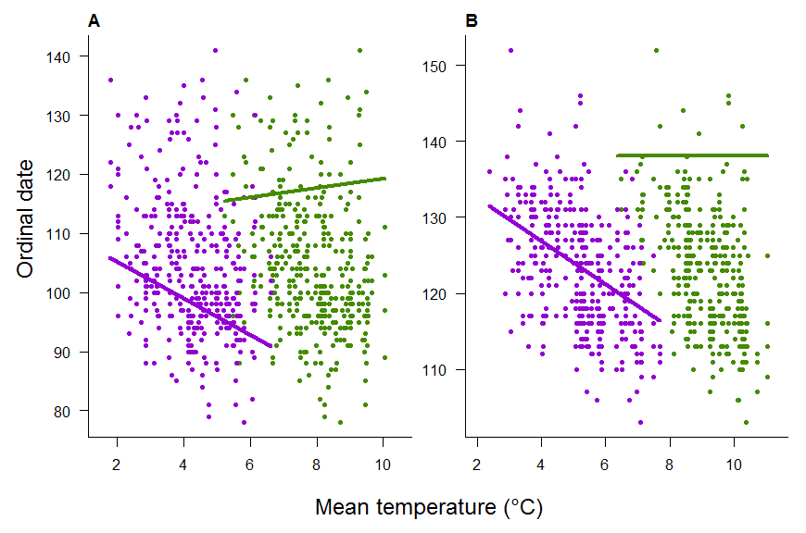

Fig A2 The slopes of a linear model with A nest initiation and B lay date as the response variable and both mean day-time (green) and mean night-time (purple) temperatures as the predictor variables, with site and year as random effects. Whilst the slope for night-time temperature remains consistent with that when it is used a single predictor (Table A2), the slope for day-time temperature is much reduced (Table A2), highlighting night-time temperature as the better predictor of both nest initiation and lay date.
Table A2 Temperature predictors of nest initiation and lay date, with slopes (b) and their associated standard errors (se) estimated from LMM’s (see methods), together with the AIC value of each for comparison, and the random effect variances (site, year and residual). The best temperature predictors of nest initiation and lay date respectively are presented in bold.

Response | Predictor | Intercept ± se | b ± se | AIC | Site variance | Year variance | Residual variance | R² marginal | R² conditional
Nest initiation | Null | 104.5 ± 1.4 |  | 3145.6 | 28.3 | 3.0 | 96.2 | 0.00 | 0.25
 | 24hr | 118.2 ± 5.2 | -2.33 ± 0.86 | 3141.1 | 21.6 | 1.9 | 96.6 | 0.04 | 0.23
 | Mean day-time | 118.2 ± 6.5 | -1.75 ± 0.82 | 3143.7 | 22.7 | 2.0 | 96.9 | 0.03 | 0.22
 | Mean night-time | 114.7 ± 3.7 | -2.43 ± 0.83 | 3139.9 | 21.9 | 2.0 | 96.2 | 0.05 | 0.24
 | Mean maximum | 111.4 ± 7.5 | -0.65 ± 0.70 | 3146.9 | 26.2 | 2.4 | 96.6 | 0.00 | 0.23
 | Mean minimum | 109.4 ± 1.9 | -2.21 ± 0.74 | 3140.7 | 23.6 | 0.7 | 96.3 | 0.05 | 0.24
Lay date | Null | 123.3 ± 2.1 |  | 2464.5 | 18.1 | 11.6 | 33.9 | 0.00 | 0.47
 | 24hr | 146.8 ± 4.6 | -3.23 ± 0.62 | 2440.2 | 11.2 | 1.6 | 34.5 | 0.17 | 0.40
 | Mean day-time | 142.7 ± 6.4 | -2.14 ± 0.69 | 2448.3 | 13.1 | 4.0 | 34.7 | 0.07 | 0.38
 | Mean night-time | 138.1 ± 3.1 | -2.87 ± 0.56 | 2437.2 | 11.3 | 2.3 | 34.1 | 0.19 | 0.42
 | Mean maximum | 128.3 ± 6.9 | -0.40 ± 0.53 | 2454.2 | 17.2 | 9.8 | 34.2 | 0.00 | 0.44
 | Mean minimum | 130.3 ± 2.1 | -2.21 ± 0.52 | 2440.9 | 11.8 | 3.9 | 34.2 | 0.15 | 0.42

Table A3 Tree phenology predictors of nest initiation and lay date, with their slopes (b) and associated standard errors (se) estimated from LMM’s (see methods), together with the AIC value of each for comparison, and the random effect variances (site, year and residual). The best tree phenology predictors of nest initiation and lay date respectively are presented in bold. BB = budburst, LF = leafing.

Response | Predictor | Intercept ± se | b ± se | AIC | Site variance | Year variance | Residual variance | R² marginal | R² conditional
Nest initiation | Null | 103.7 ± 1.2 |  | 2698.6 | 24.6 | 1.8 | 91.8 | 0.00 | 0.22
 | Mean BB | 89.4 ± 12.6 | 0.13 ± 0.11 | 2699.3 | 22.6 | 2.0 | 92.0 | 0.01 | 0.22
 | Weighted BB | 91.1 ± 11.0 | 0.11 ± 0.10 | 2699.3 | 22.4 | 1.9 | 92.1 | 0.01 | 0.22
 | Birch BB | 85.9 ± 11.4 | 0.17 ± 0.11 | 2698.2 | 22.9 | 1.7 | 91.7 | 0.01 | 0.22
Lay date | Null | 123.2 ± 2.0 |  | 2367.9 | 18.5 | 10.6 | 33.9 | 0.00 | 0.46
 | Mean BB | 97.2 ± 9.1 | 0.23 ± 0.08 | 2362.7 | 13.8 | 7.4 | 34.2 | 0.05 | 0.41
 | Weighted BB | 98.9 ± 7.8 | 0.21 ± 0.07 | 2360.8 | 14.3 | 7.8 | 33.9 | 0.05 | 0.43
 | Birch BB | 86.0 ± 7.9 | 0.35 ± 0.07 | 2349.3 | 13.3 | 5.8 | 33.0 | 0.11 | 0.44
 | Mean LF | 103.0 ± 8.0 | 0.16 ± 0.06 | 2364.9 | 13.3 | 7.0 | 34.5 | 0.04 | 0.40
 | Weighted LF | 101.2 ± 7.2 | 0.18 ± 0.06 | 2361.9 | 13.1 | 7.0 | 34.3 | 0.06 | 0.41
 | Birch LF | 99.2 ± 6.8 | 0.20 ± 0.06 | 2359.2 | 12.3 | 6.0 | 34.2 | 0.07 | 0.40

Table A4 Invertebrate abundance predictors of nest initiation and lay date, with slopes (b) and associated standard errors (se) taken from LMM’s (see methods), along with null models and AICs for comparison, and the random effect variances (site, year and residual).

Response | Start Date | Intercept ± se | b ± se | AIC | Site variance | Year variance | Residual variance | R² marginal | R² conditional
Nest initiation | Null | 104.5± 1.4 |  | 3145.6 | 28.3 | 3.0 | 96.2 | 0.00 | 0.25
 | 82 – 95 | 106.2 ± 1.8 | -2.16 ± 1.56 | 3106.5 | 24.8 | 2.4 | 98.2 | 0.01 | 0.22
Lay date | Null | 123.3 ± 2.1 |  | 2350.2 | 17.3 | 11.3 | 34.3 | 0.00 | 0.45
 | 93 – 123 | 126.7 ± 2.4 | -2.30 ± 1.21 | 2348.7 | 15.0 | 6.8 | 34.5 | 0.03 | 0.41

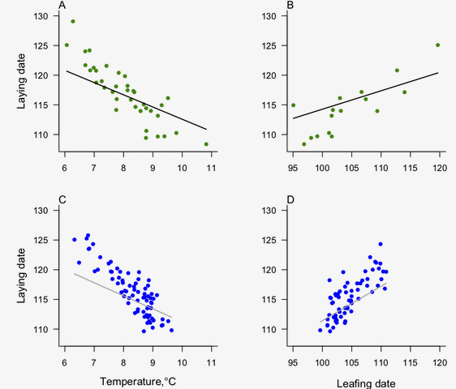

Fig A3 The relationship between lay date and spring temperature (A, C) and birch leafing date (B, D) over time (A, B) and space (C, D) across UK-wide datasets. Predicted slopes correspond to the mean posterior multiple regression slopes, with black and grey lines corresponding to significant and non-significant slopes, respectively. Green points are mean values in a year and blue points are mean values in a grid cell (over space). Only years and grid cells with a minimum of 50 observations are included as points.

Correlation of birch leafing phenology to oak leafing phenology

Methods
First leafing data for pedunculate oak (Quercus robur, n = 11285) and silver birch (Betula pendula, n = 14892) for the period 1998 – 2014 were obtained from the Woodland Trust’s Nature’s Calendar citizen science scheme. The two phenological measures were included as a bivariate response in a general linear mixed model with 50km grid cell, year and 5km grid cell included as random terms. Models were fit using MCMCglmm [4] and run for 110,000 iterations with the first 10,000 removed as burn-in. Priors were inverse-Wishart for the residual term and parameter-expanded for the other random terms. Based on the model posteriors we assessed the correlation and major axis regression between birch and oak over space and time.

Results
Across the UK silver birch leafing is strongly positively correlated with pedunculate oak leafing across 50km grid cells (r = 0.973, 95% HPD = 0.946 – 0.992) and years (r = 0.909, 0.783 – 0.977). On average oak leafing occurs 13.803 days (11.121 – 14.438) after birch. Across grid cells the major axis slope reveals that for every days delay in oak leafing there is a smaller delay in birch leafing (b = 0.657, 0.594 – 0.728). Across years phenology of birch and oak leafing is not significantly different from a 1:1 relationship (b = 0.999, 0.748 – 1.250).

Literature cited in the Supplementary Material

1. Shutt, J. D., Bolton, M., Cabello, I. B., Burgess, M. D. & Phillimore, A. B. 2018 The effects of woodland habitat and biogeography on blue tit (Cyanistes caeruleus) territory occupancy and productivity along a 220km transect. Ecography (Cop.). 41, 1967–1978. (doi:10.1111/ecog.03573)
2. Phillimore, A. B., Stålhandske, S., Smithers, R. J. & Bernard, R. 2012 Dissecting the contributions of plasticity and local adaptation to the phenology of a butterfly and its host plants. Am. Nat. 180, 655–70. (doi:10.1086/667893)
3. Phillimore, A. B., Leech, D. I., Pearce-Higgins, J. W. & Hadfield, J. D. 2016 Passerines may be sufficiently plastic to track temperature-mediated shifts in optimum lay date. Glob. Chang. Biol. 22, 3259–3272. (doi:10.1111/gcb.13302)
4. Hadfield, J. D. 2010 MCMC methods for multi-response generalized linear mixed models: The MCMCglmm R package. J. Stat. Softw. 33, 1–22. (doi:10.1002/ana.22635)

