Supplementary Material

Male black widows parasitize mate-searching effort of rivals to find females faster

Catherine E. Scott*, Sean McCann, Maydianne C.B. Andrade
Proceedings of the Royal Society B

*Correspondence:
Email: catherine.elizabeth.scott@gmail.com

CONTENTS:

- Supplementary Methods (pp. 1-5)
- Supplementary Tables S1-S4 (pp. 6-7)
- Supplementary Figures S1-S4 (pp. 8-11)

1. Supplementary Methods

(a) General field survey methods

From April to September 2016 we surveyed the population of Latrodectus hesperus inhabiting a ca. 20 x 200 m area of our study site. On a single day each month, we turned over every driftwood log and rock within this area to perform a systematic population census. The number, sex, and age class of spiders (determined by inspection; Kaston 1970) under each microhabitat was recorded, and all spiders that were within two moults of maturity were briefly collected, immobilized between a soft sponge and a mesh cloth, and marked with a unique colour code using quick-drying modelling paint (Testor’s enamel; Fig. S1) before being returned to their webs (where they remained, see Salomon 2008). We also performed more frequent nocturnal surveys (Fig. 1) that involved non-intrusive inspection of the webs of all marked spiders to record presence/absence, evidence of moulting, and presence of males or other unmarked spiders on webs of females. Spiders that had moulted were marked again and returned to their webs.

(b) Estimating the abundance of sexually receptive females.

Unmated L. hesperus females produce an airborne sex pheromone that attracts males at long range (Kasumovic & Andrade 2004; MacLeod & Andrade 2014). The exact timing of pheromone production has not been studied for this species but it likely begins shortly after the moult to maturity and definitely within the first week following maturity (CES unpublished data). Females become unattractive or difficult to detect once males arrive on the web and engage in web reduction behaviour (destroying large sections of the web, bundling them up, and wrapping them with their own silk; Watson 1986; Scott et al. 2015) and once mated, females rebuild their webs without attractive pheromones (MacLeod & Andrade 2014). At our field site, pheromone traps containing unmated females typically attract males within a few hours (Scott et al. 2015), thus it is likely that most females are visited by males and mated shortly after they mature and begin pheromone production (if not before; in other Latrodectus species, males may guard subadult females and inseminate them just prior to their moult to maturity (Biaggio et al. 2016; Baruffaldi & Andrade 2017). We did not usually know the exact date on which females moulted to maturity, so for each female we assumed that they were recently matured and available for mating for six days prior to the date on which we noted their moult, and for seven days after, for a total of 14 days. This is likely a conservative overestimate of the length of time that recently matured females remain unmated and actively signalling at this site.

(c) Estimating the abundance of adult males.

We found and marked a total of 66 males during their penultimate instar and followed 16 through to maturity (penultimate males that disappeared either died or matured and left their webs to look for females). Penultimate and adult males are much smaller and more cryptic than their female counterparts, and can use dense vegetation as microhabitats in which they are practically impossible to detect (unlike females, which almost exclusively build webs under driftwood logs at our field site; Salomon et al. 2010). Males are easier to detect when they have webs under logs or rocks, and when they are on the webs of females. We marked a total of 274 males that were found as adults cohabiting with females or juveniles. However, when we flipped over logs during monthly censuses, we often found adult males inside of females’ retreats, where they would not be visible during nightly surveys. Once we found and marked a male for the first time, we assumed that he remained alive until we confirmed his presence or absence at the next monthly census. We assumed that absent males that were not re-sighted elsewhere had died during movement between webs. These assumptions are reasonable given that the difficulty detecting males means that we likely underestimated their abundance overall, and because males from this population typically live more than one month after maturing (CES unpublished data).

(d) Tracking male movements in the field.

We mapped all microhabitats (logs and rocks) within the field site and calculated minimum distances between them. Thus, when we found previously marked males on females’ webs, we could infer the minimum distance they had traveled. We could also estimate the mortality risk associated with mate-searching in the field by (1) tracking the number of males marked on their juvenile web that were later re-sighted on females’ webs (indicating that they survived a first mate-searching event), and (2) tracking the number of males who were sighted on two or more different females’ webs (indicating that they survived two or more moves between webs). These estimates assume that males that were not re-sighted on a female’s web died during mate searching. Sexual cannibalism is rare in this population and readily apparent when it occurs because the exoskeleton of the consumed male remains identifiable in or under the female’s web for at least several days. When we found males dead in the webs of females we included them in our data set as having successfully found a female. Thus, sexual cannibalism was not likely to cause us to underestimate mortality during mate searching.

(e) Experimental animal capture and maintenance

All Latrodectus hesperus spiders used in experiments were field-collected during the summer they were used in experiments (2016 or 2017) or were the lab-reared, outbred offspring of females collected from the field in 2015 or 2016. Lab-reared spiders were raised using standard methods (Baruffaldi & Andrade 2015) and the diets gauged to their body size. Juveniles were fed vinegar flies (Drosophila melanogaster), antepenultimate males and similarly sized juvenile females were fed cricket nymphs (Acheta domesticus or Gryllodes sigillatus), and subadult females were fed adult crickets. Adult males were given water ad libitum, but were not fed (adult males do not normally hunt in nature; Foelix 2011).

Black widow males used in field experiments (both years) were collected using pheromone traps made from screen cages with an unmated female and her web inside (see Scott et al. 2015 for cage design and MacLeod & Andrade 2014 for live collection technique) or using males collected from webs of naturally occurring females in an area adjacent to our main study site (2017 only). For field experiments in 2016, females were reared in the laboratory at the University of Toronto Scarborough and then transported to the field site. In 2017, we collected females from the field in their last two juvenile instars, and reared them to maturity indoors, under conditions similar to those in the laboratory, to ensure that they remained unmated.
Steatoda grossa males were collected from our field site in 2017 as penultimate instars or adults and identified using Levi (1957). They were then kept indoors under similar conditions to lab-reared L. hesperus males. At this site, S. grossa is found in the same microhabitats as L. hesperus (i.e., under rocks and driftwood logs), but is much less common.

(f) Measuring male body size and condition

Before field or lab experiments, we measured each male by placing him in a clear plastic bag next to a size reference (see Fig. S1) and measured the tibia-patella length of both first legs (a standard size index for spiders) to the nearest 0.1 mm using ImageJ (Rasband 2015). When possible, we also weighed males to the nearest 0.1 mg using a microbalance (males used in field experiments in 2017 were weighed after marking). We calculated size-corrected mass (a body condition index) as the residuals of a linear regression of log(mass) against tibia-patella length (Jakob et al 1996).

(g) X-maze choice experiments

The choice test setup consisted of an X-shaped maze (see Fig. 2) made from cotton yarn (ca. 2.5 mm diameter) strung tightly between vertical bamboo posts topped with alligator clips (2.8 cm long). An unmated female in a mesh-sided cage (l × w × h = 9 × 9 × 11.5 cm) or an empty cage was placed 10 cm from one end of the maze, equidistant from the two end posts. For trials with wind two small fans (Travelon 3-speed folding fan, set on medium speed) behind the cage blew air (and pheromone, when a female was in the cage) toward the starting posts. The wind speed experienced by males was 0.3 m/s at the starting posts and 1.0 m/s at the end posts. The X-maze apparatus was surrounded by a shallow moat (65 × 210 cm total area) to restrict male movements and vertical walls made out of foam board (l × h = 220 × 51 cm) along the long sides of setup prevented any cross-wind.

(h) X-maze experimental protocol

For all X-maze experiments (Fig. 2a), a stimulus male (either Latrodectus hesperus or Steatoda grossa) provided a silk trail as follows. We first introduced the stimulus male on one of the two starting posts, and once he climbed to the top he would proceed upwind (fans were always on while stimulus males traversed the maze) along the string until he reached one of the ending posts, after which we recaptured him. Next, we introduced a test male onto the opposite starting post and he would traverse the maze, facing a choice between silk and no silk once he reached the intersection of the X. We alternated the side of the entry post for stimulus males between replicates. For the first experiment only, we recorded the time both stimulus and test males took to travel the distance between the intersection of the X and an end post. In four cases test males fell into the moat (because they were traversing a sagging silk line) before reaching an end post so we were not able to calculate their time, but because these were more than halfway to a female when they fell, we included them the set of males that made a choice. In the final experiment we omitted one replicate in which the test male did not touch the conspecific silk at the intersection because he was already traversing a sagging heterospecific silk line (males in this experiment were always introduced on the post where the heterospecific stimulus male had started).
(i) Sample sizes and animals used in X-maze choice tests

The sample size for the first three experiments was 22 test males. We added replicates to the fourth experiment (heterospecific silk vs. no silk) until 16 males had chosen the non-silk path (total n = 32) so that we would could run 16 replicates of the final experiment (con- vs. hetero-specific silk). In all experiments, males were never used as test males more than once. In the first experiment only, each male was used as both a stimulus and a test male, in random order. The same 22 males were each used twice as stimulus males in the second and third experiments, which were run on consecutive days.

References

Biaggio MD, Sandomirsky I, Lubin Y, Harari AR, Andrade MCB. 2016 Copulation with immature females increases male fitness in cannibalistic widow spiders. Biol. Lett. 12, 20160516.

Baruffaldi L, Andrade MCB. 2015 Contact pheromones mediate male preference in black widow spiders: avoidance of hungry sexual cannibals? Anim. Behav. 102, 25 – 32.
Baruffaldi L, Andrade MCB. 2017 Neutral fitness outcomes contradict inferences of sexual ‘coercion’ derived from male’s damaging mating tactic in a widow spider. Sci. Rep. 7, 17322.

Foelix R. 2011 Biology of Spiders. New York, NY: Oxford University Press
Jakob EM, Marshall SD, Uetz GW. 1996 Estimating fitness: a comparison of body condition indices. Oikos 77, 61 – 67.

Kaston BJ. 1970 Comparative biology of American black widow spiders. San Diego Soc Natur Hist Trans. 16, 33 – 82.

Kasumovic MM, Andrade MCB. 2004 Discrimination of airborne pheromones by mate-searching male western black widow spiders (Latrodectus hesperus): species-and population-specific responses. Can. J. Zool. 82, 1027–1034.

Levi HW 1957 The spider genera Cristulina and Steatoda in North America, Central America, and the West Indies (Araneae, Theridiidae). Bull. Mus. Comp. Zool. 117, 367 – 424
MacLeod EC, Andrade MCB. 2014 Strong, convergent male mate choice along two preference axes in field populations of black widow spiders. Anim. Behav. 89, 163–169.

Rasband WS. 2015 ImageJ 1.51 (National Institutes of Health, Bethesda). Available at https://imagej.net

Salomon M. 2008 Facultative group living in the western black widow spider, Latrodectus hesperus: an evolutionary approach. Doctoral dissertation, Simon Fraser University.

Salomon M, Vibert S, Bennett RG. 2010 Habitat use by western black widow spiders (Latrodectus hesperus) in coastal British Columbia: evidence of facultative group living. Can. J. Zool. 88, 334–346.

Scott C, Kirk D, McCann S, Gries G. 2015 Web reduction by courting male black widows renders pheromone-emitting females' webs less attractive to rival males. Anim. Behav. 107, 71–78.

Watson PJ. 1986 Transmission of a female sex pheromone thwarted by males in the spider Linyphia litigiosa (Linyphiidae). Science 233, 219–221.
2. Supplementary Tables

Table S1. Sample sizes and recapture rates for two mate-searching experiments in the field
Year |  | 10 m | 20 m | 30 m | 40 m | 50 m | 60 m | total
2016 | released: | 19 | 19 | 20 | 18 | 22 | 19 | 117
 | recaptured: | 12 | 11 | 16 | 11 | 15 | 8 | 73
2017 | released: | 21 | 22 | 22 | 22 | 22 | 21 | 130
 | recaptured: | 16 | 9 | 7 | 2 | 0 | 0 | 34

Table S2. Results of general linear models assessing the effects of distance from females on recapture rate (binomial distribution and logit link) and speed (normal distribution and identity link) in a field experiment where males searched for females over 10-60 m. See Table S1 for sample sizes.
 | Estimate | SE | Z |  | P | R²
2016: recapture rate ~ distance + leg length
Intercept | -5.015 | 2.318 | -2.163 |  | 0.031
Distance | -0.008 | 0.012 | -0.714 |  | 0.476
Leg length | 1.069 | 0.414 | 2.582 |  | 0.010
2016: log(speed) ~ distance + leg length |  |  |  |  |  | 0.336
Intercept | 0.257 | 0.801 | 0.321 |  | 0.749
Distance | 0.021 | 0.004 | 5.164 |  | <0.001
Leg length | -0.344 | 0.138 | -2.490 |  | 0.015
2017: recapture rate ~ distance + leg length + body condition index
Intercept | 3.460 | 3.265 | 1.060 |  | 0.289
Distance | -0.119 | 0.023 | -5.200 |  | <0.001
Leg length | -0.189 | 0.571 | -0.337 |  | 0.741
Condition index | -0.655 | 1.451 | -0.452 |  | 0.651
2017: log(speed) ~ distance + leg length + body condition index |  |  |  |  |  | 0.388
Intercept | -0.146 | 0.771 | -0.190 |  | 0.850
Distance | 0.011 | 0.006 | 1.996 |  | 0.055
Leg length | -0.431 | 0.138 | -3.123 |  | 0.004
Condition index | 0.582 | 0.306 | 1.904 |  | 0.067
Table S3. Results of general linear models* assessing the effects of social information availability on speed in a laboratory mate-searching experiment where first males had access to only female chemical cues and second males had access to both female chemical cues and silk cues from a rival (n = 22 pairs of males).
 | Estimate | SE | t | P | R²
Model 1: speed ~ silk + leg length |  |  |  |  | 0.258
Intercept | -0.291 | 0.663 | -0.440 | 0.663
Silk | 0.240 | 0.126 | 1.907 | 0.065
Leg length | 0.369 | 0.123 | 2.997 | 0.005
Model 2: speed ~ silk + body condition index |  |  |  |  | 0.279
Intercept | 1.272 | 0.152 | 8.364 | <0.001
Silk | 0.289 | 0.126 | 2.298 | 0.028
Body condition index | -0.906 | 0.283 | -3.197 | 0.003
*We ran two separate models because there was a significant negative correlation between leg length and size-corrected mass for males used in this experiment (R² = 0.36; F_{1,36} = 20.21; P <0.0001).

Table S4. Results of general linear models assessing the effects of male size and distance from females on recapture rate (binomial distribution and logit link) and speed (normal distribution and identity link) in a field experiment where males searched for females over 25 m (n = 25 males), 50 m (n = 24), 75 m (n = 26), or 100 m (n = 19). Details of experimental design are shown in Fig. S4.
 | Estimate | SE | Z | p | R²
2016 (100m): recapture rate ~ distance + leg length
Intercept | 3.368 | 3.471 | 0.970 | 0.332
Distance | -0.078 | 0.016 | -4.786 | <0.0001
Leg length | -0.052 | 0.600 | -0.087 | 0.930
2016 (100m): speed ~ distance + leg length |  |  |  |  | 0.198
Intercept | 0.650 | 0.236 | 2.758 | 0.011
Distance | 0.004 | 0.002 | 1.804 | 0.083
Leg length | -0.078 | 0.041 | -1.898 | 0.069

2. Supplementary Figures

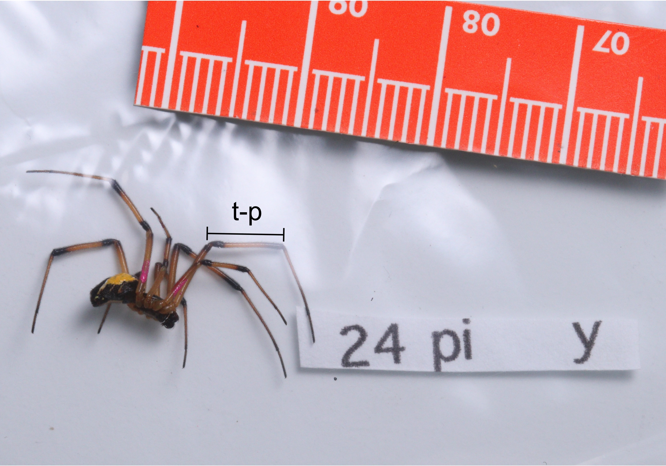
Figure S1. Sample photograph of a marked male spider with a size reference used to measure the tibia-patella (t-p) lengths of the first legs. Note the paint marks on the femora of the legs and on the abdomen; unique combinations of colour and leg numbers were used to identify individual males in the field.

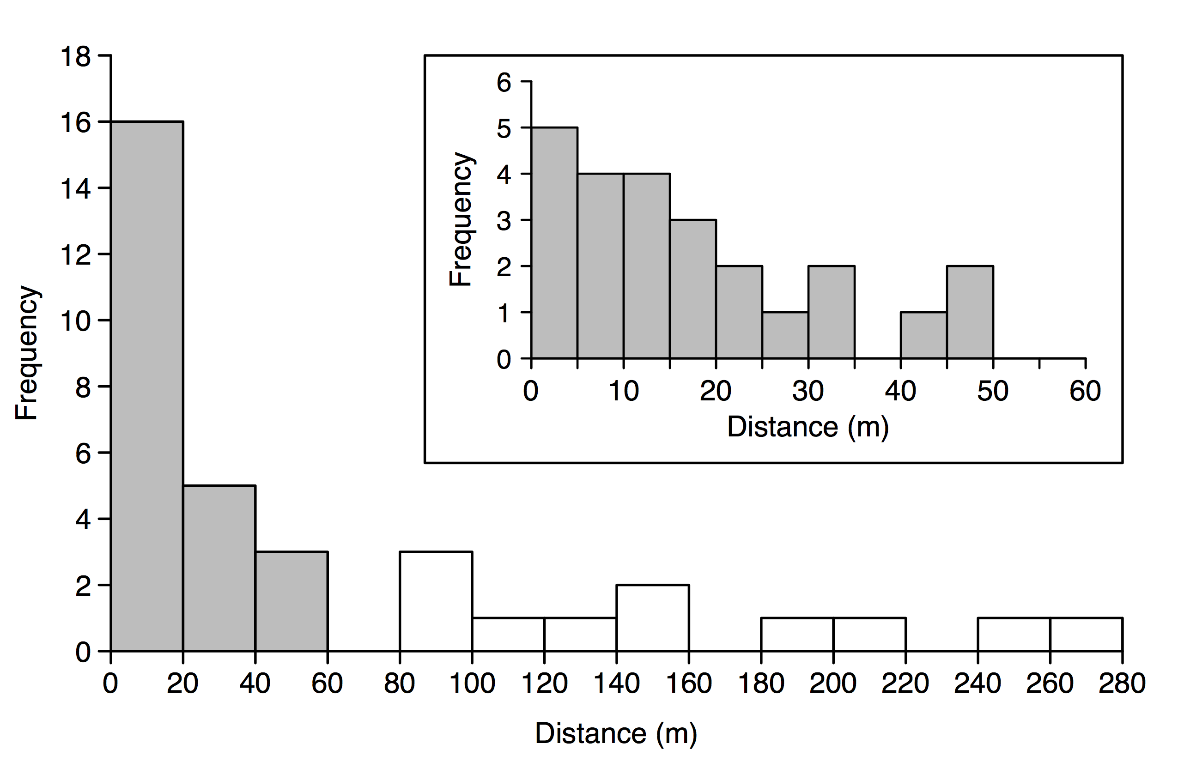
Figure S2. Distances moved by wild mate-searching males in the field. Histogram of the minimum distances moved by Latrodectus hesperus males who survived travel between their home web and that of a female and/or between webs of females between April and September 2016. Inset shows the same data as the grey bars in the main graph, for males that traveled less than 60 m.

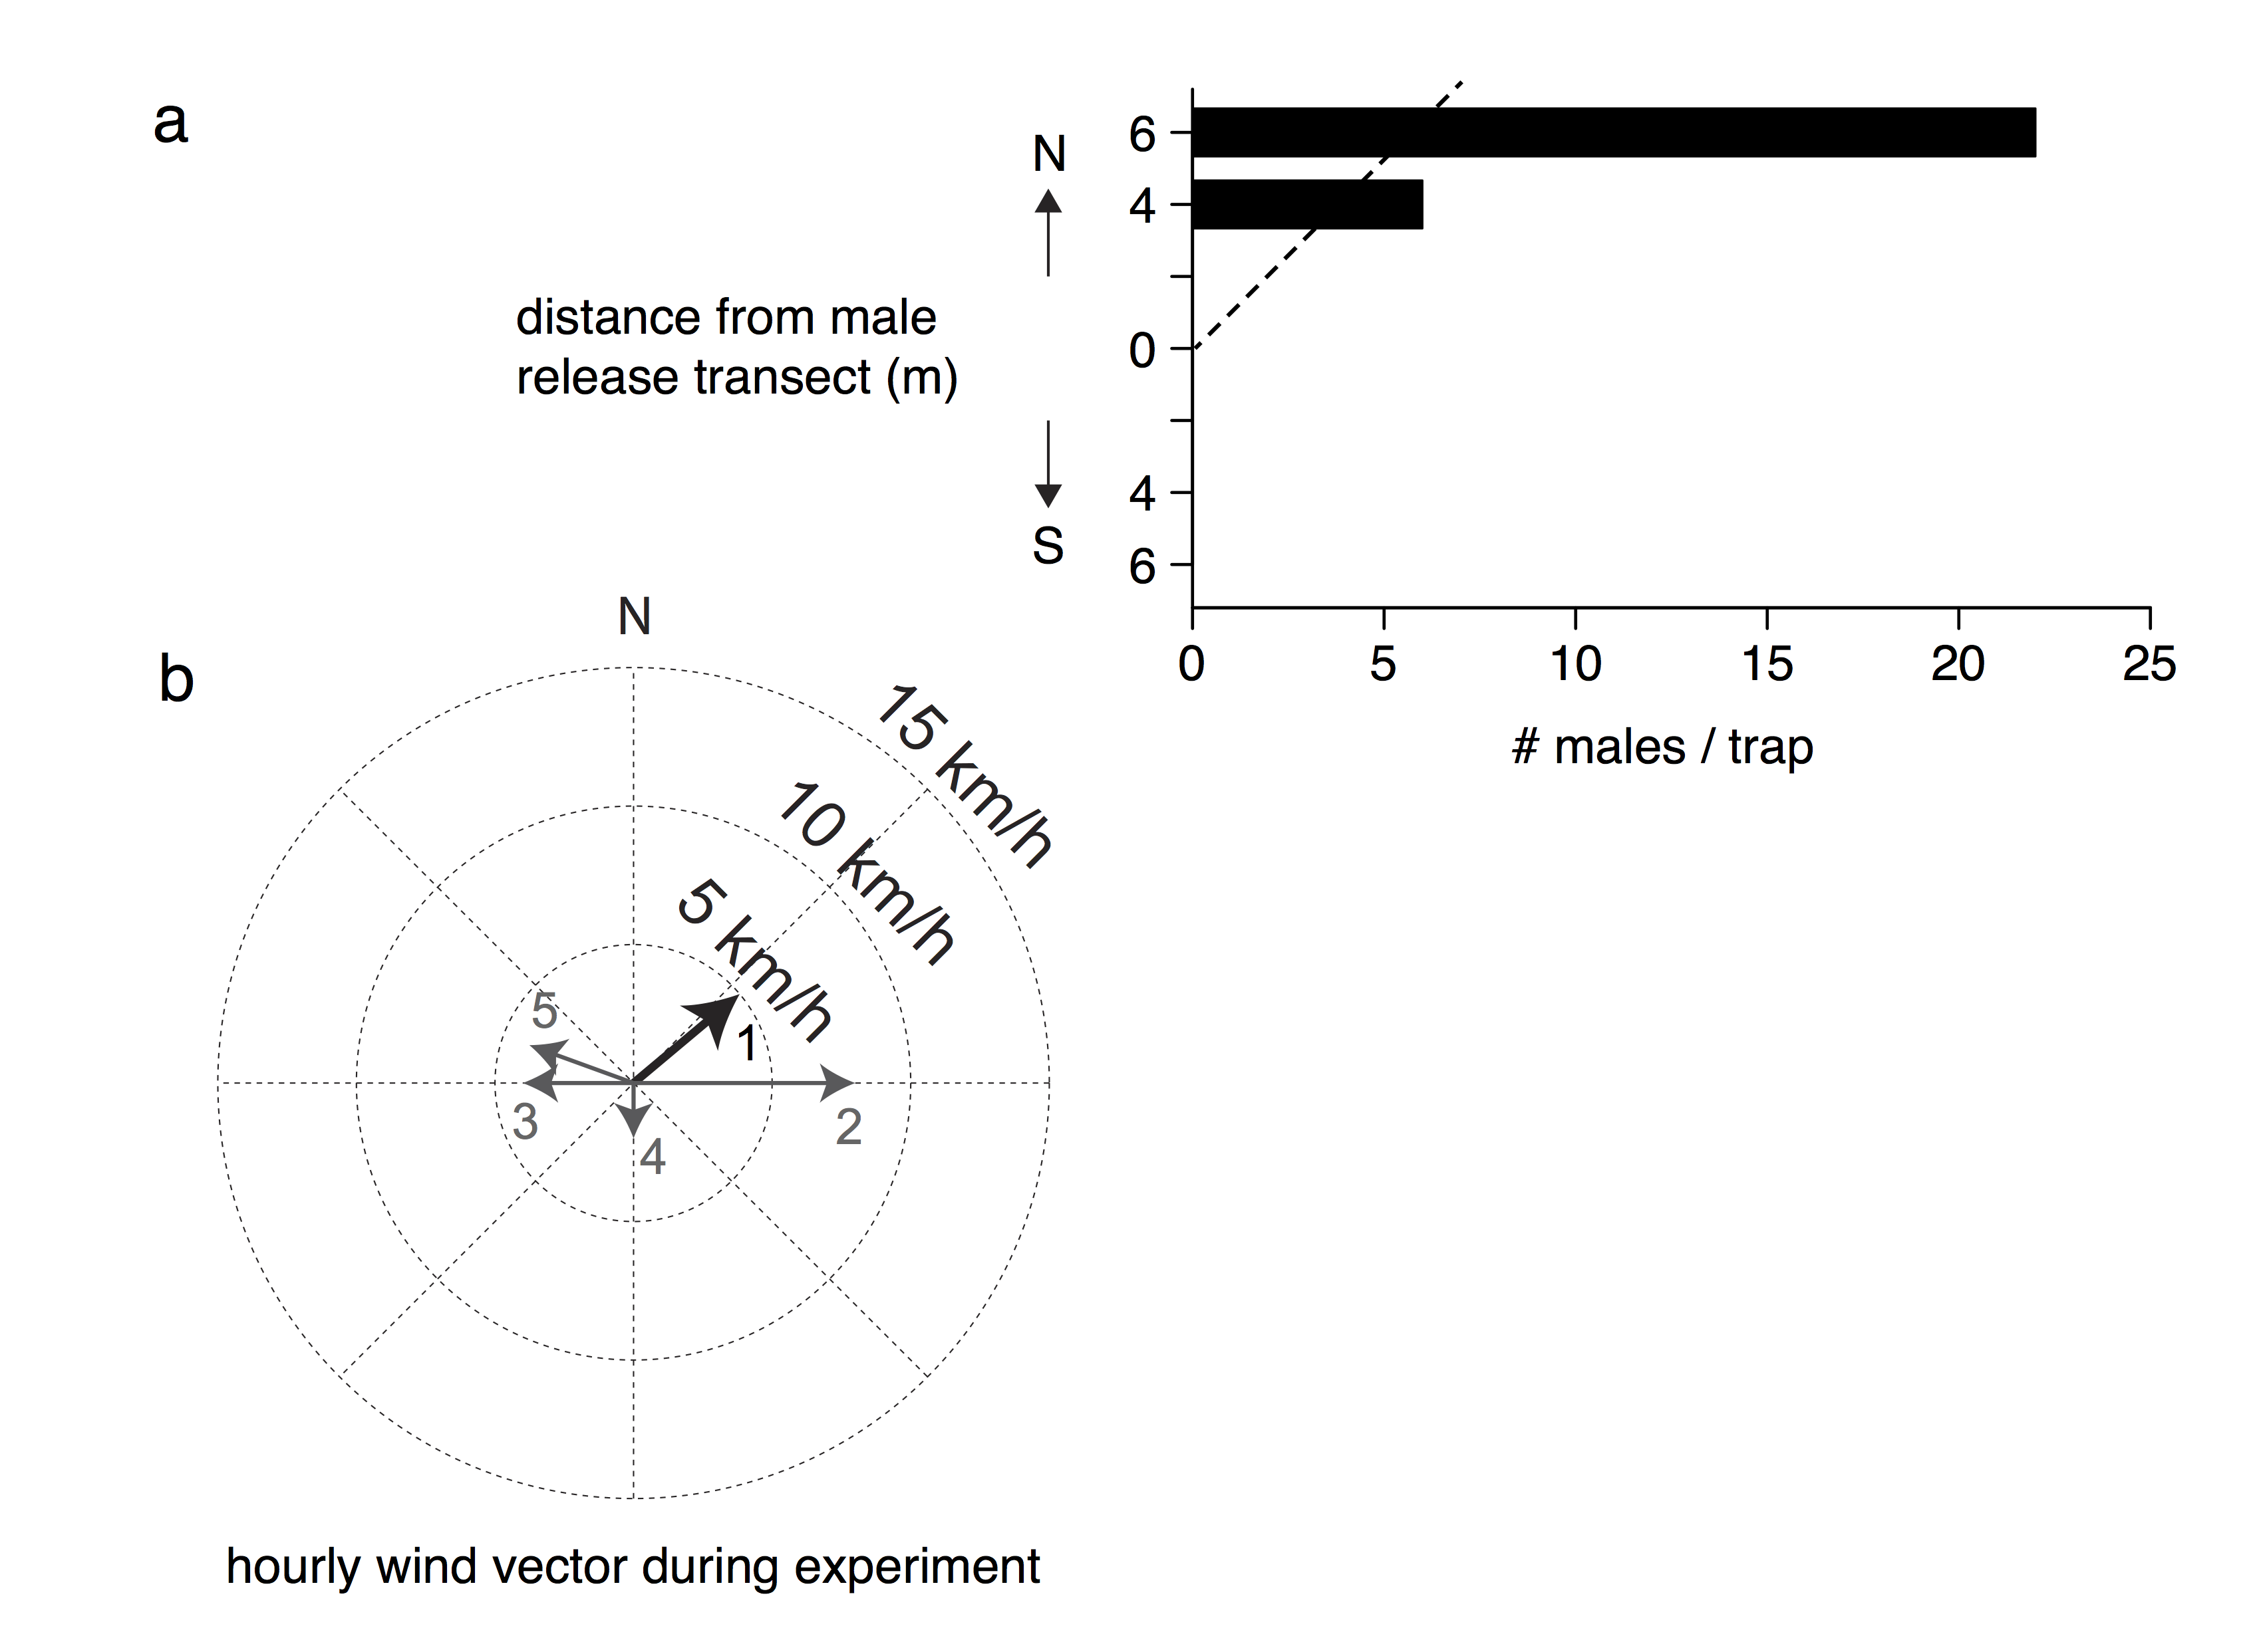
Figure S3. Patterns of attraction to pheromone traps for experimentally released males in the field. We ran this additional mate searching experiment in 2016, with methods modified from those described in the main text. On 9 September we placed four pheromone traps in two pairs (with pairs separated by 2 m) at opposite ends of a 10-m transect approximately perpendicular to the forecasted wind direction. We released males in groups at 100 m, 75 m, 50 m, and then 25 m from the point midway between the two pairs of cages. (a) Number of Latrodectus hesperus males captured at each pheromone-emitting female’s cage during a second field experiment in 2016. Dotted line represents the location of the male release transect and the locations of pheromone traps (mesh cages containing females) are shown on the (vertical) x-axis. Males used in this experiment had already been used in the 2016 mate-searching experiment discussed in the main text. (b) Wind velocity (speed and direction as recorded hourly at a nearby weather station) during the experiment. Numbered arrows represent the wind velocity over each hour that spiders continued to arrive at traps.

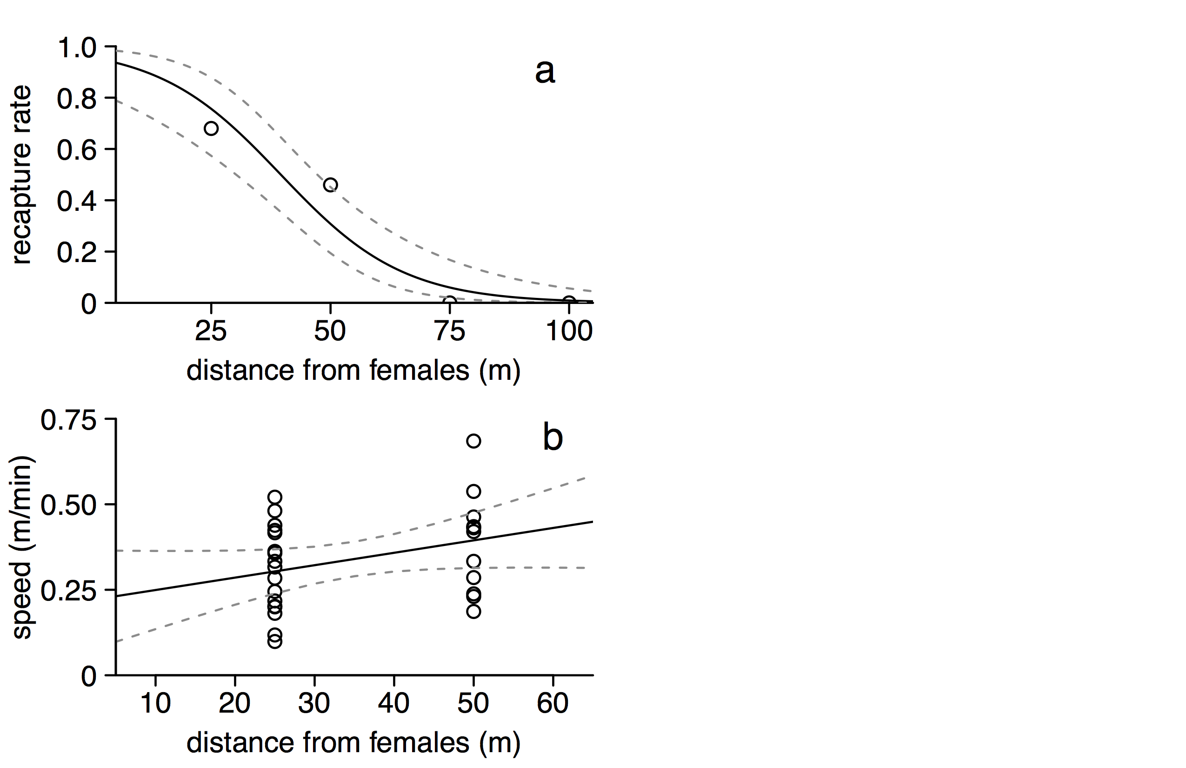

Figure S4. Relationships between distance from pheromone-emitting females and (a) recapture rate, and (b) average speed of recaptured males of Latrodectus hesperus in a mate-searching experiment in the field. Data are shown as points with predicted fits (solid lines) and approximate 95% confidence intervals (dashed grey lines) from general linear models overlaid.

