Royal Society Open Science

Electronic Supplementary Material for

Application of statistical design to evaluate critical process parameters and optimize formulation technique of polymeric nanoparticles.
Pradipta Sarkar¹*, Saswati Bhattacharya², Prof. (Dr.) Tapan Kumar Pal¹

¹Bioequivalence Study Centre, Department of Pharmaceutical Technology, Jadavpur University, Kolkata, India.
²Department of Pharmaceutical Technology, Jadavpur University, Kolkata, India.

Supplementary Content:

Table S1 | : | Experimental domain and variables of Plackett-Burman design
Table S2 | : | Observed responses in Plackett-Burman design.
Figure S1 | : | Main effect plot of factors for the yields of Particle size.
Figure S2 | : | Main effect plot of factors for the yields of Encapsulation efficiency (%EE).
Figure S3 | : | Main effect plot of factors for the yields of Zeta potential.
Figure S4 | : | Predicted value versus Actual value of (A) Particle size, (B) Encapsulation  efficiency (% EE) and (C) Zeta potential in Box–Behnken design.
Figure S5 | : | Overlay plot of Particle size, Encapsulation efficiency (% EE) and Zeta potential in respect of (A) PLGA cont: PVA%, (B) Homogenization speed: PLGA cont., (C) Homogenization speed: PVA% in Box–Behnken design.

Supplementary Table S1: Experimental domain and variables of Plackett-Burman design.
Factor | Factor significance | Coded variables levels
 |  | Level (−1) | Level (+1)
A | Poly (lactic-co-glycolic acid) (PLGA) content (mg). | 100 | 200
B | Poly(vinyl alcohol) (PVA)Percentage | 0.5 | 5
C | Homogenization Speed (RPM) | 10000 | 30000
D | Homogenization duration (min) | 5 | 10
E | PLGA molecular weight (Mw) | 38000-54000 | 190000-240000
F | PVA molecular weight (Mw) | 31000-50000 | 85000-124000
G | PLGA Terminal Group | Ester terminated | Acid terminated
H | PLGA: Drug ratio | 1:1 | 2:1

Supplementary Table S2: Observed responses in Plackett-Burman design.
Run | A | B | C | D | E | F | G | H | Particle Size (nm) | Encapsulation efficiency (%) | Zeta Potential
1 | 1 | 1 | -1 | 1 | 1 | 1 | -1 | -1 | 348.5 | 73 | -2.4
2 | 1 | -1 | 1 | 1 | -1 | 1 | 1 | 1 | 246.3 | 71 | -11.7
3 | -1 | -1 | -1 | -1 | -1 | -1 | -1 | -1 | 262.4 | 61 | -4.3
4 | 1 | 1 | -1 | -1 | -1 | 1 | -1 | 1 | 341.8 | 82 | -3.6
5 | 1 | -1 | -1 | -1 | 1 | -1 | 1 | 1 | 314.6 | 75.7 | -9.3
6 | 1 | 1 | 1 | -1 | -1 | -1 | 1 | -1 | 239.4 | 83.2 | -10.6
7 | -1 | 1 | -1 | 1 | 1 | -1 | 1 | 1 | 263.6 | 71.8 | -8.2
8 | -1 | 1 | 1 | -1 | 1 | 1 | 1 | -1 | 252.8 | 68.1 | -9.8
9 | -1 | -1 | -1 | 1 | -1 | 1 | 1 | -1 | 327 | 61.5 | -10.3
10 | 1 | -1 | 1 | 1 | 1 | -1 | -1 | -1 | 218.5 | 75.3 | -4.9
11 | -1 | 1 | 1 | 1 | -1 | -1 | -1 | 1 | 237.9 | 67.2 | -3.1
12 | -1 | -1 | 1 | -1 | 1 | 1 | -1 | 1 | 264.7 | 64.2 | -2.3

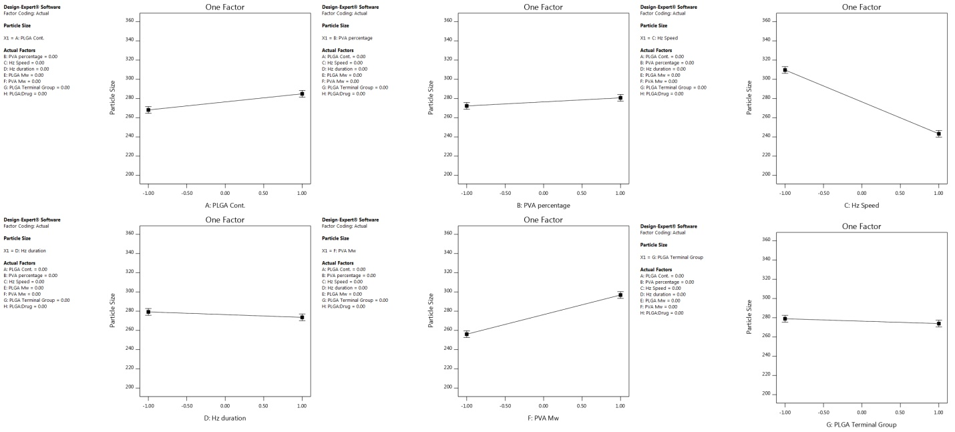
Supplementary Fig. S1: Main effect plot of factors for the yields of Particle size.
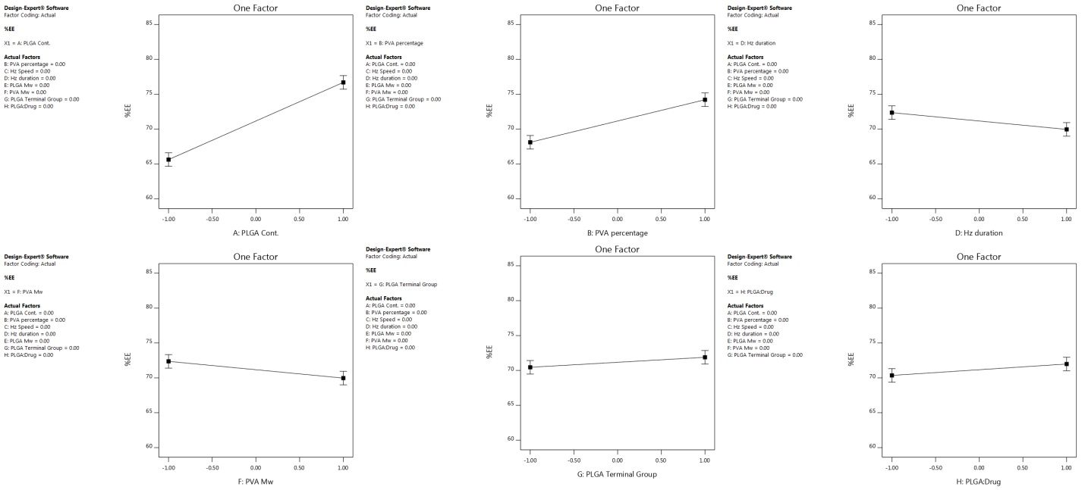
Supplementary Fig. S2: Main effect plot of factors for the yields of Encapsulation efficiency (%EE).
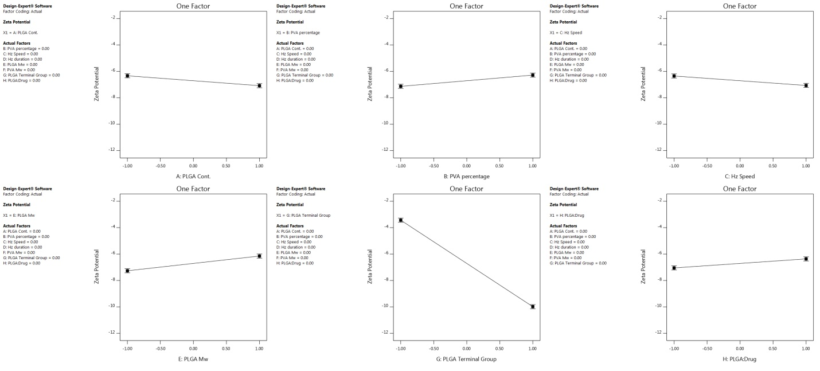
Supplementary Fig. S3: Main effect plot of factors for the yields of Zeta potential.

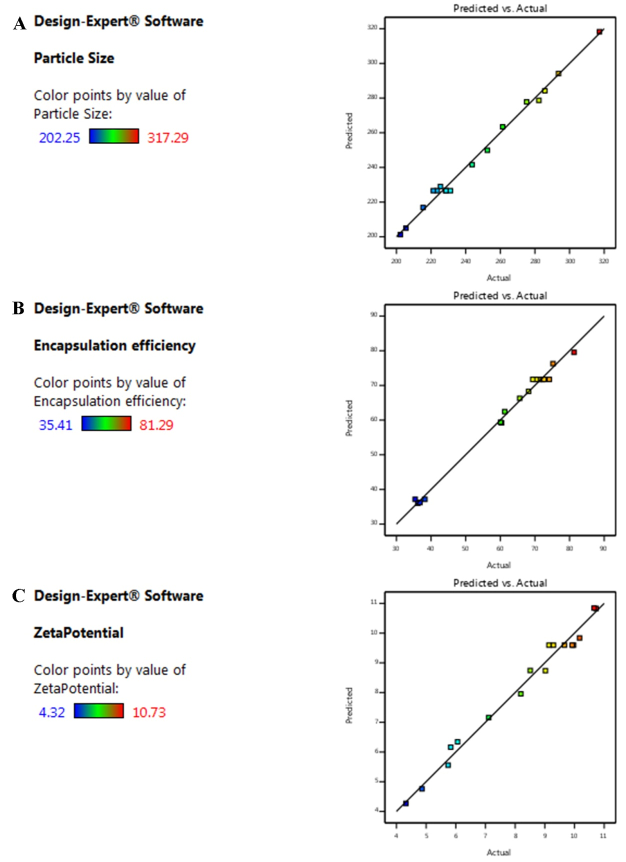
Supplementary Fig. S4: Predicted value versus Actual value of (A) Particle size, (B) Encapsulation efficiency (%EE) and (C) Zeta potential in Box–Behnken design.
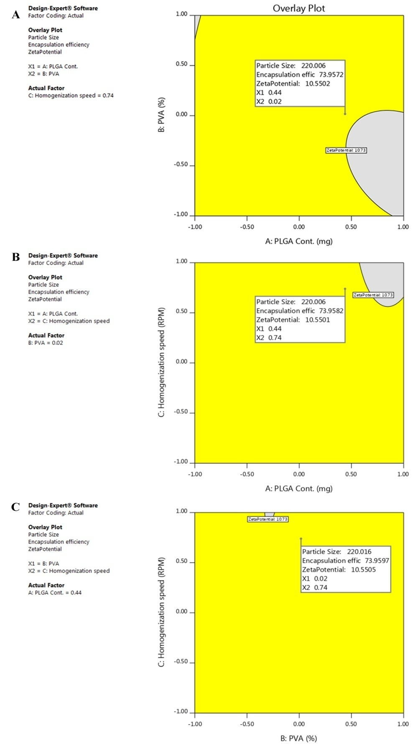
Supplementary Fig. S5: Overlay plot of Particle size, Encapsulation efficiency (%EE) and Zeta potential in respect of (A) PLGA cont: PVA%, (B) Homogenization speed: PLGA cont., (C) Homogenization speed: PVA% in Box–Behnken design.

