Appendix C: Models

Communicative Success

- Type (I) Model: Accuracy over time
Accuracy ~ centered.Round * Condition + centered.ItemCurrentAge * Condition + (1 | ItemID) + (1 +centered.Round | Group)
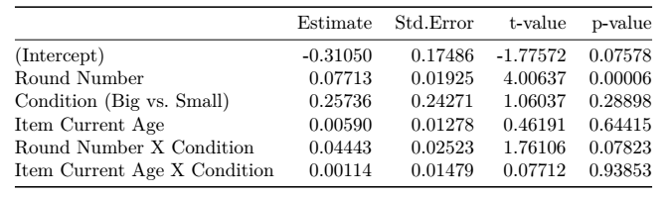

- Type (II) Model: Final Accuracy comparison
MeanAccuracy ~ Condition + (1 | Group)
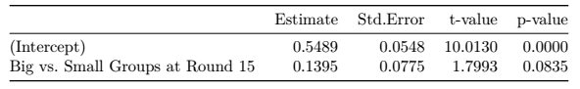

- Type (III) Model: Accuracy variance
SD_Accuracy ~ centered.Round * Condition + (1 + centered.Round | ItemID)
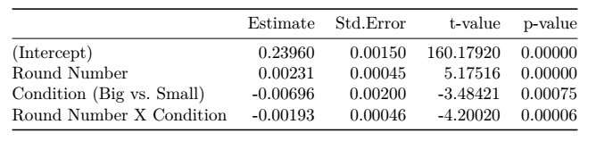

Convergence

- Type (I) Model: Convergence over time
Convergence ~ centered.Round * Condition + centered.ItemCurrentAge * Condition + (1 + centered.Round | ItemID) + (1 + centered.Round | Group)
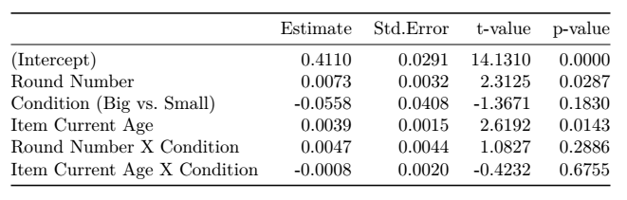

- Type (II) Model: Final Convergence Comparison
MeanConvergence ~ Condition + (1 | Group)
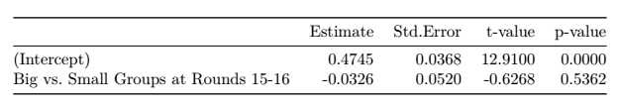

- Type (III) Model: Convergence variance
SD_Convergence ~ centered.Round * Condition
+ (1 + centered.Round | ItemID)
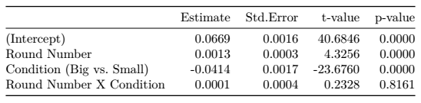

Stability

- Type (I) Model: Stability over time
Stability ~ centered.Round * Condition + centered,ItemCurrentAge * Condition + (1 | ItemID) + (1 +centered,Round | Group)
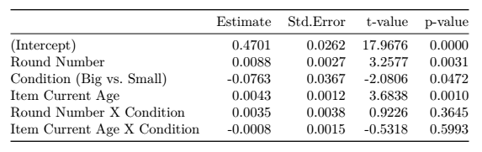

- Type (II) Model: Final Stability comparison
MeanStability ~ Condition + (1 | Group)
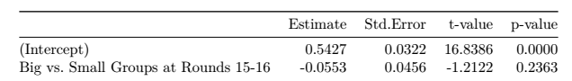

- Type (III) Model: Stability variance
SD_Stability ~ centered.Round * Condition+ (1 + centered.Round | ItemID)
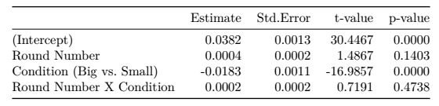

Linguistic Structure

- Type (I) Model: Linguistic Structure over time
Linguistic Structure ~ poly(centered.Round,2) * Condition
+ (1 + poly(centeredRound ,2) | Group/Producer)
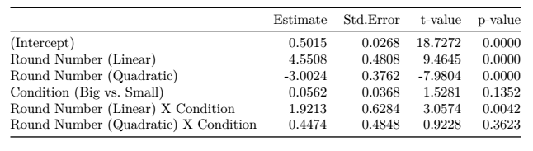

- Type (II) Model: Final Linguistic Structure comparison
MeanStructure ~ Condition + (1 | Group/Producer)
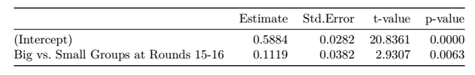

- Type (III) Model: Linguistic Structure variance
SD_Structure ~ centered.Round * Condition
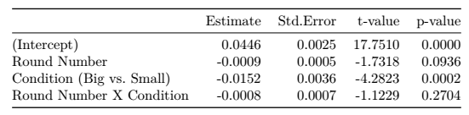

Input Variability

- Input Variability over time
MeanInputVariability ~ centered.Round * Condition
+ (1 + centered.Round | Group)
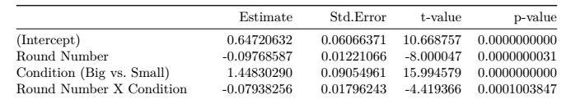

Changes in Linguistic Structure by Input Variability and Shared History

- Differences in linguistic structure by input variability
StructureDiff ~ centered.MeanInputVariability + (1 | Group/Producer)
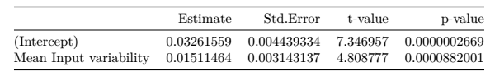

- Differences in linguistic structure by shared history
StructureDiff ~ centered.History + (1 | Group/Producer)
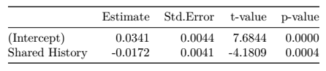

- Differences in structure by input variability and shared history
StructureDiff ~ centered.MeanInputVariability + centered.History
+ (1 | Group/Producer)
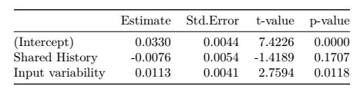
Relationship between measures

- Convergence by linguistic structure and round
MeanConvergence ~ centered.Structure * centered.Round
+ (1 + centered.Structure * centered.Round | Group)
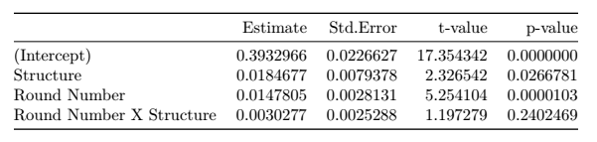

- Communicative Success by convergence, linguistic structure and round
MeanaAccuracy ~ centered.Structure * centered.Round
+ (1 + centered.Structure * centered.Round | Group)
