Supplementary

Table S1. The primers sequences used for qRT-PCR
Primer names | Sense sequence(5’-3’) | Antisense sequence(5’-3’) | Product size
CAT | AGGTGTTGAACGAGGAGGAGAGG | AGCGTTGTACTTGTCCAGAAGAGC | 161
Mn-SOD | ACGCCACCGAGGAGAAGTACC | GCTTGATAGCCTCCAGCAACTCTC | 180
CuZn-SOD | AAGCGGTGTGCGTGCTGAAG | TCCTGACAACACAACTGGTTCACC | 92
GSH-Px | CACAGTCCACCGTGTATGCCTTC | ACCGAGCACCACCAGTCCAC | 191
IL-1β | TCGCAGCAGCACATCAACAAGAG | TGCTCATGTCCTCATCCTGGAAGG | 118
GSDMD | ACTGAGGTCCACAGCCAAGAGG | GCCACTCGGAATGCCAGGATG | 140
Caspase-1 | ACAACCACTCGTACACGTCTTGC | CCAGATCCTCCAGCAGCAACTTC | 118
NF-κB | ATCCACCTCACCGGCCTCATC | TTCGCTGGCTAATGGCTTGCTC | 162
NLRP3 | GAGCTGGACCTCAGTGACAATGC | ACCAATGCGAGATCCTGACAACAC | 146
β-actin | CCTAGGCACCAGGGTGTGAT | TCCATGTCGTCCCAGTTGGT | 137

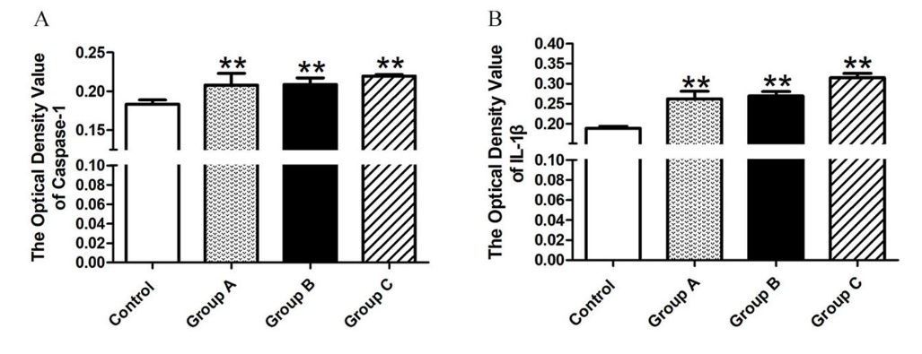

Figure S.1 The change of optical value of caspase-1 and IL-1β measured by immunohistochemistry. (A). The change of caspase-1 optical value in all experiments. (B) The change of IL-1β optical value in control group and A. adenophora administration. The optical density values were measured by three random microscopes.
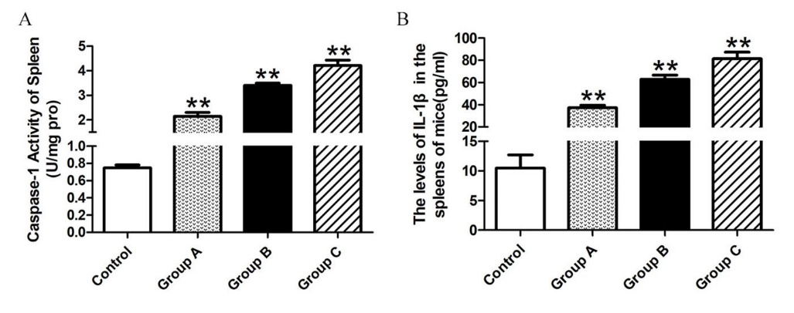

Figure S.2. The change of caspase-1 activity and IL-1β levels induced by A. adenophora. (A) The activity of caspase-1 increased with the increasing dosage of A. adenophora. (B) An increasing tendency of IL-1β level was observed in group A, B and C compared with the control group.

