Appendix A: Settings and Materials
The experimental settings between paired participants during the communication round:
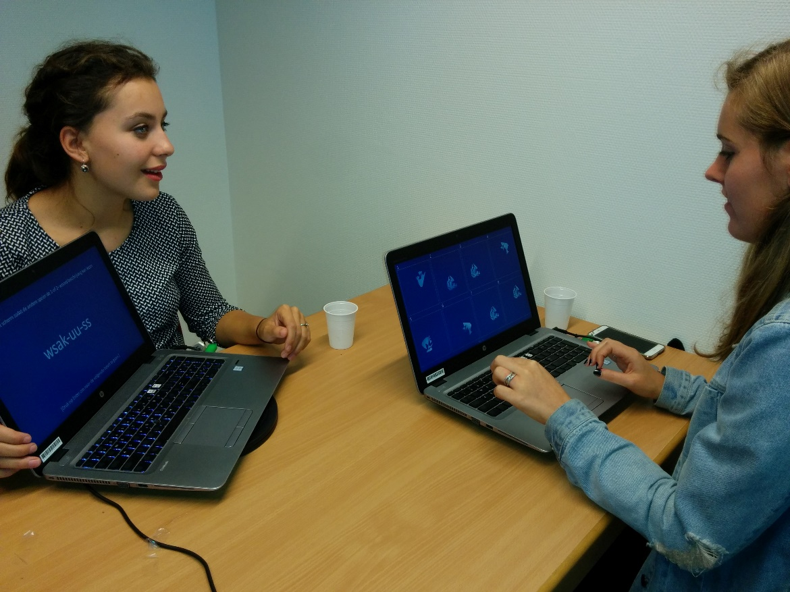
The experimental settings across a group during the communication round:
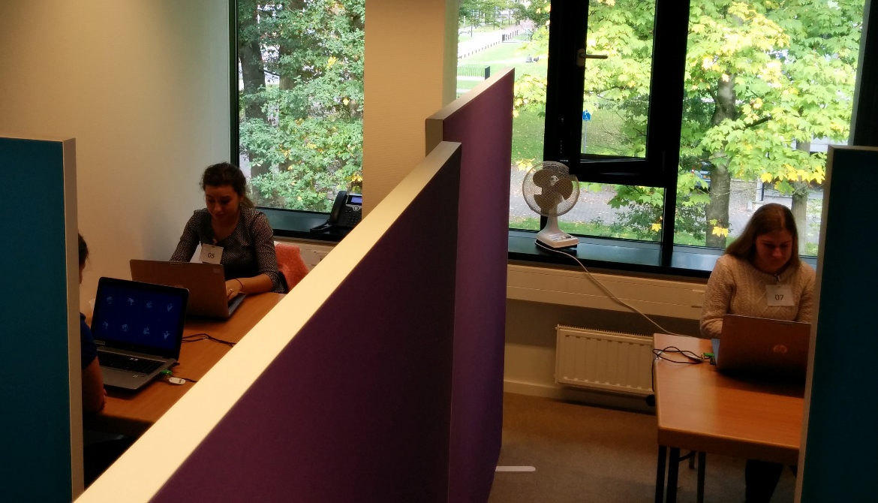
For each version of the stimuli, 23 scenes were created in the following way:
First, we created 28 static items (see initial set). The initial set contained exactly seven tokens of each of the four novel shapes, and each item was associated with a unique blue-hued fill pattern.
For each version, 23 items were randomly drawn from the 28 static items in the initial set, with the constraint that each type of shape should appear between four and seven times.
Then, each of these 23 static items was associated with an angle in order to create a moving scene. Angles were randomly selected from a set of 16 salient angles within the 360-degree-range (0⁰, 30⁰, 45⁰, 60⁰, 90⁰, 120⁰, 135⁰, 150⁰, 180⁰, 210⁰, 225⁰, 240⁰, 270⁰, 300⁰, 315⁰, 330⁰), following the constraint that in each version, each type of shape had to be associated with at least one angle from each of the four quadrants. The rest of the items’ angles were randomly drawn from this set of angles.

Initial Set:
Item Number | Shape | Stimuli
1 | 1
2 | 1
3 | 1
4 | 1
5 | 1
6 | 1
7 | 1
8 | 2
9 | 2
10 | 2
11 | 2
12 | 2
13 | 2
14 | 2
15 | 3
16 | 3
17 | 3
18 | 3
19 | 3
20 | 3
21 | 3
22 | 4
23 | 4
24 | 4
25 | 4
26 | 4
27 | 4
28 | 4

Version 1:
Item Number | Angle
1 | 210
2 | 270
3 | 90
4 | 330
5 | 30
6 | 300
7 | 135
8
9 | 270
10 | 150
11 | 330
12 | 30
13
14 | 120
15
16 | 45
17 | 315
18
19 | 135
20 | 240
21 | 360
22 | 60
23 | 360
24 | 180
25 | 315
26
27 | 120
28 | 225

Version 2:
Item Number | Angle
1 | 150
2 | 30
3 | 210
4 | 90
5 | 300
6 | 360
7 | 240
8 | 120
9 | 45
10 | 225
11 | 300
12
13 | 180
14 | 330
15 | 60
16 | 180
17 | 315
18
19
20
21 | 240
22 | 90
23 | 135
24 | 210
25 | 45
26 | 270
27
28 | 330

Version 3:
Item Number | Angle
1 | 150
2
3 | 360
4 | 210
5 | 60
6 | 240
7 | 315
8 | 270
9 | 90
10 | 210
11 | 45
12 | 135
13 | 330
14 | 180
15 | 45
16 | 135
17
18 | 180
19 | 240
20 | 315
21 | 270
22
23 | 300
24
25 | 120
26 | 225
27
28 | 30

