Supplementary Materials

Regulatory mechanisms underlying the specification of the pupal-homologous stage in a hemimetabolous insect

Yoshiyasu Ishimaru¹, Sayuri Tomonari², Takahito Watanabe¹, Sumihare Noji¹, and Taro Mito¹*

¹Division of Bioscience and Bioindustry, Graduate School of Technology, Industrial and Social Sciences, Tokushima University, 2-1 Minami-Jyosanjima-cho, Tokushima City, Tokushima 770-8513, Japan
² Division of Chemical and Physical Analyses, Center for Technical Support, Institute of Technology and Science, Tokushima University, 2-1 Minami-Jyosanjima-cho, Tokushima City, Tokushima 770-8506, Japan
³

*This author is corresponding author.

Supplementary Figure Legends
Figure S1. Typical processes of cricket wing and ovipositor development.
(a-f) Dorsal views of wild-type wing shapes in sixth (a), penultimate (seventh) (c) and final (eighth) (e) instar nymphs. Wing pads at the sixth instar (a) are marked with magenta asterisks. Wing shape of males (left panel: ♂) and females (right panel: ♀). T1–3; thorax 1–3, Ab; abdomen. Ventral views of wild-type ovipositor shapes in sixth (b), seventh (d) and eighth (f) instar nymphs. Scale bar = 2 mm.

Figure S2. Adult wing phenotypes resulting from the depletion of Gb’Kr-h1 and Gb’Br with RNAi at the fifth instar.
(a–d) dsRNA targeting DsRed2 (control) or Gb’Kr-h1 was injected into nymphs on day 1 of the fifth instar stage. In panels a and c, the control adults are on the left side and the RNAi-treated on the right. The RNAi-treated nymphs underwent precocious adult metamorphosis at the seventh instar, and the wings of these adults were significantly smaller than those of control adults (b,d). (e–h’) The effect of RNAi targeting DsRed2 (control) and Gb’Br on the wing that developed in adults (e,g). dsRNA targeting DsRed2 or Gb’Br was injected into nymphs on day 1 of the fifth instar stage. In panels e and g, the control adults are on the left side and the RNAi-treated on the right. Wing morphology in the resulting precocious adults was abnormal, with an extended side compared to control adults. Morphological variations were observed in panels f, f’, h and h’. The sex of individuals in each slide is shown at the bottom of each slide (male: ♂; and female: ♀). Scale bar = 1 cm in a, c, e–h’; 2 mm in b, d.

Figure S3. Wing phenotypes obtained from Gb’Kr-h1 and Gb’Br RNAi nymphs at the third instar.
(a–c) Development of the wing pads in sixth instar nymphs following the injection of dsRNA targeting DsRed2 (control; a), Gb’Kr-h1 (b) or Gb’Br (c) into the third instar nymphs, as indicated. Wing pads are marked with magenta asterisks. The wing pads of the Gb’ Kr-h1 (b) and Gb’Br (c)-targeted sixth instar nymphs exhibited abnormal growth, with an extended side, as compared with nymphs that were injected with DsRed2 dsRNA (a). (d,d’) Precocious adults were produced following the injection of dsRNA targeting Gb’Br. Gb’Br dsRNA was injected into third instar nymphs, and the resulting adults after the sixth instar are shown in panels d and d’. The wings of these adults were significantly reduced (d) and wrinkled (d’). Scale bar = 2 mm in a–c; 1 cm in d, d’.

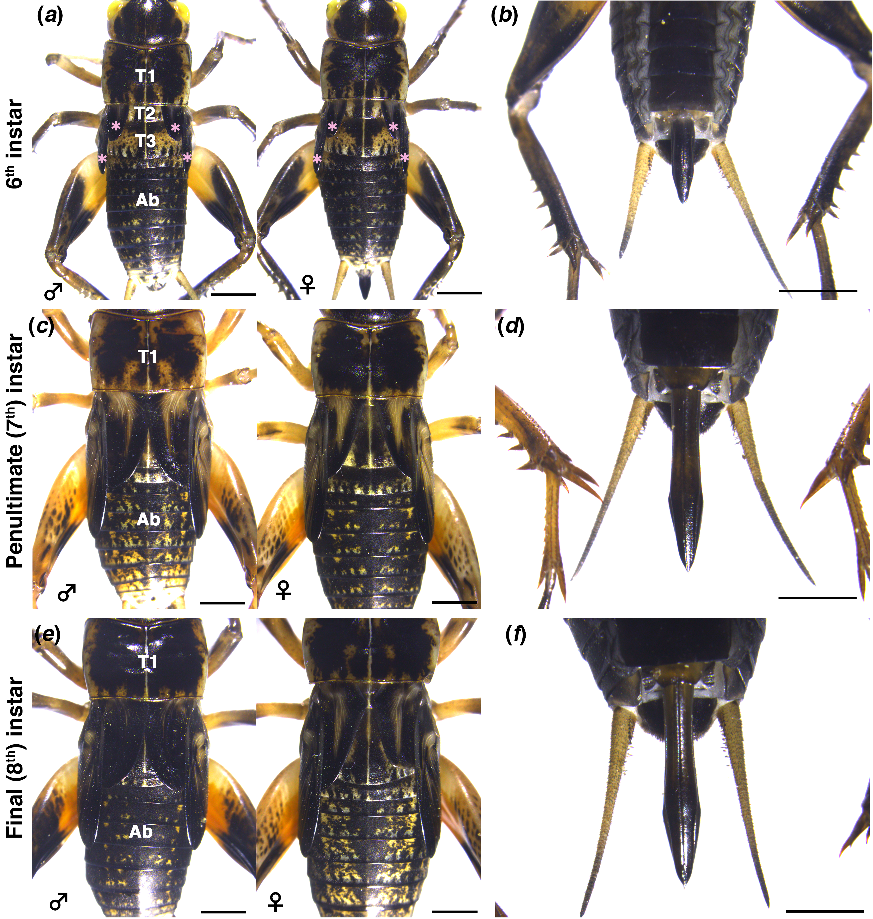

Figure S1

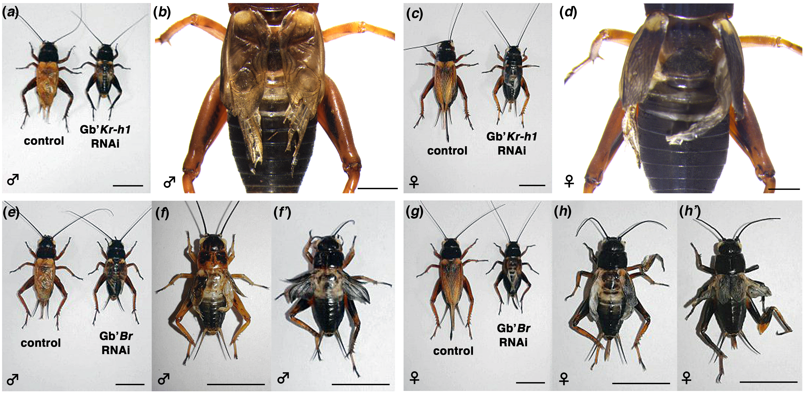

Figure S2

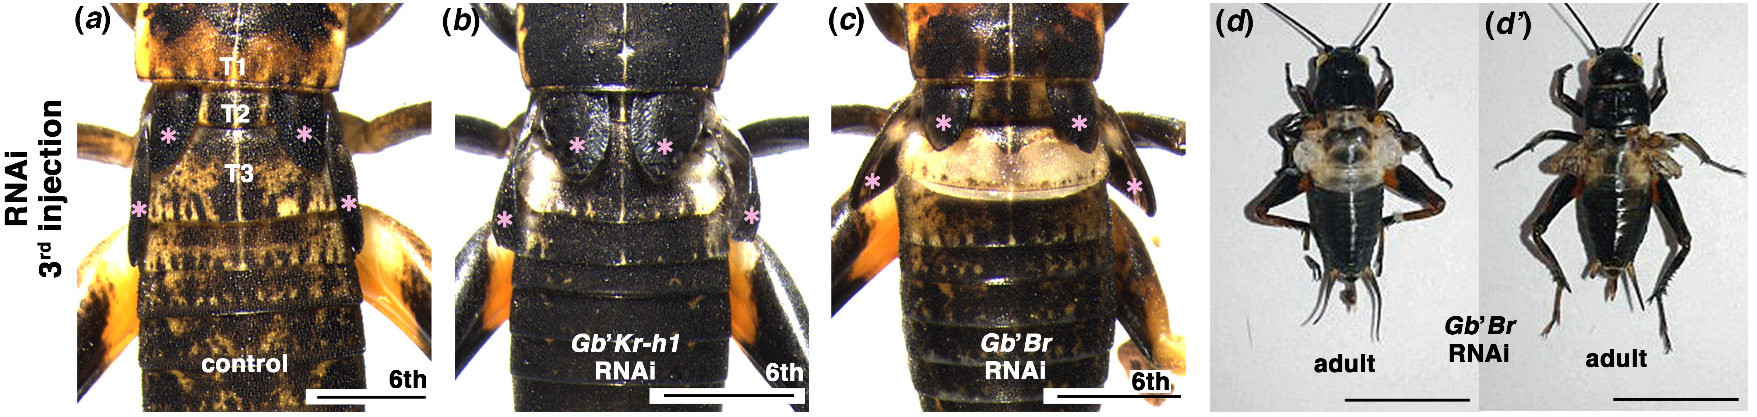

Figure S3

Supplementary Tables

Table S1. Phenotypes of G. bimaculatus injected with Gb’Kr-h1 and Gb’Br at the fifth instar.
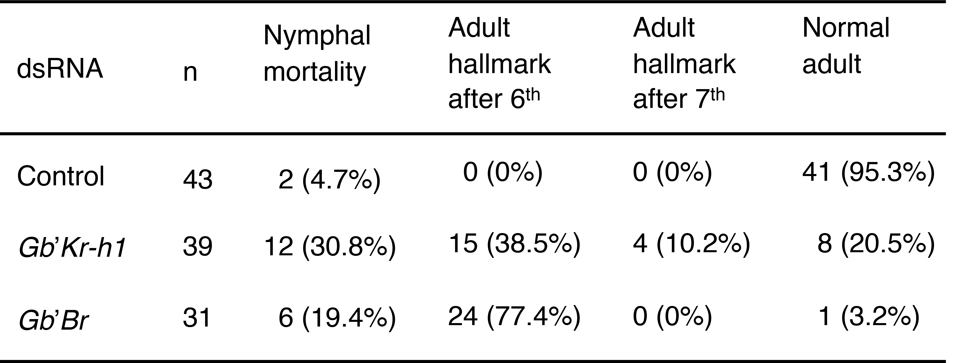
dsRNAs were injected at the fifth instar.
Adult hallmark denotes incidence of precocious adult metamorphosis at the sixth or seventh instar.

Table S2. Phenotypes of G. bimaculatus injected with Gb’E93 at the fifth instar.
dsRNAs were injected at the fifth instar.
Supernumerary moults occurred at the tenth instar, which underwent additional nymphal moults after the eighth instar, and a subsequent adult moult.

Table S3. Primer sequences used for cloning by RT-PCR.

Primer Name | Primer sequence
Gb’Kr-h1 Fw | 5'-TCGGTGAAGGAGAACCTGTC-3'
Gb’Kr-h1 Rv | 5'-GGTTGTAGCCGAAGCTCTTG-3'
Gb’Br Fw | 5'-AAATTTGCGGGATGATGAAG-3'
Gb’Br Rv | 5'-gtcgcaagatgtccttggat-3'
Gb’E93 Fw | 5'-CGCAGGCAATACACTGAAGA-3'
Gb’E93 Rv | 5'-TACAGCGCGAACTGCTTCTA-3'

Table S4. Primer sequences for the template fragment cloning of dsRNA synthesis.

Primer Name | Primer sequence
Gb’Br Fw2 | 5'-CTCATCACCCAGTCCAACCT-3'
Gb’Br Rv | 5'-gtcgcaagatgtccttggat-3'
Gb’E93 Fw2 | 5'-AGTTGTGGCCCTGAAAGATG-3'
Gb’E93 Rv2 | 5'-CGAACGAGTTCTGGAAGGAG-3'

Table S5. Primers used for qPCR.

Primer Name | Primer sequence
Gb’Kr-h1 qPCR Fw | 5'-ATTCACGTGCTCCAAGCAG-3'
Gb’Kr-h1 qPCR Rv | 5'-GTTGTAGCCGAAGCTCTTGC-3'
Gb’Br qPCR Fw | 5'-AGCATTTTTGTCTCCGTTGG-3'
Gb’Br qPCR Rv | 5'-CAAGCTTCTTCCTTCACAAGC-3'
Gb’E93 qPCR Fw | 5'-CGCAGGCAATACACTGAAGA-3'
Gb’E93 qPCR Rv | 5'-GGATGCCGTAGATGACTGCT-3'
Gb’actin qPCR Fw | 5'-TTGACAATGGATCCGGAATGT-3'
Gb’actin qPCR Rv | 5'-AAAACTGCCCTGGGTGCAT-3'

