Supplementary materials

Origin of ecdysis: fossil evidence from 535-million-year-old scalidophoran worms
Deng Wang, Jean Vannier, Isabell Schumann, Xing Wang, Xiaoguang Yang, Tsuyoshi Komiya, Kentaro Uesugi, Jie Sun, and Jian Han

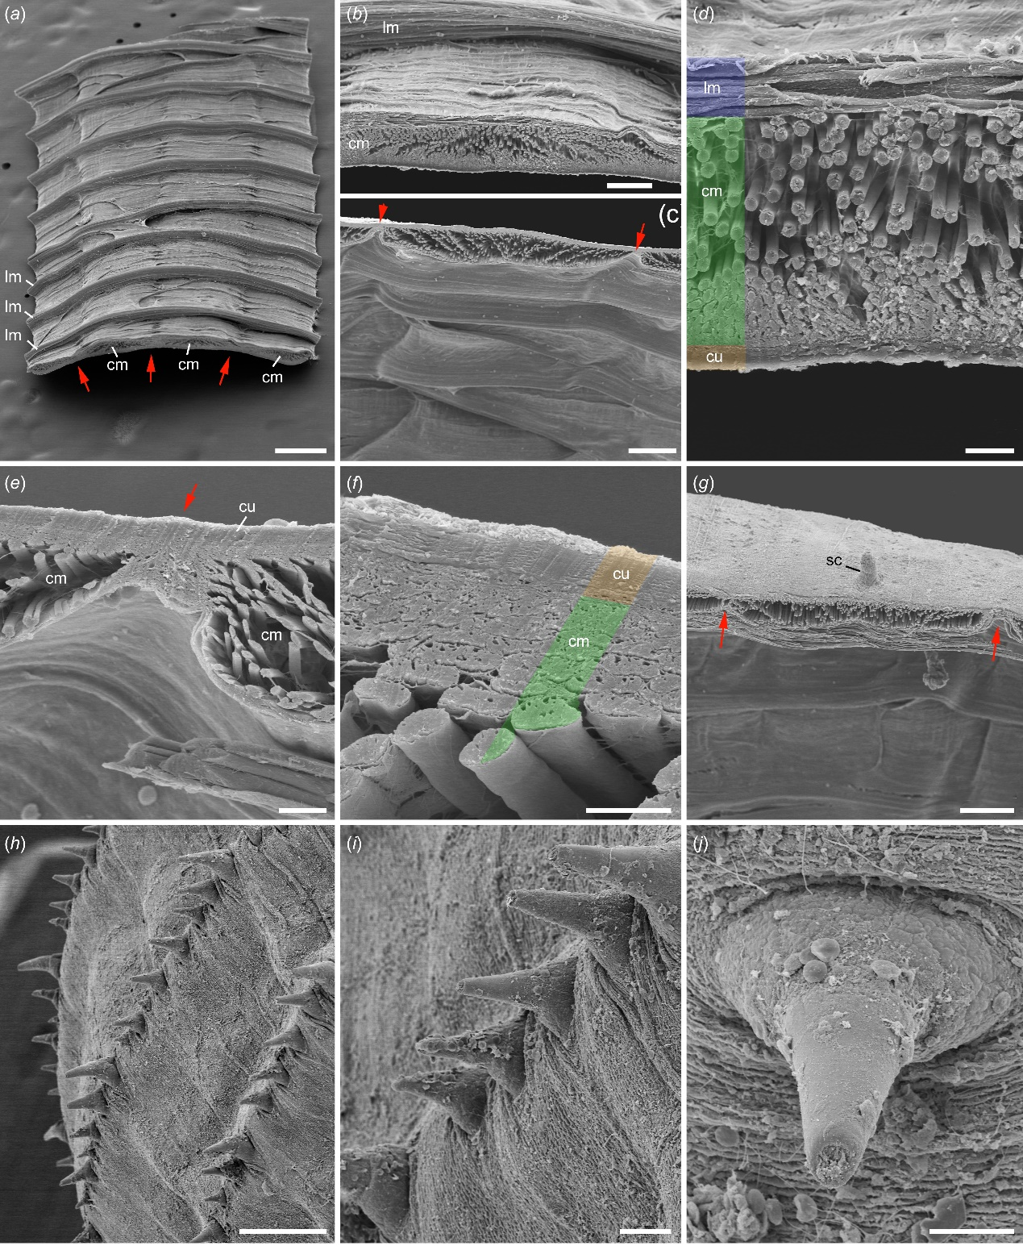
Figure S1. Cuticle and associated muscles in Priapulus caudatus (Priapulida) from Sweden [S1]. (a), fragment of body wall showing circular and longitudinal muscles. (b, c), transverse sections through circular muscles. (d), transverse section showing the cuticle (orange), circular (green) and longitudinal (blue) muscles. (e, f), transverse section showing details of chitinous cuticle and underlying muscle fibers. (g), transverse section near scalid. (h-j), scalids distributed in longitudinal rows along the proboscis and details of conical scalid. Red arrows represent boundaries between adjacent annuli. All SEM images. Abbreviations: cm, circular muscles; cu, cuticle; lm, longitudinal muscles; sc, scalids. Scale bars: 500 µm (a, h); 200 µm (c, g), 100 µm (b, i); 50 µm (j); 20 µm (d, e); 10 µm (f).

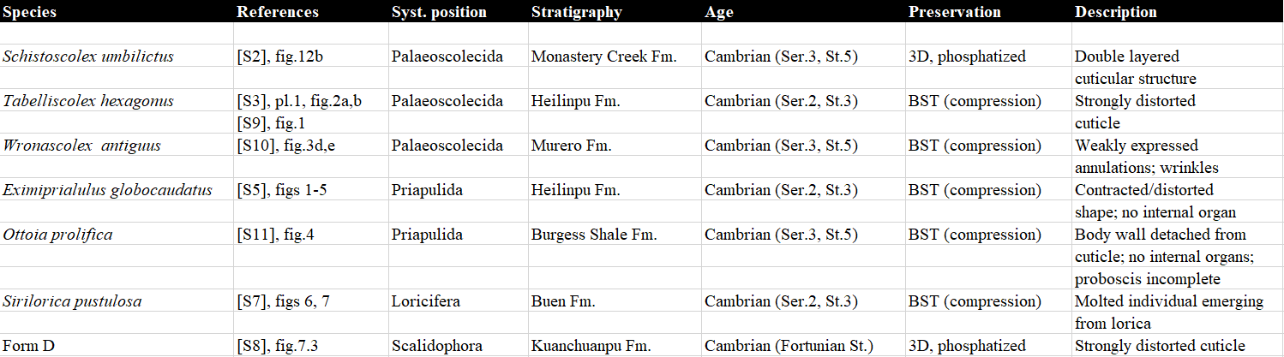
Table S2. Cambrian scalidophoran worms with assumed exuviae. Abbreviations are as follows: BST, Burgess-Shale-type preservation; Fm, Formation; Ser., Series; St., Stage; 3D, three-dimensions.
We changed “Undet. Form D” to “Form D”.
S3. Morphological descriptions of the two indeterminate scalidophoran worms described in the present paper (see Figures 1, 3), both from the lowermost Cambrian Kuanchuanpu Formation, Shaanxi Province, China.

Scalidophora Lemburg, 1995

Indeterminate Form 1

2015 Eokinorhynchus rarus, Zhang et al., fig. 3h–i.
2015 Form I, Zhang et al., fig. 4a.
2018 Form B, Zhang et al., fig. 5.1–3.
2018 Indeterminate Form 1, Liu et al., fig. 9A-B.

Material. Twelve specimens: ELIXX86-112, ELIXX63-29, ELIXX94-84, ELIXX99-492, ELIXX40-125, ELIXX85-284, ELIXX90-221, ELIXX85-429, ELIXX57-467, ELIXX98-179, ELIXX78-205 and ELIXX85-16; all from Bed 2 [16] of the Lower Cambrian Kuanchuanpu Formation (Fortunian Stage, Terreneuvian Series) in the Zhangjiagou Section in Xixiang County, Shaanxi Province South China. ELIXX86-112, ELIXX63-29, ELIXX94-84, ELIXX99-492, ELIXX40-125, ELIXX85-284, ELIXX90-221, ELIXX85-429 and ELIXX85-16 display positive relief (PER; see explanation in text). ELIXX98-179, ELIXX78-205 and ELIXX57-467 display negative relief (NER see explanation in text).

Measurements. See Table S5.

Description. Annulated trunk fragments lined with small and large spinose sclerites. Small sclerites tightly juxtaposed around annuli, each with an expanded elliptical base and a spinose projection, not aligned in longitudinal columns but showing a staggered pattern. Large sclerites with the base extending over 3 or 4 annuli and bearing a stout spinose projection. Base of small and large sclerites and other cuticular areas with well-defined reticular ornament.

Comparisons. These specimens show overall similarities to the trunk of three scalidophoran species and one indeterminate form found in the same biota. They resemble Eokinorhynchus rarus in having closely packed small sclerites around annuli. However, the small sclerites of E. rarus have a sub-quadrangular basis and do not bear a spine. The trunk of Qinscolex spinosus has five large spinose sclerites whereas the present indeterminate form has only two such features. In Indeterminate Form 1 (this paper), the small spinose sclerites are in close contact with each other and have about the same length as the annulus, whereas they do not reach the annulus margin and are more widely spaced in Shanscolex decorus. Our specimens resemble “FormIa” described by Zhang et al. 2015in many respects (e.g. shape and distribution of sclerites). Both forms have large spinose sclerites that are three times wider than the small ones within a single annulus(Figure 1(g) and [S12] text-fig. 9A-B).

Orientation. Comparisons with complete specimens of scalidophoran worms from the Kuanchuanpu Formation [8, 12-14] allow us to determine the -anterior-posterior polarity of the trunk fragments of Indeterminate Form 1 (this paper). Sclerites project radially with their main axis pointing posteriorly.

Indeterminate Form 2

2018 Indeterminate Form 1 Liu et al., fig. 9C.

Materials. From the same bed as Indeterminate Form 1 (see above). ELIXX85-120 with negative external relief (NER; see explanation in text) from the same bed as Indeterminate Form 1 (see above).

Measurements. See Table S5.

Description. Single cylindrical trunk fragment with six annuli. Small, discrete spinose sclerites border each annulus, exhibiting a spoon-shaped base and a central conical spine; base about two-thirds as long as the annulus. Base of sclerites and other cuticular areas with well-defined reticular ornament. Fragment exhibits only one type of sclerite (small).

Comparison. This specimen resembles the trunk of Qinscolex spinosus and Shanscolex decorus in having well-separated sclerites along the annuli. However, its unusual spoon-shaped sclerites have no equivalent in Q. spinosus (rounded shape), S. decorus (narrow elliptical shape) or other scalidophorans from the Kuanchuanpu Formation, including Indeterminate Form 1 (this paper; see above), which exhibits large spinose sclerites. Although preserved in negative relief, this specimen closely resembles Indeterminate Form 1 described by Liu et al. 2018 ([12] text-fig. 9C).

Figure S4. Indeterminate Form 1 (see description in S3) from the lowermost Cambrian Kuanchuanpu Formation, Shaanxi Province, China. (a-i) specimens showing positive external relief (PER; see explanation in text). (j-o) specimens showing negative external relief (NER; see explanation in text). (a, b), ELIXX85-284, general views from two opposite sides showing small and large sclerites. (c-e), ELIXX40-125, general views from two opposite sides showing small sclerites on annuli and a large sclerite and details of reticulated ornament along basal part of sclerite. (f, g), ELIXX94-84, general views from two opposite sides showing small and large sclerites. (h, i), ELIXX99-492, general views from two opposite sides showing small and large sclerites. (j, o), ELIXX78-205, wrinkled trunk fragments showing small and large sclerites and details of reticulated ornament along the basal part of the inner surface of a sclerite. (k, l), ELIXX57-467 general views from two opposite sides showing small and large sclerites. (m, n), ELIXX98-179, general views from two opposite sides showing small and large sclerites. All SEM images. Abbreviations: ant, anterior part; fu, furrow between annuli; ls, large spinose sclerite; pos, posterior part; ro, reticulated ornament; ss, small spinose sclerite. Scale bars: 500 μm (a-d), (f-n), 50 μm (e, n).

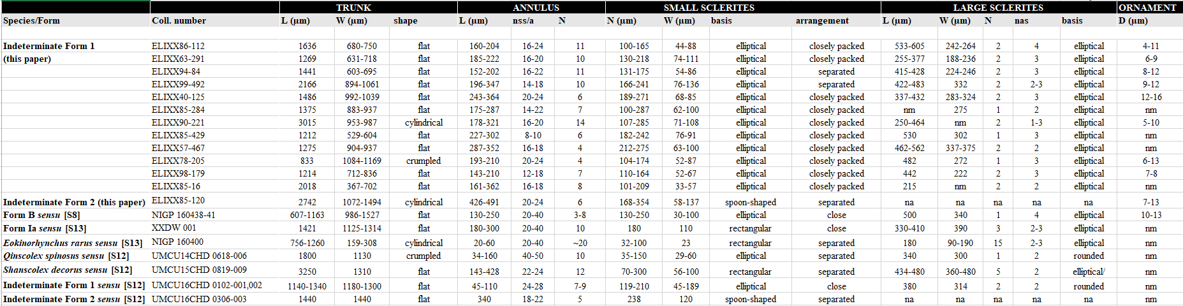
Table S5. Measurements of scalidophoran specimens described in the present paper and previous studies, all from the lowermost Kuanchuanpu Formation of China. D, diameter of ornamented pentagonal cell; L, length; n, number; Coll., Collections; na, not applicable; nas, number of annuli straddled by a large sclerite; nm, not measured due to poor preservation; nss/a, number of small sclerites per annulus; W, width.

We changed “Undet. XX1 and Undet. XX2” to “Indeterminate Form 1 and Indeterminate Form 2”. We also replaced “Undet. Form B and Undet. Form Ia” by “Form B and Form Ia”. We corrected “Indet. Form 1 and Indet. Form 2” to “Indeterminate Form 1 and Indeterminate Form 2”.

Figure S6. Ottoia prolifica from the middle Cambrian Burgess Shale, Canada. (a) ROMIP 61780, clustered specimens (body fossils). (b) ROMIP 61779 showing gut tract and gut contents (small brachiopods). (c) and (d) WQ94-0014, presumed exuvia, part and counterpart. (e) USNM 188637, presumed exuvia. (f) and (g) show close-ups of the anterior and posterior parts of the specimen shown in (e). All photographs in polarized light. Abbreviations: ant, anterior part of exuvia; ep, everted pharynx; gc, gut content (small brachiopods); gu, gut; pc, pharyngeal cuticle; ph, posterior hook; pos, posterior part of exuvia; tr, trunk; vnc?, ventral nerve chord?. Scale bars: 1cm (a-e), 5 mm (f, g).
We changed black letter “ph” in Figure S6 (f) into white letter “ph”.
Figure S7. Moulting in a mamba snake. (a) Snake crawling out of its exuvia and turning it inside out. (b) The external surface of the exuvia shows a negative relief. Abbreviations: bo, body; ex, exuvia; hp, head part of exuvia; sc(+) and sc(-), scales with a positive (body) and negative relief (exuvia). Courtesy Julia Sundukova.

Supplementary references

S1. Vannier J., Martin E.L.O. 2017 Worm-lobopodian assemblages from the Early Cambrian Chengjiang biota: Insight into the “pre-arthropodan ecology”? Palaeogeography, Palaeoclimatology, Palaeoecology 468, 373-387. (doi:10.1016/j.palaeo.2016.12.002).
S2. Müller K.J., Hinz-Schallreuter I. 1993 Palaeoscolecid worms from the middle Cambrian of Australia. Palaeontology 36(3), 549-592.
S3. Han J., Zhang X.L., Zhang Z.F., Shu D.G. 2003 A new platy-armored worm from the Early Cambrian Chengjiang Lagerstätte, South China. Acta Geologica Sinica 77(1), 1-6.
S4. Glaessner M.F. 1979 Lower Cambrian Crustacea and annelid worms from Kangaroo Island, South Australia. Alcheringa: An Australasian Journal of Palaeontology 3(1), 21-31. (doi:10.1080/03115517908565437).
S5. Ma X.Y., Aldridge R.J., Siveter D.J., Siveter D.J., Hou X.G., Edgecombe G.D. 2014 A new exceptionally preserved Cambrian priapulid from the Chengjiang Lagerstätte. Journal of Paleontology 88(2), 371-384.
S6. Walcott C.D. 1911 Middle Cambrian Annelids, Cambrian Geology and Paleontology II. Smithsonian Miscellaneous Collections 57(5), 110-144.
S7. Peel J.S. 2010 A Corset-like Fossil From The Cambrian Sirius Passet Lagerstatte of North Greenland and its Implications For Cycloneuralian Evolution. Journal of Palaeontology 84(2), 332-340.
S8. Zhang H.Q., Maas A., Waloszek D. 2018 New material of scalidophoran worms in Orsten-type preservation from the Cambrian Fortunian Stage of South China. Journal of Paleontology 92(01), 14-25. (doi:10.1017/jpa.2017.39).
S9. Han J., Liu J.N., Zhang Z.F., Zhang X.L., Shu D.G. 2007 Trunk ornament on the palaeoscolecid worms Cricocosmia and Tabelliscolex from the Early Cambrian Chengjiang deposits of China. Acta Palaeontologuca Polonica 52(2), 423–431.
S10. García-Bellido D.C., Paterson J.R., Edgecombe G.D. 2013 Cambrian palaeoscolecids (Cycloneuralia) from Gondwana and reappraisal of species assigned to Palaeoscolex. Gondwana Research 24(2), 780-795. (doi:10.1016/j.gr.2012.12.002).
S11. Conway Morris S. 1977 Fossil priapulid worms. Special Papers in Palaeontology 20, 1-95.
S12. Liu Y.H., Qin J.C., Wang Q., Maas A., Duan B.C., Zhang Y.N., Zhang H., Shao T.Q., Zhang H.Q., Zhang X.G. 2018 New armoured scalidophorans (Ecdysozoa, Cycloneuralia) from the Cambrian Fortunian Zhangjiagou Lagerstätte, South China. Papers in Palaeontology, 1-20. (doi:10.1002/spp2.1239).
S13. Zhang H.Q., Xiao S.H., Liu Y.H., Yuan X.L., Wan B., Muscente A.D., Shao T.Q., Gong H., Cao G.H. 2015 Armored kinorhynch-like scalidophoran animals from the early Cambrian. Scientific Reports 5, 16521. (doi:10.1038/srep16521).
S14. Liu Y.H., Xiao S.H., Shao T.Q., Broce J., Zhang H.Q. 2014 The oldest known priapulid-like scalidophoran animal and its implications for the early evolution of cycloneuralians and ecdysozoans. Evolution & Development 16(3), 155-165. (doi:10.1111/ede.12076).
S15. Vannier J. 2012 Gut contents as direct indicators for trophic relationships in the Cambrian marine ecosystem. PLoS One 7(12), e52200. (doi:10.1371/10.1371/journal.pone.0052200.g001).

