Electronic supplementary material

The loud scratch: a newly identified gesture of Sumatran orang-utan mothers in the wild

Marlen Fröhlich^{1*}, Kevin Lee^{1,2}, Tatang Mitra Setia³, Caroline Schuppli¹, Carel P. van Schaik¹

¹Department of Anthropology, University of Zurich, 8057 Zurich, Switzerland

²School of Human Evolution and Social Change and Institute of Human Origins, Arizona State University, AZ 85281, USA

³Fakultas Biologi, Universitas Nasional, Jakarta Selatan 12520, Indonesia

*Author for correspondence, email address: marlen.froehlich@uzh.ch

Material and Methods

Table S1. Overview on study subjects and dataset
ID | Age group | Sex | N scratch bouts | Obs. Time (hh:mm:ss) | Rec. time  (hh:mm:ss)
Chindy | Adol | female | 25 | 0:46:28 | 0:17:23
Cinnamon | Inf | female | 33 | 24:44:34 | 5:14:39
Cissy | Mot | female | 101 | 24:44:34 | 5:14:39
Diddy | Juv | male | 65 | 17:27:48 | 2:27:47
Ellie | Adol | female | 39 | 34:16:04 | 4:13:39
Frankie | Inf | male | 24 | 20:20:44 | 4:35:39
Fredy | Juv | female | 118 | 23:19:46 | 2:36:57
Friska | Mot | female | 118 | 20:20:44 | 4:35:39
Islo | Adm | male | 41 | 11:27:42 | 0:43:29
Lilly | Adol | female | 164 | 52:03:48 | 4:08:30
Lisa | Mot | female | 240 | 62:21:18 | 9:26:10
Lois | Inf | male | 165 | 62:21:18 | 9:26:10
Sarabi | Mot | female | 91 | 29:17:06 | 4:08:11
Sazu | Juv | male | 8 | 29:17:06 | 4:08:11
Simba | Inf | male | 5 | 29:17:06 | 4:08:11
Ullysses | Adm | male | 202 | 28:35:46 | 3:35:01
Xenix | Adm | male | 18 | 0:39:56 | 0:17:01
Total | 4:4:3:3:3 | 9:8 | 1457 | 305:21:00 | 41:00:57

Coding procedure

For each scratching bout, we then coded whether it was accompanied by visual orientation of scratcher towards audience (“audience checking”), visual orientation of associate relative to scratcher (“recipient’s attentional state”), and whether it was a serial scratch bout (“persistence to the goal”) [1-5]:

Scratcher’s visual orientation: The signaller visually orients towards and monitors the potential recipient before and during scratching. Clear visibility of the signaller’s head and gaze was presupposed to code this behaviour.

Associate’s visual orientation: The signaller scratches when the potential recipient is entirely visually oriented and faced towards the signaller and is thus attentive. Clear visibility of the associate’s head and gaze was presupposed to code this behaviour.

Serial scratch bout: The signaller produces scratching bout between 2 and 30 seconds after a previous one.

A subset of 33 video clips containing 64 scratching bouts were coded for accuracy by a second observer and tested using the Cohen’s kappa coefficient to ensure inter-observer reliability [6, 7]. A ‘good’ level of agreement was found for scratch characteristics (κ = 0.781), while a ‘very good’ agreement was obtained for post-scratch context (κ = 0.873), visual orientation of scratcher and associate (κ = 0.880) and associate’s response (κ = 0.880).

Model specification

In model (1) we included age-sex class (four levels: mothers, adult males, immature females, immature males), scratch duration (in seconds; range = 1–31), scratch rate (scratches per second; range = 0.3–3), scratch range (two levels: large = large scratch to body and/or limbs, small = small scratch to head or face) and association with conspecifics (two levels: in association with a conspecific (including non-clinging infants), alone or with clinging infant) as our key test predictors. For the model testing for intentional use of scratches (2), we additionally included pre-move scratching (two levels: yes, no) as fixed effect, but omitted association (not meaningful when looking only at socially directed behaviour). In model (3), we additionally included relationship (2 levels: offspring, other) instead of age-sex class, and associate’s attentional state (two levels: visually oriented towards scratcher, faced away) as fixed effect. To test for interdependence of effects in models 1 and 2, we initially included the respective interaction terms between age class (mother) and pre-move scratching, as well as age class (mother) and scratch variables (i.e. duration, rate, range). These interactions terms were excluded from further analyses of they were not significant.

Model implementation
As random effects (intercepts) we included the scratcher’s identity and interaction number (filename) in the model. To keep type 1 error rates at the nominal level of 5%, we also included the relevant random slopes components within identity, e.g. pre-move scratch, scratch duration, scratch rate, and scratch range [8]. The models were implemented in R [version 3.1.2; 9] using the function glmer of the package ‘lme4’[10]. To control for collinearity we determined variance inflation factors [VIF; 11, 12] from a model including only the fixed main effects using the function vif of the R package ‘car’. This revealed collinearity generally not to be an issue (maximum VIF = 1.72). To test the overall significance of our key test predictors [13], we compared these full models with the respective ‘null models’ comprising only the random effects using a likelihood ratio test [14]. This test revealed whether the full model including the key test predictors fits the data significantly better than the null model. To also test whether inter-individual differences had a significant effect on the response variables, we excluded scratcher’s identity (and all random slopes within identity), and ran a second likelihood ratio test comparing the full model with this reduced model. Subsequently, tests of the individual fixed effects were derived using likelihood ratio tests (R function drop1 with argument ‘test’ set to ‘Chisq’). If the interaction terms (i.e. age-sex class*move) were non-significant, they were removed so that effects were only derived for the main predictors.

Results

Overview of scratching bout characteristics
With regard to scratching rates, mothers scratched on average 4.2/h (times per hour of observation) (N = 4), adult males 12.6/h (N = 3), adolescents 12.3/h (N = 3), juveniles 3/h and infants 1.3/h (N = 4). 348 scratching bouts (26.4 % of applicable bouts) were successive bouts as part of a bout series. On average, individuals produced 3.6 scratching bouts per hour of observation that were followed (within ten seconds) by feeding behaviour, 1.4/h by moving, 0.98/h by resting and 0.19/h by other (e.g. social or solitary play, nesting, exploration) or non-determinable behaviours (e.g. due to dense vegetation). The mean (± S.D.) duration of a scratch bout for each individual was 5.9 ± 2.5 s, the mean number of produced scratches per bout was 6.9 ± 2.7, corresponding to a mean scratching rate of 0.8 ± 0.1 scratches/s. Out of the 1408 scratching bouts for which handedness could be determined, 722 (51.3 %) of scratches were produced with the right hand, 676 (48.0 %) with the left hand, and 10 (0.7 %) with both hands simultaneously. Body regions being scratched within a single bout could be determined in 1380 bouts and included the body (N= 479; 34.7 %), the head (N = 416; 30.1 %), the extremities (N = 401; 29.1 %) or a switch between regions (N= 84; 6.1 %).

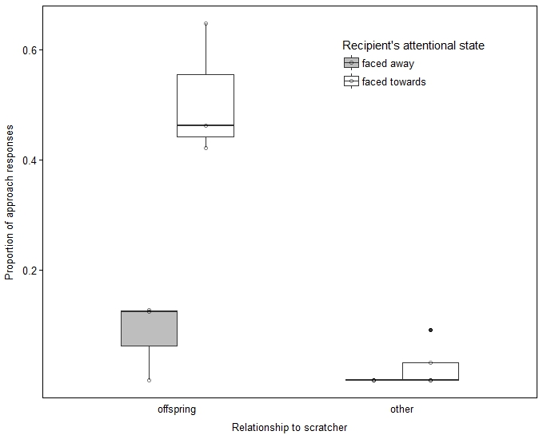
Figure S1. Proportion of approach responses by conspecifics as a function of kin relationship with and attentional state of the scratching subject and (No. of individuals included: N_{infant} = 3; N_{other} = 7). Indicated are median (horizontal lines), quartiles (boxes), percentiles (2.5% and 97.5%, vertical lines) and outliers (dots).

References

[1] Bates, E., Camaioni, L. & Volterra, V. 1975 The acquisition of performatives prior to speech. Merrill-Palmer Quarterly: Journal of Developmental Psychology 21, 205-226.
[2] Call, J. & Tomasello, M. 2007 The gestural communication of apes and monkeys. Mahwah, New York, Lawrence Erlbaum Associates; 256 p.
[3] Bates, E., Benigni, L., Bretherton, I., Camaioni, L. & Volterra, V. 1979 The Emergence of Symbols: Cognition and Communication in Infancy. New York, Academic Press.
[4] Leavens, D.A., Russell, J.L. & Hopkins, W.D. 2005 Intentionality as measured in the persistence and elaboration of communication by chimpanzees (Pan troglodytes). Child Development 76, 291-306.
[5] Fröhlich, M., Wittig, R.M. & Pika, S. 2019 The ontogeny of intentional communication in chimpanzees in the wild. Dev Sci 22, e12716.
[6] Bakeman, R. & Quera, V. 2011 Sequential analysis and observational methods for the behavioral sciences, Cambridge University Press.
[7] Altman, D. 1990 Practical statistics for medical research. London, Chapman and Hall; 616 p.
[8] Schielzeth, H. & Forstmeier, W. 2009 Conclusions beyond support: overconfident estimates in mixed models. Behav. Ecol. 20, 416-420.
[9] R Development Core Team. 2017 R: A language and environment for statistical computing. (Vienna, Austria, R Foundation for Statistical Computing.
[10] Bates, D., Maechler, M., Bolker, B. & Walker, S. 2014 lme4: Linear mixed-effects models using Eigen and S4. R package version 1.
[11] Quinn, G.P. & Keough, M.J. 2002 Experimental design and data analysis for biologists. Cambridge, Cambridge University Press.
[12] Field, A. 2005 Discovering statistics using SPSS. London, Sage publications.
[13] Forstmeier, W. & Schielzeth, H. 2011 Cryptic multiple hypotheses testing in linear models: overestimated effect sizes and the winner's curse. Behav. Ecol. Sociobiol. 65, 47-55.
[14] Dobson, A.J. 2002 An Introduction to Generalized Linear Models. Boca Raton, Chapman & Hall/CRC.

