Supplementary Information for

Degradation of methylene blue by natural manganese oxides: Kinetics and transformation products
Shuangxi Zhou, Zhiling Du, Xiuwen Li, Yunhai Zhang, Yide He*, Yongjun Zhang*

School of Environmental Science and Engineering, Nanjing Tech University, Nanjing, P.R. China

Corresponding author: Pu Zhu Nan Lu 30, 211800, Nanjing, P.R. China
Email: y.zhang@njtech.edu.cn, heyd@njtech.edu.cn

(b)
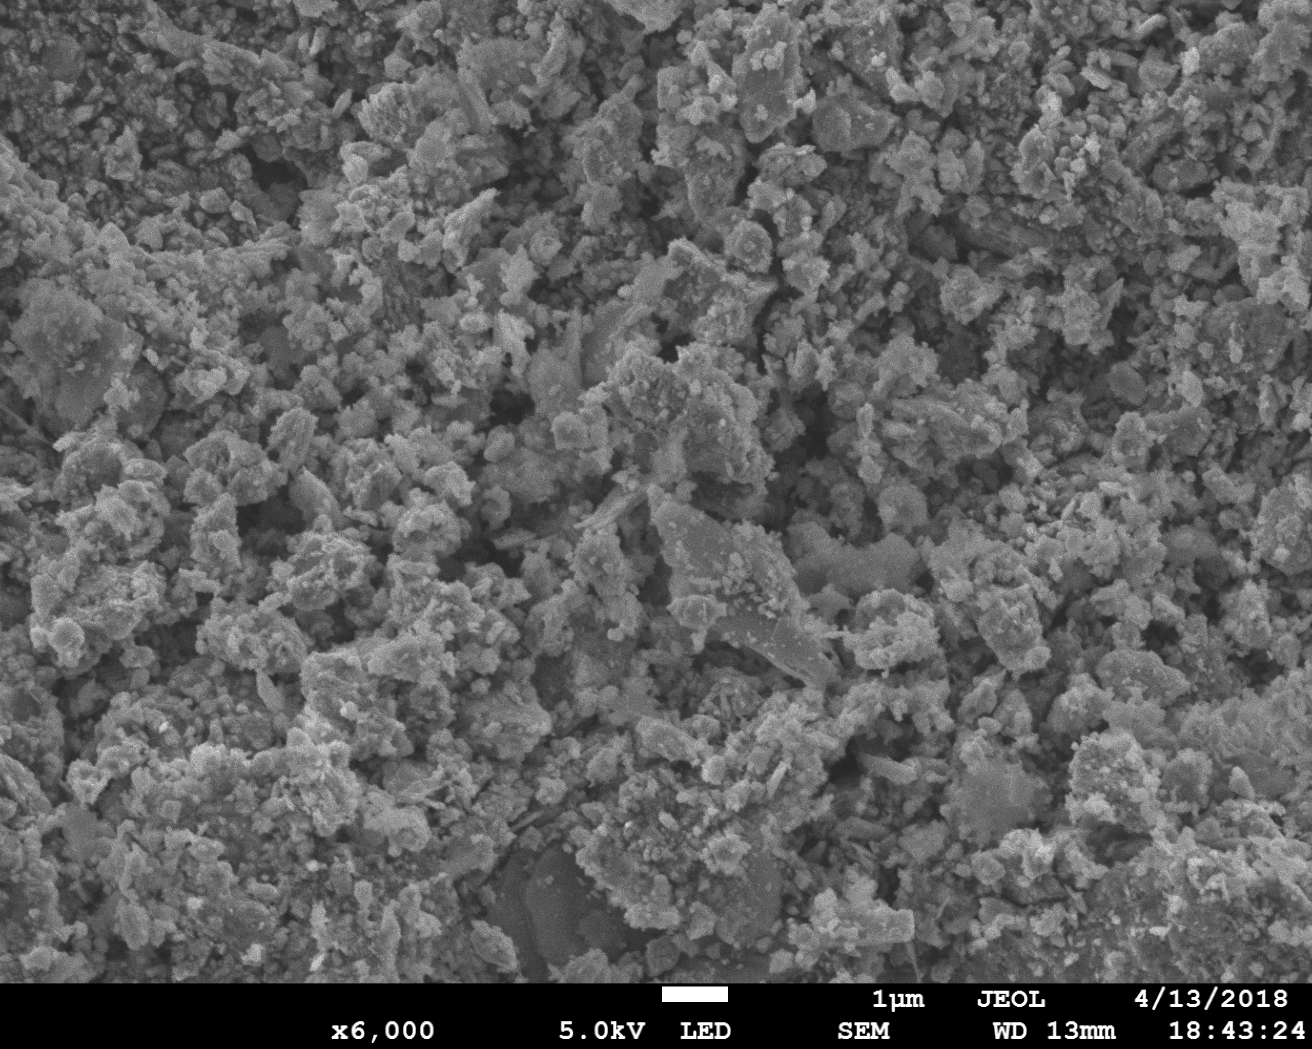

Figure S1.SEM image of MnOx
The method for the measurement of pH_{pzc}:
The point zero charges (pHpzc) value of MnOx was measured by a traditional potentiometric acid–base titration method which was conducted in 250ml flask with a series of 100 mL NaCl (0.01 M) solutions, and the pH values were adjusted from 2.0 to 10.0 using 0.1 M HCl or 0.1 M NaOH. After that, 0.15 g MnOx was added and the mixture was shaked in a thermostatic shaker at 120 rpm (30 ℃) for 48 h. The initial pH (pH_{initial}) and final pH (pH_{final}) were recorded. The pHpzc value is obtained from the plot ΔpH = (pH_{initial} - pH_{final}) versus initial pH_{initial}. The intersection of the curve with the straight line is the point of pH_{pzc}.
Figure S2.The zero point of MnOx measured by a traditional potentiometric acid–base titration method

Table∣S1 Chemical bonds energies of methylene blue molecule [1]
Molecule bonds | Bond energy (kcal/mol)
CH₃-N(CH₃)C₆H₅ | 70.8
N(CH₃)₂C₆H₅ | 93.2±2.5
C₆H₅-N-C₆H₅ | 87.4
C₆H₅-S-C₆H₅ | 76±2
C₆H₅-NH₂ | 102.6±1.0

References:
1. Luo, Y. R., 2005 Handbook of Bond Dissociation Energies in Organic Compounds. Science Press. Beijing.

