Supplementary material for: Colour plasticity in response to social context and parasitic infection in a self-fertilizing fish
Rebecca Jane Pawluk, Carlos Garcia de Leaniz, Jo Cable, Bernard Tiddeman, Sofia Consuegra
Table S1. Algorithms for colour conversion. The conversion from sRGB colour space to the CIE XYZ colour space is given by a non-linear conversion:

for k = r, g and b (to give r’, g’ and b’)
$k'=\left\{\begin{matrix}{\left(\frac{(k+0.055)}{1.055}\right)}^{2.4} & \text{if} k>0.04045 \\ \frac{k}{12.92} & \text{otherwise}\end{matrix}\right.$

followed by a linear transformation:

$\left(\begin{matrix}X \\ Y \\ Z\end{matrix}\right)=\left(\begin{matrix}0.4124 & 0.3576 & 0.1805 \\ 0.2126 & 0.7152 & 0.0722 \\ 0.0193 & 0.1192 & 0.9505\end{matrix}\right)\left(\begin{matrix}r' \\ g' \\ b'\end{matrix}\right)$

The formulae for converting from XYZ to L*a*b* are given by:

f₀ = f(y/w_{y})
L* = 116*f₀-16
a* = 500*(f(x/w_{x})-f₀)
b* = 200*(f₀-f(z/w_{z}))

Where the XYZ colour is represented by (x, y, z), and the whitepoint is (w_{x}, w_{y}, w_{z}). The function f is defined as:

$f\left(x\right)=\left\{\begin{matrix}\sqrt[3]{x} & \text{if} x>δ^{3} \\ \frac{x}{3δ^{2}}+\frac{4}{29} & \text{otherwise}\end{matrix}\right.$

where δ = 6/29.
The source code implementing the above is available at https://github.com/bptiddeman/get-region-colour.

Table S2. Comparison among models of colour expression attributes (Light, hue, chroma) in Kryptolebias marmoratus as a function of social context (single, group or control) and selfing line (DAN and R), including and excluding individual (ID) as a random factor. (a) Lightness values (b) Hue values (c) Chroma values. Post-hoc testing was completed using lsmeans (package lsmeans) on the final selected model for each attribute.

a) Model comparison:
modL3: L ~ Line + Social + Time
modL1: L ~ Line + Social + Time + (-1 + isDAN | ID) + (1 + isR | ID)
modL4: L ~ Line * Social * Time
modL2: L ~ Line * Social * Time + (-1 + isDAN | ID) + (1 + isR | ID)

Df AIC BIC logLik deviance Chisq Chi Df Pr(>Chisq)
modL3 5 1162.1 1177.3 -576.04 1152.1
modL1 7 1143.6 1165.0 -564.81 1129.6 22.458 2 1.328e-05 ***
modL4 9 1164.1 1191.5 -573.04 1146.1 0.000 2 1
modL2 11 1144.4 1177.9 -561.19 1122.4 23.687 2 7.185e-06 ***

Posthoc tests:

Social lsmean SE df lower.CL upper.CL
0 50.61784 1.571765 50.04 47.46093 53.77475
1 56.17200 1.245165 25.12 53.67107 58.67293
2 61.72615 1.742025 43.52 58.22727 65.22504

contrast estimate SE df t.ratio p.value
0 - 1 -5.554156 1.096410 93.85 -5.066 <.0001
0 - 2 -11.108311 2.192819 93.85 -5.066 <.0001
1 - 2 -5.554156 1.096410 93.85 -5.066 <.0001

Models:
modL3: L ~ Line + Social + Time
modL1: L ~ Line + Social + Time + (-1 + isDAN | ID) + (-1 + isR | ID)
Df AIC BIC logLik deviance Chisq Chi Df Pr(>Chisq)
modL3 5 1162.1 1177.3 -576.04 1152.1
modL1 7 1143.6 1165.0 -564.81 1129.6 22.458 2 1.328e-05 ***

Model simplification:

Formula: L ~ Social + (-1 + isDAN | ID) + (-1 + isR | ID)
Data: Llmm.data

Scaled residuals:
Min 1Q Median 3Q Max
-2.48532 -0.49937 0.03257 0.53356 2.74019

Random effects:
Groups Name Variance Std.Dev.
ID isDAN 16.23 4.029
ID.1 isR 55.44 7.446
Residual 64.60 8.038
Number of obs: 156, groups: ID, 34

Fixed effects:
Estimate Std. Error df t value Pr(>|t|)
(Intercept) 50.358 1.493 57.259 33.737 < 2e-16 ***
Social 5.546 1.089 94.864 5.091 1.8e-06 ***

b) Model comparison:
modL3: H ~ Line + Social + Time
modL1: H ~ Line + Social + Time + (-1 + isDAN | ID) + (1 + isR | ID)
modL4: H ~ Line * Social * Time
modL2: H ~ Line * Social * Time + (-1 + isDAN | ID) + (1 + isR | ID)

Df AIC BIC logLik deviance Chisq Chi Df Pr(>Chisq)
modL3 5 78.204 93.453 -34.102 68.204
modL1 9 74.197 101.646 -28.099 56.197 12.0065 4 0.01730 *
modL4 9 72.817 100.266 -27.409 54.817 1.3800 0 < 2e-16 ***
modL2 13 72.253 111.901 -23.126 46.253 8.5642 4 0.07297 .

c) Model comparison:
M3_C: C ~ Line + Social + Time
M1_C: C ~ Line + Social + Time + (-1 + isDAN | ID) + (1 + isR | ID)
M4_C: C ~ Line * Social * Time
M2_C: C ~ Line * Social * Time + (-1 + isDAN | ID) + (1 + isR | ID)

Df AIC BIC logLik deviance Chisq Chi Df Pr(>Chisq)
M3_C 5 662.06 677.31 -326.03 652.06
M1_C 7 640.59 661.94 -313.30 626.59 25.470 2 2.947e-06 ***
M4_C 9 659.92 687.37 -320.96 641.92 0.000 2 1
M2_C 11 638.54 672.09 -308.27 616.54 25.383 2 3.078e-06 ***

Posthoc tests:

Social lsmean SE df lower.CL upper.CL
0 5.531723 0.3166044 53.39 4.896803 6.166643
1 6.018453 0.2509449 27.73 5.515207 6.521699
2 6.505184 0.3554585 47.60 5.792346 7.218022

contrast estimate SE df t.ratio p.value
0 - 1 -0.4867305 0.2243239 109.25 -2.17 0.0810
0 - 2 -0.9734609 0.4486478 109.25 -2.17 0.0810
1 - 2 -0.4867305 0.2243239 109.25 -2.17 0.0810

Models:
M3_C: C ~ Line + Social + Time
M1_C: C ~ Line + Social + Time + (-1 + isDAN | ID) + (-1 + isR | ID)
Df AIC BIC logLik deviance Chisq Chi Df Pr(>Chisq)
M3_C 5 662.06 677.31 -326.03 652.06
M1_C 7 640.59 661.94 -313.30 626.59 25.47 2 2.947e-06 ***

Model simplification:
Formula: C ~ Social + (-1 + isDAN | ID) + (-1 + isR | ID)
Data: Clmm.data

Scaled residuals:
Min 1Q Median 3Q Max
-2.2029 -0.6758 -0.1060 0.5560 2.4078

Random effects:
Groups Name Variance Std.Dev.
ID isDAN 1.986 1.409
ID.1 isR 1.069 1.034
Residual 2.512 1.585
Number of obs: 156, groups: ID, 34

Fixed effects:
Estimate Std. Error df t value Pr(>|t|)
(Intercept) 5.4874 0.3125 58.8673 17.560 <2e-16 ***
Social 0.4796 0.2239 112.2592 2.142 0.0343 *
Table S3. Among model comparison of colour expression attributes (Light, Hue, Chroma) in Kryptolebias marmoratus as a function of infection treatment (infection or control) and selfing line (DAN and R), including and excluding individual (ID) as a random factor. (a) Lightness values (b) Hue values (c) Chroma values. Post-hoc testing was completed using lsmeans (package lsmeans) on the final selected model for each attribute.

a) Model comparison:
Models:
modL3: L ~ Line + Infection + Time
modL1: L ~ Line + Infection + Time + (-1 + isDAN | ID) + (1 + isR | ID)
modL4: L ~ Line * Infection * Time
modL2: L ~ Line * Infection * Time + (-1 + isDAN | ID) + (1 + isR | ID)

Df AIC BIC logLik deviance Chisq Chi Df Pr(>Chisq)
modL3 5 1547.7 1565.1 -768.84 1537.7
modL1 9 1555.2 1586.5 -768.58 1537.2 0.5310 4 0.9704
modL4 9 1555.4 1586.7 -768.68 1537.4 0.0000 0 1.0000
modL2 13 1562.8 1608.1 -768.42 1536.8 0.5262 4 0.9709

Posthoc tests:

Infection lsmean SE df lower.CL upper.CL
0 57.51551 0.548385 236 56.43516 58.59587
1 59.72896 0.548385 236 58.64860 60.80931

contrast estimate SE df t.ratio p.value
0 - 1 -2.213444 0.7755335 236 -2.854 0.0047

Time lsmean SE df lower.CL upper.CL
0 56.70798 0.6131131 236 55.50011 57.91586
24 58.62224 0.3877668 236 57.85831 59.38616
48 60.53649 0.6131131 236 59.32861 61.74436

contrast estimate SE df t.ratio p.value
0 - 24 -1.914253 0.4749154 236 -4.031 0.0002
0 - 48 -3.828506 0.9498307 236 -4.031 0.0002
24 - 48 -1.914253 0.4749154 236 -4.031 0.0002

b) Model comparison:
modL3: H ~ Line + Infection + Time
modL1: H ~ Line + Infection + Time + (-1 + isDAN | ID) + (1 + isR | ID)
modL4: H ~ Line * Infection * Time
modL2: H ~ Line * Infection * Time + (-1 + isDAN | ID) + (1 + isR | ID)

Df AIC BIC logLik deviance Chisq Chi Df Pr(>Chisq)
modL3 5 -338.79 -321.39 174.40 -348.79
modL1 9 -342.48 -311.15 180.24 -360.48 11.6881 4 0.019828 *
modL4 9 -349.41 -318.09 183.71 -367.41 6.9342 0 < 2.2e-16 ***
modL2 13 -355.22 -309.97 190.61 -381.22 13.8047 4 0.007945 **

c) Model comparison:

Models:
modL3: C ~ Line + Infection + Time
modL1: C ~ Line + Infection + Time + (-1 + isDAN | ID) + (1 + isR | ID)
modL4: C ~ Line * Infection * Time
modL2: C ~ Line * Infection * Time + (-1 + isDAN | ID) + (1 + isR | ID)

Df AIC BIC logLik deviance Chisq Chi Df Pr(>Chisq)
M3_C 5 1184.72 1202.1 -587.36 1174.72
M1_C 9 995.31 1026.6 -488.66 977.31 197.41 4 <2e-16 ***
M4_C 9 1185.56 1216.9 -583.78 1167.56 0.00 0 1
M2_C 13 992.63 1037.9 -483.31 966.63 200.93 4 <2e-16 ***

Posthoc tests:

Line lsmean SE df lower.CL upper.CL
DAN 10.96455 0.2504377 37.74 10.45745 11.47164
R 12.82115 0.5380402 38.39 11.73170 13.91060

contrast estimate SE df t.ratio p.value
DAN - R -1.856607 0.5934698 54.49 -3.128 0.0028

Models:
M3_C: C ~ Line + Infection + Time
M1_C: C ~ Line + Infection + Time + (-1 + isDAN | ID) + (-1 + isR |
M1_C: ID)
Df AIC BIC logLik deviance Chisq Chi Df Pr(>Chisq)
M3_C 5 1184.72 1202.1 -587.36 1174.72
M1_C 7 991.31 1015.7 -488.66 977.31 197.41 2 < 2.2e-16 ***

Model simplification:

Formula: C ~ Line + (-1 + isDAN | ID) + (-1 + isR | ID)
Data: Clmm.data

Scaled residuals:
Min 1Q Median 3Q Max
-2.94096 -0.60054 -0.03657 0.54735 3.00698

Random effects:
Groups Name Variance Std.Dev.
ID isDAN 2.149 1.466
ID.1 isR 10.616 3.258
Residual 1.628 1.276
Number of obs: 240, groups: ID, 80

Fixed effects:
Estimate Std. Error df t value Pr(>|t|)
(Intercept) 10.9645 0.2594 39.0000 42.267 < 2e-16 ***
LineR 1.8566 0.5884 56.7818 3.155 0.00257 *

Figure S1. Fish ID R_14 at the start of the treatment (0h, a) and after 48 h of infection (b)
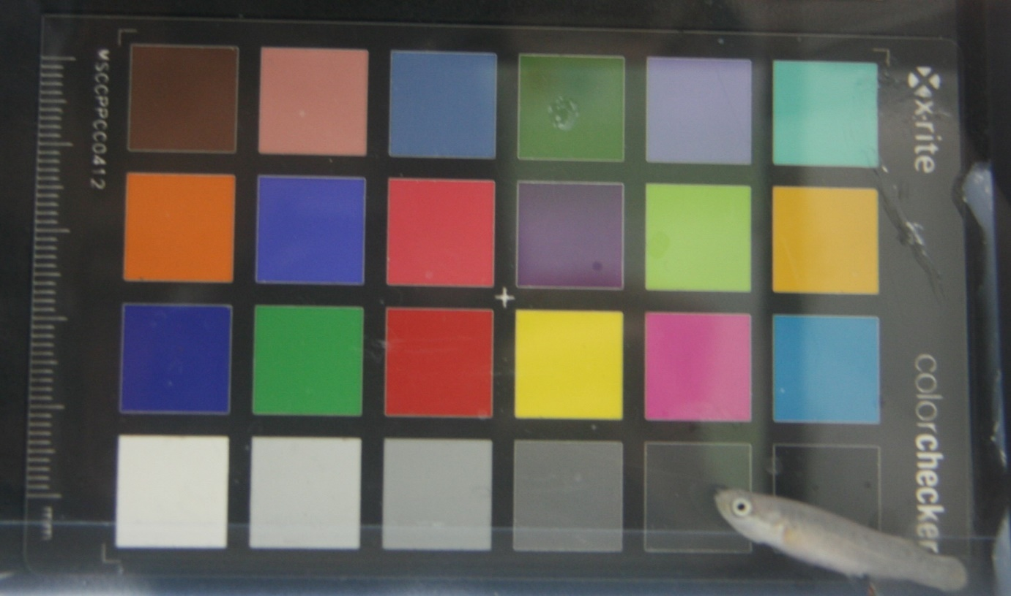
(a)

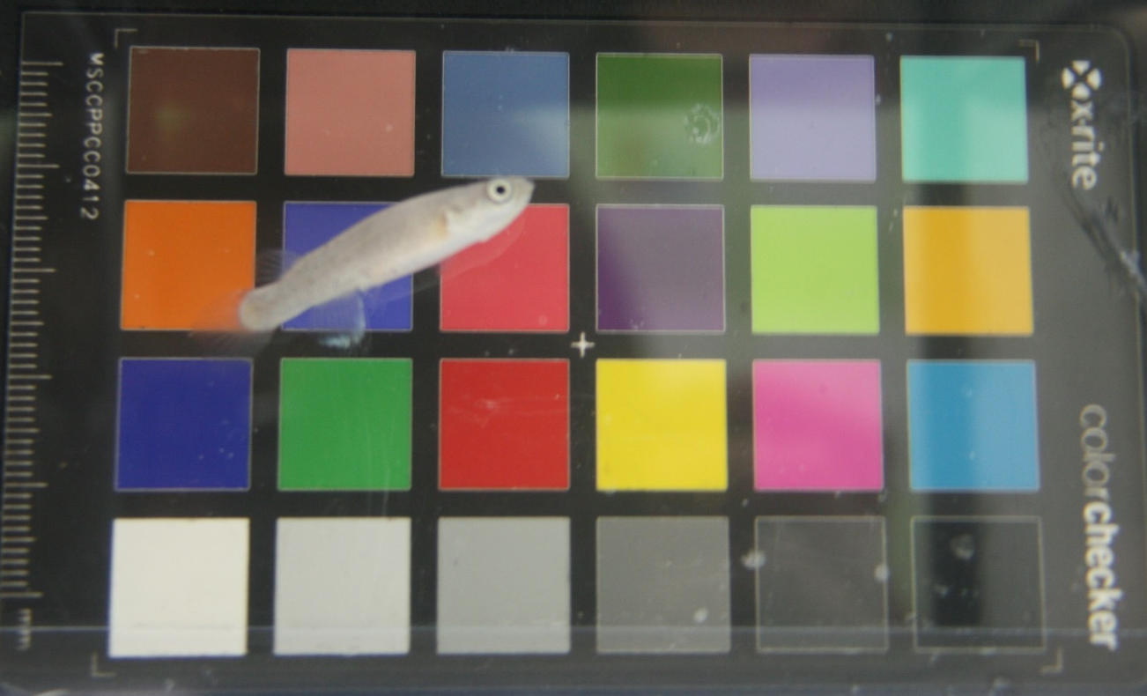
(b)

