Electronic Supplementary Materials

Authors:
Hangjian Ling¹, Guillam E. Mclvor², Kasper van der Vaart¹, Richard T. Vaughan³, Alex Thornton², Nicholas T. Ouellette¹

¹Department of Civil and Environmental Engineering, Stanford University, Stanford, CA USA;
²Center for Ecology and Conservation, University of Exeter, Penryn, UK;

³School of Computing Science, Simon Fraser University, Burnaby, Canada

Correspondence:

Alex Thornton, Email: alex.thornton@exeter.ac.uk

Nicholas T. Ouellette, Email: nto@stanford.edu

Article Title:
Local interactions and their group-level consequences in flocking jackdaws

Journal:
Proceedings of the Royal Society B.

Article DOI:
10.1098/rspb.2019.0865

Flocking event selection
Jackdaws often fly together with rooks (Corvus frugilegus) (1), forming mixed-species flocks. To avoid any effects caused by species differences, we only selected flocking events in which all the birds were jackdaws (identified by vocalisations and morphological characteristics). Further criteria for inclusion of events in our analyses were: (i) flock images were captured by all four cameras; (ii) flocks were moving primarily in one direction without making large-scale turns; and (iii) the time durations of the events were longer than time scale for birds to exchange neighbours such that our tracking results represented typical flock movement (the neighbour exchange time scale was less than 2 seconds (2)).

Camera calibration
Stereo-imaging relies on triangulation, using the two-dimensional (2D) coordinates of an object as recorded on multiple cameras to generate a 3D location (3). It requires knowledge of camera parameters such as position and orientation (extrinsic parameters) and focal length and principle point (intrinsic parameters). We determined the camera parameters following a similar procedure to that developed by Theriault et al. (2014) (4). The procedure was based on determining the fundamental matrix of each camera using the eight-point algorithm (3) and then refining camera parameters by sparse bundle adjustment (5). To generate calibration points (or known matched 2D coordinates), we flew a drone that carried two balls of distinguishably different sizes (10 and 12 cm) through the tracking volume when the birds were not present. The distance between the two balls was fixed at 1.0 m, which provided a physical scale for our calibration. Each calibration involved more than 300 calibration points and the calibration error (defined as the root-mean-square distance between original 2D coordinates and those generated by re-projecting 3D points onto the 2D image planes of the cameras) was less than 0.5 pixels.

Three-dimensional tracking
To reconstruct the 3D trajectories of each bird, we first determined the 2D locations of the birds from the camera images based on intensity-weighted centroids, which may not represent the true body centre due to flapping wings. The 2D coordinates belonging to the same bird across all four cameras were matched by finding candidates located within a small tolerance of the epipolar lines. These matched candidates were combined to calculate the 3D locations using a least-squares solution of the line-of-sight equations (3). When multiple 3D positions for the same bird were possible, we selected the one with the smallest 3D ray intersection distance (that is, the residual of the least-squares solution). We solved the optical occlusion problem by associating every detected bird on each camera with a 3D position (6). Then, we linked the 3D locations belonging to the same object over multiple time frames based on a three-frame predictive particle tracking algorithm (7). We applied a Gaussian smoothing and differentiating kernel (8) to the 3D trajectories to obtain accurate velocities and accelerations.

Since we initially calculated the birds’ 2D positions based on the intensity-weight centroids, the resulting 3D trajectories included both low-frequency body motion and higher-frequency wing motion. We separated the body and wing motions in the frequency domain. The body motion was obtained by applying a low-pass filter to the measured acceleration and then integrating this filtered acceleration. The wing motion was then calculated by subtracting the body motion from the measured trajectory. We applied a continuous wavelet transform to the wing motion to obtain the wingbeat frequency along 3D trajectories (6).

Calculation of two-dimensional force maps and one-dimension force curves
Data samples for the calculation: We treated each bird in the flock as a focal bird and calculated the corresponding F = a^{focal} – a^{neighbour}. Then, F_{Turn} and F_{Speed} are obtained by decomposing F in a local coordinate system defined based on the flight direction of the focal bird. We show the full force maps and curves for the following reasons: (i) F_{Turn} and F_{Speed} on the two sides of the axis are not guaranteed to be symmetric; (ii) a neighbouring bird may be found either in front of or behind the focal bird, and so the full force maps and curves reflect the force distribution for all possible neighbour locations; and (iii) showing the full maps and curves renders qualitative comparison to those reported in fish schools (e.g., Katz et al., 2011) simpler.

We ran this force calculation for every instantaneous time frame. Therefore, for a dataset with a group of N birds recorded for a time duration t (at 60 frames per second), we would obtain a total of 60Nt data points. To determine the number of uncorrelated data points measured from each bird, we calculated the correlation functions C(δt) of F_{Speed} and F_{Turn}, where δt is the time lag. The correlation time t₀ is determined as the time when C(δt) first goes to 0. Two data points separated by a time step larger than t₀ are uncorrelated. The total number of uncorrelated data points is equal to Nt/t₀, where t is the trajectory length. In Table S1, we list values of 60Nt (the total number of data points), t₀, and Nt/t₀ for isolated pairs and flocks #01 to 06.

Two-dimensional force maps: To calculate the two-dimensional (2D) force maps, i.e., the distribution of forces as a function of d_{Wing} and d_{Move}, we considered a 10 x 10 uniform grid on the 2D plane spanned by d_{Wing} and d_{Move}, where both d_{Wing} and d_{Move} range from -2.5 to 2.5 m. We then calculated the magnitude of F_{Speed} and F_{Turn} at each grid point by binning the data samples on the grid and averaging. For the force maps shown in Figure 4(b) and (c) for isolated pairs, the number of samples at each grid point ranges from 2,000 to 13,000. For birds in large flocks, due to the smaller sample size, we did not calculate force maps.

One-dimensional force curves: We also calculated one-dimensional (1D) force curves, i.e., F_{Speed} as a function of d_{Move} and F_{Turn} as a function of d_{Wing}. Similarly to the force map calculation, we first generated 15 evenly spaced points along the horizontal axis ranging from -2.5 to 2.5 m. We then calculated the magnitude of F_{Speed} and F_{Turn} on each point by binning and averaging. For the force curves shown in Figure 4(d) for isolated pairs, the number of samples at each point ranges from 7,000 to 30,000. For the force curves shown in Figure 5 for birds flying in large groups, the number of samples at each point ranges from 500 to 3,000. For each point on the one-dimensional curves, the standard error was calculated using a sample size corresponding to the number of uncorrelated data points.

Comparison between front and rear birds in isolated pairs
Based on the definition of F = a^{focal} – a^{neighbour}, the positive speeding forces seen for d_{Move}>1 m could be caused either by front birds slowing down or rear birds speeding up. To understand which case is more likely, we analyzed the 149,230 samples taken from 305 isolated pairs. First, we calculated the probability density functions (PDFs) of accelerations in movement direction for rear birds and front birds (a_{Move}^{rear} and a_{Move}^{front}) for d_{Move}>1 m (in the positive speeding force region). As shown in Figure S7(a), both PDFs have negative and positive a_{Move} indicating that a positive speeding force can be caused by either the rear bird speeding up or the front bird slowing down. However, the rear birds have a slightly larger a_{Move} compared to the front birds (<a_{Move}^{rear}> – <a_{Move}^{front}> = 0.26 m/s²), indicating that the rear birds are more likely to speed up than the front birds are to slow down. We also calculated the PDFs of wingbeat frequencies for rear birds and front birds (f_{wb}^{rear} and f_{wb}^{front}) for d_{Move}>1 m. As shown in Figure S7(b), the rear birds have slightly larger wingbeat frequencies compared to the front birds (<f_{wb}^{rear}> – <f_{wb}^{front}>=0.15 Hz), consistent with the slightly larger a_{Move} of the rear birds. Therefore, both the acceleration and wingbeat frequency imply that rear birds are more likely to change their behaviour in response to the front birds.

Sample data analysis code
Here, we provide a line-by-line description for one of our data analysis code (written in Matlab) that was used to generate Figure 4. Code for generating all the other figures can be found at https://figshare.com/s/490054bef08b27604934.

%% Start the calculation
load('DisPairs.mat'); % load data

% data array for neighbour position
r=[]; % r(:,1)=d_move, r(:,2)=d_wing

% data array for social force
a=[]; % a(:,1)=F_speed, a(:,2)=F_turn

% loop over 305 pairs, birds’ ids in one pair are i and i+1
for i=1:2:max(DisPairs(:,1))
% get position, velocity, acceleration for first bird in the pair
id1=find(DisPairs(:,1)==i);
xyz1=DisPairs(id1,2:4); % position for first bird
u1=DisPairs(id1,6:8); % velocity for first bird
a1=DisPairs(id1,9:11); % acceleration for first bird

% get position, velocity, acceleration for second bird in the pair
id2=find(DisPairs(:,1)==i+1);
xyz2=DisPairs(id2,2:4); % position for second bird
u2=DisPairs(id2,6:8); % velocity for second bird
a2=DisPairs(id2,9:11); % acceleration for second bird

% loop over all time steps for this pair; each time step will provide 2
% samples as either bird in the pair will be treated as the focal
% individual
for j=1:size(xyz1,1)
%%%% treat bird 1 as focal bird
% get position of neighbour with respective to focal one
r_temp=xyz2(j,:)-xyz1(j,:);

% get social force of focal bird with respective to neighbour
da_temp=a1(j,:)-a2(j,:);

% re-align r such that r(:,1) is along flight direction of focal bird and r(:,2) is along wing direction of focal bird
r_temp=Rotate2U(r_temp,u1(j,:));

% re-align force such that F(:,1) is along flight direction of focal bird and F(:,2) is along wing direction of focal bird
da_temp=Rotate2U(da_temp,u1(j,:));

% add the data sample to the data array
r=[r;r_temp];
a=[a;da_temp];

%%%% treat bird 2 as focal bird and do the same calculation
r_temp=xyz1(j,:)-xyz2(j,:);
da_temp=a2(j,:)-a1(j,:);
r_temp=Rotate2U(r_temp,u2(j,:));
da_temp=Rotate2U(da_temp,u2(j,:));
r=[r;r_temp];
a=[a;da_temp];
end
end

%% plot figure 4b-c: maps of F_turn, and F_speed
% generate 2D grid points
x_edges=linspace(-3.5,3.5,14);
y_edges=linspace(-3.5,3.5,14);
% initialize the focal on grid point as 0
a1=zeros(14,14);
a2=zeros(14,14);
% loop for binning the samples onto the grid points
for i=2:length(x_edges)-1
for j=2:length(y_edges)-1
id=find(r(:,1)>x_edges(i-1) & r(:,1)<x_edges(i+1) & ...
r(:,2)>y_edges(j-1) & r(:,2)<y_edges(j+1));
a1(i,j)=mean(a(id,1)); %
a2(i,j)=mean(a(id,2));
end
end
a2=imgaussfilt(a2,0.5,'FilterSize',3);
contourf(x_edges,y_edges,a2); % plot figure 4b,
a1=imgaussfilt(a1,0.5,'FilterSize',3);
contourf(x_edges,y_edges,a1); % plot figure 4c,

%% plot figure 4d: F_speed v.s. d_move; F_turn v.s. d_wing
% generate 1D grid points
edges=linspace(-2.5,2.5,15);
% loop for binning data onto the 1D grid points
for i=1:length(edges)-2
id=find(r(:,1)>edges(i) & r(:,1)<edges(i+2));
x1(i)=mean(r(id,1));
y1(i)=mean(a(id,1)); % F_speed
err1(i)=std(a(id,1))/length(id)^0.5; % standard error

id=find(r(:,2)>edges(i) & r(:,2)<edges(i+2));
x2(i)=mean(r(id,2));
y2(i)=mean(a(id,2)); % F_turn
err2(i)=std(a(id,2))/length(id)^0.5; % standard error
end
err1=err1*(60*0.23)^0.5; % recalculate standard errors by correlation time
err2=err2*(60*0.23)^0.5; % recalculate standard errors by correlation time
errorbar(x2,y2,err2); % F_turn
errorbar(x1,y1,err1); % F_speed

function XYZ=Rotate2U(XYZ,U)
% function for move coordinate to along flight direction
theta=atan(U(2)/U(1));
R = [cos(theta) -sin(theta); sin(theta) cos(theta)];
U(1:2)=U(1:2)*R;
for j=1:size(XYZ,1)
XYZ(j,1:2) = XYZ(j,1:2)*R;
end
end

References
1. J. W. Jolles, A. J. King, A. Manica, A. Thornton, Heterogeneous structure in mixed-species corvid flocks in flight. Anim. Behav. 85, 743–750 (2013).
2. H. Ling et al., Costs and benefits of social relationships in the collective motion of bird flocks. Nat. Ecol. Evol. (2019), doi:10.1038/s41559-019-0891-5.
3. R. Hartley, A. Zisserman, Multiple view geometry in computer vision (2004).
4. D. H. Theriault et al., A protocol and calibration method for accurate multi-camera field videography. J. Exp. Biol. 217, 1843–1848 (2014).
5. Y. Furukawa, J. Ponce, Accurate camera calibration from multi-view stereo and bundle adjustment. Int. J. Comput. Vis. 84, 257–268 (2009).
6. H. Ling et al., Simultaneous measurements of three-dimensional trajectories and wingbeat frequencies of birds in the field. J. R. Soc. Interface. 15, 20180653 (2018).
7. N. T. Ouellette, H. Xu, E. Bodenschatz, A quantitative study of three-dimensional Lagrangian particle tracking algorithms. Exp. Fluids. 40, 301–313 (2006).
8. N. Mordant, A. M. Crawford, E. Bodenschatz, Experimental Lagrangian acceleration probability density function measurement. Phys. D Nonlinear Phenom. 193, 245–251 (2004).

Figure legends
Figure S1. Six samples of three-dimensional trajectories of isolated pairs of birds coloured by flight speed |v|. Colour bars are in m/s.

Figure S2. Reconstructed 3D trajectories of flocks #2 to #6 projected onto the horizontal plane and coloured by flight speed |v|.

Figure S3. (a) Probability density function of flight speed (|v|). (b) Speeding force (F_{Speed}) as a function of d_{Move} at three different flight speed levels. (c) Turning force (F_{Turn}) as a function of d_{Wing} at three different flight speed levels. Results are obtained from 149,230 samples from the 305 isolated pairs. The three different speed levels (|v|<8 m/s, 8<|v|<12 m/s and |v|>12 m/s) are selected based on the probability density distribution of |v|. |v|<8 m/s is located in the low speed region, and |v|>12 m/s is located in the high speed region. For each line in (b) and (c), the sample size ranges from 24,000 to 80,000. As |v| increases, F_{Speed} in the region d_{Move}>0 is larger, and F_{Speed} in the region d_{Move}<0 is smaller. Both trends indicate that the strength of the speeding force increases with |v|.

Figure S4. Probability density functions of the location of the first nearest neighbour bird in flocks #2 to #6. The focal bird is located at the origin. Neighbours are more likely to be located next to the focal bird and at nearly the same height level.

Figure S5. (a)(c)(e)(g)(i) Distributions of bird locations projected onto the horizontal plane for flocks #2 to #6, respectively. x₂ is aligned with the mean flight direction of all the birds in one group. The entire flock is separated into subgroups (each is coloured differently). The vectors indicate the movement directions of individual birds. (b)(d)(f)(h)(j) Probability of bird position along x₂ for flocks #2 to #6.

Figure S6. L_{Wing}/L_{Move} of the entire groups for flocks #1 to 6, showing that most flocks are still elongated in the wing direction, similar to subgroups in flocks.

Figure S7. (a) Probability density functions of acceleration in the movement direction for rear and front birds in isolated pairs (a_{Move}^{rear} and a_{Move}^{front}). The average a_{Move}^{rear} is slightly larger than the average a_{Move}^{front} (<a_{Move}^{rear}> – <a_{Move}^{front}> = 0.26 m/s²). (b) Probability density functions of wingbeat frequency for rear and front birds (f_{wb}^{rear} and f_{wb}^{front}). The two peaks in each PDF of f_{wb} correspond to flapping and non-flapping flight. The average f_{wb}^{rear} is slightly larger than the average f_{wb}^{front} (<f_{wb}^{rear}> – < f_{wb}^{front}> = 0.15 Hz). Data are obtained from the 149,230 samples taken from 305 isolated pairs.

Figures

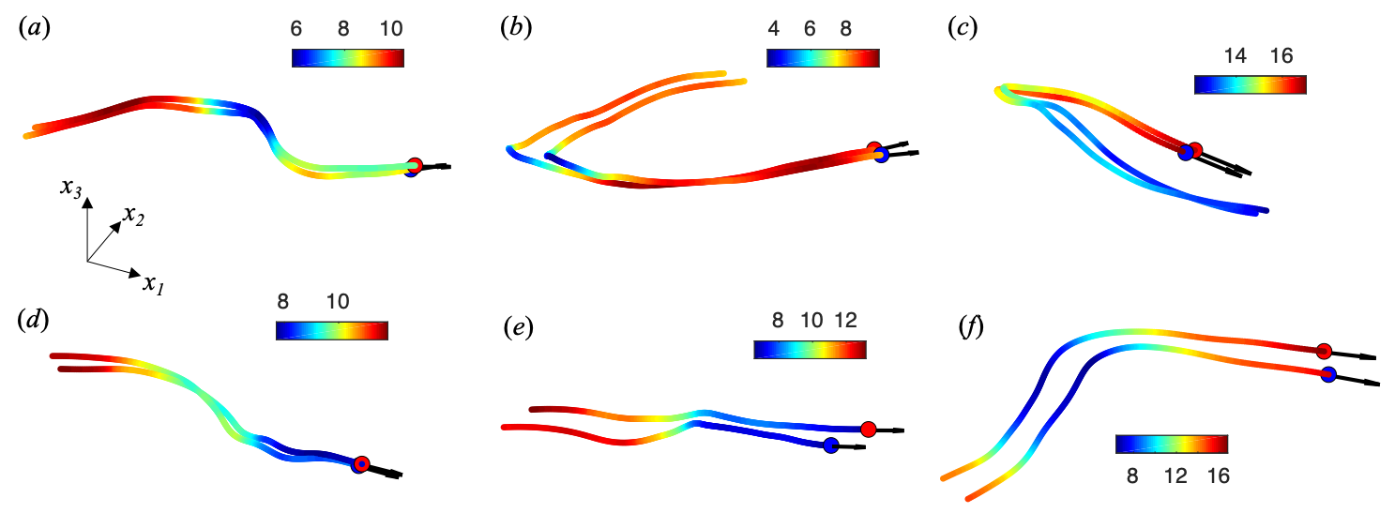
Figure S1. Six samples of three-dimensional trajectories of isolated pairs of birds coloured by flight speed |v|. Colour bars are in m/s.

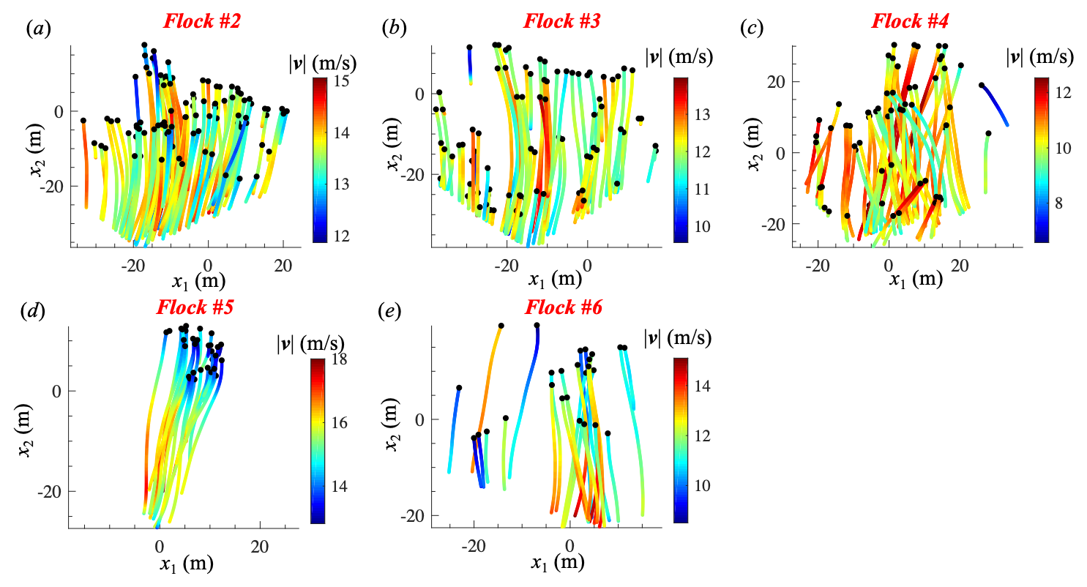
Figure S2. Reconstructed 3D trajectories of flocks #2 to #6 projected onto the horizontal plane and coloured by flight speed |v|.

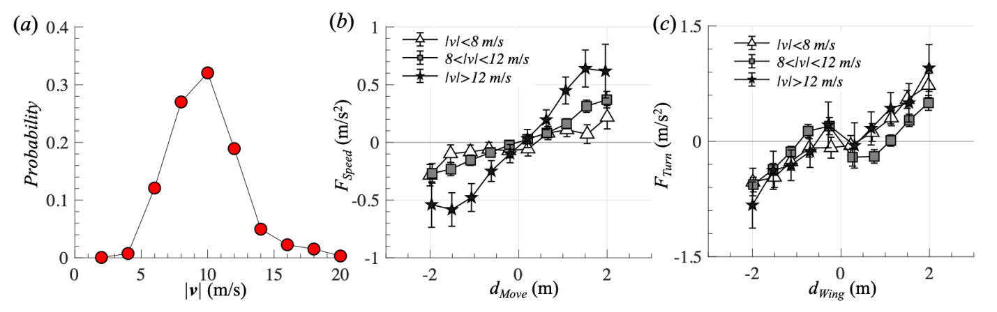
Figure S3. (a) Probability density function of flight speed (|v|). (b) Speeding force (F_{Speed}) as a function of d_{Move} at three different flight speed levels. (c) Turning force (F_{Turn}) as a function of d_{Wing} at three different flight speed levels. Results are obtained from 149,230 samples from the 305 isolated pairs. The three different speed levels (|v|<8 m/s, 8<|v|<12 m/s and |v|>12 m/s) are selected based on the probability density distribution of |v|. |v|<8 m/s is located in the low speed region, and |v|>12 m/s is located in the high speed region. As |v| increases, F_{Speed} in the region d_{Move}>0 is larger, and F_{Speed} in the region d_{Move}<0 is smaller. Both trends indicate that the strength of the speeding force increases with |v|. Error bars are standard errors.

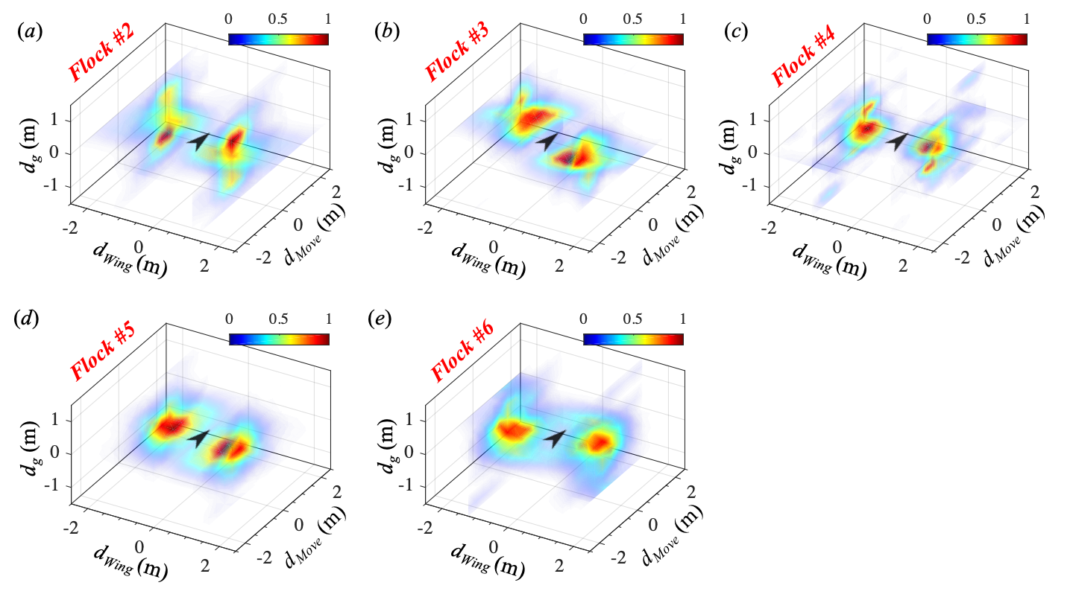
Figure S4. Probability density functions of the location of the first nearest neighbour bird in flocks #2 to #6. The focal bird is located at the origin. Neighbours are more likely to be located next to the focal bird and at nearly the same height level.

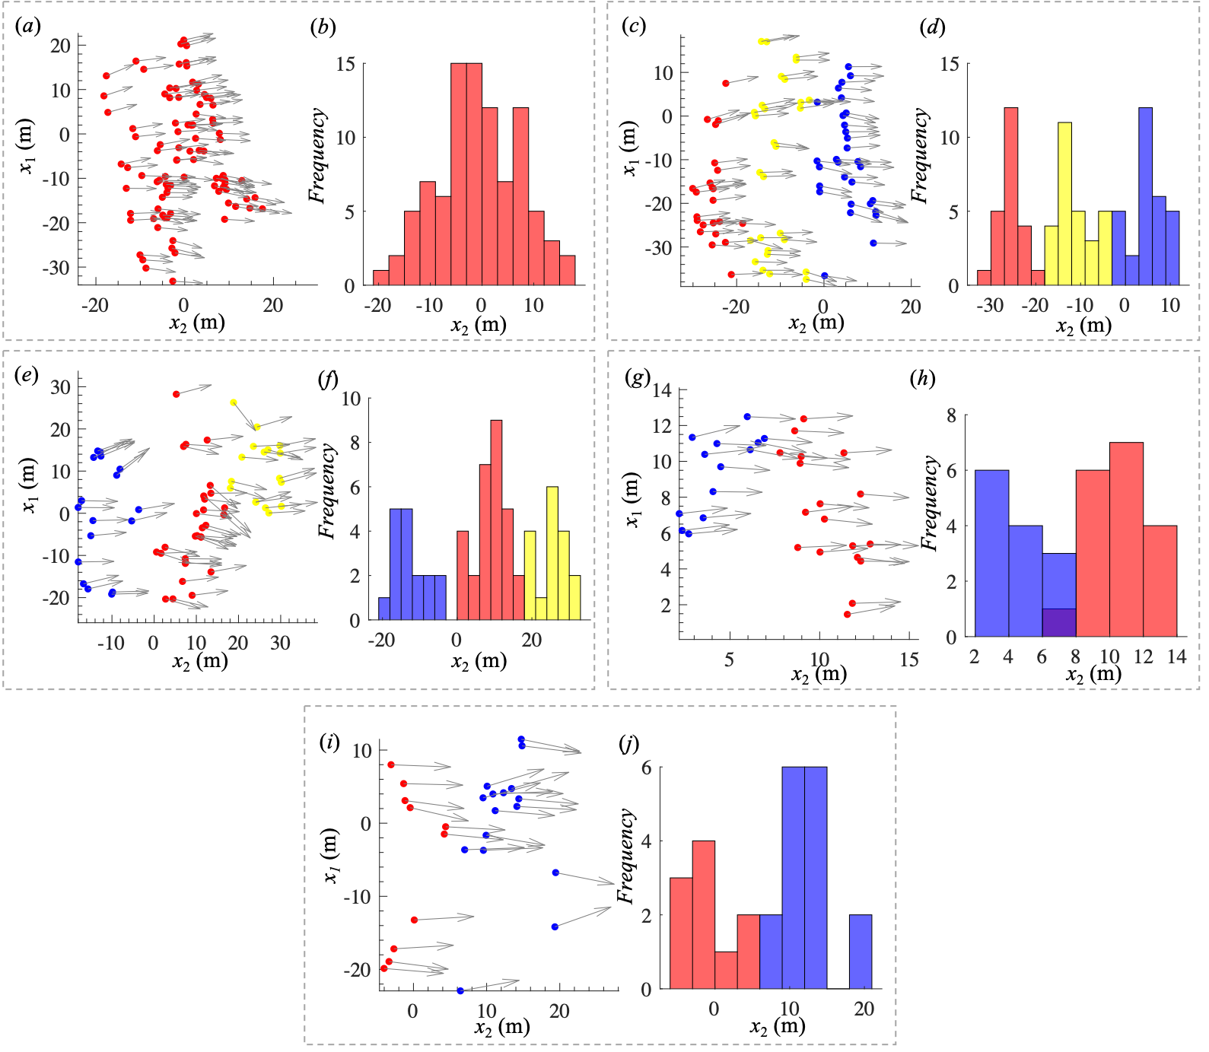
Figure S5. (a)(c)(e)(g)(i) Distributions of bird locations projected onto the horizontal plane for flocks #2 to #6, respectively. x₂ is aligned with the mean flight direction of all the birds in one group. The entire flock is separated into subgroups (each is coloured differently). The vectors indicate the movement directions of individual birds. (b)(d)(f)(h)(j) Probability of bird position along x₂ for flocks #2 to #6.

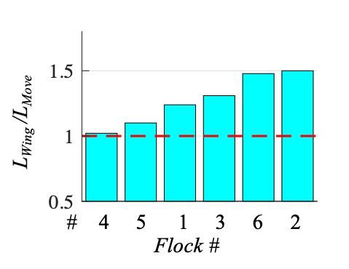
Figure S6. L_{Wing}/L_{Move} of the entire groups for flocks #1 to 6, showing that most flocks are still elongated in the wing direction, similar to subgroups in flocks.

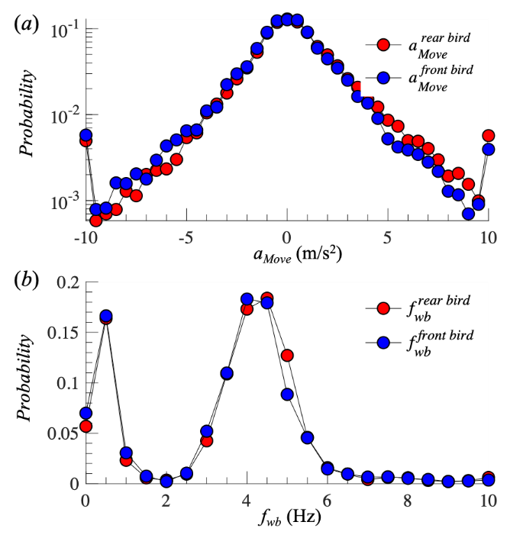
Figure S7. (a) Probability density functions of acceleration in the movement direction for rear and front birds in isolated pairs (a_{Move}^{rear} and a_{Move}^{front}). The average a_{Move}^{rear} is slightly larger than the average a_{Move}^{front} (<a_{Move}^{rear}> – <a_{Move}^{front}> = 0.26 m/s²). (b) Probability density functions of wingbeat frequency for rear and front birds (f_{wb}^{rear} and f_{wb}^{front}). The two peaks in each PDF of f_{wb} correspond to flapping and non-flapping flight. The average f_{wb}^{rear} is slightly larger than the average f_{wb}^{front} (<f_{wb}^{rear}> – < f_{wb}^{front}> = 0.15 Hz). Data are obtained from the 149,230 samples taken from 305 isolated pairs.

 | Isolated pairs | Flocks #01 | Flocks #02 | Flocks #03 | Flocks #04 | Flock #05 | Flocks #06
60Nt | 149,230 | 64,322 | 29,090 | 26,686 | 23,830 | 8638 | 11,124
t₀ (s) | 0.27 | 0.12 | 0.13 | 0.14 | 0.14 | 0.13 | 0.15
Nt/t₀ | 9210 | 8930 | 3730 | 3177 | 2837 | 1100 | 1230

Table S1. The total number of sample points 60Nt, average correlation time t₀, and total number of uncorrelated data points Nt/t₀ for 305 isolated pairs and flocks #01 to 06.

