Predation shapes sperm performance surfaces in guppies
Supplementary material

Population sampling
Male guppies were collected from nine rivers spanning the Caroni, Oropouche and Northern drainages in Trinidad’s Northern Range Mountains in May-June 2011 [see table S1 and 1 for details]. Trinidadian rivers are characterized by the presence of natural and artificial waterfalls that impede fish migration from downstream to upstream [2]. As a result, in upstream sites, the main guppy predator is Rivulus haarti, a small killifish, which feeds mainly on guppy juveniles, while in downstream sites Crenicichla alta and Hoplias malabaricus exert strong predation pressure on adults [3]. Overall, we sampled 540 males from nine rivers (see table S1); in each river, 30 males came from a low predation site (upstream populations) and 30 were taken from a high predation site (downstream populations). We used a combination of hand seine netting and dip nets (depending on the river conditions) to capture fish. Collections were approved by the Director of Fisheries, Fisheries Division, Ministry of Food Production (Trinidad and Tobago) and all animal procedures were approved by UWA’s Animal Ethics Committee (permit number RA/3/100/513).

Table S1. List of the rivers and GPS coordinates of the locations where fish were collected from in Trinidad’s Northern Range Mountains.
 | High predation site |  | Low predation site
 | GPS coordinates (DM) |  | GPS coordinates (DM)
River Name | North | West | North | West
Aripo | 10° 39.029’ | 61° 13.401’ | 10° 41.134’ | 61° 13.942’
Caura | 10° 41.354’ | 61° 21.524’ | 10° 42.683’ | 61° 20.982’
Guanapo | 10° 37.248’  10° 38.389’  10° 38.530’ | 61° 15.047’  61° 14.904’  61° 14.783’ | 10° 42.706’ | missing
Lopinot | 10° 38.329’ | 61° 19.058’ | 10° 41.595’ | 61° 19.330’
Quare | 10° 39.147’ | 61° 11.382’ | 10° 40.554’ | 61° 11.788’
St Joseph | 10° 39.245’ | 61° 24.749’ | 10° 42.806’ | 61° 23.889’
Tacarigua/Tunapuna | 10° 38.520’ | 61° 22.468’ | 10° 40.140’ | 61° 23.410’
Turure | missing | missing | 10° 40.783’ | 61° 10.024’
Yarra | 10° 47.372’ | 61° 21.216’ | 10° 44.405’ | 61° 19.279’

Sperm assays
Ejaculates were manually obtained via abdominal massage using standard procedures [1] into a sperm extender medium (207 mM NaCl, 5.4 mM KCl, 1.3 mM CaCl₂, 0.49 mM MgCl₂, 0.41 mM MgSO₄, 10mM Tris, pH 7.5) to ensure that sperm remained quiescent until activated for sperm performance assays. The stripped ejaculates were divided into two sub-samples for analysing sperm velocity and sperm morphology. To estimate sperm velocity, sperm were activated with 150 mM KCl [4] and immediately placed in a single well of a 12-well multitest slide (MP Biomedicals, Aurora, OH, USA). The sample, viewed under x100 magnification (negative phase x10 objective), was recorded using a Canon EOS 600 digital camera fitted to a Leica DM750 microscope. Obtained video-footage of motile sperm were subsequently analysed using computer assisted sperm analysis (CASA) via a CEROS Sperm Tracker (Hamilton Thorne Research, Beverly, MA, USA) to quantify sperm velocity. Sperm velocity was assessed for 480 males, meaning that usable samples were not obtained from 60 males (i.e. ejaculates were either unable to be extracted, there were technical difficulties in obtaining usable sperm velocity data, or number of motile sperm cells was <10, our minimum value for sample inclusion). Sperm velocity was measured for 70.6 ± 1.3 (mean ± SE) sperm per male (see supplementary table 1 for details). To estimate sperm morphology, sperm were preserved in 10% buffered formalin and 20 individual sperm cells from each male were measured. Due to poor preservation of samples from some males, sperm morphology could only be assessed in 264 males (134 males from low predation sites and 130 males from high predations sites). We photographed sperm cells under a 400x magnification microscope (Leica DM750) and then used ImageJ [5] to measure sperm head, midpiece and flagellum length.

Differences between high and low-predation populations in male traits
We compared male traits (fish area, orange, iridescent, black, sperm velocity and the sperm length measures) between high and low predation sites using a series of linear mixed-effects models fit by REML, using the lmer function in lme4 R package [6]. For each model, the trait of interest was entered as the dependent variable and predation regime (hereafter “Predation”) was entered as a fixed effect with two levels (high/low). To account for variation in the effect of predation both within and among rivers, our analyses incorporate the random effects of river (treated as random intercepts) and Predation (treated as random slopes). Table S2 shows the number of individuals measured for each trait in each river. In table S3 we show results of the models. The R syntax of the models was lmer(trait~Predation+(Predation+1|River)).
Table S2. Number of individuals measured for each trait in each sampled population.
 | Site | Number of complete measures | Sperm performance* | Fish morphology and colouration** | Sperm morphology***
High predation | Aripo | 18 | 27 | 30 | 20
 | Caura | 19 | 29 | 30 | 20
 | Guapo | 8 | 29 | 30 | 9
 | Lopinot | 27 | 29 | 30 | 28
 | Quare | 8 | 30 | 30 | 8
 | St Joseph | 13 | 27 | 29 | 15
 | Tacarigua/Tunapuna | 10 | 28 | 30 | 10
 | Turure | 11 | 29 | 30 | 12
 | Yarra | 8 | 26 | 30 | 8
 | High predation, total | 122 | 254 | 269 | 130
Low predation | Aripo | 20 | 28 | 30 | 20
 | Caura | 6 | 13 | 30 | 12
 | Guapo | 8 | 25 | 30 | 9
 | Lopinot | 25 | 29 | 30 | 25
 | Quare | 11 | 30 | 30 | 11
 | St Joseph | 15 | 24 | 30 | 17
 | Tacarigua/Tunapuna | 16 | 29 | 30 | 16
 | Turure | 3 | 27 | 30 | 5
 | Yarra | 14 | 21 | 30 | 19
 | Low predation, total | 118 | 226 | 270 | 134
* Sperm velocity, VAP.
** Body area, orange area, iridescent area and black area.
*** Sperm head, midpiece and flagellum length.

Table S3. Differences between guppy populations from high and low-predation sites in body size (lateral fish area, caudal fin included. Hereafter body area), ornamentation (size of coloured spots) and ejaculate characteristics (sperm velocity and sperm morphology). Linear mixed models fit by REML (lmer). Predation regime was entered as fixed factor (two-level factor: high/low predation). River and predation regime within river were entered as random factors.
Trait | Low Predation mean ± S.D. (N) | High Predation mean ± S.D. (N) | Effect size (d) | F. value | Den DF | p
Body area (mm²) | 78.72±12.89 (270) | 65.94±12.04 (269) | 1.02 | 9.27 | 8.00 | 0.02
Orange area (mm²) | 6.7±3.93 (270) | 4.36±2.4 (269) | 0.72 | 16.17 | 8.00 | <0.01
Iridescent area (mm²) | 10.31±3.26 (270) | 8.37±2.86 (269) | 0.63 | 3.44 | 8.00 | 0.10
Black area (mm²) | 1.34±0.97 (270) | 1.01±0.66 (269) | 0.40 | 9.52 | 7.99 | 0.02
Sperm velocity (VAP, µm/s) | 93.75±22.02 (226) | 95.31±21.91 (254) | 0.07 | 0.41 | 8.13 | 0.54
Sperm head (µm) | 4.32±0.16 (134) | 4.3±0.13 (130) | 0.13 | 0.09 | 7.46 | 0.77
Midpiece (µm) | 3.03±0.3 (134) | 2.98±0.23 (130) | 0.17 | 1.64 | 7.61 | 0.24
Flagellum length (µm) | 48.04±1.15 (134) | 47.17±0.95 (130) | 0.82 | 15.61 | 6.89 | <0.01

Performance analysis method step by step
In his seminal papers [7-9], Arnold and coauthors developed a two-step methods consisting of 1) determining the effect of morphology on performance and 2) determining the effect of performance of fitness. Here we focused and developed the first part of Arnold’s appraoch, which we called “performance analysis”. Performance analysis comprises the same steps as standard selection analysis [7, 10], with the difference that the dependent variable is not a fitness estimate but a general performance estimate (e.g. swiming speed, strength of bite, intensity of display). The detailed steps of the procedure include the following:
- The first step consists of standardizing the trait’s measurement to a mean of zero and standard deviation of one. Standardised trait scores are calculated by subtracting the population mean value from the observed value and dividing this difference by the standard deviation. Similar to estimates of relative fitness, performance estimates are also standardized to a mean of one by dividing the observed value by the population [sample] mean.
- Standardized trait values and performance estimates are entered as predictors and dependent variables, respectively, in a multiple regression analyses to obtain linear performance gradients (β_{p} coefficients). A second regression is then performed with the same predictors along with the quadratic [squared] and correlational [cross-product] terms. Coefficients of these variables represent the non-linear performance gradients (γ_{p} coefficients). Note that we used the subscript “p” (performance) for the gradients to differentiate these values from those generated through classic selection analyses.
- Canonical analysis involves rotating γ_{p} (through a matrix diagonalization) to obtain a new set of multivariate variables similar to a PCA and representing the directions of the fitted surface where the non-linear relationships are stronger [11]. In the new matrix, λ_{p} eigenvalues describe the curvature of the surface.
- The new transformed variables (the value for each individual in each vector) can be used in a full multiple regression [12] to obtain linear gradients (θ_{p}) and p-values for both θ_{p} and λ_{p}.
- Alternativelty, significance of new gradients can be tested with a permutational approach [e.g. 13].
- To visualize the relationships between original traits or vectors and performance, non-parametric 2D and/or 3D spline functions [14] can be drawn.

Testing the effect of predation on selection gradients
To test if performance gradients (β_{p} and γ_{p}) are affected by predation regime we developed an approach based on permutations and Monte Carlo simulations similar to that proposed by Bisgaard and Ankenman [12] and used by different authors [15-17]. This method consists of generating a distribution of performance gradients with 10000 simulated populations of 120 individuals (the average number of individuals in low and high predation populations) shuffled from the full dataset. The gradients are calculated with the regression method described above. Observed gradients obtained with a full multiple regression within each population type are then compared to the null distribution and shown in table S5 (see also figure S1). Observed values that fall outside the upper or lower 95 percentiles in the simulated distribution are considered significantly different from the respective simulated values. Importantly, our approach does not shuffle performance against trait values, but instead generates new populations of individuals where the association between traits and performance is maintained but the distribution of the phenotypes in the simulated populations is random and independent of predation regime. We thus did not remove association between traits and performance at the individual level, rather we removed the differences at the population level due to the grouping factor (predation). Each randomized population was therefore different in the level of predation regime, which could potentially vary from “complete high predation” (when all individuals where drawn from populations of high predation) to “complete low predation” (when all individuals where drawn from populations of low predation). With a similar procedure we tested if the observed differences in performance gradients between low and high predation populations are bigger than expected by chance. To this end we first calculated the observed absolute difference between the coefficients in low and high predation populations. We then compared the observed differences with a distribution of 10000 differences obtained from regressions performed in simulated populations as above. Observed differences greater than than the 95% upper percentile of the simulated distribution were considered significant (shown in table S6 and figure S2). Monte Carlo simulations were performed with PopTools [18] and R.
Table S4. Performance gradients (β_{p} and γ_{p} coefficients) representing the relationships between sperm swimming speed (VAP) and other male traits, including body size (body area, mm²), ornamentation (orange, black and iridescent colouration, mm²), and sperm morphology (head, midpiece and flagellum lengths, µm) traits for (a) low and (b) high predation populations. In parenthesis P values obtained by multiple regression models. Quadratic performance gradients have been doubled [19]. Low and high predation populations were treated separately. Significant values are indicated in bold.
 |  |  | γ_{p} coefficients
 |  |  | Body Size | Ornamentation |  |  | Sperm morphology
 | Traits | β_{p} coefficients | Body area | Orange | Black | Iridescent | Head | Midpiece | Flagellum
- Low Predation  (n=118) | Body area | 0.018 (0.567) | 0.136 (0.103)
 | Orange area | -0.003 (0.913) | -0.076 (0.145) | -0.022 (0.706)
 | Black area | 0.009 (0.696) | -0.001 (0.977) | 0.065 (0.040) | 0.012 (0.776)
 | Iridescent area | 0.046 (0.127) | -0.063 (0.395) | 0.049 (0.302) | 0.01 (0.863) | 0.016 (0.849)
 | Sperm head | 0.001 (0.950) | 0.011 (0.846) | -0.055 (0.276) | 0.035 (0.359) | 0.112 (0.035) | 0.106 (0.097)
 | Midpiece | 0.026 (0.265) | -0.03 (0.471) | -0.019 (0.554) | 0.009 (0.777) | 0.045 (0.413) | 0.046 (0.335) | -0.01 (0.792)
 | Flagellum length | 0.027 (0.253) | 0.053 (0.308) | 0.023 (0.480) | -0.037 (0.333) | -0.039 (0.419) | 0.071 (0.094) | 0.069 (0.071) | 0.018 (0.732)
- High Predation  (n=122) | Body area | 0.017 (0.545) | 0.036 (0.574)
 | Orange area | 0.024 (0.269) | -0.031 (0.397) | 0.110 (0.008)
 | Black area | -0.001 (0.946) | 0.026 (0.518) | -0.129 (0.002) | 0.060 (0.070)
 | Iridescent area | -0.002 (0.942) | -0.049 (0.295) | -0.001 (0.968) | -0.037 (0.360) | 0.092 (0.103)
 | Sperm head | 0.036 (0.086) | 0.047 (0.234) | -0.03 (0.328) | -0.054 (0.094) | 0.019 (0.574) | 0.040 (0.334)
 | Midpiece | 0.007 (0.718) | 0.029 (0.472) | 0.002 (0.918) | 0.003 (0.922) | -0.047 (0.208) | 0.036 (0.165) | -0.002 (0.939)
 | Flagellum length | 0.041 (0.064) | -0.039 (0.402) | -0.044 (0.145) | -0.003 (0.933) | 0.066 (0.150) | 0.065 (0.024) | -0.027 (0.388) | 0.040 (0.322)

Table S5. Observed performance gradients obtained with a full regression for the two predation regimes separately and compared to 95% C.I. obtained with 10000 simulated full regressions. Values with * are significant regression values. Values with # are values that fall outside the 95% C.I. intervals of the simulated distribution. Simulated performance gradients (mean and 95% C.I.) are also reported.
 | Trait | Observed value |  | Simulated  (10000 regressions)
 |  | High predation | Low predation | Mean | 95%C.I.
Linear β_{p} | Size | 0.021 | 0.004 | 0.011 | -0.046 | 0.068
 | Orange | 0.009 | 0.001 | 0.000 | -0.046 | 0.045
 | Black | -0.042 | 0.014 | 0.007 | -0.050 | 0.064
 | Iridescent | 0.001 | 0.055 | 0.019 | -0.035 | 0.072
 | Sperm head | -0.013 | 0.053 | 0.028 | -0.022 | 0.080
 | Midpiesce | 0.004 | 0.003 | -0.001 | -0.044 | 0.042
 | Flagellum length | 0.011 | -0.013 | -0.005 | -0.054 | 0.045
Quadratic γ_{p} | Size | 0.037 | 0.137 | 0.065 | -0.034 | 0.170
 | Orange | 0.110* | -0.022 | 0.044 | -0.036 | 0.122
 | Black | 0.060# | 0.012 | -0.010 | -0.094 | 0.059
 | Iridescent | 0.092 | 0.015 | 0.040 | -0.070 | 0.145
 | Sperm head | 0.041 | 0.106 | 0.036 | -0.050 | 0.113
 | Midpiece | -0.003 | -0.010 | 0.014 | -0.044 | 0.071
 | Flagellum length | 0.041 | 0.017 | 0.039 | -0.026 | 0.114
Quadratic-Correlational γ_{p} | Size*Orange | -0.031 | -0.076 | -0.021 | -0.089 | 0.045
 | Size*Black | 0.026 | -0.001 | 0.015 | -0.059 | 0.091
 | Size*Iridescent | -0.049 | -0.063 | -0.053 | -0.132 | 0.026
 | Size*Sperm head | 0.047 | 0.011 | 0.019 | -0.053 | 0.095
 | Size*Midpiece | 0.029 | -0.030 | 0.014 | -0.059 | 0.084
 | Size*Flagellum | -0.039 | 0.053 | 0.009 | -0.053 | 0.068
 | Orange*Black | -0.128*# | 0.066* | 0.004 | -0.070 | 0.069
 | Orange*Iridescent | -0.001 | 0.050 | -0.010 | -0.072 | 0.051
 | Orange*Sperm head | -0.030 | -0.055 | -0.015 | -0.073 | 0.045
 | Orange*Midpiece | 0.002 | -0.019 | 0.005 | -0.037 | 0.054
 | Orange*Flagellum | -0.044 | 0.023 | -0.012 | -0.059 | 0.036
 | Black*Iridescent | -0.037 | 0.010 | -0.027 | -0.111 | 0.045
 | Black*Sperm head | -0.054 | 0.036 | -0.019 | -0.080 | 0.042
 | Black*Midpiece | 0.003 | 0.009 | 0.008 | -0.045 | 0.065
 | Black*Flagellum | -0.003 | -0.037 | -0.005 | -0.066 | 0.057
 | Iridescent*Sperm head | 0.019 | 0.112*# | 0.030 | -0.040 | 0.096
 | Iridescent*Midpiece | -0.047 | 0.045 | -0.018 | -0.085 | 0.054
 | Iridescent*Flagellum | 0.066 | -0.039 | 0.009 | -0.059 | 0.076
 | Sperm head*Midpiece | 0.036 | 0.046 | 0.033 | -0.019 | 0.093
 | Sperm head*Flagellum | 0.065* | 0.071 | 0.052 | -0.008 | 0.103
 | Midpiece*Flagellum | -0.027 | 0.069# | 0.015 | -0.036 | 0.064

Figure S1. Observed performance gradients obtained for low (blue triangles) and high (red dots) predation populations are compared to 95% C.I.of the distribution of performance gradients obtained with 10000 simulated regressions. In each of these regressions a simultaed population (n=120) was obtained shuffling individuals from the original complete dataset (n=240).
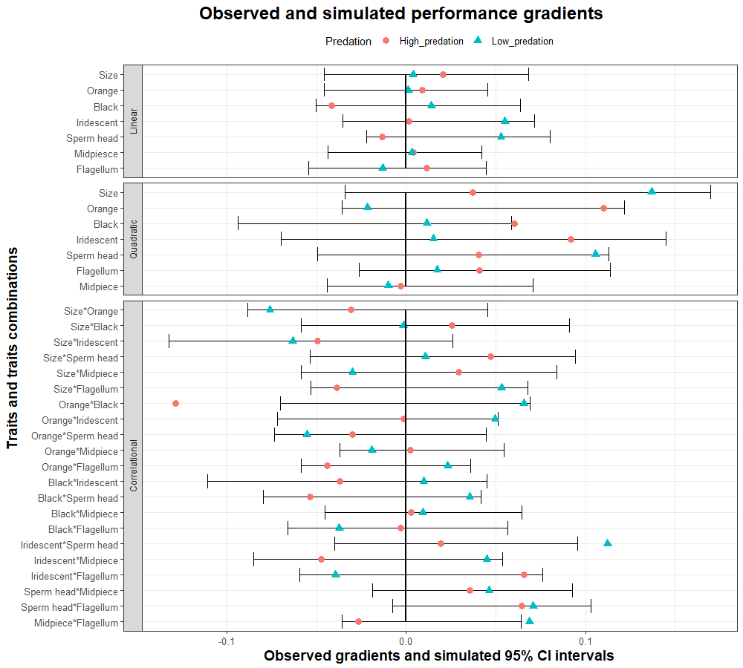

Table S6. Observed absolute difference in performance gradients obtained with a full regression for the two predation regimes separately and compared to the upper 95% percentile of a distribution of absolute differences obtained after 10000 iterations where two full regressions on two different simulated populations were performed. Values with # are values bigger than the upper 95% percentile of the simulated distribution. Simulated differences (mean and upper 95% percentile) are also reported.
 | Trait | Observed difference | Simulated  (10000 iterations)
 |  |  | Mean | Upper 95% percentile
Linear β_{p} | Size | 0.017 | 0.033 | 0.080
 | Orange | 0.008 | 0.026 | 0.065
 | Black | 0.056 | 0.033 | 0.081
 | Iridescent | 0.054 | 0.031 | 0.076
 | Sperm head | 0.066 | 0.030 | 0.073
 | Midpiesce | 0.001 | 0.025 | 0.061
 | Flagellum length | 0.025 | 0.029 | 0.069
Quadratic γ_{p} | Size | 0.100# | 0.029 | 0.072
 | Orange | 0.131# | 0.022 | 0.055
 | Black | 0.049 | 0.020 | 0.055
 | Iridescent | 0.077# | 0.030 | 0.076
 | Sperm head | 0.065# | 0.022 | 0.056
 | Midpiece | 0.007 | 0.016 | 0.040
 | Flagellum length | 0.024 | 0.020 | 0.050
Quadratic-Correlational γ_{p} | Size*Orange | 0.045 | 0.038 | 0.094
 | Size*Black | 0.027 | 0.042 | 0.106
 | Size*Iridescent | 0.014 | 0.045 | 0.114
 | Size*Sperm head | 0.036 | 0.042 | 0.103
 | Size*Midpiece | 0.059 | 0.040 | 0.100
 | Size*Flagellum | 0.092# | 0.034 | 0.085
 | Orange*Black | 0.194# | 0.039 | 0.098
 | Orange*Iridescent | 0.051 | 0.034 | 0.086
 | Orange*Sperm head | 0.026 | 0.034 | 0.083
 | Orange*Midpiece | 0.021 | 0.026 | 0.064
 | Orange*Flagellum | 0.067# | 0.026 | 0.066
 | Black*Iridescent | 0.047 | 0.043 | 0.108
 | Black*Sperm head | 0.089# | 0.035 | 0.086
 | Black*Midpiece | 0.006 | 0.031 | 0.077
 | Black*Flagellum | 0.034 | 0.035 | 0.087
 | Iridescent*Sperm head | 0.093 | 0.038 | 0.095
 | Iridescent*Midpiece | 0.092 | 0.040 | 0.096
 | Iridescent*Flagellum | 0.105# | 0.039 | 0.096
 | Sperm head*Midpiece | 0.011 | 0.032 | 0.079
 | Sperm head*Flagellum | 0.006 | 0.031 | 0.078
 | Midpiece*Flagellum | 0.096# | 0.029 | 0.070

Figure S2. Observed absolute difference (diamonds and asteriscs) in performance gradients between low and high predation populations are compared to 95% upper percentile of the distribution of differences in performance gradients obtained with 10000 simulations. In each of these simulations the difference between the same gradients was obtained from two regressions performed in two simultaed populations (n=120) made by shuffed individuals from the original complete dataset (n=240). Asteriscs represents absolute differences greater than the 95% upper percentile of the simulated distribution.
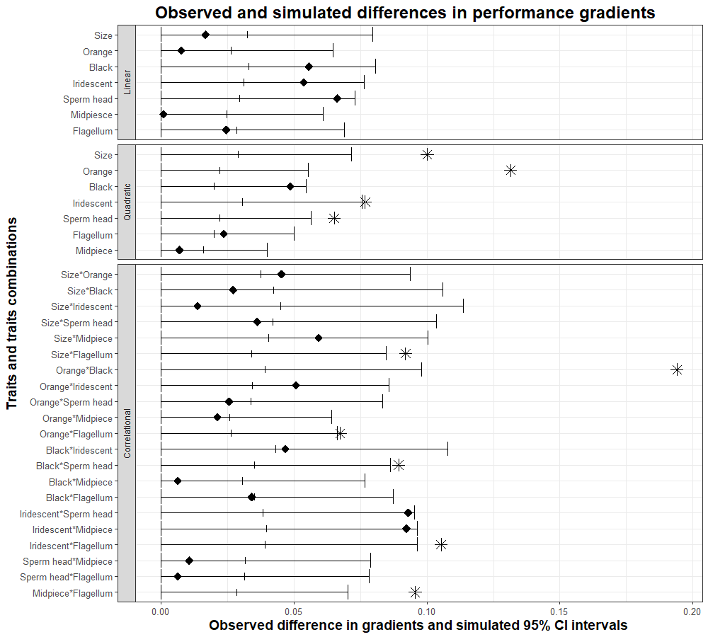

References

[1] Grueber, C.E., Fitzpatrick, J.L., Devigili, A., Gasparini, C., Ramnarine, I.W. & Evans, J.P. 2017 Population demography and heterozygosity-fitness correlations in natural guppy populations: an examination using sexually selected fitness traits. Molecular ecology 26, 4631-4643. (doi:10.1111/mec.14243).
[2] Magurran, A.E. 2005 Evolutionary ecology: the Trinidadian guppy. Oxford, Oxford University Press.
[3] Reznick, D.N. & Endler, J.A. 1982 The impact of predation on life history evolution in Trinidadian guppies (Poecilia reticulata). Evolution 36, 125-148.
[4] Billard, R. & Cosson, M.P. 1990 The energetics of fish sperm motility. In Controls of sperm motility: biological and clinical aspects (ed. C. Gagnon), pp. 153-173. Boca Raton, CRC Press, Inc.
[5] Rasband, W.S. 2016 ImageJ. (Bethesda, Maryland, USA, U. S. National Institutes of Health.
[6] Bates, D., Maechler, M., Bolker, B., Walker, S., Haubo Bojesen Christensen, R., Henrik, Singmann,, Dai, B., Grothendieck, G. & Green, P. 2016 Linear Mixed-Effects Models using 'Eigen' and S (lme4). In Reference manual of CRAN package `lme4` (
[7] Arnold, S.J. 2003 Performance surfaces and adaptive landscapes. Integrative and Comparative Biology 43, 367-375. (doi:Doi 10.1093/Icb/43.3.367).
[8] Arnold, S.J. & Bennett, A.F. 1988 Behavioural variation in natural populations. V. Morphological correlates of locomotion in the garter snake (Thamnophis radix). Biological Journal of the Linnean Society 34, 175-190. (doi:10.1111/j.1095-8312.1988.tb01955.x).
[9] Arnold, S.J. 1983 Morphology, Performance and Fitness. American Zoologist 23, 347-361.
[10] Blows, M.W. & Brooks, R. 2003 Measuring nonlinear selection. American Naturalist 162, 815-820. (doi:10.1086/378905).
[11] Svensson, E.I. & Calsbeek, R. 2012 The adaptive Landscape in Evolutionary Biology. New York, Oxford Univ Press; 1-319 p.
[12] Bisgaard, S. & Ankenman, B. 1996 Standard errors for the eigenvalues in second-order response surface models. Technometrics 38, 238-246.
[13] Reynolds, R.J., Childers, D.K. & Pajewski, N.M. 2010 The distribution and hypothesis testing of eigenvalues from the canonical analysis of the gamma matrix of quadratic and correlational selection gradients. Evolution 64, 1076-1085. (doi:10.1111/j.1558-5646.2009.00874.x).
[14] Green, P.J. & Silverman, B.W. 1994 Nonparametric regression and generalised linear models. London, Chapman and Hall.
[15] Brooks, R., Hunt, J., Blows, M.W., Smith, M.J., Bussiere, L.F. & Jennions, M.D. 2005 Experimental evidence for multivariate stabilizing sexual selection. Evolution 59, 871-880.
[16] Lewis, Z., Wedell, N. & Hunt, J. 2011 Evidence for Strong Intralocus Sexual Conflict in the Indian Meal Moth, Plodia Interpunctella. Evolution 65, 2085-2097.
[17] Lymbery, R.A., Kennington, W.J. & Evans, J.P. 2018 Multivariate Sexual Selection on Ejaculate Traits under Sperm Competition. American Naturalist 192, 94-104. (doi:10.1086/697447).
[18] Hood, G.M. 2011 PopTools version 3.2.5, Available on the internet. URL http://www.poptools.org.
[19] Stinchcombe, J.R., Agrawal, A.F., Hohenlohe, P.A., Arnold, S.J. & Blows, M.W. 2008 Estimating nonlinear selection gradients using quadratic regression coefficients: Double or nothing ? Evolution 62, 2435-2440.

