Supplementary material

Can pathogens optimise both transmission and dispersal by exploiting sexual dimorphism in their hosts?
Louise Solveig Nørgaard^{1*}, Ben L. Phillips² & Matthew Hall¹
¹School of Biological Sciences and Centre for Geometric Biology, Monash University, Melbourne 3800, Australia
²Department of Biosciences, University of Melbourne, Parkville, VIC, Australia
*Corresponding author: louise.noergaard@monash.edu
Production of male and female Daphnia
Naturally, female Daphnia can shift to producing male and female offspring given certain environmental conditions (Ebert 2005). However, in the laboratory, we can induce the production of males and females by exposing mothers to a small amount of juvenoid hormone, methyl farnesoate (Echelon Biosciences, product number S-0153). Specifically, experimental mothers were prepared by collecting juvenile female Daphnia magna from stock cultures and cultured individually in 60 mL jars filled with 50 mL artificial Daphnia medium (ADaM, Klüttgen et al. 1994; modified by Ebert et al. 1998) for three generations, to minimize maternal effects. Daphnia were transferred into fresh ADaM twice a week, maintained under standard conditions (20°C, 16L: 8D) and fed up to 5 million Scenedesmus algal cells daily; steadily increased to accommodate growing needs of the animal. Trays were rearranged every three days to minimise any positional effects.
To produce experimental male and females, the experimental mother generation were exposed to 300 μg L⁻¹ methyl farnesoate hormone, after producing their first clutch, and then transferred into fresh hormone-treated media every 2 days. Subsequent clutches were collected, and the sex of all offspring determined and used as experimental animals. Daphnia sex were determined by the presence of a “modified first leg” as per Ebert 2005, since sexual dimorphism in body size is minimal in juveniles (Ebert 2005). Finally, this method can be used to reliably produce male and female Daphnia while having no detectable impact on lifespan, fecundity, infection rates or spore loads (Thompson et al. 2017).
Manipulation of host density signals
In a variety of zooplankton, including Daphnia magna, info-chemicals and metabolic waste released from conspecifics, influence life-history investment in a variety of traits. Furthermore, presence of info-chemicals as a cue of stress, has been used in a variety of studies, exposing individuals to “stress conditioned water” (Folt & Goldman 1981; Goser & Ratte 1994; Burns 2000; Lürling et al. 2003; Michel et al. 2016). In this experiment, we exploit release of info-chemicals to simulate cues related to high density in a two-patch experimental microcosm system. Conditioned water was produced by incubating healthy Daphnia in 500 mL glass jars (~250 adult Daphnia L⁻¹). After 5 days of incubation, we collected the conditioned water by using a coarse-meshed plankton net (mesh size 0.1 mm) to remove Daphnia, and then pumping the conditioned water through a 0.45 μm filter to remove debris and algae cells, following (Michel et al. 2016).
Table S1 Probability of dispersal from a crowded habitat to an empty neighboring habitat. Results show the analysis of variance from a generalized linear model using infection status (yes or no), host sex (male or female), and their interaction as fixed effects.
Source | χ² | d.f. | P-value | Sign. code
Sex | 68.621 | 1 | <0.001 | ***
Infection status | 28.802 | 1 | <0.001 | ***
Sex x Infection status | 16.219 | 1 | <0.001 | ***

Table S2 ANCOVA results from a fitted linear mixed effect model using accumulated number of patches as a continuous response variable and time (in days) as a covariate, and host sex, infection treatment (uninfected control, pathogen C19 and C1) and their interaction, as fixed effects, and individual id as random effect.
Source | χ² | d.f. | P-value | Sign. code
Sex | 0.285 | 1 | 0.594
Infection treatment (Trt) | 4.437 | 2 | 0.109
Day number | 13251.183 | 1 | <0.001 | ***
Day number x Sex | 2507.064 | 1 | <0.001 | ***
Day number x Trt | 1464.637 | 2 | <0.001 | ***
Sex x Trt | 9.724 | 2 | 0.008 | **
Day number x Sex x Trt | 666.494 | 2 | <0.001 | ***

Table S3 ANOVA results for full model predicting square root transformed total number of patches travelled, using host sex and infection treatment (uninfected control, pathogen C19, and C1) as fixed effects.
Source | d.f. | F | P-value | Sign. code
Sex | 1,93 | 37.820 | <0.001 | ***
Infection treatment (Trt) | 2,93 | 70.349 | <0.001 | ***
Sex x Trt | 2,93 | 13.489 | <0.001 | ***
Table S4 ANOVA results for full model of square transformed pathogen spore load predicted by using host sex and pathogen genotype (Gp, pathogen C1 or C19) as fixed effects.
Source | d.f. | F | P-value | Sign. code
Sex | 1, 64 | 106.717 | <0.001 | ***
Pathogen genotype (Gp) | 1, 64 | 13.923 | <0.001 | ***
Gp x Sex | 1, 64 | 1.425 | 0.237

Size corrected spore load in male and female hosts
When accounting for standard body sized obtained from the literature (male = 2 mm and female = 5 mm, Benzie, J. A. H., 2005), we find evidence that pathogens were able to produce more transmission spores in female hosts, compared to male hosts. This suggest that the pathogens are better at utilising female resources, or, that females provide a higher quality resource patch, for pathogen proliferation.
Table S5 ANOVA results for full models for relative pathogen spore production in male and female hosts, corrected for standard body sizes. Relative spore load is predicted using host sex, pathogen genotype (C1 and C19) and their interaction as fixed effects.
Source | d.f. | F-value | P-value | Sign. code
Sex | 1,64 | 23.0245 | <0.001 | ***
Pathogen genotype | 1,64 | 22.182 | <0.001 | ***
Sex x Pathogen genotype | 1,64 | 1.417 | 0.238

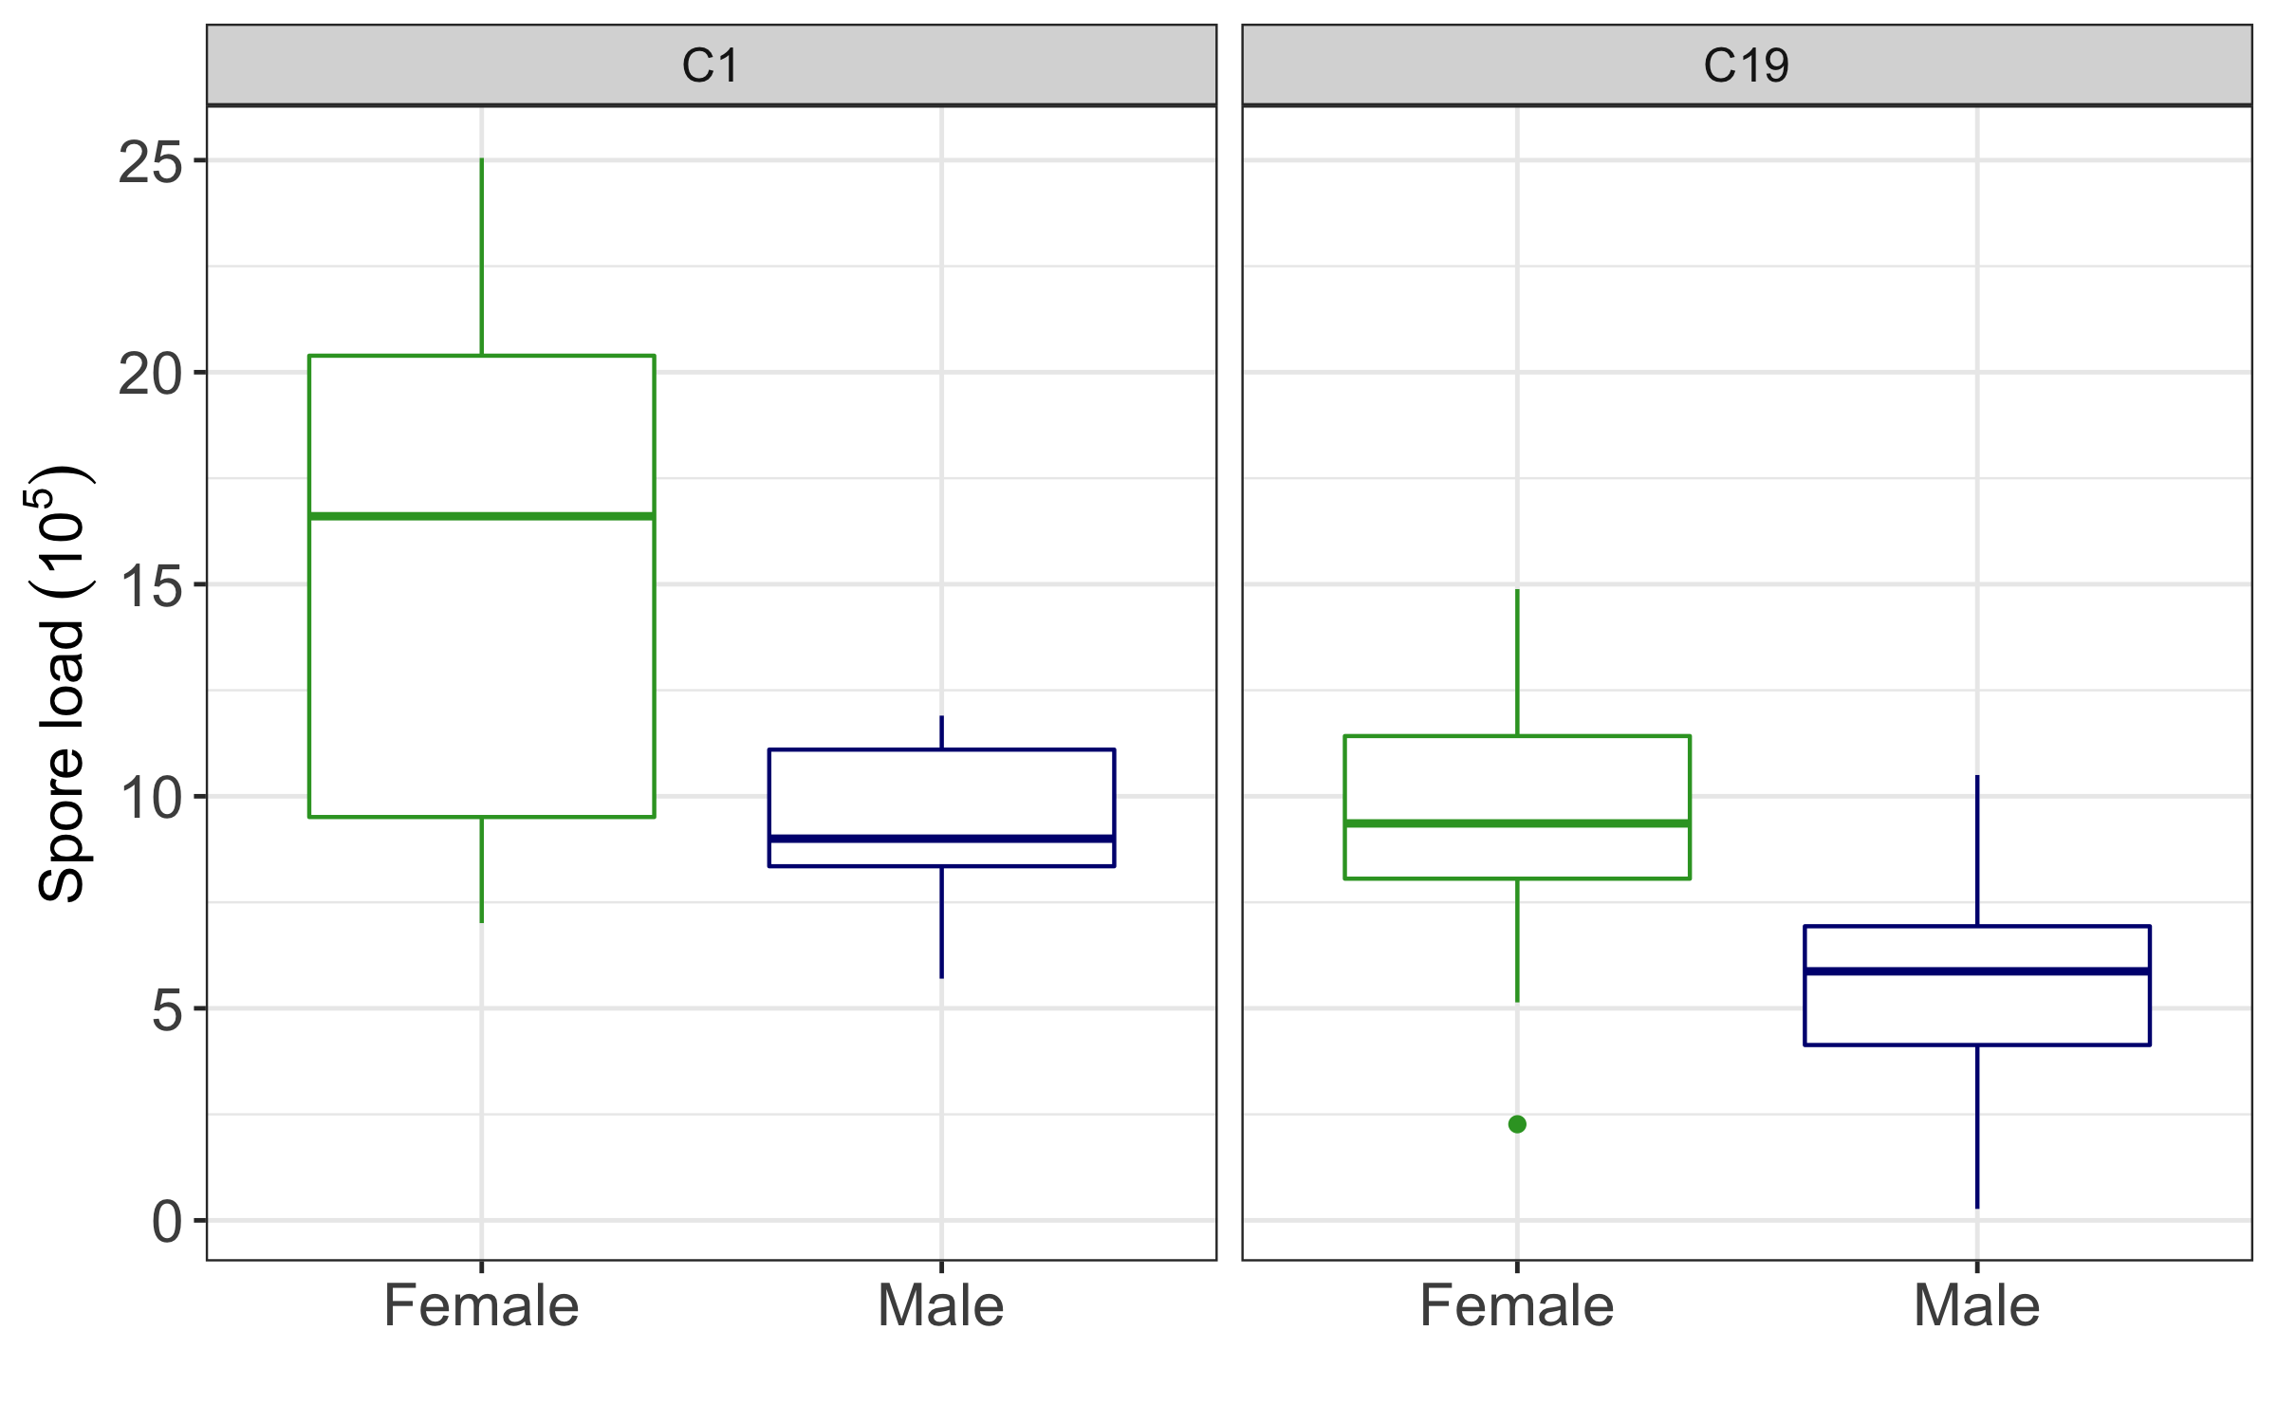
Figure S1 Relative pathogen spore production corrected by standard body size (left: pathogen C1, right: pathogen C19) of males (blue) and females (green).
Cited literature in supplementary material
Benzie, J. A. H. (2005). Cladocera: the genus of Daphnia (including Daphniopsis) (anomopoda Daphniidae). Guides to the identification of the microinvertebrates of the continental waters of the world. The Quarterly Review of Biology., 80(4). (doi: 10.1086/501297)
Burns, C.W. (2000). Crowding-induced changes in growth, reproduction and morphology of Daphnia. Freshw. Biol., 43, 19–29. (﻿doi: https://doi.org/10.1046/j.1365-2427.2000.00510.x)
Ebert, D. (2005). Ecology, Epidemiology and Evolution of Parasitism in Daphnia. Natl. Libr. Med. (US), Natl. Cent. Biotechnol.
Ebert, D., Zschokke-Rohringer, C.D. & Carius, H.J. (1998). Within–and between–population variation for resistance of Daphnia magna to the bacterial endoparasite Pasteuria ramosa. Proc. R. Soc. London. Ser. B Biol. Sci., 265, 2127–2134. (doi: ﻿10.1098/rspb.1998.0549)
Folt, C. & Goldman, C.R. (1981). Allelopathy between Zooplankton : A Mechanism for Interference Competition. Sci. New Ser., 213, 1133–1135.
Goser, B. & Ratte, H.T. (1994). Experimental evidence of negative interference in Daphnia magna. Oecologia, 98, 354–361.
Kluttgen, B., Dulmer, U., Engels, M., Ratte, H.., Klüttgen, B., Dülmer, U., et al. (1994). ADaM, an artificial freshwater for the culture of zooplankton. Water Res., 28, 743–746.
Lürling, M., Roozen, F., Van Donk, E. & Goser, B. (2003). Response of Daphnia to substances released from crowded congeners and conspecifics. J. Plankton Res., 25, 967–978. (doi: ﻿10.1093/plankt/25.8.967)
Michel, J., Ebert, D. & Hall, M.D. (2016). The trans-generational impact of population density on host-parasite interactions. BMC Evol. Biol., 16, 1–12. (doi: ﻿10.1186/s12862-016-0828-4)

