High-fidelity copying is not necessarily the key to cumulative cultural evolution: a study in monkeys and children

**Authors:** Carmen Saldana, Joël Fagot, Simon Kirby, Kenny Smith, Nicolas Claidière

*Proceedings of the Royal Society B,* doi:10.1098/rspb.2019.0729

**Supplementary material A:**

**Comparison of the copying and anti-copying tasks**

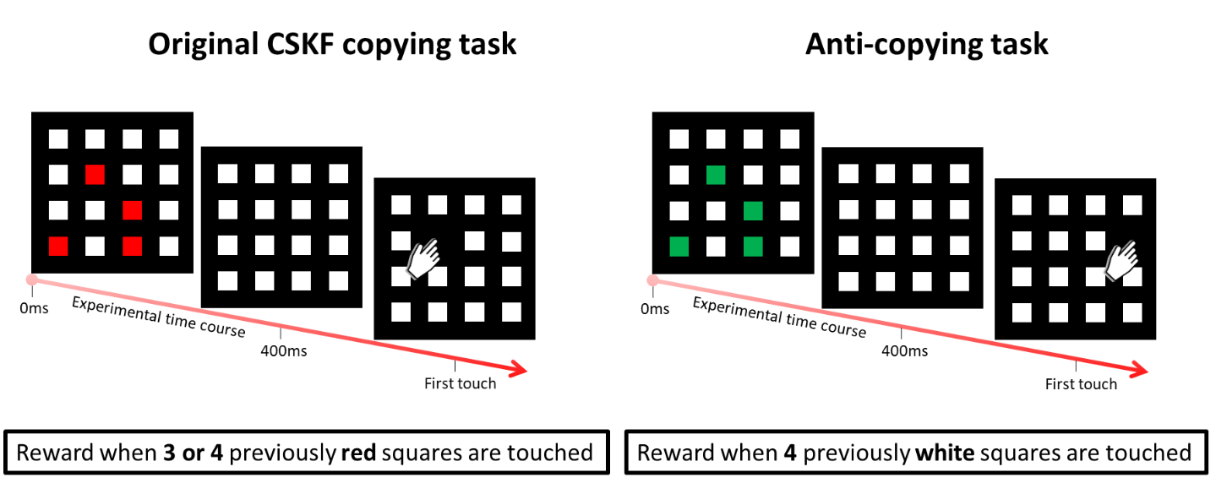

Supplementary Figure A1: From left to right: experimental designs of the copying task used in Claidière, Smith, Kirby, and Fagot (2014) and the non-copying task used here.

**Supplementary material B:**

**Test of lineage specificity in baboons**

After having performed the nine transmission chains described in the main text, we conducted an experimental test of lineage specificity borrowed from Cornish, Smith & Kirby (2013) to assess the divergence between the transmission chains. Based on Claidière et al (2014), we expected that CCE would produce systematicity because the set of 50 grids that were transmitted together should tend to collectively adapt to the task (e.g. by exploiting similar patterns or using similar regions of the grid), but that independent chains should converge to different solutions (i.e. each chain will constitute an independent and distinct lineage). This allowed us to experimentally test for lineage-specificity and systematicity, by comparing the baboons’ performance on sets of grids that evolved within a single chain of transmission to their performance on artificially-constructed sets of grids created by intermingling grids drawn from the last generation of several independent chains of transmission. Specifically, we used the test trials of the last generation of each chain to compare the baboons’ performance when exposed to unmodified sets of test trials and sets made of a recombination of test trials from different chains. ‘Natural’ sets of grids which had evolved together should be systematically related and therefore easier for the baboons; artificial sets constructed by mixing grids from different chains should lack systematicity due to their independence from each other and therefore should be harder for the baboons.

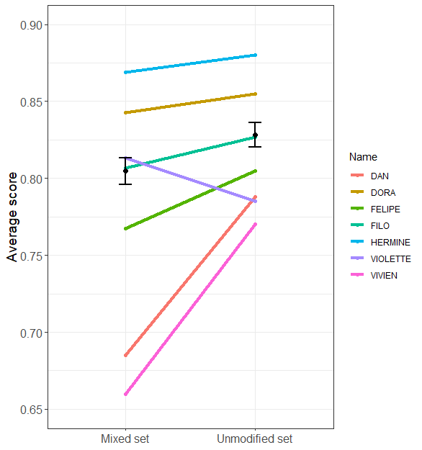

Supplementary Figure B1: Test of lineage specificity with the results at the averaged group level (black dots) and at the level of the individuals. Error bars represent the standard error.

Supplementary Figure B1 shows that, as expected, baboons were more successful in the unmodified set condition compared to the randomly mixed set; this seems to be the case at the group and individual levels for all but one baboon (i.e., Violette). We used a logistic mixed-effects regression model with trial success as dependent variable to test the significance of the difference between these two conditions. The model included Condition (mixed vs. unmodified) as a fixed effect and random intercepts for Subject as well as by-Subject random slopes for the effect of condition order. Results from the model suggest a significant difference between conditions: the odds of success were an estimated 18.7% higher in the unmodified sets compared to the mixed sets (β = 0.172, s.e. = 0.079, z = 2.161, p = 0.031).

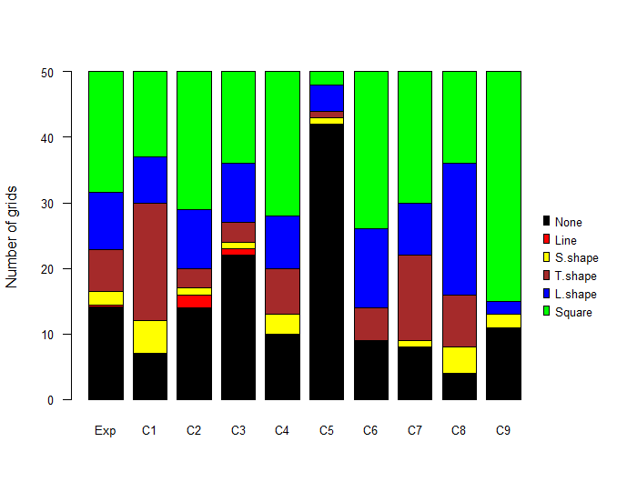

Supplementary Figure B2: Lineage specific set of tetrominoes. Distribution of the different grid types in the 9 chains at generation 10 and expected distribution obtained by collapsing across chains at this generation (Exp).

To further test for the presence of lineage specificity, we explored the cross-lineage divergence between the systems with regard to the grid types they contained. Supplementary Figure B2 shows a substantial diversity in the distribution of the different grid types between chains. We compared the distribution of the six grid types (T-shape, L-shape, S-shape, line and square tetrominoes as well as non-tetrominoes) at generation 10 in each chain to an expected distribution obtained by collapsing all the systems across all 9 chains at generation 10. Under the null hypothesis, we would expect individual chains to look like draws from this expected distribution (Supplementary Figure 2B). Three chains showed a significant degree of lineage specificity (chain 1: χ2=31.05, p=0.002; chain 2: χ2=11.07, p=0.14; chain 3: χ2=9.11, p=0.20; chain 4: χ2=2.88, p=0.71; chain 5: χ2=77.70, p<0.001; chain 6: χ2=7.44, p=0.23; chain 7: χ2=2.88, p=0.71; chain 8: χ2=77.70, p<0.001; chain 9: χ2=7.44, p=0.23; all p-values calculated by simulation with Benjamini–Hochberg correction for multiple comparisons).

**Supplementary materials C:**

**Tetromino copying by tetromino type**



Figure C1: Top row: Average number of tetrominoes produced in children and baboons by tetromino shape (over 20 and 50 trials respectively). Bottom row: Average proportion of tetrominoes that are copied from one generation to the next by shape.

Supplementary Figure C1 shows the average number of tetrominoes produced as well as the proportion of tetromino copying subset by each of the five possible tetromino shapes. A visual inspection of Supplementary Figure C1 reveals a clear preference for lines over other tetrominoes in children but no specific preference in baboons. Moreover, lines are the only pattern that shows an increase in production over time in children. We ran a logistic mixed-effects regression model to test whether the observed increase in the production of lines over generations in children could be accompanied by an increase in tetromino-copying specific to lines. Our model’s DV was whether or not the output tetromino type matched the input. We included fixed effects for Generation and Tetromino Type, random intercepts for Chain and by-Chain slopes for the effect of Generation. As reported in the main text, results show that lines are the most copied tetrominoes (β = 0.803, s.e. = 0.206, z = 3.905, p < 0.001; the smallest difference is shown with square tetrominoes: β = −1.342, s.e. = 0.316, z = −4.250, p < 0.001) but that this tendency to copy lines does not increase over time (β = −0.012, s.e. = 0.036, z = –0.324, p = 0.746). Altogether, these results suggest that children have a constant tendency to copy lines (above other tetrominoes), and once lines are introduced in the system, they are maintained. This in turn results in their accumulation and increase of the number of lines over time as new ones are introduced. Nonetheless, a further logistic mixed-effects model excluding lines (and also excluding random slopes to avoid a singular model fit) suggests that this constant tendency to copy lines is not the sole driver of the effect of generation on the overall proportion of copied tetrominoes; children still copy the shape of other input tetrominoes increasingly over generations (β = 0.009, s.e. = 0.003, z = 2.921, p = 0.003), and marginally more so than baboons (β = −0.007, s.e. = 0.035, z = −1.903, p = 0.057).

# Supplementary references

Claidière, N., Smith, K., Kirby, S., & Fagot, J. (2014). Cultural evolution of systematically structured behaviour in a non-human primate. *Proceedings of the Royal Society B: Biological Sciences, 281*(1797). doi:10.1098/rspb.2014.1541

Cornish, H., Smith, K., & Kirby, S. (2013). Systems from Sequences: an Iterated Learning Account of the Emergence of Systematic Structure in a Non-Linguistic Task. In M. Knauff, M. Pauen, N. Sebanz, & I. Wachsmuth (Eds.), *Proceedings of the 35th Annual Conference of the Cognitive Science Society* (pp. 340-345). Austin, Texas: Cognitive Science Society.