**Supplementary Materials**

# Microchannel fabrication and osmolarity calibration

To fabricate the PDMS microchannels, the master mold was first developed on a silicon wafer by photolithography (SUSS Microtec MA6) and deep reactive ion etching (STS ICP DRIE Silicon Etcher). The resulting microchannels for cell loading were 80 μm wide and 15 μm deep, whereas the channel for cells to move through was 200 μm long, 8 - 12 μm wide, and 9 μm deep. To help releasing the PDMS replica from the master, the silicon wafer was treated with trichloro (1H,1H,2H,2H-perfluorooctyl) silane (Sigma) and put in a vacuum chamber for one hour. After that, PDMS base and curing agent (Sylgard 184, Dow Corning) were mixed in a ratio of 10:1 by weight, degassed for 30 min, and poured onto the master. After curing the mixture in a 65 ºC oven for 4 hours, the cured PDMS was peeled off from the wafer and cut into small pieces with a blade. Holes were punched using a pan needle. The PDMS replica was cleaned by adhesive taper and sonicated in ethanol for 1 min. Finally, the PDMS replica and cover glass (170 μm, Deckglaser) were treated with O2 plasma for 2 min at 300 mTorr separately and bonded together. To maintain its hydrophilicity, the bonded chip was stored in DI water. In comparison, the chip was baked in a 150 ºC oven for 24 hours if hydrophobic surface was preferred.

In our experimental setup, the microchannel was connected to the medium container through a polystyrene pipe (3 mm in diameter and ~15 cm in length). The pipe was chosen to be long enough to avoid galvanotaxis during the experiment [29]. Before actual test, the pipe was sterilized under UV for 30 minutes and washed three times by 0.22 $μm$ filtered (Millipore) Phosphate Buffer Saline (PBS) to avoid contamination.

To estimate the voltage-induced osmolarity change in the culture medium, the concentrations of sodium and potassium ions (two major ion species in the medium) were measured by potentiometry (LAQUAtwin Compact Sodium/Potassium Ion Meter, Horiba, Kyoto, Japan). The calibration curves between the applied voltage and the steady-state concentrations of these two ion species are shown in the figure below.

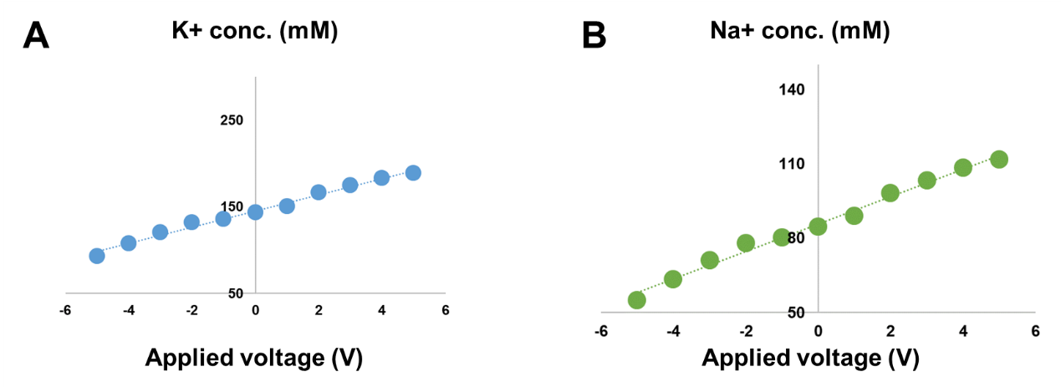

Figure S1 Calibrated concentrations of potassium and sodium ions in the culture medium as functions of the applied voltage.

# Verification of voltage-induced consistent cell movement in microchannels

To verify that directional and consistent cell movement can be induced in our experimental setup, we applied a voltage of 5V for 1 hour and then switched it to -5V for another hour. A representative migration trajectory of A549 cells under such circumstance is shown in Fig. 1B. Furthermore, it was also observed that most of the cells (>90%) move in the same direction inside the microchannel within these two hours (Fig. S2), indicating that their movement is directional and consistent.

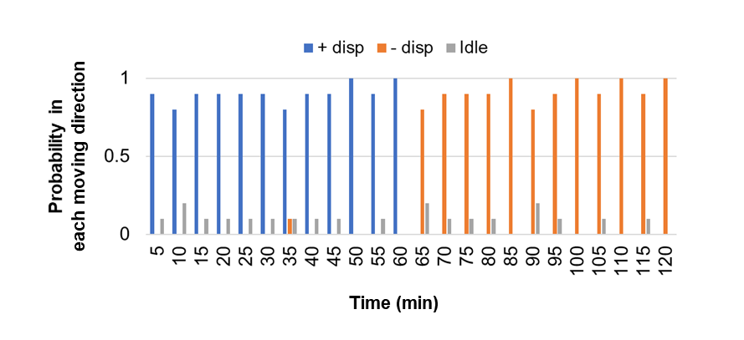

Figure S2 – Probability of cells to move in different directions (i.e. positive, negative or idle) under an applied voltage of 5V for 1 hour and then switched to -5V for another hour. Results shown here are based on10 independent measurements where the position of each cell was tracked every 5 minutes.

# Protein coating inside microchannels

4μg/mL of Bovine Serum Albumin (Sigma), 4μg/mL of fibronectin (Sigma), or 4μg/mL of collagen I (Sigma) were injected into the hydrophobic microchannels at 4°C for 12 hours to allow protein adsorption on the channel wall to occur. The coated microchannels were washed with Phosphate Buffer Saline and then sterilized under UV light for 1 hour in a clean environment. The above adsorption and washing process were repeated 3 times to ensure the entire channel wall was coated with the corresponding proteins prior to cell motility experiment.

# Characterizing the strength of cell-channel adhesion through optical pulling

Following well-established protocols, the adhesion strength between A549 cells and surfaces coated with different adhesion proteins was measured via optical pulling [20]. Specifically, A549 cells were co-cultured with 5μm-polystyrene beads (Polysciences), coated with Bovine Serum Albumin (Sigma), fibronectin (Sigma), or collagen I (Sigma), on confocal dish for 24 hours. The A549 cells were then tripsinzed with 0.01% Trypsin with EDTA (Invitrogen). After that, optical trap (MMI) was used to grab individual microspheres, in adhesive contact with A549 cells, and then pull them away from the cell immobilized on the cover-slip as illustrated in Fig. S3. The moving distance of the laser beam $δ$ was controlled in our experiment while bead displacement $u$ and the radius *a* of the contact area were measured. Based on the calibration curve, the pulling force F can be determined from $δ$ and *u*

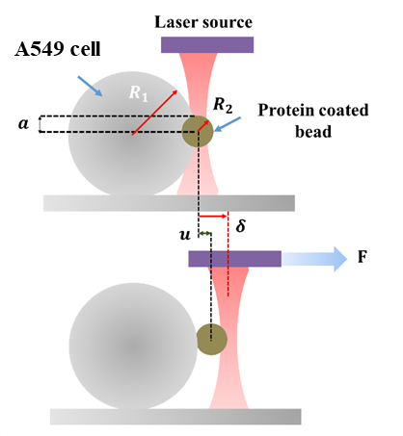

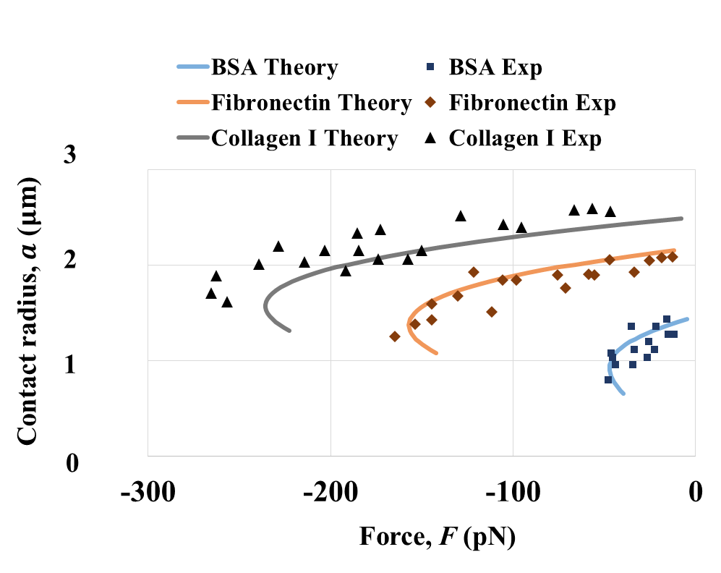

Figure S3. Schematics of the optical pulling test (Left). Measured pulling force – contact radius relationship between A549 cells and surfaces coated with different proteins (Right). Theoretical fittings by Eq. (S1) are given by the solid lines from which the adhesion strength can be estimated.

According to the well-known JKR theory, the enforced separation between two elastic spheres in adhesive contact can be described by [S1]

${\left[F-\frac{4E_{r}a^{3}}{3R}\right]}^{2}=8πγE_{r}a^{3}$ (S1)

where $a$ and $F$ are the contact radius and applied force; $γ$ is the adhesion energy density representing the energy reduction per unit area when two surfaces are brought together; and $1/R=1/R_{1}+1/R_{2}$ where $R_{1}$ ($≈5 μm$) and $R_{2}$ ($=2.5 μm$) are the radii of the cell and the bead, respectively. Since the microsphere itself is much stiffer than the cell, the so-called reduced cell modulus ($E_{r}$) takes the form $E_{r}=\frac{E_{1}}{1-υ_{1}^{2}}$, with $E_{1}$ and $υ_{1}$ being the Young’s modulus and Poisson’s ratio of the cell respectively. With such description at hand, the values of $γ$ and $E_{r}$ can then be estimated by fitting Eq. (S1) to the experimentally measured pulling force vs. contact radius relationship (Fig. S3).

# Force calibration of the optical tweezers

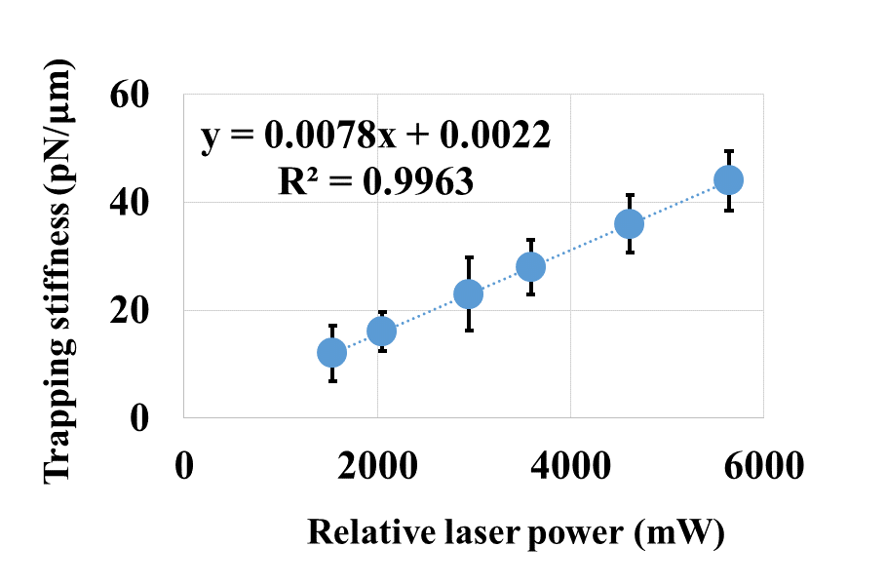

Figure S4 Calibrated relationship between the trapping stiffness and relative laser power applied

It has been suggested that optical trap works approximately like a linear spring, that is a force

$F\left(t\right)=-k\left[δ\left(t\right)-u(t)\right]$ (S2)

will be exerted on the microsphere confined within the laser beam [S2, S3] with the negative sign representing that this force is “tensile”, i.e. trying to separate the bead from the cell. Here, $δ$ is the moving distance of the laser beam (which is controlled in our experiment) and $u$ is the bead displacement, refer to Fig. S3. $k$ is the effective stiffness of the trap whose value depends on factors like the laser power and bead size and hence must be calibrated beforehand (a representative calibration curve is given in Fig. S4). In this study, a constant trapping stiffness of $40.3 pN/μm$ was used.

# Cell culture and cell invasiveness quantification

A549, C666 and HK1 cells were cultured in RPMI1640 medium (Gibco) supplemented with 10% fetal bovine serum, FBS (Sigma) and 1% antimycotic antibiotic solution (Sigma). NP69 was cultures in Keratinocyte-SFM medium (Gibco) supplemented with human recombinant Epidermal Growth Facter 1-53 (Gibco) and Bovine Pituitary extract (Gibco). Prior to experiment, single cell was injected by sterilized syringe and seeded in the microchannel.

The invasiveness of different cell lines was measured by the CytoSelect 24-well cell invasion assay kit (basement membrane, colorimetric format; Cell Biolabs, San Diego, CA, USA) according to the manufacturer’s instructions. In particular, cells were cultured on ECM basement membrane with 8μm pores pre-fabricated on surface. To avoid the influence of serum on cell growth and ensure fair comparison to the normal immortalized cell lines, all the cells performed in the test were cultured in OptiMEM serum free medium (Gibco) without any growth factors supplemented. After 18 hours, the invasive cells on the bottom of the membrane were stained and analyzed using microtitler plate reader. Specifically, results were expressed as percentage of invasion, where the non-invasive cell layer was removed while both the invasive layer and the whole cell population were stained and quantified under microtitler plate reader at 560nm. Figure S5 shows the percentage of invasive cells underneath the ECM basement membrane among the whole population.

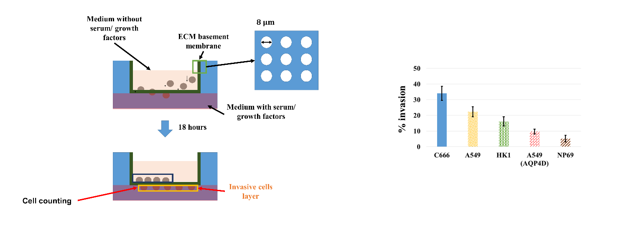



Figure S5 Procedures of the cell invasion assay measurement (Top). Bar chart illustrating the quantified cell invasiveness of C666, A549, HK1, A549 cells with AQP4 knocked down and NP69 cells (Bottom).

# Knockdown of AQP expression

Sixty-millimeter plates of confluent cells were treated for 24 hours with 4 nmol/L AQP-4 siRNA (Invitrogen, Sequence: CCGCUGGUCAUGGUCUCCUGGUUGA) where molecules were loaded by Lipofectamine 2000 (Invitrogen) according to the manufacturer’s instructions. After that, cells were grown in cell culture flasks in OptiMEM serum free medium (Gibco) for another 24 hours. The transfection efficiency was examined by real-time PCR following the standard procedures. Specifically, the cultured cells were maintained at >90% viability confirmed by labeling tripsinized cells with Trypan blue and then using hemocytometry to quantify the cell number. Total RNA was extracted using the RNeasy Micro Kit (Qiagen) and on-column DNase I digestion was performed according to the manufacturer's instructions. In particular, total RNA was eluted in 14 µL RNase-free water whose concentration was then determined by Qubit® RNA Assay Kit by Qubit® Fluorometer (Life technologies). cDNA was synthesized from 500ng of RNA in a total volume of 100 µL using SuperScript III Reverse Transcriptase (Life technologies). The AQP4-knockdown cell line was cultured in RPMI1640 medium (Gibco) supplemented with 10% FBS (Sigma) and 1% antimycotic antibiotic solution (Sigma).

# Densiometric measurement of Western blotting

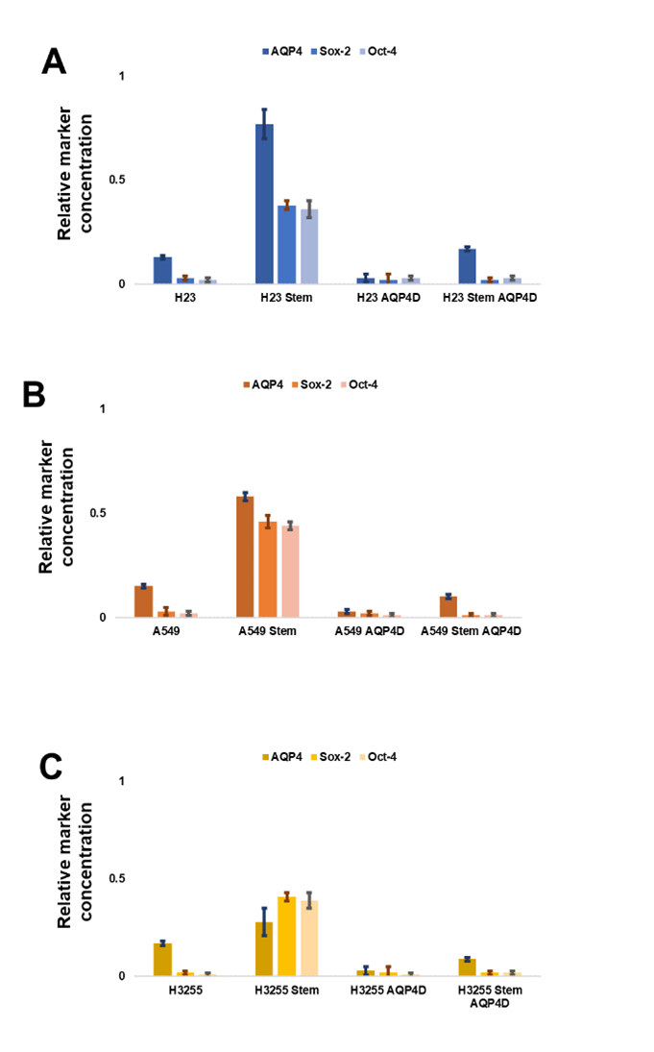Referring to the Western blot results shown in Figure 4, 10 independent experiments were conducted, and the corresponding quantitative measurements are shown below in Figure S6.

Figure S6 Densiometric measurement of Western blots where the protein concentration of each marker, including AQP4, Sox-4 and Oct-4, was normalized by the concentration of the loading control, GAPDH.

# Osmotic engine model for predicting the migration of cells under electro-osmotic manipulation

According to the recently developed osmotic engine model [15], the steady speed (*V*) of cells trapped in a micro-channel can be estimated as

 (S3)

where the is the meanings of different parameters are summarized in Table S1. To make a connection between this theory and our experiment, we systematically measured the osmolarity changes (sensed by the cell trapped in the microchannel) by summing up the concentrations (determined by ion selective electrodes (Horiba) [18]) of dominant ions, i.e. sodium and potassium, in the culture medium, refer to Table S1. The average length *L* of different cell lines used in this study was also measured (Table S2) and used as an input parameter in Eq. (S3). Finally, the water exchange rate $α$ and the friction coefficient $ζ_{w}$ were assumed to be proportional to the measured AQP-4 concentration (Table S3) and adhesion strength between the cell and the coated channel surface (Table S4), respectively. Note that, as a reference, $ζ_{w}$ and $α$ for A549 cells under BSA coating were chosen to be 6.5 $×{10}^{8}$ Pa.s/m and m Pa-1 s-1 which are comparable to those ( $ζ_{w}=$ 8 $×{10}^{8}$ Pa. s/m and m Pa-1 s-1) adopted in [15] for sarcoma cancer S180 cells confined in micro-channels without adhesion protein coating.

It must be pointed out that the average lengths of the parental cell lines were observed to be larger than their stem cell phenotypes, in agreement with previous studies [S4]. The shaded region in Fig. 5 represents the predicted traveling velocity of cells when the cell length is allowed to vary by ±30% from the measured mean value. Here, the values of $α$ and *L* for each cell type were taken as those listed in Table S2 and S3, respectively. In addition, since all results shown in Fig. 5 were based on collagen I coated channels $ζ_{w}$ was fixed as 36 $×{10}^{8}$ Pa.s/m in this case (refer to Table S4).

Table S1 – Parameters adopted in the model for predicting the migration speed of cells

|  |  |  |
| --- | --- | --- |
| Parameters | Adopted Value | Sources |
| Viscosity of cytoplasm, $η$ | 0.001 Pa.s | [15] |
| Cell length, L | Refer to Table S2 | Measured |
| Width of channel, b | 7 $μm$ | Experimental condition |
| Thickness of cortical layer, h | 100 nm | [15] |
| Diffusivity of ions, D | 500 m2/s | [15] |
| Rate constant of water transport, $α$ | Refer to Table S3 | Measured |
| Rate constant of ion flux across MS channels, | 5  mol.m-2Pa-1s-1 | [15] |
| Rate constant of ion flux across ion transporters, | 5  mol.m-2Pa-1s-1 | [15] |
| Threshold stress of MS channel at leading edge, $σ_{c,f}$ | 900 Pa | [15] |
| Threshold stress of MS channel at trailing edge, $σ_{c,b}$ | 300 Pa | [15] |
| Friction coefficient between the cell and the channel wall, $ζ_{w}$ | Refer to Table S4  (~8 $×{10}^{8}$ Pa. s/m) | [15] |
| Osmotic pressure outside the trailing end, $Π_{out,b}$, MPa | 0.77 | Measured |
| Osmotic pressure outside the leading end, $Π_{out,f}$, MPa | 0.65 | Measured |
| Critical osmotic different of ion pump at leading end, $∆Π_{c,f}$ | 6000 $Π_{out,f}$ | [15] |
| Critical osmotic different of ion pump at trailing end, $∆Π_{c,b}$ | 6000 $Π_{out,b}$ | [15] |

Table S2 – Measured length of different cells used in the present investigation

|  |  |
| --- | --- |
| Cell type | Cell length ($μm$) |
| H3255 AQP4D | 28 $±4$ |
| H3255 Stem AQP4D | 20 $±1$ |
| H1650 AQP4D | 25 $±2$ |
| H1650 Stem AQP4D | 20 $±1$ |
| A549 AQP4D | 24 $±3$ |
| A549 Stem AQP4D | 13 $±2$ |
| H23 AQP4D | 20 $±1$ |
| H23 Stem AQP4D | 10 $±2$ |
| H358 AQP4D | 19 $±1$ |
| H358 Stem AQP4D | 13 $±2$ |
| H820 AQP4D | 16 $±2$ |
| H820 Stem AQP4D | 12 $±2$ |
| H3255 | 28 $±5$ |
| H3255 Stem | 19 $±3$ |
| H1650 | 15 $±2$ |
| H1650 Stem | 11 $±2$ |
| A549 | 24 $±4$ |
| A549 Stem | 13 $±1$ |
| H23 | 21 $±3$ |
| H23 Stem | 11 $±2$ |
| H358 | 11 $±2$ |
| H358 Stem | 8 $±1$ |
| H820 | 11 $±1$ |
| H820 Stem | 8 $±1$ |

Table S3 – Adopted water exchanged rates for different types of cells

|  |  |
| --- | --- |
| Cell type | Rate constant of water transport ,  , m Pa-1 s-1 |
| H3255 AQP4D | 0.05 |
| H3255 Stem AQP4D | 0.13 |
| H1650 AQP4D | 0.07 |
| H1650 Stem AQP4D | 0.19 |
| A549 AQP4D | 0.10 |
| A549 Stem AQP4D | 0.25 |
| H23 AQP4D | 0.13 |
| H23 Stem AQP4D | 0.29 |
| H358 AQP4D | 0.17 |
| H358 Stem AQP4D | 0.36 |
| H820 AQP4D | 0.25 |
| H820 Stem AQP4D | 0.42 |
| H3255 | 0.18 |
| H3255 Stem | 0.39 |
| H1650 | 0.29 |
| H1650 Stem | 0.52 |
| A549 | 0.36 (Estimated [15]) |
| A549 Stem | 0.64 |
| H23 | 0.47 |
| H23 Stem | 0.80 |
| H358 | 0.52 |
| H358 Stem | 0.90 |
| H820 | 0.55 |
| H820 Stem | 0.91 |

Table S4 – Adopted frictional coefficients for different types of channel coatings

|  |  |  |
| --- | --- | --- |
| Cell type/Adhesion ligand | Friction coefficient between the cell and the channel wall, $ζ_{w}$ | Sources |
| A549/BSA coating | 6.5 $×{10}^{8}$ Pa.s/m | Estimated [15] |
| A549/4ug/mL fibronectin | 24 $×{10}^{8}$ Pa.s/m | From measured adhesion strength |
| A549/4ug/mL collagen I | 36 $×{10}^{8}$ Pa.s/m | From measured adhesion strength |

**References**

[S1] Chu, Y.S., Dufour, S., Thiery, J.P., Perez, E. & Pincet, F. 2005 Johnson-Kendall-Roberts theory applied to living cells. Phys Rev Lett 94, 028102. (doi:10.1103/PhysRevLett.94.028102)

[S2] Zhou, Z.L., Hui, T.H., Tang, B. & Ngan, A.H.W. 2014 Accurate measurement of stiffness of leukemia cells and leukocytes using an optical trap by a rate-jump method. RSC Advances 4, 8453-8460. (doi:10.1039/C3RA45835K).

[S3] Andersson, M., Madgavkar, A., Stjerndahl, M., Wu, Y., Tan, W., Duran, R., Niehren, S., Mustafa, K., Arvidson, K. & Wennerberg, A. 2007 Using optical tweezers for measuring the interaction forces between human bone cells and implant surfaces: System design and force calibration. Review of Scientific Instruments 78, -. (doi:doi:http://dx.doi.org/10.1063/1.2752606).

[S4] Li, Q., Rycaj, K., Chen, X. & Tang, D.G. 2015 Cancer stem cells and cell size: A causal link? Seminars in cancer biology 35, 191-199. (doi:10.1016/j.semcancer.2015.07.002).