The approach of focusing on effect size estimation is usually accompanied by an emphasis on visualization of the data to support their evaluation. A strong graphical format that achieves this involves a main panel showing the raw data and side panels helping to illustrate the estimated effect size [1]. Such plots, while intuitive, are not typically available in statistical packages and not easy to code in programming languages. However, Ho and colleagues [1] have recently developed ‘Data Analysis with Bootstrapcoupled ESTimation’ (DABEST), available in versions for Matlab, Python and R, and also as a webpage estimationstatistics.com. All versions have user-friendly, rote instructions to produce graphs that allow full exploration of your data. Figure S1 was generated from the webpage version.

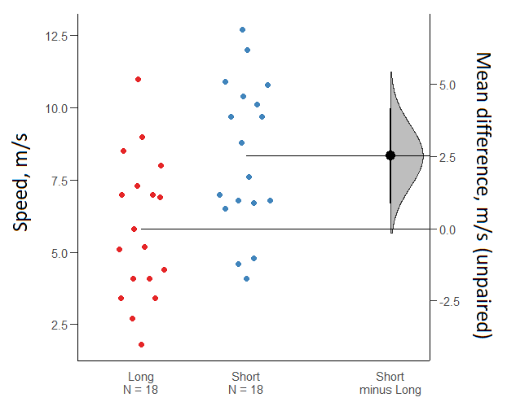
Figure S1. A Gardner-Altman estimation plot [2] for an example data set of horse mean running speeds over two categories of race distance, generated using estimationstatistics.com [1]. The plot includes the raw data points, the effect size (the difference between the means), and the effect size accuracy as the 95% confidence interval (the vertical, thick black line above and below the point estimate of the mean difference) along with the sampling error distribution of the effect size as the filled grey curve.

1. Ho J., Tumkaya T., Aryal S., Choi H., Claridge-Chang A. 2018 Moving beyond P values: Everyday data analysis with estimation plots. bioRxiv, 377978.
2. Gardner M.J., Altman D.G. 1986 Confidence intervals rather than P values: estimation rather than hypothesis testing. Br Med J (Clin Res Ed) 292, 746-750.

