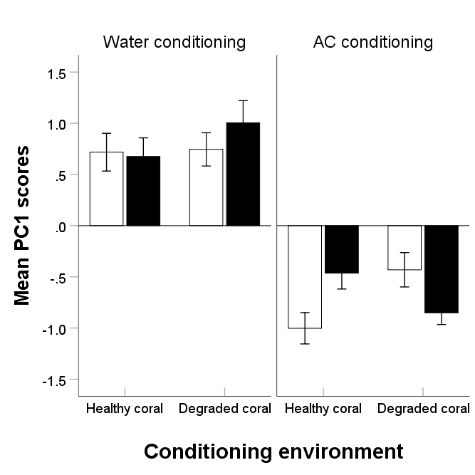
Testing environment

Supplementary Figure 1: Mean (±SE) PCA scores of the proportion change in feeding and activity of fish that received either a false conditioning (water conditioning) or a true conditioning (alarm cue conditioning) to recognize the odour of a predator as threatening. The conditioning took place in tanks that had water flowing from either healthy or degraded coral (conditioning environment), and the fish were tested for their response to the predator odour generated in testing tanks containing either healthy (empty bars) or degraded (solid bars) coral water.

