**Supplemental Information:**

*Expanded Molecular Methods:*

Total RNA was extracted from gill and kidney tissue using the RNA STAT-60 reagent (Tel-Test, Friendswood, TX, USA) according to manufacturer protocol. RNA concentrations were determined using a Nanodrop spectrophotometer (Thermo Scientific). All samples were treated for possible genomic DNA contamination using a Turbo DNA-free kit (Applied Biosystems/Ambion, Austin, TX, USA), according to manufacturer guidelines. Generation of first-strand cDNA from total DNAse treated RNA was performed using the Revertaid™ Reverse Transcriptase (Thermo Scientific) using random hexamer primers and 2 μg total RNA as starting material. All subsequent procedures were performed according to manufacturer guidelines and final cDNA was diluted 5-fold in molecular grade water. Note that due to low RNA yield, two gill samples were pooled for the purposes of cDNA synthesis for all time points except the 14 mM acclimation. Real-time PCR was performed using the Maxima SYBR Green Master Mix Kit (Thermo Scientific) and a MX3000P QPCR thermocycler. All procedures were performed according to manufacturer guidelines, with the exception that reaction volume was reduced to 12.5 µl. A cDNA dilution curve was used to define the PCR reaction efficiency for each primer pair, which ranged from 93 – 109%. A no reverse transcriptase control was included to assess potential genomic DNA contamination, as well as a general no template control to assess other potential sources of contamination. All primer pairs were generated using Primer 3 or Primer Express 2.0 software (Applied Biosystems) with a target annealing temperature of 60°C (Table S3). To further prevent genomic DNA amplification all primer pairs were designed to include exons within the amplicon region. Primer specificity was assessed using NCBI Blast: zebrafish nucleotide sequences as well as dissociation curves after completionof 40 PCR cycles. In all cases only a single dissociation peak was observed. Gene expression was analyzed using the ΔΔCt method and normalized to elongation factor 1α. Within gene analyses are expressed relative to pre-transfer treatment groups. Across gene analyses for the purposes of relative abundance within a tissue was made relative to the most abundant isoform.

Table S1: Amino acid alignment of two conserved transmembrane domains of the Na+ K+ ATPase α subunit. Amino acids highlighted in bold represent crucial substitutions within the Na+ binding sites.

|  |  |  |
| --- | --- | --- |
|  | **TM5** | **TM8** |
| *Kidney/pig* | YTLTSNIPEITPFLIF | TIVVVQWADLVICKTR |
| *Shark α1* | YTLTSNIPEITPFLVF | SIVVVQWADLIICKTR |
| *zatp1a1a.1* | YTLTSNIPEITPFLLF | SIVVVQWADLIICKTR |
| *zatp1a1a.2* | IFLTSNIPEISPFLLF | SIVIVQWADLIICKTR |
| *zatp1a1a.3* | YTLTS**K**IPEMSPFLMF | SIVIVQWADLIICKTR |
| *zatp1a1a.4* | YTLTS**K**IPEMSPFLMF | SIVIVQW**T**DLLICKTR |
| *zatp1a1a.5* | YTL**STK**IPEMSPFLMF | SIVIMQW**TT**LLVCKSR |
| *Trout α1a* | YTL**S**S**K**IPEMTPFLFL | AVVIAQWA**V**LIVCKTR |
| *Trout a1b* | YTLTSNIPEISPFLLF | SIVVVQWADLIICKTR |
| *Trout a1c* | YTLTSNIPEITPFLLF | SIVVVQWADLIICKTR |
| *Salmon α1a* | YTL**S**S**K**IPEMTPFLFL | AVVIAQWA**V**LIVCKTR |

Table S2: Water chemistry parameters for the respective acclimation treatments.

|  |  |  |  |  |
| --- | --- | --- | --- | --- |
| **Treatment** | **Na+ (µM)** | **Cl- (µM)** | **Ca2+ (µM)** | **pH** |
| 16 mM Na+ | 15951 ± 709 | 15326 ± 483 | 729 ± 68 | 8.0 ± 0.1 |
| 1.5 mM Na+ | 1638 ± 120 | 1660 ± 83 | 403 ± 15 | 7.8 ± 0.1 |
| 0.01 mM Na+ | 9 ± 2 | 7 ± 1 | 18 ± 5 | 6.5 ± 0.1 |

Table S3: Real-time PCR primer sequences for the various Na+ K+ ATPase subunits as well as the elongation factor 1α control gene. Note that the reverse primer is listed as the reverse compliment of the genomic sequence.

|  |  |  |  |
| --- | --- | --- | --- |
|  | Accession # | Forward | Reverse |
| zatp1a1a.1 | NP_571761.1 | gttgcaagaaaccgctcttg | gctgcgtcggatgataagtt |
| zatp1a1a.2 | NP_571762.1 | gcttggctgggaagatagat | ccagagcaccttcctcaaag |
| zatp1a1a.3 | NP_571763.1 | acacagccttctttgccagt | tctgacagcaacttccatgc |
| zatp1a1a.4 | NP_571764.1 | ggcctgtttgaagaaactgc | ttcttgttccacccaacctc |
| zatp1a1a.5 | NP_835200.1 | aattgcagcgttcctgtctt | ccctcctgggttttgcctaat |
| z1a | NM_131668.3 | aagatggtgacggtggctgga | tggatggtgccaatgaaaattcca |
| z1b | AF286375.1 | aagacgacggaggatggaaga | aatctgaatggtgccgataaagat |
| z2a | NM_131669.3 | aggaatccgggtcatggaagga | atacatggtgaggcagaaaacgc |
| z2b | NM_131838.2 | aggatgacaagaacggctggaa | tacatggtgagagtaaacaattcct |
| z 3a | NM_131221.2 | tcagcggagggcaaagagc | aacatggcagccaagaatcca |
| z 3b | NM_131670.1 | aacattcccgccagaaagccat | aacattcccgccagaaagccat |
| zFXYD1 | NM_001256212.1 | tgagggtcggaggtctgatc | gcttcagcgttacttcctgt |
| zFXYD2 | NM_001281921.2 | atggcagtggaaagtcctga | ataaccatgcccaaacagaac |
| zFXYD5 | XM_021466472 | aagagatgggatgagccgtt | tcgtttcactttgccacagc |
| zFXYD6 | BC054135.1 | ttggcgttcgccgttgtgct | ggggcttcttcatctcctgg |
| zFXYD7 | NM_001201426.1 | gggtcatcctagctgtggttat | ttcggagggccttccactgg |
| zFXYD11 | AB923977.1 | tgcaaaggaggggtaaaatg | cttgcgtcatcatcatgctt |
| ef1α | NM_131263.1 | aaccatcgagaagttcgagaa | aacacccaggcgtacttgaa |

Figure S1

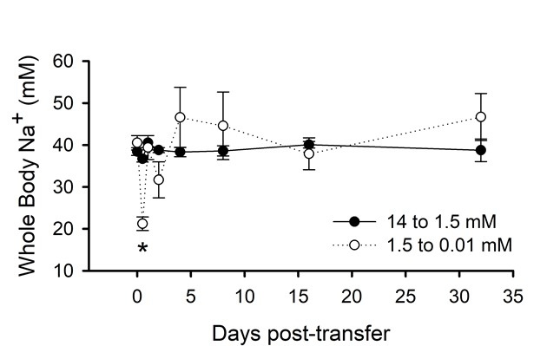

Figure S1: The whole body Na+ of zebrafish acutely transferred to lower ambient Na+ environments. An asterisk denotes a significant difference from the pre-transfer concentrations (ANOVA; *P* ≤ 0.05). Values represent mean ± S.E.M. (N = 8).

Figure S2



Figure S2: Gene expression analysis for β and γ subunits of Na+ K+ ATPase in the kidneys (A, B) and gills (C-F) of zebrafish after transfer from 14 mM to 1.5 mM environmental Na+ (A, C, E), and from 1.5 mM to 0.01 mM environmental Na+ (B, D, F). All values represent the mean ± SEM of log transformed relative expression. An asterisk denotes a significant differences from pre-transfer expression (N = 5 for gills and N = 8-10 for kidneys).

Figure S3



Figure S3: The relative expression of zebrafish α1a paralogues after acclimation to three different Na+ environments. The expression within each environment was calculated relative to the most highly expressed *zatp1a1a.2* transcript.

Figure S4



Figure S4: The relative expression of zebrafish α1a subunit paralogues in the kidney following acclimation to three different Na+ environments. The expression within each environment was calculated relative to the most highly expressed *zatpa1a.4* subunit transcript.