**Electronic supplementary material**

**Consumer co-evolution and prey trait variability determine species coexistence**

Thomas Scheuerl, Johannes Cairns,Lutz Becks and Teppo Hiltunen*

*teppo.hiltunen@helsinki.fi



Fig. S1. Difference between both coevolved ciliate lines predating on the two evolved bacterial lines. The x- axis shows ciliates coevolved with *E. coli* and ciliates coevolved with *P. fluorescens*. Dark bars show ciliates growing on *E. coli* and light bars show ciliates growing on *P. fluorescens* (mean ± s.e.).

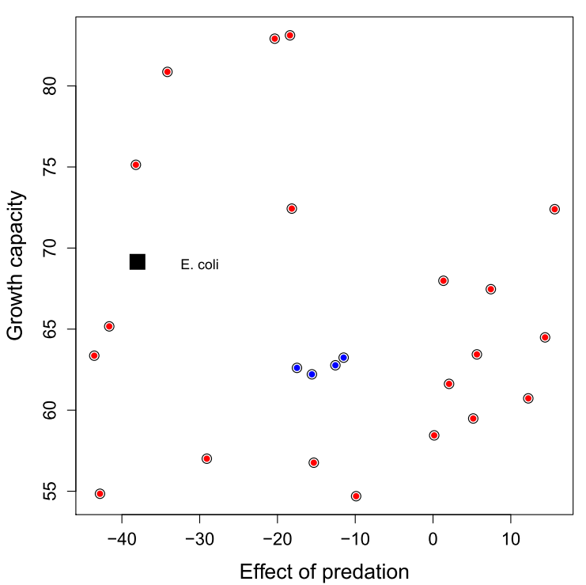

Fig. S2. Ancestral *trait space* for the two bacterial species used. The y axis represents growth capacity calculated as sum under the growth curve over 48 hours in 1% King`s B medium. The x axis shows loss due to predation compared to biomass estimates from controls. *E. coli* (black square) has a higher growth capacity compared to ancestral *P. fluorescens* (blue dots), but *E. coli* populations lose more biomass compared to *P. fluorescens* under predation. Red dots show twenty clones of *P. fluorescens* used in high-diversity populations with different location in the *trait space* representing the genetic variance of the population. For the high diversity population structure, we randomly combined 10 of these clones per replicate.

Table S1. Predation was the main effect explaining bacterial biomass

|  |  |  |  |  |
| --- | --- | --- | --- | --- |
|  | **Df** | **X2** | **P(>|Chi|)** |  |
| Predation | 2 | 205 | 0.0000 | *** |
| --- |  |  |  |  |
| Signif. codes: 0 ‘***’ 0.001 ‘**’ 0.01 ‘*’ 0.05 ‘.’ 0.1 ‘ ’ 1 | | | | |

Table S2. Time and predation together explained ciliate dynamics

|  |  |  |  |  |
| --- | --- | --- | --- | --- |
|  | **Df** | **X2** | **P(>|Chi|)** |  |
| Time | 1 | 15 | 0.0001 | *** |
| Predation | 2 | 3085 | 0.0000 | *** |
| Time x Predation | 2 | 222 | 0.0000 | *** |
| --- |  |  |  |  |
| Signif. codes: 0 ‘***’ 0.001 ‘**’ 0.01 ‘*’ 0.05 ‘.’ 0.1 ‘ ’ 1 | | | | |

Table S3. ANOVA and multiple contrasts for gls model showing the evolutionary change in defence level of *P*. *fluorescens* clones isolated at the end of the experiment.

|  |  |  |  |
| --- | --- | --- | --- |
| ANOVA for gls model *defense ~ bacterial treatment × predator treatment* | | | |
| Model terms | df | *F* | *p* |
| Bacterial treatment (B) | 2 | 15.2 | < 0.001 |
| Predator treatment (P) | 1 | 0.102 | 0.749 |
| B × P | 2 | 13.3 | < 0.001 |
| Denominator | 234 |  |  |
| Multiple contrasts |  |  |  |
|  | df | emmean | group (Tukey; α = 0.05) |
| Ancestral *P*. *fluorescens* |  |  |  |
| Naïve predator | 234 | ‒18.2 | 1 |
| Coevolved predator | 234 | ‒9.69 | 2 |
| Full-diversity |  |  |  |
| Naïve predator | 234 | ‒0.594 | 1 |
| Coevolved predator | 234 | ‒16.0 | 2 |
| High-diversity |  |  |  |
| Naïve predator | 234 | ‒9.91 | 1 |
| Coevolved predator | 234 | ‒0.108 | 2 |

Table S4. ANOVA and multiple contrasts for gls model showing the evolutionary change in growth ability of *P*. *fluorescens* clones isolated at the end of the experiment.

|  |  |  |  |
| --- | --- | --- | --- |
| ANOVA for gls model *growth ~ bacterial treatment × predator treatment* | | | |
| Model terms | df | *F* | *p* |
| Bacterial treatment (B) | 2 | 7.03 | 0.001 |
| Predator treatment (P) | 1 | 10.7 | 0.001 |
| B × P | 2 | 10.1 | < 0.001 |
| Denominator | 234 |  |  |
| Multiple contrasts |  |  |  |
|  | df | emmean | group (Tukey; α = 0.05) |
| Ancestral *P*. *fluorescens* |  |  |  |
| Naïve predator | 234 | 86.7 | 1 |
| Coevolved predator | 234 | 77.3 | 2 |
| Full-diversity |  |  |  |
| Naïve predator | 234 | 81.9 | 1 |
| Coevolved predator | 234 | 102 | 2 |
| High-diversity |  |  |  |
| Naïve predator | 234 | 91.9 | 1 |
| Coevolved predator | 234 | 91.6 | 1 |

Table S5. ANOVA and multiple contrasts for gls model showing the evolutionary change in defence level of *E*. *coli* clones isolated at the end of the experiment.

|  |  |  |  |
| --- | --- | --- | --- |
| ANOVA for gls model *defense ~ bacterial treatment × predator treatment* | | | |
| Model terms | df | *F* | *p* |
| Bacterial treatment (B) | 2 | 16.3 | < 0.001 |
| Predator treatment (P) | 1 | 9.18 | 0.003 |
| B × P | 2 | 3.04 | 0.050 |
| Denominator | 191 |  |  |
| Multiple contrasts |  |  |  |
|  | df | emmean | group (Tukey; α = 0.05) |
| Naïve predator |  |  |  |
| Ancestral *P*. *fluorescens* | 191 | ‒17.7 | 1 |
| Full-diversity | 191 | ‒4.30 | 2 |
| High-diversity | 191 | ‒5.58 | 2 |
| Coevolved predator |  |  |  |
| Ancestral *P*. *fluorescens* | 191 | ‒9.61 | 1 |
| Full-diversity | 191 | 3.01 | 2 |
| High-diversity | 191 | ‒8.03 | 1 |

Table S6. ANOVA and multiple contrasts for gls model showing the evolutionary change in growth ability of *E*. *coli* clones isolated at the end of the experiment.

|  |  |  |  |
| --- | --- | --- | --- |
| ANOVA for gls model *growth ~ bacterial treatment × predator treatment* | | | |
| Model terms | df | *F* | *p* |
| Bacterial treatment (B) | 2 | 184 | < 0.001 |
| Predator treatment (P) | 1 | 6020 | < 0.001 |
| B × P | 2 | 94.6 | < 0.001 |
| Denominator | 191 |  |  |
| Multiple contrasts |  |  |  |
|  | df | emmean | group (Tukey; α = 0.05) |
| Naïve predator |  |  |  |
| Ancestral *P*. *fluorescens* | 191 | 101 | 2 |
| Full-diversity | 191 | 93.1 | 1 |
| High-diversity | 191 | 104 | 2 |
| Coevolved predator |  |  |  |
| Ancestral *P*. *fluorescens* | 191 | 86.6 | 2 |
| Full-diversity | 191 | 42.9 | 1 |
| High-diversity | 191 | 90.6 | 2 |

Table S7. Statistical results on ciliate performance.

|  |  |  |  |  |  |  |
| --- | --- | --- | --- | --- | --- | --- |
|  | **Df** | **SumSq** | **MeanSq** | **F value** | **Pr(>F)** |  |
| Ciliate ID | 1 | 0.2115 | 0.21146 | 7.995 | 0.0198 | * |
| Bacterial ID | 1 | 0.1527 | 0.15266 | 5.772 | 0.0397 | * |
| Residuals | 9 | 0.238 | 0.02645 |  |  |  |
| --- |  |  |  |  |  |  |
| Signif. codes: 0 ‘***’ 0.001 ‘**’ 0.01 ‘*’ 0.05 ‘.’ 0.1 ‘ ’ 1 | | | |  |  |  |