Title: Adaptive Responses and Local Stressor Mitigation Drive Coral Resilience in Warmer, More Acidic Oceans

Christopher P. Jury¹ and Robert J. Toonen¹

¹Hawaiʻi Institute of Marine Biology, University of Hawaiʻi at Mānoa, Kāneʻohe, HI

jurycp@hawaii.edu
toonen@hawaii.edu

Correspondence: jurycp@hawaii.edu

Keywords (6)

Climate change, ocean acidification, adaptation, acclimatisation, super corals, resilience

Type of paper: Research article
Journal: Proceedings of the Royal Society B
Supplementary Materials

- Supplementary Methods

  - Collection sites environmental records

A weekly, seawater temperature record centered at 21° 30’ N, 157° 30’ W (a 1×1° grid cell) was downloaded from the website (iri.columbia.edu) for the Integrated Global Ocean Services System (IGOSS) at the International Research Institute for Climate and Prediction (IRI), produced by the US National Meteorological Center (NMC). This record follows optimum interpolation methods [1] and is representative of the seawater temperatures offshore of the coral collection locations. However, this record tends to slightly overestimate seawater temperatures directly offshore of eastern O‘ahu, Hawai‘i by an average of 0.19°C [2]. Thus, this 0.19°C correction was applied to the IGOSS-NMC record to better reflect seawater temperatures directly offshore of the collection locations.

Seawater temperatures at the high-temperature collection site, Kāne‘ohe Bay, often deviate substantially from offshore seawater temperatures. An hourly temperature record for the Kāne‘ohe Bay location was downloaded from the National Oceanographic and Atmospheric Administration (NOAA) Tides and Currents website (tidesandcurrents.noaa.gov) for the Moku o Loʻe climate station located at HIMB. Seawater temperature is measured at a depth of 1.2 m below mean low low water (MLLW, ~1.5 m mean depth) at this monitoring station and is available from 1994-present. Shorter-term temperature records obtained from in situ data loggers on various reefs in the bay typically show close agreement with this long-term record during periods of overlap (Jury, Toonen, Bahr, Jokiel, et al., unpublished data), hence, we assume that this record is representative of the temperatures experienced by corals on the reef at HIMB. During the period 1998-2001, the NOAA Moku o Loʻe record shows a sudden, negative temperature excursion to ~4°C below normal, which is not supported by other temperature measurements in Kāne‘ohe Bay during this time period. This large, negative temperature anomaly is likely an artifact due to instrument malfunction, so data from this period are omitted from those shown in Fig. S1.

Seawater temperatures at the low-temperature collection site, Waimānalo Bay, more closely parallel the offshore temperature than in Kāne‘ohe Bay (Fig. S1)[3-4], as do the temperatures on many Hawaiian coral reefs [5]. In situ temperature data at the Waimānalo Bay site were collected every 10-15 minutes using HOBO temperature loggers deployed at a mean depth of 0.5 m (Fig. S1)[3-4]. Additional logger deployments were performed in 2010-2011 and 2015-2016, but the loggers were repeatedly stolen or lost. During periods of data overlap (Feb-Mar 2010 and Feb-Jun 2011), seawater temperatures are highly correlated between the two bays (r² = 0.91) as are their anomalies relative to offshore water (r² = 0.79), reflecting local and shared responses to inshore heating and cooling. Seawater averages 1.0±0.3°C warmer in Kāne‘ohe Bay than in Waimānalo Bay in these datasets, and we assume that they are indicative of long-term temperature differences between the bays.

Carbonate chemistry data from each of the collection locations, as well as from other Hawaiian reefs, have been reported elsewhere [3-9].

  - Study species

The three coral species in this study are phylogenetically diverse, representing three different families (Acroporidae, Pocilloporidae, and Poritidae, respectively), both major evolutionary clades of reef-building corals (Complexa and Robusta)[10], and are abundant at each of the sites. Two of these species (Montipora capitata and Porites compressa) are among the primary reef-builders across the archipelago, whereas P. acuta is a common reef coral, but not a major framework builder in Hawai‘i [11]. These species also vary in reproductive modes and provide representatives of the three major life history strategies employed by corals [sensu ref. 12]: M. capitata is a hermaphroditic broadcast spawner and shows a competitive life history strategy; P. acuta engages in brooding as well as broadcast spawning (note that P. acuta is commonly misidentified as the cryptic sister species P. damicornis in Hawai‘i and other locations)[13-15] and shows a weedy life history strategy; P. compressa is a gonochoristic broadcast spawner and shows traits associated with stress-tolerant as well as competitive life history strategies.

  - Experimental setup and approach

For acclimation, nine branches from each of 10-12 colonies of M. capitata, P. acuta, and P. compressa were collected at 0.5-2 m depth at both Kāne‘ohe and Waimānalo Bay locations in October 2011 and placed in flow-through aquarium systems at HIMB for 2.5 months, until experiments were started in December 2011 (Fig. S2). Parent colonies were selected haphazardly at 0.5-2 m depth with at least 3 m spacing among conspecifics, to minimize the chances of sampling clones. Based on prior sampling, we estimate a <4% chance that any of the corals included in this study were clonally derived [16-18]. Neither the coral hosts nor their algal symbionts were genotyped as part of this study, so we are unable to explicitly assess the influence of these factors on the measured responses, but consider their likely contributions (see Discussion). During acclimation corals received ambient, Kāne‘ohe Bay seawater chemistry and were maintained at a temperature of 26-27°C, roughly similar to the low-temperature, intermediate-pH treatment during the experiment. While this treatment represents a change in chemistry for corals from Waimānalo Bay and ambient chemistry for corals from Kāne‘ohe Bay, it seems unlikely that any of the corals were significantly stressed by these conditions since all three species from both locations showed among the highest levels of survivorship and calcification in this treatment. Rapid mechanisms involved in coral temperature acclimation can occur within 1-2 weeks [19], whereas coral acclimation to low pH has not yet been demonstrated, though previous studies have tested for it [20-22]. Therefore, this 2.5 month period was likely sufficient to exhaust rapid mechanisms of coral acclimation.

After acclimation, the corals were randomly divided into two replicate subsets of 5-6 individuals of each species from each collection location, to test for possible effects of parent colony and tank. The two subsets were then randomly allocated to nine aquariums each (18 aquariums total), with a replicate aquarium of each environmental treatment for each coral subset, and one branch per coral colony in each treatment. Each aquarium received flow-through Kāne‘ohe Bay seawater at a rate of ~125 ml min⁻¹ for a turnover time of ~6 hr, and the incoming seawater was sand-filtered to minimize the introduction of suspended sediments. Corals were fed weekly using ~1 g dry weight of newly hatched Artemia nauplii or Reef-Roids coral food [23] evenly divided among the tanks, which provided prey availability similar to levels reported in nature [24-26]. Lighting was provided by metal halide lamps on light movers, which delivered a maximum irradiance of 400-500 µmol photons m⁻² s⁻¹ and a daily integral light flux of 8-10 mol photons m⁻² d⁻¹ during a 12 hr light cycle, while water flow and mixing were provided with aquarium pumps, and flow speeds within each tank ranged from ~5-15 cm s⁻¹ in the vicinity of the corals, roughly similar to conditions in the field. The positions of the corals in each tank were randomly reshuffled every 1-2 weeks, to minimize position effects.

A custom system [27] was used to mix CO₂ gas and CO₂-free air to achieve desired levels of pH. These mixes were then fed to the gas intake line of a protein skimmer on each aquarium, heavily aerating the aquarium water with the gas mix and thereby achieving the desired pH individually on each aquarium. Temperature was adjusted with a custom heater/chiller combination on each aquarium, which maintained the set temperature ±0.25°C. At the beginning of the experiment, the gas lines were switched on to achieve treatment levels of pH and temperature was increased at a rate of 0.5°C per day until target levels of seasonal maximum temperatures were reached (26.7, 28.2, 29.7°C). These conditions were maintained for 5 weeks, after which temperature was lowered by 1.5°C in all treatments to mean annual temperatures (25.2, 26.7, 28.2°C) at a rate of 0.5°C per day, which was maintained for an additional 9 weeks. The aquariums also contained herbivorous Trochus spp. snails for algal grazing, and small quantities of algae and invertebrates which recruited into the aquariums over the course of the experiment.

  - Environmental monitoring

Temperature was measured in each aquarium about 5-6 days per week at various times of day using a thermometer accurate to ±0.05°C. pH was measured at the beginning and end of the light cycle, typically three days per week (e.g., Monday, Wednesday, Friday), and was determined spectrophotometrically using m-cresol purple [28]. Total alkalinity (TA) was measured using a modified Gran titration, and the accuracy of titrations was verified with Certified Reference Materials obtained from Andrew Dickson [28]. Salinity was measured with a YSI conductivity meter. TA and salinity sampling were uneven across the experiment, so means and errors were temporally weighted. To better characterize the diel cycle of chemistry variation, pH was also measured in each aquarium every 3 hr for a 24 hr period (TA, temperature, and salinity were measured every 6 hr) about midway through the experiment. This 24 hr sampling showed that diel pH variation was quasi-sinusoidal and that the morning and evening pH sampling scheme described above provided robust estimates of daily minimum, mean, and maximum pH. The daily pH range averaged 0.22±0.01 units, with the variation about evenly distributed around the mean. TA tended to increase by ~10-40 µeq kg⁻¹ at night in the aquariums as compared to daytime values, likely due to lower nighttime calcification rates by the corals. TA averaged 2212±6 µeq kg⁻¹ in the incoming seawater. Median daytime values for pCO₂ and Ω_{arag} were calculated using CO2SYS [29]. See Table S1 and Fig. S2, S3 for a summary of the environmental data.

  - Bleaching, survivorship, and calcification rates

At the beginning of the experiment, all corals had normal pigmentation and were entirely covered in live tissue. Bleaching and mortality were assessed visually for each coral at the end of the experiment. Bleaching status was assigned as normal (no obvious reduction in pigment), pale (obvious reduction in pigmentation, but <50% bleached white), or bleached (>50% bleached white). Mortality was assigned as alive (<5% tissue loss), partial mortality (~30-90% tissue loss), or dead (no discernable live tissue). Some corals which paled or bleached earlier in the experiment had already begun to recover pigment by the end, so we restrict our analysis to the survivorship data. Each coral was assigned a survivorship score as follows: 2 = “alive”, 1 = “partial mortality”, 0 = “dead”. The survivorship score was then multiplied by 100/2, to convert it to a 0-100 scale, similar to previous work [30-31]. Calcification rates were determined by buoyant weighing [32]. Two methods were used to normalize calcification data. First, calcification rates were normalized to initial weight. Second, calcification rates were normalized to coral surface area. Surface area for each coral was estimated by obtaining planar surface areas from photographs of the branches using ImageJ [33]. Planar surface area was then converted to 3-dimensional surface area by assuming that the branches were approximately circular in cross section. These two methods of data normalization provided very similar results, showing that our choice of normalization had little impact on the analysis (see Fig. S5 for a comparison of these two methods of normalization). We present the data normalized to surface area because it is more ecologically and physiologically meaningful [34]. Corals which suffered partial mortality or died were excluded from the calcification analysis. A small outbreak of the Porites-eating nudibranch Phestilla spp. occurred during the experiment, which was restricted primarily to one aquarium. Phestilla leaves characteristic feeding scars which are easily distinguished from other sources of mortality. All P. compressa attacked by Phestilla were dropped from the analysis.

  - Data analyses

Survivorship data were analyzed by Fisher’s Exact Test, using raw, count data of the survivorship categories detailed above. Differences in survivorship were tested using a priori contrasts among the six groups of corals (3 species×2 collection locations), as well as among the three levels of temperature within each species, the three levels of pH within each species, and the three levels of pH within each species under high temperature only, to test for possible temp×pH interactions, and a Bonferroni correction was applied to control for the family-wise error rate.

Calcification data were analyzed by ANOVA. First, a two-way ANOVA was used to contrast the two coral subsets by collection location, to test for the influence of parent colony on the effect of collection location, as well as to test for possible tank effects. The effect of coral subset was not significant (p = 0.496) nor was the interaction (p = 0.916; data not shown), giving us confidence that the effect of collection location is robust and not dependent on the specific parent colonies sampled for this study, so the factor coral subset was dropped from the analysis and each coral nubbin was used as a statistical replicate. A factorial ANOVA was then run on the calcification data for each method of normalization with coral species, collection location, temperature, and pH as fixed factors, and tank as a nested factor, followed by a Tukey HSD as a post hoc. Separate ANOVA models were also fit for each species and both approaches yielded very similar results (Table S3-S14). Assumptions of normality and equality of variance were assessed via diagnostic plots of the residuals (residuals vs. fitted values, scale-location vs. fitted values, normal Q-Q, and residuals vs. leverage). All data analyses were performed using R v.3.5.2 [35].

References

- Reynolds, R., Rayner, N., Smith, T., Stokes, D., Wang, W. 2002. An improved in situ and satellite SST analysis for climate. Journal of Climate 15, 1609-1625. (doi:10.1175/1520-0442(2002)015<1609:AIISAS>2.0.CO;2).
- Jokiel, P. L., Brown, E. 2004. Global warming, regional trends and inshore environmental conditions influence coral bleaching in Hawaii. Global Change Biology 10, 1627-1641. (doi:10.1111/j.1365-2486.2004.00836.x).
- Lantz, C., Atkinson, M., Winn, C., Kahng, S. 2013. Dissolved inorganic carbon and total alkalinity of a Hawaiian fringing reef: chemical techniques for monitoring the effects of ocean acidification on coral reefs. Coral Reefs 33, 105-115. (doi:10.1007/s00338-013-1082-5).
- Lantz, C. 2011. Spatio-temporal variability of the carbonate chemistry in coastal O‘ahu. M.S. thesis, Hawai‘i Pacific Univeristy, Honolulu, HI.
- Gove, J. et al. 2013. Quantifying climatological ranges and anomalies for Pacific coral reef ecosystems. PLoS ONE 8, e61974. (doi:10.1371/journal.pone.0061974).
- Shamberger, K., et al. 2011. Calcification and organic production on a Hawaiian coral reef. Marine Chemistry 127, 64-75. (doi:10.1016/j.marchem.2011.08.003).
- Guadayol, Ò., Silbiger, N.J., Donahue, M.J., Thomas, F.I. 2014. Patterns in temporal variability of temperature, oxygen and pH along an environmental gradient in a coral reef. PLoS ONE 9, e85213. (doi:10.1371/journal.pone.0085213).
- Silbiger, N.J., Guadayol, Ò., Thomas, F.I., Donahue, M.J. 2014. Reefs shift from net accretion to net erosion along a natural environmental gradient. Marine Ecology Progress Series, 515, 33-44. (doi:10.3354/meps10999).
- Drupp, P. et al. 2013. Comparison of CO₂ dynamics and air-sea gas exchange in differing tropical reef environments. Aquatic Geochemistry 19, 371-397. (doi:10.1007/s10498-013-9214-7).
- Stolarski, J. et al. 2011. The ancient evolutionary origins of Scleractinia revealed by azooxanthellate corals. BMC Evol Biol 11, 316. (doi:10.1186/1471-2148-11-316).
- Jokiel, P.L., Brown, E., Friedlander, A., Rogers, K., Smith, W. 2004. Hawai‘i coral reef assessment and monitoring program: spatial patterns and temporal dynamics in coral reef communities. Pacific Science 58, 159-174.
- Darling, E. S., Alvarez‐Filip, L., Oliver, T. A., McClanahan, T. R., Côté, I. M. 2012. Evaluating life‐history strategies of reef corals from species traits. Ecology Letters 15, 1378-1386. (doi:10.1111/j.1461-0248.2012.01861.x).
- Schmidt-Roach, S., Johnston, E., Fontana, E., Jury, C. P., Forsman, Z. 2014. Daytime spawning of Pocillopora species in Kāne‘ohe Bay, Hawai‘i. Galaxea, Journal of Coral Reef Studies 16, 11-12. (doi:10.3755/galaxea.16.11).
- Johnston, E. C., et al. 2017. A genomic glance through the fog of plasticity and diversification in Pocillopora. Scientific Reports 7, 5991. (doi:10.1038/s41598-017-06085-3).
- Johnston, E.C., Forsman, Z.H. and Toonen, R.J. 2018. A simple molecular technique for distinguishing species reveals frequent misidentification of Hawaiian corals in the genus Pocillopora. PeerJ 6, p.e4355. (doi:10.7717/peerj.4355).
- Gorospe, K. D., Karl, S. A. 2013. Genetic relatedness does not retain spatial pattern across multiple spatial scales: dispersal and colonization in the coral, Pocillopora damicornis. Molecular Ecology 22, 3721-3736. (doi:10.1111/mec.12335).
- Concepción, G. T., Baums, I. B., Toonen, R. J. 2014. Regional population structure of Montipora capitata across the Hawaiian Archipelago. Bulletin of Marine Science 90, 257-275. (doi:10.5343/bms.2012.1109).
- Gorospe, K. D., Donahue, M. J., Karl, S. A. 2015. The importance of sampling design: spatial patterns and clonality in estimating the genetic diversity of coral reefs. Marine Biology 162, 917-928. (doi:10.1007/s00227-015-2634-8).
- Middlebrook, R., Hoegh-Guldberg, O., Leggat, W. 2008. The effect of thermal history on the susceptibility of reef-building corals to thermal stress. Journal of Experimental Biology 211, 1050-1056. (doi:10.1242/jeb.013284.).
- Venn, A. A., Tambutté, E., Holcomb, M., Laurent, J., Allemand, D., Tambutté, S. 2013. Impact of seawater acidification on pH at the tissue–skeleton interface and calcification in reef corals. Proceedings of the National Academy of Sciences 110, 1634-1639. (doi:10.1073/pnas.1216153110).
- Jokiel, P. L., Rodgers, K. S., Kuffner, I. B., Andersson, A. J., Cox, E. F., Mackenzie, F. T. 2008. Ocean acidification and calcifying reef organisms: a mesocosm investigation. Coral Reefs 27, 473-483. (doi:10.1007/s00338-008-0380-9).
- Rodolfo-Metalpa, R., et al. 2011. Coral and mollusc resistance to ocean acidification adversely affected by warming. Nature Climate Change 1, 308-312. (doi:doi.org/10.1038/nclimate1200).
- Forsman, Z., Kimokeo, B., Bird, C., Hunter, C., Toonen, R.J. 2011. Coral farming: effects of light, water motion and artificial foods. Journal of the Marine Biological Association of the United Kingdom 92, 721-729. (doi:10.1017/s0025315411001500).
- Leichter, J. J., Shellenbarger, G., Genovese, S. J., Wing, S. R. 1998. Breaking internal waves on a Florida(USA) coral reef: a plankton pump at work?. Marine Ecology Progress Series 166, 83-97. (doi:10.3354/meps166083).
- Holzman, R., Reidenbach, M. A., Monismith, S. G., Koseff, J. R., Genin, A. 2005. Near-bottom depletion of zooplankton over a coral reef II: relationships with zooplankton swimming ability. Coral Reefs 24, 87-94. (doi:10.1007/s00338-004-0450-6).
- Grottoli, A. G., Rodrigues, L. J., Palardy, J. E. 2006. Heterotrophic plasticity and resilience in bleached corals. Nature 440, 1186-1189. (doi:10.1038/nature04565).
- Putnam, H. M. and Gates, R. D. 2015. Preconditioning in the reef-building coral Pocillopora damicornis and the potential for trans-generational acclimatization in coral larvae under future climate change conditions. Journal of Experimental Biology 218, 2365-2372. (doi:10.1242/jeb.123018).
- DOE. 1994. Handbook of methods for the analysis of the various parameters of the carbon dioxide system in sea water.Version 2, A. G. Dickson & C. Goyet, eds. ORNL/CDIAC-74.
- Lewis, E., Wallace, D. 1998. Program developed for CO2 system calculations. ORNL/CDIAC-105. Carbon Dioxide Information Analysis Center, Oak Ridge National Laboratory, U.S. Department of Energy, Oak Ridge, Tennessee.
- McClanahan T. R., Baird A. H., Marshall P. A., Toscano M. A. 2004. Comparing bleaching and mortality responses of hard corals between southern Kenya and the Great Barrier Reef, Australia. Marine Pollution Bulletin 48, 327-335. (doi: 10.1016/j.marpolbul.2003.08.024).
- Guest, J. et al. 2012. Contrasting patterns of coral bleaching susceptibility in 2010 suggest an adaptive response to thermal stress. PLoS ONE 7, e33353. (doi:10.1371/journal.pone.0033353).
- Jokiel P.L., Maragos J., Franzisket L. 1978. Coral growth: buoyant weight technique. In: Stoddart D.R., Johannes R.E., editors. Coral Reefs: Research Methods. UNESCO monographs on oceanographic methodology; Paris, 529-542.
- Abramoff, M. 2007. ImageJ as an image processing tool and library. Microscopy and Microanalysis 13, 1672-1673.(doi:10.1017/S1431927607079652).
- Edmunds, P., Gates, R. 2002. Normalizing physiological data for scleractinian corals. Coral Reefs 21, 193-197. (doi:10.1007/s00338-002-0214-0).
- R Core Team. 2018. R: A language and environment for statistical computing. R Foundation for Statistical Computing, Vienna, Austria. URL http://www.R-project.org/.

Table S1. Summary of environmental data from the experiment. Salinity (psu), temperature (T; °C), pH_{T}, and total alkalinity (TA; µeg kg⁻¹) were measured, while pCO₂ (µatm) and Ω_{arag} were calculated as median daytime values using CO2SYS [20]. pH_{T} reported as the daily mean of morning and evening pH measurements. Temperature data grouped according to each of the two temperature phases: T_{first}, T_{second}. Treatments designated according to target temperature and pH values. Measured data shown as mean±SEM. Sample size (n) as indicated.

Treatment |  |  |  |  | Parameter  (n)
 | Tank set | Salinity  (14) | T_{first}  (22) | T_{second}  (38) | pH_{T}  (26) | TA  (9-10) |  | pCO₂ | Ω_{arag}
+0°C  8.04 | 1 | 34.8±0.2 | 26.8±0.1 | 25.3±0.0 | 8.04±0.01 | 2169±9 |  | 383 | 3.22
 | 2 | 34.7±0.2 | 26.8±0.0 | 25.2±0.0 | 8.04±0.01 | 2126±7 |  | 368 | 3.18
+1.5°C  8.04 | 1 | 34.7±0.2 | 28.2±0.1 | 26.7±0.0 | 8.01±0.01 | 2161±10 |  | 416 | 3.17
 | 2 | 34.9±0.2 | 28.2±0.0 | 26.8±0.1 | 8.02±0.01 | 2172±13 |  | 397 | 3.30
+3°C  8.04 | 1 | 35.0±0.2 | 29.8±0.1 | 28.0±0.1 | 8.05±0.01 | 2153±6 |  | 365 | 3.57
 | 2 | 34.8±0.2 | 29.7±0.1 | 28.2±0.0 | 8.06±0.01 | 2187±2 |  | 361 | 3.69
+0°C  7.88 | 1 | 34.8±0.2 | 27.0±0.0 | 25.3±0.1 | 7.90±0.00 | 2174±6 |  | 558 | 2.53
 | 2 | 34.7±0.2 | 26.6±0.0 | 25.2±0.0 | 7.89±0.01 | 2109±10 |  | 564 | 2.36
+1.5°C  7.88 | 1 | 34.9±0.2 | 28.2±0.1 | 26.7±0.0 | 7.88±0.00 | 2148±8 |  | 581 | 2.52
 | 2 | 34.9±0.2 | 28.4±0.0 | 26.8±0.1 | 7.85±0.01 | 2131±9 |  | 623 | 2.38
+3°C  7.88 | 1 | 34.9±0.2 | 29.7±0.1 | 28.2±0.1 | 7.87±0.01 | 2163±8 |  | 606 | 2.60
 | 2 | 34.8±0.2 | 29.7±0.1 | 28.3±0.0 | 7.89±0.01 | 2206±3 |  | 582 | 2.78
+0°C  7.71 | 1 | 34.8±0.2 | 26.5±0.0 | 25.1±0.1 | 7.73±0.01 | 2152±7 |  | 862 | 1.79
 | 2 | 34.7±0.2 | 26.6±0.1 | 25.2±0.0 | 7.74±0.01 | 2179±3 |  | 861 | 1.83
+1.5°C  7.71 | 1 | 34.8±0.2 | 28.3±0.1 | 26.9±0.0 | 7.69±0.01 | 2205±3 |  | 1005 | 1.77
 | 2 | 34.7±0.2 | 28.1±0.1 | 26.7±0.1 | 7.70±0.01 | 2174±8 |  | 950 | 1.79
+3°C  7.71 | 1 | 34.8±0.2 | 29.7±0.1 | 28.1±0.0 | 7.74±0.01 | 2196±4 |  | 874 | 2.05
 | 2 | 34.8±0.2 | 29.6±0.1 | 28.2±0.0 | 7.69±0.01 | 2202±4 |  | 981 | 1.89

Table S2. Fisher’s exact test results for survivorship contrasts among coral species (P. acu = P. acuta; M. cap = M. capitata; P. com = P. compressa) and collection site (WB = Waimānalo Bay; KB = Kāne‘ohe Bay), and among treatment levels of pH and temperature within each coral species. Additional contrasts among treatment levels of pH within each coral species were examined under the high temperature treatment only, to test for possible pH × temperature interactions. Treatments designated according to target temperature (LT = +0°C, MT = +1.5°C, HT = +3°C) and pH (HpH = 8.04, MpH = 7.88, LpH = 7.71), A Bonferroni adjustment was applied to correct for the family-wise error rate; p-values shown in bold are significant at the alpha = 0.05 level.

Contrast | p | Contrast | p
Species × Site |  | Species × Temp
P. acu WB vs. P. acu KB | <0.001 | P. acu
P. acu WB vs. M. cap WB | <0.01 | LT vs. MT | 1
P. acu WB vs. M. cap KB | <0.001 | LT vs. HT | <0.001
P. acu WB vs. P. com WB | <0.001 | MT vs. HT | <0.001
P. acu WB vs. P. com KB | <0.001
 |  | M. cap
P. acu KB vs. M. cap WB | <0.001 | LT vs. MT | 0.168
P. acu KB vs. M. cap KB | <0.001 | LT vs. HT | <0.001
P. acu KB vs. P. com WB | <0.001 | MT vs. HT | <0.001
P. acu KB vs. P. com KB | 0.017
 |  | P. com
M. cap WB vs. M. cap KB | <0.001 | LT vs. MT | 1
M. cap WB vs. P. com WB | <0.01 | LT vs. HT | <0.001
M. cap WB vs. P. com KB | <0.001 | MT vs. HT | 0.080
M. cap KB vs. P. com WB | 1 | Species × pH , HT
M. cap KB vs. P. com KB | 0.105 | P. acu
 |  | HpH vs. MpH | 1
P. com WB vs. P com KB | 1 | HpH vs. LpH | 1
 |  | MpH vs. LpH | 1
Species × pH
P. acu |  | M. cap
HpH vs. MpH | 1 | HpH vs. MpH | 1
HpH vs. LpH | 1 | HpH vs. LpH | 1
MpH vs. LpH | 1 | MpH vs. LpH | 1
M. cap |  | P. com
HpH vs. MpH | 1 | HpH vs. MpH | 1
HpH vs. LpH | 1 | HpH vs. LpH | 0.200
MpH vs. LpH | 1 | MpH vs. LpH | 1
P. com
HpH vs. MpH | 1
HpH vs. LpH | 0.413
MpH vs. LpH | 1

Table S3. ANOVA results for treatment effects on coral calcification rate when normalized to surface area (µg cm⁻² d⁻¹). Temperature (Temp), pH, collection site (Site), and coral species (Spp) were treated as fixed factors, while tank was treated as a nested factor. A Tukey HSD was run as a post hoc, to examine significant effects in the ANOVA model. df = degrees of freedom, SS = sum of squares, MS = mean sum of squares; p-values shown in bold are significant at the alpha = 0.05 level.

Effect | df | SS | MS | F | p
Temp | 2 | 6,817,859 | 3,408,930 | 71.022 | <0.001
pH | 2 | 2,472,442 | 1,236,221 | 25.756 | <0.001
Site | 1 | 233,624 | 233,624 | 4.867 | 0.028
Spp | 2 | 2,978,130 | 1,489,065 | 31.023 | <0.001
Temp×pH | 4 | 1,056,914 | 264,229 | 5.505 | <0.001
Temp×Site | 2 | 91,625 | 45,812 | 0.954 | 0.386
pH×Site | 2 | 36,810 | 18,405 | 0.383 | 0.682
Temp×Spp | 4 | 276,293 | 69,073 | 1.439 | 0.221
pH×Spp | 4 | 194,910 | 48,728 | 1.015 | 0.400
Site×Spp | 2 | 1,329,928 | 664,964 | 13.854 | <0.001
Temp×pH×Site | 4 | 55,747 | 13,937 | 0.290 | 0.884
Temp×pH×Spp | 8 | 292,738 | 36,592 | 0.762 | 0.636
Temp×Site×Spp | 3 | 207,033 | 69,011 | 1.438 | 0.232
pH×Site×Spp | 4 | 310,936 | 77,734 | 1.620 | 0.169
Temp×pH×Site×Spp | 6 | 119,954 | 19,992 | 0.417 | 0.868
Tank(Temp×pH×Site×Spp) | 46 | 3,041,946 | 66,129 | 1.378 | 0.060
Residuals | 331 | 15,887,410 | 47,998

Table S4. Tukey HSD results for pairwise comparisons of significant treatment effects on coral calcification rate when normalized to surface area (µg cm⁻² d⁻¹) from the ANOVA model. Temperature (Temp), pH, collection site (Site), and coral species (Spp) were treated as fixed factors. KB = Kāne‘ohe Bay, WB = Waimānalo Bay, P. acu = P. acuta, M. cap = M. capitata, P. com = P. compressa, treatments designated according to target temperature (LT = +0°C, MT = +1.5°C, HT = +3°C) and pH (HpH = 8.04, MpH = 7.88, LpH = 7.71), and Diff = difference between group means; p-values shown in bold are significant at the alpha = 0.05 level.

Contrast | Diff | p | Contrast | Diff | p
Main effects |  |  | Interactive effects
Temp |  |  | Temp × pH
LT – MT | -26.598 | 0.498 | LT, HpH – LT, MpH | -21.029 | 1
LT – HT | 311.98 | <0.001 | LT, HpH – LT, LpH | 247.32 | <0.001
MT – HT | 338.58 | <0.001 | LT, HpH – MT, HpH | 101.66 | 0.249
 |  |  | LT, HpH – MT, MpH | -7.135 | 1
pH |  |  | LT, HpH – MT, LpH | 80.113 | 0.679
HpH – MpH | -62.637 | 0.037 | LT, HpH – HT, HpH | 394.47 | <0.001
HpH – LpH | 123.09 | <0.001 | LT, HpH – HT, MpH | 335.62 | <0.001
MpH – LpH | 185.72 | <0.001 | LT, HpH – HT, LpH | 467.96 | <0.001
Site |  |  | LT, MpH – LT, LpH | 268.35 | <0.001
KB – WB | 47.224 | 0.029 | LT, MpH – MT, HpH | 122.69 | 0.063
 |  |  | LT, MpH – MT, MpH | 13.893 | 1
Spp |  |  | LT, MpH – MT, LpH | 101.14 | 0.336
P. acu – M. cap | -168.58 | <0.001 | LT, MpH – HT, HpH | 415.50 | <0.001
P. acu – P. com | 9.2008 | 0.937 | LT, MpH – HT, MpH | 356.65 | <0.001
M. cap – P. com | 177.78 | <0.001 | LT, MpH – HT, LpH | 488.88 | <0.001
Interactive effects |  |  | LT, LpH – MT, HpH | -145.65 | 0.009
Site × Spp |  |  | LT, LpH – MT, MpH | -254.45 | <0.001
P. acu KB – M. cap KB | -115.23 | 0.010 | LT, LpH – MT, LpH | -167.20 | 0.004
P. acu KB – P. com KB | -47.214 | 0.731 | LT, LpH – HT, HpH | 147.15 | 0.044
P. acu KB – P. acu WB | 43.489 | 0.931 | LT, LpH – HT, MpH | 88.308 | 0.701
P. acu KB – M. cap WB | -196.63 | <0.001 | LT, LpH – HT, LpH | 220.65 | 0.004
P. acu KB – P. com WB | 123.78 | 0.007
 |  |  | MT, HpH – MT, MpH | -108.80 | 0.167
M. cap KB – P. com KB | 68.014 | 0.305 | MT, HpH – MT, LpH | -21.551 | 1
M. cap KB – P. acu WB | 158.72 | 0.006 | MT, HpH – HT, HpH | 292.80 | <0.001
M. cap KB – M. cap WB | -81.406 | 0.217 | MT, HpH – HT, MpH | 233.96 | <0.001
M. cap KB – P. com WB | 239.01 | <0.001 | MT, HpH – HT, LpH | 366.30 | <0.001
P. com KB – P. acu WB | 90.703 | 0.325 | MT, MpH – MT, LpH | 87.249 | 0.564
P. com KB – M. cap WB | -149.42 | <0.001 | MT, MpH – HT, HpH | 401.60 | <0.001
P. com KB – P. com WB | 171.00 | <0.001 | MT, MpH – HT, MpH | 342.76 | <0.001
 |  |  | MT, MpH – HT, LpH | 475.10 | <0.001
P. acu WB – M. cap WB | -240.12 | <0.001
P. acu WB – P. com WB | 80.295 | 0.494 | MT, LpH – HT, HpH | 314.36 | <0.001
 |  |  | MT, LpH – HT, MpH | 255.51 | <0.001
M. cap WB – P. com WB | 320.42 | <0.001 | MT, LpH – HT, LpH | 387.85 | <0.001
 |  |  | HT, HpH – HT, MpH | -58.845 | 0.982
 |  |  | HT, HpH – HT, LpH | 73.493 | 0.963
 |  |  | HT, MpH – HT, LpH | 132.34 | 0.532

Table S5. ANOVA results for treatment effects on coral calcification rate when normalized to weight (mg g⁻¹ d⁻¹). Temperature (Temp), pH, collection site (Site), and coral species (Spp) were treated as fixed factors, while tank was treated as a nested factor. A Tukey HSD was run as a post hoc, to examine significant effects in the ANOVA model. df = degrees of freedom, SS = sum of squares, MS = mean sum of squares; p-values shown in bold are significant at the alpha = 0.05 level.

Effect | df | SS | MS | F | p
Temp | 2 | 210.0 | 105.01 | 54.764 | <0.001
pH | 2 | 67.0 | 33.50 | 17.472 | <0.001
Site | 1 | 47.1 | 47.12 | 24.573 | <0.001
Spp | 2 | 196.6 | 98.32 | 51.274 | <0.001
Temp×pH | 4 | 24.7 | 6.17 | 3.217 | 0.013
Temp×Site | 2 | 14.3 | 7.13 | 3.719 | 0.025
pH×Site | 2 | 1.1 | 0.56 | 0.291 | 0.748
Temp×Spp | 4 | 4.0 | 0.99 | 0.516 | 0.724
pH×Spp | 4 | 2.0 | 0.50 | 0.261 | 0.903
Site×Spp | 2 | 5.3 | 2.64 | 1.375 | 0.254
Temp×pH×Site | 4 | 2.8 | 0.70 | 0.368 | 0.832
Temp×pH×Spp | 8 | 13.6 | 1.70 | 0.886 | 0.528
Temp×Site×Spp | 3 | 3.3 | 1.09 | 0.566 | 0.638
pH×Site×Spp | 4 | 5.2 | 1.31 | 0.684 | 0.603
Temp×pH×Site×Spp | 6 | 6.3 | 1.05 | 0.547 | 0.772
Tank(Temp×pH×Site×Spp) | 46 | 124.5 | 2.71 | 1.412 | 0.047
Residuals | 331 | 634.7 | 1.92

Table S6. Tukey HSD results for pairwise comparisons of significant treatment effects on coral calcification rate when normalized to weight (mg g⁻¹ d⁻¹) from the ANOVA model. Temperature (Temp), pH, collection site (Site), and coral species (Spp) were treated as fixed factors. KB = Kāne‘ohe Bay, WB = Waimānalo Bay, P. acu = P. acuta, M. cap = M. capitata, P. com = P. compressa, treatments designated according to target temperature (LT = +0°C, MT = +1.5°C, HT = +3°C) and pH (HpH = 8.04, MpH = 7.88, LpH = 7.71), and Diff = difference between group means; p-values shown in bold are significant at the alpha = 0.05 level.

Contrast | Diff | p | Contrast | Diff | p
Main effects |  |  | Interactive effects
Temp |  |  | Temp × pH
LT – MT | -0.2376 | 0.250 | LT, HpH – LT, MpH | -0.0767 | 1
LT – HT | 1.6784 | <0.001 | LT, HpH – LT, LpH | 1.2345 | <0.001
MT – HT | 1.9160 | <0.001 | LT, HpH – MT, HpH | 0.4525 | 0.720
 |  |  | LT, HpH – MT, MpH | -0.2272 | 0.993
pH |  |  | LT, HpH – MT, LpH | 0.3948 | 0.895
HpH – MpH | -0.3474 | 0.077 | LT, HpH – HT, HpH | 2.0955 | <0.001
HpH – LpH | 0.6225 | <0.001 | LT, HpH – HT, MpH | 1.8381 | <0.001
MpH – LpH | 0.9699 | <0.001 | LT, HpH – HT, LpH | 2.4279 | <0.001
Site |  |  | LT, MpH – LT, LpH | 1.3113 | <0.001
KB – WB | 0.6707 | <0.001 | LT, MpH – MT, HpH | 0.5292 | 0.492
 |  |  | LT, MpH – MT, MpH | -0.1505 | 1
Spp |  |  | LT, MpH – MT, LpH | 0.4715 | 0.742
P. acu – M. cap | -1.4673 | <0.001 | LT, MpH – HT, HpH | 2.1723 | <0.001
P. acu – P. com | -0.0878 | 0.863 | LT, MpH – HT, MpH | 2.9048 | <0.001
M. cap – P. com | 1.3795 | <0.001 | LT, MpH – HT, LpH | 2.5046 | <0.001
Interactive effects |  |  | LT, LpH – MT, HpH | -0.7821 | 0.054
Temp × Site |  |  | LT, LpH – MT, MpH | -1.4618 | <0.001
LT KB – MT KB | -0.1956 | 0.918 | LT, LpH – MT, LpH | -0.8398 | 0.059
LT KB – HT KB | 2.1049 | <0.001 | LT, LpH – HT, HpH | 0.8610 | 0.085
LT KB – LT WB | 0.8209 | <0.001 | LT, LpH – HT, MpH | 0.6036 | 0.603
LT KB – MT WB | 0.6795 | 0.032 | LT, LpH – HT, LpH | 1.1933 | 0.027
LT KB – HT WB | 1.9401 | <0.001
 |  |  | MT, HpH – MT, MpH | 0.6797 | 0.180
MT KB – HT KB | 2.3006 | <0.001 | MT, HpH – MT, LpH | 0.0577 | 1
MT KB – LT WB | 1.0166 | <0.001 | MT, HpH – HT, HpH | 1.6431 | <0.001
MT KB – MT WB | 0.8752 | <0.01 | MT, HpH – HT, MpH | 1.3857 | <0.001
MT KB – HT WB | 2.1357 | <0.001 | MT, HpH – HT, LpH | 1.9754 | <0.001
HT KB – LT WB | -1.2840 | <0.001 | MT, MpH – MT, LpH | 0.6220 | 0.392
HT KB – MT WB | -1.4254 | <0.001 | MT, MpH – HT, HpH | 2.3228 | <0.001
HT KB – HT WB | -0.1649 | 0.997 | MT, MpH – HT, MpH | 2.0653 | <0.001
 |  |  | MT, MpH – HT, LpH | 2.6551 | <0.001
LT WB – MT WB | -0.1414 | 0.990
LT WB – HT WB | 1.1192 | <0.01 | MT, LpH – HT, HpH | 1.7008 | <0.001
 |  |  | MT, LpH – HT, MpH | 1.4434 | <0.01
MT WB – HT WB | 1.2605 | <0.01 | MT, LpH – HT, LpH | 2.0331 | <0.001
 |  |  | HT, HpH – HT, MpH | 0.2574 | 0.999
 |  |  | HT, HpH – HT, LpH | 0.3323 | 0.996
 |  |  | HT, MpH – HT, LpH | 0.5897 | 0.889

Table S7. ANOVA results for treatment effects on P. acuta calcification rate when normalized to surface area (μg cm⁻² d⁻¹) and to weight (mg g⁻¹ d⁻¹). Temperature (Temp), pH, and collection site (Site) were treated as fixed factors, while tank was treated as a nested factor. A Tukey HSD was run as a post hoc, to examine significant effects in the ANOVA model. df = degrees of freedom, SS = sum of squares, MS = mean sum of squares; p-values shown in bold are significant at the alpha = 0.05 level.

Surface area normalized
Effect | df | SS | MS | F | p
Temp | 2 | 1,214,938 | 607,469 | 14.558 | <0.001
pH | 2 | 785,472 | 392,736 | 9.412 | <0.001
Site | 1 | 75,136 | 75,136 | 1.801 | 0.183
Temp×pH | 4 | 462,732 | 115,683 | 2.772 | 0.032
Temp×Site | 1 | 54,066 | 54,066 | 1.296 | 0.258
pH×Site | 2 | 65,885 | 32,943 | 0.789 | 0.457
Temp×pH×Site | 2 | 29,142 | 14,571 | 0.349 | 0.706
Tank(Temp×pH×Site) | 14 | 991,615 | 70,830 | 1.697 | 0.072
Residuals | 82 | 3,421,540 | 41,726
Weight normalized
Temp | 2 | 29.37 | 14.684 | 14.719 | <0.001
pH | 2 | 21.25 | 10.625 | 10.651 | <0.001
Site | 1 | 6.97 | 6.966 | 6.983 | <0.01
Temp×pH | 4 | 9.27 | 2.317 | 2.322 | 0.064
Temp×Site | 1 | 1.90 | 1.898 | 1.902 | 0.172
pH×Site | 2 | 2.70 | 1.351 | 1.355 | 0.264
Temp×pH×Site | 2 | 0.86 | 0.428 | 0.429 | 0.653
Tank(Temp×pH×Site) | 14 | 17.05 | 1.218 | 1.221 | 0.276
Residuals | 82 | 81.80 | 0.998

Table S8. Tukey HSD results for pairwise comparisons of significant treatment effects on P. acuta calcification rate when normalized to surface area (μg cm⁻² d⁻¹) from the ANOVA model. Temperature (Temp), pH, and collection site (Site) were treated as fixed factors. KB = Kāne‘ohe Bay, WB = Waimānalo Bay, treatments designated according to target temperature (LT = +0°C, MT = +1.5°C, HT = +3°C) and pH (HpH = 8.04, MpH = 7.88, LpH = 7.71), and Diff = difference between group means; p-values shown in bold are significant at the alpha = 0.05 level.

Contrast | Diff | p | Contrast | Diff | p
Surface area normalized
Main effects |  |  | Interactive effects
Temp |  |  | Temp × pH
LT – MT | -79.828 | 0.126 | LT, HpH – LT, MpH | -82.862 | 0.951
LT – HT | 340.93 | <0.001 | LT, HpH – LT, LpH | 252.69 | <0.01
MT – HT | 420.75 | <0.001 | LT, HpH – MT, HpH | -20.617 | 1
 |  |  | LT, HpH – MT, MpH | -27.294 | 1
pH |  |  | LT, HpH – MT, LpH | 8.5533 | 1
HpH – MpH | -46.843 | 0.590 | LT, HpH – HT, HpH | 439.36 | 0.025
HpH – LpH | 147.87 | <0.01 | LT, HpH – HT, MpH | 366.83 | 0.112
MpH – LpH | 194.71 | <0.001 | LT, HpH – HT, LpH | 416.32 | 0.155
 |  |  | LT, MpH – LT, LpH | 335.55 | <0.001
 |  |  | LT, MpH – MT, HpH | 62.245 | 0.994
 |  |  | LT, MpH – MT, MpH | 55.568 | 0.996
 |  |  | LT, MpH – MT, LpH | 91.415 | 0.937
 |  |  | LT, MpH – HT, HpH | 522.23 | <0.01
 |  |  | LT, MpH – HT, MpH | 449.69 | 0.018
 |  |  | LT, MpH – HT, LpH | 499.18 | 0.038
 |  |  | LT, LpH – MT, HpH | -273.31 | <0.01
 |  |  | LT, LpH – MT, MpH | -279.98 | <0.01
 |  |  | LT, LpH – MT, LpH | -244.14 | 0.023
 |  |  | LT, LpH – HT, HpH | 186.67 | 0.861
 |  |  | LT, LpH – HT, MpH | 114.14 | 0.992
 |  |  | LT, LpH – HT, LpH | 163.63 | 0.975
 |  |  | MT, HpH – MT, MpH | -6.6772 | 1
 |  |  | MT, HpH – MT, LpH | 29.170 | 1
 |  |  | MT, HpH – HT, HpH | 459.98 | 0.018
 |  |  | MT, HpH – HT, MpH | 387.45 | 0.085
 |  |  | MT, HpH – HT, LpH | 436.93 | 0.123
 |  |  | MT, MpH – MT, LpH | 35.847 | 1
 |  |  | MT, MpH – HT, HpH | 466.66 | 0.012
 |  |  | MT, MpH – HT, MpH | 394.12 | 0.064
 |  |  | MT, MpH – HT, LpH | 443.61 | 0.100
 |  |  | MT, LpH – HT, HpH | 430.81 | 0.035
 |  |  | MT, LpH – HT, MpH | 358.28 | 0.145
 |  |  | MT, LpH – HT, LpH | 407.76 | 0.186
 |  |  | HT, HpH – HT, MpH | -72.534 | 1
 |  |  | HT, HpH – HT, LpH | -23.048 | 1
 |  |  | HT, MpH – HT, LpH | 49.486 | 1

Table S9. Tukey HSD results for pairwise comparisons of significant treatment effects on P. acuta calcification rate when normalized to weight (mg g⁻¹ d⁻¹) from the ANOVA model. Temperature (Temp), pH, and collection site (Site) were treated as fixed factors. KB = Kāne‘ohe Bay, WB = Waimānalo Bay, treatments designated according to target temperature (LT = +0°C, MT = +1.5°C, HT = +3°C) and pH (HpH = 8.04, MpH = 7.88, LpH = 7.71), and Diff = difference between group means; p-values shown in bold are significant at the alpha = 0.05 level.

Contrast | Diff | p
Weight normalized
Main effects
Temp
LT – MT | -0.4636 | 0.056
LT – HT | 1.5872 | <0.001
MT – HT | 2.0507 | <0.001
pH
HpH – MpH | -0.0989 | 0.906
HpH – LpH | 0.8676 | <0.01
MpH – LpH | 0.9665 | <0.001
Site
KB – WB | 0.5304 | 0.012

Table S10. ANOVA results for treatment effects on M. capitata calcification rate when normalized to surface area (μg cm⁻² d⁻¹) and to weight (mg g⁻¹ d⁻¹). Temperature (Temp), pH, and collection site (Site) were treated as fixed factors, while tank was treated as a nested factor. A Tukey HSD was run as a post hoc, to examine significant effects in the ANOVA model. df = degrees of freedom, SS = sum of squares, MS = mean sum of squares; p-values shown in bold are significant at the alpha = 0.05 level.

Surface area normalized
Effect | df | SS | MS | F | p
Temp | 2 | 1,962,351 | 981,176 | 19.557 | <0.001
pH | 2 | 428,285 | 214,142 | 4.268 | 0.016
Site | 1 | 246,594 | 246,594 | 4.915 | 0.029
Temp×pH | 4 | 476,998 | 119,250 | 2.377 | 0.056
Temp×Site | 2 | 37,668 | 18,834 | 0.375 | 0.688
pH×Site | 2 | 18,272 | 9,136 | 0.182 | 0.834
Temp×pH×Site | 4 | 24,915 | 6,229 | 0.124 | 0.974
Tank(Temp×pH×Site) | 16 | 1,035,000 | 64,688 | 1.289 | 0.215
Residuals | 117 | 5,869,839 | 50,170
Weight normalized
Temp | 2 | 76.5 | 38.27 | 11.456 | <0.001
pH | 2 | 23.3 | 11.63 | 3.480 | 0.034
Site | 1 | 17.0 | 17.04 | 5.102 | 0.026
Temp×pH | 4 | 19.7 | 4.93 | 1.475 | 0.214
Temp×Site | 2 | 5.1 | 2.55 | 0.763 | 0.469
pH×Site | 2 | 2.4 | 1.21 | 0.362 | 0.697
Temp×pH×Site | 4 | 6.2 | 1.56 | 0.466 | 0.761
Tank(Temp×pH×Site) | 16 | 75.1 | 4.70 | 1.406 | 0.151
Residuals | 117 | 390.8 | 3.34

Table S11. Tukey HSD results for pairwise comparisons of significant treatment effects on M. capitata calcification rate when normalized to surface area (μg cm⁻² d⁻¹) and to weight (mg g⁻¹ d⁻¹) from the ANOVA models. Temperature (Temp), pH, and collection site (Site) were treated as fixed factors. KB = Kāne‘ohe Bay, WB = Waimānalo Bay, treatments designated according to target temperature (LT = +0°C, MT = +1.5°C, HT = +3°C) and pH (HpH = 8.04, MpH = 7.88, LpH = 7.71), and Diff = difference between group means; p-values shown in bold are significant at the alpha = 0.05 level.

Contrast | Diff | p | Contrast | Diff | p
Surface area normalized |  |  | Weight normalized
Main effects |  |  | Main effects
Temp |  |  | Temp
LT – MT | 48.180 | 0.457 | LT – MT | 0.0556 | 0.984
LT – HT | 318.33 | <0.001 | LT – HT | 1.9098 | <0.001
MT – HT | 270.15 | <0.001 | MT – HT | 1.8542 | <0.001
pH |  |  | pH
HpH – MpH | -57.380 | 0.402 | HpH – MpH | -0.4507 | 0.430
HpH – LpH | 72.045 | 0.253 | HpH – LpH | 0.5037 | 0.363
MpH – LpH | 129.42 | 0.012 | MpH – LpH | 0.9545 | 0.026
Site |  |  | Site
KB – WB | -79.816 | 0.033 | KB – WB | 0.6635 | 0.030

Table S12. ANOVA results for treatment effects on P. compressa calcification rate when normalized to surface area (μg cm⁻² d⁻¹) and to weight (mg g⁻¹ d⁻¹). Temperature (Temp), pH, and collection site (Site) were treated as fixed factors, while tank was treated as a nested factor. A Tukey HSD was run as a post hoc, to examine significant effects in the ANOVA model. df = degrees of freedom, SS = sum of squares, MS = mean sum of squares; p-values shown in bold are significant at the alpha = 0.05 level.

Surface area normalized
Effect | df | SS | MS | F | p
Temp | 2 | 3,368,494 | 1,684,247 | 33.705 | <0.001
pH | 2 | 1,680,901 | 840,450 | 16.819 | <0.001
Site | 1 | 1,068,185 | 1,068,185 | 21.377 | <0.001
Temp×pH | 4 | 371,206 | 92,801 | 1.857 | 0.122
Temp×Site | 2 | 345,245 | 172,602 | 3.455 | 0.035
pH×Site | 2 | 232,889 | 116,444 | 2.330 | 0.101
Temp×pH×Site | 4 | 202,973 | 50,743 | 1.015 | 0.402
Tank(Temp×pH×Site) | 16 | 1,015,330 | 63,458 | 1.270 | 0.226
Residuals | 132 | 6,596,031 | 49,970
Weight normalized
Temp | 2 | 90.80 | 45.40 | 36.977 | <0.001
pH | 2 | 32.66 | 16.33 | 13.299 | <0.001
Site | 1 | 29.84 | 29.84 | 24.302 | <0.001
Temp×pH | 4 | 7.34 | 1.83 | 1.494 | 0.208
Temp×Site | 2 | 13.22 | 6.61 | 5.386 | <0.01
pH×Site | 2 | 2.09 | 1.05 | 0.852 | 0.429
Temp×pH×Site | 4 | 2.89 | 0.72 | 0.589 | 0.671
Tank(Temp×pH×Site) | 16 | 32.33 | 2.02 | 1.646 | 0.066
Residuals | 132 | 162.07 | 1.23

Table S13. Tukey HSD results for pairwise comparisons of significant treatment effects on P. compresassa calcification rate when normalized to surface area (μg cm⁻² d⁻¹) from the ANOVA model. Temperature (Temp), pH, and collection site (Site) were treated as fixed factors. KB = Kāne‘ohe Bay, WB = Waimānalo Bay, treatments designated according to target temperature (LT = +0°C, MT = +1.5°C, HT = +3°C) and pH (HpH = 8.04, MpH = 7.88, LpH = 7.71), and Diff = difference between group means; p-values shown in bold are significant at the alpha = 0.05 level.

Contrast | Diff | p
Surface area normalized
Main effects
Temp
LT – MT | -52.607 | 0.406
LT – HT | 293.47 | <0.001
MT – HT | 346.08 | <0.001
pH
HpH – MpH | 23.377 | 0.174
HpH – LpH | 287.66 | <0.001
MpH – LpH | 360.88 | <0.001
Site
KB – WB | 160.46 | <0.001
Interactive effects
Temp × Site
LT KB – MT KB | -39.172 | 0.983
LT KB – HT KB | 399.27 | <0.001
LT KB – LT WB | 225.40 | <0.001
LT KB – MT WB | 164.24 | 0.063
LT KB – HT WB | 408.24 | <0.001
MT KB – HT KB | 438.44 | <0.001
MT KB – LT WB | 264.57 | <0.001
MT KB – MT WB | 203.41 | 0.015
MT KB – HT WB | 447.41 | <0.001
HT KB – LT WB | -173.87 | 0.037
HT KB – MT WB | -235.03 | <0.01
HT KB – HT WB | 8.9719 | 1
LT WB – MT WB | -61.158 | 0.906
LT WB – HT WB | 182.84 | 0.065
MT WB – HT WB | 244.00 | <0.01

Table S14. Tukey HSD results for pairwise comparisons of significant treatment effects on P. compresassa calcification rate when normalized to weight (mg g⁻¹ d⁻¹) from the ANOVA model. Temperature (Temp), pH, and collection site (Site) were treated as fixed factors. KB = Kāne‘ohe Bay, WB = Waimānalo Bay, treatments designated according to target temperature (LT = +0°C, MT = +1.5°C, HT = +3°C) and pH (HpH = 8.04, MpH = 7.88, LpH = 7.71), and Diff = difference between group means; p-values shown in bold are significant at the alpha = 0.05 level.

Contrast | Diff | p
Weight normalized
Main effects
Temp
LT – MT | -0.2959 | 0.315
LT – HT | 1.5101 | <0.001
MT – HT | 1.8060 | <0.001
pH
HpH – MpH | -0.3691 | 0.156
HpH – LpH | 0.7607 | <0.01
MpH – LpH | 1.1298 | <0.001
Site
KB – WB | 0.8481 | <0.001
Interactive effects
Temp × Site
LT KB – MT KB | -0.2998 | 0.894
LT KB – HT KB | 2.1170 | <0.001
LT KB – LT WB | 1.1728 | <0.001
LT KB – MT WB | 0.9150 | 0.024
LT KB – HT WB | 2.0228 | <0.001
MT KB – HT KB | 2.4167 | <0.001
MT KB – LT WB | 1.4725 | <0.001
MT KB – MT WB | 1.2146 | <0.01
MT KB – HT WB | 2.3224 | <0.001
HT KB – LT WB | -0.9442 | 0.016
HT KB – MT WB | -1.2020 | <0.01
HT KB – HT WB | -0.0942 | 1
LT WB – MT WB | -0.2578 | 0.951
LT WB – HT WB | 0.8500 | 0.100
MT WB – HT WB | 1.1078 | 0.019

Figure S1. Seawater temperature data for the Kāne‘ohe Bay and Waimānalo Bay collection locations, and the offshore temperature from 1994-2015 (a) and from 2010-2012 (b), as well as the temperature anomaly at each collection location relative to the offshore temperature (c, d). Data shown at weekly resolution. Dashed, horizontal line in (a, b) indicates nominal bleaching threshold, and arrows indicate coral bleaching events. Absolute temperature and temperature anomalies are highly correlated between the two collection locations (r² = 0.91 and r² = 0.79, respectively) and the Kāne‘ohe Bay location averages 1.0±0.3°C warmer than the Waimānalo Bay location during periods of overlap. Data gaps are due to sensor loss or malfunction.
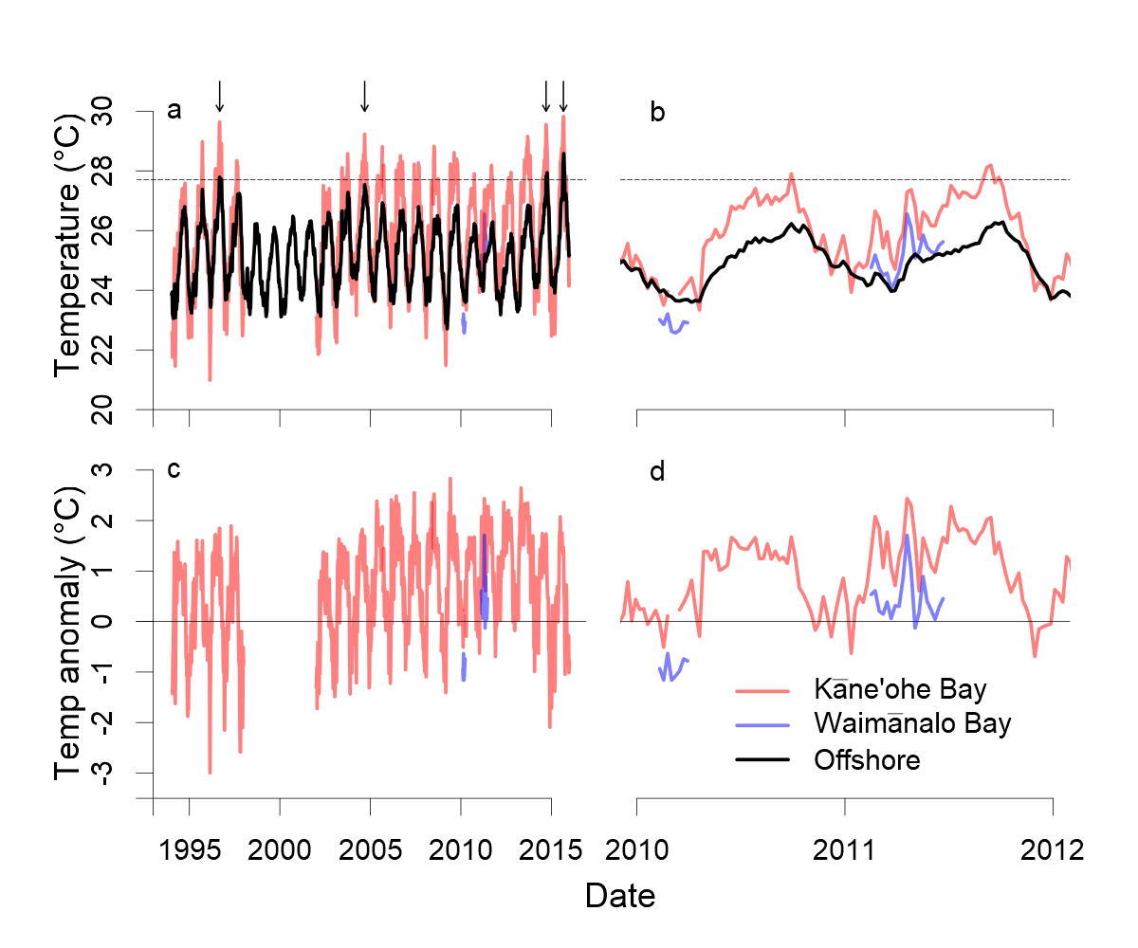

Figure S2. Conceptual diagram illustrating the experimental design used in this study. The three coral species were collected from each of two sites which experience natural differences in seawater pH and temperature. Ten to twelve parent colonies per species were sampled at each site and then given 2.5 months to acclimate to the same environment in flow-through aquaria at the HIMB. After acclimation, one branch per parent colony was randomly allocated to each of the nine environmental treatments (3 Temp×3 pH levels), with two replicate aquaria per environmental treatment, and the corals were exposed to these conditions for three months. See text for details. Photos courtesy of Keoki and Yuko Stender.

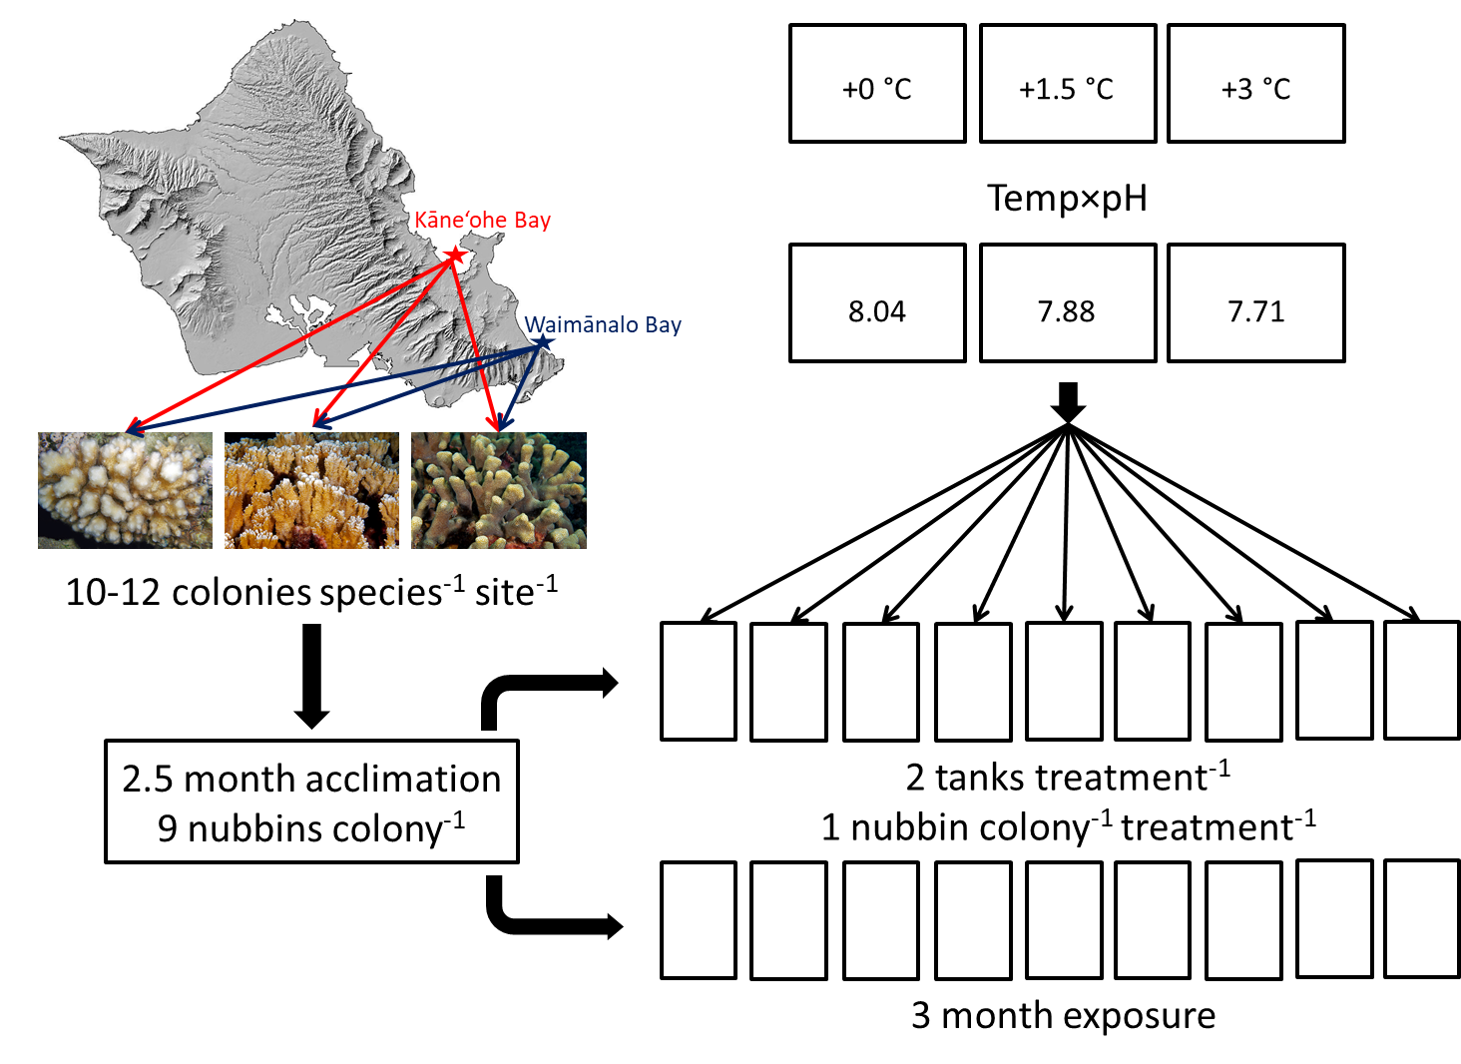

Figure S3. Scatterplot of pH measurements from each aquarium during the 3 month experiment. Two replicate aquaria for each environmental treatment are shown by round and triangular symbols, respectively. pH values shown for morning (daily minimum) (a) and evening (daily maximum) (c) measurements, as well as the mean of these measurements (daily mean pH) (b). Treatments designated according to target temperature (LT = +0°C, MT = +1.5°C, HT = +3°C) and pH (HpH = 8.04, MpH = 7.88, LpH = 7.71).

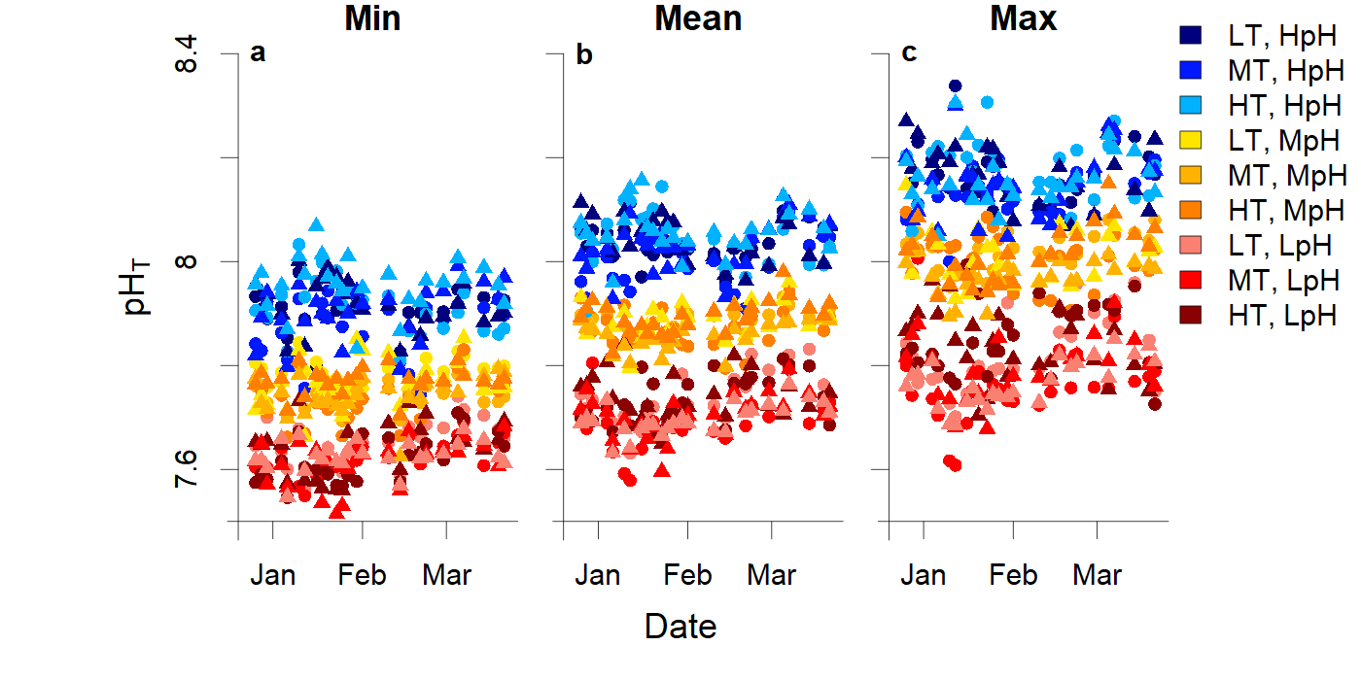
Figure S4. Time-series of measured pH (a) and total alkalinity (TA) (b) as well as calculated pCO₂ (c) and Ω_{arag} (d) from each aquarium during the 24-hr sampling period. Samples were collected Feb. 16-17, 2012, about mid-way through the 3-month experiment, and data are shown according to hour of the day. Grey shading in each plot indicates the nighttime, dark period when aquarium lights were off. Two replicate aquaria for each environmental treatment are shown by round and triangular symbols, respectively. Treatments designated according to target temperature (LT = +0°C, MT = +1.5°C, HT = +3°C) and pH (HpH = 8.04, MpH = 7.88, LpH = 7.71).

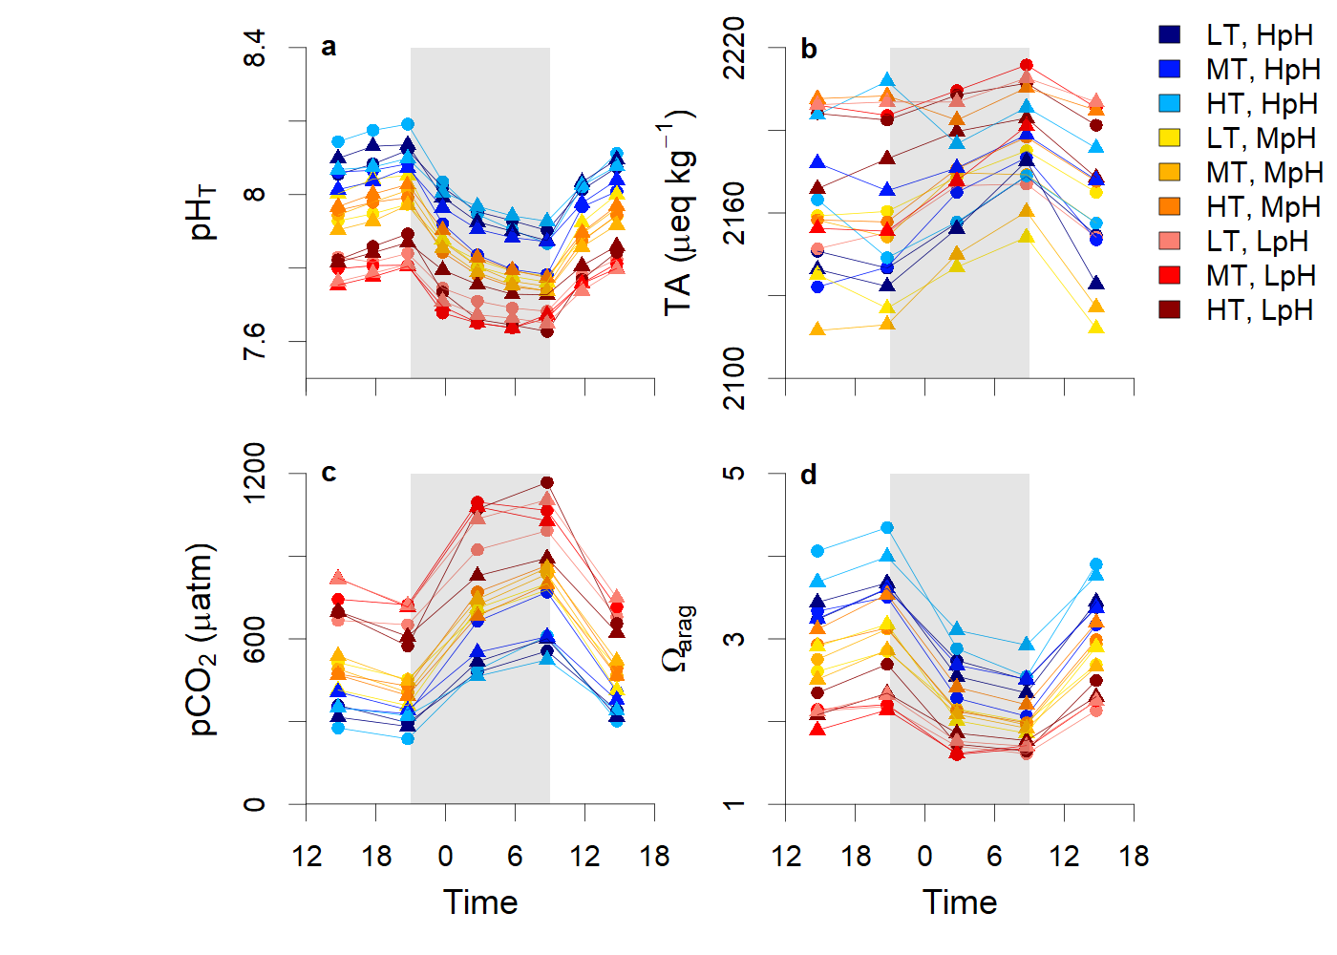

Figure S5. Raw, count data for bleaching and survivorship categories for each coral species and collection location. Lower sample sizes for P. compressa in some treatments are due to predation by the Porites-eating nudibranch Phestilla spp., which were dropped from the analysis.

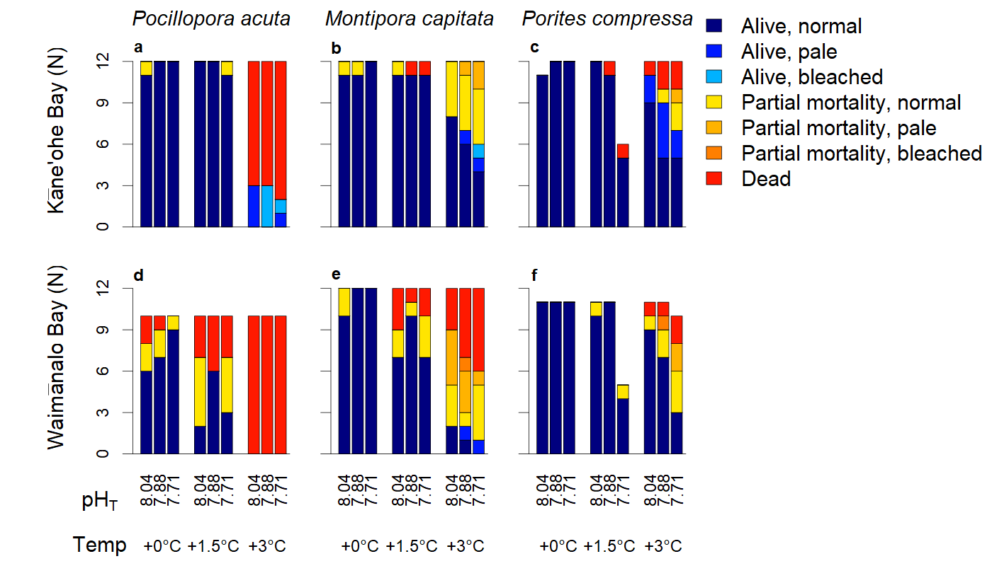

Figure S6. Effects of pH and temperature after 3 months of exposure on calcification rate for the three coral species examined in this study (a-c) when normalized to initial weight (d-f) or surface area (g-i), shown according to collection location, as in Fig 1. Corals which experienced partial mortality or died were excluded from the calcification analysis; data shown for treatments with n = 2-12 survivors. All data reported as mean ± SEM. Photos courtesy of Keoki and Yuko Stender.

