Contents
Figure S1. Cerrado biodiversity hotspot distribution in Brazil (thicker line), the second largest vegetation formation in South America, and the study area location: Itirapina Ecological Station. Map elaborated using DIVA-GIS version 7.5 [1]; Biomes of Brazil shapefile obtained from [2]. 2
Fieldwork Methods 3
Data analyses 3
Table S1. The relationship between total number of species per plot and number of invasive species per plot using a linear model. In total, 300 5x5m plots were sampled,114 in campo sujo and 186 in campo úmido. In both cases there is a significant relationship (Pr(>|t|) in bold). 3
Table S2. Partitioning of total Jaccard dissimilarity (β_{jac}) into turnover (β_{jtu}) and nestedness (β_{jne}) (in relation to the percentage of total Jaccard) calculated with the beta.multi function in the betapart package from R [4,5]. Turnover dominates biodiversity change in all cases in both campo sujo and campo úmido habitats. 3
Table S3. Kruskal-Wallis results of the multiple comparisons of total Jaccard dissimilarity (β_{jac}) between plots with native species only, and plots with 1, 2 or 3 to 4 invasive species in both campo sujo and campo úmido habitats. Bonferroni correction for multiple comparisons was applied. 4
Figure S2. Percentage of occurrence of invasive species (open triangles) and native species (filled circles) in all sampled plots. Each plot that contained one isolated pine (Pinus elliottii) individual (a and c) was paired with one plot with no pines (b and d) in both campo sujo and campo úmido habitats. The three other invasive species present (all grass species) were: Melinis repens, Melinis minutiflora and Urochloa decumbens. Invasive grass species are widespread amongst all conditions. 5
References 5

Figure S1. Cerrado biodiversity hotspot distribution in Brazil (thicker line), the second largest vegetation formation in South America, and the study area location: Itirapina Ecological Station. Map elaborated using DIVA-GIS version 7.5 [1]; Biomes of Brazil shapefile obtained from [2].

Fieldwork Methods
Fieldwork was carried out at the Itirapina Ecological Station (IES), a Protected Area located at the Cerrado biodiversity hotspot (Southeast of Brazil). The non-native pine (Pinus elliottii) is invading two contrasting, botanically distinct habitats in the Itirapina Cerrado: campo sujo and campo úmido. Our survey was in a 7 km² portion at the south of the Conservation Unit. To evaluate the changes in diversity caused by invasion we randomly selected isolated pine trees, placed at the centre of the invaded plot. Each plot with no pines was placed 10m away at a random direction - and at least 10m distant from the nearest pine tree individual. All plots were placed at least 10m away from the tracks that give access to different IES areas, to avoid edge effect disturbance. We recorded all plants present in each plot (incidence data), identified each plant to species (or the lowest taxonomic level possible) and categorized as native or invasive. In total, we sampled 300 5x5m plots (57 with one isolated pine and 57 with no pines in campo sujo and 93 with one isolated pine and 93 with no pines in campo úmido). In total, we recorded 80 plant taxa, belonging to 17 botanical families, of which 76 species are native and four are invasive to Brazil - the pine P. elliottii (slash pine) and three grass species Urochloa decumbens (signal grass, previously named as Brachiaria decumbens), Melinis repens (natal grass) and Melinis minutiflora (molasses grass). These invasive grasses are widespread in Brazil and have also established in the Cerrado [3]. In campo sujo, 37 plots had 1 invasive species, 54 had 2, 16 had 3 to 4 and seven had natives only. In campo úmido, 83 of the sampled plots contained 1 invasive species, 43 plots contained 2, 10 plots contained 3 to 4 and 50 plots contained native species only.

Data analyses
We first modelled the number of invasive species per plot (0 (native species only), 1, 2, 3 or 4) as a predictor of the total number of species per plot. We used the lm function from R to fit the linear model. The graphs were plotted using the plotly package from R [25,26].

Table S1. The relationship between total number of species per plot and number of invasive species per plot using a linear model. In total, 300 5x5m plots were sampled,114 in campo sujo and 186 in campo úmido. In both cases there is a significant relationship (Pr(>|t|) in bold).
Habitat | Predictor | df | Estimate | Standard error | t value | Pr(>|t|) | Multiple R²
campo sujo | Intercept |  | 6.4604 | 0.7124 | 9.069 | 4.65e-15
 | Number of invasive species | 112 | 1.5282 | 0.3720 | 4.108 | 7.63e-05 | 0.1309
campo úmido | Intercept |  | 5.5327 | 0.3003 | 18.423 | < 2e-16
 | Number of invasive species | 184 | 1.7996 | 0.2183 | 8.244 | 3.07e-14 | 0.2697

Table S2. Partitioning of total Jaccard dissimilarity (β_{jac}) into turnover (β_{jtu}) and nestedness (β_{jne}) (in relation to the percentage of total Jaccard) calculated with the beta.multi function in the betapart package from R [4,5]. Turnover dominates biodiversity change in all cases in both campo sujo and campo úmido habitats.
Habitat | Number of invasive species per plot | Turnover | Nestedness | Total Jaccard
campo sujo | 1 Invasive spp | 97.6 | 2.4 | 100
 | 2 Invasive spp | 98.2 | 1.8 | 100
 | 3 to 4 Invasive spp | 97.3 | 2.7 | 100
 | Natives only | 77.4 | 22.6 | 100
campo úmido | 1 Invasive spp | 99.2 | 0.9 | 100
 | 2 Invasive spp | 98.0 | 1.9 | 100
 | 3 to 4 Invasive spp | 90.4 | 9.6 | 100
 | Natives only | 98.3 | 1.7 | 100

Table S3. Kruskal-Wallis results of the multiple comparisons of total Jaccard dissimilarity (β_{jac}) between plots with native species only, and plots with 1, 2 or 3 to 4 invasive species in both campo sujo and campo úmido habitats. Bonferroni correction for multiple comparisons was applied.
Habitat | Comparison | P-value
campo sujo | Natives only v. 1 invasive | 0.44
 | 1 invasive v. 2 invasives | < 2.2e-16
 | 2 invasives v. 3-4 invasives | < 2.2e-16
 | Natives only v. 2 invasives | 0.00083
 | Natives only v. 3-4 invasives | 1.4e-08
 | 1 invasive v. 3-4 invasives | < 2.2e-16
campo úmido | Natives only v. 1 invasive | 0.015
 | 1 invasive v. 2 invasives | < 2.2e-16
 | 2 invasives v. 3-4 invasives | 3.6e-12
 | Natives only v. 2 invasives | < 2.2e-16
 | Natives only v. 3-4 invasives | < 2.2e-16
 | 1 invasive v. 3-4 invasives | < 2.2e-16

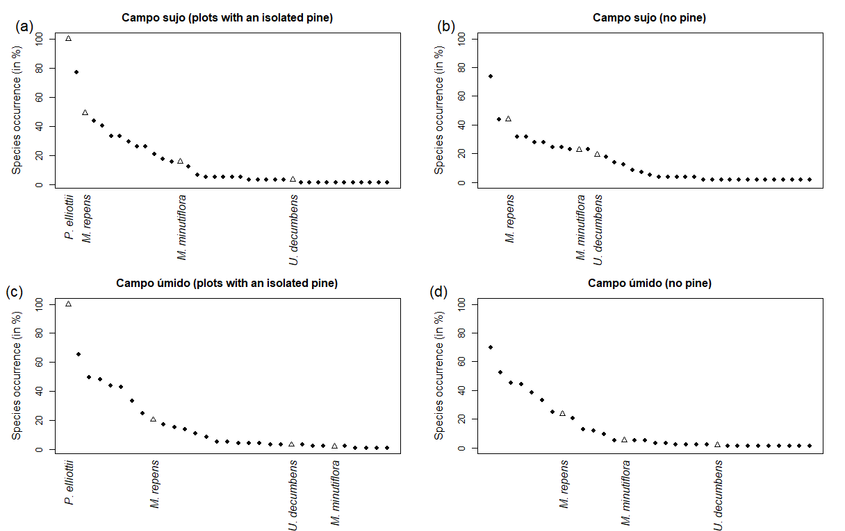

Figure S2. Percentage of occurrence of invasive species (open triangles) and native species (filled circles) in all sampled plots. Each plot that contained one isolated pine (Pinus elliottii) individual (a and c) was paired with one plot with no pines (b and d) in both campo sujo and campo úmido habitats. The three other invasive species present (all grass species) were: Melinis repens, Melinis minutiflora and Urochloa decumbens. Invasive grass species are widespread amongst all conditions.

References
1. Hijmans RJ, Guarino L, Mathur P. 2012 DIVA-GIS. Version 7.5. A geographic information system for the analysis of species distribution data.
2. MMA. 2017 Download de dados geográficos (Geographic data download). Ministério do Meio Ambient. See http://mapas.mma.gov.br/i3geo/datadownload.htm (accessed on 1 May 2017).
3. Zenni RD, Ziller SR. 2011 An overview of invasive plants in Brazil. Rev. Bras. Botânica 34, 431–446. (doi:10.1590/S0100-84042011000300016)
4. RCoreTeam. 2014 R: A Language and Environment for Statistical Computing Foundation for Statistical Computing, Vienna).
5. Baselga A, Orme CDL. 2012 Betapart: An R package for the study of beta diversity. Methods Ecol. Evol. 3, 808–812. (doi:10.1111/j.2041-210X.2012.00224.x)

