SUPPLEMENTARY MATERIAL
Böhmer et al.: “Correlated Evolution of Neck Length and Leg Length in Birds”

Content:
Supplementary text 1: Material and methods - Study specimens

Figure S1: Measurements.
Figure S2: Neck length and feeding technique in birds.
Figure S3: Neck length, vertebra length, and cervical count in birds.
Figure S4: Variation in leg bone length.

Table S1: Data.
Table S2: Explanation of the ecological categories.
Table S3: Cervical count in birds.

Supplementary material references

Supplementary text 1: Material and methods - Study specimens
The neck in birds is used for a variety of tasks, but feeding behavior certainly plays a major role since it is an important factor for the survival of a species. Since categorizing ecology can be difficult and some taxa may not perform exclusively one type of behavior, the most typical category was selected. For instance, the southern rockhopper penguin (Eudyptes chrysocome) feeds prevalently on invertebrates (diet) below the water surface (foraging) and catches its food items by pursuit diving (feeding technique). In contrast, the griffon vulture (Gyps fulvus) scavenges prevalently on vertebrates and fish (diet) on the ground (foraging) and gets its food items by ripping (feeding technique).

Figure S1: Measurements. Photographs illustrate the taken measurements on (a) the cervical vertebrae (ce = centrum length; Gavia arctica, MNHN MO-AC 1992-9, in dorsal view) and (b) three long bones of the hindlimb (fe = femur, ti = tibiotarsus, ta = tarsometatarsus; Otis tarda, MNHN 1875-784, in anterior view). The functional vertebral length was measured using (c, d) a digital caliper with larger or smaller accessory pins depending on the size of the vertebrae (adapted from Taylor and Wedel [1]). Abbreviation: MNHN = Muséum National d’Histoire Naturelle in Paris.
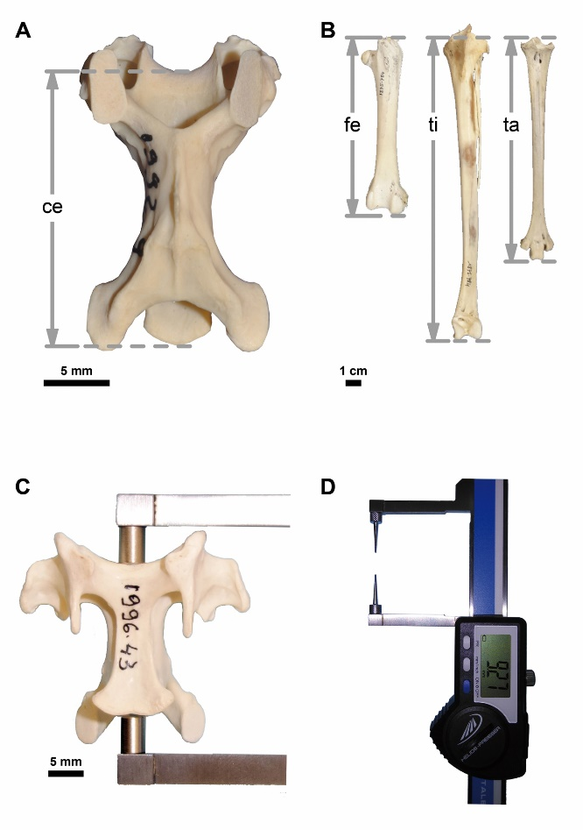

Figure S2: Neck length and feeding technique in birds. There appears to be a trend towards having a rather short neck in relation to total leg length in cracker, forager, gleaner, and ripper. The other feeding technique categories are more variable, but browser, plunge-diver, and striker include the longest-necked taxa. Refer to table S2 for explanation of ecological categories.
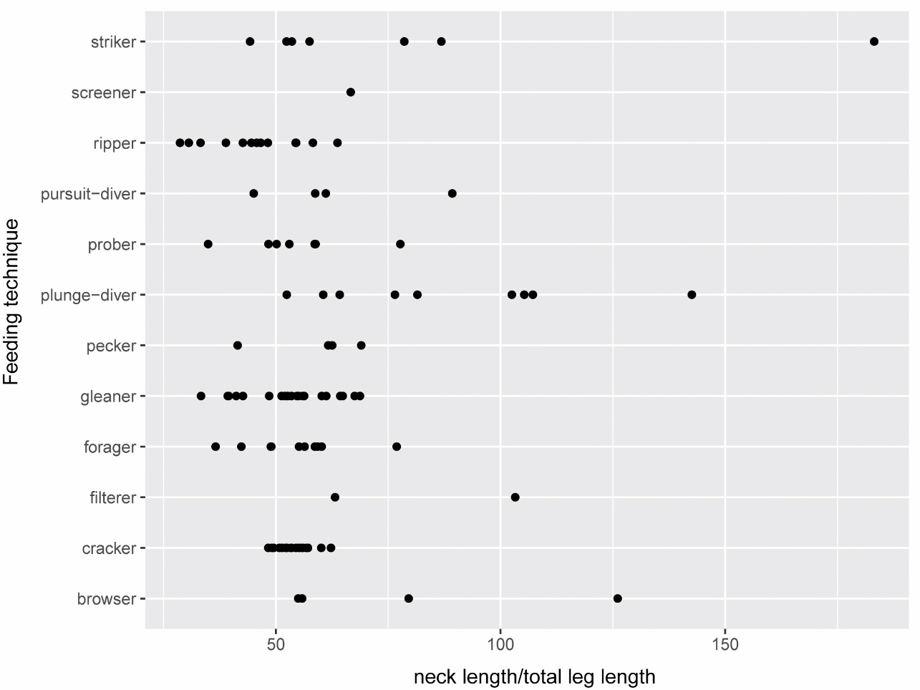

Figure S3: Neck length, vertebra length, and cervical count in birds. The higher the cervical count, the shorter the central vertebra in relation to neck length.

Figure S4: Variation in leg bone length. Boxplot showing the variance of the obtained log-transformed variables (femur lengt, tibiotarsus length, tarsometatarsus length).
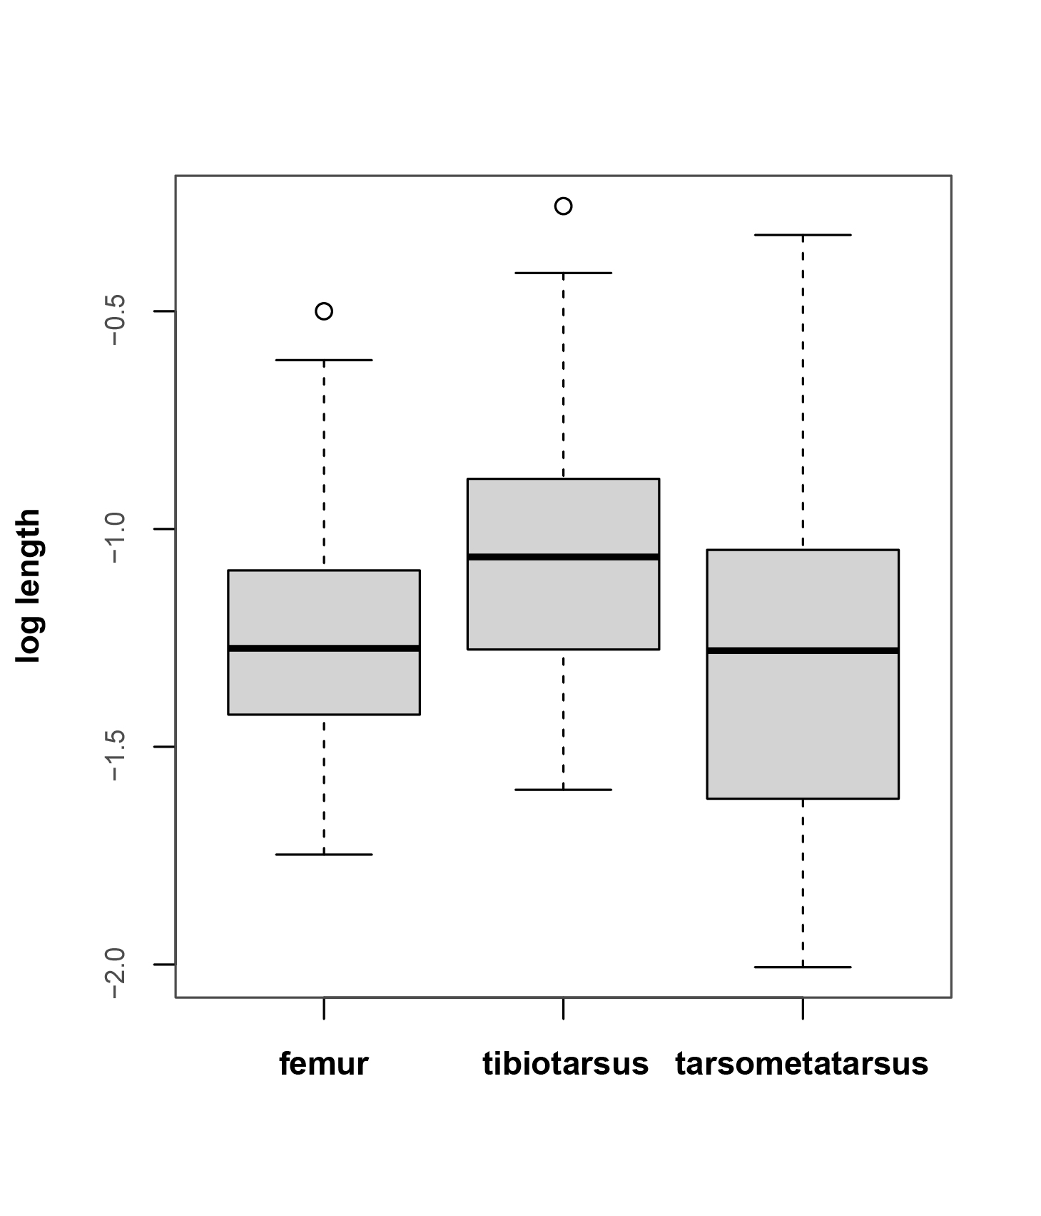

Supplementary Table S1: Data. A total of 103 extant avian species comprising 34 orders and 68 families were sampled from the bird collection of the Muséum National d’Histoire Naturelle in Paris. Taxa were chosen to comprise a large range in body mass, a wide phylogenetic scope representing most major clades, and a broad spectrum of lifestyles. Based on trait values compiled by Wilman, H., Belmaker, J., et al. (2014) and information collected from the literature, each taxon in the present study was assigned to one group of the following ecological categories: diet, foraging, body mass, and feeding technique (Refer to table 1 for explanation of the categories). Diet includes five categories and taxa are assigned to one dominant diet category (Wilman et al. 2014). Foraging (10 categories) refers to the substrate where food is taken (Wilman et al. 2014). Body mass is classified into six body mass bins. Feeding technique (12 categories) refers to the manner in which a food item is obtained (de Graaf et al. 1985) with special focus on techniques that involve the neck.
Order | Taxon | Diet | Forarging | Body mass bin | Feeding technique
Accipitriformes | Aquila chrysaetos | VertFishScav | ForStrat.ground | 4000-12000 | ripper
Accipitriformes | Coragyps atratus | VertFishScav | ForStrat.ground | 1000-4000 | cracker
Accipitriformes | Gypaetus barbatus | VertFishScav | ForStrat.ground | 4000-12000 | ripper
Accipitriformes | Gyps fulvus | VertFishScav | ForStrat.ground | 4000-12000 | ripper
Accipitriformes | Gyps rueppellii | VertFishScav | ForStrat.ground | 4000-12000 | ripper
Accipitriformes | Neophron percnopterus | VertFishScav | ForStrat.ground | 1000-4000 | ripper
Accipitriformes | Pandion haliaetus | VertFishScav | ForStrat.wataroundsurf | 1000-4000 | ripper
Accipitriformes | Sagittarius serpentarius | Invertebrate | ForStrat.ground | 4000-12000 | ripper
Accipitriformes | Sarcoramphus papa | VertFishScav | ForStrat.ground | 1000-4000 | ripper
Accipitriformes | Vultur gryphus | VertFishScav | ForStrat.ground | 4000-12000 | ripper
Anseriformes | Anas acuta | PlantSeed | ForStrat.watbelowsurf | 100-1000 | filterer
Anseriformes | Anseranas semipalmata | PlantSeed | ForStrat.ground | 1000-4000 | browser
Anseriformes | Chauna chavaria | PlantSeed | ForStrat.ground | 1000-4000 | browser
Anseriformes | Cygnus olor | PlantSeed | ForStrat.watbelowsurf | 4000-12000 | browser
Apodiformes | Apus apus | Invertebrate | ForStrat.aerial | 10-40 | screener
Apterygiformes | Apteryx mantelli | Invertebrate | ForStrat.ground | 1000-4000 | prober
Bucerotiformes | Anorrhinus galeritus | FruiNect | ForStrat.midhigh | 1000-4000 | gleaner
Bucerotiformes | Upupa epops | Invertebrate | ForStrat.ground | 40-100 | prober
Caprimulgiformes | Caprimulgus europaeus | Invertebrate | ForStrat.understory | 40-100 | gleaner
Cariamiformes | Cariama cristata | Invertebrate | ForStrat.ground | 1000-4000 | gleaner
Casuariiformes | Casuarius casuarius | FruiNect | ForStrat.ground | >12000 | gleaner
Casuariiformes | Dromaius novaehollandiae | Omnivore | ForStrat.understory | >12000 | forager
Charadriiformes | Burhinus oedicnemus | Omnivore | ForStrat.ground | 100-1000 | forager
Charadriiformes | Catharacta skua | VertFishScav | ForStrat.wataroundsurf | 1000-4000 | ripper
Charadriiformes | Glareola pratincola | Invertebrate | ForStrat.ground.under.mid | 40-100 | gleaner
Charadriiformes | Haematopus ostralegus | Invertebrate | ForStrat.ground | 100-1000 | prober
Charadriiformes | Himantopus himantopus | Invertebrate | ForStrat.wataroundsurf | 100-1000 | prober
Charadriiformes | Larus glaucescens | VertFishScav | ForStrat.wataroundsurf | 1000-4000 | plunge-diver
Charadriiformes | Pluvialis apricaria | Invertebrate | ForStrat.ground | 100-1000 | gleaner
Charadriiformes | Scolopax rusticola | Invertebrate | ForStrat.ground | 100-1000 | prober
Charadriiformes | Uria lomvia | VertFishScav | ForStrat.watbelowsurf | 100-1000 | pursuit-diver
Charadriiformes | Vanellus vanellus | Invertebrate | ForStrat.ground | 100-1000 | gleaner
Ciconiiformes | Ciconia ciconia | VertFishScav | ForStrat.ground | 1000-4000 | striker
Columbiformes | Columba livia | PlantSeed | ForStrat.ground | 100-1000 | gleaner
Coraciiformes | Baryphthengus ruficapillus | Invertebrate | ForStrat.ground | 100-1000 | gleaner
Coraciiformes | Megaceryle torquata | VertFishScav | ForStrat.watbelowsurf | 100-1000 | plunge-diver
Coraciiformes | Merops apiaster | Invertebrate | ForStrat.midhigh | 40-100 | gleaner
Eurypygiformes | Eurypyga helias | VertFishScav | ForStrat.ground | 100-1000 | striker
Eurypygiformes | Rhynochetos jubatus | VertFishScav | ForStrat.ground | 100-1000 | striker
Falconiformes | Caracara plancus | VertFishScav | ForStrat.ground | 1000-4000 | ripper
Galliformes | Gallus gallus | Omnivore | ForStrat.ground | 100-1000 | forager
Galliformes | Megapodius cumingii | Invertebrate | ForStrat.ground | 1000-4000 | gleaner
Galliformes | Mitu tuberosum | FruiNect | ForStrat.ground | 1000-4000 | gleaner
Galliformes | Numida meleagris | PlantSeed | ForStrat.ground | 1000-4000 | forager
Gaviiformes | Gavia arctica | VertFishScav | ForStrat.wataroundsurf | 1000-4000 | pursuit-diver
Gruiformes | Aramides cajanea | Omnivore | ForStrat.ground | 100-1000 | gleaner
Gruiformes | Gallirallus australis | Omnivore | ForStrat.ground | 100-1000 | forager
Gruiformes | Grus grus | PlantSeed | ForStrat.ground | 4000-12000 | striker
Musophagiformes | Tauraco corythaix | FruiNect | ForStrat.midhigh | 100-1000 | gleaner
Opisthocomiformes | Opisthocomus hoazin | PlantSeed | ForStrat.midhigh | 100-1000 | browser
Otidiformes | Otis tarda | Omnivore | ForStrat.ground | 4000-12000 | forager
Passeriformes | Bombycilla garrulus | Omnivore | ForStrat.under.mid | 40-100 | forager
Passeriformes | Calyptomena viridis | FruiNect | ForStrat.understory | 40-100 | gleaner
Passeriformes | Corvus corax | VertFishScav | ForStrat.ground | 100-1000 | forager
Passeriformes | Falculea palliata | Invertebrate | ForStrat.midhigh | 100-1000 | prober
Passeriformes | Oriolus oriolus | Omnivore | ForStrat.canopy | 40-100 | forager
Pelecaniformes | Ardea cinerea | VertFishScav | ForStrat.wataroundsurf | 1000-4000 | striker
Pelecaniformes | Geronticus eremita | Omnivore | ForStrat.ground | 1000-4000 | prober
Pelecaniformes | Pelecanus crispus | VertFishScav | ForStrat.watbelowsurf | 4000-12000 | plunge-diver
Pelecaniformes | Scopus umbretta | VertFishScav | ForStrat.wataroundsurf | 100-1000 | striker
Phaethontiformes | Phaethon aethereus | VertFishScav | ForStrat.watbelowsurf | 100-1000 | plunge-diver
Phoenicopteriformes | Phoenicopterus ruber | Omnivore | ForStrat.wataroundsurf | 1000-4000 | filterer
Piciformes | Andigena nigrirostris | Omnivore | ForStrat.canopy | 100-1000 | forager
Piciformes | Dendrocopos major | Omnivore | ForStrat.under.mid.canopy | 40-100 | pecker
Piciformes | Dendrocopos medius | Invertebrate | ForStrat.under.mid.canopy | 40-100 | pecker
Piciformes | Dryocopus martius | Invertebrate | ForStrat.ground.under.mid | 100-1000 | pecker
Piciformes | Lybius dubius | FruiNect | ForStrat.midhigh | 40-100 | gleaner
Piciformes | Picus viridis | Invertebrate | ForStrat.ground | 100-1000 | pecker
Podicipediformes | Podiceps cristatus | VertFishScav | ForStrat.watbelowsurf | 100-1000 | plunge-diver
Procellariiformes | Calonectris diomedea | VertFishScav | ForStrat.wataroundsurf | 100-1000 | plunge-diver
Procellariiformes | Thalassarche melanophrys | Omnivore | ForStrat.wataroundsurf | 1000-4000 | plunge-diver
Psittaciformes | Amazona amazonica | FruiNect | ForStrat.under.mid.canopy | 100-1000 | cracker
Psittaciformes | Amazona autumnalis | FruiNect | ForStrat.under.mid.canopy | 100-1000 | cracker
Psittaciformes | Amazona dufresniana | Omnivore | ForStrat.midhigh | 100-1000 | cracker
Psittaciformes | Amazona vinacea | PlantSeed | ForStrat.under.mid.canopy | 100-1000 | cracker
Psittaciformes | Anodorhynchus hyacinthinus | FruiNect | ForStrat.midhigh | 1000-4000 | cracker
Psittaciformes | Aprosmictus erythropterus | Omnivore | ForStrat.under.mid | 100-1000 | cracker
Psittaciformes | Ara ararauna | PlantSeed | ForStrat.midhigh | 1000-4000 | cracker
Psittaciformes | Ara macao | PlantSeed | ForStrat.midhigh | 1000-4000 | cracker
Psittaciformes | Ara militaris | FruiNect | ForStrat.midhigh | 1000-4000 | cracker
Psittaciformes | Charmosyna pulchella | FruiNect | ForStrat.canopy | 10-40 | cracker
Psittaciformes | Coracopsis nigra | FruiNect | ForStrat.under.mid | 100-1000 | gleaner
Psittaciformes | Cyanoliseus patagonus | PlantSeed | ForStrat.ground | 100-1000 | cracker
Psittaciformes | Deroptyus accipitrinus | PlantSeed | ForStrat.under.mid.canopy | 100-1000 | cracker
Psittaciformes | Lorius garrulus | FruiNect | ForStrat.canopy | 100-1000 | cracker
Psittaciformes | Platycercus elegans | PlantSeed | ForStrat.midhigh | 100-1000 | cracker
Psittaciformes | Platycercus eximius | PlantSeed | ForStrat.ground.under.mid | 100-1000 | cracker
Psittaciformes | Poicephalus gulielmi | PlantSeed | ForStrat.midhigh | 100-1000 | cracker
Psittaciformes | Poicephalus robustus | FruiNect | ForStrat.midhigh | 100-1000 | cracker
Psittaciformes | Poicephalus senegalus | PlantSeed | ForStrat.midhigh | 100-1000 | cracker
Psittaciformes | Psittacula krameri | FruiNect | ForStrat.ground.under.mid | 100-1000 | cracker
Psittaciformes | Psittacus erithacus | Omnivore | ForStrat.canopy | 100-1000 | cracker
Pteroclidiformes | Pterocles quadricinctus | PlantSeed | ForStrat.ground | 100-1000 | gleaner
Rheiformes | Rhea americana | Omnivore | ForStrat.ground | >12000 | forager
Sphenisciformes | Eudyptes chrysocome | Invertebrate | ForStrat.watbelowsurf | 1000-4000 | pursuit-diver
Strigiformes | Bubo bubo | VertFishScav | ForStrat.ground | 1000-4000 | ripper
Strigiformes | Tyto alba | VertFishScav | ForStrat.ground | 100-1000 | ripper
Struthioniformes | Struthio camelus | PlantSeed | ForStrat.ground | >12000 | gleaner
Suliformes | Anhinga melanogaster | VertFishScav | ForStrat.watbelowsurf | 1000-4000 | striker
Suliformes | Fregata ariel | VertFishScav | ForStrat.wataroundsurf | 100-1000 | plunge-diver
Suliformes | Morus bassanus | VertFishScav | ForStrat.watbelowsurf | 1000-4000 | plunge-diver
Suliformes | Phalacrocorax verrucosus | Omnivore | ForStrat.watbelowsurf | 1000-4000 | pursuit-diver
Tinamiformes | Crypturellus cinereus | FruiNect | ForStrat.ground | 100-1000 | gleaner

Supplementary Table S2: Explanation of the ecological categories. Each taxon in the present study was assigned to one group of the following categories based on trait values compiled by Wilman et al. (2014) [2] and information collected from the literature. Diet includes five categories and taxa are assigned to one dominant diet category [2]. Foraging (10 categories) refers to the substrate where food is taken [2]. Feeding technique (12 categories) refers to the manner in which a food item is obtained [3] with special focus on techniques that involve the neck.
Category | Trait & description
Diet | FruitNectar | PlantSeed | VertFishScav | Invert | Omnivore
 | fruits and nectar | plant and seeds | vertebrates, fish, carrion | invertebrates | omnivore
Foraging | watbelow | wataround | ground | understory | midhigh
 | below water surface | on or just (<5 inches) below water surface | ground | below 2m in understory in forest, forest edges, bushes or shrubs | mid to high levels in trees or high bushes (2m upward), but below canopy
Foraging | ground.under.mid | under.mid | under.mid.canopy | canopy | aerial
 | ground, understory, and midhigh | understory and midhigh | understory, midhigh, and canopy | in or just above (from) tree canopy | well above vegetation or any structures
Feeding technique | browser | cracker | filterer | forager | gleaner
 | feeds on plants | cracks open seeds or nuts | filters food items from water | takes almost any food items encountered upon the substrate | selects particular food items from the substrate
Feeding technique | pecker | plunge-diver | prober | pursuit-diver | ripper
 | drilles holes into trees | plunges from air into water | inserts the bill into the substrate | dives from water surface for underwater food | tears prey into pieces
Feeding technique | screener | striker
 | flies with bill open and screens prey from air | straightens neck to strike with bill very fast

Supplementary Table S3: Cervical count in birds. The present study includes a sample of 103 extant avian species comprising 34 orders and 68 families. They are pooled into seven taxonomic groups. The group “other Neoaves” includes all sampled neoavian birds excluding Aequornithes, Charadriiformes, Telluraves and Australaves.
Taxonomic group | number of taxa | total number of cervical vertebrae
 |  | mean | max. | min.
Aves | 103 | 13 | 23 | 10
Palaeognathae | 6 | 16 | 18 | 14
Galloanseriformes | 8 | 16 | 23 | 14
other Neoaves | 15 | 14 | 19 | 11
Aequornithes | 13 | 14 | 18 | 12
Charadriiformes | 10 | 13 | 14 | 12
Telluraves | 24 | 13 | 15 | 11
Australaves | 27 | 11 | 13 | 10

Supplementary Table S4: Obtained data. ID = specimen identficiation number. MNHN ZO = Muséum National d’Histoire Naturelle Paris Zoological Collection; BMNH = British Museum of Natural History London. Mean body mass (BM) estimates for each of the bird species were obtained from the literature [17]. All other measurements were log-transformed for subsequent analyses. Total leg length (tll) is the sum of the lengths of femur, tibiotarsus, and tarsometarsus. Total neck length (neck) is the sum of all vertebral lengths. The central vertebra is identified by dividing the cervical vertebral column into two parts. Refer to the material & methods section of the main manuscript for more details.
Taxon | ID |  | log_BM^{1/3} | log_tll | log_femur | log_tibiotarsus | log_tarsometatarsus | log_neck | log_central vertebra
Amazona amazonica | MNHN ZO | 2009-833 | -0.13874488 | -0.92705197 | -1.36713796 | -1.251192 | -1.71511829 | -1.17018181 | -2.1260984
Amazona autumnalis | MNHN ZO | 2000-262 | -0.13282774 | -0.92223251 | -1.37099838 | -1.24169382 | -1.70487292 | -1.20502426 | -2.14935377
Amazona dufresniana | MNHN ZO | 2004-198 | -0.08707315 | -0.82663888 | -1.27425167 | -1.1437546 | -1.61870438 | -1.08465294 | -2.04143612
Amazona vinacea | MNHN ZO | 2000-250 | -0.13931221 | -0.89715484 | -1.34543845 | -1.21190237 | -1.69486368 | -1.14923127 | -2.08990945
Anas acuta | MNHN ZO | 1986-35 | -0.02352703 | -0.82739707 | -1.38774609 | -1.16761884 | -1.39935376 | -0.81341091 | -1.88605665
Andigena nigrirostris | MNHN ZO | 1986-38 | -0.1515643 | -0.7540927 | -1.29946934 | -1.11339649 | -1.31015859 | -0.97465317 | -1.93255716
Anhinga melanogaster | MNHN ZO | 1883.543 | 0.05243521 | -0.72642005 | -1.24283181 | -1.06419055 | -1.35340025 | -0.46351731 | -1.75970042
Anodorhynchus hyacinthinus | MNHN ZO | 1999-144 | 0.06483811 | -0.68742071 | -1.1490476 | -1.01908806 | -1.41184038 | -0.99636716 | -1.95781841
Anorrhinus galeritus | MNHN ZO | 2000-302 | 0.02524313 | -0.65253337 | -1.15384852 | -1.00291957 | -1.27515091 | -0.84420865 | -1.8431481
Anseranas semipalmata | MNHN ZO | 2004-151 | 0.14905268 | -0.50912892 | -1.09065796 | -0.86157098 | -1.0411973 | -0.60851796 | -1.74208155
Aprosmictus erythropterus | MNHN ZO | 1997-925 | -0.26895847 | -1.00872961 | -1.48905305 | -1.32938311 | -1.72723041 | -1.21459898 | -2.17717836
Apteryx mantelli | BMNH | 17-01-72-1 | 0.16610352 | -0.54060751 | -1.03971954 | -0.89469424 | -1.15926677 | -0.84034259 | -1.90274269
Apus apus | MNHN ZO | 1997-995 | -0.46065063 | -1.27115943 | -1.74787545 | -1.59894427 | -1.97839728 | -1.44733178 | -2.45842076
Aquila chrysaetos | MNHN ZO | 2013-362 | 0.18920481 | -0.45974563 | -0.88883834 | -0.88880472 | -1.0526153 | -0.83003183 | -1.78277934
Ara ararauna | MNHN ZO | 1995-233 | 0.02487787 | -0.75631719 | -1.21211465 | -1.0835987 | -1.50293206 | -1.06308432 | -1.96940028
Ara macao | MNHN ZO | 1995-262 | 0.0257893 | -0.7654321 | -1.21896306 | -1.09685573 | -1.50570623 | -1.02420069 | -1.97633608
Ara militaris | MNHN ZO | 2011-357 | 0.00747612 | -0.78528858 | -1.24139086 | -1.11565785 | -1.52331326 | -1.05700041 | -2.01954211
Aramides cajanea | MNHN ZO | 1880-1395 | -0.12977995 | -0.58986414 | -1.09974214 | -0.9515582 | -1.18151018 | -0.84218072 | -1.85636077
Ardea cinerea | MNHN ZO | 1993-103 | 0.06311664 | -0.36468719 | -1.06419055 | -0.70289635 | -0.83159092 | -0.42604981 | -1.53003079
Baryphthengus ruficapillus | MNHN ZO | 1997-920 | -0.27904567 | -0.92554928 | -1.46382047 | -1.28785559 | -1.48425858 | -1.20460667 | -2.19246497
Bombycilla garrulus | MNHN ZO | 2010-115 | -0.40849435 | -1.12627262 | -1.64569944 | -1.47172622 | -1.73494621 | -1.43640027 | -2.29843202
Bubo bubo | MNHN ZO | 2000-343 | 0.14418949 | -0.48359685 | -0.99744519 | -0.83129632 | -1.09506817 | -0.96237433 | -1.8951716
Burhinus oedicnemus | MNHN ZO | 2009-801 | -0.12819202 | -0.66786464 | -1.30469348 | -1.04157947 | -1.12842706 | -1.10474325 | -2.07883395
Calonectris diomedea | MNHN ZO | 2004-413 | -0.0634801 | -0.71586266 | -1.32873457 | -1.05963295 | -1.23440595 | -0.93386051 | -1.91865269
Calyptomena viridis | MNHN ZO | 1997-886 | -0.41344405 | -1.0790944 | -1.55021315 | -1.39891827 | -1.81616096 | -1.32873457 | -2.25181197
Caprimulgus europaeus | MNHN ZO | 1995-250 | -0.36837678 | -1.14593699 | -1.64149409 | -1.49322446 | -1.78225293 | -1.41805034 | -2.33724217
Caracara plancus | MNHN ZO | 1979-107 | -0.01630181 | -0.55171117 | -1.14898639 | -0.94237193 | -1.01963297 | -0.96213544 | -1.9710223
Cariama cristata | MNHN ZO | 1934-614 | 0.05869709 | -0.29682904 | -1.07644514 | -0.65091683 | -0.70421306 | -0.70031841 | -1.72078949
Casuarius casuarius | MNHN ZO | 1947-72 | 0.58780933 | -0.02181948 | -0.61261017 | -0.41228904 | -0.49485002 | -0.42772102 | -1.57202729
Catharacta skua | MNHN ZO | 2000-344 | 0.04870935 | -0.6474509 | -1.23143589 | -1.00256993 | -1.17334221 | -0.91108465 | -1.91115544
Charmosyna pulchella | MNHN ZO | 1997-936 | -0.51005933 | -1.27197105 | -1.73660067 | -1.59756665 | -2.00612309 | -1.51769823 | -2.44733178
Chauna chavaria | MNHN ZO | 1921-255 | 0.16610352 | -0.37860559 | -0.99714307 | -0.72955409 | -0.88223171 | -0.63859328 | -1.77624455
Ciconia ciconia | MNHN ZO | 1997-940 | 0.17501494 | -0.24621018 | -0.99580764 | -0.58502665 | -0.68550077 | -0.52730205 | -1.59057413
Columba livia | MNHN ZO | 1876-642 | -0.18954541 | -0.7503859 | -1.25235518 | -1.10507502 | -1.36421476 | -0.93835907 | -1.92118082
Coracopsis nigra | MNHN ZO | 1883-507 | -0.19225138 | -0.94351441 | -1.43027505 | -1.25531594 | -1.67345933 | -1.16392919 | -2.1090204
Coragyps atratus | MNHN ZO | 1923-13 | 0.05127162 | -0.54059243 | -1.10056255 | -0.87817762 | -1.11747546 | -0.82985568 | -1.86934465
Corvus corax | MNHN ZO | 1997-949 | 0.03714352 | -0.60216424 | -1.1534155 | -0.95459878 | -1.16316971 | -0.97576069 | -1.9175737
Crypturellus cinereus | MNHN ZO | 2004-187 | -0.12050358 | -0.69024212 | -1.20252471 | -1.08202212 | -1.23254728 | -0.94962024 | -2.05453142
Cyanoliseus patagonus | MNHN ZO | 1996-26 | -0.1845394 | -0.905459 | -1.37365963 | -1.23121395 | -1.63264408 | -1.19962665 | -2.1260984
Cygnus olor | MNHN ZO | MNHN1871-420 | 0.34447459 | -0.29551488 | -0.95726702 | -0.55268689 | -0.93572925 | -0.19486631 | -1.48691564
Dendrocopos major | MNHN ZO | 2000-283 | -0.35857357 | -1.19702115 | -1.71624662 | -1.58419227 | -1.73849923 | -1.35822853 | -2.31875876
Dendrocopos medius | MNHN ZO | 1997-526 | -0.36563667 | -1.05276239 | -1.58502665 | -1.42724454 | -1.59911678 | -1.43497907 | -2.33348202
Deroptyus accipitrinus | MNHN ZO | 1997-433 | -0.20361131 | -0.95967462 | -1.42296801 | -1.28299559 | -1.70223949 | -1.22366209 | -2.17783192
Dromaius novaehollandiae | MNHN ZO | 1897-89 | 0.58655595 | -0.03007181 | -0.6838199 | -0.42481216 | -0.45593196 | -0.25824192 | -1.48386142
Dryocopus martius | MNHN ZO | 2013-344 | -0.18847703 | -0.88779731 | -1.37923951 | -1.28449806 | -1.44635966 | -1.09178315 | -2.02918839
Eudyptes chrysocome | MNHN ZO | 1997-112 | 0.15413267 | -0.73776255 | -1.19395576 | -1.02951365 | -1.59345982 | -0.9516359 | -1.95116991
Eurypyga helias | MNHN ZO | 1869-396 | -0.24194738 | -0.78036309 | -1.44105155 | -1.12101888 | -1.26825012 | -0.88505558 | -1.89448982
Falculea palliata | MNHN ZO | 1883-531 | -0.31628249 | -0.96509093 | -1.5182708 | -1.33059013 | -1.50390101 | -1.19708951 | -2.15552282
Fregata ariel | MNHN ZO | 1997-178 | -0.04164625 | -0.92800759 | -1.37809704 | -1.23210238 | -1.75547549 | -0.9056337 | -1.88472241
Gallirallus australis | MNHN ZO | 1870-182 | -0.01638285 | -0.61459037 | -1.11970101 | -0.97138809 | -1.22061999 | -0.84618514 | -1.86486735
Gallus gallus | MNHN ZO | 1893-232 | 0.0085718 | -0.44070397 | -0.98733147 | -0.82364824 | -0.96082392 | -0.68954036 | -1.72307887
Gavia arctica | MNHN ZO | 1992-9 | 0.12368929 | -0.60537324 | -1.36071277 | -0.90423804 | -1.09772508 | -0.9516359 | -1.65915945
Geronticus eremita | MNHN ZO | 1997-750 | 0.05408854 | -0.58377568 | -1.16647042 | -0.92223251 | -1.13679614 | -0.81423127 | -1.86486735
Glareola pratincola | MNHN ZO | 2009-803 | 0.01046949 | -1.05222329 | -1.6367642 | -1.4205594 | -1.55877633 | -1.42227848 | -2.39040559
Grus grus | MNHN ZO | 1997-102 | 0.24939601 | -0.16857818 | -0.88840148 | -0.53209605 | -0.59294919 | -0.40904677 | -1.47586362
Gypaetus barbatus | MNHN ZO | 1992-2 | 0.254476 | -0.45069014 | -0.95506845 | -0.81559252 | -1.04359143 | -0.79056542 | -1.79997073
Gyps fulvus | MNHN ZO | 1996-43 | 0.254476 | -0.35310638 | -0.85328296 | -0.7212464 | -0.94573176 | -0.54890469 | -1.62451929
Gyps rueppellii | MNHN ZO | 1997-948 | 0.29920903 | -0.33136253 | -0.81835646 | -0.69897 | -0.94180181 | -0.59593639 | -1.65915945
Haematopus ostralegus | MNHN ZO | 1994-36 | -0.04785774 | -0.74586297 | -1.33077613 | -1.09533854 | -1.27942728 | -1.0216825 | -2.01457353
Himantopus himantopus | MNHN ZO | 1986-41 | -0.24388536 | -0.53766191 | -1.46750041 | -0.88163606 | -0.90465627 | -0.99473367 | -1.99182582
Larus glaucescens | MNHN ZO | 1993-346 | -0.36745764 | -0.57298479 | -1.15558496 | -0.910837 | -1.12708656 | -0.7654068 | -1.77391588
Lorius garrulus | MNHN ZO | 1996-137 | -0.22252051 | -0.96050657 | -1.42527442 | -1.29056043 | -1.68319125 | -1.18170811 | -2.11182051
Lybius dubius | MNHN ZO | 1997-879 | -0.3469862 | -1.01781925 | -1.58703573 | -1.36261035 | -1.57332611 | -1.3080349 | -2.29499204
Megaceryle torquata | MNHN ZO | 2004-196 | -0.07601508 | -1.00948356 | -1.45419824 | -1.32413005 | -1.81559252 | -1.09832377 | -2.09745322
Megapodius cumingii | MNHN ZO | 1884-379 | 0.17217846 | -0.63895246 | -1.17082493 | -1.00992767 | -1.19097928 | -0.92281385 | -1.96417018
Merops apiaster | MNHN ZO | 1997-1080 | -0.40489006 | -1.24526953 | -1.70774393 | -1.5965363 | -1.92335956 | -1.41578189 | -2.35753548
Mitu tuberosum | MNHN ZO | 1997-333 | 0.1955291 | -0.40021515 | -0.94861592 | -0.76853041 | -0.93949102 | -0.6134832 | -1.63732907
Morus bassanus | MNHN ZO | 1997-191 | 0.22556454 | -0.63165732 | -1.1382267 | -0.99186844 | -1.22988471 | -0.62085771 | -1.70996539
Neophron percnopterus | MNHN ZO | 1995-229 | 0.01379756 | -0.5754777 | -1.13235577 | -0.94838448 | -1.10001544 | -0.92679504 | -1.94846161
Numida meleagris | MNHN ZO | 1885-332 | 0.0461009 | -0.55462935 | -1.06048075 | -0.93352499 | -1.12314735 | -0.78175342 | -1.82419837
Opisthocomus hoazin | MNHN ZO | 1997.802 | -0.03230334 | -0.68411358 | -1.19111413 | -1.04958646 | -1.27286558 | -0.93726764 | -1.9905491
Oriolus oriolus | MNHN ZO | 1993-131 | -0.38088917 | -1.08291481 | -1.59277911 | -1.44454278 | -1.67468963 | -1.19708951 | -2.3080349
Otis tarda | MNHN ZO | 1875-784 | 0.35851565 | -0.30365235 | -0.89966392 | -0.67736729 | -0.79371396 | -0.61469766 | -1.61493022
Pandion haliaetus | MNHN ZO | 1996-49 | 0.06803999 | -0.6067232 | -1.11605481 | -0.92357803 | -1.28785559 | -0.93824603 | -1.95900231
Pelecanus crispus | MNHN ZO | 1995-278 | 0.35356595 | -0.36849535 | -0.89506926 | -0.74593555 | -0.9163899 | -0.21442105 | -1.3471737
Phaethon aethereus | MNHN ZO | 1997-198 | -0.05163399 | -0.91861668 | -1.4225082 | -1.27067319 | -1.53476591 | -1.03498655 | -2.01278077
Phalacrocorax verrucosus | MNHN ZO | 1979-191 | 0.11414089 | -0.63065425 | -1.19654288 | -0.95565627 | -1.2238802 | -0.6799992 | -1.7883456
Phoenicopterus ruber | MNHN ZO | 1997-205 | 0.16378723 | -0.15765916 | -1.02747318 | -0.51173139 | -0.53180041 | -0.35714983 | -1.3819519
Picus viridis | MNHN ZO | 1997-1126 | -0.23739942 | -0.97155076 | -1.49241396 | -1.35251923 | -1.52028077 | -1.18170811 | -2.15181088
Platycercus elegans | MNHN ZO | 1996-134 | -0.29042591 | -1.02209357 | -1.50514998 | -1.35941919 | -1.69723629 | -1.33818731 | -2.20342567
Platycercus eximius | MNHN ZO | 1997-923 | -0.32627023 | -1.0437355 | -1.54272381 | -1.36511986 | -1.73002032 | -1.33818731 | -2.25570702
Pluvialis apricaria | MNHN ZO | 1997-1171 | -0.21529719 | -0.85118149 | -1.43640027 | -1.20059052 | -1.38457605 | -1.3283644 | -2.2636035
Podiceps cristatus | MNHN ZO | 1997-118 | 0.00609477 | -0.68875488 | -1.36865771 | -1.00300702 | -1.20300961 | -0.65856548 | -1.80715389
Poicephalus gulielmi | MNHN ZO | A9223 | -0.185579 | -0.96842997 | -1.42308304 | -1.2964507 | -1.71534372 | -1.24146658 | -2.17783192
Poicephalus robustus | MNHN ZO | 2004-197 | -0.16815189 | -0.9265016 | -1.37396775 | -1.25696085 | -1.68131073 | -1.23210238 | -2.15428198
Poicephalus senegalus | MNHN ZO | 1881-147 | -0.28410789 | -1.03574037 | -1.49689056 | -1.36181036 | -1.77520804 | -1.32532253 | -2.26520017
Psittacula krameri | MNHN ZO | 1997-439 | -0.30815101 | -1.02452224 | -1.48638293 | -1.34949821 | -1.76548272 | -1.27753061 | -2.24488773
Psittacus erithacus | MNHN ZO | 1997-445 | -0.11688838 | -0.8645811 | -1.31921139 | -1.18943147 | -1.61996975 | -1.14490505 | -2.1001795
Pterocles quadricinctus | MNHN ZO | 1878-598 | -0.2482425 | -0.94036086 | -1.4015378 | -1.3165927 | -1.57170319 | -1.20259395 | -2.21968269
Rhea americana | MNHN ZO | 1993-6 | 0.45072751 | -0.12557617 | -0.73189027 | -0.53342893 | -0.56751174 | -0.38411305 | -1.45419824
Rhynochetos jubatus | MNHN ZO | 1886-128 | -0.0152525 | -0.54637593 | -1.16800232 | -0.92241409 | -1.01448371 | -0.90059563 | -1.90868484
Sagittarius serpentarius | MNHN ZO | 1892-965 | 0.17217846 | -0.171295 | -0.94703687 | -0.5529971 | -0.55098468 | -0.68552182 | -1.73400363
Sarcoramphus papa | MNHN ZO | 1995-03 | 0.17609126 | -0.4490871 | -1.00397017 | -0.79398412 | -1.01877051 | -0.76603986 | -1.81191563
Scolopax rusticola | MNHN ZO | 1997-1107 | -0.18662613 | -0.83283041 | -1.33639329 | -1.20210952 | -1.41941712 | -1.14849705 | -2.1408617
Scopus umbretta | MNHN ZO | 1896-300 | -0.12472443 | -0.70679218 | -1.34601609 | -1.04522701 | -1.21296482 | -0.97802555 | -1.90101036
Struthio camelus | MNHN ZO | 1908-160 | 0.70240332 | 0.1271048 | -0.50031292 | -0.2588484 | -0.32513886 | -0.03589129 | -1.23239893
Tauraco corythaix | MNHN ZO | 1996-129 | -0.2205145 | -0.79347095 | -1.28332902 | -1.15027356 | -1.41953122 | -1.10773839 | -2.07468791
Thalassarche melanophrys | MNHN ZO | 1889-34 | 0.20068666 | -0.49724523 | -1.13047494 | -0.81852801 | -1.0347042 | -0.77780395 | -1.76396685
Tyto alba | MNHN ZO | 1997-494 | -0.16449832 | -0.72126926 | -1.30697693 | -1.08698132 | -1.23047498 | -1.26416167 | -2.23433145
Upupa epops | MNHN ZO | 1993-123 | -0.39023208 | -1.12436006 | -1.65995268 | -1.47820835 | -1.69962194 | -1.23395914 | -2.22914799
Uria lomvia | MNHN ZO | 1993-347 | -0.0081894 | -0.75654027 | -1.30155146 | -1.06560256 | -1.40616034 | -0.98750022 | -1.98046832
Vanellus vanellus | MNHN ZO | 1997-1150 | -0.21338817 | -0.81987413 | -1.42770939 | -1.17757038 | -1.32230182 | -1.20551195 | -2.19517932
Vultur gryphus | MNHN ZO | 1973-202 | 0.35038417 | -0.31461659 | -0.83238733 | -0.66294027 | -0.92009553 | -0.54947377 | -1.59345982

Supplementary material references
1. Taylor M.P., Wedel M.J. 2013 The effect of intervertebral cartilage on neutral posture and range of motion in the necks of sauropod dinosaurs. PLoS One 8(10), e78214. (doi:10.1371/journal.pone.0078214).
2. Wilman H., Belmaker J., Simpson J., de la Rosa C., Rivadeneira M.M., Jetz W. 2014 EltonTraits 1.0: Species-level foraging attributes of the world's birds and mammals. Ecology 95(7), 2027. (doi:10.1890/13-1917.1).
3. De Graaf R.M., Tilgham N.G., Anderson S.H. 1985 Foraging guilds of North American birds. Environmental management 9(6), 493-536.

