Transitive inference in Polistes paper wasps
Elizabeth A. Tibbetts, Jorge Agudelo, Sohini Pandit, Jessica Riojas

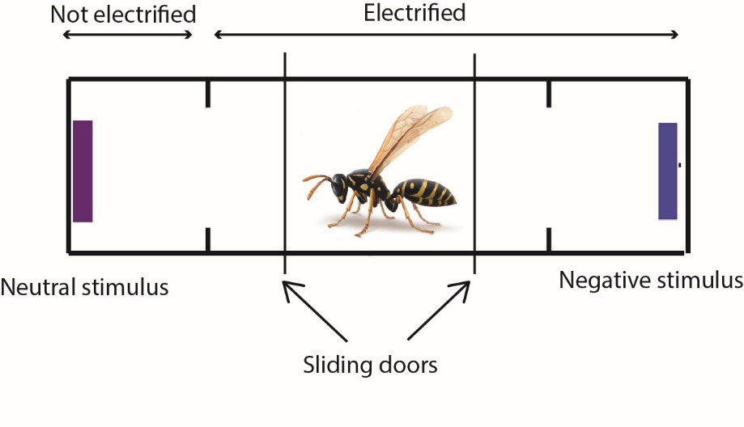
S Fig 1: Design of the training and testing apparatus. During training, wasps were free to move through the rectangle for 30 seconds. The area near the negative stimulus was electrified, while the area near the neutral stimulus was not electrified. During the 10 trial test, wasps were removed as soon as they ‘made a choice’ by moving past the small dividers 2.5cm from each end of the rectangle. No part of the arena was electrified for the transitive inference test where preference for B vs D and A vs E were tested. P. dominula drawing by John Megahan.

Supplemental figure 2, Colors used during transitive inference training

Supplemental Table 1, Results of one-sample t-test comparing choices to the neutral 50:50 expectation. AB first indicates wasps that were trained to discriminate A vs B on day 1. DE first indicates wasps that were trained to discriminate D vs E on day 1.
 | BD | AE
P. dominula all | t₂₂=8.5, p<0.001 | t₂₂=4.4, p<0.001
P. dominula AB first | t₁₁=4.5,  P=0.001 | t₁₁=3.2,  P=0.01
P. dominula DE first | t₁₀=9.0,  P<0.001 | t₁₀=3.1,  P=0.01
P. metricus all | t₁₆=4.12,  P=0.001 | t₁₆=5.6,  P<0.001
P. metricus AB first | t₆=3.4,  P=0.014 | t₆=2.7,  P=0.037
P. metricus DE first | t₉=2.6,  P=0.03 | t₉=5.2,  P=0.001

