SUPPLEMENTARY MATERIAL

- Wider-community questionnaires: pp.2-3
- Quiz: pp.4-14
- Within-group questionnaires: p.15
- List of participating groups: p.16
- List of named influential community members: p.17-20
- List of named community learning models and learning topic p.21-24

YOUR ID NUMBER:________ YOUR GENDER: ______ YOUR YEAR OF BIRTH: _______
Please name someone who you think of as having high status, or as being highly influential, in either your local community or in your country. By “highly influential” we mean: is paid attention to, leads decisions. E.g. The Prime Minister, an M.P., Councilor, Mayor, or local celebrity:
Name: ___________________________ Their role/position/job: _________________________
Please rate this person according to the following scale:
1------------2------------3------------4------------5------------6------------7
Very Much/ TRUE

Not At All/ NOT TRUE
Somewhat

- Members of your community respect and admire them _____
- Members of your community do NOT want to be like them_____
- They enjoy having control over other members of the community_____
- Members of your community always expect them to be successful_____
- They often try to get their own way regardless of what others in the community may want_____
- Members of your community do NOT value their opinion_____
- They are willing to use aggressive tactics to get their way_____
- They are held in high esteem by members of the community_____
- They try to control others rather than permit others to control them_____
- They do NOT have a forceful or dominant personality_____
- Members of the community know it is better to let them have their way_____
- They do NOT enjoy having authority over other members of the community_____
- Their unique talents and abilities are recognized by others in the community_____
- They are considered an expert on some matters by members of the community_____
- Members of your community seek their advice on a variety of matters_____
- Members of your community are afraid of them_____
- Others do NOT want to spend time with them_____

YOUR ID NUMBER: __________
Please name someone either from your country or your local community that you would like to learn from or learn to be like. E.g. learn a skill of theirs, or gain knowledge/advice from:

Name: ___________________________ What of theirs would you like to learn:_________________________
Please rate this person according to the following scale:
1------------2------------3------------4------------5------------6------------7
Very Much/ TRUE

Not At All/ NOT TRUE
Somewhat

- Members of your community respect and admire them _____
- Members of your community do NOT want to be like them_____
- They enjoy having control over other members of the community_____
- Members of your community always expect them to be successful_____
- They often try to get their own way regardless of what others in the community may want_____
- Members of your community do NOT value their opinion_____
- They are willing to use aggressive tactics to get their way_____
- They are held in high esteem by members of the community_____
- They try to control others rather than permit others to control them_____
- They do NOT have a forceful or dominant personality_____
- Members of the community know it is better to let them have their way_____
- They do NOT enjoy having authority over other members of the community_____
- Their unique talents and abilities are recognized by others in the community_____
- They are considered an expert on some matters by members of the community_____
- Members of your community seek their advice on a variety of matters_____
- Members of your community are afraid of them_____
- Others do NOT want to spend time with them_____

ART QUIZ

- Henri Matisse was a French artist of the:
  - 15th Century
  - 20th Century

- The singing butler is a famous modern painting by the Scottish painter:
  - Jack Vettriano
  - Andrew Geddes

- The starry night is a famous painting by:
  - Vincent van Gogh
  - Jackson Pollock

- The Birth of Venus
  - Sandro Botticelli
  - Leonardo da Vinci

- Rembrandt was famous for which style of painting?
  - Baroque
  - Surrealism

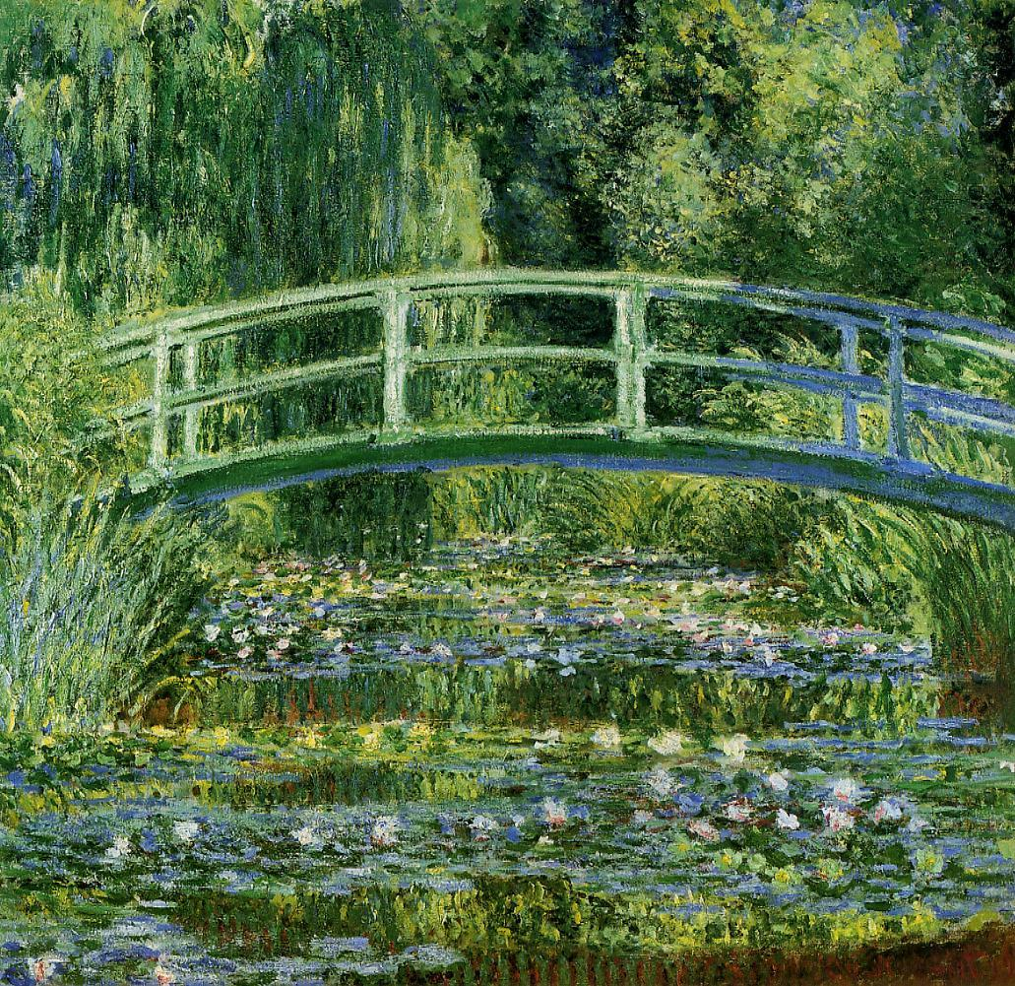
- The above is an image of a painting by which artist?
  - Claude Monet
  - Eduard Manet

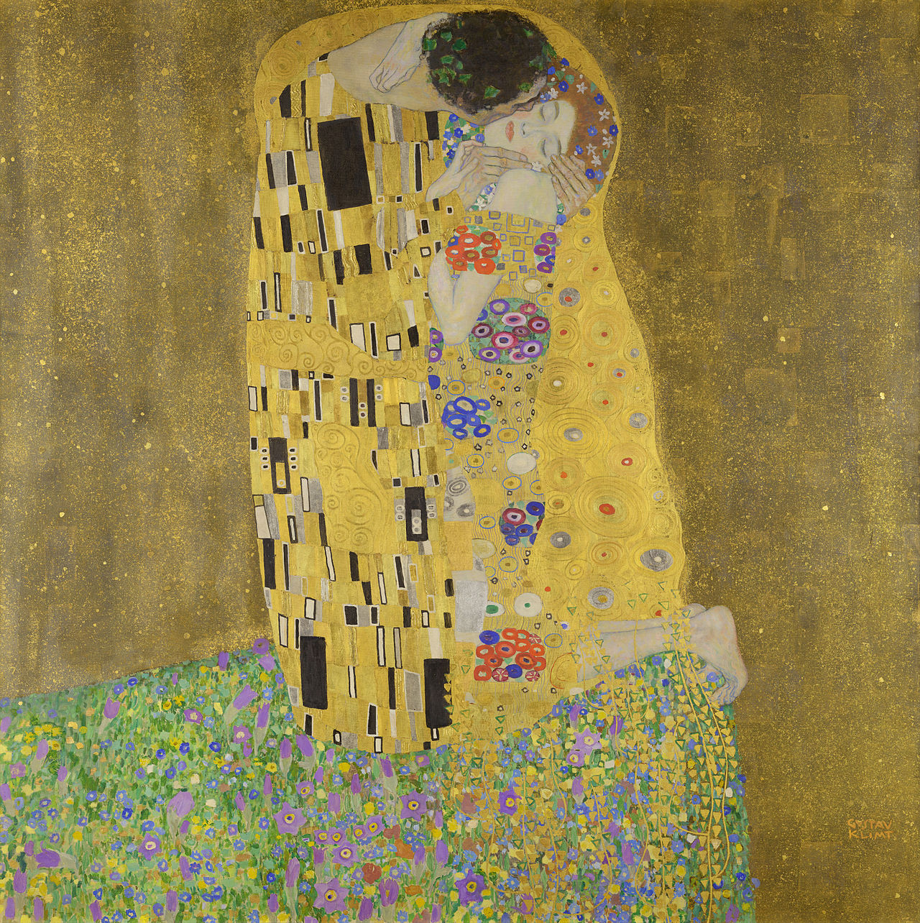

- The above is an image of a painting by which artist?
  - Rudolf Hausner
  - Gustav Klimt
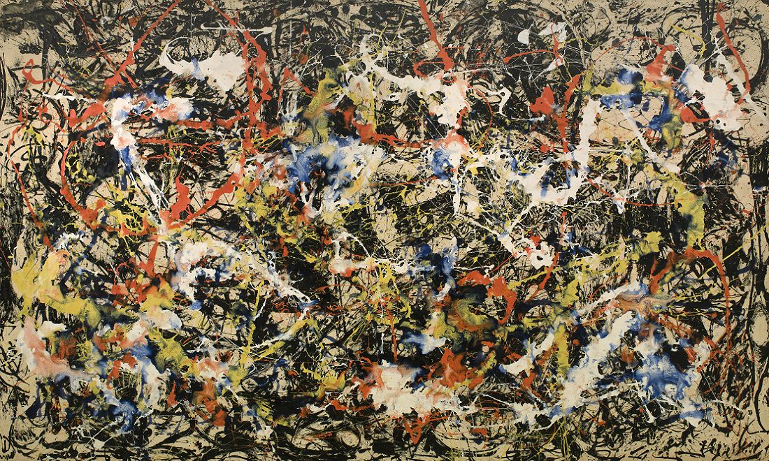
- The above is an image of a painting by which artist?
  - Jackson Pollock
  - Franz Kline
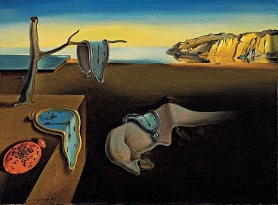
- The above is an image of a painting by which artist?
  - Marcel Duchamp
  - Salvador DalÌ
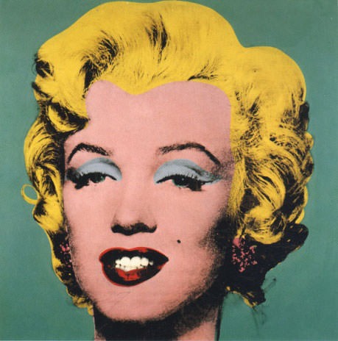
- The above image is associated with which artist?
  - Roy Lichtenstein
  - Andy Warhol

GEOGRAPHY QUIZ

- Oklahoma state shares a border with:
  - New Mexico
  - Arizona

- Tokyo is closer to:
  - Hamamatsu
  - Kyoto

- The capital of the Philippines is:
  - Davao
  - Manila

- Melbourne is in:
  - Australia
  - New Zealand

- Which city is closer to Rome?
  - Naples
  - Florence

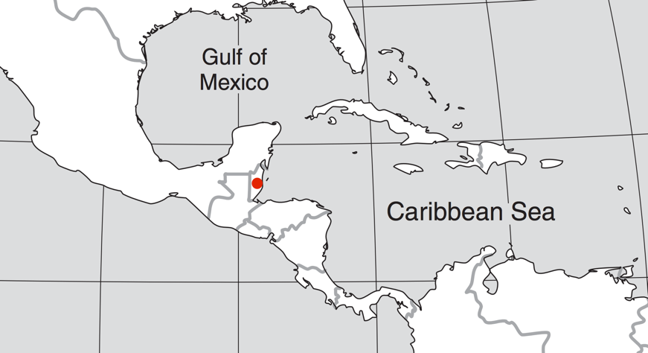
- In which country is the red dot located in? (Above)
  - Belize
  - Guatemala

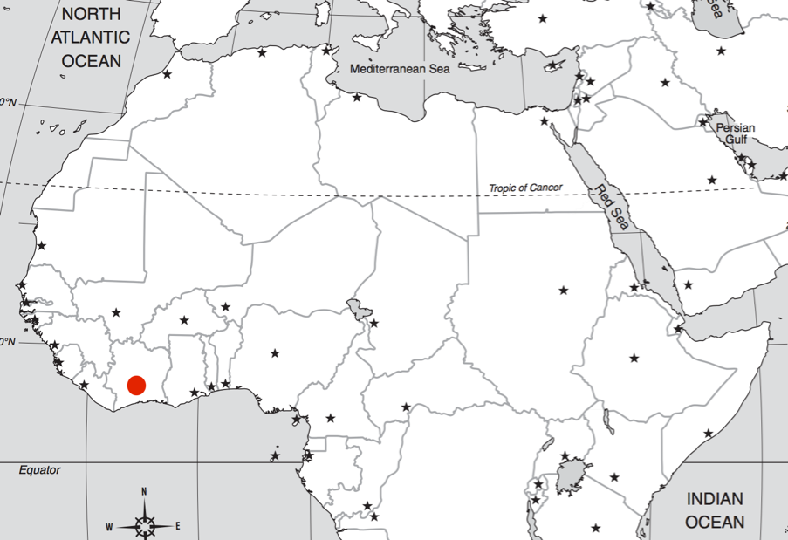

- In which country is the red dot located in? (Above)
  - The Ivory Coast
  - Nigeria

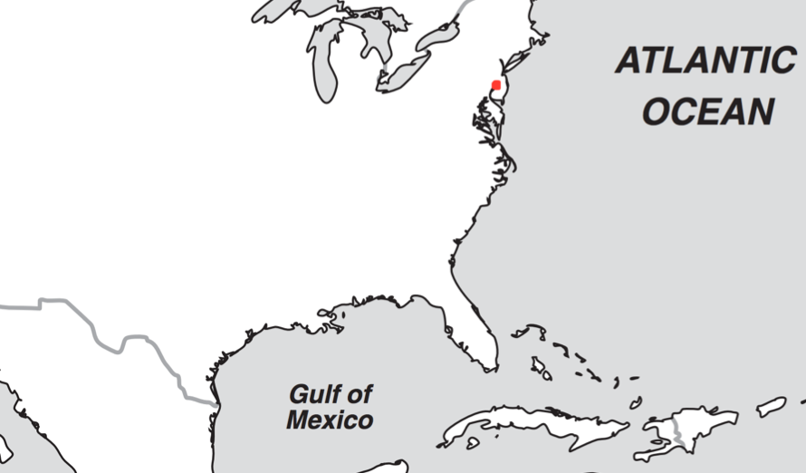

- In which city is the red dot located? (Above)
  - Seattle
  - Philadelphia

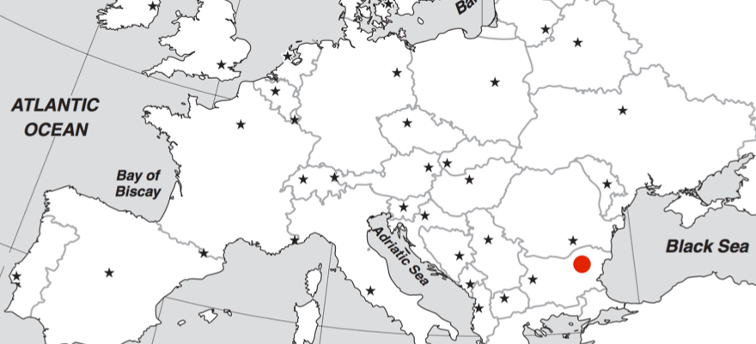
- In which country is the red dot located? (Above)
  - Bulgaria
  - Greece

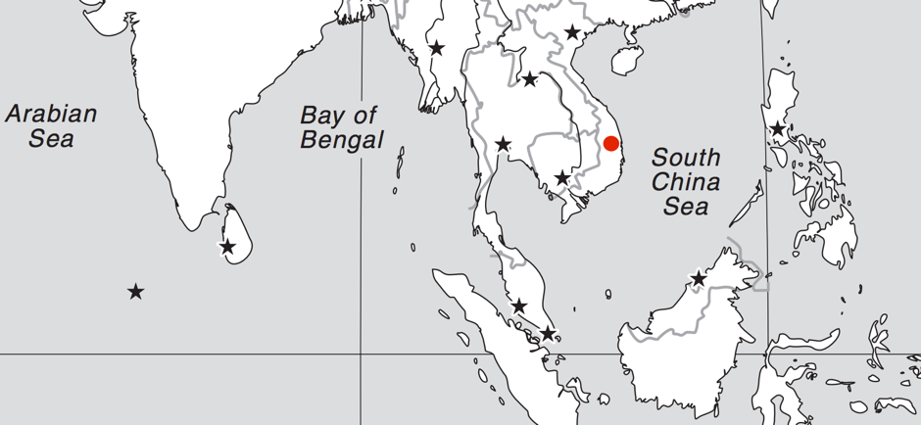
- In which country is the red dot located? (Above)
  - Vietnam
  - Laos

LANGUAGE IDENTIFICATION

- ‘Gobierno’ means ‘government’ in which language?
  - Spanish
  - Portuguese

- ‘Vinaka’ means ‘Thank you’ in:
  - Fijian
  - Swedish

- ‘Umut’ is ‘hope’ in:
  - German
  - Turkish

- ‘Pudel’ means ‘bottle’ in:
  - Bulgarian
  - Estonian

- ‘Bloem’ means ‘flower’ in:
  - Dutch
  - Danish

- The above means 'festival' written in which language?
- Japanese
- Korean

- The above means ‘star’ written in which language?
  - Macedonian
  - Greek

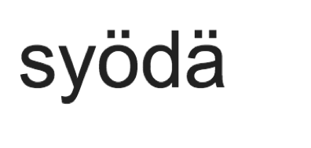
- The above means ‘to eat’ written in which language?
  - Finnish
  - Swedish
- The above means ‘soul’ written in which language?
  - Arabic
  - Armenian

- The above means ‘fire’ written in which language?
  - Russian
  - Bulgarian

WEIGHT ESTIMATION

- A tennis ball weighs:
  - 58.5g
  - 5.85g

- What does a typical (class 1A) fire extinguisher weigh?
  - 115kg
  - 1.15kg

- Which weighs more, on average?
  - Apricot
  - Avocado

- Which weighs more, on average?
  - An ostrich egg
  - A hen’s egg

- What does an average baking potato weigh?
  - 18 g
  - 180g

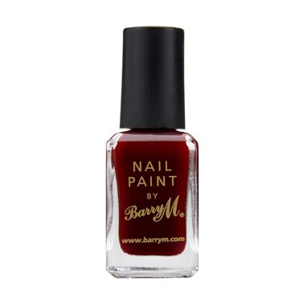
- An average pot of nail varnish weighs:
  - 62g b. 162 g

- A Rubik’s cube weighs:

  - 0.14kg b. 1.14kg

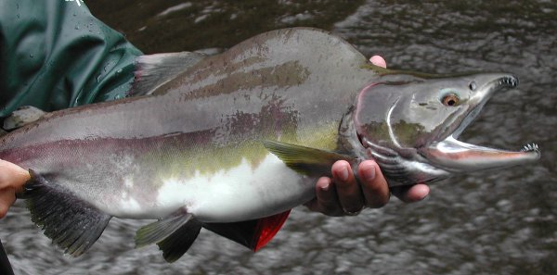
- An average Pink Salmon weighs:
  - 1.7kg b. 17kg

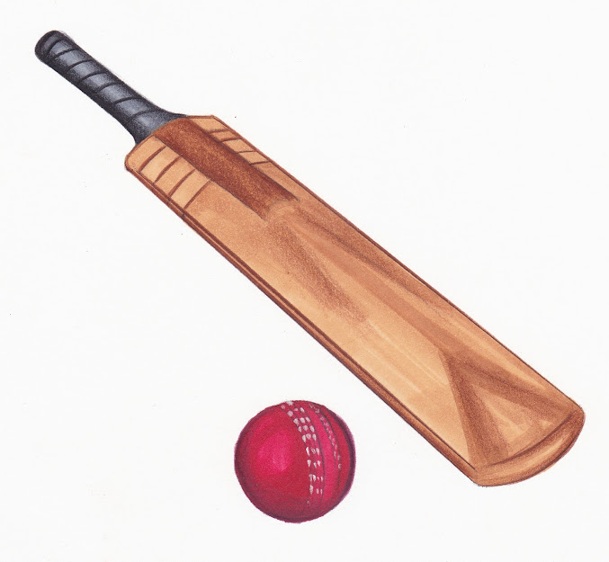
- A cricket bat weighs:
  - 1.4 kg
  - 14 kg

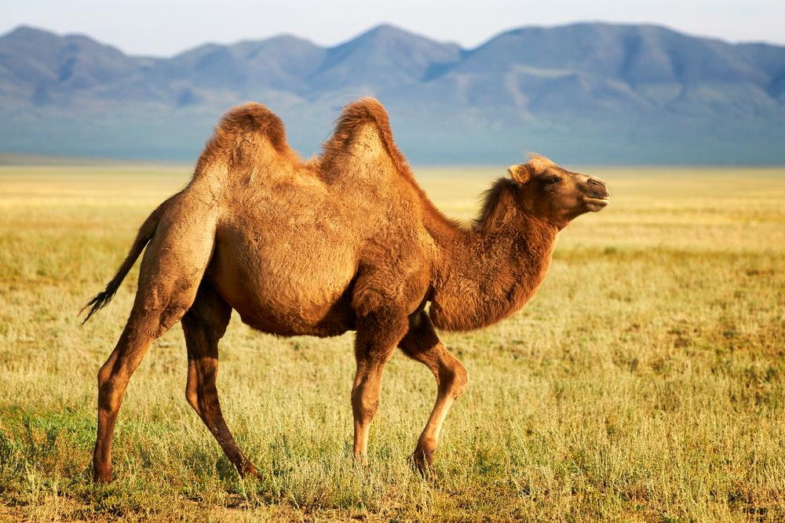
- The average weight of a camel is:
  - 480kg
  - 48kg

Estimated score (out of 40): __________

YOUR ID NUMBER: __________ THEIR ID NUMBER: ___________
Please rate this person according to the following scale:
1------------2------------3------------4------------5------------6------------7
Not At All/ NOT TRUE
Somewhat
Very Much/ TRUE

- Members of your group respect and admire them _____
- Members of your group do NOT want to be like them_____
- They enjoy having control over other members of the group_____
- Members of your group always expect them to be successful_____
- They often try to get their own way regardless of what others in the group may want_____
- Members of your group do NOT value their opinion_____
- They are willing to use aggressive tactics to get their way_____
- They are held in high esteem by members of the group_____
- They try to control others rather than permit others to control them_____
- They do NOT have a forceful or dominant personality_____
- Members of the group know it is better to let them have their way_____
- They do NOT enjoy having authority over other members of the group_____
- Their unique talents and abilities are recognized by others in the group_____
- They are considered an expert on some matters by members of the group_____
- Members of your group seek their advice on a variety of matters_____
- Members of your group are afraid of them_____
- Others do NOT want to spend time with them_____
During the group quiz discussion, this person:
- Had high status_____

- Led the task_____

- Was paid attention_____

Overall:

- I like this person _____ 22. I like working with this person________

Group no. | Group_Affiliation | Date of participation
1 | PILOT TEST (Office) --DELETED | 22/05/2017
2 | Newquay Zoo Staff | 20/07/2017
3 | FXPlus Library Staff | 15/08/2017
4 | Falmouth Cruiseship Ambassadors_4 | 15/08/2017
5 | Falmouth Cruiseship Ambassadors_5 | 15/08/2017
6 | REDWING Community Centre | 11/10/2017
7 | REDWING_2 | 11/10/2017
8 | SourceFM Presenters | 22/10/2017
9 | Nankersey Male Choir | 07/11/2017
10 | Active Plus_Hayle | 04/12/2017
11 | Active Plus_2 -DELETED FOR WITHIN-GROUP | 04/12/2017
12 | Flushing & Mylor Gig Rowing | 06/12/2017
13 | SSE_Truro Health&Wellbeing Innovation Centre | 15/01/2018
14 | ActivePlus_St Ives | 16/01/2018
15 | Active Plus_Clies | 17/01/2018
16 | Psych-Soc_Streatham | 30/01/2018
17 | Psych-Soc_Streatham2 | 30/01/2018
18 | Dyslexia Cornwall_Truro Innovation Centre | 31/01/2018
19 | Bio-Soc Streatham_3 | 08/02/2018
20 | Streatham Students_4 | 08/02/2018
21 | Clarinet Choir | 08/02/2018
22 | Hotel Perfect_Tremough Innovation Centre | 09/02/2018
23 | Falmouth Kayak Club_students | 13/02/2018
24 | Roaming CIC _Penzance | 15/02/2018
25 | Penryn MSc students | 26/02/2018
26 | Mylor Mums | 04/03/2018
27 | Philosopher's Hat | 05/03/2018
28 | Calstock Chess Club | 06/03/2018
29 | Falmouth Fish Sea Shanty Collective | 07/03/2018
30 | Pirates of Penryn boardgame creators | 07/03/2018
31 | Cambourne Chess Club | 12/03/2018
32 | Penryn MSc students_2 | 15/03/2018

name | position
A**** ***** | Mother
Andrew | Councillor
Andrew **** | Councillor
Andrew ***** | Broadcaster
***** ***** | VC of Falmouth Uni
Arthur **** | Union leader
B. Portman | X Mayor
Ben Bradshaw | MP
B** ***** | Head Teacher
Beppe Grillo | Politician
Beyonce | Singer
Bob
Bob Devereux | Poet, Playwrite
Boris Johnson | Foreign Secretary
Boris Johnson | Foreign Secretary
Boris Johnson | Foreign Secretary
Boris Johnson | Foreign Sec
Boris Johnson | F. minister
Boris Johnson | Foreign Minister
Brad Brown | Creator of "more to life" programme
Brother Roger | Late Friar of Taize
Captain Holt | Captain of Police (Brooklyn 99)
Carl Sagan | SETI, attack on superstition, novel Contact
Caroline Lucas | Leader Green Party
Christopher ***** | Director of******, Cathedral
Christopher ***** | Lead story developer
Colin ****** | Neighbour
Cornelius Oliver | Councillor
Cyndi Lauper | Singer/ human rights activist
David Attenborough | Broadcaster
David Attenborough | Broadcaster
David Attenborough | Tv presenter
David Attenborough | Conservationist/presenter
David Attenborough | BBC Presenter
David Attenborough | tv presenter/environmentalist/wildlife activist
David Attenborough | Presenter
David Attenborough | Presenter/ecologist
David Attenborough | Naturalist
David Attenborough | Tv presenter
Deborah Francis-White | Leads the Guilty Feminist Podcast
Dennis Skinner | MP For Bolsever
Donald Trump | Prime Minister
Dr Nigel Hewitt | Director of a Charity
Dr Peter Rodgers | GP/chairman of tennis club
Eddie Calvo | Govenor of Guam
Eddie Home | Football Club Manager
Edward Davey | MP
Enoch Powell | Politician
Frank Whittal | Inventor
Friedensreich Hundertwasser | Artist
George Eustace | MP
George Orwell | Author
Ghandi | leader
Grayson Perry | Artist/potter
Grenville Chapple | Mayor
Henry Bew | Head of English Department
Jamie Shiner | Business Leader
Jane Goodall | Primatologist
Jenny | Artist/musician
Jeremy Corbyn | Leader of opposition
Jeremy Corbyn | Politician
Jeremy Corbyn | Labour Party Leader
Jeremy Corbyn | Leader Labour Party
Jeremy Corbyn | Labour Party Leader
Jeremy Corbyn | Leader of the labour party
Jeremy Corbyn | Labour Leader
Jeremy Corbyn | labour Party Leader
Jeremy Corbyn | Labour Party Leader
Jeremy Corbyn | Leader of the opposition
Jeremy Corbyn | Leader of the labour party
Jeremy Corbyn | Leader of opposition
Jeremy Hunt | Health Cabinet
JK Rowling | Author
Jo Feather | Taught sailing after the war, got MBE
John Goodman | Newquay Facebook Community Admin
John Pollard | Councillor
Johnny Depp | Celebrity
Lesley | manageress of Hayle community centre
L***** ****** | Day care centre manager
Linda | Mayor
Mancelo Rebelo Sousa | Republic President
Marconi For Radio | Early Communications
Margaret Thatcher | Prime Minister
Mark Ashton | Activist
Mary Berry | Cook
Mary Holborough | High Sherrif
Michael Gove | M.P.
Michael Tyade | Musician
M***** ******* | Step Father
Mrs May | Prime Minister
Mrs Sanderson | Headmistress of local school
Mrs x | Headteacher of primary school
na | na
Nicholas ******* | Leader of local group
Nicolae Ceausescu | President (Former)
Oscar Wilde | author/activist/dandy
Ozzy Osbourne | Rock Star Supreme
Patrick Gale | Author
Paul | International project director
Penny HC Dinh | Youtuber
Peter L Mere | Peace Campaigner CND
Phil ***** | Traveller&Gypsy Liason Officer
Prince Charles | Duke of Cornwall
Prince William | Heir to the Throne
The Queen | Head of State
The Queen | Queen
Richard Charter | ex Bishop of London
****** ****** | Chess club secretary + local accountant
Richard ****** | free software advocate & software developer
Rick Stein | Celeb Chef
R********** | President of ****** Association
Rodrigo Duterte | President of Phillipines
Roselyn | Director
Rupaul Charles | Drag Queen
Sam Mezec | States of Jersey Reform Party Member
Sarah Newton | MP Falmouth
Sarah Newton | M.P.
Sarah Newton | Tory MP Truro & Falmouth
Sarah Porter | Councilor
Shanne Sands | Poet
******** | Head drama teacher sixth form
Sheryll Murray | Local MP
Shinzo Abe | Prime minister of Japan
Sir Humphry Davy | Statue
Steve ***** | Advocacy Support Worker
Tarja Halona | former president of Finland
Theresa May | The Prime Minister
The Queen | Queen of England
The Queen | Monarch
Theresa May | Prime Minister
Theresa May | Prime Minister
Theresa May | PM
Theresa May | Prime Minister
Theresa May | Prime minister
Theresa May | Prime Minister
Theresa May | Prime Minister
Theresa May | Prime minister
Theresa May | Prime Minister
Theresa May | Prime Minister
Theresa May | Prime Minister
Theresa May | Prime Minister
Theresa May | Prime Minister
Theresa May | Prime Minister
Theresa May | Prime Minister
theresa May | Prime minister
Theresa May | Prime Minister
Theresa May | Prime Minister
Theresa May | Prime Minister
Theresa May | Prime Minister
Tony Blair | past PM
Traian Bruma | Head of alternative university in Romania
Vicky M | Green politician
Winston Churchill | Wartime PM
Winston Churchill | Prime Minister
Winston Churchill | ex Prime minister

name | want to learn:
Alex Pritchard | Politics
Alf Coles | Devloping conviction in others
Alice | social skills
Alistair | Maths education
Amanda Brown | Yoga Skills
Andrew George | Clear public speaking and articulation
Andrew Mitchell | Council affairs
Andrew Mitchell | Council affairs
Andrew Nancharrow | Wooden Boat Building
Andrew Tozer | Artist
Annabelle Waite | Singing/performance
Augustine | Rhetoric
B. Portman | ability to sort thngs out
Ben Mayer | na
Bethany Saunders | See life like she does
Bobby Moore | Football Skills
Boris Johnson | Expand on knowledge of German
Boris Johnson | Foreign Sec.
Brian Cox | Scientific Knowledge
Brian Goldthorp | Knowledge
Bryony Oncuul | Their knowledge of colonisation and heritage
Carl Hester | Dressage coaching
Caroline Harris/boss | eventing/riding
Caroline Lucas | Eloquence
Che Willbraham | Digital Story making
Chris D | Patience/teaching skills
Chris Rubbery | Advance Sailing Safety
Churchill | Public Speaking
Claire Hall | sewing skills
Claire Ingleheart | Personality&Music
Cliff Thomas | His philosophy on life
College professor | communication skills
Dalai Lama | Wisdom
Dali Lama | Tolerance
Dan | To play music/sing well
Darryl Thorpe | Seal Rescue
David Attenborough | Animal knowledge
David Attenborough | to inspire and motivate
David Bowie | Knowledge
DAVID COLEMAN | DEMOGRAPHY
Dawn French | Comedy
Delia Smith | Cooking
Derek Guthrie | Knowledge of art
Doctor | Patience
Dr Drummond | be like him
Dr. Phil Hammond | Presentaiton & speaking skills
Eddy Jones | na
Elaine Taneye | Musical understanding & technique
Emilia Clarke | Confidence
Emma Watson | Influential Speaking on feminist issues
Eniola Aluko | Football
Eric Meijaard | Productivity, influence
Fiona Richardson | Positivity & Passion
Frank Auerbach | Painting
Fuzz Townsend | Mechanical Knowledge/car restoration
Gary | Be awesome
Gary Ward (senior bird keeper) | knowledge of bird husbandry
Giorgio Fraticelli | outgoing/ networking skills
Grayson Perry | artistic confidence
Hannah | choreography
Head horse worker, Bosence Farm | Equine Therapy
Helen Mirren | to be confident & forthright
Helen Porter | Musical performance
J. K. Rowling | Success
J.K. Rowling | writing skills
James Scourse | ability to understand and use knowledge
Jamie Oliver | How to cook
Jane Sand | How to paint
Jard Acton | Pleasant Nature Outdoor Sessional Skills
Jennifer Morrison | Acting Skills
Jeremy Corbyn | Conviction
Jeremy Paxman | General Knowledge
JK Rowling | writing
JK Rowling | Writing
John | Zen Buddhism
John Gordon | Poet
John Gordons | Guitar Teacher
John Williams | Guitar Skills
Johnny Cowling | Ability to make people laugh
Julia Nott | Play piano better
Kerstin Skining | organisation
Kim Conchie(Cornwall Chamber of Commerce) | Management & Presentation Skills
Lawrence John | Tailoring
Lecturer X | Enthusiasm & public speaking
Les
Lesley Chenels | Fairness
Leslie Bradley Peers | Standing my ground, networking, communicating
Lisa Wisdom | Artistic forwardness/success
M Bryant | Outlook on life
Madhar Jaffrey | Recipes, Cooking, techniques and skills
Margaret Attwood | Writing
Marianne De Trey | Living a potter's life
Mary | Only see the best in people
Mary Chan | their profession
Matthew Mercer | Creativity
Matthew Rogers | To relax
Matthew Rogers | Management skills
Max Shepherd | most things
Melanie Wheeler | be more like them
Mestre zo Antonio | Caspiera
Michael Smith | Diplomacy
Mike Parknoy | Drumming & Music
Mom | Perseverance, energetic personality, wanting to step out of comfort zone
Mother | patience/compassion
Mr Harvey | Biology
Mum | kindness, patience, understanding
Music band | strength of will
My Mother | loyalty, resiliance
na | na
na | na
Nicholas Smith | How to lead others
Nicole Crane | Quilting
Nik Elvy | How to lead/teach/manage youth group
Niki Pearce | Socialising Skills
no.127 | excellent parenting skills
Olivia A | Dance
Oscar Wilde | confidence/writing skills
Pat Parelli | Horsemanship
Paul Smith | Motivation
Peter Jones | Business acumen
Phil | Carpentry/ ship building
Prince William | Modern way of thinking
Puzzle | Painting Landscapes
Queen Elizabeth | na
Queen Elizabeth II | her patience
Richard Baker | Book keeping skills
Richard Branson | Business acumen
Richard Osmond | General Knowledge
Robert Fischer | Chess Genius
Roisin Perry | Dedication
Ros Williams | Printmaking
Roselyne | Management
Roxana Marin | enthusiasm & energy
S. Thompson | Patience
Sean | Paddleboarding weSUP Gylly Beach
Shakleton | Adventurous spirit/exploration
Shane Glachin | Academic
Shannon McManus | music
Shirley Williams | Leadership/negotiation
Simon Clark | Video editing skills
Simon Parry | Knowledge
Stan Lee | Drawing Style
Stephen Hawking | Cosmology
Suvi Pattibagar | Discipline & organisational skills
Suzanne Cotter | Knowledge
Terry McClintock | Indian Cooking
The PM | general skills
Tim Brabants | commitment to training
Tim Shaw | Sculptor
Tom Rice | His knowledge of anthropology
Tony Blair | Self-confidence
Wilfred Owen | Skills with words
Will Smith | Ambition
William F Sanday | Music, oragn & piano
Yo yo ma | technique

